

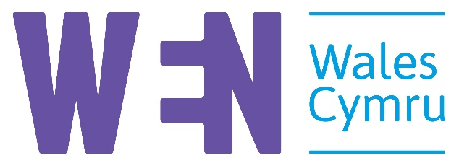
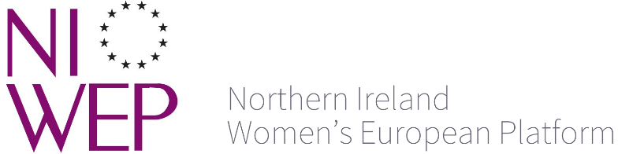

CONVENTION ON THE ELIMINATION OF ALL FORMS OF DISCRIMINATION AGAINST WOMEN
SHADOW REPORT FROM THE FOUR NATIONS OF THE UNITED KINGDOM, JANUARY 2019
Eighth periodic report of the government of the United Kingdom on measures taken to give effect to CEDAW.
Engender (Scotland), Northern Ireland Women’s European Platform, Women’s Equality Network Wales, Women’s Resource Centre (England)

INTRODUCTION
Since the UK’s last examination, UK Government has continued to implement wide-ranging austerity measures, diminishing women’s rights. Gender mainstreaming throughout the public sector, and active promotion of women’s rights is urgently needed. Instead, public funding that crucially impacts on women’s lives has been decimated. Women are shouldering cuts to social security that are directly causing poverty, homelessness, physical insecurity and fatality. Cuts to vital public services are seeing women lose secure employment and take on additional unpaid care. Women are being placed at risk of violence through government policy that erodes their financial and bodily autonomy. The capacity of women’s organisations to deliver frontline services, including specialist violence against women services for Black, Asian, minority ethnic and refugee (BAMER), disabled and LGBT women, has been slashed, despite their added value.
This is on top of entrenched inequalities that systematically breach women’s rights. The UK’s forthcoming exit from the European Union (‘Brexit’) will jeopardise the rights of women and girls yet further.
1.1 Intersectionality
This breach of rights is experienced more emphatically by women who face multiple inequalities. Disabled women, women from BAMER communities, LGBT women, younger and older women, migrant, asylum-seeking and stateless women, low-income women, women with minority faiths, unpaid carers and women in rural areas all experience gender inequality in particular ways that is ignored by policymakers in the UK. This report is not a thorough intersectional analysis, but we highlight particularly urgent issues for groups of marginalised women.
1.2 Devolution settlement
The four countries of the UK (England, Northern Ireland (NI), Scotland and Wales) are subject to policy set by the UK Parliament, to varying degrees. England is exclusively governed by the UK Government, which also retains control of core funding for ‘devolved’ matters.
Northern Ireland, Scotland and Wales have their own parliaments, which determine policy on areas at the heart of CEDAW. These include health, social care, early years, violence against women and aspects of social security. Scotland and NI also have distinct legal systems.
As the state party, UK Government has ultimate responsibility for implementing the Convention across the UK, although levers for doing so regarding matters devolved to Wales and Scotland are weak. We indicate which government has power to implement respective issues raised throughout the report. Northern Ireland has had no Assembly or Executive since January 2017.
1.3 UK State Report
The UK State Report focuses largely on future initiatives rather than assessment of the Government’s work. It is bereft of data, reflecting a longstanding deficit in the systematic data collection required to monitor women’s equality, and where statistics are included these are often not linked to concrete plans for change (for instance the 48% employment rate for disabled women). Nor was the report produced in partnership with women’s organisations, as required by CEDAW guidance; engagement that did take place was wholly inadequate. This is partly because the UK Women’s National Commission was abolished in 2010 and there is no mechanism to ensure that a diverse range of women’s and girls’ voices are heard by UK decision-makers. The UK Government’s 2016 non-advocacy or ‘gagging clauses’ also restricts organisations that campaign against government policy. The report does not therefore offer the Committee a comprehensive analysis of the last four years.
1.4 Process
Our report sets out major issues for women’s rights across the UK, and draws attention to areas of particular concern in each jurisdiction. Suggested questions for the Committee are marked for respective governments.
It draws on evidence submitted to Engender, Northern Ireland Women’s European Platform, Women’s Equality Network Wales and the Women’s Resource Centre by 118 women’s, equalities and human rights organisations across the UK.

ARTICLE 2

2.1 Incorporating CEDAW into domestic law
Since 1999, the Committee has recommended the UK incorporate the provisions of CEDAW into domestic legislation. However, the State Report claims that this would “giv[e] women more rights than others”; we fundamentally disagree. The UK has no Equality Strategy to promote women’s rights or monitor progress under CEDAW.

Progressive realisation of rights across the UK could be hastened through incorporation into UK and Scots law, and the laws of devolved administrations where appropriate. Scotland has a separate legal system, and devolved Governments are accountable for human rights protection across devolved policy areas.

Recommendations
- UK and Scottish Government should incorporate CEDAW into UK, Scots, and Northern Irish Law.

- Welsh Government should enshrine the principles of CEDAW into legislation regarding devolved matters.

2.2 Rights at risk after ‘Brexit’
Anti-discrimination and equality-enabling regulation in the UK is bound up in membership of the EU. ‘Brexit’ will end current guarantees that prevent the roll back of rights for women, with employment rights regarding equal pay, maternity leave and part-time work at particular risk. Evolving EU legislation on parental leave, flexible working and breastfeeding at work, will be lost. Loss of EU funding will leave critical gaps for women’s organisations, including violence against women specialist support services.
In the immediate aftermath of the EU referendum, anti-Muslim hate crimes and incidents in England and Wales increased by 475%, and the majority of victims were women. This hostile environment is exacerbated by UK Government’s punitive immigration system which systematically breaches women’s rights, and by its narrative that migrants are a cost to the taxpayer, when in fact UK migrants are a net contributor to the public purse.
The UK Government plans to remove the EU Charter of Fundamental Rights and its EU Withdrawal Bill allows Ministers “effectively unlimited powers” to determine which laws will remain in place post-Brexit. This “would fundamentally challenge the constitutional balance of powers between Parliament and Government and would represent a significant—and unacceptable—transfer of legal competence.” UK Government should ensure that current legal rights cannot be changed without scrutiny by Parliaments, citizens and civil society and ensure that equality impact assessments of trade agreements inform negotiations. Northern Ireland’s distinctive circumstances mean that it will be profoundly affected by Brexit, including regarding cross-border trade, health and social care provision, and peace and security.
Recommendations
- UK Government should demonstrate how it will protect and enshrine women's rights and ensure their future enhancement during and after Brexit;

- UK Government should develop action to mitigate the negative impacts of Brexit such as the rise in hate crime in England and Wales, and address the particular concerns of women in NI.
2.3 Data
Compliance with CEDAW by governments across the UK is fundamentally undermined by lack of gender-disaggregated data, which makes women’s inequality and the impact of government policy on women increasingly invisible.
This has recently compromised our work with regard to health, housing, prejudice-based bullying in schools, women’s participation in politics, and disabled women’s reproductive and parental rights. Analysis of women’s poverty across the UK is based on household data, which masks the extent of women’s economic inequality, and links between rising maternal and child poverty.
Intersectional data illustrating the deeper inequality experienced by BAMER, disabled, LGBT, rural, asylum-seeking and stateless women, young women and girls, and older women is exceptionally rare. Evidence submitted for this report highlights data barriers regarding violence against BME women, disabled and BME women’s employment and representation, childcare for disabled children, and access to healthcare for refugee, asylum-seeking, Romany Gypsy and Traveller women.
Recommendations
- UK Government should remedy the systemic lack of gender-disaggregated data and intersectional data by introducing a strategy that covers all four nations.
- Scottish Government should build on its Equality Evidence Strategy 2017-2021 to systematically collect and monitor intersectional equalities data.
- Welsh Government should use Equality Impact Assessments to disaggregate data and set up a gender research centre.
2.4 Public sector equality duty
The public sector equality duty (PSED) forms part of the Equality Act 2010 and is the key lever for gender mainstreaming in policymaking in Great Britain. PSED does not apply to NI, which has a separate mainstreaming duty, S75 of the Northern Ireland Act 1998.
PSED regulations are different in England, Wales and Scotland. Regulation is weakest in England where UK Government, inter alia, has removed the requirement for equality impact assessments (EQIAs).
Where slightly stronger regulation exists, however, PSED is still not advancing women's equality. EQIAs are weakly implemented, other requirements are not closing gender gaps or addressing multiple discrimination, and compliance is worsening.
The shape of the specific duties in Wales and Scotland need to be revisited.
Recommendations
- UK Government should amend PSED regulations in England to include equality impact assessments.
- Scottish and Welsh Government should improve the gender-sensitivity of their specific PSED regulations.
- UK Government should ensure that S75 in NI includes robust equality impact assessment.
2.5 Institutional mechanisms in Northern Ireland
A draft five-year Programme for Government setting out strategic priorities was published by the Northern Ireland Executive in 2016. It is not formulated around international human rights obligations, lacks a gendered perspective and fails to strengthen equality mechanisms, including high-level, cross-cutting government policy. This is particularly concerning as, despite commitments made during the UK’s last reporting period, NI has no gender or broader equality strategy. Equality is a responsibility devolved to the NI government, but NI currently has no Equality Strategy or other significant strategies that address structural gender inequalities.
Recommendation
- UK Government and devolved administrations should establish machinery of government for effective implementation, reporting, and follow up of treaty body requirements.

ARTICLE 3

3.1 The cumulative, intersectional impact of austerity
Since 2010, UK Government’s austerity agenda and programme of ‘welfare reform’ has had an enormously disproportionate impact on women. As mothers, carers and the majority of older people in the UK, women have limited access to paid work and rely on shrinking social security and public services. As the majority of the public-sector labour force, women have experienced job losses and pay freezes. Between 2010 and 2020, cuts to the social security budget will amount to £82 billion, and up to 86% of this will be borne by women. Disabled, BAMER and rural women, unpaid carers and other groups are disproportionately impacted within this and by wider spending cuts.
This inequality breaches women’s basic human rights. Lack of economic independence is both a cause and consequence of violence against women. Diverse groups of women in the UK are now at greater risk of deeper and sustained poverty. For instance, single mothers face an average annual loss of £5250. Recently the UN Rapporteur on Extreme Poverty came to the UK. In Wales he found that 25% of jobs pay below the minimum wage, and low-paid, part-time or insecure jobs are often disproportionately taken up by women, due to difficulties in balancing work and caring responsibilities. The UK Government should end public spending cuts that affect the fulfilment of socio-economic rights.
Recommendation
- UK Government must undertake a cumulative, intersectional equality impact assessment of its cuts to social security and public spending, and act to mitigate the impact on women and girls.

3.2 Violence against women and girls (VAWG)

3.2.1 Provision of VAWG support services
Demand for specialist VAWG support services far outstrips supply in the UK. In 2016/17, 60% of all referrals to refuges in England were declined, and nearly 10% of these women had no recourse to public funds. This disastrous situation would be worsened by proposals to devolve refuge and Rape Crisis funding to local level. Local government resources in England have been halved by UK Government since 2010. Istanbul requires one rape crisis centre per 200,000 women:[1] the UK is 100 short.
Specialist refuge provision across the UK for BAMER, disabled and LGBT women, and women with mental health or substance abuse issues is rare. In 2017/18, 12,166 survivors of abuse were supported by specialist services in Wales, of whom only 12% identified as disabled. Yet the commitment to deliver a sustainable funding model for specialist VAWG services has not yet become a reality in Wales. In 2014/15, only 21% of BME women referred to refuges in London were offered a place.
There is critical need for sustainable funding models for Rape Crisis centres across bthe UK. Rape Crisis England & Wales has a waiting list of over 6,000, lasting up to 12 months; forced closures of lists mean that many areas lack any support service. In Scotland, sexual crimes have increased each year since 2008-09. Yet, Scottish Government’s Rape Crisis Specific Fund has been frozen for ten years and the need for support is rising steeply, with rape crisis centres experiencing up to a 160% increase in demand. There is no specialist rape crisis service in NI, and its only sexual violence counselling charity has a waiting list of over 800.
Disabled women in the UK are up to twice as likely to experience sexual violence as noo-disabled women, yet there are enormous gaps in knowledge around their experiences and appropriate service provision. More adult survivors of child sexual abuse access services.
Recommendations
- UK, Scottish and Welsh Governments must act to address the endemic sexual abuse of disabled girls and women.
- UK Government should provide nationally ring-fenced funding for violence against women specialist support services in England, in line with the National Statement of Expectations
- UK Government should establish sufficient specialist rape crisis provision in England and Northern Ireland.
- Scottish and Welsh Governments should develop appropriate funding models to ensure that rape and sexual assault services meet rising demand.
- Welsh Government should commit to ring-fencing Supporting People and homelessness grants to secure VAWG services

3.2.2 Violence against women and girls (VAWG) national strategies
In Wales, the Violence Against Women Domestic Abuse and Sexual Violence (Wales) Act 2015 provides the framework for a strategic approach to ending VAWG. Delivery, however, has been slow. Post-legislative scrutiny of the Act raised concerns over the continued inconsistency of implementation, and the detailed actions and timescales in the delivery plan.
Northern Ireland’s response to VAWG is fundamentally restricted by lack of a strategic and gendered approach. The Stopping Domestic and Sexual Violence and Abuse Strategy is gender-neutral and there is no dedicated VAWG strategy or action plan.
Recommendations
- Welsh Government should commit sufficient resource to successfully implement its VAWDASV National Strategy across all departments, including delivery of the ‘Istanbul Convention’ in Wales.
- UK and NI government should abandon gender neutral policy making to deliver a strategy and action plan on domestic and sexual violence and abuse of women in Northern Ireland.

3.2.3 Homelessness
Homelessness is a gendered issue across the UK. In Scotland, domestic abuse is the third most common reason for a homeless application. Women and children spend months in refuges and unsuitable temporary accommodation, which compounds the trauma of domestic abuse and impacts enormously on their health and wellbeing.
Legislation is required to ensure immediate protection for victim-survivors of domestic abuse, to prevent women from being forced to leave their homes. In Scotland, existing protective civil orders that enable some women to exclude abusive partners from the home require women to actively seek and pay for protection, despite civil legal aid being increasingly difficult to access.
Young women and girls make more homeless applications than young men and boys in Scotland. Since records began in 2002, 16 and 17-year-old girls have consistently filed around 60% of applications for their age group, and 18 – 24-year-old women are overrepresented in figures every year. This is partly explained by higher rates of domestic and child abuse experienced by young women. Homelessness places them in danger of further abuse and other harm.
Recommendations
- Scottish and UK Governments should legislate to ensure that women victimised by men’s domestic abuse are made safe without having to leave their homes.
- Scottish Government should address high rates of homelessness amongst older girls and young women.

3.3 Legal Aid
The Legal Aid, Sentencing and Punishment of Offenders Act 2012 (LASPO) savagely curtailed legal aid in England and Wales, even for the most vulnerable. Women are significantly more reliant on legal aid than men, so this had a devastating impact on access to justice and enforcement of rights.

Some women are required to pay contributions to legal aid based on the (inaccessible) equity in a jointly-owned family home. Eligibility for legal aid must be realistically related to affordability.
In Scotland, access to a Legal Aid lawyer who accepts domestic abuse cases, understands the dynamics of domestic abuse, and is affordable (especially given constrained access to family assets that survivors routinely experience) is highly unlikely.
Recommendations
- UK Government should reverse the cuts to legal aid in the LASPO Act 2012.
- Scottish Government should reconfigure Scottish Legal Aid provision to enable access by all victim-survivors of domestic abuse.

3.4 Social care
Social care systems across the UK are in crisis. People are living without essential support beyond the bare minimum for survival, largely due to chronic underinvestment. Demographic trends mean that demand for care will only increase; with a 30% increase in adults needing care projected by 2026. 85% of the UK workforce is female, and the low pay that characterises the sector reinforces occupational segregation and the cultural undervaluation of care.
Adequately-funded social care supports full participation in society, preventing isolation, exclusion, illness, and poverty. However, experts across the UK warn that systems of funding for social care are fundamentally broken.
Nor is the contribution of unpaid carers recognised within social care, and inadequate services are worsened by lack of independent advocacy and barriers to justice. Women carers and carers’ organisations across the UK have long called for a redress mechanism to protect the rights of carers and those for whom they care.
Recommendations
- Scottish, UK and Welsh governments should develop a sustainable infrastructure of social care.
- Scottish Government should establish an independent social care tribunal.
ARTICLE 5
5.1 The care economy

Across the UK, unpaid care is worth £132 billion to the economy per annum, with around 70% of this work undertaken by women. In Scotland, 85% of professional care staff are women, and similar occupational segregation is seen across the UK. Chronic underinvestment in these sectors is reflected, for example, in the annual turnover of a third of staff in Scotland’s care homes.

Women’s unpaid and underpaid care work is as vital to a functioning economy and society as physical infrastructure such as transport networks. For instance, research shows a much greater return on state investment in caring than in construction. However, economic strategies in the UK do not recognise this, leading to disproportionate investment in a small number of male-dominated sectors.

The Scottish Government’s economic strategy identifies a small number of key sectors for investment and policy focus. If social care was made a key sector, this would bring care within the scope of economic development and skills agencies, enabling a more robust model of investment and treating care as part of Scotland’s essential infrastructure.

The UK Government’s proposed Industrial Strategy identifies four Grand Challenges, which include meeting the needs of an ageing society. We recommend that this challenge be expanded to meet wider caring needs for disabled people, people with long-term conditions and children, and that the caring economy be prioritised for investment. Governments across the UK must also invest in developing the care workforce. This will be key to tackling occupational segregation, and the lifelong gender stereotyping that underpins it.

Recommendations
- Scottish Government should recognise care as a key sector in Scotland’s Economic Strategy.
- UK Government should recognise the wider care needs of society within its Industrial Strategy.
- Scottish, UK and Welsh governments should develop care workforce strategies to ensure care is highly-skilled and appropriately remunerated work.

ARTICLE 6
6.1 Prostitution
The State Report mentions £150,000 for research into prostitution in England and Wales. This is unacceptable as an account of progress over the last four years. UK Government must stop legitimising the purchase of access to women’s bodies as a form of commerce, and must decriminalise women and expunge their police records in order to support their exiting prostitution.
Recommendations
- UK Government fund adequate exiting programmes in England, Northern Ireland and Wales.
- Scottish and UK Governments should decriminalise women who sell sex, expunge their police records and tackle the causes of commercial sexual exploitation.

ARTICLE 7
7.1 Women, peace and security
NI Government established a Women and Community Transformation Programme following the recommendations of the Fresh Start Panel on the Disbandment of Paramilitary Groups in Northern Ireland. However, this has not been evaluated and there is little evidence of women’s participation in securing peace or in post-conflict reconstruction.
A Westminster Inquiry on implementation of UNSCR 1325 in NI heard how women’s participation was limited, including by economic factors, and that, without appropriate intervention, regression on women’s rights was inevitable. Extensive consultation shows that women hold strong feelings of disempowerment, find difficulties in circumnavigating community gate-keepers and fear harm from speaking out. In 2014, a UNSCR Toolkit was developed to assist public authorities to enhance women’s rights and advance gender equality. However, in 2016, only one woman was amongst 15 appointments to the Commission on Flags, Identity, Culture and Tradition.
The current UK Government consultation on legacy issues acknowledges that a ‘disproportionate number of survivors and family members are women’ but it is unclear how this relates to the development of the institutions under consultation.

Recommendation
- UK Government must develop mechanisms to ensure the internationally-recognised principles and protections regarding women, peace and security extend to women in NI.
7.2 Political and public life
Women form 52% of the population, yet in no part of the UK do they hold an equal share of power across public life. For example, in Wales, women are 18% of council leaders, 45% of Assembly Members, and head up only 6% of top 100 businesses –
LGBT, disabled, working-class and BAMER women face additional barriers to representation and positions of power across public life. In Wales, disabled or BME people hold less than 4% of public appointments.
Evidence shows that increased representation for women has a positive impact on gender equality issues. We welcome the new First Minister of Wales delivering on his promise of a gender equal cabinet in late 2018.
Recommendations
- UK Government should transfer powers to legislate for gender quotas to the Scottish and Welsh Parliaments.
- UK and Welsh Governments should support increased representation of diverse women in private and public sector leadership, including through job-sharing opportunities.
- UK Government should mandate political parties to collect and publish diversity data.

ARTICLE 9

9.1 Domestic abuse
Protection and support for women with insecure immigration status experiencing domestic abuse in the UK is inadequate. Eligibility for the Domestic Violence Discretionary Visa (DVDV) Concession is limited to those who enter the country as the partner of a UK resident. Despite a recent court ruling to the contrary, many asylum seekers remain excluded from the DVDV Concession. This places migrant women at risk of destitution.
Recommendation
- UK Government should extend access to the DVDV Concession to all women with insecure immigration status.
9.2 Women in detention
Detention for immigration purposes is a predominantly male experience; only 15% of those held in detention in 2017 were women. A recent inspection report explains how this has led to “inevitable risks” and recommends “a specific safer custody and safeguarding policy for women”.
The UK Government’s Adults at Risk policy is intended to reduce the incidence and length of detention for vulnerable people, including victim-survivors of gender-based violence and pregnant women. However, the former are routinely detained for significant periods (and made even more vulnerable to gender-based violence in detention), and pregnant women are still unnecessarily detained.
Community-based alternatives to detention for women are urgently needed.
Recommendations
- UK Government should pilot community-based alternatives to detention for migrant women.
- UK Government should effectively implement its Adults at Risk policy for survivors of gender-based violence, and other vulnerable people.
- UK Government should implement an absolute bar on the detention of pregnant women.

ARTICLE 11
11.1 Childcare
Childcare costs in the UK are amongst the highest in the world, with major implications for women’s access to employment. As a result, 25% of parents living in absolute poverty in Scotland have given up work, a third have turned down employment, and 25% have been unable to take up education or training. 11% of expectant mothers surveyed in Wales felt forced to leave their jobs, making them ineligible for Welsh Government’s childcare scheme and creating a huge barrier for them to re-enter the workforce.
The situation worsens for parents of disabled children and those in rural areas of the UK. Recent data are scarce, however provision gaps for disabled children are increasing, in Wales in particular. In 2015, 7% of Welsh local authorities had enough childcare for disabled children, compared with 18% in 2014.
Childcare offers across the UK fall short of the wrap-around services needed to enable women to undertake paid work, training and education on an equal basis. Of particular concern in Wales, is the lack of support for self-employed, unemployed or single parents. There has been a fundamental failure to address childcare needs in NI which still lacks a childcare strategy.
Recommendations
- Scottish, UK and Welsh Governments should develop service provision models that offer flexibility, fitting the needs of all children and the realities of all parents.
- Welsh Government should address the price of childcare as a barrier to women returning to work, and ensure that the needs of self-employed, unemployed, single parents, and parents of disabled children are met.
- UK Government must ensure the development and implementation of a childcare strategy in NI.
ARTICLE 12

12.1 Abortion

Access to safe abortion is fundamental to women’s economic and social rights, employment, education and access to resources. Abortion is vital, standard healthcare that around one in three women will experience in her lifetime, yet laws and policies in the UK do not yet reflect this.

In England and Wales, and in Scotland, women’s right to choose still requires the legal authority of two doctors, without which both women and health practitioners are subject to prosecution under the 1967 Abortion Act. The Act does not extend to NI where abortion remains illegal in almost every circumstance, including rape, incest, and fatal foetal abnormality.

Abortion should be decriminalised and provision regulated in line with all other healthcare.

12.1.1 Abortion in Northern Ireland

The UK Government has failed to establish a legal framework to guarantee NI women’s right to abortion, exposing them to health risks from unsafe abortion and risks of criminal conviction. It has also failed to meaningfully address the social, practical and financial obstacles to accessing abortion. Abortion law remains governed by legislation from 1861, under which several women have pleaded guilty or have accepted a caution for offences. Currently, a mother awaits trial for obtaining pills for her 15-year-old daughter; a judicial review of the decision to prosecute her is pending.

A comprehensive test of public opinion in NI shows there is very strong support for changes to the law.

In its recent report on women’s access to abortion in NI under the Optional Protocol, the Committee made thirteen recommendations to UK Government. No action has been taken to implement these, except waiving NHS fees for NI women accessing abortions in England. However, travel and accommodation costs are only applicable to those on annual incomes below £15,276. While welcome, this measure is grossly inadequate and does not address the fundamental injustices and violations identified by the CEDAW Committee.

12.1.2 Abortion in Scotland

Although the legal gestational limit for most abortion is 24 weeks in the UK, abortion for non-medical reasons is not normally provided after 18-20 weeks in Scotland. Women must therefore travel to England to access abortions, presenting clear barriers to fulfilment of their reproductive rights.
Recommendations
- UK and Scottish Government should set out plans to decriminalise abortion in England, Wales and NI, and in Scotland respectively.
- UK Government must ensure the implementation of the recommendations in the Committee’s report on abortion in Northern Ireland under the Optional Protocol.
- Scottish Government should develop service provision of abortion up to the legal threshold of 24 weeks in Scotland.

12.2 Health inequalities
There are stark inequalities across healthcare in the UK and this has a particular impact on women facing multiple discrimination. For instance, disabled women and girls face significant barriers when accessing sexual and reproductive health services; 41% of trans people state that healthcare staff lack understanding of their needs; in Wales, 42% of Deaf British Sign Language users say communication at their appointments is limited by lack of an interpreter; and migrants, asylum-seekers and refugees are not able to register for NHS general medical services in England or NI free of charge.
Women report a lack of advice and support regarding the menopause, and 56% of women state that the menopause is treated as a joke in their workplace. Endometriosis is a chronic gynaecological condition that affects around one in ten women of reproductive age, yet it is routinely dismissed as ‘period pain’ and women wait an average of 7.5 years to receive a diagnosis.
Recommendations
- Welsh, Scottish and UK Governments should ensure that women who face multiple inequalities are able to access health services on an equal basis across the UK.
- Welsh, Scottish and UK Governments should improve recognition and workplace policies around menopause.

- Welsh, Scottish and UK Governments should act to address the systemic misdiagnosis and mismanagement of endometriosis.
ARTICLE 13
13.1 Universal Credit payments
An independent income is vital to securing human rights, including those to food, security and housing. However, UK Government’s policy of paying joint awards of Universal Credit to one individual in a couple is undermining women’s economic autonomy. The practice of requiring recipients to nominate which individual receives the entitlement does not recognise that financial decision-making takes place within gendered power dynamics. The option to ask for a split payment is not a realistic ‘choice’ for many women, especially those experiencing coercive control and domestic abuse.
Recommendation
- UK Government should introduce automatic split payments of Universal Credit.
13.2 Family cap and rape clause
The UK Government has restricted child elements of Child Tax Credit (CTC) and Universal Credit to two children, unless any further children are conceived as a result of rape or a coercive controlling relationship. This is a grotesque policy that polices low-income women’s reproductive rights, and has been widely criticised as abhorrent and unworkable. The ‘family cap’ means an annual average loss of £2800 per ‘additional’ child, and will push 200,000 children (and therefore their mothers) into poverty by 2020. It will have a disproportionate impact on BAMER women and women in Northern Ireland who are more likely to have three or more children and to be reliant on social security than other women in the UK.
Recommendation
- UK Government should entirely lift the ‘family cap’ as it incompatible with its commitments to end child poverty.
13.3 Unpaid carers
Across the UK, £1bn has been cut from carers’ incomes between 2011 and 2018. Carer’s Allowance is already set at the lowest rate for any income replacement benefit, equalling less than 25% of the minimum wage. This reflects the value that UK Government places on carers and women’s work.
Long-term unpaid care work is mainly done by women and is worth approximately £132 billion to the UK economy per annum. Women are twice as likely as men to give up paid work in order to care, and four times as likely to have multiple caring responsibilities, with clear ramifications for their access to education, income, and physical and mental health. Carers who are in full-time education, earn over £120 a week, or have multiple caring roles are ineligible for Carer’s Allowance.
Scottish Government pays Carers’ Allowance at a slightly higher rate, but this still only represents a maximum of £2 per hour for providing essential care.
Recommendation
- UK, Scottish, and Welsh Governments should increase their financial support for unpaid carers.
ARTICLE 15

15.1 Treatment of rape victim-survivors
Despite the rise in reported sexual crime, conviction rates are falling in Scotland. Only 39% of cases resulted in conviction in 2016-17, the lowest rate seen in eight years. Yet, known inadequacies within the criminal justice system have been allowed to persist. Key components of the Scottish Courts and Tribunal Service evidence and procedure review from 2015 have not been enacted. It recommended urgent consideration for “development of a new, structured scheme that treats child and vulnerable witnesses in an entirely different way”, including pre-recording of victim-survivors’ evidence and cross-examination.
Under section 5 of the Criminal Law Act in NI, failure to report a rape carries a sentence of up to five years. This puts pressure on victims to report to the police, as they and any support workers they disclose to may be liable. Under the family cap and ‘rape clause’ in Northern Ireland, victims of rape may be forced to report to the police in order to access social security.
Recommendations
- Scottish Government must act on the findings in the Scottish Courts and Tribunal Service’s evidence and procedure review.
- The UK Government should repeal s5 of the Criminal Law Act in N. Ireland.
15.2 Coercive Control
Coercive control is criminalised in England and Wales within Section 76 of the Serious Crime Act. However, this excludes coercive control outside an ongoing intimate or family relationship, or where parties do not live together, despite extensive evidence of coercive control post-separation. Use of the law is very low, indicating issues with police identification, understanding and prioritisation. Police forces in England and Wales have received limited funding and training to implement the new law. In NI, there is no dedicated legislation tackling emotional abuse or coercive control.
Recommendations
- UK Government should extend the law in England and Wales to cover ex-intimate partner relationships (regardless of residential status).
- UK Government should ensure police forces in England and Wales are adequately resourced to implement the law.
- UK Government must act to criminalise coercive control in N. Ireland.

This report is endorsed by:

 | 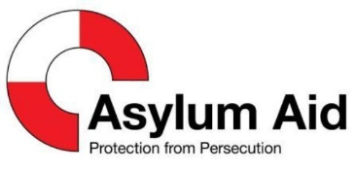 |  | 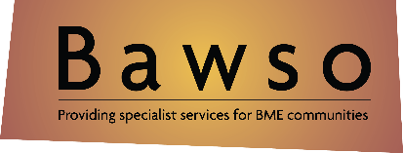
The Angelou Centre | Asylum Aid |  | BAWSO
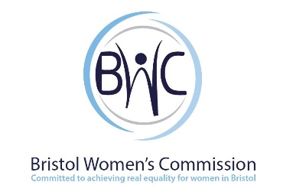 | 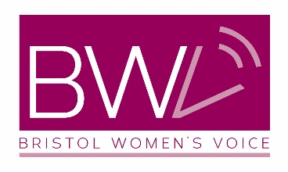 |  | 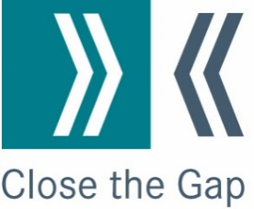
Bristol Women’s Commission | Bristol Women’s Voice |  | Close the Gap
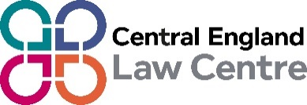 | 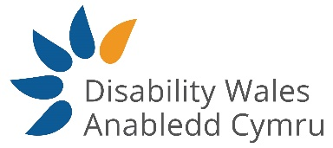 |  | 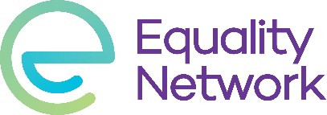
Central England Law Centre | Disability Wales |  | Equality Network
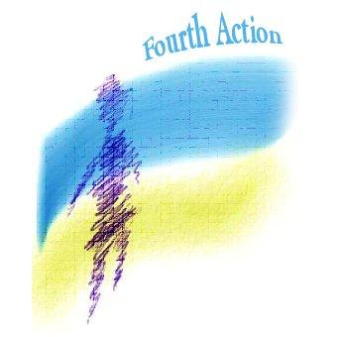 | 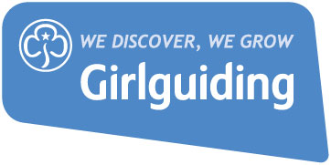 |  | 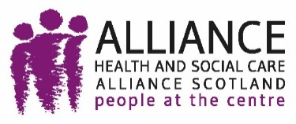
Fourth Action | Girlguiding UK |  | The Health and Social Care Alliance Scotland (the ALLIANCE)
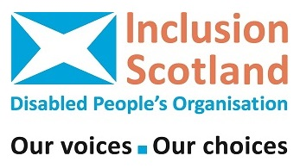 |  |  | 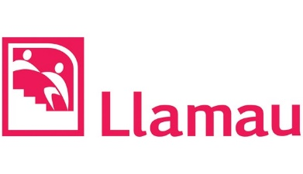
Inclusion Scotland | Journey to Justice |  | Llamau
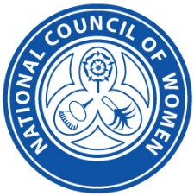 | 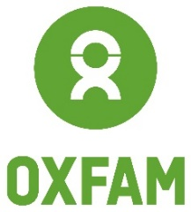 |  | 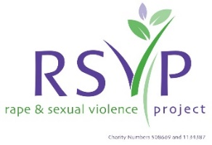
National Council of Women | Oxfam Cymru |  | Rape and Sexual Violence Project
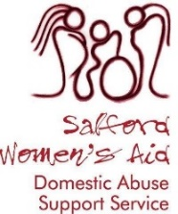 |  |  | 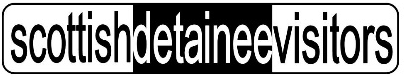
Saford Women’s Aid | Scottish Council for Voluntary Organisations |  | Scottish Detainee Visitors
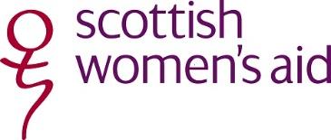 | 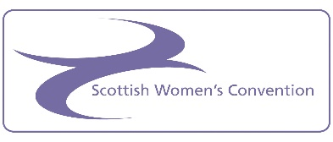 |  | 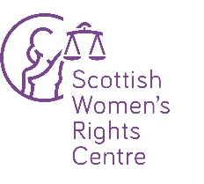
Scottish Women’s Aid | Scottish Women’s Convention |  | Scottish Women’s Rights Centre
 | 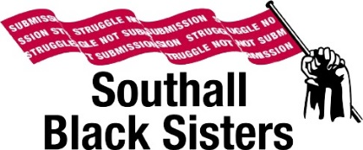 |  | 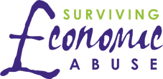
Soroptimist International of Cambridge | Southall Black Sisters |  | Surviving Economic Abuse
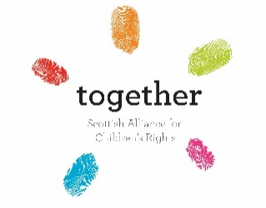 | 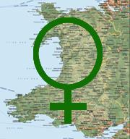 |  | 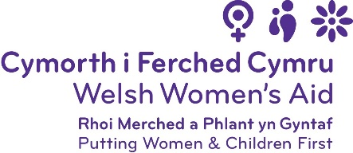
Together (Scottish Alliance for Children’s Rights) | Wales Assembly of Women |  | Welsh Women’s Aid
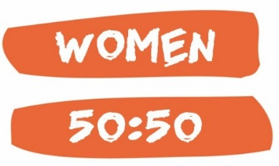 | 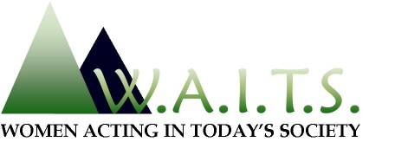 |  | 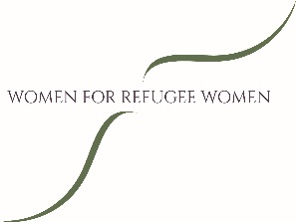
Women 5050 | Women Acting in Today’s Society |  | Women for Refugee Women
 |  | 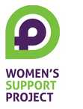 | 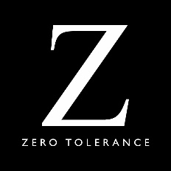
Women in Prison |  | Women’s Support Project | Zero Tolerace

This work was funded by the Equality and Human Rights Commission, one of the UK’s National Human Rights Institutions. This report was developed independently, and therefore does not necessarily reflect the views of the Commission.

British Medical Journal (2017) Effects of health and social care spending constraints on mortality in England: a time trend analysis; Around 120,000 excess deaths have occurred from 2010 to 2017
UK Women’s Budget Group (December 2018) Life-Changing and Life-Saving: Funding for the women’s sector Accessed at: https://wbg.org.uk/wp-content/uploads/2018/12/WBG-Funding-Report-2.pdf
UK Women’s Budget Group (October 2018) Briefing on the impact on women of trade and investment agreements October 2018 Accessed at: https://wbg.org.uk/analysis/2018-wbg-briefing-gender-and-trade-post-brexit/
Cabinet Office (2016) Government Grants Minimum Standards
Women’s Budget Group (2018) Exploring the Economic Impact of Brexit on Women
Tell MAMA (2016) A constructed threat: Identity, prejudice and the impact of anti-Muslim hatred
Asylum Aid (2012) “I feel as a woman I’m not welcome”
Office for Budget Responsibility (2017) Fiscal Sustainability Report (the highest rate of migration “would reduce […] net debt by 26% by 2066-67”)
House of Commons Library (2017) Briefing Paper Number 8140
House of Lords Constitution Committee (2017) European Union (Withdrawal) Bill: interim report, para 44
House of Lords European Union Committee (2017) Brexit: devolution, 4th Report
Please see submissions from England, Scotland and Wales
Close the Gap (Forthcoming) Assessment of public sector employers’ compliance with PSED
Equality and Human Rights Commission (2017) Public Authorities’ performance in meeting the Scottish Specific Equality Duties, 2017
CEDAW/C/GBR/Q/7/Add.1 paragraph 11
Women’s Budget Group (2015) The impact on women of the Autumn Statement and Comprehensive Spending Review 2015
Women’s Budget Group (2016) The impact on women of the 2016 Budget
EHRC (2017) Poorest hit hardest by tax, social security and public spending reforms
https://www.ohchr.org/EN/NewsEvents/Pages/DisplayNews.aspx?NewsID=23881&LangID=E
Women’s Aid Federation England (2017) Nowhere to turn
National Audit Office (2018) Financial sustainability of local authorities 2018
‘The Final Activity Report of the Council of Europe Task Force to Combat Violence against Women, including Domestic Violence (EG-TFV (2008)6) recommends that one such centre should be available per every 200,000 inhabitants and that their geographic spread should make them accessible to victims in rural areas as much as in cities.’ Para 142, Explanatory Report to the Council of Europe Convention on preventing and combating violence against women and domestic violence Istanbul,.2011 https://rm.coe.int/16800d383a
Imkaan (2016) Capital Losses: the state of the specialist BME ending violence against women and girls’ sector in London
https://rapecrisis.org.uk/media/1920/report-on-funding-and-commissioning-of-sv-and-abuse-services-2018.pdf
Scottish Government (2017) Recorded crime in Scotland, 2016-17
Evidence submitted for this report by Rape Crisis Scotland.
Balderston (2013) Victimised again? Intersectionality and injustice in disabled women’s lives after hate crime and rape
42% of Rape Crisis England and Wales clients last year were adult survivors of child sexual abuse, https://rapecrisis.org.uk/get-informed/rcew-statistics/
Equality, Local Government and Communities Committee (2016) Is the Violence against Women, Domestic Abuse and Sexual Violence (Wales) Act 2015 working?
Equality, Local Government and Communities Committee (2016) Is the Violence against Women, Domestic Abuse and Sexual Violence (Wales) Act 2015 working? Chwarae Teg (2018) https://www.cteg.org.uk/wp-content/uploads/2018/07/final-Rapid-Review-of-Gender-Equality-Phase-One.pdf
Scottish Government (2017) Homelessness in Scotland: 2016-17
Fife Domestic and Sexual Abuse Partnership (2015) Change, Justice, Fairness
Scottish Women’s Aid (2017) Written evidence to the Justice Committee call for evidence on the Domestic Abuse (Scotland) Bill
Scottish Government (2017) Homelessness in Scotland: 2016-17, Tables (Table 6)
Homeless Link (2018) Young and homeless 2018
Evidence submitted for this report by Southall Black Sisters
Evidence submitted for this report by Cris McCurley
Scottish Women’s Rights Centre (2017) Gender, justice and legal aid in Scotland
Social care is state support for people with long-term needs, including disabled people, elderly people and those with long-term conditions
Coalition of Carers in Scotland (2017) Manifesto for Carers in Scotland
Scottish Social Services Council (2017) Report on 2016 workforce data
Local Government Association (2017) Adult Social Care Funding: State of the Nation Report; Scottish Care Independent Living in Scotland (2015) Briefing on social care funding in Scotland; Expert advisory panel on adult care and support (2017) Power to people: proposals to reboot adult care and support in Northern Ireland
The Scottish Independent Advocacy Alliance (2016) Map of advocacy across Scotland
Carers UK (2015) Valuing carers 2015: the rising value of carers’ support
Scottish Social Services Council (2017) Report on 2016 workforce data
Scottish Care (2018) The open doors of recruitment and retention in social care
Women’s Budget Group (2016) Investing in the Care Economy: A gender analysis of employment stimulus in seven OECD countries
UK Government (2017) Building a Britain fit for the future: Industrial Strategy White Paper
Northern Ireland Executive (2016) The Fresh Start Panel report on the disbandment of paramilitary groups
Law and Gray (2014) The politics of defining armed conflict in Northern Ireland
Community Foundation for Northern Ireland (2014) Women, Peace and Security: Women's Rights and Gender Equality - Strategic Guide and Toolkit
Northern Ireland Office (2018) Addressing the legacy of Northern Ireland's past
Increased from 42% at the last Assembly election due to by-elections.
ibid
A v Secretary of State for the Home Department [2016] CSIH 38
Home Office (2017) Immigration statistics, October to December 2017
HM Chief Inspector of Prisons (2015) Report on an unannounced inspection of Dungavel House immigration removal centre
Home Office (2016) Immigration Act 2016: Guidance on adults in risk in immigration detention
Women for Refugee Women (2017) We are still here: The continued detention of women seeking asylum in Yarl’s Wood
OECD (2017) Family Database: PF3.4 Childcare support
Save the Children (2017) Soaring childcare costs push parents out of work in Scotland
EHRC (2016) Pregnancy and maternity-related discrimination and disadvantage: Experiences of mothers
Family and Childcare Trust (2015) Childcare costs survey 2015
Most state-funded childcare options coincide with school hours. This drives women’s low-paid, part-time work and underemployment.
Purcell (2015) The sociology of women’s abortion experiences: recent research and future directions
ARK NI (2017) Attitudes to abortion in Northern Ireland
CEDAW (2018) Report of the inquiry concerning the UK under article 8 of the optional protocol
NI women can access abortion on NHS Scotland, but cost barriers remain. There are proposals to extend access on NHS Wales.
Medical reasons for abortion are grave risk to life or health of the woman, and severe foetal anomalies
Engender (2017) Our bodies, our choice: The case for a Scottish approach to abortion
CRPD (2017) Concluding observations on the initial report of the United Kingdom of Great Britain and Northern Ireland
Stonewall (2018) LGBT in Britain: Trans report
Action on Hearing Loss Cymru (2018) Good Practice?
WEN Wales (2016) A call to action on the menopause
TUC (2017) The Menopause, a workplace issue
NICE (2017) Endometriosis: diagnosis and management
Engender (2016) Gender Matters in social security: Individual payments of Universal Credit
For example by the British Medical Association and Equality and Human Rights Commission
Child Poverty Action Group (2017) Broken promises: what has happened to support for low-income families under Universal Credit
Carers UK (2014) Caring and Family Finances Inquiry
Carers UK (2015) Valuing carers 2015: the rising value of carers’ support
Carers UK and Employers for Carers (2012) Sandwich caring: combining childcare with caring for older or disabled relatives
Scottish Government (2017) Recorded crime in Scotland, 2016-17
Rates are also falling in NI, and are low in England and Wales
Scottish Government (2018) Criminal proceedings in Scotland, 2016-17
Scottish Courts Service (2015) Evidence and procedure review
Please see section 10.2 for details
NSPCC (2012) Domestic violence, child contact, post separation violence

