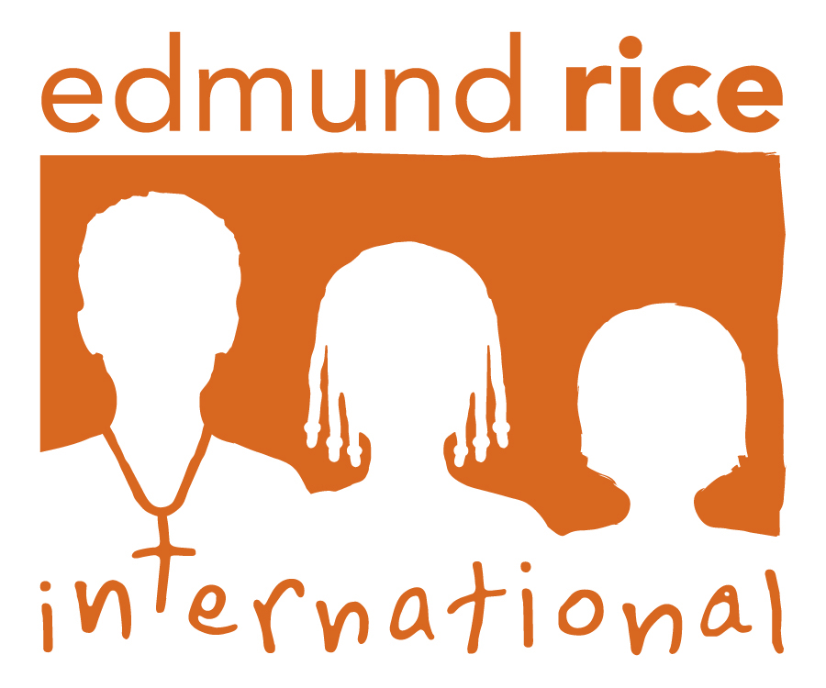

Convention on the Rights of the Child (CRC)
71st Session

(11th – 29th January 2015)

Child Rights in Kenya

Submission to the Committee on the Rights of the Child by:

Edmund Rice International

Geneva, July 2015

Edmund Rice Advocacy Network UNCRC Report 2015

Introduction

- Edmund Rice International presents this submission concerning children rights situation in Kenya. This report will comment on three thematic areas namely: (I) Children with Disabilities; (II) Children Living with HIV and AIDS; and (III) Child Abuse, Neglect and Child Labour. The data provided in this submission was obtained from individuals and local partners with firsthand experience of working with children in these thematic areas.

CHILDREN LIVING WITH DISABILITIES

Situational Analysis

- A survey conducted by the National Coordinating Agency for Population and Development in 2008 revealed that the overall level of disability rates in Kenya is 4.6%. Among these, 1.6% have physical disabilities and 1.4% have visual disabilities. The report established that among children between 0-14 years, 0.5% suffer from hearing disabilities, 0.2% speech, 0.4% visual, 0.1% mental, 0.6% physical, 0.3% have self care challenges. Among teenagers between 15-24 years, 0.4% have hearing difficulties, 0.2% speech, 1.1% visual, 0.2% mental, 1.1% physical, 0.3% have challenges related to self care[1].

- The survey also established that 32% of People with Disability (PWDs) use assistive device or support service. Out of this proportion, one in every five uses an information device while 12% use a personal mobility device. Other devices such as communication aids (0.3%), household items (0.1%), personal care and protection (0.4%), handling products and goods (0.1%), and computer (0.1%) were rarely used. PWDs in urban areas (41%) were more likely to use an assistive device or support service than their rural counterparts (26%). Similarly they were more exposed to use of information devices (30% for urban verses 11% for rural).

- Many children living with disabilities in Kenya continue to experience discrimination due to retrogressive cultural practices and dispositions. Many children with special needs are considered a bad omen by some families and are therefore locked in and denied opportunities for personal growth and development.

- Many public schools in Kenya, both primary and secondary, have not prioritized and integrated special needs education into their learning curricula as is required by law. There is a significant shortage of teachers with special needs training and many of the schools have no adequate equipments or facilities that support learning for children with disabilities.

- Schools that are specialized in providing special needs education are very few and sparsely distributed across the country, often making them inaccessible to many children. Subsequently, the costs associated with special needs education are also high, making it expensive for many parents with low income to afford such specialized schools.
- Due to inadequate facilities and equipments for children with special needs in many public and private schools, children with special needs often find it difficult to catch up with the rest of their colleagues. Some schools continue to discriminate against children with special needs by refusing them admission.

- Treatment and medication for children with special needs are often very expensive considering that many of these children are frequently ill and in need of regular treatment and medication. Some repair procedures and equipments such as wheelchairs for physically disabled children are very expensive and unaffordable to many families.

- Lastly, children with disabilities, particularly those who have undergone apprenticeship or vocational training programmes also find it increasingly difficult to find job placements where they can put their skills to gainful use.

Legal Framework

- Article 53 (1) (b) of the Constitution 2010[2] states that every child has the right to free and compulsory education (c) to basic nutrition, shelter and health care. Articles 7 (1-2) of the Children’s Act 2001[3]

- Article 28 of the United Nations Convention on the Rights of the Child (UNCRC)[4]; Article 28-29 and 32 of the Basic Education Act 2013[5] also provides for free and compulsory education for children.

- Article 54 (1) of the Constitution 2010 provides for the rights of persons with disabilities. In specific, Article 54 (1) (a) requires that people with disabilities be treated with dignity and respect; (c) to access educational institutions and facilities for persons with disabilities that are integrated into society to the extent compatible with interests of the person; (d) to reasonable access to all places; (e) to use sign language, Braille or other appropriate means of communication; (f) to access materials and devices to overcome constraints arising from the person’s disability.

- Article 2 of UNCRC; Article 5 of the Children’s Act 2001 states that no child shall be discriminated against on grounds of origin, sex, religion, creed, custom, language, opinion, conscience, colour, birth, social, political, economic or other status, race, disability, tribe, residence or connection.

- Article 18 (1) of the Persons with Disability Act 2003[6] also states that no person with disability shall be denied admission to any course of study by reason only of such disability; (2) learning institutions shall take into account the special needs of persons with disabilities with respect to the entry requirements, pass marks, curriculum, examinations, auxiliary services, use of school facilities, class schedules, physical education requirements and other similar considerations.

- Article 9 of the Children’s Act 2001 states the right of a child to health and medical care and Article 12 states that a disabled child shall have the right to be treated with dignity, and to be accorded appropriate medical treatment, special care, education and training free of charge or at a reduced cost whenever possible.

- Recommendations
Our organization recommends to the government of Kenya to:
- Map out and create a database of the special needs requirements of all children living with disabilities, and, through budgeting, fast-track the provision of assistive devices, materials, equipments and facilities to ensure their easy learning, mobility and personal development
- Take measures to facilitate training and recruitment of teachers for special needs education to eliminate the existing shortage.
- Increase the number of units in public schools offering special needs education to increase access for children with special needs.
- Ste-up the process of integrating special needs children into mainstream education and facilitate availability of materials and equipments to ease their learning.
- Fully implement the provisions of the Persons with Disabilities Act 2003 and other legislations to ensure all children with disabilities are able to access free treatment and medication in all public health facilities
- Ensure non-discrimination of all children living with disabilities in all public and private institutions through enforcement of policies and legislations.
- Continue with its effort to create awareness among citizens with the view of creating a positive and receptive attitude towards children living with disabilities and to counter retrogressive cultures that continue to discriminate against them.
- Set aside special places for apprenticeship of children with disabilities through the National Youth Service and thereafter facilitate their absorption into employment.

CHILDREN LIVING WITH HIV/AIDS

Situational Analysis

- A study conducted by the National AIDS Control Council of Kenya (2014)[7] established that there were at least 190, 131 children between 0-14 years living with HIV in Kenya in 2013, 95,743 male and 94, 388 female. Children between the age of 15 years and above living with HIV were estimated at 87, 291, of which 37, 514 are male and 49, 778 female.

- The Government, other Non-Governmental Organizations (NGOs), Faith Based Organizations (FBOs) and Community Based Organizations (CBOs) have in the last decade scaled-up the fight against HIV/AIDS in view to realizing the zero infection rates. A lot of public awareness has been created in this regard to combat the spread of HIV/AIDS including other policy interventions such as the Youth Communication Strategy, Condom Policy and Strategy, Male Circumcision Policy, HIV and AIDS policy at workplace, HIV and AIDS Prevention and Control Act, National Aids Control Council and Stakeholder’s Code of Conduct and guidelines inter alia.

- Deliberate programme interventions such as the Prevention of Mother to Child Transmission (PMTCT), Early Infant Diagnosis, PMTCT ARV prophylaxis, HIV counselling and Testing, and Cash Transfer Programmes where Orphans and Vulnerable Children receive Ksh 2000 per month have also been established.

- However, despite these interventions, HIV/AIDS stigma, particularly of children living with HIV and AIDS still remains a significant course for concern. Many orphaned children living with HIV suffer neglect from caregivers and family members due to unfounded fear and belief that they may pass on the HIV virus to their children. For this reason, children living with HIV/AIDS are often stigmatized through restricted play and interaction with other children and even forced to use separate utensils and beddings.

- Many children living with HIV/AIDS are not facilitated to attend hospitals or clinics for treatment and medication or when the medication has been provided, they are not properly administered by the caregivers as prescribed. Many children living with HIV/AIDS are often considered a burden in the family and believed to have a shorter time to live hence less attention is given to them, including the necessary medical and educational needs.

- There are a growing number of children living with HIV/AIDS who have been disowned by their families and or caregivers, thus ending up on streets or children homes. In some instances, children are dispossessed of their inheritance by greedy relatives while others suffer physical, sexual and emotional abuse.

- There are also incidents where children living with HIV/AIDS experience discrimination in schools. Some schools either refuse to admit children living with HIV/AIDS or in other incidents; insensitive language or examples related to HIV pandemic are used in class by teachers that continue to stigmatize these children.

- Many orphaned children are also forced to drop out of school due to lack of school fees, particularly due to high fees charged in most secondary schools.

Legal Framework

- Article 53 (1) (b) of the Constitution 2010 states that every child has the right to free and compulsory education (c) to basic nutrition, shelter and health care.

- Article 19 of UNCRC obligates States Parties to take all appropriate legislative, administrative, social and educational measures to protect the child from all forms of physical or mental violence, injury or abuse, neglect or negligent treatment, maltreatment or exploitation, including sexual abuse, while in the care of parent(s), legal guardian(s) or any other person who has the care of the child.

- Articles 7 (1-2) of the Children’s Act 2001; Article 28 of the United Nations Convention on the Rights of the Child; Article 28-29 and 32 of the Basic Education Act 2013 provides for free and compulsory education for children.

- Article 5 of the Children’s Act 2001 states that no child shall be discriminated against on grounds of origin, sex, religion, creed, custom, language, opinion, conscience, colour, birth, social, political, economic or other status, race, disability, tribe, residence or connection.

- Recommendations
- Our organization recommends to the government of Kenya to:
- Provide adequate protection to orphaned children to ensure their rightful inheritance is guaranteed.
- Facilitate the provision of child and youth friendly desks in all health care institutions to sensitize children and teenagers on HIV/AIDS and reproductive health for behaviour change and character formation
- Step-up efforts to demystify HIV/AIDS retrogressive myths through appropriate campaigns, and training and workshop particularly for teachers to avoid re-victimization of children living with HIV/AIDS within school set-ups
- Map out and create a database of all children orphaned by and living with HIV/AIDS and prioritize the provision of bursary and sponsorships to facilitate their education

CHILD ABUSE, NEGLECT AND CHILD LABOUR

Situational Analysis

- According to a national survey conducted in 2010 on violence against children in Kenya[8], three out of every ten females and nearly two out of every ten males aged 18 to 24 reported at least one experience of sexual violence prior to age 18; Seven percent of females aged 18 to 24 reported experiencing physically forced sexual intercourse prior to age 18; Of females whose first sex occurred before age 18, 24% reported that it was unwilling, meaning that they did not want it to happen and were forced, pressured, tricked or threatened to engage in sexual intercourse. In the 12 months prior to the survey, about 11% of females and 4% of males aged 13 to 17 experienced some type of sexual violence. Among 18 to 24 year olds, almost two-thirds of females and three-quarters of males reported experiencing physical violence prior to age of 18. During the year preceding the survey, approximately half of all females and males aged 13 to 17 experienced some type of physical violence. About one-quarter of females and one-third of males aged 18 to 24 years reported experiences of emotional violence prior to age 18.

- The government of Kenya has put in place important measures to protect children from abuse and facilitate easy access to justice. Such measures include the establishment of institutions such as the Children’s Courts, National Council for Children’s Services, Children Offices and the introduction of children’s rights into school curriculum among other measures. Other Non-governmental Organizations also play significant role in the promotion and protection of children’s rights by establishing institutions of childcare and learning and by promoting awareness of child rights and abuse to local citizens.

- However, many children in Kenya are continuously subjected to worst forms of child abuse in schools, childcare institutions and even at home. There have been a growing number of cases reported by the media of child defilement, physical abuse, neglect and emotional abuse. Cases of children being defiled, abducted, strangled and or badly mutilated and their bodies dumped have been on a steady rise with some of them going unresolved. The reluctance of law enforcers to expedite investigations, make arrests and charge perpetrators is worrying. There is also reluctance among the public to assist with investigation, including instances of alleged bribery, either of law enforcers or family members to compromise or withdraw cases.

- There is also a growing concern of alleged criminal activities perpetrated by children in many informal settlements. In Mukuru informal settlements and Kayole areas in Nairobi, for instance, there is an alleged criminal gang named GAZA that is recruiting children, both boys and girls, as young as 9 years and thereafter inducting them into criminal activities. The children are lured through sports such as football and later made to take illegal oaths, which bind them as members of that gang. These children are then slowly introduced into crime, ranging from extortions, theft, robbery, sex and illicit drugs. The gang operates very secretively, making it difficult to know the whereabouts of its leaders, and it thrives through instilling fear and threats to local residents.

- Child labour in Kenya is also rampant with a steady growth of street children, especially in Nairobi. In many informal settlements such as Mukuru, illicit brew, locally known as chang’aa also contributes to this problem. Many chang’aa dens are opened as early as 7.00am and sometimes children are involved in selling, which is often their parents’ occupation. This happens despite the law requiring all pubs and bars selling alcohol to open not earlier than 5.00 pm on weekdays and 3.00 pm on weekends. Many children are also involved in hawking of groundnuts and fruits on streets and in bars.

- In addition, many children are involved in plastics and scrap metal collection, sometimes to subsidize family income instead of going to school.

Legal Framework

- Chapter Four of the Constitution 2010 provides for the bill of rights and fundamental freedoms of all citizens; Article 53 of the Constitution 2010 provides for special guarantees for children rights

- Article 10 of the Children’s Act 2001 provides for the protection from economic exploitation and any work that is hazardous or likely to interfere with the child’s education, or to be harmful to the child’s health or physical, mental, spiritual, moral or social development

- Article 19 of UNCRC obligates States Parties to take all appropriate legislative, administrative, social and educational measures to protect the child from all forms of physical or mental violence, injury or abuse, neglect or negligent treatment, maltreatment or exploitation, including sexual abuse, while in the care of parent(s), legal guardian(s) or any other person who has the care of the child.

- Article 56 the Employment Act 2007 and Article 4 of the Children’s Act 2001; ILO Convention 138 establishes the minimum age of work permissible for children.

- Article 53 (1) of the Employment Act 2007 prohibits any person from employing a child in any activity that constitute worst form of child labour; Article 16 of the children’s Act

- ILO Convention 182 illustrates the worst forms of child labour

- The Sexual Offenses Act 2006 provides for different forms of sexual offenses and applicable penalties thereto.

- Article 13 of the Children’s Act 2001 provides for the protection from physical and psychological abuse, neglect and any other form of exploitation including sale, trafficking or abduction by any person

- Recommendations
- Our organization recommends to the government of Kenya to:
- Consider establishing a child unit within the police to promote public awareness on children’s rights and to fast-track investigations and prosecution of all cases related to child abuse.
- Investigate the activities of GAZA and provide safeguards to protect children from being recruited into this gang, and where applicable, prosecute all those found culpable of exploiting children to promote criminal activities.
- Promote community-based initiatives that help children and teenagers to channel their energies through games and sports so as not to be victims of criminal gangs.
- Work with other non-state actors to establish effective rehabilitation and integration measures to curb the rapid growth of street children.
- Strengthen legislations to stop business people and individuals from buying scrap metals and plastics from children and prosecute all those found culpable of exploiting children for their commercial gains.
- Step-up efforts to combat the distribution and sell of illicit brew through the enforcement of existing legislation and policies

[1] National Coordinating Agency for Population and Development (2008) Kenya national Survey for Persons with Disabilities: Preliminary Report, Nairobi: National Coordinating Agency for Population and Development
[2] National Council for Law Reporting (2010) Constitution of Kenya 2010, Nairobi: National Council for Law Reporting
[3] National Council for Law Reporting (2001) Children’s Act 2001, Nairobi: National Council for Law Reporting
[4] United Nations ( ) United Nations Convention on the Rights of the Child
[5]National Council for Law Reporting (2013) Basic Education Act 2013, Nairobi: National Council for Law Reporting
[6] National Council for Law Reporting (2003) Persons with Disabilities Act 2003, Nairobi: National Council for Law Reporting
[7] National AIDS Control Council of Kenya (2014) Kenya AIDS Response Progress Report 2014: Progress towards Zero, Nairobi: National AIDS Control Council of Kenya
[8] Violence against Children in Kenya: Findings from a 2010 National Survey. Summary Report on the Prevalence of Sexual, Physical and Emotional Violence, Context of Sexual Violence, and Health and Behavioural Consequences of Violence Experienced in Childhood. Nairobi, Kenya: United Nations Children’s Fund Kenya Country Office, Division of Violence Prevention, National Centre for Injury Prevention and Control, U.S. Centres for Disease Control and Prevention, and the Kenya National Bureau of Statistics, 2012.

