 | 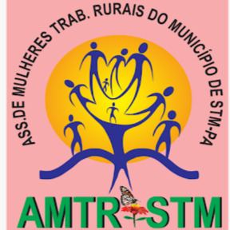

Parallel Report on Brazil
Committee on the Elimination of Discrimination against Women (CEDAW)

88th session (13 to 31 May 2024)

Terra de Direitos
15 April 2024

We are grateful to the Committee on the Elimination of Discrimination against Women (CEDAW) for this opportunity to address them at this important moment for Brazil. Our focus is the rights of women in the context of territorial conflicts and social claim for the right to land, territory and environment.

1. SIGNATORY ORGANIZATIONS
Terra de Direitos is a Brazilian Human Rights organization that works to defend, promote and enforce rights, especially economic, social, cultural and environmental rights (DHESCA). Created in Curitiba/Paraná in 2002, to act in situations of collective conflicts related to access to land and rural and urban territories, it currently has offices in Santarém (PA), Curitiba (PR) and Brasília (DF) and works with peasants, quilombola´s communities, indigenous people and traditional people and communities, besides human rights defenders.
The organization uses popular legal advice as an action strategy, working with collective and community demands, in partnership with popular social movements, recognizing them as active subjects in the social process and struggles for rights. Develops training activities, acts in strategic litigation and in political advocacy on the following topics: Land, Territory and Spatial Justice; Politics and Culture of Human Rights; Biodiversity and Food Sovereignty and Democratization of Justice.
Site: https://terradedireitos.org.br/
E-mail: terradedireitos@terradedireitos.org.br / camila@terradedireitos.org.br
Associação de Mulheres Trabalhadoras Rurais de Santarém (AMTR) – since 2015, it works in defense of Women Rural Workers and agroecology in the Amazon.
The organization was created by a group of women rural workers from Santarém concerned about the paths of their realities, the destruction of forests, rivers and streams with the advance of agribusiness in the region, and the dangerous way in which food reaches people's tables.
The activities carried out by women are based on agroecology, a sustainable way of using land to grow products while respecting nature. AMTR stands as a model against agribusiness, as in addition to generating jobs within communities, it empowers and strengthens women economically, also improving the quality of life of families.
Site: https://www.instagram.com/amtrstm/?igsh=Yng0anJuZTRmaHM0
Email: amtr.stm@gmail.com

2. WOMEN’S RIGHT TO PARTICIPATE IN POLITICS AND PUBLIC LIFE (Articles 7 and 8)
In Brazil, violence has historically been used as an instrument to prevent and/or retaliate against people's participation in politics and public life, resulting in high rates of violence against human rights defenders, fueled by persistent impunity for these crimes. Added to this, from 2016 onwards, misogyny intensified in the country - in society and in institutional spaces, resulting in increased rates of political violence against women.
Next, we present some general data on violence against DDHs (numbers, types and context of violations, etc.) and then some data and analyzes with a gender and race focus (which types of crimes most affect women and people black and indigenous people).
Next, the main findings of the second edition of the research “Racism and Violence against Quilombos in Brazil” are presented, with emphasis on violence committed against quilombola women.
Further on, information is presented on the rates of political violence, highlighting that this has mostly occurred against black women. Finally, in this topic, some notes are presented about political violence resulting from a space for debate and reflection among women leaders in the Baixo Tapajós Region, west of the State of Pará.
The data and analysis presented below are part of research and studies developed by the petitioning organization, in partnership with other organizations and movements, indicated below.

2.1) VIOLENCE AGAINST HUMAN RIGHTS DEFENDERS IN BRAZIL - ACTUALIZED DATA (thematic approach: HRDs; national)
“On the Frontline: Violence against Human Rights Defenders in Brazil” is a report that exposes the attacks on those who stand up for human rights in the country. The survey, conducted by the Brazilian human rights organizations Terra de Direitos and Justiça Global, covers the cases of violence that occurred between 2019 and 2022. It has mapped 1171 cases of violence against human rights defenders during the period (physical aggression, threat, murdes, attack, criminalization (institutional), delegitimization, sexual harassment and suicide), of which 169 were murders and 579 were threats. The data was collected from news sources, previous reports, and cases monitored by the two organizations. The report highlights the violence against both individual and collective defenders, such as indigenous and quilombola peoples, and show the intensification of territorial and environmental conflicts in the country, with cases registered in all Brazilian states.
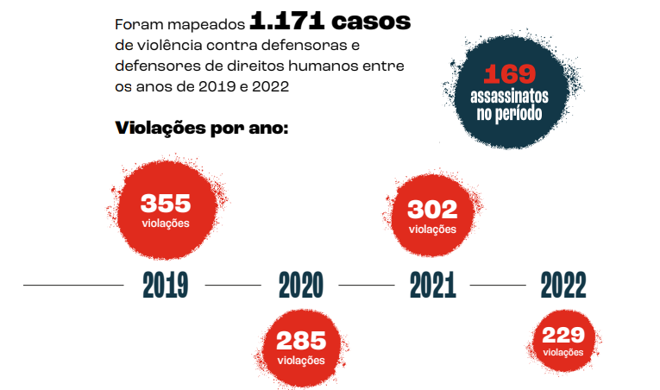

- Main research findings
- 169 cases of murdered between 2019 and 2022, an average of 3 defenders per month in the analyzed period.
- 140 murdered human rights defenders were fighting for the right to land, territory, and an ecologically balanced environment; this is the type of struggle of 78.5% of human rights defenders victims of any type of violence identified by the survey.
- Even though 2022 is the year with the lowest number of cases, it is the year with the highest proportion of murders among registered cases.
- Violations per region: All 27 states of the federation had at least one incident of violence mapped during the period. The state with the highest number of registered violations against human rights defenders was Pará, where 143 violations occurred, followed by Maranhão, with 131 cases, and Bahia, with 109 cases.
- The North region is the one with the highest number of murders, which can be explained by the high rate of land conflicts in the region (grabbing of public lands, invasion of indigenous lands, deforestation, illegal mining).
- Rights advocated by defenders: Defenders advocate for a series of different themes. The main category mapped is the struggle for land, territory, and the environment.

Violations by type of violence and by year
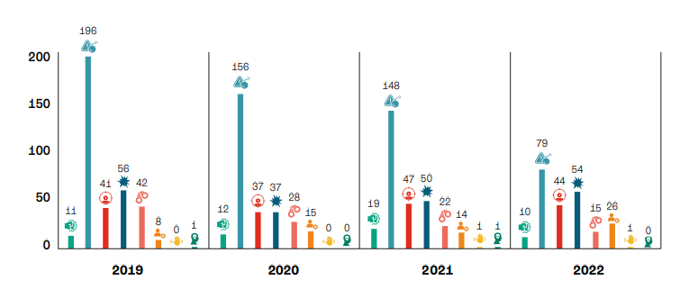
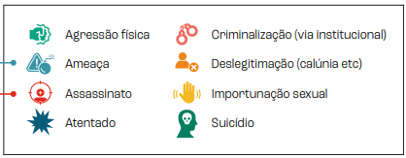

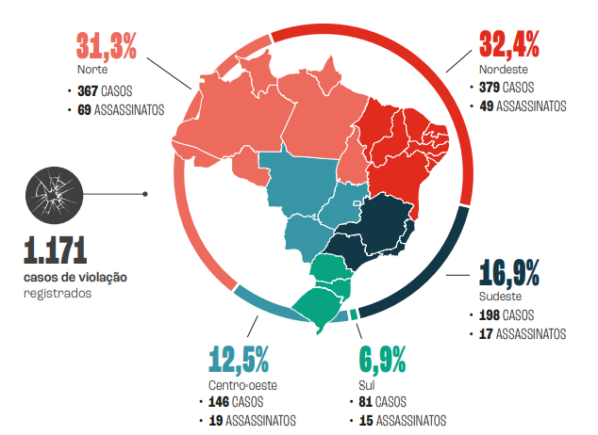

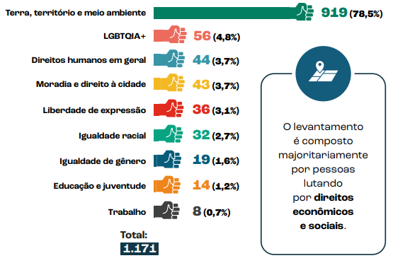
The research reveals that practically 80% of cases of violence against HRDs occur in the context of fighting for land, territories, and defense of the environment.
It is widely known that access to land, territory and the environment are directly related to access to a series of other rights, such as education, housing, sanitation, culture, among others.
In this way, the use of violence against people who claim this type of rights proves to be a mechanism for maintaining a reality of land concentration, which, in turn, implies unequal access to territorial rights and other rights, to the detriment of people indigenous people, quilombolas and other traditional peoples and communities, peasants.
Defenders engaged in the fight for land are more threatened, attacked and murdered than those fighting for civil and political rights. This shows that people at the forefront of the struggle for land, whether in the context of traditionally occupied territories, rural, or urban territories, are particularly exposed to attacks against their physical integrity and their lives. There is statistical significance in the difference in means found.
Defenders fighting for individual human rights, categorized in opposition to defenders engaged with collective rights, are more recurrently victims of delegitimization than defenders fighting for land, territory, housing, environment, and employment. This type of violence affects their physical, psychological, and symbolic bodies, even if the aggression is only verbal.

- Defender´s profile
The survey also reveals that:
- The predominant age group of people in the fight for human rights who suffer violence in Brazil is between 34 and 46 years old. The mean age is 40.5 years;
- Cisgender men are the category that appears most among the group of defenders who are the victims of violence (48,1%), followed by cisgender women (21,6%).
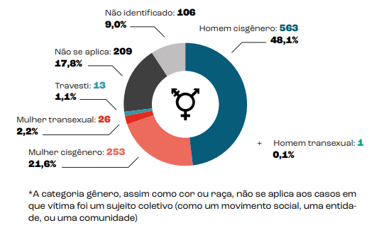
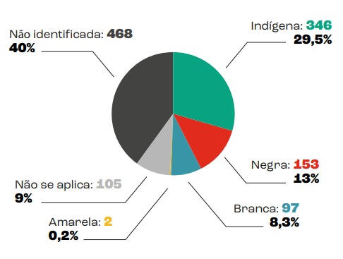
The data presented in this survey show that indigenous and black people are more vulnerable to being victims of violence when they are human rights defenders. Records also show that black people who defend rights were more frequently victims of murder than of other types of violence.
- Indigenous people were victims in more than ¼ of the violence cases recorded in the research, and almost 60% of the cases in which it was possible to identify the race or color of the victims.
- - The episodes of delegitimization identified in this survey are more recurrent against black defenders when compared to the average for white or indigenous defenders.
- Threat is the most frequent type of violence in the study, with a total of 579, which represents almost half of the cases in the period.

- Violence against women defenders (cisgender, transgender and “travestis”)
Women are more frequently victims of threats, which represent 63% of violence recorded against them.
And when we look by the type of violence, cisgender women are the most frequent victims of some form of delegitimization among all defenders who are victims of this type of violence, which also frequently affects transgender women and travestis.
The proportion of murders among transgender or transvestite defenders is also high: 1 in every 4 cases of violence against this population is recorded in the survey.

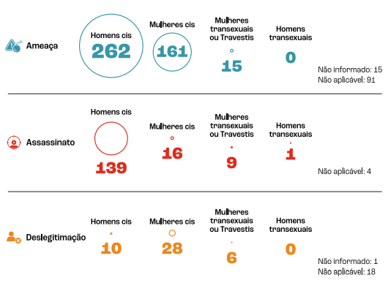

- Lack of official data about violence against HRDs
In Brazil, the production of data on the situation of HRDs has been carried out by civil society organizations. There is no official data on the situation of HRDs, violence suffered, violating agents, nor is there transparency of information regarding the execution of the protection policy.
Improving and strengthening public protection policy requires official production of data (with a regional, gender and racial focus) and transparency.
Recommendations:
»» To understand the threats and those who fight from the perspectives of race and gender, in order to qualify the protective policy.
»» To create a stage in the proceedings with the purpose of articulating public policies to face the structural issues that generate threats, attacks, criminalization, and murder.
»» To create a specialized stage to investigate cases of threats, attacks, and homicides related to the work of human rights defenders.
»» Complaints or information about threats must always be received by the authorities of the criminal justice system and by the Programs for the Protection of HRDs, regardless of the internal division of attribution and competence, and the receiving body must forward the complaint or information to the body with attribution or competence for its proper processing;
»» Investigations of threats, attacks, and homicides must be thorough.
»» To ratify and implement ECLAC’s (Economic Commission for Latin America and the Caribbean) Regional Agreement on Access to Information, Public Participation and Justice in Environmental Matters in Latin America and the Caribbean — the Escazú Agreement.
»» To approve a federal legal framework for the protection policy for human rights defenders, in broad consultation with civil society.

  - RACISM AND VIOLENCE AGAINST QUILOMBOLOS IN BRAZIL (national approach)
The survey “Racism and Violence against Quilombos in Brazil” is an initiative of the National Coordination for the Articulation of Black Rural Quilombola Communities (Coordenação Nacional de Articulação das Comunidades Negras Rurais Quilombolas – Conaq, in Portuguese) and Terra de Direitos. Its purpose is to identify and analyze the extent of violence experienced by quilombolas across the country. The second edition of the survey has identified murders documented within quilombos between 2018 and 2022. It highlights the worsening inequalities and violence historically practiced against quilombola communities.
32 QUILOMBOLAS WERE MURDERED BETWEEN 2018 AND 2022. IN 15 YEARS, 70 QUILOMBOLAS HAVE BEEN MURDERED
AGAINST QUILOMBOS IN BRAZIL 2022 RACISM AND VIOLENCE Compared to the first edition, which encompassed the years 2008 to 2017, the annual average of recorded murders in quilombos has surged from 3.8 to 6.4 murders per year in the second edition. This figure represents an almost twofold increase in the annual average of murders when compared to the previous survey. During the 10 years analyzed in the first edition, the occurrence of more than four murders of quilombolas in a single year was a rare exception – only two years exceeded this number. However, in this second edition, even the years with the lowest recorded violence saw four murders of quilombolas, with the years 2019 to 2021 experiencing peaks of up to 8 murders.
STATES WITH RECORDED MURDERS BETWEEN 2018 AND 2022: Most murders of quilombolas were recorded in the Northeast region (65.6%), followed by the North (12.5%) and Southeast (9.4%) regions. The South and Central-West regions registered 6.25% of the murders. Maranhão is the state with the highest number of murders (9), followed by Bahia, Pará, and Pernambuco, with four cases each. Maranhão, Bahia, and Pará were also among the states with the highest number of murders recorded in the first edition of the survey, when Bahia had the highest number of recorded murders.
CONTEXT BEHIND THE MURDERS: A look at the motivation behind these cases shows that, although they are victims of various forms of violence – which are also the result of processes of denial of other rights – quilombolas have died primarily due to land conflicts or femicides.
MURDER BY GENDER: Although men are the main victims, it is clear that quilombola women have been killed because they are women. The proportion of quilombola women who were victims of murder more than doubled when comparing the second edition to the previous survey. The first edition identified 8 female leaders murdered over the period of ten years, while the second edition recorded the murder of 9 women in five years
A component of cruelty was identified in the murders of women, with the majority of these acts carried out using bladed weapons (such as knife, sickle, axe, or screwdriver) or with torture methods.
VIOLENCE PERPETRATORS: In the case of murdered women, the research found that spouses, partners, ex-spouses, and ex-partners were the perpetrators in 100 percent of femicide cases. Men, on the other hand, were mostly killed by other private agents, i.e. people who are not linked to the State.
RELATION BETWEEN VIOLENCE AND LACK OF TERRITORIAL REGULARIZATION
69% of murders were recorded in quilombos that have not yet been titled. A look at the violence recorded in quilombos based on the stage of the titling process reveals that securing and guaranteeing territory is essential for mitigating violence stemming from land conflicts.
However, progress needs to be made in implementing other public policies to protect families. Cases of femicide, for example, were recorded in quilombos that were at different stages of the titling process, including in titled quilombos. Titling is a first step in combating violence, but we need to go further.
Another survey done by Terra de Direitos shows that if the Brazilian State maintains the current pace of land regularization of quilombola territories, it will take 2,188 years to fully title the 1,802 processes currently open at the National Institute for Colonization and Agrarian Reform (Instituto Nacional de Colonização e Reforma Agrária – INCRA, in Portuguese). If the advance of partial titling of quilombola territories with processes in independent federal agencies is taken into account, the time needed is 1,156 years.
See the survey in English here: https://terradedireitos.org.br/uploads/arquivos/Quilombola-english.pdf
Recommendations to combat racism and violence against quilombos in Brazil:
»» Titling of the country’s quilombola territories
»» Access to public health, education, labor, and income generation policies
»» Implementation of public policies to combat violence against women, taking into account the specificities of quilombola women
»» Respect for the Right to Prior, Free, and Informed Consultation
»» Comprehensive and inter-institutional protection for quilombolas who have been threatened
»» Investigation and accountability of those involved in the threats and murders of quilombolas
»» Establishment of anti-racist actions by the public authorities, with the creation of quotas for quilombolas and training for officials who work in government bodies and the justice system
»» Creation of a National Policy to Combat Institutional Racism at the National Institute for Colonization and Agrarian Reform (Instituto Nacional de Colonização e Reforma Agrária – INCRA, in Portuguese)

  - POLITICAL VIOLENCE IN BRAZIL (national approach)
Já na primeira edição da pesquisa “Violência Política e Eleitoral no Brasil. Panorama das violações de direitos humanos de 2016 a 2020”, realizada pela Terra de Direitos e Justiça Global, chamava-se atenção para o fato de que “os últimos quatro anos e meio, assassinatos e atentados tiveram papel relevante na estruturação da violência política e eleitoral no Brasil”. A execução sumária da vereadora do Rio de Janeiro Marielle Franco (PSOL), em março de 2018, constitui um marco do processo de intensificação da violência política no país.
In the first edition of the research “Violência Política e Eleitoral no Brasil. Panorama das violações de direitos humanos de 2016 a 2020” (Political and Electoral Violence in Brazil. Panorama of human rights violations from 2016 to 2020), carried out by Terra de Direitos and Justiça Global, drew attention to the fact that “in the last four and a half years, murders and attacks have played a relevant role in structuring political and election in Brazil”. The summary execution of Rio de Janeiro councilor Marielle Franco (PSOL), in March 2018, constitutes a milestone in the process of intensification of political violence in the country.
From the 1st. Edition of the research, the following excerpts from the Conclusion stand out:
Da 1ª. Edição da pesquisa, destaca-se os seguintes trechos da Conclusão:
[...] By creating significant obstacles to political participation, the proper functioning of public institutions, the development of political processes and rights, including constraining, interfering and even interrupting the fulfillment of elective mandates, political violence compromises the integrity of democracy itself. The violence sustained in episodes of racism, sexism and LGBQTIA+ phobia, in turn, does not only affect specific people, in fact, it torments and destabilizes processes of representation and political participation of entire segments of society. Peripheral regions and historically discriminated groups, which already face underrepresentation and serious obstacles to meaningful political participation and representation, are disproportionately affected by political violence, which, in turn, compromises the quality of representation in a democratic state.
[...]
Alarmingly, female politicians, especially black women, are unequally affected by political violence, especially when considering the low level of representation of these women in political positions. Additionally, the record of cases relating to attacks related to the sexual orientation of political agents is worrying.
It is also important to highlight that the forms of violence seem to strengthen and become more sophisticated over the years. The existence of the internet, social networks and applications has multiplied new forms of subjection, especially of women, to violence, with specific types of online violence and disinformation and defamation campaigns.

In 2023, the 2nd was published. Edition of the Research, with an overview of human rights violations between September 2, 2020 and October 31, 2022, confirms the reading that “mapping, identifying, recording, disseminating, reporting and monitoring data on political violence in Brazil is, therefore, an urgent and necessary task to ensure the political and institutional health of the country”.
Some excerpts from the publication stand out:
The slowness with which Brazil has sought to consolidate effective monitoring mechanisms greatly contributes to the spread of episodes of political and electoral violence”. Associated with the above, “the low levels of accountability of agents of violence, the scarcity of support protocols for victims, protection measures and public security policies have contributed to the repetition of these cases, which is serious, as the majority of them compromise the integrity of the fundamental rights of parliamentarians and activists.
Even though this and other cases have gained more visibility, the low number of initiatives undertaken by parties to mitigate the impacts of political and electoral violence on the actions of politicians, especially those who represent historically discriminated and minority groups in institutional spaces, it further contributes to the configuration of a situation in which doing politics represents a risk.
Furthermore, there are few actions by the Brazilian State in relation to monitoring and combating political and electoral violence. The judiciary and the legislative houses of the federation still do not pay due attention to monitoring these cases. Given this scenario and understanding the need to expand actions aimed at combating political and electoral violence, Justiça Global and Terra de Direito continue the project launched in 2020, with the production of the second edition of the Political Violence and Electoral in Brazil.
This work consisted of mapping 542 cases of political and electoral violence between September 2, 2020 and October 31, 2022, of which 497 people were victims.

- General data – 1st Edition

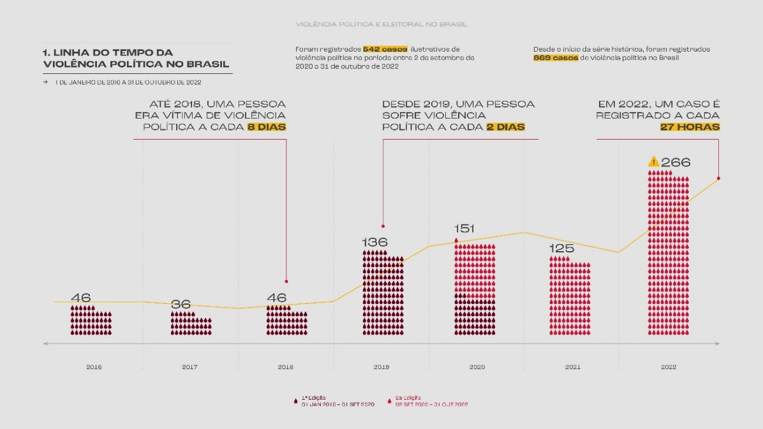
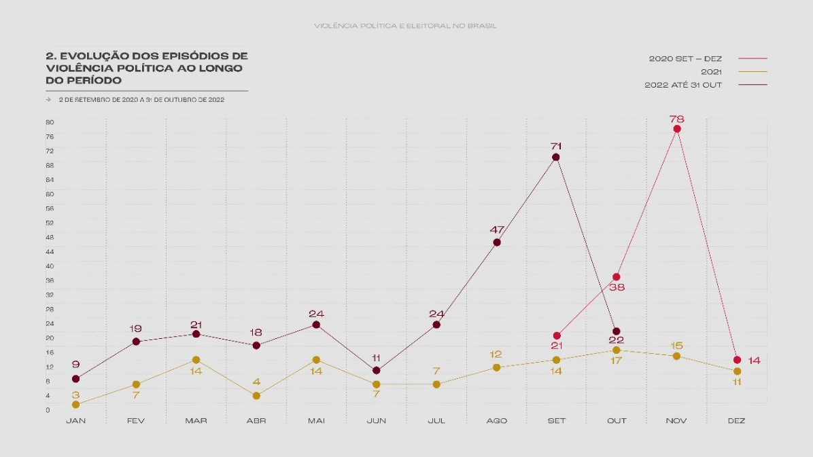
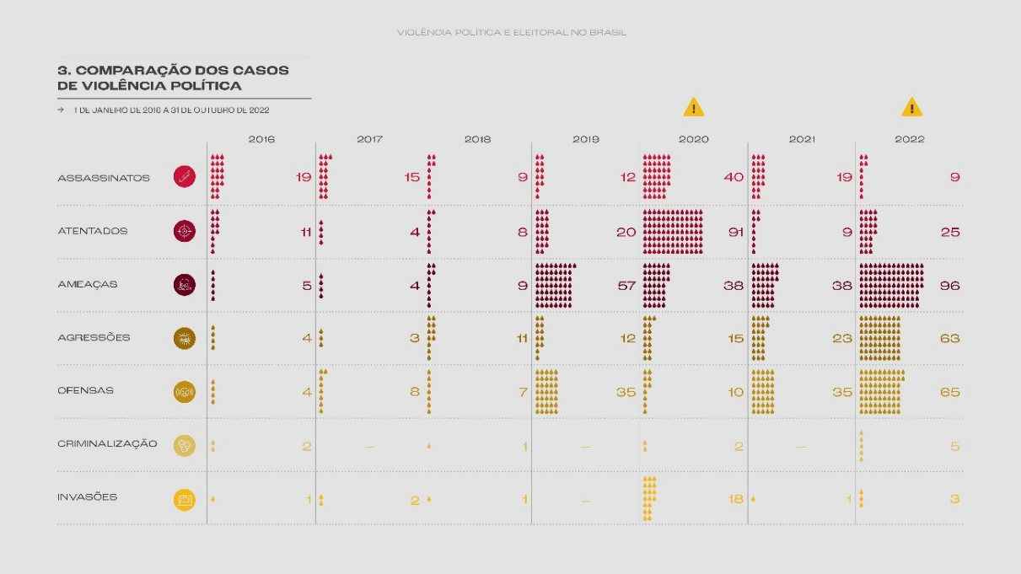

- General data – 2nd Edition:
• Political violence occurs throughout the national territory and concentrates 41% of cases in the southeast region.
• It significantly affects vulnerable social groups active in the progressive political field, in particular, the black population, which accounts for 47% of cases, and cis-gender women, transsexuals and transvestites who represent 41% of victims.
• It mainly affects agents who have political activities focused on actions at a regional level, such as councilors, who represent 46% of victims of political and electoral violence.
• Its main causes are partisan and ideological motivations; those based on issues of gender and sexual orientation; economic and territorial causes and causes based on ethnic-racial issues.
• Its main consequences are the destabilization or interruption of the exercise of political rights by many individuals, motivated by threats, attacks and offenses that represent 74% of attacks in Brazil and, ultimately, homicides that killed 55 people in the period analyzed.
• It occurs both in an episodic manner, in different locations and in periods that accompany the political tensions and polarization of the electoral period, and in a selective manner, which represents organized actions in which specific people or groups are the target of violence in premeditated acts with the objective of reaching political actors or their origin groups.
• Violent acts against life, such as Murders and Attacks, represent 40% of cases of political and electoral violence in Brazil.
• Sexism, Racism, Homophobia, Transphobia, Harassment and Ableism are among the 8 main types of offensive treatments given for political motivation.
• Between 2016 and 2022, a survey of cases reported in the media showed that 123 people died as a result of political and electoral violence in Brazil.
• Every 2 days, a person suffers political and electoral violence in Brazil.

  - CONFRONTING POLITICAL VIOLENCE AGAINST WOMEN IN WESTERN PARÁ (regional approach with a gender and racial focus)
In August 2023, around 40 women leaders of social movements, peoples and traditional communities from the Amazon of Pará participated in the Seminar on Confronting Political Violence held by Terra de Direitos in the city of Santarém, in the west of the State of Pará. On the occasion, it was a debate was held on political gender violence and the specificities of this violence in the Amazon region and the challenges that these women face in occupying and experiencing public spaces, of power and decision-making in society.
In the end, a Collective Letter to Combat Political Violence against Women was created, containing some measures to combat this violence. The following recommendations are made at the end of the meeting:
Thus, in view of the recurrent violations of women's rights, especially due to their political struggles for land, territory, forests, waters, the environment and gender equality, we, Amazonian leaders representing social movements and undersigned organizations, demand from the Brazilian State, organizations/social movements and society themselves, coping measures, such as:
● Gender parity within organizations and social associations
● Mechanisms to promote gender parity within the political system, where women have the same conditions of access, participation and financing.
● Training workshops on political violence aimed at women and men;
● Creation of coping and protection strategies and mechanisms for women victims of violence within social organizations;
● Creation of a women's council within each district/territory;
● Removal of leaders who practice gender-based violence, investigation of complaints and punishment of those responsible.
● Creation of a support network for women in situations of political violence (Women's collective, legal collective, psychosocial collective, among others);
● Ensure the inclusion and participation of PCD women leaders in the political decision-making space.

Recommendations for tackling gender and racial violence:

RECOMMENDATIONS TO THE SUPERIOR ELECTORAL COURT
• establish a national program to monitor and combat political and electoral violence;
• promote campaigns to combat racial and gender-based violence and other types of preventive actions against political and electoral violence;
• create mechanisms for monitoring hate speech and fake news;
• collaborate with the creation of coalitions between the justice system, the national human rights council, civil entities, parliaments, universities, research centers and electoral management and oversight bodies.

RECOMMENDATIONS TO ELECTORAL AND JUSTICE SYSTEM BODIES
• improve spaces for reporting electoral political violence for a more qualitative reception of cases of racial and gender-based violence;
• create policies and actions focused on combating racial and gender-based violence.

RECOMMENDATIONS TO LEGISLATIVE BODIES
• treat with transparency and speed the episodes of political and electoral violence that occur in the premises of the Chamber of Deputies, the Senate, the Legislative Assemblies and the Municipal Chambers;
• implement programs to combat political and electoral violence in the environment in legislative bodies that include the security of advisory teams and co-parliamentarians elected by collective mandates;
• improve mechanisms for reporting and monitoring political and electoral violence;
• guarantee the implementation of the code of ethics in disciplinary processes against agents of political and electoral violence;
• promote campaigns and produce informative materials against racial and gender-based political violence;
• create training spaces aimed at groups responsible for monitoring episodes of political and electoral violence;

RECOMMENDATIONS FOR SECURITY FORCES
• guarantee training spaces for security force agents to increase knowledge about the electoral system and laws, racism in politics, gender-based violence and political violence;
• ensure that combating racism, gender-based violence and political and electoral violence are part of the security forces' code of ethics.

- RURAL WOMEN’S RIGHT TO HEALTH AND USE OF PESTICIDES (Articles 10 and 14)
Brazil is the world leader in the use of pesticides. The indiscriminate use of pesticides affects the Brazilian population as a hole, but above all, rural workers, native peoples, and traditional communities, such as Indigenous peoples, quilombolas, and family farmers. And has implications on a several rights, as food sovereignty, the right to adequate food, water, and a balanced environment, the right to health, to biodiversity, among others.
The indiscriminate use of pesticides has specific negative consequences on women's health. In this sense, the National Campaign Against the Use of Pesticides and for Life points out that “60% of pesticides sold in Brazil have carcinogenic potential or can cause hormonal changes”.
Furthermore, the Brazilian Public Health Association-ABRASCO prepared the Technical Note “Pesticides, human exposure, damage to reproductive health and health surveillance”.
Investigations show that pesticides are directly responsible for around 200,000 deaths each year. The majority of these deaths occurred in peripheral, vulnerable countries with weak regulatory and health systems to protect health from exposure to such dangerous substances.
There is a huge North-South global inequity when it comes to permitting the trade and use of pesticides. Brazil still uses 195 pesticides banned in the European Union, including Mancozeb, Chlorothalonil, Atrazine, Acephate, Chlorpyrifos, Imidacloprid, Carbendazim, Diquat Dibromide, Methomyl, Diurom. [...]
The intensification of the use of pesticides in Brazil and the adoption of the agro-industrial model of transgenics associated with the consumption of pesticides, especially glyphosate and 2,4 D, has worsened its sanitary and environmental situation. Brazil is poorly monitored by public policies due to the agribusiness lobby on the executive, legislative and judicial powers, which invests heavily in deregulation and dismantling the legal and institutional framework structured in the Brazilian State after the promulgation of its 1988 Federal Constitution. In November 2023, Brazil was reported to the Inter-American Court of Human Rights for violating reproductive justice, which is part of human rights. This right was recognized by 179 countries at the International Conference on Population and Development in Cairo in 1994, and includes three fundamental principles: the right to have children, the right not to have children and the right to have children in safe and healthy environments.
The effects on the health of women and girls have even more perverse repercussions as they affect reproductive health not only in relation to fertility, pregnancy, the fetus and children through direct exposure, but also by causing transgenerational damage and cytogenetic damage that can be transmitted hereditarily.
Damage to reproductive health comprises a wide range of problems ranging from male and female infertility; to all hormonal changes; pre-conception, as it affects male and female gametes; changes in fertilization; in embryogenesis; in fetal development; in the production of mutations; low weight at birth; prematurity; congenital malformation; low Apgar (indicator of newborn vitality); post-birth developmental disorders; childhood cancer; cancer of the reproductive system; in the thyroid and brain of adults, among other diseases.
We all know that socio-environmental constraints are fundamental to reproductive justice. The evidence that pesticides cause harm to sexual and reproductive health is unquestionable. Damage to reproductive health resulting from the exposure of men, women and children to pesticides is an expression of the violation of these rights.
The exposure of peasant women to pesticides increases the risk of DNA damage and an increase in the prevalence of cancer, including acute leukemia in children under 2 years of age. Studies have shown that cases of childhood cancer and mortality were higher in agricultural production centers. The changes in the endocrine system caused by pesticides cause damage to organs and tissues in the prenatal, fetal and neonatal period with serious effects on children's health.
Pesticides can have a negative impact on the growth and development of adolescents and can cause precocious puberty, and indirect effects on women, such as infertility, ovarian, thyroid and breast cancer.
In areas with the highest intensity of pesticide use, the presence of these substances in breast milk and the umbilical cord is observed, affecting the health of the fetus and post-birth children early on.
This entire serious situation is obviously contextualized in broad conditions of socio-environmental inequities, due to production and work processes that are unsustainable due to the harmful effects generated.
[...]
Violence in Brazil due to pesticides is also felt due to their intentional use to expel workers and peasants from their lands. Aerial spraying over communities, including rural schools and indigenous villages, contaminates water and production in areas where pesticide-free production is sought. The research results showing that pesticides are found in breast milk and rainwater are impressive.
Unfortunately, 90% of cases of pesticide release on populations in a criminal manner (due to their intentionality) have not received adequate actions from the bodies responsible for public policies aimed at protecting the rights of populations, especially health, work, environmental, justice and social security. An example is the Amazon, which saw an increase of more than 600% in cases of neurological illnesses; and Rio Grande do Sul, a tobacco production area, where there was an increase in cases of childhood autism.
The Map of Brazil shows the highest prevalence of cancer and congenital malformations in areas with the highest use of pesticides, such as the South and Southeast, as shown in the Map (Hess, 2023)

Finally, it´s extremely important to highlight the impacts in the sense of loss of food and nutritional security.

Recommendations:
- Adopt more protective criteria for human health and biodiversity regarding the registration of pesticides in the country and reject draft bills that weaken the regulatory framework on the theme.

- Establish criteria for the renewal of pesticides and adopt a system of periodic re-evaluation of products.

- Review the registration of products not authorized or banned in at least three member countries of the Organization for Economic Cooperation and Development (OECD) or in the European Union.

- Improve national rules on aerial spraying of pesticides, in order to protect native peoples and traditional communities, such as Indigenous peoples, quilombolas, and family farmers.

- Create mechanisms to control and track the pesticides used by different companies and in regions, in order to allow for impact studies and assessments to be carried out.

- Facilitate access to justice for affected communities, as well as mechanisms for reporting, accompanying, and inspecting violations.

- Ratify the Escazú Agreement on Access to Information, Public Participation and Justice in Environmental Matters in Latin America and the Caribbean, as well as the UN Declaration on the Rights of Peasants and Other People Working in Rural Areas.

Recommendations extracted from the ABRASCO Technical Note:
- Overcome the gap regarding the protection of reproductive health in populations exposed to pesticides, as well as the lack of data and notifications on the impacts of pesticides on health, which includes the invisibility of their harmful effects on reproductive health
- It is urgent to propose immediate initiatives that seek new forms and practices of health surveillance, especially in the context of pesticides, considering their potential risks to both human health and the environment.
- Adoption of urgent protection and prevention measures, monitoring and surveillance of health in a participatory, integrated and territorialized manner.
- Participation is a fundamental tool to intensify surveillance practices in territories, addressing aspects of care and prevention in an integrated manner in different sectors, including health, the environment, work and consumption.
- The adoption of sustainable agricultural practices, such as agroecology and family farming, emerges as a vital path to safeguarding the reproductive health and food security of the Brazilian population. This approach respects cultural food diversity and extends across the territories where people live and work.

4. RURAL WOMEN’S RIGHTS AND AGROECOLOGY – HEALTHY ENVIRONMENT (Article 14) – GOOD PRACTICE
The Paraná Seed Guardians Booklet (Guardiãs de Sementes do Paraná) was created based on the reflections made by women from different organizations that work around the Agroecology Seeds Network (ReSA). Intended for guardians, researchers, universities, social organizations and society as a whole, the material addresses the relationship between agroecology and women family farmers, settlers of agrarian reform, indigenous peoples and traditional communities. They are women who resist a violent agricultural model that is imposed against the environment, health and food sovereignty of the people.
The Booklet deals specifically with an essential, and often anonymous and little recognized, work of urban, rural and forest women, from different generations, in selecting, producing, storing, preserving and adapting Creole seeds (semenste crioulas). This work is of fundamental importance for the preservation of knowledge and agrobiodiversity.

5. FINAL CONSIDERATIONS
We are grateful to the Committee on the Elimination of Discrimination against Women (CEDAW) for this opportunity to address them. Finally, we respectfully present the above information and recommendations to the Committee.

Terra de Direitos

Associação de Mulheres Trabalhadoras Rurais de Santarém (AMTR)

https://www.tapajosdefato.com.br/noticia/613/associacao-de-mulheres-trabalhadores-rurais-de-santarem-elegem-nova-diretoria
Fact Sheet in English: https://terradedireitos.org.br/uploads/arquivos/Data-synthesis-%28EN%29.pdf . Entire survey: https://terradedireitos.org.br/nalinhadefrente/index?download=1
The information about the relation between the territorial protection and the violence against human rights defenders was recently presented to the Committee on Economic, Social and Cultural Rights, on a parallel inform presented by Terra de Direitos, Transnational Law Institute, King´s College London, and Clean Trade. Link: https://terradedireitos.org.br/noticias/noticias/protecao-territorial-indigena-e-quilombola-e-condicao-de-acesso-a-direitos-enfatizam-organizacoes-para-onu/23939
Threat: Encompasses any form of direct, indirect, explicit or implicit threat to the lives of people who defend human rights.
Delegitimization: All forms of stigmatization or constraint of a person or collectivity; includes episodes of slander, insult, defamation, and detraction, which happened as a insult way to delegitimize the work of this person or collectivity while defending rights.
Conselho Indigenista Missionário, Comissão Partoral da Terra, Comitê Brasileiro de Defensores de Direitos Humanos, Terra de Direitos, Justiça Global, CONAQ, among others.
Recommendation formulated by the research authors (page 87).
https://terradedireitos.org.br/en/archive/publications/boletins/49/quilombola-titling-a-historical-debt-of-the-brazilian-state/23894
Recommendation formulated by the research authors
Fonte: Violência Política e Eleitoral no Brasil. Panorama das violações de direitos humanos de 2016 a 2020. 1ª. Edição. Realização: Terra de Direitos e Justiça Global. Link: https://terradedireitos.org.br/violencia-politica-e-eleitoral-no-brasil/download?id=cGJrbG51cGd0Mm03bHFzMGNnOGY1YmJpazA=&f=1&success=1 Gráficos: https://terradedireitos.org.br/violencia-politica-e-eleitoral-no-brasil/download?id=cGJrbG51cGd0Mm03bHFzMGNnOGY1YmJpazA=&f=2&success=1
Fonte: Violência Política e Eleitoral no Brasil. Panorama das violações de direitos humanos de 2016 a 2020. 1ª. Edição. Realização: Terra de Direitos e Justiça Global. Link: https://terradedireitos.org.br/violencia-politica-e-eleitoral-no-brasil/download?id=cGJrbG51cGd0Mm03bHFzMGNnOGY1YmJpazA=&f=1&success=1 Gráficos: https://terradedireitos.org.br/violencia-politica-e-eleitoral-no-brasil/download?id=cGJrbG51cGd0Mm03bHFzMGNnOGY1YmJpazA=&f=2&success=1
Violência Política e Eleitoral no Brasil. Panorama das violações de direitos humanos entre 2 de setembro de 2020 e 31 de outubro de 2022. 2ª. Edição. Realização: Terra de Direitos e Justiça Global. Link: https://terradedireitos.org.br/violencia-politica-e-eleitoral-no-brasil/download?id=cGJrbG51cGd0Mm03bHFzMGNnOGY1YmJpazA=&f=3&success=1 Gráficos: https://terradedireitos.org.br/violencia-politica-e-eleitoral-no-brasil/download?id=cGJrbG51cGd0Mm03bHFzMGNnOGY1YmJpazA=&f=4&success=1
Referida pesquisa se soma a outras produzidas por organizações, como: Instituto Marielle Franco, Onu Mulheres, Internet Lab, TretAqui, Politize, Centro de Estudos de Segurança e Cidadania da Universidade Cândido Mendes, Núcleo de Estudos Guerreiro Ramos da Universidade Federal Fluminense, Instituto Alziras.
Ibidem, pág. 16 e 17.
Recommendation formulated by the research authors.
https://www.scielo.br/j/csp/a/4jh7ZyXMVtDsMYVMhSYShZL/?format=pdf&lang=pt
https://abrasco.org.br/wp-content/uploads/2023/12/Nota-Tecnica-Agrotoxicos-exposicao-humana-dano-a-saude-reprodutiva-e-vigilancia-da-saude_04.12.pdf
O Centro de Direitos Reprodutivos demandou à Comissão Interamericana de Direitos Humanos investigação de Violação dos Direitos Reprodutivos no Brasil e outros países da América do Sul devido pulverização aérea de agrotóxicos (nocivos à Saúde Reprodutiva) sobre populações vulneráveis, em novembro de 2023 houve audiência com depoimentos de especialistas dos países envolvidos.
Guardiã de sementes do Paraná : terra, alimento e preservação da vida pelas mulheres / organização Terra de Direitos ; coordenação Rede Sementes da Agroecologia. -- 1. ed. -- Curitiba : Terra de Direitos, 2021. Link: https://terradedireitos.org.br/uploads/arquivos/PUBLICACAO_GUARDIAS_SEMENTES_arquivo-web-final%281%29.pdf

