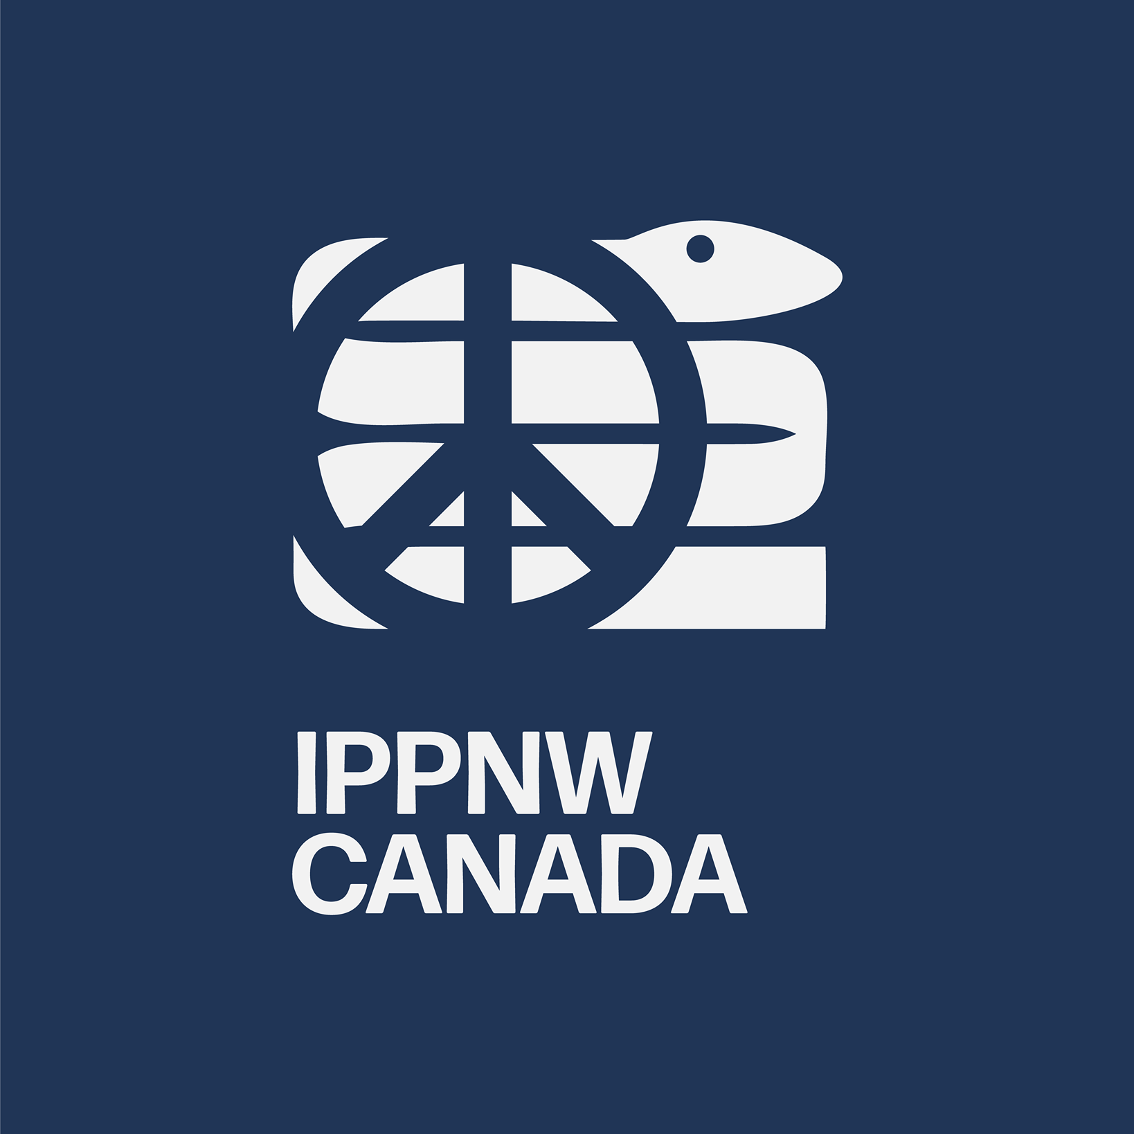

CANADA

Parallel report to CEDAW 2024 - Convention on the Elimination of Discrimination Against Women
Submitted by: International Physicians for the Prevention of Nuclear War Canada

Parallel Report to CEDAW 2024 - Convention on the Elimination of Discrimination Against Women
This Parallel Report to CEDAW 2024, made on behalf of the International Physicians for the Prevention of Nuclear War Canada (“IPPNWC”), contains recommendations to the Canadian government on how to eliminate discrimination against women and enhance equal treatment through the promotion of nuclear disarmament

Nuclear Disarmament: An issue for women is an issue for Canada

The Canadian government has consistently voiced its desire to advance feminist foreign policies. In fact, the federal government has highlighted its Women, Peace and Security (WPS) agenda as a key area. The threat of nuclear weapons should be at the forefront of Canada’s ongoing discussions to advance feminist foreign policy Nuclear weapons pose a disproportionate threat against the health of women and girls.It is a gendered crisis that continues to be deliberated on by predominantly male state representatives, diplomats, and professionals.

The continued existence of nuclear weapons and the current race to expand and modernise the nuclear arsenal is the most egregious manifestation of the commitment to use violence to manage conflict. It legitimizes the use of violence at the highest level which creates the permissive attitude that the use of violence is acceptable. Violence is increasingly seen as maladaptive, yet women continue to suffer disproportionately from its impact at all levels across the world. Disarmament declares that violence is not needed. This salient recognition has profound implications for women as violence become less normative.

Peace is a prerequisite for health. Women and children suffer the brunt of all armed conflicts. Disarmament is a necessary precursor to peace and will have a disproportionate heuristic impact on the health of women and children.

The Convention on the Elimination of All Forms of Discrimination against Women (“CEDAW”) is an international treaty that was entered into force on December 22, 2000. This treaty has guided conversations to forward gender equality globally. CEDAW has noted that nuclear disarmament would “promote social progress and development and as a consequence will contribute to the attainment of full equality between men and women.”

The Foundations for Peace: Canada’s National Action Plan on Women, Peace and Security – 2023 to 2029 highlights that women and gender-diverse peoples have the same rights as men to participate fully in operational and decision-making capacities. However, there is no recognition of the threat posed by nuclear weapons, nor does it address the disproportionate impact that this threat poses on women. The absence of reference to nuclear weapons demonstrates the Canadian government’s inability to prioritize this issue as a whole.

- Background on Disarmament and Nuclear Weapons in Canada

The Treaty on the Non-Proliferation of Nuclear Weapons (“NPT”) is an international treaty that was entered into force in 1970. The purpose of the NPT is to prevent the proliferation of nuclear weapons and to eventually achieve disarmament. There are three key pillars to this treaty: disarmament, non-proliferation, and promotion of the peaceful use of nuclear power. It is currently the only binding legal instrument that is committed to nuclear disarmament with all five nuclear-weapon states as signatories. The NPT currently has 191 signatory members, including Canada.

The TPNW is a legally-binding treaty that prohibits nuclear weapons and ultimately leads towards total elimination. The Treaty prohibits participation in any and all activities regarding nuclear weapons including but not limited to its development, use, accumulation, and deployment. State parties are obliged to provide reparations to those affected by nuclear testing.. The TPNW was entered into force in 2021. Canada has not signed onto the TPNW but continues to assert that disarmament is appreciated and necessary.

Despite Canada’s absence from ongoing nuclear disarmament negotiations, Canadian civil society organisations, parliamentarians and activists have continued to advocate for nuclear weapon disarmament. Many organisations reach out to government representatives from Canada and abroad to discuss capacity building efforts to advance disarmament advocacy. However, little can be done locally if the Canadian government refuses to participate in the discourse.

- The Gendered Role of Humanitarian Disarmament

Women in Disarmament Treaties and International Law

There are three multilateral arms control treaties that have been signed since 1945 and have specific language and provisions relating to gender:

- The Arms Trade Treaty (“ATT”)
- The Treaty on the Prohibition of Nuclear Weapons (“TPNW”)
- The Convention on Cluster Munitions (“CCM”)

The ATT requires State Parties to assess how the export of conventional weapons and ammunition may be used to perpetuate or commit gender-based violence (“GBV”). Similarly, there is a legally-binding provision that requires State Parties to consider GBV as an essential criterion in their export assessments of conventional weapons and ammunition.

The TPNW prohibits States Parties from developing, testing, producing, manufacturing, acquiring, possessing, or stockpiling nuclear weapons or other nuclear explosive devices. The TPNW acknowledges the disproportionate impact of nuclear radiation on women and girls.

Similarly, the preamble of the TPNW states the following:

‘‘the catastrophic consequences of nuclear weapons cannot be adequately addressed, transcend national borders, pose grave implications for human survival, socioeconomic development, the global economy, food security and the health of current and future generations, and have a disproportionate impact on women and girls, including as a result of ionizing radiation.’’

The TPNW further recognizes that:

‘‘the equal, full and effective participation of both women and men is an essential factor for the promotion and attainment of sustainable peace and security, and committed to supporting and strengthening the effective participation of women in nuclear disarmament.”

It is evident that the TPNW has made efforts to recognize the disproportionate effects of nuclear weapons on women. However, the treaty will lack impact in Canada if the country continues to deny the value of participation in ongoing nuclear weapon disarmament discourse.

Following the 2024 NPT PrepCom, John Guilfoyle, President of IPPNWC, stated the following:

“Non-proliferation is not enough.

The Total Prohibition of Nuclear Weapons is the treaty that humanity now needs to implement globally. This will need a clear pathway to disarmament that includes making aggressive wars illegal with the robust and timely means of enforcement.”

The Disproportionate Health Effect of Nuclear Weapons on Women

In the event of nuclear weapon detonation, we would see widespread harm and mass casualties. Such harm would include ionizing radiation, damaged eyesight and potential blindness, among countless other injuries. Research has demonstrated that women face greater vulnerability to the effects of ionizing radiation in comparison to men.

A study was conducted on the survivors of the nuclear weapon attacks on Hiroshima and Nagasaki. This study determined that women were twice as likely to die or develop cancer due to ionizing radiation due to sensitive reproductive and adipose tissue, as well as differences in metabolism. For pregnant women exposed to ionizing radiation, their children are at serious risk of harm, including developmental challenges, physical malformations, stillbirth, or abortion. Similarly, this evidence is corroborated by a study on the 1986 Chernobyl nuclear power plant accident.

It is indisputable that women are at greater risk of biological and physical harm from the use of nuclear weapons. This is demonstrated by the TPNW’s explicit recognition of these health effects in the treaty’s preamble.

Sociological Perspective

From a Sociological standpoint, women are disproportionately affected by nuclear weapon detonation through psychological impact, evacuation and displacement, social stigma and discrimination, and environmental impact.

Understandably, nuclear weapon detonation may leave people in a state of uncertainty and heightened anxiety regarding the potential of lifelong consequences stemming from the detonation. Research from has shown that women survivors from nuclear incidents have experienced disproportionately higher levels of stress and mental health problems, often times resulting in the implementation of preventative measures. Similarly, studies have shown that mothers have the suffered the most severe mental health deterioration.

In the event of displacement following nuclear weapon detonation, women face a greater risk of sexual violence, diminished access to assistance, and the infringement of their rights to housing, property, land, and health. To better understand this relationship, it is important to note that women globally face discriminatory practices on an explicit and implicit level. Women are subjected to differential treatment on a day-to-day basis that is often impacted by social, cultural, and political perspectives. This differential treatment would only be heightened in the event of nuclear weapon detonation.

Beatrice Fihn’s statement on Canada’s current position on the nuclear weapons crisis states it well:

“A foreign policy that promotes women’s rights must recognize that the testing and use of nuclear weapons specifically harms women, who are more acutely affected by nuclear fallout than men.”

Neglecting nuclear disarmament in Canadian foreign policy undermines Canada’s credibility and leadership in women’s rights and underserves the Canadian populations.

Women Participating in Nuclear Disarmament Advocacy

Women continue to be underrepresented in multilateral disarmament meetings and only make up about a third of participants. In fact, the CEDAW Committee cited a low participation of women in institutions working in nuclear disarmament.

In October 2018, Falco Mueller-Fischler, on behalf of the Canadian delegation, made the following statement at the UN First Committee on Disarmament and International Security:

“Advancing international peace and security depends on our collective ability to recognize and account for the gender dimensions of non-proliferation, arms control, and disarmament. Integrating gender perspectives into this work requires systematic and dedicated efforts.

Canada prioritizes these efforts in line with our Feminist Foreign Policy. We believe
that advancing gender equality, including in the disarmament field, is the most effective way to build a more peaceful, inclusive, and prosperous world.”

Canada has continuously voiced its intention to include women in ongoing peace conversations. This sentiment is meaningless if Canada continues to boycott conversations pertaining to nuclear weapons disarmament – an issue that directly and disproportionately affects women.

- Recommendations

Empowering and Promoting Women for Equal Opportunities in Discussions

Women have historically voiced their opinions in Canadian and international discourse surrounding nuclear weapons. However, women continue to be underrepresented in these conversations. While the Canadian government continues to advocate for feminist foreign policy, it should account for the empowerment of civil society organisations that uplift women’s voices. Similarly, the Canadian government should be promoting and appointing women into roles with greater participatory capacity. This active participation must be consistent with meaningful participation at an operational and decision-making level. “Attendance” is not synonymous with “participation”. Given the disproportionate effect that nuclear weapons pose on the health of women and girls, it is most appropriate to support women in reaching these positions.

Empowering Civil Society Organisations

Canada’s history of nuclear disarmament advocacy cannot be discussed without acknowledging the profound contributions of Canadian women towards this cause. The Canadian Voice of Women for Peace (“VOW”) is Canada’s oldest feminist peace group and has historically played a fundamental role in advancing nuclear disarmament advocacy. Furthermore, IPPNWC’s board and members consist of female physicians and medical professionals with a concerted interest in nuclear disarmament advocacy, including but not limited to: Marney Cuff-Eisenbarth, Dr. Huguette Hayden, Dr. Erica Frank, Dr. Nancy Covington, and Maureen Brouwer. Setsuko Thurlow is a survivor of the atomic bombing of Hiroshima, Japan in 1945 and a Japanese-Canadian champion of the International Campaign to Abolish Nuclear Weapons (“ICAN”). Canadian women have historically been at the forefront of nuclear disarmament advocacy within Canada and abroad.

Yet, there are few to no opportunities organized by Canada for linkages, dialogue and funding between civil society organizations (“CSOs”) to work together towards nuclear disarmament. There is no forum that brings Canadian CSOs together with government representatives to discuss advocacy or policy. This absence can create a somewhat adversarial relationship whereby CSOs are forced to send letters, commence campaigns, or reach out to the media to grab the attention of the Canadian government. It would be far more productive to create a forum for Canadian CSOs to gather with official Canadian government representatives to share findings and perspectives.

Participating in the TPNW as an Observer

It is of utmost importance to have women in roles of active participation. But it is similarly important to have these women participating in the ongoing TPNW conversations. Even if Canada is going to continue to dissent in nuclear weapons talks, the country should at the very least have representation at these conversations.

Canada touts itself as a country that values equal opportunity. Yet, the country’s denial of ongoing nuclear weapons discourse only serves to exclude ourselves from the conversation. The committees and state parties will continue to meet despite Canada’s absence. If we, as a country, want our voices to be heard, we need to be present to do so. And in doing so, we need more women at the forefront. As a disproportionately affected group, women deserve to have their voices heard in this discourse.

https://live-amnesty.pantheonsite.io/sites/default/files/Feminist%20Foreign%20Policy%20-%20%20Scene%20Setter%20%28002%29.pdf
https://live-amnesty.pantheonsite.io/sites/default/files/Feminist%20Foreign%20Policy%20-%20%20Scene%20Setter%20%28002%29.pdf
Convention on the Elimination of All Forms of Discrimination against Women (CEDAW), preamble, http://www.ohchr.org/EN/ ProfessionalInterest/Pages/CEDAW.aspx (accessed 28 September 2016)
https://disarmament.unoda.org/wmd/nuclear/npt/
https://disarmament.unoda.org/wmd/nuclear/npt/
https://disarmament.unoda.org/wmd/nuclear/npt/
https://disarmament.unoda.org/wmd/nuclear/tpnw/
https://www.ippnwcanada.ca/archive/ippnwc-presidents-letter-reflections-on-the-npt
M. Olson, ‘Nuclear: War of Human Consequences—Presentation to the Vienna Conference on Humanitarian Impacts of Nuclear Weapons’, Nuclear Information and Resource Service, December 2014, p. 34: http://www.nirs. org/international/olsontalkvienna12414.pdf.
A.G. Dimmen, ‘Gendered impacts’, op.cit.; https://unidir.org/files/publication/pdfs/gender-development-and-nuclear-weapons-en-659.pdf
Risk here referring to Excess Relative Risk per Gray (ERR/Gy). K. Ozasa et al, ‘Studies of the mortality of atomic bomb survivors: Report 14, 1950−2003—an overview of cancer and noncancer diseases’, Radiation Research, vol. 177 no. 3, 2012, pp. 229−243, p. 232.; https://unidir.org/files/publication/pdfs/gender-development-and-nuclear-weapons-en-659.pdf
https://unidir.org/files/publication/pdfs/gender-development-and-nuclear-weapons-en-659.pdf
United Nations Scientific Committee on the Effects of Atomic Radiation, Report to the General Assembly with Scientific Annexes, ‘Sources and effects of ionizing radiation’, Volume II (Scientific Annexes C, D and E), 2008, p. 60, figure VIII on health effects due to radiation from the Chernobyl accident.; https://unidir.org/files/publication/pdfs/gender-development-and-nuclear-weapons-en-659.pdf
https://unidir.org/files/publication/pdfs/gender-development-and-nuclear-weapons-en-659.pdf
H. M. Vyner, ‘The psychological dimensions of health care for patients exposed to radiation and the other invisible environmental contaminants’; https://unidir.org/files/publication/pdfs/gender-development-and-nuclear-weapons-en-659.pdf
J. M. Havenaar et al, ‘Mental health problems in the Gomel region (Belarus): an analysis of risk factors in an area affected by the Chernobyl disaster’, Psychological Medicine, vol. 26 issue 4, 1996, pp. 845–855. 43 M. Yamada and S. I; M. Yamada and S. Izumi, ‘Psychiatric sequelae in atomic bomb survivors in Hiroshima and Nagasaki two decades after the explosions’, Social Psychiatry and Psychiatric Epidemiology, vol. 37, 2002, pp. 409–415, p. 414. See also M.A. Dew and E.J. Bromet, ‘Predictors of temporal patterns of psychiatric distress during 10 years following the nuclear accident at Three Mile Island’, Social Psychiatry and Psychiatric Epidemiology, vol. 28, no. 2, 1993, pp. 49–55, p. 54; https://unidir.org/files/publication/pdfs/gender-development-and-nuclear-weapons-en-659.pdf
https://unidir.org/files/publication/pdfs/gender-development-and-nuclear-weapons-en-659.pdf
Beatrice Fihn, ‘‘Canada’s feminist foreign policy cannot include nuclear weapons,’’ The Globe and Mail, 28 September 2018.
Committee on the Elimination of Discrimination against Women. General recommendation No. 30 on women in conflict prevention, conflict and post-conflict situations, CEDAW/C/ CG/30, 2013, para 30: http://www.ohchr.org/ Documents/HRBodies/CEDAW/GComments/ CEDAW.C.CG.30.pdf
https://www.international.gc.ca/world-monde/international_relations-relations_internationales/un-onu/statements-declarations/2018-10-disarm-Fischler.aspx?lang=eng

