Annex to the Common Core document

The Republic of Suriname



December 2021

Annex A

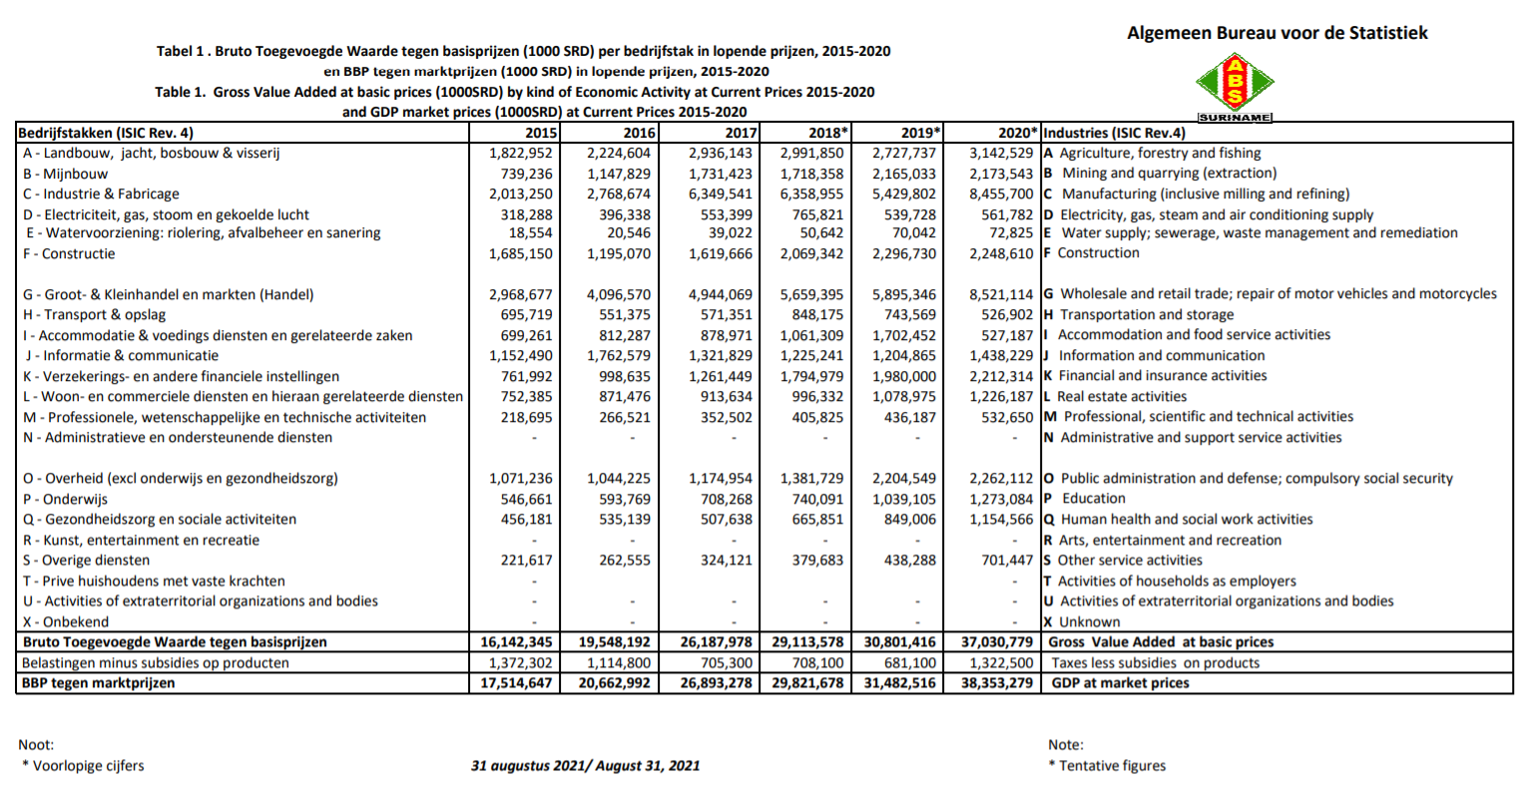

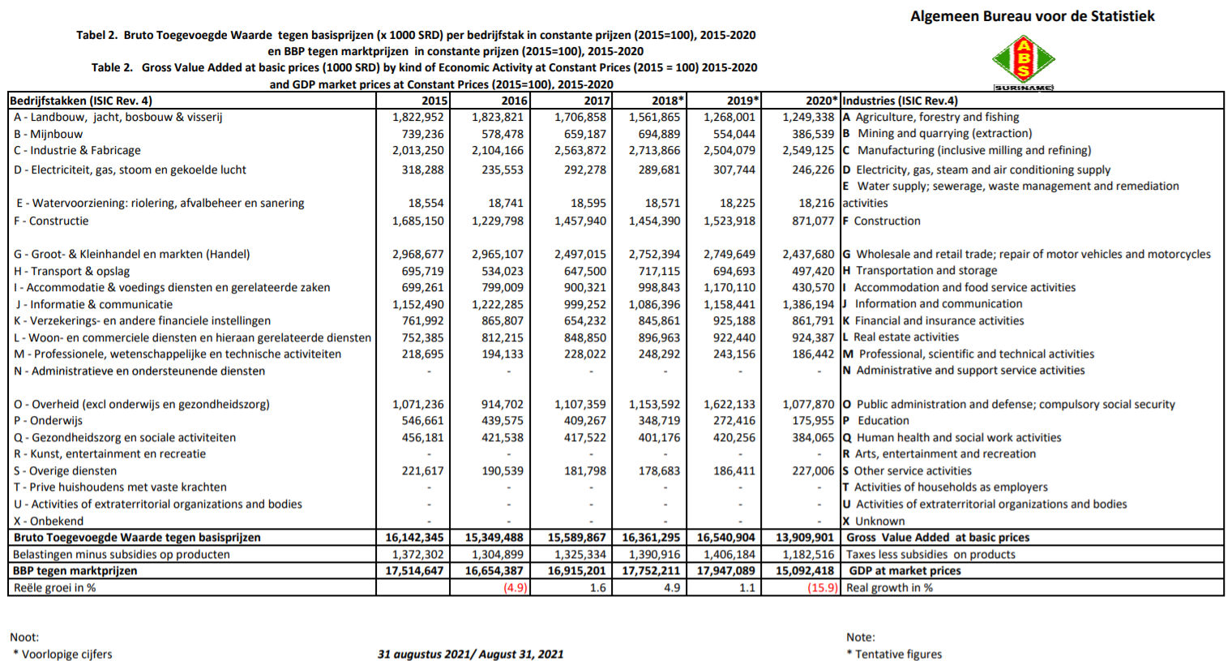

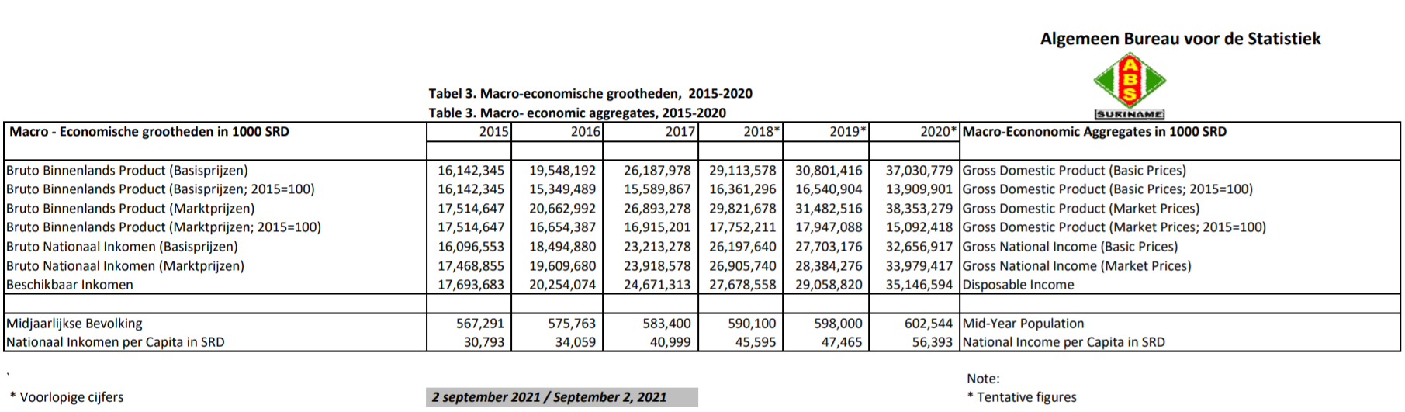

Annex B

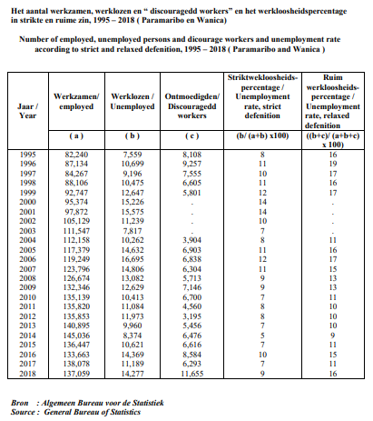

Annex C
Homicide cases per quarter over 2019
Quarter | M Manslaughter | Murder | Severe abuse resulting in death | Murder with Robbery | Total cases | Solved cases
1st. | 4 | 3 | - | 2 | 9 | 5
2nd. | 1 | 3 | 1 | 1 | 6 | 2
3rd. | 2 | 2 | - | 1 | 5 | 1
4th. | - | 5 | - | 5 | 10 | 4
Total | 7 | 13 | 1 | 9 | 30 | 12

Overview victims and perpetrators by sex
Delict / Crime | Victims |  | Perpetrators
Delict / Crime | Male | Female | Male | Female | Unknown
M Murder# | 7 | 6 | 9 | 1 | 3
Manslaughter# | 7 | - | 5 | 1 | -
Robbery (assault)# | 8 | 1 | 6 | - | 4
Severe mistreatment resulting in  death # | 1 | - | 3 | - | -
Total | 23 | 7 | 23 | 2 | 7

Overview victims and perpetrators by age
Age | Victims |  | Perpetrators
Age | Male | Female | Male | Female
15 – 20 years | - | 1 | 1 | -
21 – 30 years | 1 | 1 | 4 | 1
31 – 40 years | 4 | 1 | 2 | -
41 – 50 years | 5 | 1 | 1 | 1
51 years & older | 6 | 3 | 1 | -
Unknown | 7 | - | 22 | -
Total | 23 | 7 | 30 | 2

Overview relationship between victims and perpetrators
Relationship between victim and perpetrator | Total
Woman – man (couple) | 1
Grandmother - grandson | 1
Father - foster son | 1
Girlfriend - boyfriend | 2
Acquaintances with each other | 7
Housemates | 1
Settlement | 3
Relationship Unknown | 14
Total | 30
Source: DCIV

Annex D
Total number of Prisoners by Age group, for the years 2015-2019
 | Year
Age Group | 2015 | 2016 | 2017 *) | 2018 | 2019 *)
unknown | 1 | 0 | 0 | 0 | 0
16-20 | 416 | 388 | 297 | 578 | 340
21-25 | 1667 | 1747 | 877 | 1580 | 916
26-30 | 2085 | 2233 | 1093 | 1819 | 1090
31-35 | 2109 | 2111 | 1449 | 1963 | 1176
36-40 | 1300 | 1370 | 944 | 1529 | 1055
41-45 | 977 | 965 | 768 | 1108 | 817
46-50 | 539 | 603 | 384 | 615 | 380
51-55 | 305 | 320 | 146 | 386 | 325
55-60 | 160 | 236 | 162 | 173 | 94
61 - > | 111 | 116 | 69 | 173 | 124
Total | 9670 | 10089 | 6189 | 9924 | 6317
Note: Data for the years 2017 and 2019 does not include information from NW. H.V.B
Source: Central Statistics Unit of the Ministry of Justice and Police

