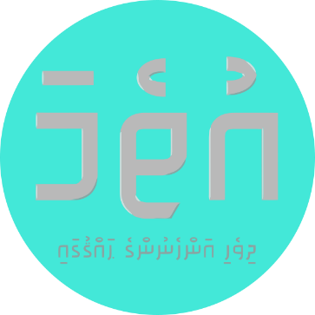

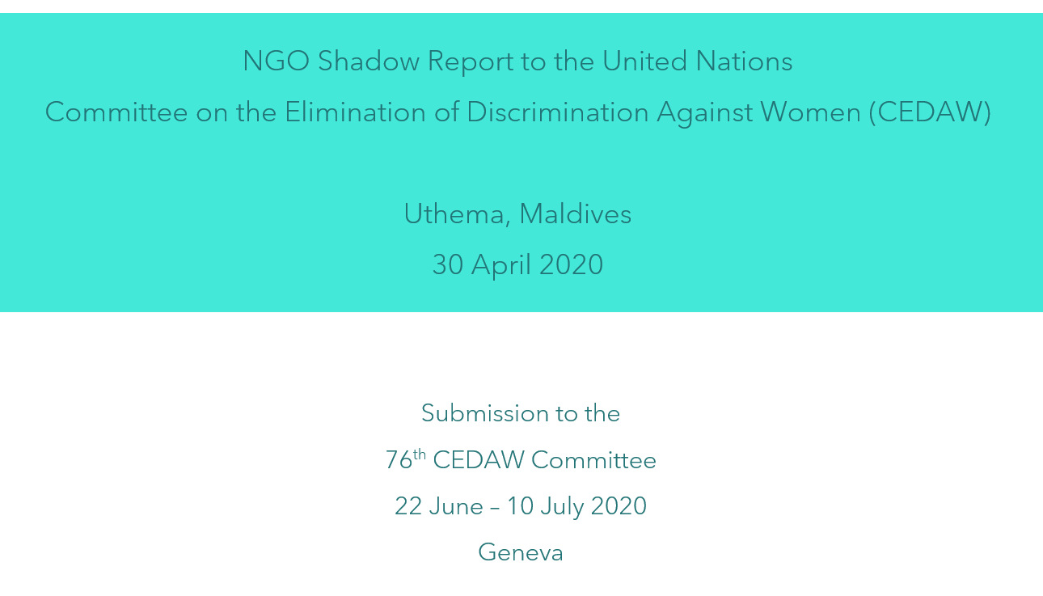

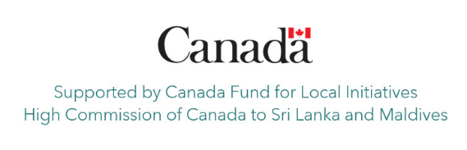

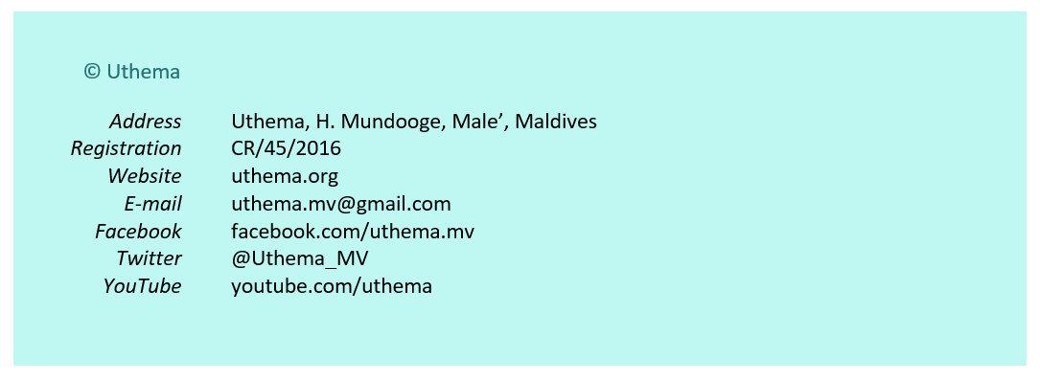

This NGO shadow report by Uthema responds to the 6th Periodic State Report of the Maldives (April 2019) to the CEDAW Committee. This is a summary of a comprehensive report produced by Uthema which contains further details and recommendations.
Articles 1 - 3

- SRP 18-20 : While 38 institutions are reported to have established complaints mechanisms to report on issues covered by the Gender Equality Act (GEA), no information is provided on the number of reported cases or resolutions.
- SRP 20-23 : A 2018 survey by Hope for Women NGO found that 4 years since the Sexual Harassment Prevention Act (SHPA), 62% of consulted ministries did not have a committee as per the law, or a policy. 12 ministries had investigated just 3 cases, which all involved male perpetrators. In 1 case, he was given a written warning. The other 2 cases were dismissed due to lack of evidence.
- SRP 24 : The State’s recognition that disparate interpretations of Shari’ah, particularly by the judiciary on Family Law application may hinder or harm girls and women’s realization of their “full development” is important. State must address the role of institutions in this.
- SRP 25-27 : The Gender Focal Points initiative remains a “superficial exercise”. Women’s Development Committees (WDCs) have not survived the decentralisation experiment, following political changes of 2008 and consequences. Continuing reconfiguration of the Ministry of Gender with its changing leadership indicates perennial instability of the NWM.

Recommendations :
- Implement the national framework on gender equality and women’s rights, specifically the GEA, SHPA and Family Law.

Article 4

- SRP 28 : Women’s political party membership reaches over 40% in most parties, although women are not represented in party leadership. Reluctance to include women in political decision-making lies with attitudes of political party hierarchies dominated by men. Studies conducted in 2015 by IFES and Uthema’s 2019 position paper provide robust recommendations to improve the status quo.

Recommendations :
- Amend the Political Parties Act 4/2013 to include provision(s) to improve the internal governance of political parties, facilitate fair and democratic representation of party members by gender in leadership positions.

Article 5

- SRP 32-38 : Maldives has been affected by the global phenomenon of radicalisation and ideologies driving increasingly socially destabilizing narratives of discrimination and violence against women, based on interpretations of Shari’ah. International preachers and their families have been invited by State institutions to conduct sermons where harmful practices such as child marriage were endorsed. The 2015 Preliminary Assessment of Radicalisation in the Maldives by Maldivian Democracy Network (MDN) provides deeper insights into the consequences of this on the school curriculum, institutions and the public. Recent developments vilifying the MDNs report is indicative of the seriousness of the issue. Maldives has been included in the South Asian Terrorism Portal since 2018.

Recommendations :
- Acknowledge and address the issue of radicalisation identified in the MDN report.

Article 6

- SRP 39-58 : The State report conveys inadequacy of the definition of marital rape in the Sexual Offences Act 2014 and the concept’s ill-recognition both institutionally and socially. Inquiries show the prevailing legal framework does not address this issue. Disturbingly, State institutions continue to enable clerics supporting violence against women.
- Available data indicates the critical need to strengthen inter-sectoral coordination and cooperation required in the Domestic Violence Prevention Act (DVPA) 2012. It shows the continuing gender disparity in the number of cases reported and the unusual trend where reporting by women dip while the same by men increases.

- The reality of domestic violence and abuse is reflected in public concerns and reports of violence occurring within communities reported in the media. A particularly relevant case is that of a woman from Gaaf Dhaal Atoll Thinadhoo, who was brutally sexually attacked by her estranged husband in December 2015 and subsequently died from her injuries. It is extremely unusual in Maldives for a community to organise in protest against such cases, which commanded a high level of interest and investigation from the authorities. However, handling of the case by the Criminal Court is indicative of failure of the judiciary to implement relevant laws. Four years after the assault, the court acquitted the victim’s husband of the charges at a closed-door trial in 2019. The PGO unusually issued a statement announcing its decision to appeal the case. Media reported that “the PG office accused Judge …. of failing to give “sufficient weight” to witness testimony and evidence submitted by the prosecution.” The appeal case is currently ongoing.
- The Health Sector Response to Gender Based Violence Guideline (2014) and its online course to train healthcare practitioners remain yet to be implemented. Anecdotal evidence suggest awareness of the existence of the guideline is negligible among health practitioners, indicating knowledge gaps of the DVPA mandate.
- The State acknowledges the Family Protection Authority (FPA) has been under-funded over much of its life since the law, although data shows an improvement in the situation. While the FPAs administrative budget has increased over the years, its programme budget remains limited.

- Family Court data gives a snapshot of the utilisation of the Protection Order (PO) under the DVPA. Overall, the number of women applicants for POs far outweigh men, but analysis shows that although numbers are lower, the likelihood is higher for men to obtain a PO. Available literature informs that victims of domestic violence in most cases decline to press criminal charges against perpetrators and complaints are withdrawn in nearly 70% of cases.

- Human trafficking in the Maldives has been estimated to be the second largest industry following tourism, at an estimated US$123 million per annum, according to authorities in 2011. The 2015 Trafficking In Persons (TIP) Report states “Maldives is a destination country for men, women, and children subjected to forced labor and sex trafficking, and a source country for women and children subjected to labor and sex trafficking.” The State remains on tier two of the 2019 TIP report, which informs that “Girls from Maldives and Bangladesh and - to a lesser extent - women from Africa, Asia, and Eastern Europe are subjected to sex trafficking in Maldives.”

Recommendations :
- Strengthen the legal framework on marital rape consistent with CEDAW recommendations, and Islamic principles forbidding violence against women.

Articles 7 - 8

- SRP 59-63 : Studies show stereotypes and negative perceptions prevalent in the country context on women’s participation in public life, as confirmed by data. Uthema position paper on the issue found while “a societal narrative suggesting women have “equal opportunities” to participate in public life, with “no legal barriers” obstructing equal access” existed, legislation “supporting non-discrimination on the basis of gender… remain firmly on paper from Constitutional to lower levels of law and policy.” Data shows women’s representation in all ranks and the executive ranks of the civil service has a marked gender-gap indicating a ‘glass ceiling’.

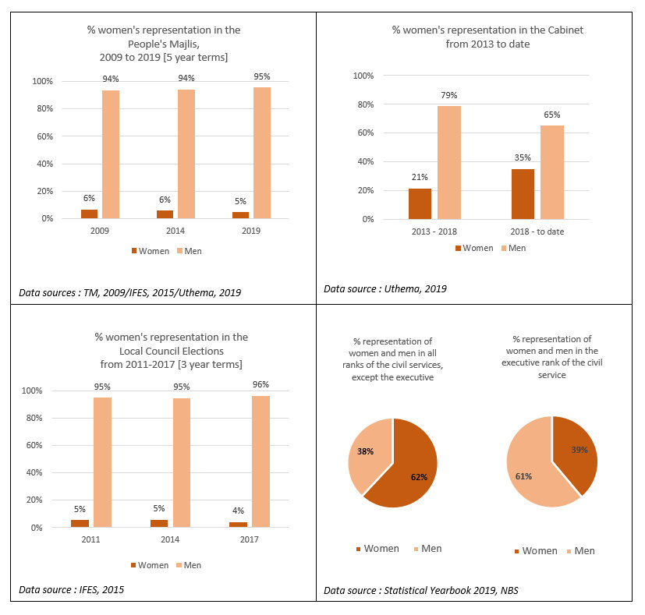

- The 8th Amendment to the Decentralisation Act (7/2010) in December 2019, introduced a 33% women’s quota in local councils, although a valid point of concern is elaborated below.

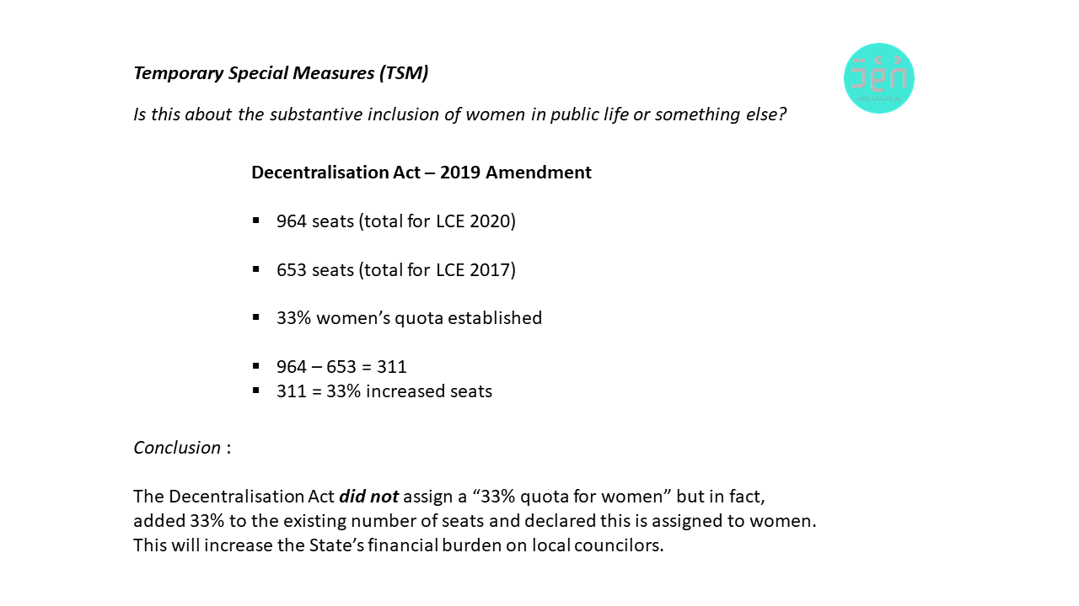
- Women’s representation among judges can be seen in the data below. The historic appointment of two women judges to the Maldives Supreme Court September 2019 is an unprecedented step forward. Despite this, women’s representation in the judiciary stands at 7% with the majority of Magistrates Courts having just 5% women.
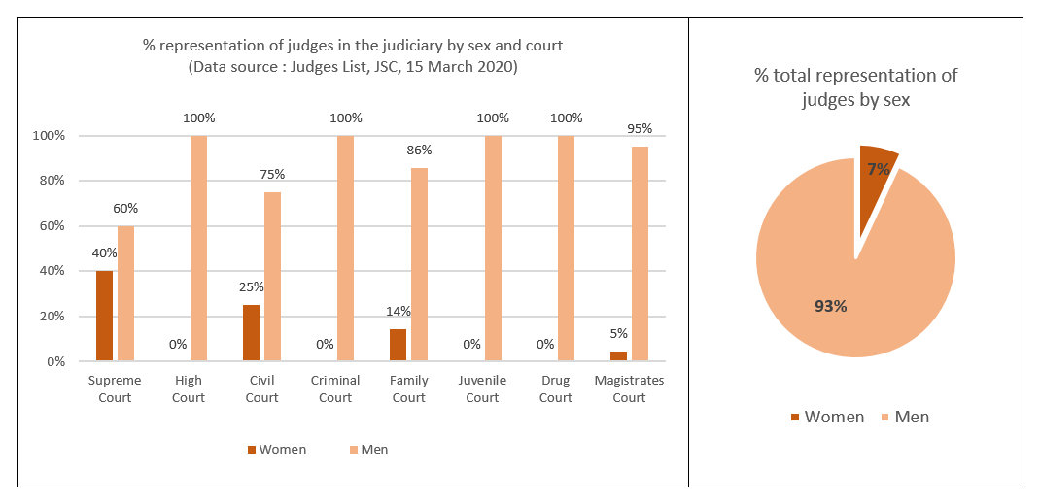

- The reference to the inclusion of women on the board of the tourism association MATI does not reflect on the fact that women’s participation in tourism remains a mere 7.4% (Census, 2014).

Recommendations :
- Introduce robust measures to increase women’s inclusion in the :
- executive, parliament and the judiciary
- tourism and construction sectors

Article 9

- SRP 64 : The State fails to provide an accurate response to the Committee’s recommendation on equality in nationality.

Article 10

- SRP 65-71 : The attribution of free education to a government policy in the State report is misleading, as the 2008 Constitution provides for free education up to secondary level.
- Unplanned teenage pregnancy is a real issue impacting girls’ education and health, and reported practice of child marriage among radicalised groups is alarming. An unpublished UNFPA Maldives study shows that between 2017-2019, 21 students became pregnant, and while authorities made attempts to facilitate schooling in such cases, this is subject to the vagaries of location and context.
- A review of the subject textbooks for Dhivehi, English, Islam and Social Studies concluded that most of the “gender related content is found in Dhivehi and Islam book[s] of which the secondary school books included more gender-stereotyping.” The study “strongly recommended that teachers be advised and, in fact, even be warned by the Ministry of Education, school principals and supervisors, not to express their personal gender-biased beliefs when teaching; especially bringing in content that is outside of the curriculum should be prohibited.”
- As the mapping information provided below reveals, the integration of sexual, reproductive health and rights (SRHR) in the curriculum is nowhere close to meaningful or desirable.

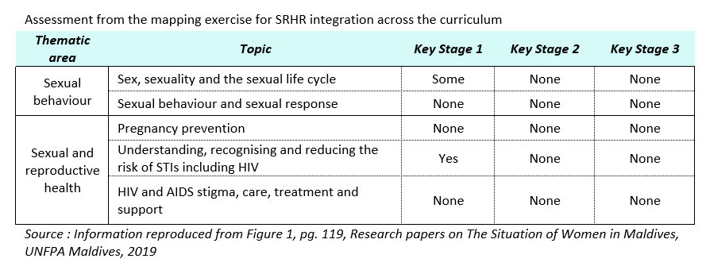
Recommendations :
- Integrate SRHR components in the national school curriculum to address identified gaps prioritising the inclusion of age appropriate comprehensive sexuality education.

Article 11

- SRP 72-86 : Data shows economic inequality is one of the most pronounced forms of gender inequality in the Maldives. While policies and laws supporting employment rights exist, system-wide implementation is lacking hindering de facto changes to the lives of women in the workplace.

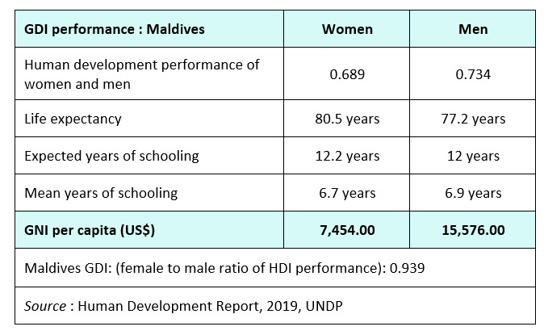

- Data shows a significant gender gap in the labour force participation rate (LFPR) indicating women’s much reduced opportunity for economic independence and access to financial security. The public sector is the largest employer among whom women constitute the majority and women’s inclusion in tourism is 7.4%. The gender pay gap is 26% meaning on average Maldivian women earn MVR 22.51 ($1.45) per hour less than men.

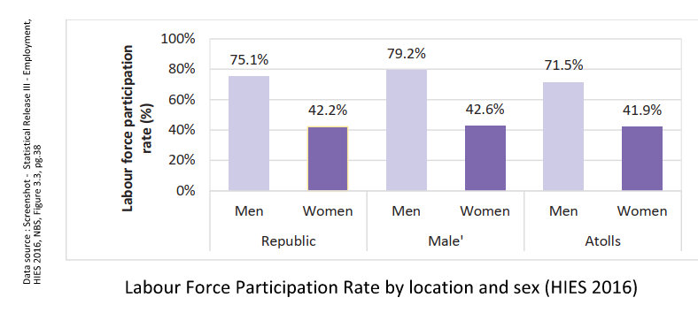

- Despite legislation, the situation of women PWDs as documented in the lived experiences shared below remain challenging.
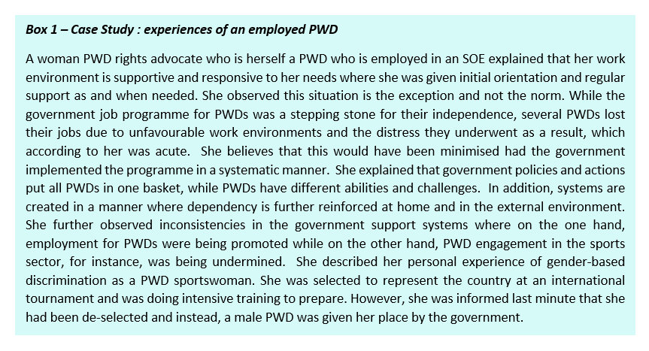
Recommendations
- Establish gender inclusion targets for the tourism industry.

Article 12

- SRP 87-103 : The national population sex ratio is 100 women to 105 men. The sex ratio in the resident population is “177 men per every 100 women”, reflected in the population pyramid below. The impact of this imbalance on women and girls remains to be studied.

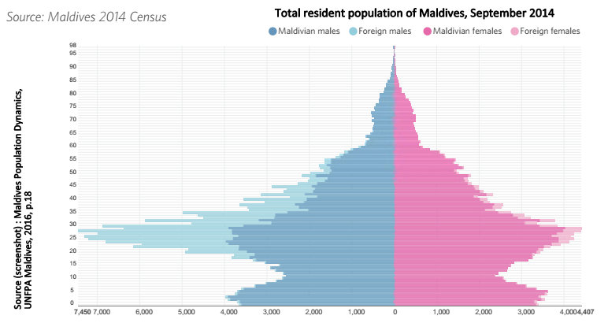

- A key concern regarding maternal health is the increasing prevalence of caesarean section births, which rose from 32% in 2009 to 40% in 2016-17 (DHS2016-2017). The international healthcare community has long considered “the ideal rate for caesarean sections to be between 10% and 15%.”
- The National Family Planning Guideline (NFPG) is described as “non-discriminatory” without considering context, where 11% women consider getting permission to access medical treatment a barrier. The NFPG requires spousal consent to obtain both female and male sterilisation. Sterilisation as a family planning method is highest among women, showing the guideline prevents substantive equality of women.

- The State report fails to acknowledge persistent barriers to universal access to SRH with estimated 52% youth demographic in a context denying access to SRH information/services for unmarried persons. The contraceptive prevalence rate of married women using any method dropped significantly from 35% in 2009 (DHS) to 19% in 2016-2017 (DHS). The need exists to support existing tools to improve SRH education, such as the Siththaa mobile application.
- While conditional abortion is permitted through a fatwa, there is no data on practice. It is disturbing that credible anecdotal evidence suggests that in complex cases involving abortion, medical practitioners are given legal advice to seek the opinion of the non-medical fatwa committee.
- The emerging FGM/C issue must be viewed in the context of a radicalisation narrative, where ultra-conservative clerics working closely with State institutions are calling for its revival.

Recommendations :
- Make Siththaa app accessible to young people within and outside schools.

Article 13

- SRP 105-113 : The evidence shows that among depositors and borrowers, a significant discrepancy exists between men and women. In the distribution of employment types, the HIES survey shows that women are more likely to be own-account workers (21%) than men (9%).

- Access to credit is a major challenge for women entrepreneurs, and ad-hoc government schemes to address these issues are ineffective. In the absence of data, anecdotal evidence indicate that such schemes are not serving women well.
- A 2019 study informs that women constitute 84% of home-based workers in the Maldives. Data shows that 35% of employed women in rural areas and 16% in Male’ earn their livelihoods working in their homes or living quarters.
- Data from the Ministry of Economic Development shows that for the six SME loan schemes conducted in the past four years, on average 25% of loan scheme beneficiaries were women. This suggests that gender-based targeting of the loan programmes are ineffective, with majority of loan beneficiaries being men, while women face multiple challenges to access credit.
SME Loan schemes run by the Government
Name of the Loan Scheme | Female | Male | % Female
GETSET 2015 | 17 | 55 | 23.61
GETSET 2017 | 24 | 51 | 32.00
SME 2016 | 26 | 69 | 27.37
SME 2017 | 22 | 67 | 24.72
FM 2015 | 6 | 36 | 14.29
Line of Credit Facility (LCF) 2014 | 29 | 69 | 29.59

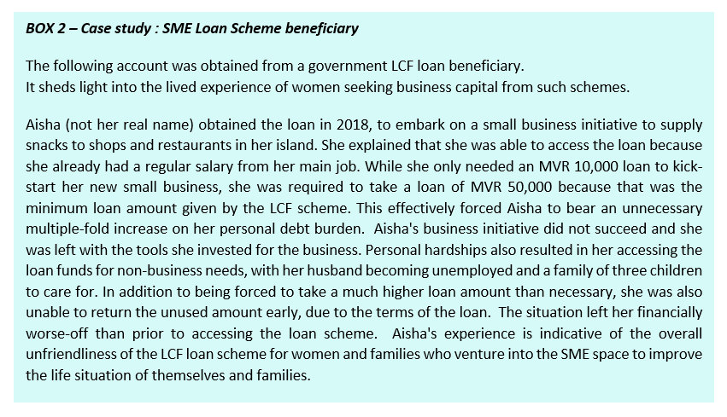
- The impact of government-run and donor-funded SME support programmes have not been positive for women. A summary of the key SME development programmes implemented by the government shows a sizeable sum of USD 34.2 million was committed to SME development activities. While only one project is currently ongoing, lack of monitoring and evaluation provides no data to assess results.

Donor funded projects implemented by the government to support SMEs
(Data source : donor websites)
Donors/Multilateral Partners | Amount | Duration
Asian Development Bank (ADB) | - | -
Small and medium enterprise finance and leasing (Loan) | USD 4.5m | 2007-2011
Private Sector Development Project (Loan) | USD 7.5m | 2008-2014
Inclusive Micro, Small, and Medium-Sized Enterprise Development Project (Grant) | USD 4.45m | 2012-2018
Inclusive Micro, Small, and Medium-Sized Enterprise Development Project (Loan) | USD 2.91m | 2012-2019
Islamic Development Bank | - | -
Inclusive Micro, Small, and Medium-Sized Enterprise Development Project - (Loan) | USD 10.5m | 2012-2021
Microfinance project to the Bank of Maldives - (Loan) | USD 3.1m | 2005-2011
SAARC Development Fund | - | -
Strengthening the livelihood initiative for home based workers in SAARC Region (SABAH) project (Grant) | USD 1.2m | 2008-2014
Total | USD 34.2m | -

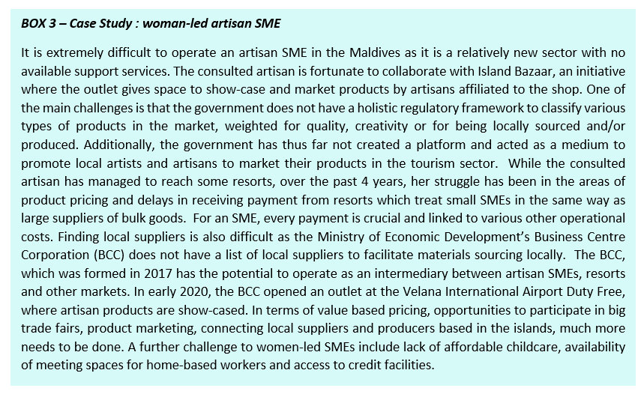

- The prevalence of PWDs in the Maldives is 7.3% women and 6.2% men, and only 25.5% of PWDs were receiving the disability allowance. Beneficiaries are 19% women as against 34% men. Reasons for not receiving the allowance includes non-application due to social stigma, lack of eligibility awareness and costly, laborious application process.
- A 2019 performance audit report of the State care institution in Kaafu Atoll Guraidhoo informs 54 women mental health patients and 11 female PWDs were admitted at the centre as at December 2017. The audit highlighted women’s vulnerability in the centre including sexual abuse allegations against some staff members.
- The pension scheme coverage of informal businesses particularly those of women-owned and/or women-run businesses is low. Majority of FGD participants (home-based workers) consulted by Uthema were not aware of the option to participate in the scheme.

Recommendations :
- Facilitate and enable affordable and accessible child-care services for working women.

Article 14

- SRP 114-122 : The 8th Amendment to the Decentralisation Act (24/2019) heralds significant changes including the TSM of 33% women in local councils, formalised elections for WDCs, allocation of minimum 5% of the council budget to the WDC and a host of legal responsibilities for WDCs which are unlikely to be achievable in the prevailing context. The law requires the WDC to have an active, participatory and advisory role in the work of the council including in the development of policy and regulations at local level.
- The arbitrariness of the State’s decision-making and use of common public livelihoods assets such as land and natural resources has long been a serious concern for rural women. The central government and local councils are equally negligent, as exemplified by numerous cases of loss and damage to rural livelihoods. In Haa Dhaal Atoll Kulhudhuffushi, approximately 404 families depending on the island’s wetland/mangroves for livelihoods making coir rope, “generating an estimated annual income of MVR 8.7 million (USD 564,202.00)” were displaced without consultation or compensation. New industries exclude women from access to community resources, significantly reduce community access to public spaces such as beaches and expose them to the ill-effects of unsustainable developments.
- Despite national health insurance and disability allowance, limitations in care services available for PWDs in rural contexts puts a financial strain on the most vulnerable families burdened with out-of-pocket health expenses to seek services in Male’.
- According to the 2019 FAO gender assessment, 235 loans were processed for fisheries and agriculture through the Ministry of Fisheries and Agriculture between 2013-2018. Although 50% of the loans were reserved for women, only 38% of the borrowers were women. With no monitoring systems, the study observed the “tendency for men to take out loans under the name of a woman”, with consequent responsibility of debt burden on the woman.

Recommendations :
- Conduct a national rapid assessment of impacts of unsustainable development practices to assess loss and damage to lives and livelihoods of rural women.

Article 15

- SRP 123-136 : In 2019, the UN Special Rapporteur on torture observed that “the insufficient qualifications of judicial magistrates responsible for the first instance adjudication of cases, and a perceived lack of awareness and understanding of international due process and human right standards among the judiciary” are challenges in the Maldivian judiciary.
- Regarding hadd punishment, Criminal Court data shows while flogging sentences continue to be issued, executing punishment stopped in 2017.

- A disturbing unprecedented development is introducing hitherto alien concept of sentencing women to death by stoning in 2015 and 2019, although both sentences were revoked.

Recommendations :
- Significantly improve professional training and accountability of judges.

Article 16

- SRP 137-150 : In February 2020, Maldives submitted to withdraw its reservation to Part 1 (b)(e)(g)(h) and Part 2 of CEDAW Article 16. Details of the inconsistencies in the State’s decision-making on this process is provided in the previously cited comprehensive report by Uthema.
- On matters of equality in the family, women’s experiences show these issues remain a source of deprivation and despair.
- Maldives continues to have high divorce rates. Judicial sector data shows that the measures to “control the high rates of divorce”, as described in the State report, are ineffective as divorce statistics remain near constant over the years.

- Data on polygamous marriages show prevalence of the practice, although this data is for marriages registered at the Family Court in Male’. Anecdotal evidence suggest polygamy is widespread in some islands outside Male’, although comprehensive data is unavailable.

- Marriage to minors had declined and the Child Rights Protection Act 2019 prohibits the practice. The emergent practice of unregistered marriage is a serious issue, during and prior to the reporting cycle. In November 2019, President Solih “established a special task force to investigate the case where a child "bride" was impregnated by rape under the justification of extremist religious ideologies.”

- The State has successfully removed barriers violating the independence of the NHRI following the Supreme Court’s 2014 ruling. The court’s bench has since changed, which includes the appointment of two women judges in September 2019.
Recommendations :
- Review and initiate complete withdrawal of reservations on CEDAW Article 16.

Note : Serious emerging issues violating women’s and girls’ rights including child marriage, stoning rulings, attacks on HRDs, returnees from conflict zones are elaborated in the previously noted comprehensive report by Uthema.

________________________________________

Comprehensive Shadow Report on the Maldives 6th Periodic State Report to CEDAW, Uthema, 2020
SRP = State Report paragraph

