Assessment of Economic and Social Rights Fulfilment in Georgia
Submission from the Human Rights Measurement Initiative to the United Nations Committee on Economic, Social and Cultural Rights for its 79th Session scheduled to be held in February 2026.
I. Reporting Organisation
1. The Human Rights Measurement Initiative (HRMI) measures the human rights performance of countries around the world, including Georgia. HRMI is an independent, not-for-profit NGO with its primary base of operations in New Zealand, and a second base in the United States of America at the University of Georgia’s Center for the Study of Global Issues (GLOBIS).
II. Assessment Methodology
2. HRMI uses the award-winning and peer-reviewed SERF Index methodology to measure the fulfilment of economic and social rights (ESRs).
3. This methodology uses bellwether indicator data from international organisations—such as the WHO and UNICEF—and compares each country’s achievement to what other countries at the same income level (GDP per capita) have achieved. HRMI measures progressive realisation of economic and social rights as defined in the International Covenant on Economic, Social, and Cultural Rights (ICESCR). A country’s ‘income adjusted’ HRMI score is thus a measure of how well its government is converting its resources into good human rights outcomes for its people.
4. HRMI supplements these scores with qualitative information sourced by a secure, online survey of in-country human rights experts, such as NGO researchers, journalists, and human rights lawyers and advocates. For more details, please refer to the resources on our website.
5. All HRMI’s data are published annually on the Rights Tracker and are freely available for non-commercial use under a Creative Commons License. The Rights Tracker is a certified Digital Public Good with the Digital Public Good Alliance.
III. Overview of Economic and Social Rights Fulfilment in Georgia
6. HRMI’s most recent ESR scores for Georgia measure its achievement across five rights as of 2022, and indicate a significant room for improvement. They are shown in the graph below.
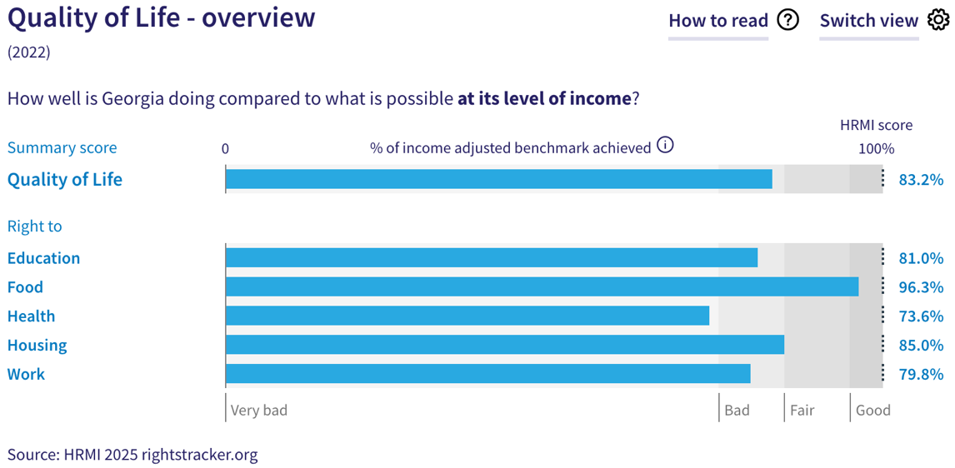
7. Georgia’s scores for 2022 are as follows:
- Overall Quality of Life score = 83.2% (‘bad’)
- Right to education = 81.0% (‘bad’)
- Right to food = 96.3% (‘good’)
- Right to health = 73.6% (‘very bad’)
- Right to housing = 85.0% (‘bad’)
- Right to work = 79.8% (‘bad’).
8. Georgia scores 83.2% on overall ‘Quality of Life’ on the ‘income adjusted’ benchmark, which means that it is achieving only 83.2% of what is possible to achieve at its existing income levels. This overall score falls in the ‘bad’ range, and indicates that Georgia is underperforming in using its resources to their full potential to fulfil its immediate economic and social rights obligations.
9. In other words, these scores indicate that Georgia is not achieving what ought to be possible with its current level of resources. Georgia’s scores lie from ‘good’ to ‘very bad’ performance ranges and indicate contrasting progress on different rights. Any ‘income adjusted’ score that is less than 100% indicates that a country is not meeting its immediate obligations under international human rights law. Therefore, our assessment is that Georgia is performing ‘lower than average’ compared to other countries in Europe, and has a long way to go to meet its economic and social rights obligations.
IV. Right to Education
10. HRMI defines the right to education in accordance with ICESCR Article 13 and CESCR General Comments 11 and 13. For low- and middle-income countries such as Georgia, HRMI further breaks down the right to education into three areas of measurement: primary school enrolment, secondary school enrolment, and quality of education. Georgia scores an ‘income adjusted’ 81.0% on the overall right to education, indicating that it is doing only 81.0% of what is possible to achieve with its existing resources. Our scores show a comparatively better performance on two components, but indicate concerns regarding general quality of education.
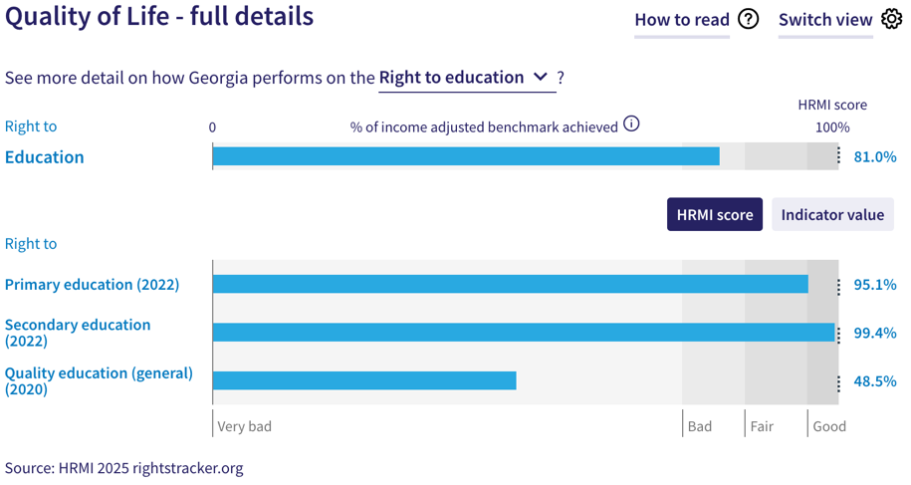
11. Georgia scores an ‘income adjusted’ 95.1% on the right to primary education, and this score falls in the ‘good’ performance range. While this score has remained relatively high, it has also fluctuated over the last two decades from 99.4% in 2006 to 98.9% in 2021, and thereafter showed a sharp decline to the current score of 95.1% in 2022.
12. Georgia has a score of 99.4% on the right to secondary education indicating that it is close achieving an ‘income adjusted’ 100%, and that it is almost reaching its potential for this component. This score is constructed using the indicator data from UNESCO which shows that 99.4% of upper secondary school-aged children were enrolled in school in Georgia in 2022. This score has also shown ‘good’ performance over time. Notably, Georgia ranks 1st out of 49 countries in Europe and Central Asia in our dataset on the right to secondary education.
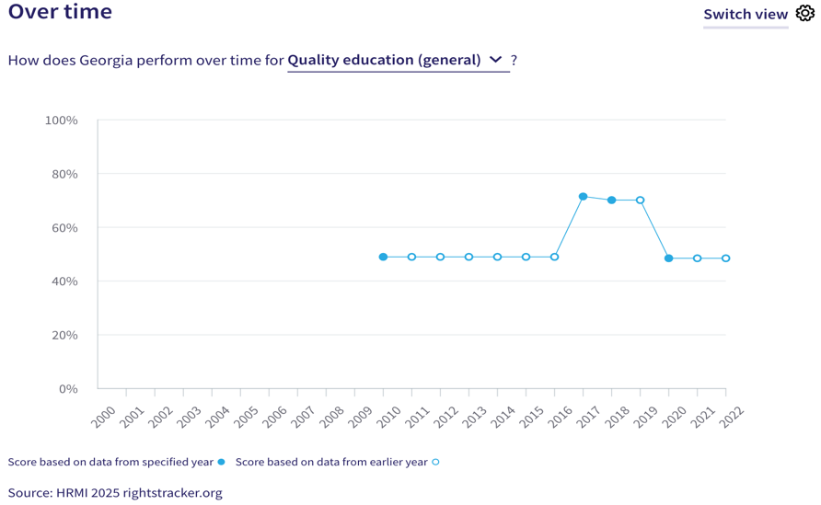
13. Georgia’s performance for general quality education, however, contrasts with its performance on the other two components of the right to education. For low- and middle-income countries such as Georgia, HRMI measures the general quality of education based on the percentage of TIMSS (Trends in International Maths and Science Study) equivalent range from The Human Capital Project of the World Bank. Georgia achieves 30.7% of the TIMSS equivalent range in 2020, translating to an ‘income adjusted’ HRMI score of 48.5% on the right to quality education. This score falls in the ‘very bad’ range, and has shown marked decline since 2017.
V. Right to Food
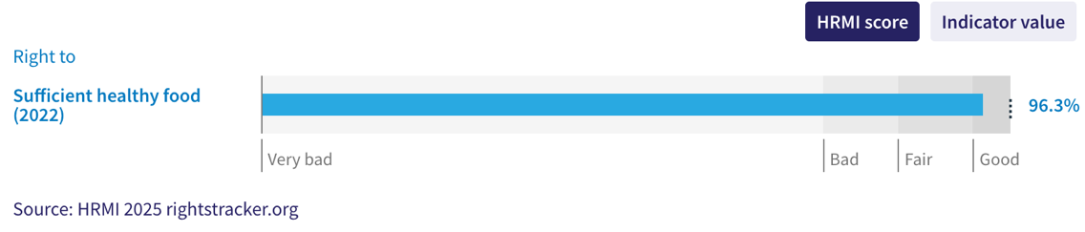
14. HRMI defines the right to food in accordance with ICESCR Article 11 and CESCR General Comment 12. For low- and middle-income countries such as Georgia, HRMI uses a bellwether indicator of how many children are growing well (are not stunted) published by the UNICEF-WHO-World Bank: Joint child malnutrition (JME) database.
15. According to the UNICEF-WHO-World Bank: Joint child malnutrition (JME) database, 95.2% of children under five in Georgia are ‘not stunted’, which translated into an ‘income adjusted’ HRMI score of 96.3% in 2022. This score falls in the ‘good’ performance range. Georgia’s performance on this right has continued to show improvement over a 20-year period to ensure that more children under the age of five grow well. From a score of 86.4% in 2000 to its current peak score of 96.3% in 2022, Georgia is close to meeting its full potential on this right.
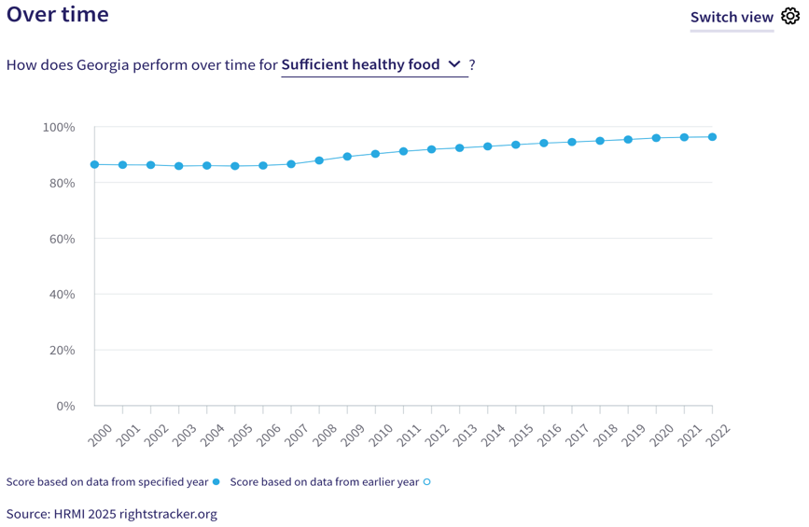
VI. Right to Health
16. HRMI defines the right to health in accordance with ICESCR Article 12.1 and CESCR General Comment 14. For low- and middle-income countries such as Georgia, HRMI uses three indicators to measure the country’s achievement on the right to health: child health, adult health, and reproductive health. Georgia’s overall score on the right to health is 73.6%, and falls in the ‘very bad’ performance range. Overtime trends show complete stagnation with no progress on this right over a decade -- from 75.8% in 2011 to the current score of 73.6% in 2022.
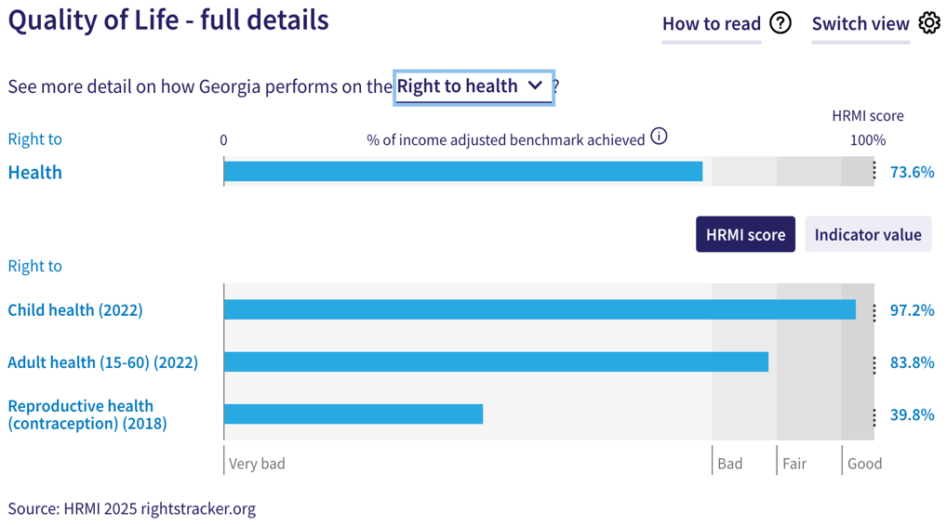
17. For low- and middle- income countries, HRMI measures the right to child health using the indicator of survival to age five from the UN Inter-Agency Group for Child Mortality Estimation (UN IGME). Georgia scores an ‘income adjusted’ 97.2% on the child health, and it falls in the ‘very good’ range. This score showed a slow but consistent progress over the 2000-2012 period from 91.5% in 2000 to 97.2% in 2012, and has thereafter remained fairly constant in the same performance range, including the current score of 97.2 in 2022.
18. Georgia has an ‘income adjusted’ score of 83.8% for the right to adult health, which lies in the ‘bad’ range. It is based on the indicator of adult (15-60) survival rate as available in the UNDP and Max Planck Institute Human Mortality Database. The overtime graph for this right has largely stagnated over the last two decades.
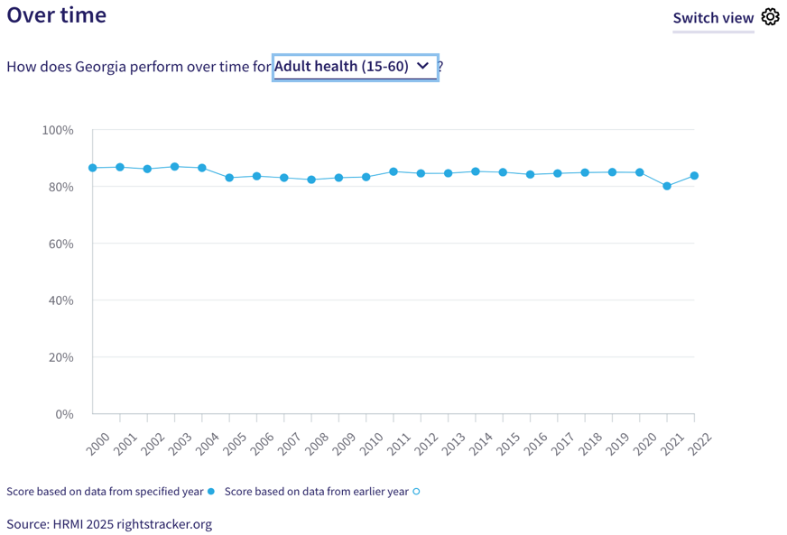
In fact, it has marginally declined from 86.5% in 2000 to the current score of 83.8% in 2022. This score also showed a sharp decline between 2020-2021 period, coinciding with the COVID-19 pandemic, reaching its lowest score of 80.1%. Georgia stands at a lower rank of 43rd out of 54 other countries in Europe and Central Asia in our dataset on this right.
19. For low- and middle-income countries such as Georgia, HRMI measures the right to reproductive health based on modern contraceptive use rate. In 2018, which is the most recent available data, Georgia reported a contraceptive use rate of 31.2%, which translates into its current ‘income adjusted’ HRMI score of 39.8%, which falls in the ‘very bad’ range. The indicator data used to construct this score has been patchy, and overtime graph for this right has vastly fluctuated over two decades. Among 23 countries in Europe and Central Asia in our dataset, Georgia ranks 17th on the right to reproductive health based on modern contraceptive use rate.
VII. Right to Housing
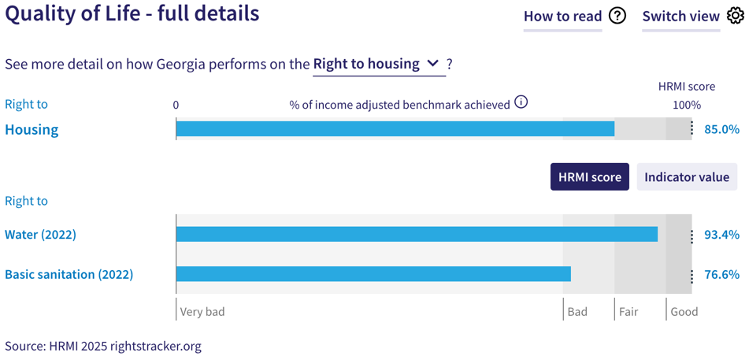
20. HRMI defines the right to housing in accordance with ICESCR Article 11.1 and CESCR General Comment 4. For low- and middle-income countries such as Georgia, HRMI measures this right using the indicators of access to water on premises and to at least basic sanitation. Georgia has an ‘income adjusted’ HRMI score of 85.0% on the right to housing based on these indicators, and it falls in the ‘bad’ performance range. Notably, this score has also shown a consistent decline between 2000 and 2022. Among 52 countries in Europe and Central Asia in our dataset, Georgia ranks 46th and is among the lowest scoring countries on this right in the region.
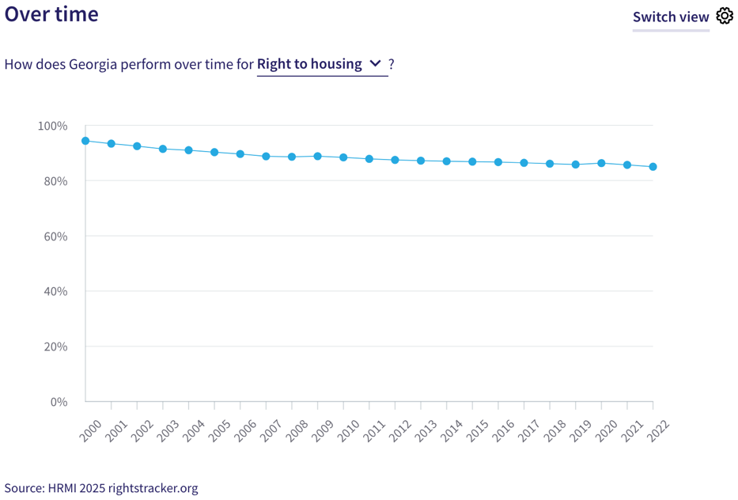
21. The WHO UNICEF Joint Monitoring Project (JMP) data show that 95.0% people in Georgia had access to water on premises as of 2022. This translates to an ‘income adjusted’ HRMI score of 93.4%, which falls in the ‘fair’ performance range. However, there has been no remarkable improvement in this score over the last decade; in fact, this score has gradually declined from 97.1% in 2000 to its current score of 93.4% in 2022.
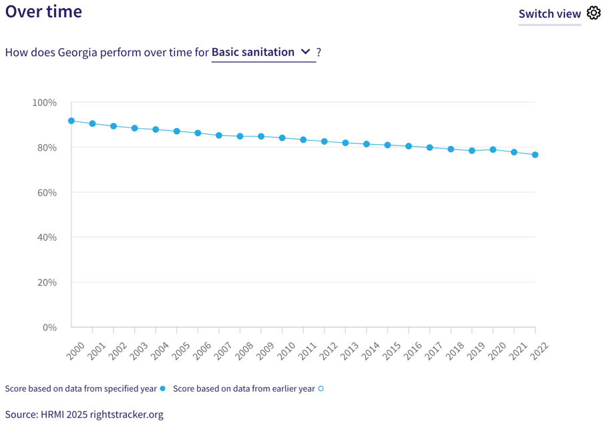
22. Georgia’s ‘income adjusted’ score for the right to basic sanitation is 76.6%, which means that Georgia is achieving only 76.6% of what is possible to achieve with its existing resources. According to the WHO UNICEF Joint Monitoring Project (JMP), only 86.3% people in Georgia have access to basic sanitation facilities that are not shared between households. Not only does this score lie in the ‘bad’ performance range, it has also shown a consistent downward trend, declining from 91.7% in 2000 to its lowest score of 76.6% in 2022. This indicates underperformance and underscores the need for immediate measures to prevent further decline. Georgia ranks 47th out of 53 countries in Europe and Central Asia in our dataset on this right.
VIII. Right to Work
23. HRMI measures the right to work in accordance with ICESCR Articles 6 and 7. For low- and middle-income countries such as Georgia, HRMI uses subsistence income indicator to measure this right. According to the World Bank PovcalNet, 85.0% of people in Georgia were classified as ‘not absolutely poor’ in 2022, which translated into an ‘income adjusted’ HRMI score of 79.8%. This score has fluctuated over the past two decades, but has shown a slow and gradual increase from 55.2% in 2000 to its current peak score of 79.8% in 2022. However, this score still falls in the ‘bad’ range, and shows that Georgia is underperforming to fulfil the right to work of its people.
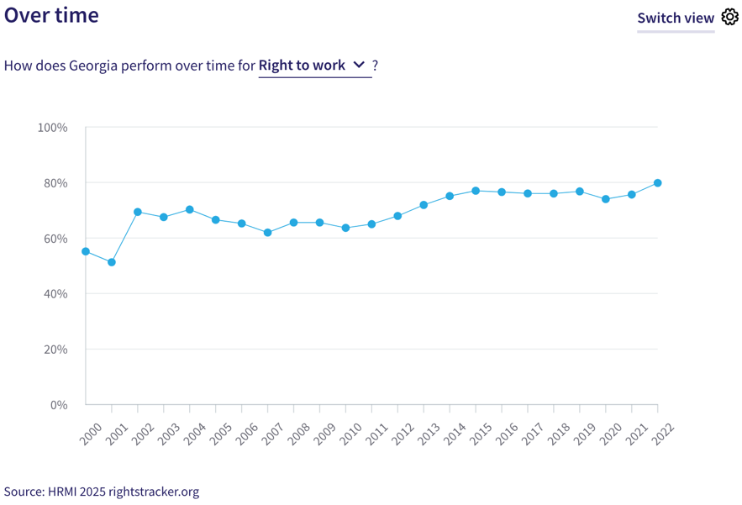
24. Notably, among 47 countries in Europe and Central Asia in our dataset, Georgia ranks last on the right to subsistence income, and is the weakest-performing country in the region on this right.
IX. Concluding Remarks
25. Georgia’s best ‘income adjusted’ scores are for the right to primary education, right to secondary education, the right to child health, and the right to food. The score for the right to food has shown steady progress over the last two decades. Georgia also ranks 1st among 49 other countries in Europe and Central Asia for the right to secondary education.
26. Georgia’s most concerning scores are for the right to general quality education, the right to reproductive health, the right to basic sanitation, and the right to subsistence income. Some scores such as the right to general quality of education, the right to reproductive health, the right to water, and the right to basic sanitation, have shown a concerning decline over time. While the graph for the right to subsistence income has shown inconsistent but slow progress, Georgia ranks last among 47 other countries in Europe and Central Asia on this right.
27. Our analysis is that Georgia is not constrained by resources from making considerable improvements in areas with low and declining scores. It has the income available to make progress, and can prioritise to put it to use to improve the economic and social rights of its people.
28. We recommend that the Committee assure the State Party concerned that it has the available resources to make significant improvements, especially in areas of quality of education as well as access to modern contraceptives, to basic sanitation, and to subsistence income.
29. We also recommend that the following questions be asked of the State Party:
- What measures will the State Party take to enhance quality of education at all levels?
- What steps will the State Party take to lift access to modern contraceptives?
- What actions will the State Party take to prevent further decline and expand access to basic sanitation and water on premises?
- What steps will the State Party take to lift access to at least subsistence income?
30. HRMI respectfully submits its data and findings on the fulfilment of economic and social rights in Georgia. We hope that this submission will serve as a useful resource to the Committee on Economic, Social and Cultural Rights in their review for drafting specific and pertinent questions to the State Party concerned during the CESCR’s 79th Pre-Sessional Working Group.

Visit HRMI’s website to learn more about our mission and work, https://humanrightsmeasurement.org/.
This content represents the opinions of the Human Rights Measurements Initiative. It carries no endorsement of the University of Georgia.
See HRMI’s methodology for measuring economic and social rights: https://humanrightsmeasurement.org/methodology and https://rightstracker.org/page/methodology.
Ibid.
HRMI 2025 Rights Tracker, https://rightstracker.org/.
See Human Rights Measurement Initiative (HRMI) Digital Public Good Certificate, https://app.digitalpublicgoods.net/a/11781. The Digital Public Goods Alliance, endorsed by the UN Secretary General’s “Roadmap for Digital Cooperation”, defines digital public goods as: “open source software, open data, open AI models, open standards and open content that adhere to privacy and other applicable laws and best practices, do no harm, and help attain the SDGs”, https://digitalpublicgoods.net/standard/.
HRMI 2025 Rights Tracker, https://rightstracker.org/country/GEO?tab=report-esr
The labels on the country charts of good, fair, bad, and very bad are used to give a general indication of how to understand the scores. HRMI’s income adjusted Quality of Life scores can be broadly interpreted as showing the percentage of the country’s obligation it has met, compared to what the best performing countries have achieved at each income level. A country scoring below 75% with a label of “very bad” is either underperforming to put in place the kinds of structures and policies that help people enjoy the right, or that the structures and policies in place most likely prevent many people from claiming their rights. See HRMI’s methodology for measuring human rights, https://rightstracker.org/page/methodology.
HRMI 2025 Rights Tracker, https://rightstracker.org/country/GEO?tab=report-esr
Ibid.
HRMI 2025 Rights Tracker, https://rightstracker.org/metric/education
HRMI 2025 Rights Tracker, https://rightstracker.org/country/GEO?tab=report-esr
Ibid.
Ibid.
HRMI 2025 Rights Tracker, https://rightstracker.org/metric/tot-sec-enrol?tab=report-esr&region=europe-central-asia
HRMI 2025 Rights Tracker, https://rightstracker.org/country/GEO?tab=report-esr
HRMI 2025 Rights Tracker, https://rightstracker.org/metric/not-stunted
HRMI 2025 Rights Tracker, https://rightstracker.org/country/GEO?tab=report-esr
Ibid.
HRMI 2025 Rights Tracker, https://rightstracker.org/metric/health
HRMI 2025 Rights Tracker, https://rightstracker.org/country/GEO?tab=report-esr
Ibid.
Ibid.
HRMI 2025 Rights Tracker, https://rightstracker.org/metric/adult-survival?tab=report-esr&region=europe-central-asia
HRMI 2025 Rights Tracker, https://rightstracker.org/country/GEO?tab=report-esr
HRMI 2025 Rights Tracker, https://rightstracker.org/metric/contraception?tab=report-esr&region=europe-central-asia
HRMI 2025 Rights Tracker, https://rightstracker.org/metric/housing
HRMI 2025 Rights Tracker, https://rightstracker.org/country/GEO?tab=report-esr
HRMI 2025 Rights Tracker, https://rightstracker.org/metric/housing?tab=report-esr&region=europe-central-asia
HRMI 2025 Rights Tracker, https://rightstracker.org/country/GEO?tab=report-esr
Ibid.
HRMI 2025 Rights Tracker, https://rightstracker.org/metric/basic-sanitation?tab=report-esr&region=europe-central-asia
HRMI 2025 Rights Tracker, https://rightstracker.org/country/GEO?tab=report-esr
HRMI 2025 Rights Tracker, https://rightstracker.org/metric/absolute-poverty?tab=report-esr&region=europe-central-asia

