Annexes on the Response of the Sultanate of Oman to the List of Questions and Issues Relating to the Fourth National Report

Annex No. (1)

Royal Oman Police Decision No. 98/2023 Determining the Competences of the National Center for Management of Emergency and Adopting Its Organisational Structure
Based on the Royal Oman Police Law promulgated by Royal Decree No. 35/90;
the Royal Decree No. 76/91 Promulgating the Civil Defence Law;
Royal Decree No. 75/2020 Regarding the Administrative Apparatus of the State ;
Royal Decree No.13/2021 Reorganizing the National Security Council;
the approval of the National Security Council,
and in pursuance of public interest,

The following has been issued:

Article 1
The National Center for Management of Emergency, established pursuant to Article No. (23 bis) of the aforementioned Civil Defense Law, operates as a public administration within the organizational structure of the Royal Oman Police. Its primary objective is to ensure preparedness in dealing with public disasters and extraordinary emergencies that may occur within the country.

Article 2
The terms of reference of the National Center for Management of Emergency shall be determined in accordance with Annex 1.

Article 3
Subject to the approval of the National Security Council, the organizational structure of the National Center for Management of Emergency will be formally approved as per the attached Annex 2. Furthermore, the specific responsibilities and functions of the administrative divisions within the said Center will be determined by a decision from the Inspector General of Police and Customs,

Article 4
The Inspector General of Police and Customs shall issue the necessary regulations and decisions to effectively implement the provisions hereof. In the absence of these regulations and decisions, the current laws and regulations shall remain in effect.

Article 5
All that is contrary to such decision, or in conflict with its provisions, is hereby repealed.

Article 6
Such decision shall be published in the Official Gazette, and comes into force on the day following the date of its publication.
Issued on: 9 of Shawwal 1444 AH
Corresponding to: 30-Apr-2023
Lieutenant General Hassan bin Mohsen Al-Shuraiqi
Inspector General of Police and Customs

Published in the Official Gazette No. 1492 issued on 7 May 2023.

Annex No. (1) Competences of the National Center for Management of Emergency
1- Ensuring the execution and implementation of policies, strategies, and plans outlined by the National Committee for Management of Emergency . This also includes coordinating with relevant entities to address public disasters and exceptional emergencies.
2 -Collaborating with both governmental and non-governmental entities involved in managing exceptional emergency cases when emergency indicators or exceptional emergencies arise, in addition to initiating the process of convening a meeting of the national committee responsible for handling such cases.
3- Facilitating coordination among various concerned authorities. This involves directing and mobilizing necessary resources and capabilities required to effectively manage public disasters and exceptional emergencies.
4- Maintaining the national risk register within the sectors of the national emergency management system, in compliance with the requirements set by the General Secretariat of the National Security Council, which oversees the national risk register.
5- Developing up-to-date plans for managing both general disasters and exceptional emergencies. These plans take into account potential risks and clearly define roles and responsibilities. They also establish coordination mechanisms with sectors and relevant entities, besides coordination with operations centers involved in emergency response.
6- Ensuring the readiness of the national system and promoting integration for joint response operations. This includes ensuring the readiness of operations centers within the system to handle general disasters and exceptional emergencies, in addition to maintaining effective communication and information management capabilities within these operations centers.
7- Monitoring and overseeing plans and programs aimed at enhancing capabilities, resources, and capacities necessary to effectively respond to exceptional emergencies, in coordination with relevant entities. 8- Ensuring the readiness and functionality of vital and productive facilities and installations during exceptional emergencies.
9- Implementing the national emergency management plan, besides following up and coordinating response and recovery efforts, in accordance with the directives of the head of the National Committee for Emergency Management.
10- Developing and implementing an annual plan to conduct specialized exercises, training programs, and skill acquisition activities focused on managing public disasters and exceptional emergencies. Such activities shall follow best practices and involve the participation of various sectors and relevant stakeholders. The plan is subject to approval of the National Committee for Emergency Management.
11- Conducting necessary studies and research, as well as enhancing cooperation and coordination with national, regional, and international organizations, entities, and centers working in the field of the management of public disasters and exceptional emergencies.
12- Proposing legislation, plans, and measures aimed at enhancing national readiness and reducing the risks associated with general disasters and exceptional emergencies, in coordination with the relevant entities.
13- Coordinating with the relevant authorities to propose specific guidelines governing the operations of voluntary institutions. This is in addition to encouraging individual voluntary work in areas related to the Center's competences. These proposed controls are then submitted to the National Committee for Emergency Management.
14- Undertaking any additional work or tasks assigned thereto by the National Committee for Emergency Management or its chairman.
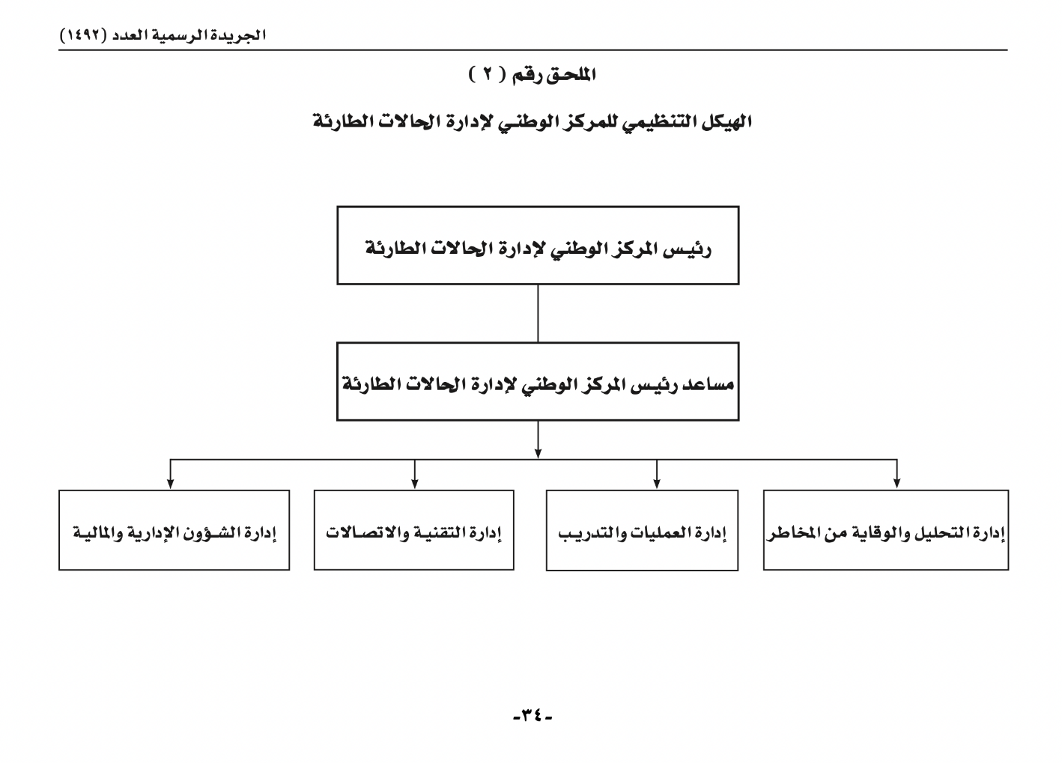

Annex No. (2)
Total Judicial Staff (Women) in the Public Prosecution
Number by Year |  |  |  |  | Job Title | S.N.
2023 | 2022 | 2021 | 2020 | 2019 | Job Title | S.N.
- | - | - | - | 8 | Assistant Attorney General | 1
- | - | - | - | 8 | The Public Prosecution Chief | 2
- | - | - | - | 9 | The Principle Public Prosecution Agent | 3
- | - | - | - | 8 | The Secondary Public Prosecution Agent | 4
3 | 9 | 8 | - | - | The Public Prosecution Assistant | 5
3 | 9 | 8 | - | 33 | Grand Total | 6
33 |  |  |  |  | Total

Source: Public prosecution

Annex No. (3)

Royal Decree No. 57/2022 Reorganising the Oman Human Rights Commission
We, Haitham bin Tarik, the Sultan of Oman
After perusal of the Basic Statute of the State,
Royal Decree No. 124/2008 Establishing the Oman Human Rights Committee and Determining Its Competences,
Royal Decree No. 20/2022 Extending the Membership of the Members of the Omani Human Rights Committee,
and in pursuance of public interest,

have decreed as follows

Article 1
A national commission for human rights is hereby established named the “Oman Human Rights Commission”. It shall have legal personality and its headquarters shall be in the Governorate of Muscat. The commission may establish branches thereof in other governorates.

Article 2
The provisions of the attached system shall apply in regard to the Oman Human Rights Commission.

Article 3
The membership of the Oman Human Rights Commission shall continue until it is recomposed in a manner compliant with the attached system.

Article 4
The aforementioned Royal Decree 124/2008 is hereby repealed, as well as all that is contrary to this decree and the attached system, or is in conflict with their provisions.

Article 5
This decree shall be published in the Official Gazette, and comes into force on the day following the date of its publication.
Issued on: 5 th of Dhu al-Hijjah 1443Hcorresponding to:
4 July 2022
Haitham bin TarikSultan of Oman

Published in Official Gazette 1449 issued on 13 July 2022.

System of the Oman Human Rights Committee (OHRC)

Article 1
The OHRC is composed of 14 members who possess expertise and demonstrate interest in human rights. It also includes representatives from various government entities that are involved in human rights matters.

Article 2
The appointment of OHRC members shall be carried out through the issuance of a Royal Decree.

Article 3
During the inaugural meeting of the OHRC, its members shall conduct an election to select a chairman and a vice-chairman, provided that these individuals are not affiliated with any government entity.

Article 4
The OHRC membership term is set at four (4) years, aligning with the term of the Council of Oman. Members have the option to be reappointed for one additional term.

Article 5
The OHRC Chairman serves as its representative in legal matters and interactions with external entities. In the event of the chairman's absence or vacancy, the deputy chairman shall assume the responsibilities and functions of the chairman.

Article 6
The OHRC operates with full independence in carrying out its activities related to human rights.

Article 7
The OHRC shall establish a technical secretariat, who shall also be headed by a secretary appointed by a Commission decision. The secretary may be chosen from among the Commission members or external individuals.

Article 8
The secretary of the OHRC technical secretariat shall be responsible for implementing the committee's decisions and overseeing its financial and administrative matters in accordance with internal regulations. The secretary shall also attend OHRC meetings without voting rights.

Article 9
The OHRC shall develop internal regulations that govern its operational procedures, as well as its financial and administrative affairs.

Article 10
The OHRC's primary objective is to promote and safeguard human rights within the Sultanate of Oman. It operates pursuant to the Basic Statute of the State, relevant international conventions and treaties ratified by Oman, as well as applicable domestic legislation.

Article 11
The OHRC has the following competencies:
1- Formulating a national human rights strategy and following up on its implementation in coordination with all competent human rights entities.
2- Supervising the protection of human rights and freedoms in the Sultanate of Oman in accordance with the Basic Statute of the country, as well as the international charters and conventions ratified by the Sultanate of Oman and the applicable laws.
3- Monitoring any concerns or observations raised by foreign governments, international organizations, and non-governmental organizations regarding human rights in Oman. The committee collaborates with relevant entities to investigate and respond to the same.
4- Advising the concerned entities in Oman on matters relating to human rights and freedoms, and contributing to the preparation of reports dealing with these topics.
5- Monitoring any instances of human rights violations or abuses occurring in the Sultanate of Oman and actively contributing to their resolution.
6- Conducting on-site visits to prisons, detention centers, hospitals, and workers' accommodations to assess and monitor the human rights conditions therein.
7- Receiving and reviewing complaints related to human rights issues, making recommendations to the appropriate authorities, and following up on the implementation of the recommended actions.
8- Cooperating with relevant international human rights mechanisms, preparing reports, and participating in regional or international human rights meetings.
9- Organizing conferences, courses, and symposia related to human rights in coordination with the competent authorities.
10- Representing the Sultanate of Oman in regional and international conferences, events and meetings relating to human rights.

Article 12
The OHRC financial resources are derived from the allocations designated in the general state budget, as well as any other approved resources determined by the Cabinet.

Article 13
The OHRC shall convene at the request of its Chairman a minimum of four times per year, or whenever necessary. The meeting shall be deemed valid if at least two-thirds of the committee members are present, including the Chairman or his/her deputy. Decisions shall be made by a majority vote of the attending members, representing civil society. In the event of a tie, the Chairman of the meeting shall have the deciding vote. Government entity representatives participate in the proceedings of the OHRC and attend its meetings without the right to vote.

Article 14
The OHRC may seek the assistance of individuals deemed necessary to support its functions, who may attend its meetings without the right to vote.

Article 15
The governmental administrative units and other juristic persons shall assist the OHRC in carrying out its tasks, facilitating the exercise of its responsibilities, and providing the requested data or information within its jurisdiction, as long as it is in compliance with the applicable laws and regulations.

Article 16
The OHRC shall prepare an annual report on its activities and efforts, including any recommendations it deems appropriate within its competences. The report shall be submitted to the Sultan.

Annex No (4)

Royal Decree 75/2020 Regarding the Administrative Apparatus of the State
We, Haitham bin Tarik, the Sultan of Oman
After perusal of the Basic Statute of the State,
Royal Decree No. 26/75 Promulgating the Law Governing the Administrative Apparatus of the State,
Royal Decree No. 116/91 Promulgating the System of Public Authorities and Institutions,
and in pursuance of public interest,
.
have decreed as follows
Article 1
The attached system shall apply in regard to the Administrative Apparatus of the State.
Article 2
The aforementioned Royal Decrees 26/75 and116/91 are hereby repealed, as well as all that is contrary to the attached system or in conflict with its provisions.
Article 3
This decree shall be published in the Official Gazette, and comes into force on the date of its issuance.
Issued on: 22 Dhu al-Hijjah 1441AHCorresponding to:
12 August 2020
Haitham bin TarikSultan of Oman

Published in Official Gazette No.1353 issued on 19 August 2020.

System of the Administrative Apparatus of the State

Chapter One General Provisions
Article 1
The administrative apparatus of the state means: ministries, military and security apparatuses, councils, and other executive units that derive their authority from the state, whatever their name. This definition includes juristic persons responsible for managing a public utility or asset, such as public authorities and public establishments.
Article 2
The administrative apparatus of the state consists of central units such as ministries, apparatuses, councils, and their equivalent, besides decentralised units such as authorities, public establishments, and their equivalent.
Article 3
Units within the administrative apparatus are established, governed, and abolished through the issuance of royal decrees.
Article 4
Units within the state's administrative apparatus may issue regulations, decisions, or instructions within the scope of their prescribed competences as defined by the royal decrees pertaining thereto.
Article 5
Civil units within the state's administrative apparatus shall submit a report to the Council of Ministers within three months following the end of each calendar year. This report shall include details of their activities, achievements, challenges encountered in meeting their objectives, as well as the proposed solutions to overcome these challenges.
Additionally, before the end of October annually, such units shall provide the Cabinet with their work plan for the upcoming year, outlining their objectives.
Article 6
Units of the administrative apparatus of the states are exempt from all taxes.

Chapter Two
Ministries, Apparatuses, and Councils

Article 7
Ministries, apparatuses, and councils have an organizational structure comprising sectors, and each sector includes general directorates, departments, and divisions. General directorates consist of a number of directorates and the directorates consist of a number of departments.
The organisational structure of ministries, apparatuses, and councils may include administrative divisions with other names equivalent to the names mentioned in the first paragraph hereof.
Article 8
Sectors or general directorates shall be established or modified under a decision from the head of the Unit, following the approval of the Cabinet and competent entities. Similarly, the establishment or modification of departments or sections requires a decision from the head of the Unit, following the approval of the competent entities.
Chapter Three
Public Authorities and Institutions
Article 9
Public authorities are established with the purpose of managing public utilities that are intended for the benefit and service of the public, without aiming to generate profit. On the other hand, public institutions are established to manage economic assets and actively contribute to the development of the national economy, while operating in a commercial manner. Both public authorities and institutions possess juristic personality, as well as financial and administrative independence.
Article 10
The affiliation of public authority or institution is determined in the royal decree issued to establish them.
Article 11
Each public authority or institution shall establish a board of directors, which is formed by a decision of the Cabinet. The board members serve a term of 3 (three) years, and they may be reappointed for an additional period.
Article 12
The board of directors of a public authority or institution shall convene a minimum of 2 (two) meetings per year. The chairman of the board, or his/her representative, is responsible for sending out the invitations to these meetings. For a meeting to be considered valid, the presence of the chairman, or his/her representative, and a majority of board members is required. The decisions of the board are made by a majority vote of the attending members.
The board may seek assistance from external individuals as it deems necessary. These individuals may attend board meetings and participate in discussions, but they do not have voting rights.

Article 13
The board of directors of the public authority or institution is responsible for formulating its general policy to ensure the achievement of its goals. This includes the following specific responsibilities:
1- Approving the organisational structure of the public authority or institution, after obtaining the approval of the Cabinet and the competent entities.
2 - Approving the regulations necessary for the operation of the public authority or institution within its area of work.
3- Approving the annual financial budget and final account of the public authority or institution.
4- Approving the financial and administrative audit reports on the functioning of the public authority or institution in accordance with the approved financial rules.
5 - Approving agreements and contracts concluded by the public authority or institution with third parties.
6 - Approving periodic and annual reports submitted to the Cabinet on the activity of the public authority or institution.
7 - Exercising any other competences specified by the regulations governing the public authority or institution.
Article 14
The president or executive president of the public authority or institution is appointed by royal decree, unless the decree establishing the same stipulates otherwise.
Article 15
The president or executive president of the public authority or institution is responsible for managing its administrative and financial affairs. They represent the authority or institution in its dealings with others and in legal matters. The president or executive president possesses the authorities granted to the head of the Unit as specified in laws and royal decrees. They attend all meetings of the board of directors but do not have a voting right.
Article 16
Unless specified otherwise in the establishing decree, the position of the president or executive president of the public authority or institution shall not be combined with the position of the chairman of the board of directors.
Article 17
The public authority or institution operates with an independent budget, and its fiscal year spans from January 1st to December 31st of each year. However, if deemed necessary, the decree establishing the public authority or institution may specify an alternative date for the commencement of the fiscal year.
Article 18

The financial resources of the public authority or institution comprises the following:
1- Appropriations allocated thereto in the general budget of the state.
2- Consideration of the services it provides to others.
3 - Gifts, bequests, and donations accepted by its board of directors, after approval by the Cabinet.
4- Revenues of the investment of its funds.
5- Any other resources stipulated in the decree of its establishment.

Annex No. (5)
Number of Voters Registered in the Electoral Register for the Elections of Municipal Council Members for the Third Period 2022
Electoral periods | Males | Females | Total
3rd period 2022 | 383802 | 347965 | 731767

Annex No. (6)
Number of Voters Participating in the Municipal Council Elections for the Third Term of 2022
Electoral periods | Males | Females | Total
3rd period 2022 | 164108 | 124360 | 288468

Annex No. (7)
Various programs and initiatives have been established to support different groups including women, families in the social security category, low-income individuals, entrepreneurs, and job seekers.
These initiatives include the following:
- * Providing technical and financial support for home production projects through collaboration between the Ministry of Social Development and the Zubair Foundation.
- * Implementing workshops and training programs to develop women's skills in the economic fields and the development of financial culture, in cooperation between the Ministry of Social Development and Otaxi
- * Implementing WEB initiative aimed at developing entrepreneurship skills and supporting economic projects, in cooperation between the Ministry of Social Development,the Modern College of Business and Science (MCBS) and one of the private sector companies
- * Photography training and support for related projects.
- * Development of cooking and hospitality projects in partnership with Noon Omanarts, including the establishment of a production line.
- * Training program and employment opportunity in cooperation between the Ministry of Social Development and "Sohar Textiles" Company.
- * “Empowering and Upgrading” Exhibition (tamkeen w ertikaa) for Productive Families .
- * Oman Air initiative in cooperation between the Ministry of Social Development and “Transom” Company.
- * “Hafez” initiative, in cooperation between the Ministry of Social Development and the Authority for SME Development

