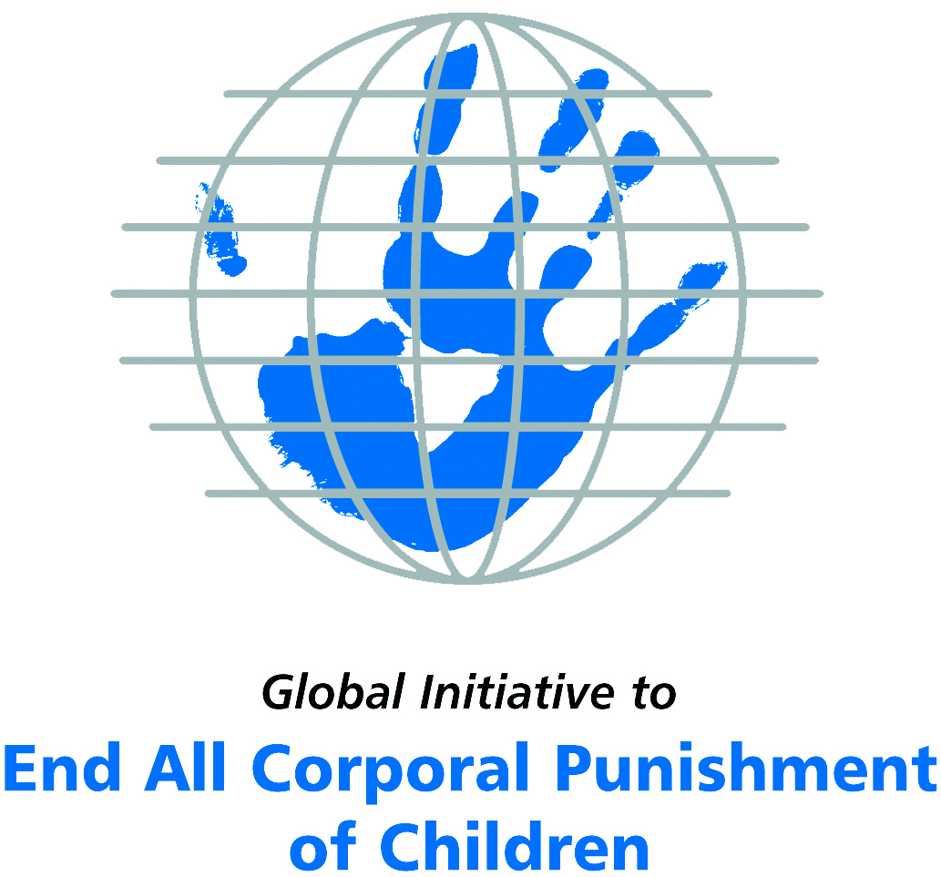
Briefing on Montenegro for the Committee on the Rights of Persons with Disabilities, 7th Pre-Sessional Working Group, March 2017
From the Global Initiative to End All Corporal Punishment
of Children, February 2017

(a) About the Global Initiative to End All Corporal Punishment of Children
1. The Global Initiative (www.endcorporalpunishment.org) promotes universal prohibition and elimination of corporal punishment in fulfilment of states’ obligations under the UN Convention on the Rights of the Child and other international treaties. Our aims are supported by UNICEF, UNESCO, human rights institutions and international and national NGOs. Since 2002, the Global Initiative has regularly briefed the Committee on the Rights of the Child on this issue, and since 2004 has similarly briefed the Committee Against Torture, the Committee on the Elimination of Discrimination Against Women, the Committee on Economic, Social and Cultural Rights, the Human Rights Committee and the Human Rights Council; we have briefed the Committee on the Rights of Persons with Disabilities since the beginning of its work.

(b) Summary
2. Corporal punishment of children in Montenegro might have been prohibited in all settings under the 2016 amendments to the Family Law.
3. With reference to articles 7, 15, 16 and 17 of the Convention on the Rights of Persons with Disabilities, and in light of the particular vulnerability of children with disabilities to corporal punishment by adults, the jurisprudence of the UN treaty bodies, the emphasis on eradicating this form of violence given by the UN Secretary General’s Study on Violence against Children and the importance of the issue to achieving target 16.2 on ending violence against children in the 2030 Sustainable Development Goals, we hope the Committee on the Rights of Persons with Disabilities will:
- include the issue of corporal punishment in its List of Issues for Montenegro, in particular asking: “does the prohibition of corporal punishment included in the 2016 amendments to the Family Law refer to all corporal punishment of children, however light, and does it apply in all aspects of their lives, including when used as a disciplinary measure in penal institutions”;
- recommend to the Government of Montenegro, in the Committee’s concluding observations on the initial report, “that measures are put in place to ensure the law is properly implemented and that campaigns are conducted to educate the public and train professionals on positive, participatory and non-violent forms of education and childrearing”.

(c) Detailed briefing
The right of children with disabilities not to be subjected to corporal punishment
4. The Convention on the Rights of Persons with Disabilities confirms that children with disabilities should enjoy all human rights and fundamental freedoms on an equal basis with other children (art. 7). The Convention also states that all persons have the rights to freedom from torture or cruel, inhuman or degrading treatment or punishment (art. 15), to freedom from exploitation, violence and abuse within and outside the home (art. 16) and to respect for their physical and mental integrity (art. 17). The jurisprudence of treaty monitoring bodies, led by the Committee on the Rights of the Child monitoring the Convention on the Rights of the Child, is clear that these rights put an obligation on states parties to prohibit and eliminate all corporal punishment of children, including within the family. However, the issue is not addressed in Montenegro’s initial state party report.
5. As confirmed in the UN Secretary General’s Study on Violence against Children, children with disabilities are particularly vulnerable to violence, including corporal punishment, and corporal punishment is a significant cause of impairment among children. Yet the obligation to prohibit corporal punishment is frequently ignored or evaded by governments. The near universal acceptance of violence in childrearing together with deeply held views that parents and other adults have a “right” to physically punish children can challenge efforts to achieve prohibition. It also means that corporal punishment – at least to some degree – is not readily perceived as violence in the same way as, for example, sexual and other socially unacceptable forms of violence.
6. The newly adopted Sustainable Development Goals under the 2030 Agenda include target 16.2 on ending all forms of violence against children. Violent punishment is the most common form of violence against children: ending it through the adoption and implementation of legislation prohibiting it in all settings including the home is critical.

The legality of corporal punishment of children with disabilities in Montenegro
7. It appears that corporal punishment of children in Montenegro might have been prohibited by 2016 amendments to the Family Law – the scope of the reform still needs to be confirmed.
8. Corporal punishment is possibly unlawful in the home. There is no legal defence for its use enshrined in law. The Law on Prevention of Family Violence 2010 protects family members, including children, from physical force inflicted by other family members, whether or not it results in bodily injury. There is no indication that this applies to the use of force in “disciplining” children. Amendments to the Family Law enacted in July 2016 have modified the Family Law to state in article 9a: “Child shall not be subjected to corporal punishment or any other cruel, inhuman or degrading treatment.” Paragraph 2 of the article states that the prohibition applies “to parents, guardians and all other persons taking care of or coming into contact with the child”. We are seeking confirmation that this prohibition includes all corporal punishment, however light, as defined by the Committee on the Rights of the Child’s General Comment no. 8, and whether it applies in all settings.
9. Corporal punishment is possibly unlawful in alternative care settings. Corporal punishment might be prohibited in alternative care settings under the 2016 amendments to the Family Law.
10. Corporal punishment is possibly unlawful in day care settings. Corporal punishment is prohibited in the provision of preschool education under article 111 of the General Law on Education. It might be prohibited in all other day care settings under the 2016 amendments to the Family Law.
11. Corporal punishment is unlawful in schools. Corporal punishment is prohibited in schools in article 111 of the General Law on Education – “the employment of a teacher who … (9) humiliates, insults, or punishes students physically … shall be ceased”. The Law on Primary Education (art. 66) and the Law on High School (art. 49) do not include corporal punishment among permitted disciplinary measures.
12. Corporal punishment is unlawful as a disciplinary measure in penal institutions. Corporal punishment is considered unlawful as a disciplinary measure in penal institution. It might be prohibited under the 2016 amendments to the Family Law – it is unclear whether this prohibition applies to all corporal punishment and in all settings.
13. Corporal punishment is unlawful as a sentence for crime. Corporal punishment is unlawful as a sentence for crime under the Criminal Code and the Law on Juvenile Perpetrators of Criminal Acts and on Criminal Legal Protection of Minors, which make no provision for judicial corporal punishment. Under the Law on Execution of Criminal Sanctions any actions which involve subjecting a convicted person to ill-treatment or against human dignity are prohibited.

Recommendations by human rights treaty monitoring bodies and during the UPR
15. The Committee Against Torture has twice recommended to Montenegro that corporal punishment of children be explicitly prohibited in all settings – in its concluding observations on the initial state party report in 2009 and on the second report in 2014.
16. The Committee on the Rights of the Child examined the initial state party report of Montenegro in 2010 and recommended prohibition of corporal punishment of children in all settings.
17. In 2014, the Human Rights Committee recommended to Montenegro that steps be taken – including legislative measures – to end corporal punishment of children in all settings.
18. At the second cycle Universal Periodic Review of Montenegro in 2013, the Government accepted recommendations to explicitly prohibit corporal punishment of children in all settings, stating: “Montenegro will embark on legal amendments to explicitly prohibit corporal punishment of children in all settings; a media campaign will be launched on the consequences of corporal punishment of children.”

Briefing prepared by the Global Initiative to End All Corporal Punishment of Children
www.endcorporalpunishment.org; info@endcorporalpunishment.org

Pinheiro, P. S. (2006), World Report on Violence against Children, Geneva: United Nations. See also Krug E. G. et al (eds) (2002), World Report on Violence and Health, Geneva: World Health Organisation
19 January 2009, CAT/C/MNE/CO/1, Concluding observations on initial report, para. 22
17 June 2014, CAT/C/MNE/CO/2, Concluding observations on second report, para. 21
21 October 2010, CRC/C/MNE/CO/1, Concluding observations on initial report, paras. 36 and 37
21 November 2014, CCPR/C/MNE/CO/1, Concluding observations on initial report, para. 13
18 April 2013, A/HRC/23/12/Add.1, Report of the working group: Addendum, para. 21

