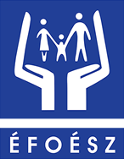
Submission by Self-Advocate members
of The Hungarian Association for Persons
with Intellectual Disability (ÉFOÉSZ)

29th session of the Committee
on the Rights of Persons with Disabilities (CRPD)

Follow-up on HUNGARY
in relation to the Committee’s inquiry’s report (CRPD/C/HUN/IR/1)

25th July 2023

Authors of this submission

This submission was written by Self-Advocate members

of The Hungarian Association
for Persons with Intellectual Disability (ÉFOÉSZ).
Among them are people who live in institutions.
Self-advocates living in different parts of Hungary
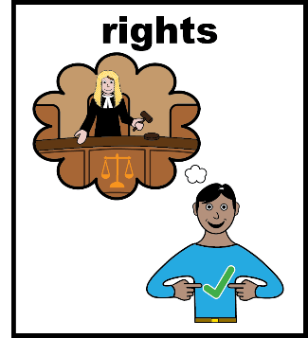
shared their experiences and made recommendations.

We want the rights of people with disabilities
to be respected.
We want to live independent and happy lives,
just like everyone else.
Key findings and recommendations

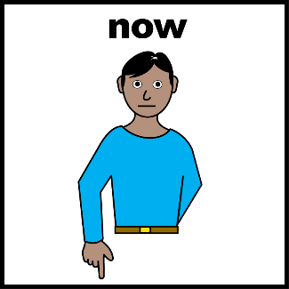
First, we want to state,
that we need change now.
We keep writing and saying the same things
over and over again,
yet nothing happens.

Many of us

- live in segregated institutions
- are unable to make decisions and vote
- cannot find support services
suitable for our needs
- cannot find work
- live in poverty.

We want this to change in our lifetime.
We want to live better now! We have no more time!

Equal recognition before the law (article 12)

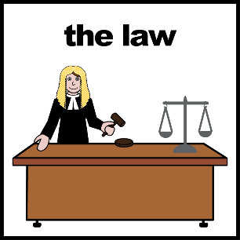
Equal recognition before the law means,

that people with disabilities have the same rights,

as everyone else.

According to the CRPD Committee

this is not the case in Hungary.

We agree with the Committee.

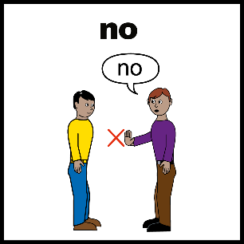
Some of us used to be under guardianship

and some of us still are.
Many of us need support,
for example, with our finances.
But guardianship is not good support,
because it takes away our independence.

If the guardian is not a family member, they often
- do not keep in touch with the person under guardianship.
- or do not spend the money of the person under guardianship
on what they really need.

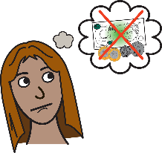
We have to ask the guardian for our own money,
if we want to buy something.
We often have to wait months for our own money.
For example, to buy clothes.

People under guardianship cannot sign contracts
or conduct official business alone.
It feels like we are different or less than other people.

Some of us used to be under guardianship,
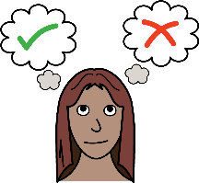
but now they are using supported decision-making.
They say, they feel free now.
They no longer have to beg for their own money.
They can do things on their own,
they would not think being capable of doing before.


Most people under guardianship
are neither allowed to vote nor to stand for elections.
People under guardianship
have to answer difficult questions.
If they cannot answer, they lose their right to vote.
If we cannot vote, we can't have a say in our community
and in our country.
It feels, like we are not citizens of our country.

Hungary must end guardianship.
and strengthen supported decision-making.

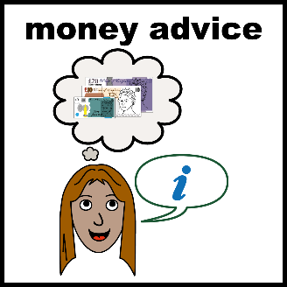
Everyone needs support from time to time.
For example, in financial decisions.
We need good support to make decisions,
not guardianship.

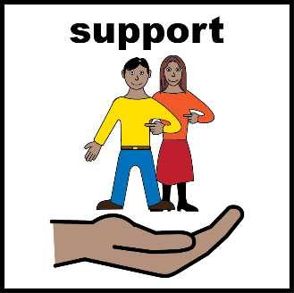
It matters a lot, who supports us and how.
Support persons should always ask first,
if they can help with something.
We want to decide, who supports us and how.

A good supporter lets us make mistakes
and learn from our mistakes.
Everyone makes mistakes,
not just people with intellectual disabilities.

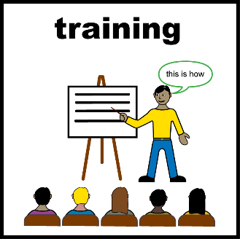
We need to do trainings on supported decision-making.
We organized training courses
- for guardians
- for judges
- and for support persons.

Everyone should have a training
on supported decision-making,
who work with people with disabilities.
We always need to include experts by experience
when talking about guardianship
and supported decision-making.


All persons with disabilities
should have the right to vote
We are citizens too.
It is important that we can vote
and stand for election.

Living independently and being included in the community (article 19)

In recent years, there have been changes in Hungary:
- The deinstitualisation has started.
- New supported housing services have been built.
But the government needs to do more than this.
There are still very many
people with disabilities living in institutions.

Some of us Self-Advocates also live in institutions.
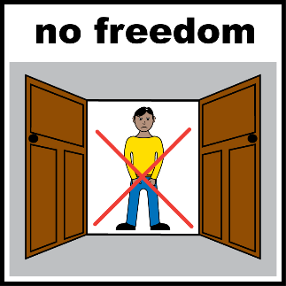
One of us used to live in the community all his life,
then ended up in an institution,
because he did not get right support.
For him the institution feels like prison.
Institutions have strict rules.
We cannot live independently and make decisions.
We do not get support suitable to our individual needs.

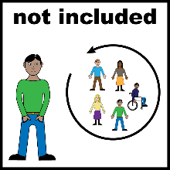
Most institutions are located
on the outskirts of small towns or villages.
People with disabilities are segregated
from the local community.
Public transport is not good in small towns.
It is difficult to travel to the cities nearby.
This makes it difficult to find work too.

New supported housing services
function almost in the same way,
as institutions.
The new houses are built in small towns,
where public transport is also poor.
Supported housing also has strict rules.
Residents are still not allowed to live independently and make decisions.

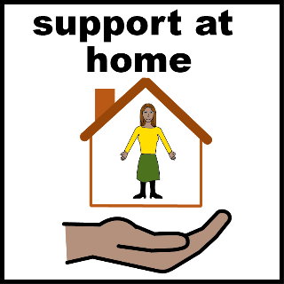
We should prevent people with disabilities,
from getting into institutions.
People with disabilities and families
need support services at their homes.
These services should be accessible to everyone.

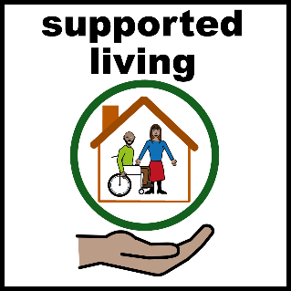
We need more supported housing services.
We need to make sure,
that supported housing really enables
independent living.

New services should to be located
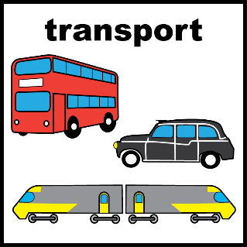
close to the centre of towns,

- where public transport is good.

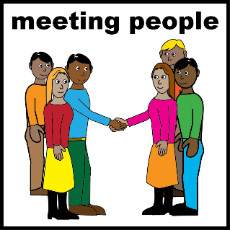

- where people with disabilities
can have real relations with the local community.
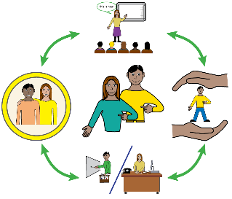
- where they can access services.

We also want to live in supported housing
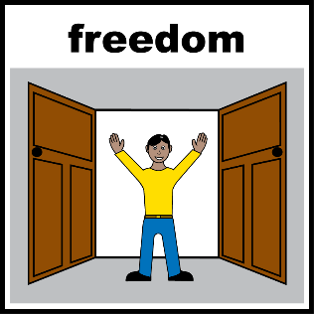
instead of institutions.
We believe that in supported housing
- we can have more freedom
- we can go out when we want to
- we can have more peace of mind,
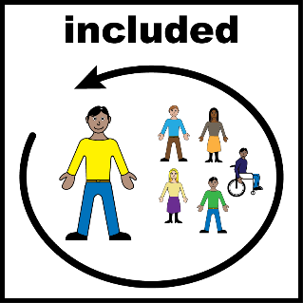
because there's not so many of us.

We need to raise awareness in local communities,
so, they know more about people with disabilities
and are able to include them.
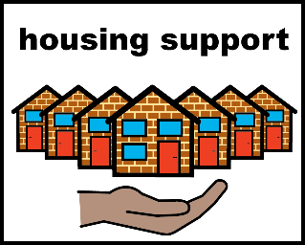
The government must spend money
on supporting independent living,
not on institutions.

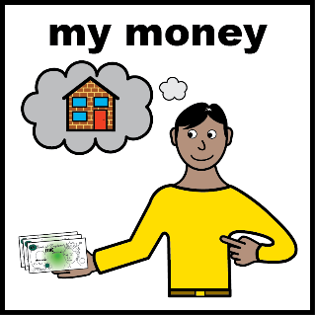
We need personal budgets, so we can decide,
which services we want to use.
That way, service providers have to provide
good quality services,
otherwise, people will not use them.

Equality and non-discrimination (article 5)

The CRPD Committee described in their report,
that in Hungary, many people with disabilities
face discrimination.
This is also our experience.

it is difficult to find a job as a person with a disability.
Many employers do not want to hire
people with disabilities.
They think we can't do the job
without even knowing us and our skills.

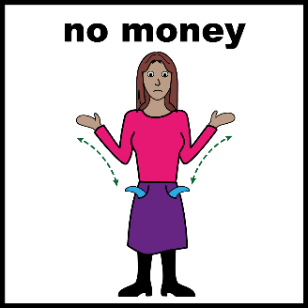
Even if we find a job,
we earn very little,
or have to travel a lot to get to our workplaces.
There are jobs,
where they only hire people with disabilities
to get the benefits from the state.
In this case, people with disabilities have no real work to do,
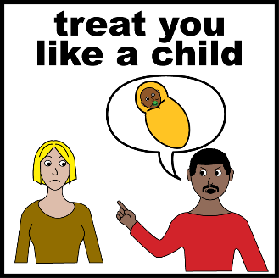
they have to sit around for hours.

Many of us have had that experience,
when we were treated like children.
For example, at work or in offices of authorities.

Some of us work in the open labour market.
We have better experiences on the open labour market,
but it is very difficult to get into.
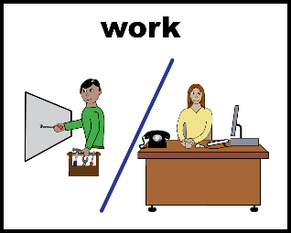
We need
- more jobs

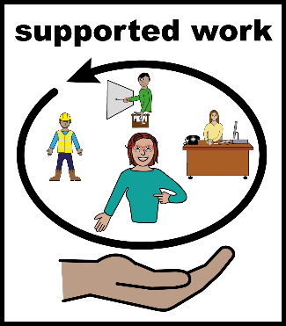

- better support at work

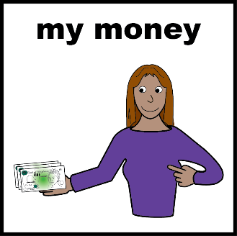

- and more salary.

We need to raise the awareness of employers
and employees without disabilities
- to treat us well
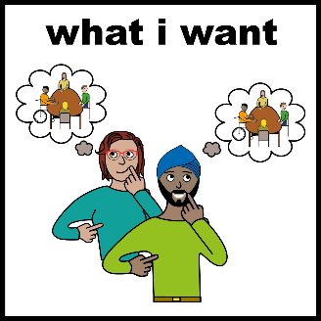
- and to support us the right way.

We want to do meaningful work,
in the open labour market.

We need good quality education to find a job.
Books and documents should be easy-to-understand
in schools and in vocational trainings.

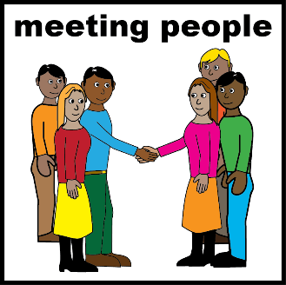
The government must make sure
that people without disabilities
know more about people with disabilities.

We need to raise the awareness of
- employers
- workers in the public sector
- healthcare workers
- workers in the social sector

Instead of treating us like children,
they should get to know us
and support us so, we can grow.
Other recommendations

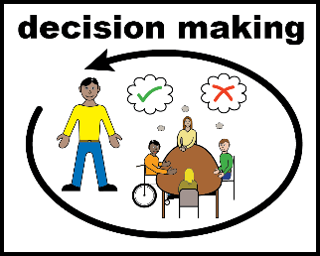
We know what is good for us.
So, people with disabilities must be involved
in decisions that affect them.
For example through disabled people's organisations.

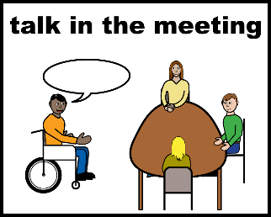
The government must meaningfully involve
people with disabilities
trough the National Disability Council.
The Council should meet more frequently.
We need to make sure,
that decision-makers take into account what we say.

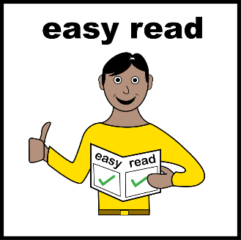
Easy-to-read information must be available.
We need accessible information
- to understand the world around us
- to make decisions
- and to live independently.

The Hungarian Association
for Persons with Intellectual Disability

ÉFOÉSZ is short for The Hungarian Association
for Persons with Intellectual Disability.
ÉFOÉSZ is an organisation fighting for the rights
of persons with intellectual disabilities
and their families’.

ÉFOÉSZ has 25 local branches
and 22 000 individual members
all around Hungary.

Self-Advocates in ÉFOÉSZ

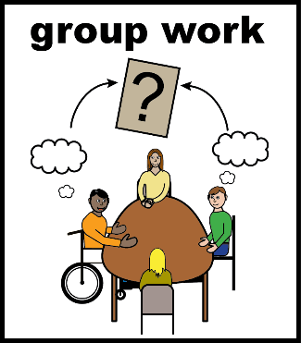
ÉFOÉSZ supports self-advocacy groups
all around Hungary.
Members of self-advocacy groups
can learn their rights,
and share their experiences.
We support each other
and speak up for our rights together.

The Co-president of ÉFOÉSZ is also a Self-Advocate.
The Co-president is a member
of the National Board of the Association.
The Co-Chair represents the interests of the Self-Advocates
in the Board.
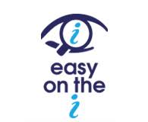

All Images/Resources copyright © LYPFT

Written by Self-Advocate members of the Hungarian Association for Persons with Intellectual Disability (ÉFOÉSZ):
Dávid Aranyos, Antal Balogh, Renáta Barna, László Bercse, Katalin Beringer, Zsolt Bob, Zsolt Bujdosó, Zsolt Cziráki, Miklós Farkas, Erzsébet Gajdán, Lilla Harmath, Erika Hornyák, Mihály Lakatos, Tamás Kiss, László Kolompár, Csilla Lesku, Éva Molnár, Ferenc Németh, Sándor Pataricza, Ilona Sallai, Pál Tóbiás, Veronika Vida

