
THEMATIC REPORT ON ARTICLE 16, MUSLIM FAMILY LAW AND MUSLIM WOMEN’S RIGHTS IN
Afghanistan

75th CEDAW Session
Geneva, Switzerland
February 2020

Musawah
15 Jalan Limau Purut, 59000 Kuala Lumpur, Malaysia
Tel: +603 2083 0202Fax: +603 2202 0303
Email: musawah@musawah.org
Website: www.musawah.org

A. INTRODUCTION

Musawah, the global movement for equality and justice in the Muslim family, submits this Thematic Report on Article 16 and related concerns for consideration by the CEDAW Committee in its review of the Government of Afghanistan, reporting before the 75th CEDAW Session in February 2020.
In particular, this report examines Afghan laws and practices that enforce de jure and de facto discrimination against women in the following areas: discriminatory legal framework, child marriage, divorce rights, polygamy, inheritance and matrimonial assets and guardianship of children.

We hope that the CEDAW Committee will utilize this report as a key resource during its Constructive engagement with the State party, and in follow-up activities on the Concluding Observations. Musawah would like to acknowledge the vital input and feedback from Afghan women’s rights activists and issue experts into this report.

B. MUSLIM FAMILY LAWS IN AFGHANISTAN

Article 54 of the Constitution of Afghanistan states that the family is the fundamental pillar of the society, and shall be protected by the state. It commits the State to adopt necessary measures to attain the physical and spiritual health of the family, especially of the child and mother, upbringing of children, as well as the elimination of related traditions contrary to the principles of the sacred religion of Islam.

Matters regarding marriage and family relations of the predominantly Muslim population in Afghanistan are mainly governed by the following codified laws:

- For the Sunni majority: The Civil Code is the main codified law that governs matters relating to marriage and family relations. Based on Article 1(2) of the Civil Code, in the absence of codified laws that sufficiently address a particular matter of personal status of Sunnis, generally, the rules of Hanafi jurisprudence (fiqh) apply; and

- For the Shia minority: The Shiite Personal Status Law (SPSL) is the main codified law that governs matters relating to marriage and family relations. Based on Article 2(3) of the SPSL, in the absence of codified laws that sufficiently address a particular matter of personal status of Shias, generally, the rules of Jafari fiqh apply.

C. KEY ISSUES AND LIVED REALITIES

1. DISCRIMINATORY LEGAL FRAMEWORK

Despite the equality guarantee under Article 22 of the Constitution, the Civil Code and the SPSL provide for a marital framework based on ‘reciprocal’ or ‘complementary’ rights (as opposed to ‘equal’ rights) between the two spouses, whereby in return for maintenance and protection from her husband, a wife is expected to obey him. Provisions in the family laws therefore discriminate against women as it is based on male authority and male guardianship.

Delayed reform process:
According to the State Party report, in 2016 the Ministry of Women’s Affairs (MoWA) together with relevant ministries and organisations undertook efforts to review and draft a Family Law to replace the Civil Code. According to women’s rights groups who provided inputs into the draft, there is little information pertaining to the timeline and process of finalizing and enactment of the new/revised Family Law. The amendments and new provisions proposed have also been watered down and do not address all the most urgent areas of discrimination under the Muslim family laws in Afghanistan. The draft currently remains under review with the Ministry of Justice.

RECOMMENDATIONS

We recommend the CEDAW committee to urge the State party to:
- Ensure that the draft Family Law is based on equality between spouses and the provisions within it addresses the areas of discrimination faced by women and girls.
- Ensure timely enactment of the Family Law, following consultations with women’s rights groups to address any gaps in the current draft.

2. CHILD MARRIAGE

According to UNICEF’s State of the World’s Children 2016 report, 33% of women aged 20- 24 in Afghanistan were first married by 18 and according to the Afghan government, women who marry below 15 make up 3% of married women.

For both Sunnis and Shias, the minimum legal age for marriage is 16 for females and 18 for males as per Article 70 of the Civil Code and Article 99(1) of the SPSL, respectively. However, marriages below the minimum legal age for marriage are permissible for both sects:

- For Sunnis: Article 71(1) of the Civil Code provides that either a competent father or competent court may permit girls below 16 to marry. Article 71(2) of the Civil Code absolutely prohibits the marriage of girls below 15.

- For Shias: Articles 99(2) and 99(3) of the SPSL provide that a guardian appearing before the court may permit girls and boys below 16 and 18, respectively, to marry if the marriage is considered necessary and in their best interest. The SPSL does not stipulate an absolute minimum age below which a marriage may not be authorised.

According to women’s advocates, registration of marriages continues to be voluntary and as a result child and forced marriages are more likely to be unregistered. The lack of registration of marriages imposes difficulties on women with regard to their right to seek divorce in addition to their right to a dower (mahr), maintenance and child custody.

RECOMMENDATIONS

We recommend the CEDAW committee to urge the State party to:
- Establish a standard minimum age of 18 years for all citizens of Afghanistan regardless of sex, sect, religion, tribe, geographic region and remove all legal loopholes that allow for exceptions.
- Ensure mandatory registration of all marriages and facilitate a standard process for registering of marriages.
- Improve awareness raising campaigns among tribal and rural communities about forced marriages and related penalties.

2. POLYGAMY

According to Article 86 of the Civil Code and Article 91 of the SPSL, both Sunni and Shia men may marry up to four wives at one time. According to Afghanistan’s 2015 Demographic and Health Survey, 6% of marriages in Afghanistan are polygamous. The survey also found that:

- Older women were more likely than younger women to have co-wives. For instance, 11% of married women aged 45-49 reported having co-wives, as compared with 3% of women aged 20-24;
- Rural women were more likely to report having co-wives than urban women (7% versus 5%);
- Lower educated women were slightly more likely to report having co-wives than higher educated women.

According to research compiled by the Ireland Refugee Documentation Centre reasons for polygamous marriages in Afghanistan include:
- The very poor social status of divorcees which pressurises wives to agree to become a second or third wife to avoid being single;
- The view among men that the ability to enter into a polygamous marriage is an indication of material and social prestige;
- The failure of the existing wife to produce a male child; and
- The wife as an incurable disease.
RECOMMENDATIONS

We recommend the CEDAW committee to urge the State party to:
- Ensure that the Family Law must contain provisions to prohibit polygamy by Afghan Muslim men, following examples of other Muslim countries which have abolished the practice in the best interest of family well-being.

3. DIVORCE RIGHTS

Divorce rights between Muslim men and women are not equal. Both the Civil Code and the SPSL provide for three different mechanisms for divorce: (i) unilateral repudiation (talāq) by husbands; (ii) judicial divorce (fasakh) by wife on fault grounds; and (iii) redemptive divorce (khul’) by wife with consent of husband. The marriage may also be annulled.

Under both the Civil Code and SPSL, the husband may unilaterally repudiate a marriage, which may be effectuated without much restrictions. While the Civil Code is silent on the requirement for witnesses to the repudiation, the SPSL specifically requires the presence of two male witnesses who must be Muslims. A woman can initiate a judicial divorce only on specific grounds and must follow a different procedure than for talaq. She also has the responsibility to bring the burden of proof. According to reports by the Afghan government as well as civil society, several factors restrict a wife’s right to divorce:

- Many women are not aware of their right to seek judicial divorce. This is largely because divorce is culturally unfavourable;
- The lack of access to legal representation for women in family matters; and
- The fear of losing custody of her children.

Both Sunni and Shia husbands may delegate their unilateral right to divorce to their wives (isma) through a stipulation in the marriage contract, thus permitting her to pronounce talāq upon herself (talāq-i-tafwid), however activists state that this practice is rare as most women have little opportunity to negotiate the contracts prior to marriage.

RECOMMENDATIONS

We recommend the CEDAW committee to urge the State party to:
- Amend divorce provisions whereby Muslim men no longer have the right to unilaterally divorce their wives without reason or out of court.
- Ensure divorce procedures are just and fair for women, especially in instances of harm (eg. domestic violence).
- Ensure that all divorces must be administered via in the court after assessing the best interest of the parties and child/ren involved. Divorces must be registered via an official body and a divorce certificate/document issued to both parties.

4. INHERITANCE & MATRIMONIAL PROPERTY

There is no legal concept of matrimonial assets for both Sunnis and Shias, and inheritance rights between women and men are unequal for both Sunnis and Shia, although there are exceptions to the general rule. The Civil Code and the SPSL details the inheritance shares of beneficiaries. In many instances, women are entitled to half the share of the estate as compared to man.

According to the Afghan government, it is relatively difficult for a woman to exercise her inheritance rights because:

- Men often deprive women of their inheritance rights;
- Women in turn do not ask for their inheritance because such requests are deemed ‘dishonourable’ and not socially acceptable; and
- In instances where women are courageous enough to ask for their inheritance, their access to justice is limited because women’s issues are not frequently considered by the competent authorities.

RECOMMENDATIONS

We recommend the CEDAW committee to urge the State party to:
- Introduce a matrimonial property regime, drawing from progressive legislation in other Muslim contexts such as Malaysia (see Annexe 1), Brunei and Singapore. Law on matrimonial property must consider the financial and non-financial contributions of women during marriage.
- Reform provisions on inheritance to grant inheritance on equal grounds for women and men.

5. GUARDIANSHIP OF CHILDREN

Both Sunni and Shia fathers have priority right over the guardianship of their children. For Sunnis, the Civil Code is silent on the person with the priority right over the guardianship of the children in a marriage. Nevertheless, it is implied in the Civil Code that the priority right over the guardianship of the children belongs to father through various provisions as follows: (i) Under Article 71(1) of the Civil Code, the father may conclude the marriage of girls between 15 and 16 years of age; (ii) Under Article 252, as long as the mother is married, she cannot take the child on a journey without the permission of the father; (iii)

Under Article 256, the father shall provide maintenance to his son until the son has the power to work and his daughter until she gets married; and (iv) Under Article 268, a father has priority guardianship over the property of his children. In addition, according to all Sunni schools of law, the father is obliged to provide for education, upbringing, development, health and security of the minor child.

For Shias, Article 45 of the SPSL specifies that a father and paternal grandfathers have priority right over the guardianship of his children. The exercise of the guardianship rights of the father and grandfather does not require the authorisation of the court.

A minor’s father or paternal grandfather may appoint an alternative guardian to manage the affairs of minors.

RECOMMENDATIONS

We recommend the CEDAW committee to urge the State party to:
- Amend and/or enact family law provisions to ensure that mothers and fathers have equal right to guardianship over children and that courts determine guardianship based on the best interest of the child/children.

ANNEXE 1: JUSTIFICATION FOR REFORM

Equality in marriage

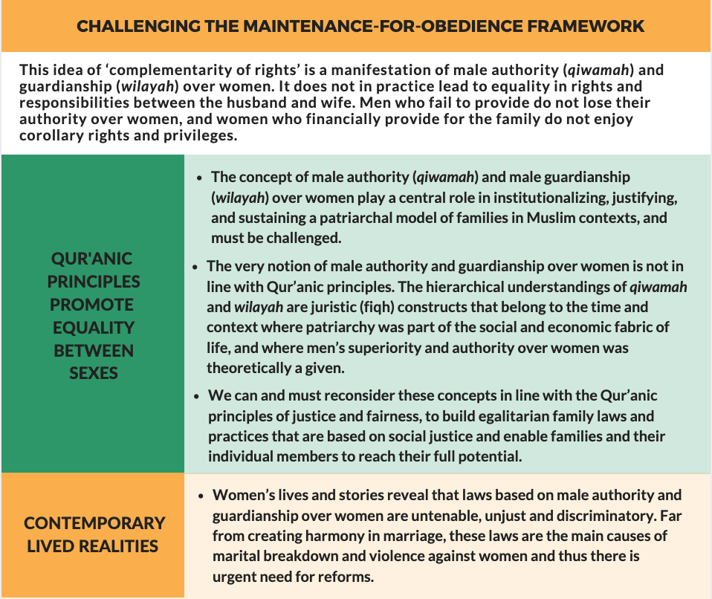

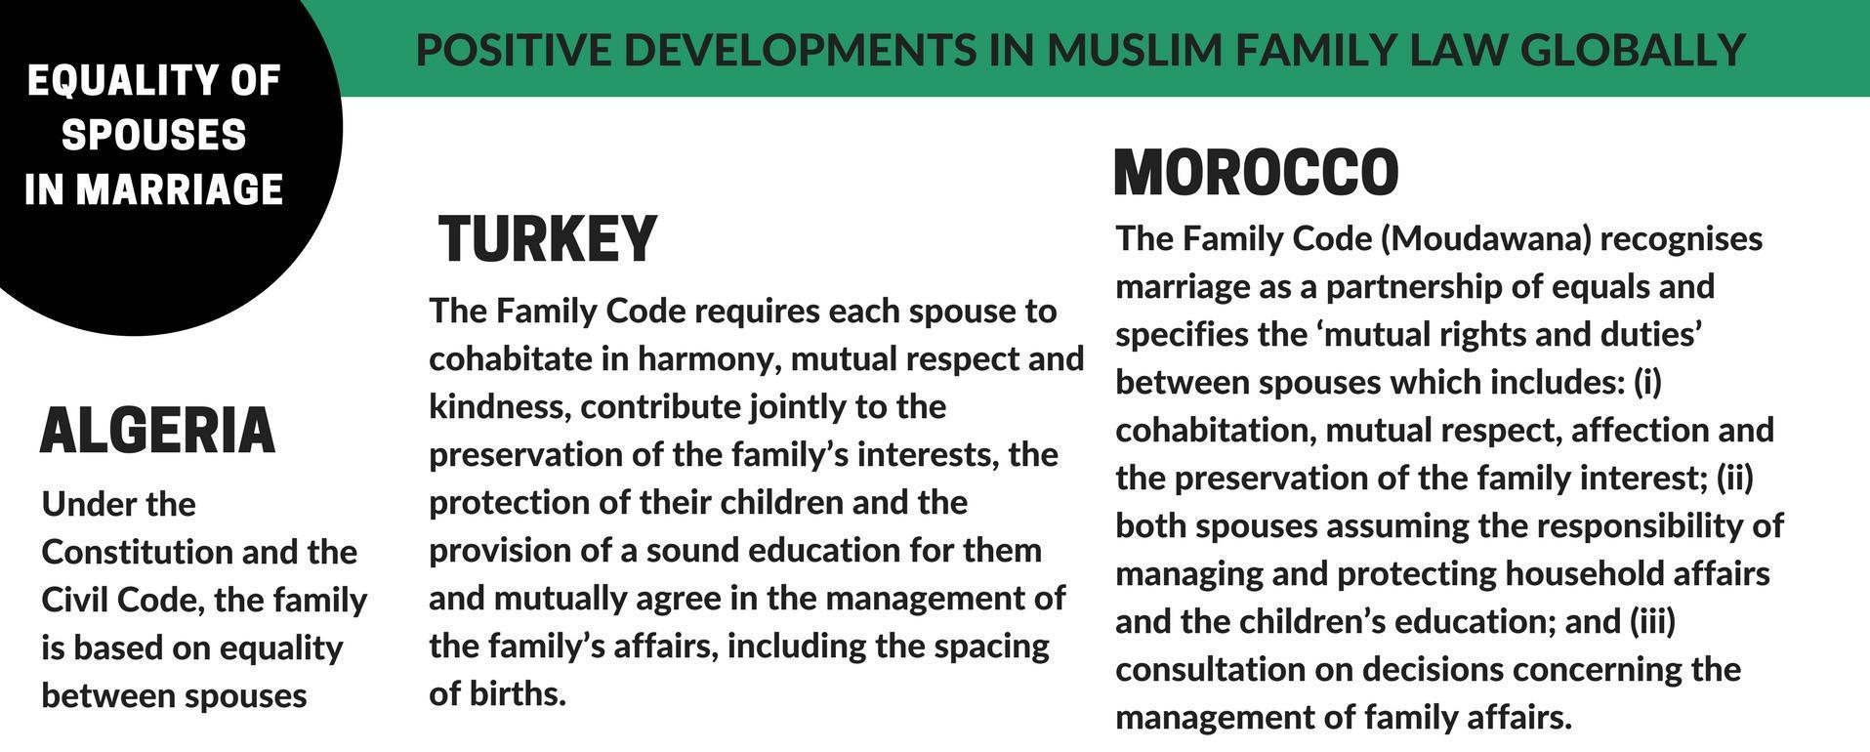

Minimum age of marriage as 18 years

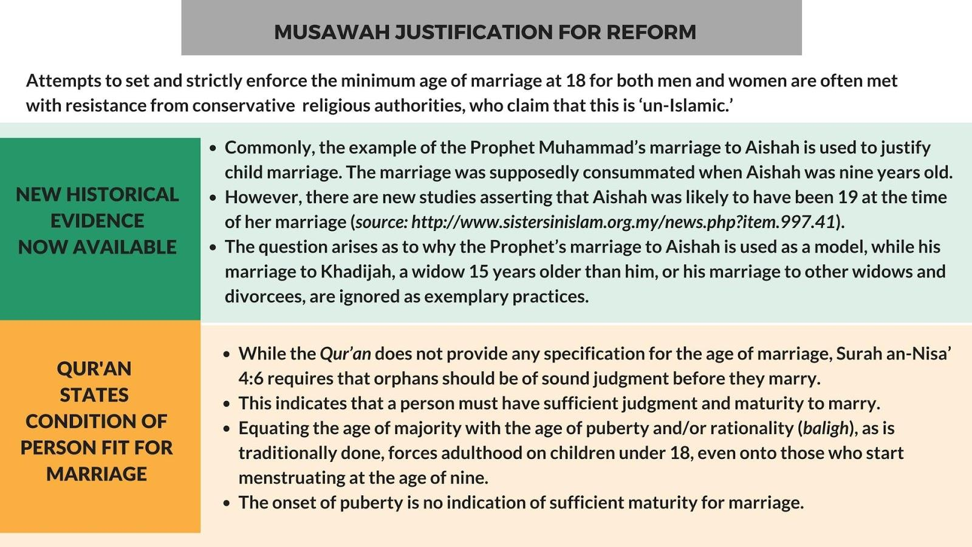

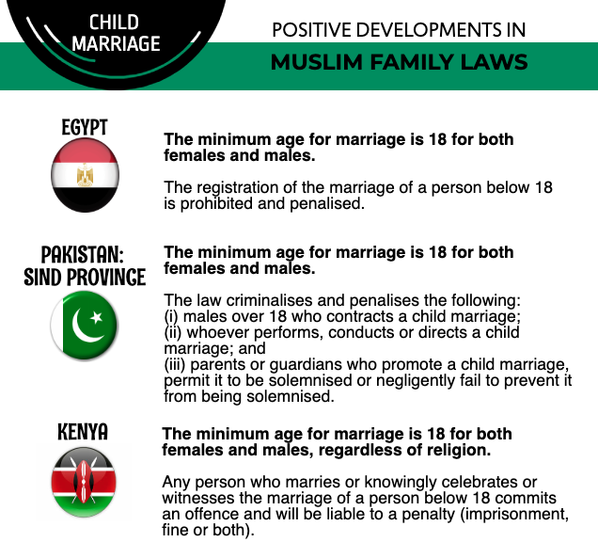

3.Abolishment of polygamy

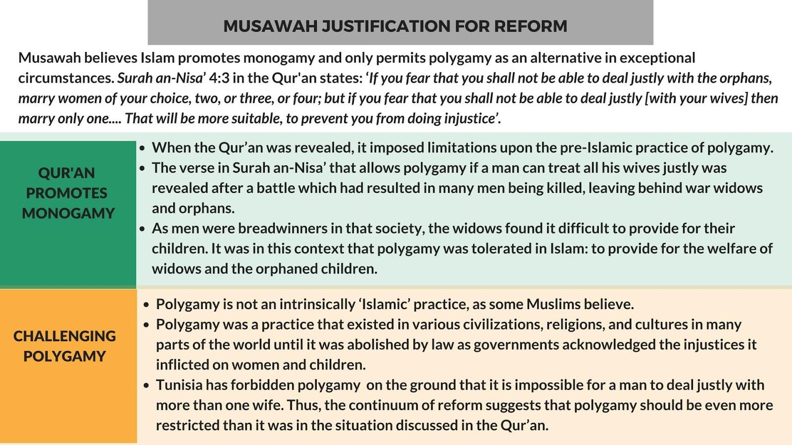

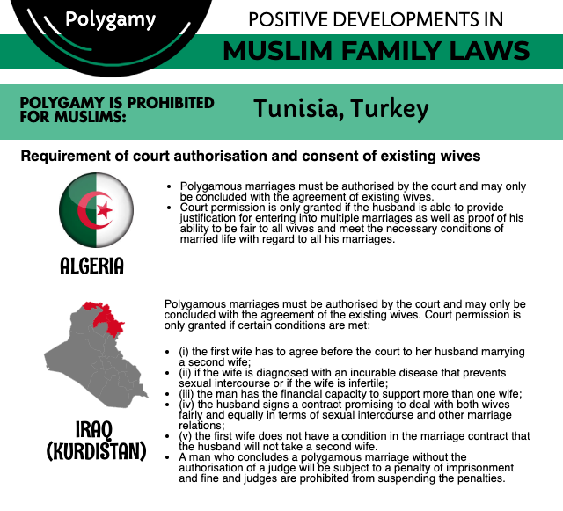

- Equal rights to divorce

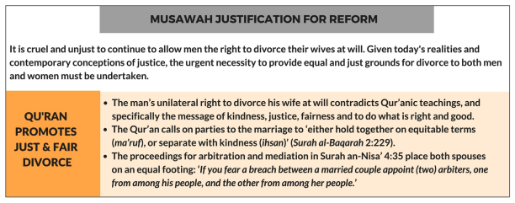

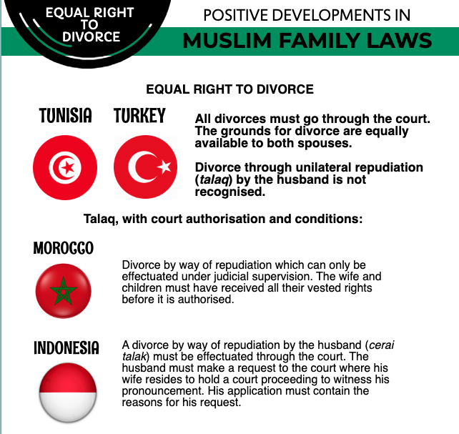

- Financial rights after divorce
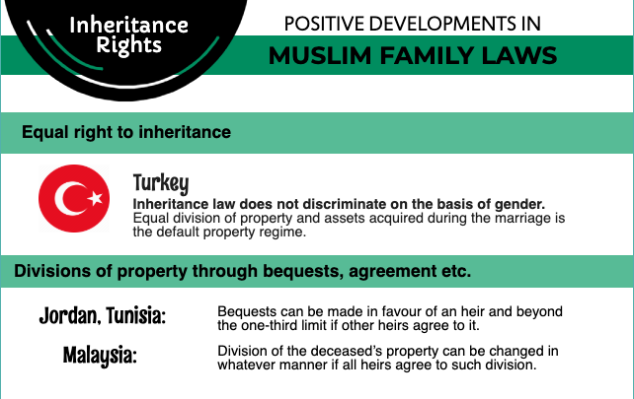

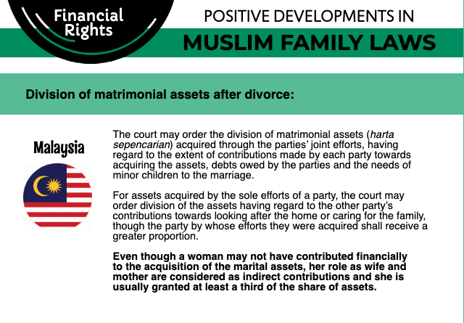

- Guardianship of children

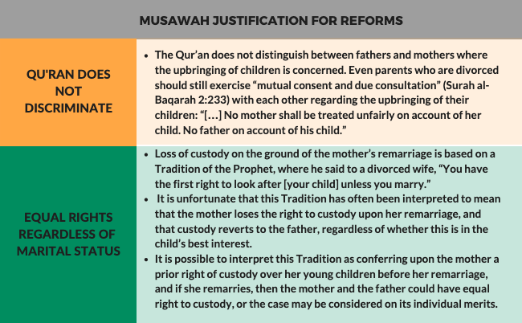

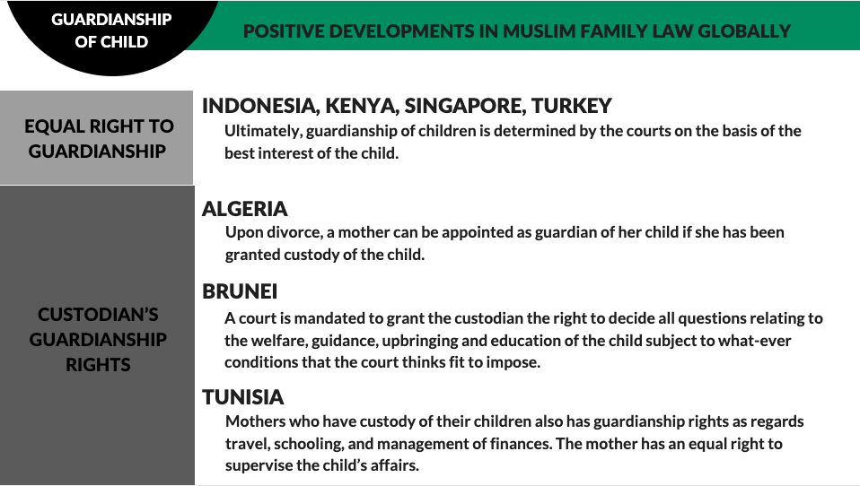

ANNEXE 2:

MUSAWAH VISION for the family
Musawah asserts that in the twenty-first century, there cannot be justice without equality. Many provisions in Muslim family laws, as defined by classical jurists and as reproduced in modern legal codes, are neither tenable in contemporary circumstances nor defensible on Islamic grounds. Not only do these family laws fail to fulfill the Shari’ah requirements of justice, but they are being used to deny women rights and dignified choices in life. These elements lie at the root of marital disharmony and the breakdown of the family.
Musawah believes that Qur’anic principles and the richness of the Islamic juristic tradition enable us to formulate Muslim family laws today that are egalitarian and reflect the needs of contemporary societies. Islamic teachings and universal human rights standards, including the CEDAW Convention, are fully compatible and are dynamic and constantly evolving, based on changing times and circumstances. Inspired by the Qur’anic vision of justice and gender relations, Musawah contends that gender equality and non-discrimination can only be achieved with laws that transform power relations in the family and in society in the direction of just outcomes.
It is our hope that the CEDAW Committee will encourage Governments everywhere, and particularly those purporting to speak for and in the name of Islam and Muslim communities, to:
- Recognize the diversity of opinions, laws and practices in the Muslim world and the growing scholarship in Islam that recognizes equality and justice and the possibility and necessity for reform of Muslim family laws today.
- Promote human rights standards as intrinsic to the teachings of Islam, national guarantees of equality and non-discrimination, and the lived realities of men and women today.
- Encourage open and inclusive public debate regarding diversity of opinion and interpretations in Muslim laws and principles relating to family laws and practices.
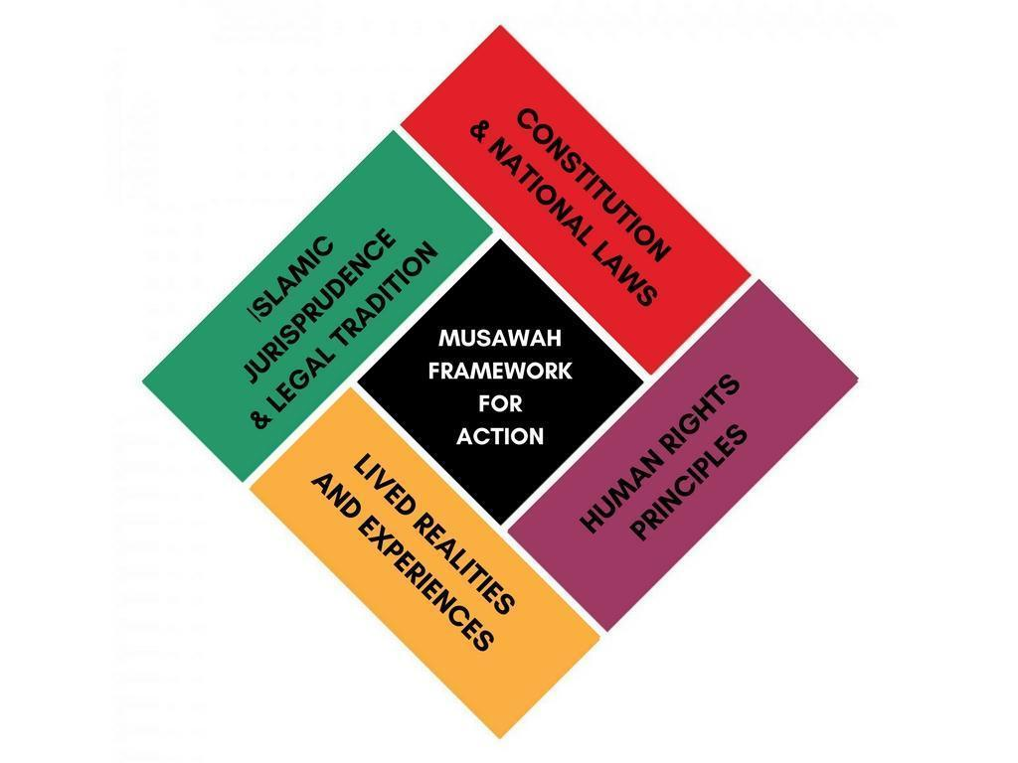

Article 54 of Afghanistan’s Constitution (2004), https://www.constituteproject.org/constitution/Afghanistan_2004.pdf?lang=en
Civil Code (1977), http://law.stanford.edu/wp-content/uploads/sites/default/files/publication/737834/doc/slspublic/Afghan%20Civil%20Code%20%20English%20translation%20ALEP%20Sept%202014.pdf
Article 1(2) of the Civil Code (1977), http://law.stanford.edu/wp-content/uploads/sites/default/files/publication/737834/doc/slspublic/Afghan%20Civil%20Code%20%20English%20translation%20ALEP%20Sept%202014.pdf; Article 130 of Afghanistan’s Constitution (2004), https://www.constituteproject.org/constitution/Afghanistan_2004.pdf?lang=en
Shiite Personal Status Law (2009), http://www.refworld.org/pdfid/4a24ed5b2.pdf; Article 131 of Afghanistan’s Constitution (2004), https://www.constituteproject.org/constitution/Afghanistan_2004.pdf?lang=en
Article 2(3) of the Shiite Personal Status Law (2009), http://www.refworld.org/pdfid/4a24ed5b2.pdf
Articles 60, 99, 115, 117, 155 of the Civil Code (1977), http://law.stanford.edu/wp-content/uploads/sites/default/files/publication/737834/doc/slspublic/Afghan%20Civil%20Code%20%20English%20translation%20ALEP%20Sept%202014.pdf
Articles 74, 132, 133, 155 of the Shiite Personal Status Law (2009), http://www.refworld.org/pdfid/4a24ed5b2.pdf
According to Girls Not Bride, factors that contribute to the high prevalence of child marriage in Afghanistan include poverty, poor access to education and strong patriarchal values that have given rise to cultural practices that assign a low value to girls “such as bride price, child engagement (where children are engaged before birth), exchange marriages (between girls from two separate families) and giving girls in baad (to solve a community dispute) - Girls Not Brides, “Afghanistan”, Child marriages around the world, http://www.girlsnotbrides.org/child-marriage/afghanistan/
UNICEF, “The State of the World’s Children 2016”, Table 9, pp. 150-153, https://www.unicef.org/publications/files/UNICEF_SOWC_2016.pdf; Afghanistan State party report, U.N. Doc. CEDAW/C/AFG/1-2 (2011), para. 359, http://www.ohchr.org/en/hrbodies/cedaw/pages/cedawindex.aspx
Article 70 of the Civil Code (1977), http://law.stanford.edu/wp-content/uploads/sites/default/files/publication/737834/doc/slspublic/Afghan%20Civil%20Code%20%20English%20translation%20ALEP%20Sept%202014.pdf; Article 91(1) of the Shiite Personal Status Law (2009), http://www.refworld.org/pdfid/4a24ed5b2.pdf
Article 71(1) of the Civil Code (1977), http://law.stanford.edu/wp-content/uploads/sites/default/files/publication/737834/doc/slspublic/Afghan%20Civil%20Code%20%20English%20translation%20ALEP%20Sept%202014.pdf
Article 71(2) of the Civil Code (1977), http://law.stanford.edu/wp-content/uploads/sites/default/files/publication/737834/doc/slspublic/Afghan%20Civil%20Code%20%20English%20translation%20ALEP%20Sept%202014.pdf
Articles 99(1)-99(3) of the Shiite Personal Status Law (2009), http://www.refworld.org/pdfid/4a24ed5b2.pdf
Afghanistan State party report, U.N. Doc. CEDAW/C/AFG/1-2 (2011), para. 355, http://www.ohchr.org/en/hrbodies/cedaw/pages/cedawindex.aspx
Article 86 of the Civil Code (1977), http://law.stanford.edu/wp-content/uploads/sites/default/files/publication/737834/doc/slspublic/Afghan%20Civil%20Code%20%20English%20translation%20ALEP%20Sept%202014.pdf
Articles 130, 132 of the Shiite Personal Status Law (2009), http://www.refworld.org/pdfid/4a24ed5b2.pdf
Refugee Documentation Centre (Ireland), “Information on Polygamous Marriages in Afghanistan”, 2011, https://www.justice.gov/sites/default/files/eoir/legacy/2013/06/11/polygamous_marriages.pdf
Central Statistics Organisation, Afghan Ministry of Public Health and the DHS Program, “Afghanistan Demographic and Health Survey 2015”, Table 4.2.1, p. 67, https://dhsprogram.com/pubs/pdf/FR323/FR323.pdf
Article 131 of the Civil Code (1977), http://law.stanford.edu/wp-content/uploads/sites/default/files/publication/737834/doc/slspublic/Afghan%20Civil%20Code%20%20English%20translation%20ALEP%20Sept%202014.pdf; Article 140 of the Shiite Personal Status Law (2009), http://www.refworld.org/pdfid/4a24ed5b2.pdf; Kabeh Rastin-Tehrani and Nadjma Yassari, “Max Planck Manual on Family Law in Afghanistan”, (Hamburg, Germany: Max Planck Institute, Amended Second Edition, 2012), p. 71, http://www.mpipriv.de/files/pdf3/max_planck_manual_on_afghan_family_law_english.pdf
Articles 135-145 of the Civil Code (1977), http://law.stanford.edu/wp-content/uploads/sites/default/files/publication/737834/doc/slspublic/Afghan%20Civil%20Code%20%20English%20translation%20ALEP%20Sept%202014.pdf; Articles 158-161 of the Shiite Personal Status Law (2009), http://www.refworld.org/pdfid/4a24ed5b2.pdf; Kabeh Rastin-Tehrani and Nadjma Yassari, “Max Planck Manual on Family Law in Afghanistan”, (Hamburg, Germany: Max Planck Institute, Amended Second Edition, 2012), pp. 73, 77, http://www.mpipriv.de/files/pdf3/max_planck_manual_on_afghan_family_law_english.pdf
Afghanistan State party report, U.N. Doc. CEDAW/C/AFG/1-2 (2011), paras. 356, 372, http://www.ohchr.org/en/hrbodies/cedaw/pages/cedawindex.aspx; Human Rights Watch, “Afghanistan” Submission to the CEDAW Committee for the 55th Session, 2013, https://www.hrw.org/news/2013/07/04/submission-combined-initial-and-second-periodic-report-afghanistan-united-nations
Article 142 of the Civil Code (1977), http://law.stanford.edu/wp-content/uploads/sites/default/files/publication/737834/doc/slspublic/Afghan%20Civil%20Code%20%20English%20translation%20ALEP%20Sept%202014.pdf; Article 155(3) of the Shiite Personal Status Law (2009), http://www.refworld.org/pdfid/4a24ed5b2.pdf; Kabeh Rastin-Tehrani and Nadjma Yassari, “Max Planck Manual on Family Law in Afghanistan”, (Hamburg, Germany: Max Planck Institute, Amended Second Edition, 2012), p. 73, http://www.mpipriv.de/files/pdf3/max_planck_manual_on_afghan_family_law_english.pdf
Article 135(2) of the Civil Code (1977), http://law.stanford.edu/wp-content/uploads/sites/default/files/publication/737834/doc/slspublic/Afghan%20Civil%20Code%20%20English%20translation%20ALEP%20Sept%202014.pdf; Article 155(1) of the Shiite Personal Status Law (2009), http://www.refworld.org/pdfid/4a24ed5b2.pdf; Kabeh Rastin-Tehrani and Nadjma Yassari, “Max Planck Manual on Family Law in Afghanistan”, (Hamburg, Germany: Max Planck Institute, Amended Second Edition, 2012), p. 73, http://www.mpipriv.de/files/pdf3/max_planck_manual_on_afghan_family_law_english.pdf
For instance: - Under Article 2007 of the Civil Code as well as Article 219 of the SPSL, upon the death of his wife, a husband shall inherit 1/2 of her estate unless there are children, in which case he will receive 1/4. A wife, on the other hand, is entitled to 1/4 of his estate upon the death of her husband if there are no children and 1/8 if there are children; - Where a parent leaves behind both sons and daughters, Article 2019 of the Civil Code and Article 222 of the SPSL, provides for the sons to inherit twice as much as the daughters. Source: Articles 2007, 2019 of the Civil Code (1977), http://law.stanford.edu/wp-content/uploads/sites/default/files/publication/737834/doc/slspublic/Afghan%20Civil%20Code%20%20English%20translation%20ALEP%20Sept%202014.pdf; Articles 219, 222 of the Shiite Personal Status Law (2009), http://www.refworld.org/pdfid/4a24ed5b2.pdf
Afghanistan State party report, U.N. Doc. CEDAW/C/AFG/1-2 (2011), para. 299, http://www.ohchr.org/en/hrbodies/cedaw/pages/cedawindex.aspx
Articles 71(1), 252, 256, 268 of the Civil Code (1977), http://law.stanford.edu/wp-content/uploads/sites/default/files/publication/737834/doc/slspublic/Afghan%20Civil%20Code%20%20English%20translation%20ALEP%20Sept%202014.pdf
Kabeh Rastin-Tehrani and Nadjma Yassari, “Max Planck Manual on Family Law in Afghanistan”, (Hamburg, Germany: Max Planck Institute, Amended Second Edition, 2012), pp. 106-107, http://www.mpipriv.de/files/pdf3/max_planck_manual_on_afghan_family_law_english.pdf
Article 45 of the Shiite Personal Status Law (2009), http://www.refworld.org/pdfid/4a24ed5b2.pdf
Article 47(2) of the Shiite Personal Status Law (2009), http://www.refworld.org/pdfid/4a24ed5b2.pdf

