India’s Compliance with International Covenant on Civil and Political Rights:
The Death Penalty

Submitted by The Advocates for Human Rights
a non-governmental organization in special consultative status with ECOSOC since 1996
and
The World Coalition Against the Death Penalty

for the 141st Session of the Human Rights Committee

1–22 July 2024

Submitted 3 June 2024
The Advocates for Human Rights (The Advocates) is a volunteer-based non-governmental organization committed to the impartial promotion and protection of international human rights standards and the rule of law since its founding in 1983. The Advocates conducts a range of programs to promote human rights in the United States and around the world, including monitoring and fact finding, direct legal representation, education and training, and publication. The Advocates is the primary provider of legal services to low-income asylum seekers in the Upper Midwest region of the United States. In 1991, The Advocates adopted a formal commitment to oppose the death penalty worldwide and organized a death penalty project to provide pro bono assistance on post-conviction appeals, as well as education and advocacy to end capital punishment. The Advocates currently holds a seat on the Steering Committee of the World Coalition Against the Death Penalty.
The World Coalition Against the Death Penalty, an alliance of more than 150 NGOs, bar associations, local authorities and unions, was created in Rome on May 13, 2002. The aim of the World Coalition is to strengthen the international dimension of the fight against the death penalty. Its ultimate objective is to obtain the universal abolition of the death penalty. To achieve its goal, the World Coalition advocates for a definitive end to death sentences and executions in those countries where the death penalty is in force. In some countries, it is seeking to obtain a reduction in the use of capital punishment as a first step towards abolition.

Executive Summary
- India has failed to uphold its obligations under the International Covenant on Civil and Political Rights with respect to the death penalty. Rather than move away from the death penalty, lawmakers have recently introduced legislation that may increase the number of death-eligible offenses, including for offenses not entailing an intentional killing. As of 31 December 2023, a total of 561 people were living under a sentence of death. In 2022, 15 women were on death row. Since 2016, trial courts have been sentencing an average of 123 people to death each year. Over the years, however, appellate courts have become increasingly more reluctant to confirm these death sentences. In fact, the Supreme Court has acquitted many people sentenced to death on all charges and has commuted other death sentences to life imprisonment.
- This report discusses fair trial violations both at the guilt determination and sentencing phases that prompt the Supreme Court to reverse determinations of guilt or commute death sentences. In September 2022, the Supreme Court acknowledged the gaps in India’s death penalty sentencing framework and called for a Constitution Bench (five judges) of the Supreme Court to address these issues. So far, this bench has not been formed and trial courts continue to sentence people to death.
- This report also discusses the socio-economic profile of people on death row to demonstrate the disparate use of the penalty on persons from marginalized socio-economic backgrounds. Given the high number of appellate acquittals in death penalty cases, this report also highlights the urgent need to focus on compensation and rehabilitation of such persons. The report also addresses discrimination against women charged with capital crimes.
- Finally, the report also discusses the psychological consequences of life on death row in light of the differential treatment of people under sentence of death. Considering the fairness concerns with the administration of the death penalty, this report recommends that India should abolish the death penalty altogether. In the meantime, India should impose a formal moratorium on the use of the death penalty.

India fails to uphold its obligations under the International Covenant on Civil and Political Rights.

India fails to ensure that courts impose the death penalty only for the most serious crimes and lawmakers have expanded the number of offenses that carry the death penalty (List of Issues Prior to Reporting paragraph 17).
- In its List of Issues Prior to Reporting, the Committee asked India to “elaborate on any comprehensive review of relevant legislation to ensure that the death penalty may be imposed only for the most serious crimes, as prescribed in article 6 (2) of the Covenant, that is, only for crimes of extreme gravity involving intentional killing.” India does not directly respond to this question in its report and no such review is publicly available.
- Despite the global trend toward abolition, India has consistently expanded the number of offenses that carry the death penalty, primarily for sexual offenses. Amendments in 2018 introduced the death penalty for two non-homicidal sexual offenses involving minors: rape of a female under the age of 12 years (S. 376AB, IPC) and gang-rape of a female under the age of 12 years (S. 376DB, IPC). Soon thereafter, lawmakers amended India’s law against child sexual abuse, the Protection of Children From Sexual Offences, to make aggravated penetrative sexual assault of a minor a capital offense. A special committee constituted by the government in 2013 to suggest amendments to criminal law in India had recommended against the death penalty for sexual offenses due to the lack of data to justify the death penalty as a deterrent. Similarly in 2015, the Law Commission of India had recommended that the death penalty be abolished for all crimes other than terrorism-related offenses and waging war. Lawmakers have not heeded these recommendations.
- In 2024, India notified a new set of criminal laws increasing the number of death-eligible offenses from 12 to 18. Before these laws were notified, a government committee had invited expert submissions on the need for new criminal laws. These experts challenged the expanded use of the death penalty and argued in favor of abolition. They cited the low rate of death sentence confirmations by the Supreme Court and the global trend toward abolition. In its final report to parliament, the government committee recorded that the strongest argument in favor of abolition was the fallibility of the judicial process and the frequency with which innocent persons are sentenced to death. Nonetheless, the committee did not recommend abolition.
- In its List of Issues, the Committee asked India to “indicate whether the imposition of the death penalty is mandatory for certain crimes.” In its report, India responds that the mandatory death sentence is inconsistent with the concept of judicial review, which is one of the basic features of India’s Constitution. The Supreme Court’s landmark decision in Mithu v. State of Punjab struck down as unconstitutional the mandatory death sentence for murder carried out while the offender was serving a sentence of life imprisonment. Court challenges to a spate of similar mandatory death penalty provisions have prompted courts to read the penalties down to permit lesser sentences, and the government has subsequently amended these provisions. Certain legislation, however, still authorizes the mandatory death penalty. For instance, the Scheduled Castes & Scheduled Tribes (Prevention of Atrocities) Act, 1989 stipulates a mandatory death sentence for a witness who gives false evidence, which results in the conviction and execution of an innocent person belonging to a Scheduled Caste or a Scheduled Tribe. Petitions challenging the constitutionality of this provision are pending before the Supreme Court.
- Suggested recommendations relating to the scope of the death penalty:
- Abolish the death penalty and ratify the Second Optional Protocol to the ICCPR.
- In the interim, amend the criminal law to eliminate any provisions authorizing the death penalty for crimes that do not involve intentional killing by the accused person.

The criminal legal system is characterized by deficient investigations and has resulted in wrongful prosecutions (List of Issues Prior to Reporting paragraph 19).
- The Committee inquired as to the existence of any enforceable right to compensation for wrongful arrest and detention and asked for a response to allegations of violations of the right to a fair trial. The State Party Report does not mention fair trial concerns or wrongful prosecutions in capital cases.
- The criminal legal system in India is characterized by deficient investigations and trials fraught with violations of the rights to due process and fair trial. Trial courts convict and sentence persons to death despite these human rights violations.
Deficient investigations in death penalty cases
- When the Supreme Court acquits people on appeal in capital cases, it often observes that the police deliberately manufactured evidence against the accused during investigations. In any given case, police may tamper with evidence such as bloodstains or fingerprints, coerce the accused into confessing, falsify incriminatory evidence such as dying declarations made by victims (which have high probative value in Indian law), or suppress material evidence consistent with the accused person’s innocence. Although the law recognizes procedural safeguards to check against such practices, police, prosecutors, and lower courts often ignore these safeguards in order to privilege the “truth seeking” function of the criminal legal system.
- The Supreme Court has often criticized the manner in which police carry out investigations and highlighted deficiencies in the handling of evidence. In Prakash Kewat v. State of Maharashtra (2023), the Supreme Court reiterated the roles of investigating authorities and criticized the police for failing to take precautions to safeguard the fact-finding and investigation exercise. Despite these lapses in the investigation, an innocent person was on death row for close to nine years before the Supreme Court eventually acquitted him.
- In a recent case resulting in the acquittal of two people on death row, the Supreme Court in Rajesh and Ors. v. State of Madhya Pradesh (2023) highlighted significant concerns with the manner in which the police carried out their investigation. Forced to acquit the accused for lack of proper investigation, the Supreme Court remarked that “[i]t is high time, perhaps, that a consistent and dependable code of investigation is devised with a mandatory and detailed procedure for the police to implement and abide by during the course of their investigation so that the guilty do not walk free on technicalities, as they do in most cases in our country.”
Faulty criminal trials and wrongful convictions
- The Supreme Court has also criticized hasty trials where the accused was not given a fair opportunity to present an adequate defense. In Anokhilal v. State of Madhya Pradesh (2019), the Supreme Court observed that authorities carried out the investigation and completed the capital trial in merely twelve working days. In another case from the same state, Naveen @ Ajay v. State of Madhya Pradesh (2023), authorities completed the investigation within fifteen days, and the trial imposed the death penalty even before formally writing and publishing the reasons for the conviction. The Supreme Court remanded both matters back for retrial. The trial court eventually acquitted Anokhilal after receiving competent legal assistance and a fair hearing. Naveen @ Ajay is awaiting trial; his fate remains uncertain.
- The Supreme Court has often reminded trial courts of their duty to ensure fair trials, and thereby maintain public confidence in the administration of justice. In Ramanand v. State of Uttar Pradesh (2022), the Supreme Court acquitted an innocent man who had been sentenced to death and who had spent 12 years in prison, observing: “The courts administering criminal justice cannot turn a blind eye to vexatious or oppressive conduct that has occurred in relation to proceedings, even if a fair trial is still possible, except at the risk of undermining the fair name and standing of the judges as impartial and independent adjudicators.”
- As referenced above in paragraph 7, the 246th report of the Parliamentary Standing Committee on Home Affairs noted that the strongest argument against the retention of the death penalty is the prevalence of wrongful convictions. The following table presents data on the number of people on death row acquitted by appellate courts.
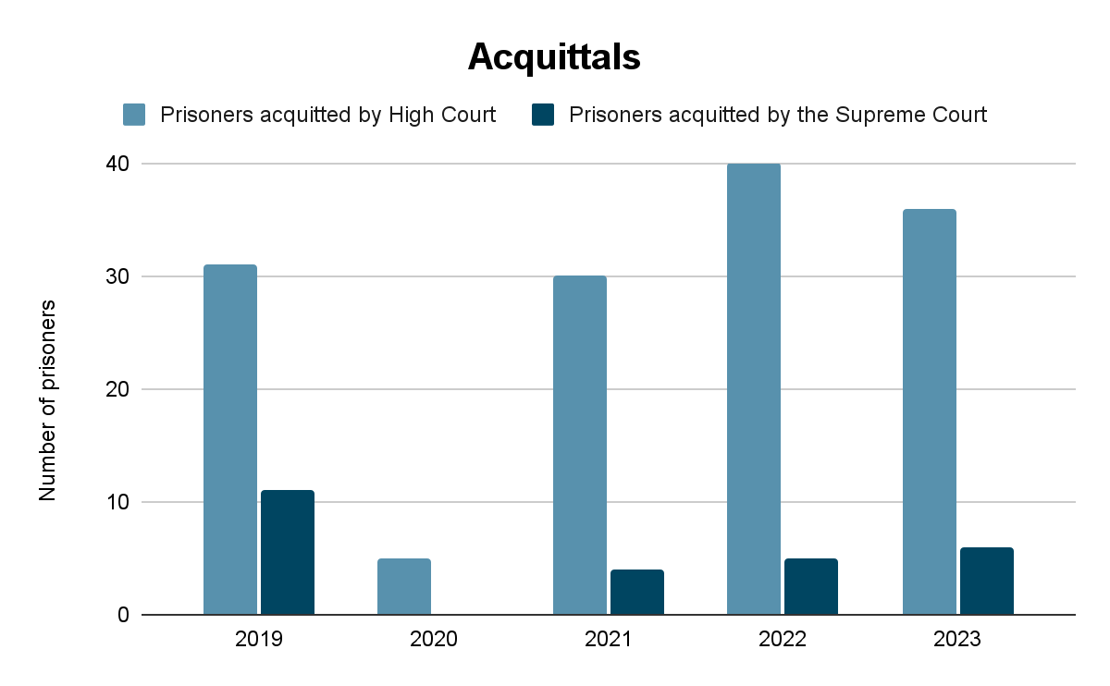
Fig. 1: Number of people sentenced to death and subsequently acquitted by appellate courts
- Appellate courts have often expressed skepticism about the manner in which criminal trials are conducted in India and have highlighted the need for large-scale institutional reform. In 2017, the Supreme Court instituted suo moto proceedings in order to address systemic deficiencies in criminal trials and criminal appeals. In 2018, the Delhi High Court expressed grave concern over wrongful prosecution of innocent persons and requested the Law Commission of India to look into the possibility of an adjudicatory mechanism to accommodate claims by wrongfully convicted people and offer them compensation. These are but a few piecemeal remedial measures taken by the judiciary to address a larger crisis in the criminal justice system warranting institutional reform.
Recent trends in death penalty sentencing
- As of 31 December 2023, 561 people are on death row in India— the highest number in nearly two decades. Trial courts across the country have on average imposed 123 death sentences every year in the past five years. Murder simpliciter and murder involving sexual offenses constitute the majority of offenses for which courts sentence prisoners to death: 85% of death sentences imposed in 2023 were for either of these two offenses. Figure 2 below represents the number of people sentenced to death by trial courts since 2019, when the Committee previously reviewed India’s compliance with its obligations under the ICCPR.
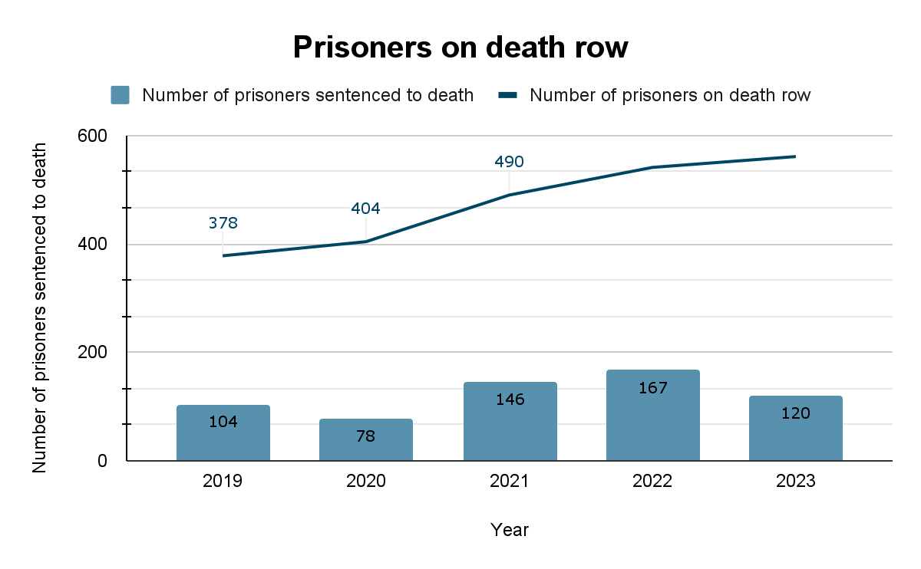
Fig. 2: 2019 - 2023 number of people sentenced to death
- The increase in the death row population between 2019 to 2023 may partly be because of the comparatively slower rate of case disposal by High Courts in these years [Figure No. 3 below], and the large number of death sentences imposed by trial courts. All death sentences imposed by trial courts are automatically sent to High Courts for confirmation. Yet the High Court’s pace of reviewing capital cases lags behind the trial courts’ pace of issuing death sentences every year. The average rate of disposal at the High Courts fell by 15% in 2023, as compared to the average rate of disposal between 2016 and 2022, during which time High Courts were deciding cases of 94 people per year.
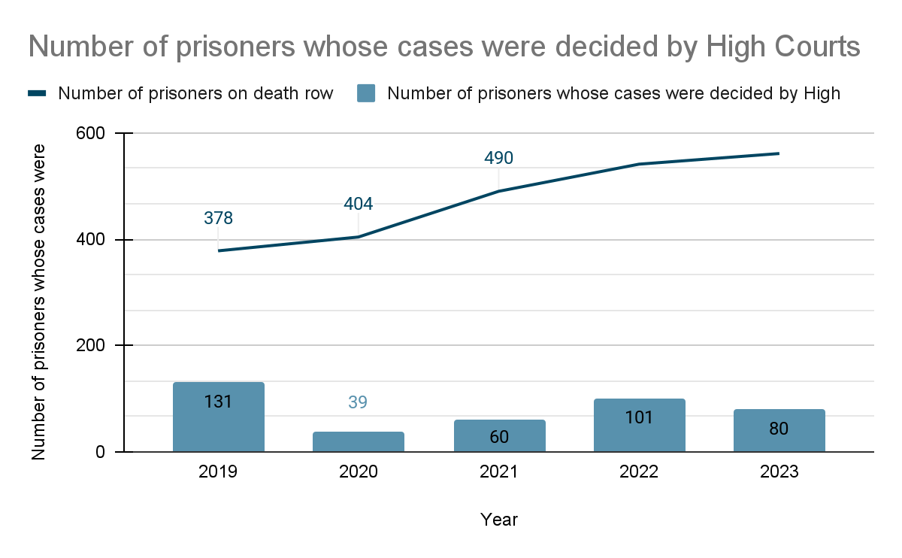
Fig. 3: 2019 - 2023 number of prisoners whose cases were decided by High Courts
- Since 2020, High Courts have rarely confirmed death sentences, opting instead either to commute death sentences to life imprisonment or to acquit. Figure 4 below illustrates this trend. In 2023, the median time for the High Court to decide a death sentence confirmation case was 2 years. People experiencing prolonged exposure to death row due to appellate delays can face trauma, resulting in or exacerbating severe mental health concerns.
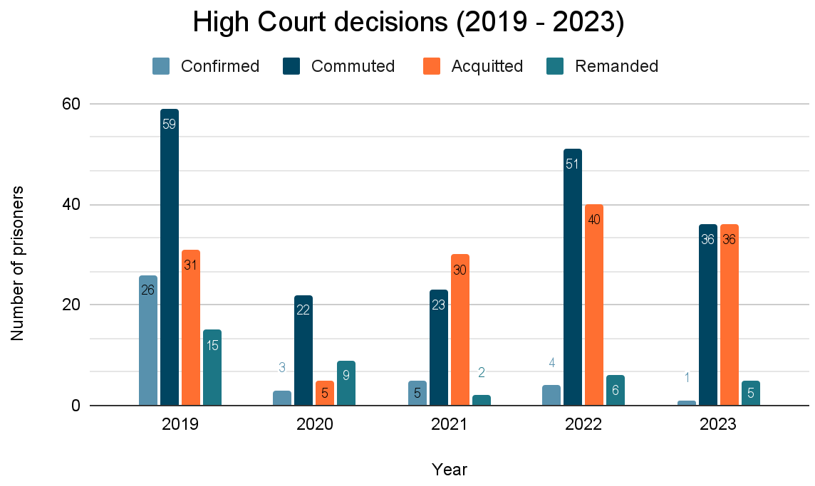
Fig. 4: 2019 - 2023 High Court decisions in confirmation cases
- If the High Court confirms a death sentence, the person sentenced to death does not have an automatic appeal to the Supreme Court. Since 2019, a majority of cases that reach the Supreme Court result in either commutations or acquittals, while trial courts continue to hand down a high number of death sentences each year. Out of 79 total decisions by the Supreme Court in capital cases since 2019, only 14 (~17%) resulted in confirmations. Clemency proceedings for all 14 prisoners are pending. 61 cases (~77%) decided by the Supreme Court between 2019-2023 resulted in commutations (35 cases) or acquittals (26 cases). In 2023, the median time for the Supreme Court to decide a criminal appeal from a death sentence was 7 years. As mentioned in the preceding paragraph, protracted time on death row can result in trauma, particularly for people wrongfully accused and sentenced to death.
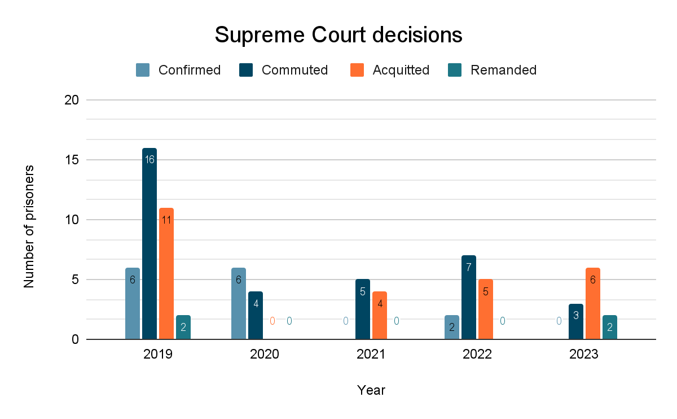
Fig. 5: 2019 - 2023 Supreme Court decisions in death penalty cases
- The Supreme Court’s decision in Bachan Singh v. State of Punjab (1980) outlines a broad judicial framework guiding sentencing in capital cases. The Supreme Court articulated the “rarest of rare” framework, whereby courts can sentence a person to death only if the default punishment of life imprisonment is unquestionably foreclosed and there is no probability of reformation of the accused. This analysis requires weighing of “aggravating” and “mitigating” factors, which roughly correspond to the circumstances of the crime and the criminal, respectively. Under this framework, courts must ensure the defense has adequate time to prepare, that the court has access to sufficient information relating to the accused, and that the court considers the possibility of reformation.
- Although trial courts have imposed over 400 death sentences since 2021, the Supreme Court has confirmed only 2 death sentences during this time period. A pan India study of 306 death sentences imposed by trial courts between 2018 and 2020 reveals that trial courts frequently ignore key aspects of the Supreme Court’s framework to ensure individualized sentencing in death penalty cases. The study revealed that courts impose death sentences on the same day as conviction; courts fail to proactively place mitigating evidence into the record; and courts fail to assess the accused person’s probability of reformation. These flaws show that trial courts orient their sentencing hearings toward the circumstances of the crime above all else and dilute the significance of mitigating circumstances.
Gaps in the death penalty sentencing framework
- The problem with death penalty sentencing in India is not merely that courts fail to comply with the law laid down in Bachan Singh; it is that the law itself is unclear. The Bachan Singh framework seeks to ensure that sentences are individualized. Sentencing courts must weigh aggravating and mitigating factors and assess whether the lesser alternative punishment of life imprisonment is “unquestionably foreclosed.” Neither Bachan Singh nor subsequent Supreme Court decisions have clarified how courts should carry out this analysis Instead, subsequent Supreme Court benches have adopted conflicting interpretations of the Bachan Singh framework that bear little resemblance to the original formulation.
- Bachan Singh does not clarify many other aspects of the death penalty sentencing framework. The judgment does not explain how aggravating and mitigating factors are to be identified, what purpose they serve, or how courts should weigh them in the final sentencing analysis. In the absence of any normative understanding of the role of mitigation, sentencing courts have chosen to arbitrarily discard certain mitigating factors or not accord them appropriate weight. The lack of normative clarity has resulted in courts outrightly rejecting certain factors during sentencing, choosing instead to focus exclusively on the brutality of the crime to justify a death sentence. This practice disregards Bachan Singh’s emphasis on mitigating factors. Furthermore, Bachan Singh offers no guidance on how courts should assess the probability of reformation and rehabilitation. Although the Supreme Court has placed upon the prosecution the primary burden of proving that reformation is not probable, it is unclear how prosecutors can ever demonstrate this claim. While the Supreme Court has started calling for relevant reports from jail that speak to the accused person’s behavior, work done in jail, and mental health, these efforts have not percolated to trial courts, where death sentences are first imposed. Trial court analysis of the probability of reformation is inconsistent and arbitrary.
- Data confirm the prejudice caused by these normative gaps in the Bachan Singh framework. Empirical analysis reveals that sentencing is not individualized even when courts formally comply with the procedural safeguards stipulated in Bachan Singh. Courts do not understand the implications of mitigating factors on the defendant’s culpability or on the possibility of their reform. For instance, the age of the accused person is often cited as a mitigating factor without any additional analysis as to how it may influence the probability of reformation or relate to the severity of the offense. Age is cited interchangeably as both an aggravating and mitigating factor, depending partly on the judge’s intended sentence. Particularly problematic has been the Supreme Court’s approach to assessing the probability of reform. Between 2007 and 2021, the Court simply did not address probability of reformation in 41.5% commutation judgments (44 out of 106) and in 50% of confirmation judgments (20 out of 40). In addressing probability of reform, the Supreme Court has expressed diverging opinions regarding whether it constitutes a mitigating factor to be weighed against other aggravating factors, or whether reformation is a determinative consideration on the question of sentence.
- Supreme Court judges have expressed confusion about the Bachan Singh framework. A 2017 opinion survey of 60 former Supreme Court judges found that judges perceive the Bachan Singh “rarest of rare” doctrine to be hollow. In the absence of guidance to cabin judicial discretion, judges can use the framework to support whatever outcome they see fit. For instance, 21 former judges asserted that the nature of the crime and the manner in which it was committed were determinative of whether the accused deserved to be sentenced to death. One judge who decided nearly 130 murder cases as an appellate judge said that “the heinous nature of the crime certainly colours our judgement.” 13 judges conceded that the Bachan Singh framework was so subjective that it was no real standard at all. One judge, who decided nearly 140 murder cases in his 21 years as an appellate judge, remarked: “It can be safely said that the Bachan Singh threshold of rarest of rare cases has been most variedly and inconsistently applied by the various High Courts as also this court. [...] This extremely uneven application of Bachan Singh has given rise to a state of uncertainty in capital sentencing law which clearly falls foul of constitutional due process and equality principle.”
- Recognizing Bachan Singh’s inadequacies, the Supreme Court in 2022 laid down extensive guidelines to be followed in death penalty cases in Manoj v. State of Madhya Pradesh (2022). Manoj also highlights the significance of reformation and rehabilitation at the sentencing stage. It suggests that the information collected at sentencing speaks to the possibility of reformation and may assist sentencing judges in assessing whether the alternative of life imprisonment is foreclosed. Accordingly, Manoj clarifies that the state has a duty to submit information relating to the accused’s socio-economic background, mental health, and psychological condition, as well as evidence of the probability that the accused can be reformed. Yet Manoj failed to acknowledge structural challenges in implementing this duty in trial courts across the country. These challenges include the scarcity of experts to collect such information, public bias against people charged with capital crimes, poor quality legal aid, and trial courts’ lackadaisical approach to sentencing. Hence, trial court compliance with Manoj since 2023 has been woefully inadequate. Since Manoj’s guidelines on collecting mitigating circumstances, trial courts have imposed 182 death sentences in 121 cases on 180 prisoners (as of December 31, 2023). Judgments in 80 out of 121 cases are available in public domain. In these 80 cases, authorities summoned jail reports in only 8 cases (10%) and called for psychiatric evaluation reports in only 3 cases (3.75%). Despite the Manoj guidelines, in 2023 alone, trial courts elicited materials on sentencing in only 13.04% of cases studied (9 out of 69) and the state led materials on the probability of reform in only 8.6% of cases studied (6 out of 69). Despite these repeated failures to implement consistent sentencing procedures, the executive has not made any progress toward eliminating the arbitrary nature of trial court sentencing in capital cases..
- The Manoj guidelines, though welcome, do not engage with the foundational concerns with Bachan Singh highlighted in paragraphs 22–27 above. Confusion persists regarding the relevance of mitigating circumstances and how sentencing authorities should analyze them, how sentencing authorities should assess the probability of reformation, when a sentencing authority can conclude that a lesser alternative punishment is foreclosed, and what kind of analysis the “rarest of rare” framework truly entails.
- The Supreme Court recognizes the lack of procedural fairness in the administration of the death penalty in India. In 2022, it instituted suo moto proceedings to address concerns arising out of India’s arbitrary death penalty sentencing practices. These proceedings have been referred to a Constitution Bench of five judges, in order to deliver a verdict on how courts can ensure a “real, effective, and meaningful” hearing prior to sentencing in capital cases. The proceedings will address issues striking at the core of India’s sentencing framework, implicating fundamental constitutional values of human dignity, liberty, and due process. Despite recognizing that death penalty sentencing in India is flawed and possibly arbitrary, neither the Supreme Court nor the Government of India has considered imposing a moratorium on death sentences during the adjudication of the constitutionality of death penalty sentencing procedures. Meanwhile, courts continue to sentence people to death and subject them to indefinite and prolonged detention on death row.
Same day sentencing
- The Supreme Court has consistently highlighted the importance of ensuring persons accused of capital crimes have adequate time to prepare before the sentencing hearing. Yet research shows that trial courts routinely sentence people to death on the same day as their conviction or without sufficient time between the guilt pronouncement (hearing on conviction) and the sentencing hearing. Data reveal that courts imposed 54.6% (166 out of 304) of sentences less than two days after the hearing on conviction. In 90.13% cases (274 out of 304), courts imposed the sentence within one week of the hearing on conviction. This practice undermines the Bachan Singh framework of weighing aggravating and mitigating factors by limiting sentencing analysis to information that is available as part of the guilt-phase case file. Invariably, courts restrict the analysis to the heinous nature of the crime and the circumstances in which it was committed. Courts’ failure to provide adequate time to prepare for sentencing frustrates the defense’s opportunity to present mitigating circumstances other than circumstances tied to the crime itself, or beyond perfunctory information about the accused such as age. By failing to give the defense the opportunity to gather and present more granular and potentially relevant information about the accused, courts disregard the mandates of Bachan Singh and Manoj to conduct individualized sentencing determinations.
Mitigating circumstances not considered
- The Bachan Singh framework envisions that judges will take on a proactive role during sentencing. It requires judges to actively take steps to elicit sentencing information from the prosecution and the defense. In some cases, judges call the accused to the stand and put questions to them directly. This procedure aims to ensure that all accused persons—including people represented by free legal aid—receive a fair defense and can present their unique circumstances at the sentencing stage. This procedure also ensures that judges have adequate information about the accused person’s mitigating circumstances so that the judge can articulate reasons for the sentencing decision. In a pan-India study of 304 death sentences imposed between 2018 and 2020, in only one case did the judge proactively call for sentencing materials before handing down a death sentence. The lack of judicial initiative is particularly alarming because neither party produced any sentencing material in 83.5% of cases (253 out of 303 death sentences studied).
- The above-mentioned study also found that in over 77% sentences, trial court judges invoke their perceptions of the dominant public opinion as justification for sentencing decisions. These perceptions suggest that public opinion is predominantly focused on retribution and therefore the court considers only the circumstances of the crime.
- As discussed in greater detail below, courts also often overlook gender-specific mitigation, and the absence of guidance on such mitigation opens the door for judges to rely on gender stereotypes in determining whether to sentence a particular female defendant to death.
Failure to assess the probability of reform
- An important part of the Bachan Singh framework is assessing the probability of reformation. Courts have placed the obligation on the state to lead materials to establish the probability (or lack thereof) of reformation. Yet out of the 303 death sentences studied between 2018 and 2020, the state produced evidence of improbability of reform in just 20 cases (6.6%). Instead, courts relied on the heinousness of the crime and related circumstances to presume that the accused person could not be reformed. In other words, even when courts consider the possibility of reformation, their analysis does not consider conduct after the incident, such as work done in jail or improvements in behavior subsequent to detention, while purportedly assessing the future possibility of their reformation. Such an approach is contrary to the individualized sentencing required under law.
- In summary, research shows that sentencing courts routinely disregard key features of the Bachan Singh death penalty sentencing framework in several respects: failing to provide adequate time to prepare before the sentencing hearing; failing to proactively call for relevant material to consider at sentencing; and ignoring the possibility of the accused person’s reformation and rehabilitation. These failures undermine implementation the death penalty sentencing framework.
Pervasive custodial violence and torture (List of Issues Prior to Reporting paragraphs 18, 19(d))
- The Committee in its List of Issues inquired as to “reports of widespread torture and other forms of ill-treatment of persons deprived of liberty” and as to “the use of coerced confessions in criminal cases, notwithstanding the legal prohibition against using them.” The State Party Report asserts that “India condemns any form of torture,” and concedes that “police training needs to be re-oriented to bring in a change in the mindset and attitude of the Police personnel with regard to investigations, so that they recognize and respect human rights, and adopt thorough and scientific investigation methods.” The State Party Report further asserts that “[u]nder the Indian Evidence Act, all confessional statements made to police officers are inadmissible in evidence, unless permitted by special laws. Notwithstanding this, any confession that is coerced is inadmissible as evidence in a court of law.”
- The Law Commission of India has issued several reports on custodial violence and torture. India has not ratified the UN Convention Against Torture and has not passed any central legislation to prevent custodial violence. As such, Article 21 of the Constitution, which guarantees the fundamental right of life and personal liberty, is the primary vehicle to protect against custodial violence. Courts have played an important role in addressing this issue, issuing several directions to the police and to states to protect rights of persons in custody. Yet investigating officers commonly use torture during interrogations and compel arrested persons to sign blank papers that officials later filled in with confessional statements corroborating the prosecution’s case. Although confessions made to a police officer are not strictly admissible as evidence in a trial, investigating authorities circumvent this rule by relying on an exception under S. 27, Indian Evidence Act (1872). This exception allows certain parts of a confessional statement to be admitted, so long as the statement leads to the discovery of new evidence against the accused. This practice is so ubiquitous that as many as 38 of 60 former Supreme Court judges surveyed in a 2017 study agreed that investigating agencies abused procedural laws to torture accused persons and fabricate evidence. 216 out of 270 people on death row (80%) surveyed between 2014 and 2016 stated that police tortured them in custody.
- Suggested recommendations relating to the right to a fair trial, torture, and arbitrary capital sentencing practices:
- Enact a law to provide compensation and rehabilitation for wrongful prosecution and implement recommendations of the Law Commission of India to develop mechanisms for adjudicating claims of compensation for wrongful prosecution, prioritizing people wrongfully sentenced to death and taking into account the period of time under which they lived under sentence of death as well as the degree of government wrongdoing that resulted in the wrongful conviction and death penalty.
- Considering that the framework and administration of death penalty sentencing in India is currently under review before a Constitution Bench of the Supreme Court of India, institute a formal moratorium on executions and death sentences at least until the Constitution Bench reference has decided on a just and fair sentencing framework.
- In collaboration with civil society organizations and individuals with expertise on defending capital cases, develop and deliver training modules for judges on mitigation and sentencing in death penalty cases.
- Ensure that sentencing judges accord mitigating weight to defendants’ experiences of trauma, gender-based violence, economic pressures, duress, and family caretaking responsibilities.
- In collaboration with civil society organizations and individuals with expertise on defending capital cases, create a capital sentencing bench card to guide trial court judges preparing for and conducting sentencing hearings to ensure full compliance with Supreme Court frameworks and directives.
- Recognize mitigation investigators as an essential part of a capital defense team and institutionalize the profession by empanelling mitigators as a part of the legal aid system and funding expenses for their work. Collaborate with civil society organizations to conduct comprehensive training and continuing education for mitigation investigators.
- Close the loophole created by the exception under S. 27, Indian Evidence Act (1872) to bar any court from considering any evidence obtained via torture, except as evidence against the alleged perpetrator of the torture.
- Ensure that all persons accused of capital crimes have meaningful access to counsel at all stages of legal proceedings, starting from the time of arrest and including during any interrogations, through to any appellate and other post-conviction proceedings.
- Establish and implement systems to gather data on allegations of torture during custodial interrogations and on at least an annual basis publish such data, including allegations, status of any investigations, results of any accountability efforts such as charges against and convictions of police and other officials accused of engaging in torture during custodial interrogations.

Authorities have disproportionately used the death penalty against marginalized persons (List of Issues Prior to Reporting paragraphs 17, 11).
- In its List of Issues, the Committee asked India to “respond to the reported racial bias in death penalty convictions resulting in disproportionate representation of ‘backward’ classes and religious minorities, particularly Muslims, among prisoners sentenced to death.” India’s response does not engage with these specific concerns and asserts that its “criminal justice framework is strongly rooted in principles of equality and non-discrimination. There is nothing in the institution of criminal justice in India that classifies accused and prisoners as people belonging to different religions, castes or classes.”
- Socio-economically marginalized and vulnerable communities are disproportionately affected by the death penalty. Interviews with 373 people on death row between July 2013 and January 2015 revealed that 74.1% of the death row population at the time were people classified as economically vulnerable and over 76% of people sentenced to death belonged to marginalized communities, including religious minorities. 23% (84) of India’s death row population had never attended school, and 61.6% (225) had not completed secondary education. The Supreme Court has long recognized these disproportionate effects. Justice PN Bhagwati in his dissenting opinion in Bachan Singh v. State of Punjab, stating that the death penalty is unconstitutional, remarked that “[the d]eath penalty in its actual operation is discriminatory, for it strikes mostly against the poor and deprived sections of the community and the rich and the affluent usually escape from its clutches. This circumstance also adds to the arbitrary and capricious nature of the death penalty . . . .”
- The 262nd Report of the Law Commission of India on the death penalty also recognized the discriminatory effects of the death penalty, concluding that “The vagaries of the system also operate disproportionately against the socially and economically marginalized who may lack the resources to effectively advocate their rights within an adversarial criminal justice system.”
- The Committee also requested information about “measures taken, and progress achieved, to effectively tackle violence against women.” The State Party Report notes the 2005 adoption of the Protection of Women from Domestic Violence Act,” asserting that it “establishes a remarkable support structure for the victims of domestic violence,” but makes no reference to women in conflict with the law who have often experienced protracted gender-based violence.
- As of 2022, 15 women were on death row in India, making up around 3% of all people on death row in India.
- In 2018, 4 of the 12 women on death row had been convicted of murdering a member of their immediate or extended family, one had been convicted for terrorism, two for child kidnapping and murder, and two for sacrificial killings. All but two of the women on death row had allegedly committed their offenses with at least one co-conspirator.
- In India, the offenses for which women are sentenced to death are sometimes tied to harmful practices entailing or facilitating gender-based violence, including restrictive marriage practices. Although officially banned, the caste system and its attendant marriage norms were relevant context for at least three of the killings for which women received a death sentence.
- India is one of the rare retentionist countries where courts have in some cases recognized “sustained provocation” as a defense to murder, upholding women’s right to self-defense in a context of protracted gender-based violence. Nonetheless, India does not have formal sentencing guidelines for women who have experienced protracted intimiate-partner violence, leaving consideration of gender-based mitigating circumstances to the discretion of the judge.
- In India, women are at risk of discrimination in the criminal legal system, including but not limited to the sentencing phase. Capital trials are permeated with candidly sexist language. For example, the court characterized a woman accused with her lover of killing her husband as the “kind of woman” who brings “shame” upon her family, village, and society and who represents a threat to women and men alike. Similarly, in a case involving a woman convicted of killing several members of her family, the Supreme Court stated that as a daughter, she had violated her gender role as “the caregiver” for her parents. Indeed, research indicates that women who are perceived to be violating entrenched norms of gender behavior are more likely to receive the death penalty.
Research suggests that women facing the death penalty are particularly vulnerable to ill-treatment and violations of fair trial rights, either at the police station, during trial, or while incarcerated. For example, women are more likely than men to be illiterate, which may affect their right to a fair trial and increase their vulnerability to coercion and exploitation during the investigation of the case. In 2015, of the 12 women on India’s death row, six had never attended school.
Suggested recommendations relating to discrimination and the death penalty:
- Collect, publish, and regularly update data on the number of persons sentenced to death, the number of persons on death row, and the number of persons who have been executed since 1950, disaggregated by gender, age, nationality, religion, age of any dependents at the time of the offense, highest educational level attained at the time of the offense, occupation at the time of the offense, the nature of the crime, charges, relationship between the accused and any victims or codefendants, date of conviction, date of sentencing, date of confirmation, current location, and the status of mercy petitions.
- Ensure that all persons charged with capital crimes have meaningful access to counsel with training and experience in capital defense, including mitigation, and ensure adequate public funding to every capital defense team to conduct investigations as to guilt, mitigation, and other relevant sentencing considerations such as likelihood of reformation.
- Codify gender-specific defenses and mitigation in capital trials, encompassing trauma, gender-based violence, economic pressures, and family caretaking responsibilities.
- Require that court-appointed attorneys in capital cases against women defendants have prior experience in capital cases and have training regarding gender-based violence, gender-specific defenses, and gender-specific mitigation.
- Establish mandatory trainings for judges on gender-based discrimination, domestic violence, gender-based violence, and tactics of coercive control that can lead to women committing death-eligible offenses.
- Implement legislative reforms to prevent application of the death penalty when women who experience gender-based violence act against their abusers.

Conditions on death row violate prisoners’ right to live with dignity and exacerbate mental health conditions (List of Issues Prior to Reporting paragraph 21).
- The Committee inquired about treatment of persons deprived of their liberty, including “prison conditions that are reported to be often life-threatening.” The State Party Report makes no mention of detention conditions for people under sentence of death or to accommodations for people with disabilities who are sentenced to death, beyond a passing reference to a Supreme Court decision “direct[ing] regular mental health evaluation of death row convicts.” Nothing in the State Party Report references any procedures to implement this directive.
- Data discussed above indicate that people spend an inordinate amount of time on death row, only for appellate courts to commute their sentences or to acquit them entirely. In 2023, the median time taken for the Supreme Court to dispose of criminal appeals involving the death sentence was close to 7 years. In 2023, after inordinate delay, the Supreme Court either acquitted or commuted the sentences of 9 people on death row. A study of all capital cases in India between 2000 and 2015 revealed that only 4.9% of people sentenced to death by trial courts remained on death row after the Supreme Court decided their appeals.
- With the burgeoning crisis in India’s capital sentencing procedure, the impact of living on death row merits further consideration. Courts are sentencing hundreds of persons to death in violation of Supreme Court guidelines. These persons subsequently spend years on death row awaiting the outcome of their appeals. People on death row experience the punishment of death not just in the final minutes of hanging, but in every moment that precedes the outcome of appellate proceedings. This protracted and unnecessary threat of execution violates the right to live with dignity, a right which continues even on death row.
- The experience of being on death row can be debilitating. Authorities consider people on death row to be dangerous and accordingly, prison authorities treat them differently. Every state in India is empowered to make rules to administer prisons and regulate the conditions of incarceration. Nevertheless, most states in India prescribe similar rules for people on death row. Most states separate people on death row from the general population immediately after the trial court imposes the death sentence. In some cases, conditions of their incarceration resemble solitary confinement or quasi-solitary confinement: prison authorities do not allow them to see, hear, or interact with other people and do not allow them to leave their cells for most of the day. Even when prison authorities allow them to leave their cells, people on death row are not let out at the same time such that they may interact with each other. Prison authorities limit access to people on death row and prison rules prescribe greater scrutiny of their cells and their bodies, stipulating a greater number of physical searches in a day than other people in prison. People on death row are not allowed to work and earn money. This prohibition hinders their ability to support their families and restricts their ability to contribute to and reintegrate into society if released. Prison authorities treat people as death row inmates from the moment the trial court issues the death sentence, contrary to the Supreme Court’s directions in Sunil Batra (II). That case clarified that a person is not under a sentence of death until they have exhausted all judicial remedies. The Supreme Court reiterated this rule in In re: Inhuman Conditions in 1382 Prisons, a case instituted in light of reported overcrowding and unnatural deaths in prisons. The Court emphasized the importance of allowing people on death row to meet their lawyers, families, and mental health professionals at regular intervals, in order to protect their rights at all stages of proceedings.
- Courts acknowledge that people under sentence of death experience significant pain and suffering in prison, and relatedly, the death penalty sentencing framework recognizes severe psycho-social disability as a mitigating circumstance. Recent judgments have recognized the importance of collecting information about a prisoner’s mental health to facilitate relevant fact-finding at the sentencing phase, in the context of understanding ability to reform. Even though the Supreme Court has maintained that psycho-social disabilities and mental health are relevant at the sentencing stage, relevant government data on those issues and their connection to conditions of detention on death row is scarce.
- A 2022 study on mental health of people on death row undertaken in collaboration with the National Institute of Mental Health and Neurosciences revealed that over 60% of people on death row who were interviewed had a psycho-social disability and 11% had an intellectual disability. The study found that the proportion of persons with psycho-social disabilities and intellectual disabilities on death row is overwhelmingly higher than the proportion in the community population. It also established correlations between conditions of death row incarceration and psycho-social disability and ill-health. In July 2023, the World Psychiatric Association released a statement opposing the death penalty for people with psycho-social disabilities, developmental disabilities, and intellectual disabilities. The statement acknowledges the disproportionate impact of the death penalty on persons with such disabilities. Such persons face unique vulnerabilities, including a lack of support mechanisms to accommodate their disabilities, placing them at greater risk of violations of their dignity rights and their right to a fair trial. These risks correspondingly exacerbate the risk of arbitrary death sentences and wrongful executions. The harsh conditions of death row serve as additional punishment for people with psycho-social, intellectual, and developmental disabilities.
- Detention conditions for women on death row do not comply with international human rights standards, including the Bangkok Rules. In some prisons, women are confined to a single room, which is often unsanitary and infested with rats. In India’s Tihar Jail, which may be South Asia’s largest prison, the women’s ward (including women under sentence of death) accommodates twice as many women as its official capacity.
- Detention conditions reflect gender-based discrimination. While some men’s wards have hospitals, including operating rooms, women’s wards have, at best, small clinics. Without adequate healthcare facilities in prison, women have to rely on prison staff to assess them and transport them to the hospital. In addition, women in detention do not have access to libraries or to sports.
- Suggested recommendations relating to detention conditions and people with disabilities charged with capital crimes:
- Comprehensively review state prison rules and manuals for segregation and conditions of incarceration of people under sentence of death to ensure compliance with relevant directions of the Supreme Court of India and international human rights standards prohibiting the use of solitary confinement as a condition of detention pursuant to a sentence of death.
- Create a system to assess at the time of arrest the need for accommodations for any person with disabilities who is accused of a capital crime, and in particular collaborate with civil society organizations to develop suitable training for police and defense counsel on accommodating persons accused of capital crimes who may have psycho-social, intellectual, or developmental disabilities, so as to ensure their rights to a fair trial and to due process and their full and meaningful participation in their defense.
- Adopt policies to systematize the collection and consideration of information regarding the accused person’s disabilities, including psycho-social, intellectual, and developmental disabilities, as potential mitigation at the sentencing stage, and provide adequate funding to the defense to gather relevant mitigation information in this regard.
- Incorporate a care perspective in the treatment of prisoners with disabilities and ensure adequate facilities are available to accommodate their disabilities and provide for their wellbeing as well as any appropriate treatment to which they consent.
- Amend state prison rules and manuals to provide regular and unfettered access for people on death row to their lawyers and make necessary institutional changes to ensure that such access can be availed through virtual means.
- In accordance with the United Nations Bangkok Rules and the Nelson Mandela Rules, adopt gender-sensitive policies regarding the detention women charged with capital crimes and women on death row, ensuring their safety and fair and just treatment during pre-trial detention, trial, sentencing, and thereafter.
- Ensure that all persons in detention have regular access to family visits, regardless of the sentence being served.
- Ensure that no person under sentence of death is precluded from participating in prison employment programs or other vocational or educational programs by virtue of the person’s sentence.

Lack of compensation and rehabilitation contributes to continued struggles for death row exonerees (List of Issues Prior to Reporting paragraphs 17, 19).
- An important yet completely overlooked aspect of wrongful convictions is compensation and rehabilitation for the exonerated person. Even though acquitting courts have made scathing observations against investigating authorities for lapses in their investigations, these courts have not entertained claims for compensation or similar remedies. In Adambhai Sulemanbhai and Ors. v. State of Gujarat, the Supreme Court expressed its “anguish” about police fabrication of evidence, noting “the incompetence with which the investigating agencies conducted the investigation of the case of such a grievous nature, involving the integrity and security of the nation. Instead of booking the real culprits responsible for taking so many precious lives, the police caught innocent people and got imposed the grievous charges against them which resulted in their conviction and subsequent sentencing.” After acquittal, the accused in this case filed a petition seeking compensation for wrongful conviction. But the Supreme Court refused to consider their request, observing that compensation would set a “dangerous precedent” and encourage other exonerated prisoners to seek similar relief.
- Compensation is particularly necessary for people released from death row back into a life of poverty. The prison complex is ill-suited to prepare a person on death row for reintegration into society, particularly with sentence-based bars on employment and other means to facilitate reintegration. Without post-release rehabilitation or financial assistance, exonerated people may struggle to contribute meaningfully upon release. As discussed above, most states prohibit people on death row from participating in prison employment programs. Without such vocational training and experience, it is difficult for these people to earn a living for themselves and their families upon release. In several cases, exonerees were arrested and detained at an early age and spent a large portion of their lives behind bars. The government provides few opportunities for such people to earn a living once released into society.
- There is no statutory or legal scheme in India to compensate people who are wrongfully incarcerated or wrongfully sentenced to death. In 2018, the Delhi High Court referred the matter to the Law Commission of India to undertake a comprehensive examination of the issue of relief to victims of wrongful prosecution. The Law Commission subsequently recommended certain amendments to existing law that sought to prescribe principles for courts to follow in determining compensation. The Bharatiya Nagarik Suraksha (Second) Sanhita, 2024, omits these recommendations. No information regarding the public consultation process for the law is available, so it cannot be ascertained whether the drafters of the revisions even considered the issue of wrongful prosecution.
- Suggested recommendations relating to compensation and rehabilitation for death row exonerees:
- Implement rehabilitation schemes for people exonerated or otherwise released from death row to ensure that they can meaningfully contribute to society upon release.
- Adopt legislation to institute a minimum compensation award for every year a person spends under sentence of death when that person is subsequently acquitted or exonerated, and ensure that every such exoneree can access free and competent legal aid to pursue such awards.
- Direct all states to ensure that no person is denied access to prison employment or vocational or educational programming on account of the person’s sentence.

Poor quality of legal aid increases rates of wrongful convictions (List of Issues Prior to Reporting paragraph 19(a)).
- The Committee asked the State Party to respond to allegations regarding “limited access to legal aid upon arrest and appearance before a magistrate, owing, inter alia, to the insufficient number of legal aid lawyers.” The State Party Report asserts that India “ensures that everyone gets access to legal aid through” various legal services committees and authorities, noting that “Article 39A of the Constitution of India provides for free legal aid to ensure that opportunities for securing justice are not denied to any citizen.” The State Party Report makes no reference to the quality of such legal aid or the timeliness of provision of legal counsel, particularly in capital proceedings.
- The quality of legal representation is an important metric for assessing fairness in the administration of the death penalty in India. Considering the stakes involved in such matters, it is essential for lawyers to fairly represent the accused person’s interests during trial, both at the guilt phase and during sentencing. People on death row are seldom able to afford competent legal assistance. Interviews with 373 people on death row between July 2013 and January 2015 revealed a deep-seated fear of the quality legal aid lawyers, forcing people charged with capital crimes to engage private counsel. Over 60% of interviewees had engaged private counsel before the trial court and at the High Court stage. They incurred immense debts to finance their legal representation, often being forced to sell their land, jewelry, livestock, and other belongings. Fears about relying on legal aid likely stem from concerns about the competence of legal aid attorneys.
- The Law Commission of India has recognized that poor quality of legal aid increases the likelihood of wrongful convictions, and that poor quality legal aid prejudices the accused person’s chances for relief on appeal: “The ability to hire quality legal representation before trial courts, and to ensure that a robust record is created at the trial court level, is likely to be compromised in such instances. The impact of the lack of access to quality legal representation, particularly at the trial stage is also likely to be compounded by the existence of inconsistencies in the death penalty jurisprudence, which result in ill-trained lawyers having to argue before inadequately guided judges on an incoherent area of law.” The Law Commission has observed that people who cannot afford to hire private legal counsel are more likely to have their sentences confirmed by appellate courts.
- In commuting an accused person’s death sentence to life imprisonment, the Supreme Court noted that “the poor are more often than not at the receiving end in access to justice and access to the remedies available is evident from a fairly recent report prepared by the Supreme Court Legal Services Committee which acknowledges, through Project Sahyog, enormous delays in attending to cases of the poor and the needy. Quality legal aid to the disadvantaged and weaker sections of society is an area that requires great and urgent attention and we hope that a vigorous beginning is made in this direction in the new year.” The Supreme Court has recommended that courts appoint only experienced lawyers to conduct sessions trials of death-eligible offences: “[we] remind the learned District and Sessions Judges across the country conducting sessions trials, more particularly relating to serious offences involving severe sentences, to appoint experienced lawyers who had conducted such cases in the past. . . . Then only the effective and meaningful legal aid would be said to have been provided to the accused.”
- Engaging private counsel is no guarantee of competent legal representation. In the aforementioned study, 70.2% (181 out of 373) interviewees said that their lawyers at the trial court stage never discussed their case with them, and 68.4% never interacted with or even met their High Court lawyers. These statistics are startling and assume even greater significance in the context of death penalty cases. As discussed in the second section of this report, the death penalty sentencing framework is oriented toward collecting information from the accused, which necessarily requires that defense counsel have genuine and meaningful discussions with their clients. It is impossible for a lawyer to build legal strategy at the sentencing stage and to prepare to place on record relevant mitigating circumstances without interacting with their client.
- A study of 215 trial court decisions that imposed 322 death sentences between 2000 and 2015 in Delhi, Maharashtra, and Madhya Pradesh further highlights defense lawyers’ lackadaisical approach to the sentencing stage. Arguments by defense counsel focused predominantly on biological facts of the accused such as their age, family ties, lack of criminal antecedents, and the nature of evidence in the case. Counsel did not attempt to contextualize this information to the different and unique aspects of the accused’s life. These failures rendered defense counsel sentencing arguments perfunctory and largely ineffective, thereby enabling judicial disregard for these factors.
- Recognizing the poor quality of legal representation in death penalty cases, the Supreme Court has on multiple occasions remanded matters for retrial. The Supreme Court has declared that such sensitive matters ought to be argued only by advocates with more than 10 years’ experience. This declaration is the only quality-based restriction on legal assistance in capital cases in India. India does not have more comprehensive guidelines or standards for effective legal defence, such as the American Bar Association’s Guidelines for the Appointment & Performance of Defence Counsel in Death Penalty Cases.
- In the absence of any such guidelines, the legal aid system applicable to general criminal cases applies to capital cases as well. The legal aid system has several drawbacks. Data collected between 2016 and 2019 reveal that only 7.91% of undertrials made use of legal aid services to which the defendant was entitled, indicating underutilization of legal aid. Although the law recognizes the right to receive free legal assistance, legal aid schemes are currently inadequate. The legal aid system lacks mechanisms to assess the competence of lawyers during the selection process, relying instead on years of practice as a proxy for ability. Concerns persist with the manner of appointment, the process of allocating cases, compensation of legal aid lawyers, and their workload.
- Suggested recommendations relating to the quality of legal aid in capital cases:
- Audit legal aid mechanisms to understand and address problems in legal aid delivery, particularly in capital cases and prioritizing such cases that have resulted in wrongful convictions or appellate acquittals.
- Issue standard minimum guidelines or best practices for litigating death penalty cases, ensuring competent legal assistance and accountability mechanisms to incentivize effective legal representation.
- Collaborate with civil society organizations to provide comprehensive training and continuing legal education for the capital defense bar, and ensure that judges prioritize appointment of counsel who have completed such training successfully.

Suggested Questions for the Government of India
- During the constructive dialogue, the Committee should pose the following questions to the Government of India:
- To what extent are authorities certain that death sentences imposed are correct in law, given the pending Constitution Bench reference on the collection of mitigating circumstances? What is the status of the Constitution Bench reference and what are the Government’s plans for implementation of its recommendations?
- What measures has the Government taken to impose a moratorium on sentencing people to death and carrying out executions, pending the Constitution Bench reference on the collection of mitigating circumstances?
- Has any government body collected data on psycho-social disabilities and mental health conditions of people under sentence of death? Has any such data been published?
- What measures has the Government taken to investigate and address allegations of significant fairness concerns in the administration of the death penalty?
- What safeguards are in place to ensure that prosecutors and judges do not rely on gender stereotypes in capital cases against women?
- What training is available to judges, prosecutors, police, and defense counsel on issues of coercive control and gender-based violence as they may be relevant to women in conflict with the law, particularly women suspected of committing capital crimes?
- How many women are currently under sentence of death, and what were their crimes of conviction?
- What steps has the Government taken to ensure compensation for and rehabilitation of people wrongfully convicted and sentenced to death?
- What is the status of Government efforts to implement recommendations by the Law Commission of India on wrongful prosecutions?
- What steps has the Government taken to ensure that state governments are directing prosecutors to implement the new judicial sentencing policy that the Supreme Court outlined in Manoj v. State of Madhya Pradesh (2022)?
- What steps has the Government taken to ensure that people under sentence of death are not kept in solitary or quasi-solitary conditions of confinement, in accordance with the law promulgated by the Supreme Court in this regard?
- What steps have authorities taken toward consideration of the position taken by the World Psychiatric Association that persons with psycho-social disabilities, intellectual disabilities, and developmental disabilities should not be executed?
- What efforts has the Government taken to adopt and implement minimum standards to ensure the quality of legal representation in capital cases?
- As recommended by the 262nd Law Commission of India’s report on the death penalty, is the Government considering abolishing the death penalty for non-terror offenses?
- What measures has the Government taken to preclude states from adopting policies to offer career incentives to prosecutors for securing death sentences at trial?

See Bharatiya Nyaya Sanhita, 2023.
Project39A, National Law University Delhi, Death Penalty in India Annual Statistics Report pg. 11 (2023).
Email correspondence between Project 39A and the World Coalition Against the Death Penalty, Nov. 2022, on file with the World Coalition Against the Death Penalty.
Project39A, National Law University Delhi, Death Penalty in India Annual Statistics Report pg. 31(2023).
Project 39A, National Law University Delhi, Death Penalty India Report (2016); P. Basarkar and S. Jain, Supreme Court acquittal of 8 men on death row reveals failures by police, prosecution & lower courts, Article 14 (16 Jan 2023) available at https://article-14.com/post/supreme-court-acquittal-of-8-men-on-death-row-reveals-failures-by-police-prosecution-lower-courts-63c45f79e9af3.
In re: Framing Guidelines Regarding Potential Mitigating Circumstances to be Considered while Imposing Death Sentences (Suo Moto Criminal Writ Petition No. 1 of 2022) (order dt. Aug 19, 2022).
Project 39A, National Law University Delhi, Death Penalty in India Annual Statistics Report pg. 28-29, 52-53 (2023).
See Law Commission of India, Wrongful Prosecution (Miscarriage of Justice): Legal Remedies (Report No. 277) (2018).
Human Rights Committee, List of issues prior to the submission of the fourth periodic report of India (August 22, 2019), U.N. Doc. CCPR/C/IND/QPR/4, ¶ 17.
See Human Rights Committee, Fourth periodic report submitted by India under article 40 of the Covenant pursuant to the optional reporting procedure, due in 2020 (May 31, 2022), U.N. Doc. CCPR/C/IND/4, ¶¶ 86-89.
A. Surendranath and M. Pathak, Legislative Expansion and Judicial Confusion: Uncertain Trajectories of the Death Penalty in India, International Journal for Crime, Justice and Social Democracy 11(3), 70 (2022).
Criminal Law (Amendment) Act, 2018 (Act No. 22 of 2018).
Protection of Children From Sexual Offences (Amendment) Act, 2019.
Justice JS Verma Committee (2013), Amendments to Criminal Law, pg. 249-250 available at https://adrindia.org/sites/default/files/Justice_Verma_Amendmenttocriminallaw_Jan2013.pdf.
Law Commission of India, The Death Penalty (Report No. 262), (2015).
Project 39A, National Law University Delhi, Death Penalty in India Annual Statistics Report (2023); See Bharatiya Nyaya Sanhita, 2023.
Department Related Parliamentary Standing Committee on Home Affairs, 246th report on the Bharatiya Nyaya Sanhita 2023, (10 November 2023), ¶ 2.9 - 2.11.
Department Related Parliamentary Standing Committee on Home Affairs, 246th report on the Bharatiya Nyaya Sanhita 2023, (10 November 2023), ¶ 2.12.
Human Rights Committee, List of issues prior to the submission of the fourth periodic report of India (August 22, 2019), U.N. Doc. CCPR/C/IND/QPR/4, ¶ 17.
Human Rights Committee, Fourth periodic report submitted by India under article 40 of the Covenant pursuant to the optional reporting procedure, due in 2020 (May 31, 2022), U.N. Doc. CCPR/C/IND/4, ¶ 88.
Mithu v. State of Punjab (1983) 2 SCC 277.
Indian Harm Reduction Network v Union of India (2011) SCC Online Bom 715; State of Punjab v. Dalbir Singh (2012) 3 SCC 346.
Section 2(3)(i), Scheduled Castes & Scheduled Tribes (Prevention of Atrocities) Act, 1989.
Kush Kalra v. Union of India WP (C) No. 1197 of 2023; Rishi Malhotra v. Union of India WP (Crl.) No. 103 of 2019.
Human Rights Committee, List of issues prior to the submission of the fourth periodic report of India (August 22, 2019), U.N. Doc. CCPR/C/IND/QPR/4, ¶ 19.
Human Rights Committee, Fourth periodic report submitted by India under article 40 of the Covenant pursuant to the optional reporting procedure, due in 2020 (May 31, 2022), U.N. Doc. CCPR/C/IND/4, ¶¶ 96-100.
Prakash Kewat v. State of Maharashtra 2023 SCC Online SC 666.
Rajesh and Ors. v. State of Madhya Pradesh 2023 SCC Online SC 1202.
Irfan @ Naka v. State of Uttar Pradesh 2023 SCC Online SC 1060.
Ankush Maruti Shinde v. State of Maharashtra (2019) 15 SCC 470.
See Maghavendra Pratap Singh v. State of Chhattisgarh 2023 SCC Online SC 486.
Prakash Kewat v. State of Maharashtra 2023 SCC Online SC 666.
Rajesh v. State of Madhya Pradesh 2023 SCC OnLine SC 1202.
Anokhilal v State of Madhya Pradesh (2019) 20 SCC 196.
Naveen @ Ajay v. State of Madhya Pradesh 2023 SCC Online SC 1365.
State of Madhya Pradesh v. Anokhilal Sessions Case No. 100053/2013, judgement dt. 19.03.2024.
Ramanand v. State of Uttar Pradesh 2022 SCC Online SC 1396.
Department Related Parliamentary Standing Committee on Home Affairs, 246th report on the Bharatiya Nyaya Sanhita 2023, (10 November 2023).
Cases taken up by the Supreme Court by their own notice, without any petition being filed, or interest being brought before them. See Supreme Court Observer, 46 Suo Moto Cases in the Supreme Court from 1990-2021 (2021).
In re: To Issue Certain Guidelines Regarding Inadequacies and Deficiencies in Criminal Trials Suo Moto Writ (Crl.) No. 1 of 2017.
Babloo Chauhan v. State Government of NCT of Delhi 247 (2017) DLT 31.
Project39A, National Law University Delhi, Death Penalty in India Annual Statistics Report pg. 11 (2023).
Project39A, National Law University Delhi, Death Penalty in India Annual Statistics Report (2023).
Source: Project39A, National Law University Delhi, Death Penalty in India Annual Statistics Report (2023).
S. 366, CrPC.
Source: Project39A, National Law University Delhi, Death Penalty in India Annual Statistics Report (2023).
Project39A, National Law University Delhi, Death Penalty in India Annual Statistics Report (2023).
Project 39A, National Law University Delhi, Deathworthy: A Mental Health Perspective on the Death Penalty 2021.
Project39A, National Law University Delhi, Death Penalty in India Annual Statistics Report (2023).
Project39A, National Law University Delhi, Death Penalty in India Annual Statistics Report (2023).
Bachan Singh v. State of Punjab (1980) 2 SCC 684.
Bachan Singh v. State of Punjab (1980) 2 SCC 684.
Project 39A, National Law University Delhi, Death Penalty in India Annual Statistics Report (2023).
Bachan Singh v. Union of India (1980) 2 SCC 684.
A. Surendranath et al “The Enduring Gaps and Errors in Capital Sentencing in India,” National Law School of India Review: 32(1), 54 (2020); Dhananjoy Chatterjee v State of WB (1994) 2 SCC 220; Ravji v State of Rajasthan (1996) 2 SCC 175; Mahesh v State of MP (1987) 3 SCC 80; Paniben v State of Gujarat (1992) 2 SCC 474; Jashubha Bharatsinh Gohil v State of Gujarat (1994) 4 SCC 353; Paras Ram v State of Punjab (1981) 2 SCC 508; Allauddin Mian v State of Bihar (1989) 3 SCC 5 : AIR 1989 SC 1456.
State of Karnataka v. Krishnappa (2000) 4 SCC 75; A. Surendranath et al “The Enduring Gaps and Errors in Capital Sentencing in India,” National Law School of India Review: 32(1), 58 (2020).
A. Surendranath et al “The Enduring Gaps and Errors in Capital Sentencing in India,” National Law School of India Review: 32(1), 58 (2020).
Project 39A, National Law University Delhi, Death Penalty and the Supreme Court (2007-2021), (2022).
Project 39A, National Law University Delhi, Death Penalty and the Supreme Court (2007-2021), (2022).
Project 39A, National Law University Delhi, Death Penalty and the Supreme Court (2007-2021), (2022).
Muniappan v State of Tamil Nadu (1981) 3 SCC 11; Ankush Maruti Shinde v State of Maharashtra 2019 SCC Online SC 317; Mofil Khan v State of Jharkhand (2021) SCC 684.
Santosh Kumar Satishbhushan Bariyar v State of Maharashtra (2009) 6 SCC 498; Rajendra Prahlad Rao Wasnik v State of Maharashtra (2019) 12 SCC 460.
Project 39A, National Law University Delhi, Matters of Judgement (2017).
Project 39A, National Law University Delhi, Matters of Judgement, 65 (2017).
Project 39A, National Law University Delhi, Matters of Judgement, 62 (2017).
Manoj and Ors. v. State of Madhya Pradesh (2023) 2 SCC 353.
Manoj and Ors. v. State of Madhya Pradesh (2023) 2 SCC 343.
Project39A, National Law University Delhi, Death Penalty in India Annual Statistics Report (2023); See A. Mandhani,‘Blatantly erroneous’ - how 56 death sentences in 14 months defied latest Supreme Court guidelines, The Print (29 August 2023).
Project39A, National Law University Delhi, Death Penalty in India Annual Statistics Report (2023); See A. Mandhani,‘Blatantly erroneous’ - how 56 death sentences in 14 months defied latest Supreme Court guidelines, The Print (29 August 2023).
Suo Moto Writ Petition (Crl.) No. 1 of 2022.
Suo Moto Writ Petition (Crl.) No. 1 of 2022
Allaudin Mian v State of Bihar (1989) 3 SCC 5; Manoj and ors v. State of Madhya Pradesh (2023) 2 SCC 353; See S. 235(2), CrPC (which requires sentencing courts to hear the accused on the question of sentence before passing judgement) and S. 354(3) CrPC (which requires courts to assign special reasons for imposing a death sentence).
Project 39A, National Law University Delhi, Death Penalty Sentencing in India’s Trial Courts (2018-2020), 22 (2022).
Project39A, National Law University Delhi, Death Penalty Sentencing in India’s Trial Courts (2018-2020), 23 (2022).
Santosh Kumar Satishbhushan Bariyar v State of Maharashtra (2009) 6 SCC 498, ¶ 56; Muniappan v State of Tamil Nadu (1981) 3 SCC 11, ¶ 2; Md. Mannan v. State of Bihar (2011) 5 SCC 317, ¶ 74; Dattatraya v. State of Maharashtra (2020) 14 SCC 290, ¶ 130-131.
Project 39A, National Law University Delhi, Death Penalty Sentencing in India’s Trial Courts (2018-2020), (2022).
Project 39A, National Law University Delhi, Death Penalty Sentencing in India’s Trial Courts (2018-2020), (2022).
Project 39A, National Law University Delhi, Death Penalty Sentencing in India’s Trial Courts (2018-2020), (2022).
Manoj and Ors. v. State of Madhya Pradesh (2023) 2 SCC 353.
Project 39A, National Law University Delhi, Death Penalty Sentencing in India’s Trial Courts (2018-2020), (2022).
Human Rights Committee, List of issues prior to the submission of the fourth periodic report of India (August 22, 2019), U.N. Doc. CCPR/C/IND/QPR/4, ¶ 18.
Id. ¶ 19(d).
Human Rights Committee, Fourth periodic report submitted by India under article 40 of the Covenant pursuant to the optional reporting procedure, due in 2020 (May 31, 2022), U.N. Doc. CCPR/C/IND/4, ¶ 90.
Id. ¶ 100.
Law Commission of India, Implementation of United Nations Convention against Torture and other Cruel, Inhuman and Degrading Treatment or Punishment through Legislation (Report No. 273), (2017); Law Commission of India, Injuries in Police Custody (Report No. 113), (1985); Law Commission of India, Custodial Crimes (Report No. 152) (1994); National Police Commission, 4th Report (1980).
DK Basu v State of West Bengal (1997) 1 SC 416; Arnesh Kumar v. State of Bihar (2014) 8 SCC 273; Sunil Batra v. State (1978) 4 SCC 494; Nandini Satpathy v. PL Dani and Anr. (1978) 2 SCC 424.
S. 24 - 27, Indian Evidence Act 1872.
Project 39A, National Law University Delhi, Matters of Judgement (2017).
Project 39A, National Law University Delhi, Death Penalty India Report, Vol. 2 Ch. 6 pg. 20 (2016).
Human Rights Committee, List of issues prior to the submission of the fourth periodic report of India (August 22, 2019), U.N. Doc. CCPR/C/IND/QPR/4, ¶ 17.
Human Rights Committee, Fourth periodic report submitted by India under article 40 of the Covenant pursuant to the optional reporting procedure, due in 2020 (May 31, 2022), U.N. Doc. CCPR/C/IND/4, ¶ 89.
Law Commission of India, The Death Penalty (Report No. 262), (2015), pg. 215; United Nations Economic and Social Council. Capital punishment and implementation of the safeguards guaranteeing protection of those facing the death penalty [Internet]. 2020 Apr 17. 51 p. Report No.: E/2020/53.
Project 39A, National Law University Delhi, Death Penalty India Review (2016).
Bachan Singh v. State of Punjab (1980) 2 SCC 684, ¶ 213.
Law Commission of India, The Death Penalty, (Law Commission No. 262, 2015) Pg. 215.
Human Rights Committee, List of issues prior to the submission of the fourth periodic report of India (August 22, 2019), U.N. Doc. CCPR/C/IND/QPR/4, ¶ 11.
Human Rights Committee, Fourth periodic report submitted by India under article 40 of the Covenant pursuant to the optional reporting procedure, due in 2020 (May 31, 2022), U.N. Doc. CCPR/C/IND/4, ¶ 55.
Email correspondence between Project 39A and the World Coalition Against the Death Penalty, Nov. 2022, on file with the World Coalition Against the Death Penalty.
Cornell Center on the Death Penalty Worldwide, Judged for More Than Her Crime: A Global Overview of Women Facing the Death Penalty, (September 2018), at 9, available at: https://deathpenaltyworldwide.org/publication/judged-more-than-her-crime/.
Id. at 25.
Ibid.
Ibid, p7.
Ibid.
Ibid, p4.
Human Rights Committee, List of issues prior to the submission of the fourth periodic report of India (August 22, 2019), U.N. Doc. CCPR/C/IND/QPR/4, ¶ 21.
Human Rights Committee, Fourth periodic report submitted by India under article 40 of the Covenant pursuant to the optional reporting procedure, due in 2020 (May 31, 2022), U.N. Doc. CCPR/C/IND/4, ¶¶ 111-114.
Human Rights Committee, Fourth periodic report submitted by India under article 40 of the Covenant pursuant to the optional reporting procedure, due in 2020 (May 31, 2022), U.N. Doc. CCPR/C/IND/4, ¶ 114.
Project 39A, National Law University Delhi, Death Penalty in India Annual Statistics Report, 11 (2023).
Project 39A, National Law University Delhi, Death Penalty in India Annual Statistics Report, 11 (2023).
Project 39A, National Law University Delhi, Death Penalty India Review (Vol. 2) 190 (2016).
Civil Writ Petition No. 406 of 2013 order dated 13 December 2018; Accused X v State of Maharashtra 2019 SCC Online SC 543.
This practice is illegal and inconsistent with the Supreme Court’s decision in Sunil Batra (II), where it was held that a prisoner can only be said to be on death row when all judicial remedies have been exhausted.
Andhra Pradesh Prison Rules, 1979, Ch. 44; Assam Prison Rules 2013 Ch. 6; Karnataka Prisons Act, 1963 Ch.5; Karnataka Prison Manual 2021, Ch. 41; Maharashtra Prisons and (Prisoners Sentenced to Death) Rules, 1971; Rajasthan Prison Rules, 2022 Ch. 34; Tripura Sansodhanghar Rules, 2021 Ch. 12; West Benagl Jail Code, Ch. 31; Puducherry Prison Rules 2021, Ch. 19.
Shatrughan Chauhan and Anr. v. Union of India [(2014) 3 SCC 1]; BA Umesh v. Union of India 2022 SCC Online SC 1528.
Sunil Batra v. Delhi Administration (1978) 4 SCC 494.
Civil Writ Petition No. 406 of 2013 order dated 13 December 2018.
Shatrughan Chauhan and Anr. v. Union of India [(2014) 3 SCC 1]; Accused X v State of Maharashtra 2019 SCC Online SC 543.
Manoj and Ors. v. State of Madhya Pradesh (2023) 3 SCC 353.
Project 39A, National Law University Delhi, Deathworthy: A Mental Health Perspective on the Death Penalty (2021).
World Psychiatric Association, WPA Position Statement on Mental Health and the Death Penalty GA23.10.19 (2023).
Cornell Center on the Death Penalty Worldwide, Judged for More Than Her Crime: A Global Overview of Women Facing the Death Penalty,(September 2018), at 25, available at: https://deathpenaltyworldwide.org/publication/judged-more-than-her-crime/.
Ibid.
Adambhai Sulemanbhai Ajmeri and Ors. v. State of Gujarat (2014) 7 SCC 716, ¶ 225.
Adambhai Sulemanbhai Ajmeri and Ors. v. State of Gujarat WP (Crl.) No. 25 of 2015 order dated 5 July 2016; Chotkau v. State of Uttar Pradesh WP (Crl.) No. 310 of 2023 order dt. 28 July 2023.
Babloo Chauhan v. State Government of NCT of Delhi 247 (2017) DLT 31; Law Commission of India, Wrongful Prosecution (Miscarriage of Justice): Legal Remedies (Report No. 277) (2018).
Babloo Chauhan v. State Government of NCT of Delhi 247 (2017) DLT 31.
Law Commission of India, Wrongful Prosecution (Miscarriage of Justice): Legal Remedies (Report No. 277) (2018).
Human Rights Committee, List of issues prior to the submission of the fourth periodic report of India (August 22, 2019), U.N. Doc. CCPR/C/IND/QPR/4, ¶ 19.
Human Rights Committee, Fourth periodic report submitted by India under article 40 of the Covenant pursuant to the optional reporting procedure, due in 2020 (May 31, 2022), U.N. Doc. CCPR/C/IND/4, ¶ 97.
Project 39A, National Law University Delhi, Death Penalty India Review (2016).
Law Commission of India, The Death Penalty (Report No. 262), (2015).
Law Commission of India, The Death Penalty (Report No. 262), 153 (2015).
MA Antony v. State of Kerala (2020) 17 SCC 751.
Ramanand v. State of Uttar Pradesh (2022) SCC Online SC 1396.
Project 39A, National Law University Delhi, Death Penalty India Review (2016).
Project 39A, National Law University Delhi, Death Penalty Sentencing in Trial Courts: Delhi, Madhya Pradesh & Maharashtra (2000 - 2015), 25 (2020).
Project 39A, National Law University Delhi, Death Penalty Sentencing in Trial Courts: Delhi, Madhya Pradesh & Maharashtra (2000 - 2015), 26 (2020).
Anokhilal v State of Madhya Pradesh (2019) 20 SCC 196; Naveen @ Ajay v. State of Madhya Pradesh 2023 SCC Online SC 1365.
Anokhilal v State of Madhya Pradesh (2019) 20 SCC 196.
A. Surendranath and G. Andrew, State Legal Aid and undertrials: are there no takers, Indian Law Review 6(2) (2022).
F. Akhtar, The Standard of assistance from legal aid lawyers: an Indian perspective, Indian Law Review 5(2) 189 (2021).

