Intersex Genital Mutilation
Human Rights Violations Of Children
With Variations Of Reproductive Anatomy

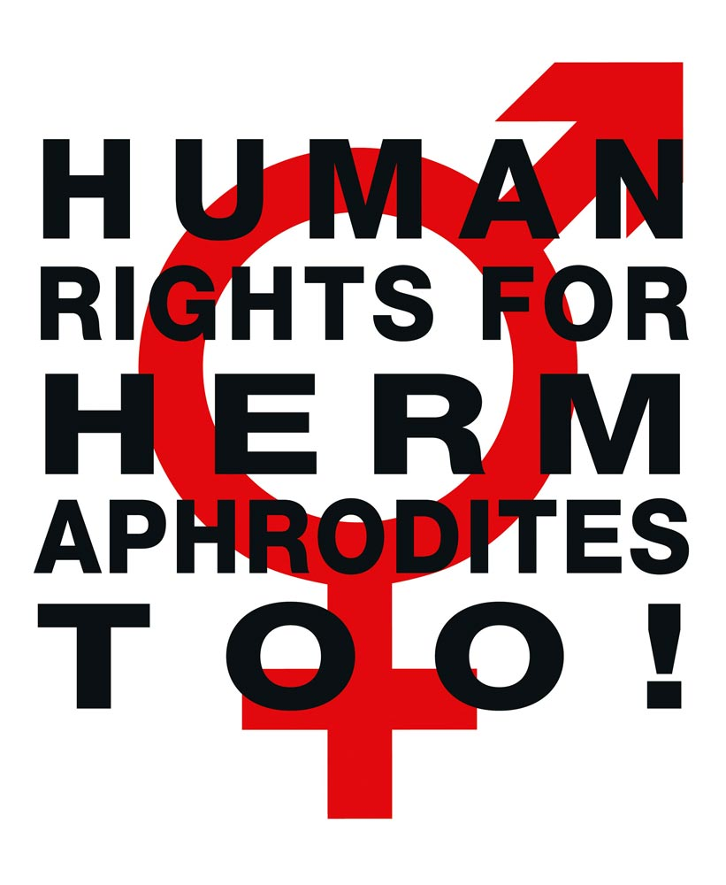

NGO Report (for Session)
to the 2nd and 3rd Periodic Report of Germany on the
Convention on the Rights of Persons with Disabilities
(CRPD)
Compiled by:

StopIGM.org / Zwischengeschlecht.org (International Intersex Human Rights NGO)
Markus Bauer, Daniela Truffer
Zwischengeschlecht.org
P.O.Box 1318
CH-8031 Zurich
info_at_zwischengeschlecht.org
https://Zwischengeschlecht.org/
https://StopIGM.org

August 2023

This NGO Report online:
DOCX: https://intersex.shadowreport.org/public/2023-CRPD-Germany-NGO-Intersex-StopIGM.docx
PDF: https://intersex.shadowreport.org/public/2023-CRPD-Germany-NGO-Intersex-StopIGM.pdf

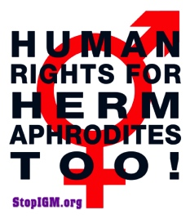

Executive Summary
Despite a new 2021 “Law on the Protection of Children with Variants of Sex Development”, all typical forms of IGM practices are still widespread in Germany today, facilitated and paid for by the State party via the public health care system, and practiced with impunity. Latest available statistics indicate about 1,900 involuntary, non-urgent interventions annually. Survivors of IGM continue to be denied access to justice and reparations due to lack of effective legal prohibition and the statutes of limitations.
Germany is thus in breach of its obligations to (a) take effective legislative, administrative, judicial or other measures to prevent involuntary, non-urgent genital surgery and other harmful medical treatment of intersex children, (b) to ensure access to justice, redress, compensation and rehabilitation for victims, and c) to provide families with intersex children with adequate psychosocial and peer support (art. 17).
This Committee, as well as CAT, CEDAW, CCPR and CRC have already considered IGM in Germany as constituting at least violation of the integrity of the person, inhuman treatment and a harmful practice. Nonetheless, to this day the German Government fails to act.
In total, UN treaty bodies CRPD, CRC, CEDAW, CAT and CCPR have so far issued 83 Concluding Observations recognising IGM as a serious violation of non-derogable human rights, typically obliging State parties to enact legislation to (a) end the practice and (b) ensure redress and compensation, plus (c) access to free counselling. Also, the UN Special Rapporteurs on Torture (SRT) and on Health (SRH), the UN High Commissioner for Human Rights (UNHCHR), the World Health Organisation (WHO), the Inter-American Commission on Human Rights (IACHR), the African Commission on Human and Peoples’ Rights (ACHPR) and the Council of Europe (COE) recognise IGM as a serious violation of non-derogable human rights.
Intersex people are born with Variations of Reproductive Anatomy, including atypical genitals, atypical sex hormone producing organs, atypical response to sex hormones, atypical genetic make-up, atypical secondary sex markers. While intersex people may face several problems, in the “developed world” the most pressing are the ongoing Intersex Genital Mutilations, which present a distinct and unique issue constituting significant human rights violations.
IGM practices include non-consensual, medically unnecessary, irreversible, cosmetic genital surgeries, and/or other harmful medical procedures that would not be considered for “normal” children, without evidence of benefit for the children concerned. Typical forms of IGM include “masculinising” and “feminising”, “corrective” genital surgery, sterilising procedures, imposition of hormones, forced genital exams, vaginal dilations, medical display, involuntary human experimentation and denial of needed health care.
IGM practices cause known lifelong severe physical and mental pain and suffering, including loss or impairment of sexual sensation, painful scarring, painful intercourse, incontinence, urethral strictures, impairment or loss of reproductive capabilities, lifelong dependency of artificial hormones, significantly elevated rates of self-harming behaviour and suicidal tendencies, lifelong mental suffering and trauma, increased sexual anxieties, and less sexual activity.
For 30 years, intersex people have denounced IGM as harmful and traumatising, as western genital mutilation, as child sexual abuse and torture, and called for remedies.
This Thematic NGO Report was compiled by the international intersex NGO Zwischengeschlecht.org / StopIGM.org. It contains Suggested Recommendations (p. 21).
NGO Report (for Session) to the 2nd and 3rd Periodic Report of Germany
on the Convention on the Rights of Persons with Disabilities (CRPD)

Table of Contents

IGM Practices in Germany

Executive Summary 3
A. Introduction 5
1. Intersex, IGM and Human Rights in Germany 5
2. About the Rapporteurs 5
3. Methodology 6
B. Precedents: Concluding Observations, LOIPR, State Party Report 7
1. Previous Concluding Observations 7
a) Inhuman Treatment: CAT 2011, CAT/C/DEU/CO/5, para 20 7
b) Integrity of the Person: CRPD 2015, CRPD/C/DEU/CO/1, paras 37-38 7
c) Harmful Practices: CEDAW 2017, CEDAW/C/DEU/CO/7-8, paras 23-24 8
d) Inhuman Treatment: CCPR 2021, CCPR/C/DEU/CO/7, paras 20-21 9
e) Harmful Practices: CRC 2022, CRC/C/DEU/CO/5-6, para 24(c)) 9
2. Current 2nd and 3rd CRPD Cycle: LOIPR and State Party Report 9
a) 2018 List of Issues (LOIPR) (CRPD/C/DEU/QPR/2-3, para 16(b)) 9
b) 2019 State Party Report under LOIPR (CRPD/C/DEU/2-3, para 162) 10
C. IGM in Germany: State-sponsored and pervasive, Gov fails to act 11
1. Germany’s commitment to “protect intersex children” 11
a) UNHRC45 Statement, 01.10.2020 11
b) UNHRC48 Statement, 04.10.2021 11
2. IGM practices in Germany: Still pervasive, no effective protections 11
3. 2019 Follow-up study on IGM underlines persisting practice 12
4. Insufficient 2021 Law introducing § 1631e BGB aimed at prohibiting IGM 13
5. Medical guidelines prescribing IGM practices remain in force 15
6. Statutes of limitations and lack of effective prohibition 15
7. IGM Practices: Known German Case Law (updated) 16
a) Criminal Law: 0 cases 16
b) Civil Law: 1 successful adult case, 2 adult settlements 17
c) Victim’s Compensation Law (OEG): 4 failed Cases 18
d) Compensation Fund 20
D. Suggested Recommendations 21
Annexe 1 – Intersex as “Invalidity”: Historical Medical Examples 22
1916–1950s: “Intersex = bastardisation” caused by “racial mixing” 22
Baltimore and Zurich 1950: Start of systematic “genital corrections” 23
Annexe 2 – “IGM in Medical Textbooks: Current Practice” 24
IGM 1 – “Masculinising Surgery”: “Hypospadias Repair” 24
IGM 2 – “Feminising Surgery”: “Clitoral Reduction”, “Vaginoplasty” 26
IGM 3 – Sterilising Surgery: Castration / “Gonadectomy” / Hysterectomy 28
“Bad results” / “Gonadectomy, Feminising Genitoplasty” 30

A. Introduction

1. Intersex, IGM and Human Rights in Germany
Germany has been reviewed by CAT (2011), CRPD (2015), CEDAW (2017), CCPR (2021) and CRC (2022) with all Committees recognising IGM in Germany as constituting a harmful practice, cruel, inhuman or degrading treatment or torture, and a violation of integrity respectively.
IGM practices were mentioned in the LOIPR (para 16). In its State Party Report (para 162) the German Government referred to the then upcoming Draft Law eventually resulting in the 2021 “Law on the Protection of Children with Variants of Sex Development” introducing § 1631e BGB aimed at prohibiting IGM, which, however, fails to adequately protect intersex children from IGM practices (see below, p. 13-15).
Nonetheless, Germany continues to deny the serious nature of the violations constituted by IGM practices, and refuses to take effective legislative, administrative, judicial or other measures, including prohibition under Criminal Law, to protect intersex children from cruel, inhuman or degrading treatment and harmful practices, despite public criticism by intersex advocates and even Government appointed legal, human rights and other experts (see below, p. 14).
This NGO Report demonstrates that the persisting harmful medical practice on intersex persons in Germany – advocated, facilitated and paid for by the State party, and practiced with impunity –, as well as the ongoing denial of access to justice and reparations for IGM survivors, constitute serious breaches of Germany’s obligations under the Convention.

2. About the Rapporteurs
This NGO report has been prepared by the international intersex NGO StopIGM.org / Zwischengeschlecht.org:
- StopIGM.org / Zwischengeschlecht.org is an international intersex human rights NGO based in Switzerland, working to end IGM practices and other human rights violations perpetrated on intersex people, according to its motto, “Human Rights for Hermaphrodites, too!” According to its charter, StopIGM.org works to support persons concerned seeking redress and justice and regularly reports to relevant UN treaty bodies, often in collaboration with local intersex advocates and NGOs, substantially contributing to the so far 83 Treaty body Concluding Observations recognising IGM as a serious human rights violation.
StopIGM.org includes members from Germany and has been active in Germany since 2007, supporting intersex persons suing IGM perpetrators, publicly confronting individual perpetrators and hospitals, documenting the ongoing practice, raising awareness in the media, collaborating with members of parliament on parliamentary questions on the federal and on the Länder level, and testifying before the German National Ethics Council, calling for effective remedies to end the practice, and previously reported on IGM in Germany to CAT, CRPD, CEDAW, CCPR and CRC.
In personal capacity co-founder Daniela Truffer is also a member of the German intersex self-help group XY-Women, serving as a first contacter for 7 years, and of the German Association of Intersex People, serving as chair when it first submitted a thematic report to a UN Treaty body, leading to the first ever recommendations on intersex in 2009.
3. Methodology
This thematic NGO report is an update to the 2018 CRPD NGO Report for LOIPR. It is based on the 2022 CRC NGO Report for Session.

B. Precedents: Concluding Observations, LOIPR, State Party Report
1. Previous Concluding Observations
a) Inhuman Treatment: CAT 2011, CAT/C/DEU/CO/5, para 20
Intersex people
20. The Committee takes note of the information received during the dialogue that the Ethical Council has undertaken to review the reported practices of routine surgical alterations in children born with sexual organs that are not readily categorized as male or female, also called intersex persons, with a view to evaluating and possibly changing current practice. However, the Committee remains concerned at cases where gonads have been removed and cosmetic surgeries on reproductive organs have been performed that entail lifelong hormonal medication, without effective, informed consent of the concerned individuals or their legal guardians, where neither investigation, nor measures of redress have been introduced. The Committee remains further concerned at the lack of legal provisions providing redress and compensation in such cases (arts. 2, 10, 12, 14 and 16).
The Committee recommends that the State party:
(a) Ensure the effective application of legal and medical standards following the best practices of granting informed consent to medical and surgical treatment of intersex people, including full information, orally and in writing, on the suggested treatment, its justification and alternatives;
(b) Undertake investigation of incidents of surgical and other medical treatment of intersex people without effective consent and adopt legal provisions in order to provide redress to the victims of such treatment, including adequate compensation;
(c) Educate and train medical and psychological professionals on the range of sexual, and related biological and physical, diversity; and
(d) Properly inform patients and their parents of the consequences of unnecessary surgical and other medical interventions for intersex people.

b) Integrity of the Person: CRPD 2015, CRPD/C/DEU/CO/1, paras 37-38
Protecting the integrity of the person (art. 17)
37. The Committee is concerned about: (a) the use of compulsory and involuntary treatment, in particular for persons with psychosocial disabilities in institutions and older persons in residential care; (b) the lack of data on involuntary placement and treatment; (c) the practice of carrying out forced sterilization and coercive abortions on adults with disabilities on the basis of substituted consent; and (d) the lack of implementation of the 2011 recommendations of the Committee against Torture (see CAT/C/DEU/CO/5, para. 20) regarding upholding the bodily integrity of intersex children.
38. The Committee recommends that the State party take the measures, including of a legislative nature, necessary to:
(a) Repeal section 1905 of the German Civil Code and explicitly prohibit in law sterilization without the full and informed consent of the individual concerned, eliminating all exceptions, including those based upon substituted consent or court approval;
(b) Ensure that all psychiatric treatments and services are always delivered with the free and informed consent of the individual concerned;
(c) Investigate human rights violations in psychiatric and older persons care settings in all Länder;
(d) Implement all the recommendations of the Committee against Torture (ibid.) relevant to intersex children.

c) Harmful Practices: CEDAW 2017, CEDAW/C/DEU/CO/7-8, paras 23-24
Harmful practices
23. The Committee welcomes the adoption of legislative and other measures to combat harmful practices, including the forty-seventh Criminal Law Amendment Act (2013) prohibiting female genital mutilation and the establishment of an inter- ministerial working group on intersexuality/transsexuality. Nevertheless, the Committee is concerned about:
[…]
(d) The lack of clear legislative provisions prohibiting the performance of unnecessary medical procedures on infants and children of indeterminate sex until they reach an age at which they are able to provide their free, prior and informed consent;
(e) Inadequate support and the lack of effective remedies for intersex persons who have undergone medically unnecessary surgical procedures at a very early age, often with irreversible consequences, resulting in long-term physical and psychological suffering.
24. In the light of joint general recommendation No. 31 of the Committee on the Elimination of Discrimination against Women/general comment No. 18 of the Committee on the Rights of the Child (2014) on harmful practices, the Committee recommends that the State party:
[…]
(d) Adopt clear legislative provisions explicitly prohibiting the performance of unnecessary surgical or other medical treatment on intersex children until they reach an age at which they can provide their free, prior and informed consent; provide the families of intersex children with adequate counselling and support; and ensure that the German Medical Association provides information to medical professionals on the legal prohibition of unnecessary surgical or other medical interventions for intersex children;
(e) Ensure the effective access to justice, including by amending the statute of limitations, of intersex persons who have undergone unnecessary surgical or other medical treatment without their free, prior and informed consent; and consider the proposal of the German Ethics Council to establish a State compensation fund.

d) Inhuman Treatment: CCPR 2021, CCPR/C/DEU/CO/7, paras 20-21
Intersex persons
20. The Committee is concerned about reports that intersex children have sometimes been subjected to invasive, medically unnecessary and irreversible medical procedures aimed at assigning them a sex. It is also concerned that such actions are often based on a stereotyped vision of gender roles, involve humiliating and painful procedures and are carried out before the affected persons are of an age to give their free and informed consent. It is further concerned that victims of such practices face significant barriers to accessing remedies, despite suffering lasting physical and psychological harm, including owing to statutes of limitations impeding child victims from seeking redress when they are adults, difficulties accessing health records and compensation not being available. The Committee commends the State party for introducing the Law on the Protection of Children with Variations in Sex Development in 2021. It nevertheless remains concerned by reports that the Law does not specifically restrict all problematic practices, establish criminal liability or effectively address all barriers to access to remedies for victims (arts. 2–3, 7, 17, 24 and 26).
21. The State party should take all steps necessary to ensure that all acts relating to the assignment of a sex to intersex children performed without their free and informed consent are specifically prohibited, except in cases where such interventions are absolutely necessary for medical reasons and the best interests of the child have been duly taken into account. This should include the consideration of amendments to the Law on the Protection of Children with Variations in Sex Development of 2021 within the five-year period allocated for its review, if necessary. The State party should also ensure that all victims have access to remedies, including through a revision of the application of statutes of limitation for violations in childhood, taking steps to ensure that all victims have access to their health records and considering the establishment of a dedicated compensation fund.

e) Harmful Practices: CRC 2022, CRC/C/DEU/CO/5-6, para 24(c))
Harmful practices
24. Recalling joint general recommendation No. 31 of CEDAW/general comment No. 18 of CRC on harmful practices, the Committee recommends that the State party: […]
(c) Enforce the Act on the Protection of Children with Variants of Sex Development, and establish procedural safeguards and accountability mechanisms for medical doctors.

2. Current 2nd and 3rd CRPD Cycle: LOIPR and State Party Report
a) 2018 List of Issues (LOIPR) (CRPD/C/DEU/QPR/2-3, para 16(b))
Protecting the integrity of the person (art. 17)
16. Please inform the Committee about: [...]
(b) Initiatives to implement its recommendations relating to intersex children (CRPD/C/DEU/CO/1, para. 38 (d)).
b) 2019 State Party Report under LOIPR (CRPD/C/DEU/2-3, para 162)
Paragraph 16 (b)
162. Germany is working on a provision to protect children with variations in physical sex characteristics against gender confirmation. A law is to clarify that gender confirmation surgery on children is only permitted to avert risks to life or health. The details on the form a legislative provision should take were discussed at an interdisciplinary conference with individuals concerned and experts from various disciplines. A legislative draft will be presented shortly.

C. IGM in Germany: State-sponsored and pervasive, Gov fails to act
1. Germany’s commitment to “protect intersex children from violence and harmful practices”, “investigate abuses”, “ensure accountability” and “access to remedy”
a) UNHRC45 Statement, 01.10.2020
On occasion of the 45th Session of the Human Rights Council the State party supported a public statement calling to “protect […] intersex adults and children […] so that they live free from violence and harmful practices. Governments should investigate human rights violations and abuses against intersex people, ensure accountability, […] and provide victims with access to remedy.”
b) UNHRC48 Statement, 04.10.2021
On occasion of the 48th Session of the Human Rights Council the State party supported a public follow-up statement reiterating the call to end harmful practices and ensure access to justice:
“Intersex persons also need to be protected from violence and States must ensure accountability for these acts. […]
Furthermore, there is also a need to take measures to protect the autonomy of intersex children and adults and their rights to health and to physical and mental integrity so that they live free from violence and harmful practices. Medically unnecessary surgeries, hormonal treatments and other invasive or irreversible non-vital medical procedures without their free, prior, full and informed consent are harmful to the full enjoyment of the human rights of intersex persons.
We call on all member states to take measures to combat violence and discrimination against intersex persons, develop policies in close consultations with those affected, ensure accountability, reverse discriminatory laws and provide victims with access to remedy.”
2. IGM practices in Germany: Still pervasive, no effective protections
Nonetheless, in Germany, as well as in many more State parties, there are
- no effective legal or other protections in place to ensure the rights of intersex children to physical and mental integrity, autonomy and self-determination, and to prevent IGM
- no measures in place to ensure systematic data collection and monitoring of IGM
- no legal or other measures in place to ensure the accountability of IGM perpetrators
- no legal or other measures in place to ensure access to redress and justice for adult IGM survivors
Despite adopting a new Law aimed at prohibiting IGM practices which entered in force on 12 May 2021, to this day the German government refuses to “take effective legislative, administrative, judicial or other measures” to protect intersex children, denying survivors of IGM practices access to justice and redress.
3. 2019 Follow-up study on IGM underlines persisting practice
In 2016, two studies using partial data from the “Diagnosis Related Groups (DRG)” of intersex surgeries in German hospitals financed by the Public Health System reported on average 1,700 IGM procedures every year (see our 2018 NGO Report for LOIPR, p. 13-14, 21-24).
A new 2019 “Follow-up study” on IGM practices commissioned by the Federal Government again using partial data from the “Diagnosis Related Groups (DRG)” reported on average almost 1,900 “masculinising” and “feminising” surgeries every year on intersex children 0-9 years alone:
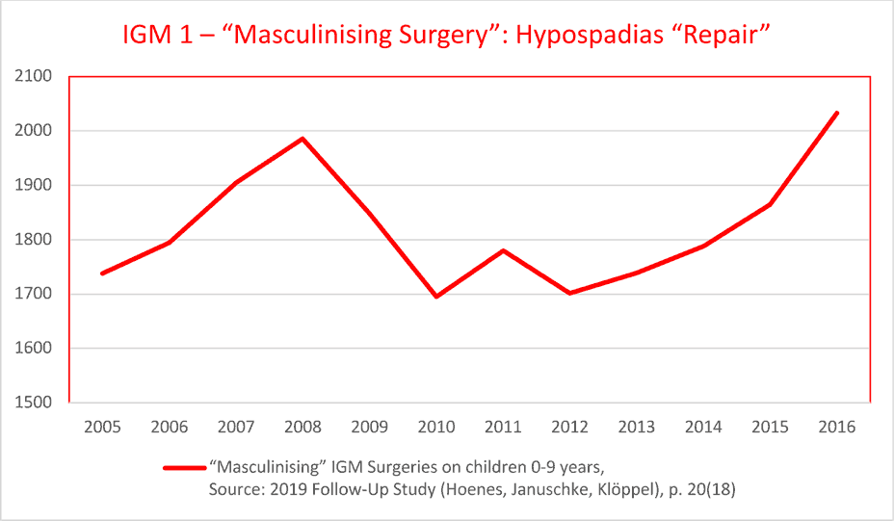
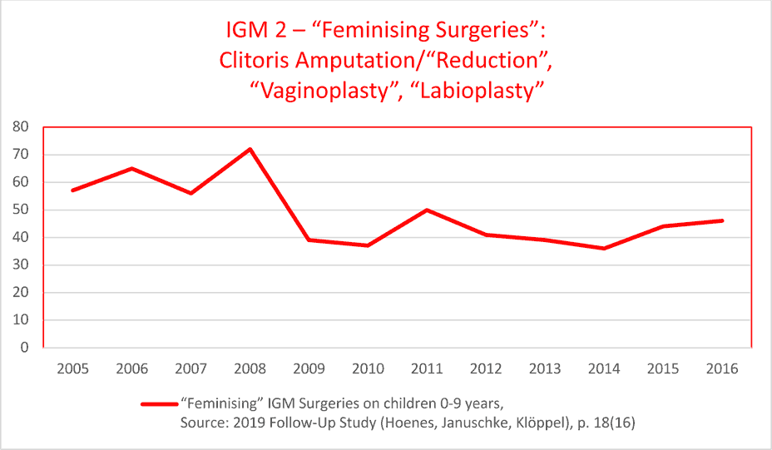
While the “Follow-up study” fails to document sterilising procedures, partial figures published by the “Statistisches Bundesamt (Destatis)” show that also IGM 3 continues:
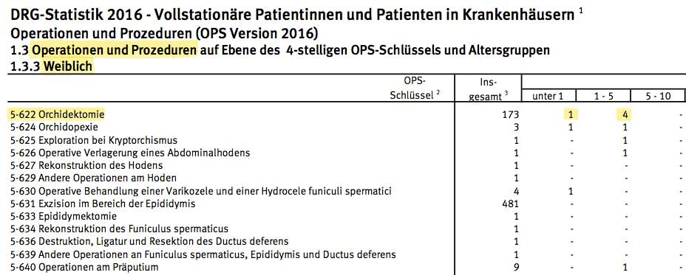
4. Insufficient 2021 Law introducing § 1631e BGB aimed at prohibiting IGM
After 25 years of endless “discussions” and “careful examination” without any actual consequences, the current German government has to be commended for finally adopting a Law aimed at prohibiting IGM practices in March 2021 – insufficient as it may be:
In January 2020, the Ministry of Justice and Consumer Protection (BMJV) presented a preliminary Draft Law (RefE) aimed at prohibiting IGM practices (“Draft Law for the protection of children from sex-modifying surgical interventions”). However, it failed to provide adequate protections for intersex children (see also State Party Report, para 162).
In November 2020, the German Federal Government presented an amended “Draft Law for the protection of children with variants of sex development” (DS 19/24686, 25.11.2020), which in March 2021 was again amended by the Committee on Legal Affairs and Consumer Protection (DS 19/27929, 24.03.2021) and eventually adopted by the German Federal Parliament (Bundestag) on 25.03.2021 and published in the Federal Law Gazette on 21.05.2021 as “Law on the Protection of Children with Variants of Sex Development of 12 May 2021”:
Basically, this new Law introduces in Art. 1 a new § 1631e in the Civil Law (BGE) which in some cases limits parental consent to unnecessary surgery on intersex children (§ 1631e (1)-(3)), and requires them to seek authorisation by the Family Court (§ 1631e (3)-(5)):
“Parental custody does not include the right to consent to treatment of a child who is incapable of giving consent and has a variant of sex development, or to carry out such treatment oneself, which, without any further reason for the treatment being added, is carried out solely with the intention of aligning the child’s physical appearance with that of the male or female sex.” (Civil Law (BGB), § 1631e (1))
Further, the Law obliges medical practitioners, “where treatment has been carried out on the internal or external sex characteristics, [to] keep the patient’s file until the day on which the person treated reaches the age of 48 years.” (§ 1631e (6))
Also, in Art. 6 on “Evaluation” of the new Law stipulates a review and possible amendments within five years:
“The Federal Government shall review the effectiveness of the provisions of Articles 1 and 3 of this Act within five years of their entry into force and shall submit a report thereon to the German Bundestag.”
However, this new Law
- only partially restricts IGM 2 and IGM 3, while in turn explicitly allows, among other things, the most frequent unnecessary interventions, i.e. IGM 1
- fails to criminalise or adequately sanction IGM practices
- fails to address obstacles to access to justice and redress, namely the statutes of limitation
- fails to implement minimal requirements as stipulated in UN Conventions, and recognised by the relevant Committees as applicable to IGM practices in previous State party reviews and Concluding Observations, inter alia CAT art. 2, 10, 12, 14 (in conjunction with General Comment No. 3), 16 (in conjunction with General Comment No. 2), CRC art. 24(3) and CEDAW art. 5, both in conjunction with the CRC-CEDAW Joint General Comment No. 18/31 on harmful practices, CCPR art. 2, 3, 7, 9, 17, 24, 26, as well as CRPD art. 10, 15, 16, 17.
Particularly the lack of criminalisation or adequate sanctions and the lack of addressing the statutes of limitation, as well as the failure to establish a national register for relevant medical records, was also criticised by several experts at a hearing by the Federal Committee on Legal Affairs and Consumer Protection on 13.01.2021.
After the adoption of the new Law, its shortcomings and loopholes were again widely criticised by intersex NGOs and legal experts.
The lack of sanctions was also highlighted by doctors involved in IGM practices:
“[…] Olaf Hiort - a professor at the University Hospital in Luebeck - said he hoped [the German ban] would ‘curb uncontrolled operations’.
He noted, however, that while there was now a ban, ‘there is no penalty’.”
Nonetheless, during the 2021 interactive dialogue with CCPR the German delegation counterfactually claimed:
“Yes, on the question of the statute of limitations, I had forgotten that yesterday, that was actually discussed during the legislative process. The time limits have been extended and it is now available for those affected up to the age of 48 to investigate or ask questions about it and to deal with it.”
However, according to the Law, only the period for keeping medical records was extended to 48 years, but not the statutes of limitations.
Accordingly, in its 2021 Concluding Observations CCPR once more obliged Germany to “ensure that all victims have access to remedies, including through a revision of the application of statutes of limitation for violations in childhood, taking steps to ensure that all victims have access to their health records and considering the establishment of a dedicated compensation fund” (CCPR/C/DEU/CO/7, paras 20-21).
5. Medical guidelines prescribing IGM practices remain in force
Despite the new Law, the German Urological Association (“Deutsche Gesellschaft für Urologie (DGU)”) still endorses the 2023 Guidelines of the European Association of Urology (EAU), which include the current ESPU/EAU “Paediatric Urology” Guidelines 2023 of the European Society for Paediatric Urology (ESPU) and the European Association of Urology (EAU) which promote all forms of IGM practices, in particular IGM 3: “removal of testes”, IGM 2: partial clitoris amputation on young children based on “social and emotional conditions” and substituted decision-making by “parents and caregivers implicitly act[ing] in the best interest of their children”, and IGM 1: “The age at surgery for primary hypospadias repair is usually 6-18 (24) months.”
6. Statutes of limitations and lack of effective prohibition:
Main obstacles preventing access to justice for IGM survivors
Generally, the statutes of limitation prevent survivors of early childhood IGM Practices to call a court, because IGM survivors often do not find out about their medical history until much later in life, which in combination refusal of hospitals to provide access to medical records and severe trauma caused by IGM Practices regularly prove to amount to an insurmountable obstacle.
This is well-known to and publicly admitted by the Government at least regarding Civil Law, referring to “claims” of intersex advocates for “prolongation of limitation periods for asserting civil claims under medical malpractice law”.
Also the fact that the lack of effective legislative prohibition of IGM practices constitutes yet another insurmountable obstacle to IGM survivors seeking redress has been publicly admitted by the Federal government, as well as by various Social Courts (see next section).
7. IGM Practices: Known German Case Law (updated)
As already mentioned in our 2020 NGO Report for LOI (p. 3), the lack of access to justice, redress and compensation for survivors of IGM practices in Germany is well known and near total. The following updated and expanded section demonstrates that also in 2022 this is still true:
a) Criminal Law: 0 cases
No survivor of IGM practices ever succeeded in successfully filing criminal charges.
In case of average early surgeries “in the first two years of life”, all statutes of limitations have long passed before survivors come of age. This is also confirmed by a practical case:
Case 1: Survivor of IGM practices with acknowledged disability grade (GdB) of 50% and unable to work due to IGM. Born 1972, at age 5 the person concerned was submitted to a non-consensual full clitoridectomy, and from 1979-1983 to involuntary human experimentation with “Androcur” (the risky, meanwhile discredited preparation best known for its application for “chemical castration” of sex offenders). On 24.06.2022 the person concerned filed a criminal complaint on the grounds of genital mutilation (§ 226 a) StGB) against involved doctors to the State prosecutor’s office. However, on 25.07.2022 the State prosecutor’s office rejected the complaint due to expiration of the statutes of limitations and further stated that § 226 a) of the Criminal Code was not applicable in this case.
To this day, persons concerned and their organisations in vain call for a legal review of the statutes of limitations in cases of IGM practices, referring to current and recent legal reviews regarding adjournment or suspension of the statutes of limitation in cases of child sexual abuse (§§ 176 ff. StGB), and female genital mutilation (§ 226a StGB).
Already in 2014, also the 24th Conference of Ministers for Women’s Issues and Equality (GFMK) explicitly called for a “legal ban of medically unnecessary surgical and pharmacological [...] interventions on intersex minors,” explicitly referring to the need of intersex children for similar protection against sterilisation (§ 1631c BGB) and female genital mutilation (§ 226a StGB) that other children and girls already enjoy.
On occasion of the adoption of the new insufficient Law § 1631e BGB, its lack of criminalisation or adequate sanctions and the lack of addressing the statutes of limitation has again been widely criticised by intersex NGOs and legal experts (see above, p. 14).
b) Civil Law: 1 successful adult case, 2 adult settlements
No survivor of childhood IGM practices ever succeeded in filing civil charges.
Only 3 survivors of IGM practices so far succeeded in filing civil charges – all of them only for surgeries they were submitted to as adults of 18 years or older.
All other survivors of IGM practices attempting to sue so far were prevented by the statutes of limitations.
Already in 2009 during an intersex hearing of the State Parliament of Hamburg, specialised local lawyer Dr Oliver Tolmein stated: “Interestingly, a great many [intersex] persons come to our lawyer’s office wanting to sue their doctors for damages [however, so far all were prevented by the statutes of limitations]”.
Case 1: The first case in Cologne 2007-2009 filed by Christiane Völling concerned the removal of ovaries and uterus without informed consent and resulted in a surgeon being sentenced to pay 100’000 Euros damages.
Case 2: Case filed 2012 in Munich. In the meantime the claimant agreed to a settlement as the person couldn’t afford to continue a costly, lengthy Civil Law suit.
Case 3: Case filed 2011 in Nuremberg by Michaela Raab concerning involuntary partial clitoris amputation and gonadectomy (castration), with a first instance verdict on 17.12.2015 sentencing the Erlangen University Clinic to pay damages. After the defendants lodged an appeal, the case rested 3 years without activity in the second instance at the Higher Court (OLG), Eventually, a court date was set for 07.02.2019 to “appraise the facts” and “attempt a settlement”. In the end, Michaela Raab, worn down and tired after 8 years of legal proceedings and without the necessary funds to continue a costly, lengthy Civil Law suit, accepted a settlement of 40,000 Euros, as reported in a local newspaper:
“Michaela Raab demanded 250,000 euros plus a pension through lawyer Paul Haubrich - and has now settled for 40,000 euros in a settlement before the Higher Court. The representatives of the university hospital (annual budget 2017: 769 million euros, 7586 employees, 1194 of them doctors) say the insurance would not cover the period in question. More than 40,000 euros could not be financed. Theoretically, Michaela Raab is free to reject the settlement and continue to fight with the clinic. But after the OLG comes the BGH [Federal Supreme Court] - and the financial risk of litigation is incalculable for Michaela Raab.”
c) Victim’s Compensation Law (OEG): 4 failed Cases
The Victims Compensation Law (Opferentschädigungsgesetz, OEG) was introduced with the stated intent “to create a financial compensation in cases of the state failing its mission to prevent crimes”.
So far, no survivor of IGM practices succeeded in winning any compensation, with the courts consistently denying compensation to IGM victims, including by explicitly stating that for the plaintiff to be eligible for compensation, “there would have to be laws [against IGM practices] in place. However, there aren’t.” (see below Case 2)
Another case, originally initiated in Hamburg in 2009 (!), has been dragging on for 12 years, with court after court concluding that non-consensual full clitoridectomy and medical experimentation with “Androcur” would constitute “state of the art” legal medical interventions “serv[ing] the well-being of the patient”, and that – contrary to CAT/C/DEU/CO/5, para 20; CRPD/C/DEU/CO/1, paras 37-38; CEDAW/C/DEU/CO/7-8, paras 23-24; CCPR/C/DEU/CO/7, paras 20-21 – “[a]lso a human experiment and torture [or CIDT] is not to be assumed”, and the right to compensation under OEG definitively rejected by the highest instance in 2021 (see below Case 4).
Case 1: Survivor of IGM practices with acknowledged disability grade (GdB) due to IGM, unable to work. Right to compensation denied by court in 2012, on the grounds of lacking “hostile intent” (“feindselige Absicht”) of perpetrating doctors, referring to lack of “own financial interests of treating clinicians”.
Case 2: Survivor of IGM practices with acknowledged disability grade (GdB) of 80% due to IGM, unable to work. Right to compensation denied by court in 2012, on the grounds of lacking “hostile intent” (“feindselige Absicht”) of perpetrating doctors. As mentioned above (D.2.), in addition the court explicitly stated, for the plaintiff to be eligible for compensation “there would have to be laws [against IGM practices] in place. However, there aren’t.”
Case 3: Survivor of IGM practices with acknowledged disability grade (GdB) of 60% due to IGM, unable to work. Right to compensation denied by court in 2014, on the grounds of lacking “hostile intent” (“feindselige Absicht”) of perpetrating doctors.
Case 4: Survivor of IGM practices with acknowledged disability grade (GdB) of 50% and unable to work due to IGM. Born 1972, at age 5 the person concerned was submitted to a non-consensual full clitoridectomy, and from 1979-1983 to involuntary human experimentation with “Androcur” (the risky, meanwhile discredited preparation best known for its application for “chemical castration” of sex offenders). On 29.10.2009 the person concerned first submitted an informal application for OEG compensation, together with the application for disability grade. On 25.06.2010 the person followed-up with a formal application to the State Ministry for Work, Social Affairs, Family and Intergration (BASFI) Hamburg. On 19.03.2012 the lawyer of the person concerned explicitly informed the State ministry of the recent CAT Concluding Observations for Germany on IGM (CAT/C/DEU/CO/5, para 20).
Right to compensation denied by State ministry in 2013, on the grounds of lacking “hostile intent” (“feindselige Absicht”), stating the deeds in question, including non-consensual full clitoridectomy and human experimentation with “Androcur, would not constitute a punishable criminal offense.
On 02.04.2013 the person concerned lodged an appeal at the Social Court Hamburg. There, the case rested for over 69 months.
On 19.12.2018 the Social court eventually denied compensation, arguing the non-consensual full clitoridectomy and medical experimentation with “Androcur” would constitute a legal medical therapy for intersex children still recommended today, which would “serve the well-being of the patient”, further directly contradicting the CAT Concluding Observations on intersex interventions in Germany, considered as inhuman treatment under CAT arts. 2, 10, 12, 14 and 16 (CAT/C/DEU/CO/5, para 20):
“At the beginning of the 70’s of the last century an early correction of the external genital at Prader stage III was recommended. Even today, surgery in the first two years of life is recommended. It is only since a few years that the choice of the timing of surgery has been controversially discussed in science. Since the surgery corresponds to the state of science, i.e. serves the well-being of the patient, an assault in the sense of the OEG is not given. Also a human experiment and torture [or CIDT] is not to be assumed.” (p. 3-4)
Accordingly, in its conclusion the Social Court Hamburg reiterated, the IGM practices in question would not constitute “punishable medical interventions”, but again “objectively […] serve [the] well-being” of the person concerned:
“The plaintiff has not become a victim of violence in the sense of the OEG, because neither the surgery at the age of five nor the treatment with Androcur nor the bladder puncture are punishable medical interventions, which objectively, i.e. from the point of view of a reasonable third party, did not serve their well-being.” (p. 8)
On 21.01.2019 the person concerned lodged an appeal against this decision at the Higher Social Court Hamburg (Landessozialgericht LSG Hamburg), which on 13.07.2021 rejected the appeal, again ruling the “full clitoris amputation” (“clitoridectomy”) would have lacked “hostile intent” (“feindselige Absicht”), would not constitute “torture and other cruel, inhuman or degrading treatment”, but would essentially be “covered by a curative mandate of the treating doctors”.
On 13.08.2021 the person concerned therefore lodged an appeal at the Federal Social Court (Bundessozialgericht BSG). However, in its ruling of 16.12.2021, the Federal Social Court rejected the appeal. Therefore, after 12 years of legal struggle, the right to compensation under OEG was definitively rejected by the highest instance.
This situation is clearly not in line with Germany’s obligations under the Convention.
d) Compensation Fund
A longstanding demand is a compensation fund for IGM survivors unable to pursue legal avenues, for example due to the statutes of limitations. In 2012 the German Ethics Council recommended to establish a compensation fund.
This all is well-known to and publicly admitted by the Government confirming already in 2016, “Other claims touch on the question of the establishment of a compensation fund for people who have had sex-assigning surgeries in the past”.
Also, in 2017 CEDAW explicitly obliged Germany (CEDAW/C/DEU/CO/7-8, paras 23-24) to “consider the proposal of the German Ethics Council to establish a State compensation fund”.
What’s more, in 2021 CCPR once more obliged Germany to “ensure that all victims have access to remedies, including through a revision of the application of statutes of limitation for violations in childhood, taking steps to ensure that all victims have access to their health records and considering the establishment of a dedicated compensation fund” (CCPR/C/DEU/CO/7, paras 20-21).
However, to this day the Government refuses to undertake any actual steps, again ...
D. Suggested Recommendations

The Rapporteurs respectfully suggest that, with respect to the treatment of intersex persons in Germany, the Committee includes the following measures in their recommendations to the German Government:

Intersex Genital Mutilation
While welcoming the recent adoption of the Law on the Protection of Children with Variants of Sex Development (12 May 2021), the Committee remains seriously concerned about cases of medically unnecessary and irreversible surgery and other treatment on intersex children without their informed consent, which can cause severe suffering, and the lack of legal protections, redress and compensation in such cases.
The Committee recommends that the State party (Articles 15 and 17):
Adopt clear legislative provisions that explicitly prohibit the performance of unnecessary and irreversible medical interventions, including surgical, hormonal or other medical procedures, on intersex infants and children; provide adequate counselling and support for families of intersex children; extend the statute of limitations to enable criminal and civil remedies; and provide health care and psychosocial support to intersex persons who have been subjected to intersex genital mutilation.
Systematically collect data on the number of irreversible surgical and other procedures that are performed on intersex children, disaggregated by age, type of intervention, and geographic location.
Annexe 1 – Intersex as “Invalidity”: Historical Medical Examples

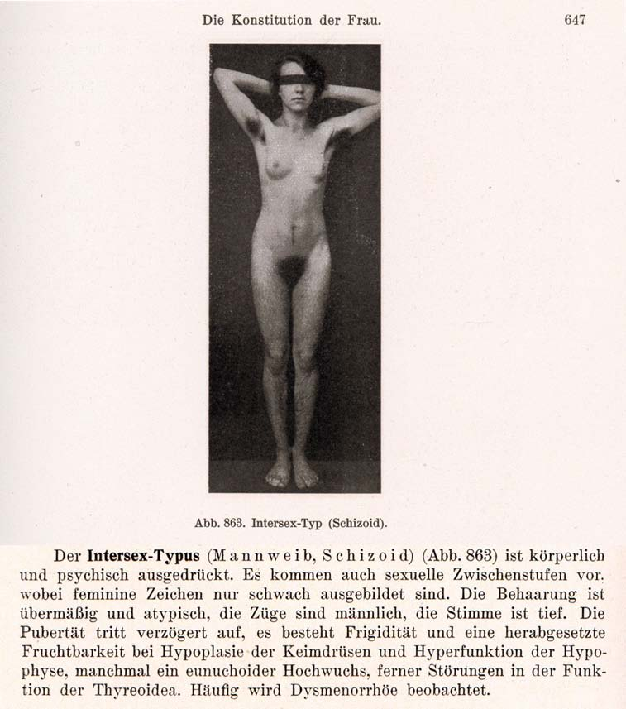
1916–1950s: “Intersex = bastardisation” caused by “racial mixing”;
racist gynaecological diagnosis “intersexual constitution”
The German geneticist Richard Goldschmidt (1878–1958) coined the terms “Intersex” and “Intersexuality” when publicising his experiments of crossbreeding “different geographic races” of gypsy moths, claiming to be able to produce “hermaphroditic” a.k.a. “intersex” specimens of any grade and shape at will, and thereafter extrapolating his findings to humans. Of Jewish descent, in 1936 Goldschmidt was forced to resign as director of the “Kaiser-Wilhelm-Institut für Biologie” in Berlin and emigrated to the United States. Despite Goldschmidt downplaying the “racial” background of his findings since the early 1930’s and later renouncing the underlying genetic theories altogether, the term “Intersex” and its “racial” implications prevailed. In 1924 the gynaecologists Paul Mathes (1871-1923, Austria) and Hans Guggisberg (180-1977, Switzerland) introduced the derived diagnosis “Intersexual Constitution” into human medicine, allegedly caused by “racial mixing”, “most frequent in Jews” and associated with “biological inferiority”, mental illnesses (see above “schizoid”), “hypertrophied clitoris” and a strict verdict “not fit for marriage.” It proved particularly popular among prominent eugenicists and Nazi doctors, including Fritz Lenz, Hans Naujoks, Lothar Gottlieb Tirala, Robert Stigler, Wilhelm Weibel, Walther Stoeckel, and kept being used in medical publications until the 1950s.
Sources: Wilhelm Weibel: Lehrbuch der Frauenheilkunde, 7th ed., Berlin/Wien 1944 p. 647 (photo), 648 (text).
Richard Goldschmidt: “Die biologischen Grundlagen der konträren Sexualität und des Hermaphroditismus beim Menschen”, in: Archiv für Rassen- und Gesellschaftsbiologie 12, 1916.
Paul Mathes, Hans Guggisberg: “Die Konstitutionstypen des Weibes, insbesondere der intersexuelle Typus”, in: Josef Halban, Ludwig Seitz: Biologie und Pathologie des Weibes. Bd.3, 1924.
Helga Satzinger: Racial Purity, Stable Genes, and Sex Difference: Gender in the Making of Genetic Concepts by Richard Goldschmidt and Fritz Lenz, 1916 to 1936. In: Heim et al. (ed.), The Kaiser Wilhelm Society under National Socialism, 2009.
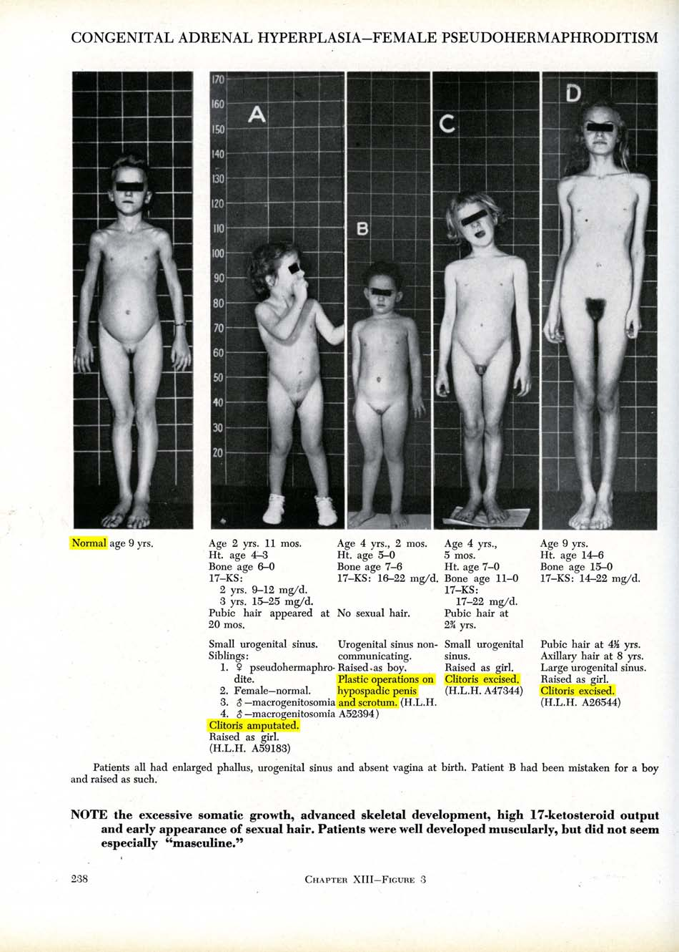
Baltimore and Zurich 1950: Start of systematic “genital corrections”
Lawson Wilkins (1894-1963), “The Father of Pediatric Endocrinology”, and teacher of the famous Swiss paediatric endocrinologist Andrea Prader in 1950, who then introduced the practice in Europe, was also the “inventor” of systematic cosmetic genital surgeries on children. As Wilkins’s monograph illustrates, in 1950 at Johns Hopkins in Baltimore, any child diagnosed “not normal” was submitted to drastic “genital corrections”, either “feminising” or “masculinising”. Often the psychologist John Money gets erroneously credited as having “invented” the systematic mutilations, however, it was Wilkins (and Prader) who started systematic surgeries; Money “only” delivered a “scientific rationale” five years after the fact.
Sources: Lawson Wilkins: The Diagnosis and Treatment of Endocrine Disorders in Childhood and Adolescence. Springfield, 1950.
Alison Redick: American History XY: The Medical Treatment of Intersex, 1916-1955, Dissertation 2004
Annexe 2 – “IGM in Medical Textbooks: Current Practice”
IGM 1 – “Masculinising Surgery”: “Hypospadias Repair”
“Hypospadias,” i.e. when the urethral opening is not on the tip of the penis, but somewhere on the underside between the tip and the scrotum, is arguably the most prevalent diagnosis for cosmetic genital surgeries. Procedures include dissection of the penis to “relocate” the urinary meatus. Very high complication rates, as well as repeated “redo procedures” — “5.8 operations (mean) along their lives … and still most of them are not satisfied with results!”
Nonetheless, clinicians recommend these surgeries without medical need explicitly “for psychological and aesthetic reasons.” Most hospitals advise early surgeries, usually “between 12 and 24 months of age.” While survivors criticise a.o. impairment or total loss of sexual sensation and painful scars, doctors still fail to provide evidence of benefit for the recipients of the surgeries.
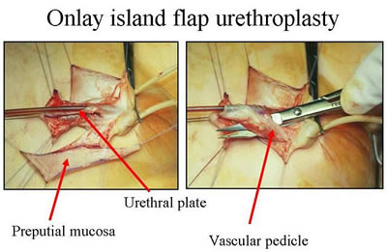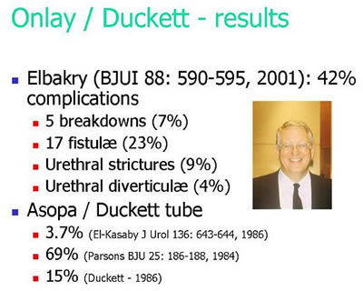
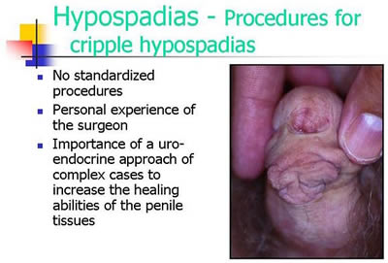
Official Diagnosis “Hypospadias Cripple”
= made a “cripple” by repeat cosmetic surgeries

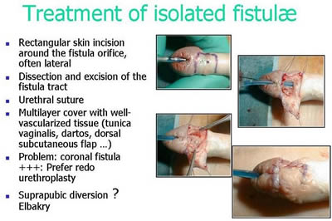
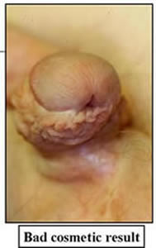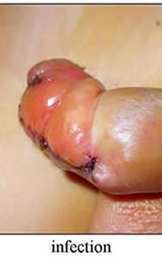
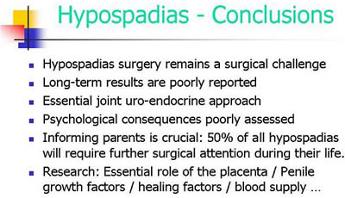
Source: Pierre Mouriquand: “Surgery of Hypospadias in 2006 - Techniques & outcomes”

IGM 2 – “Feminising Surgery”: “Clitoral Reduction”, “Vaginoplasty”
Partial amputation of clitoris, often in combination with surgically widening the vagina followed by painful dilation. “46,XX Congenital Adrenal Hyperplasia (CAH)” is arguably the second most prevalent diagnosis for cosmetic genital surgeries, and the most common for this type (further diagnoses include “46,XY Partial Androgen Insufficiency Syndrome (PAIS)” and “46,XY Leydig Cell Hypoplasia”).
Despite numerous findings of impairment and loss of sexual sensation caused by these cosmetic surgeries, and lacking evidence for benefit for survivors, current guidelines nonetheless advise surgeries “in the first 2 years of life”, most commonly “between 6 and 12 months,” and only 10.5% of surgeons recommend letting the persons concerned decide themselves later.
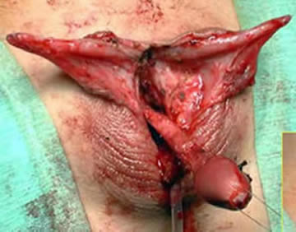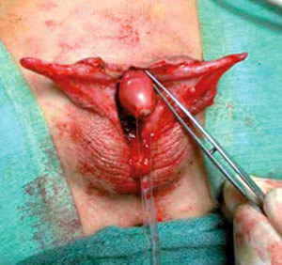
Source: Christian Radmayr: Molekulare Grundlagen und Diagnostik des Intersex, 2004
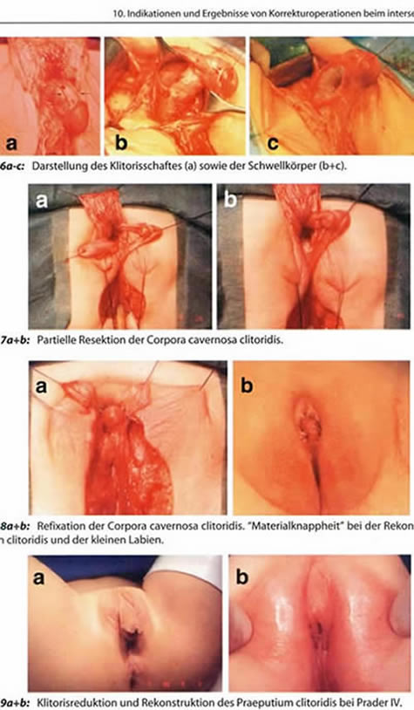
Source: Finke/Höhne: Intersexualität bei Kindern, 2008
Caption 8b: “Material shortage” [of skin] while reconstructing the praeputium clitoridis and the inner labia.
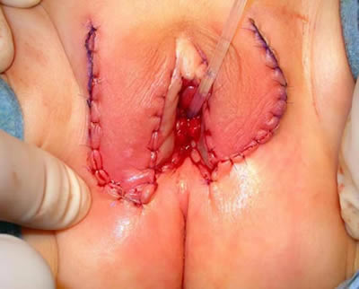
Source: Pierre Mouriquand: “Chirurgie des anomalies du développement sexuel - 2007”, at 81: “Labioplastie”
IGM 3 – Sterilising Surgery: Castration / “Gonadectomy” / Hysterectomy
Removal of healthy testicles, ovaries, or ovotestes, and other potentially fertile reproductive organs. “46,XY Complete Androgen Insufficiency Syndrome (CAIS)” is arguably the 3rd most common diagnosis for cosmetic genital surgeries, other diagnoses include “46,XY Partial Androgen Insufficiency Syndrome (PAIS)”, male-assigned persons with “46,XX Congenital Adrenal Hyperplasia (CAH)”, and other male assigned persons, who have their healthy ovaries and/or uteruses removed.
Castrations usually take place under the pretext of an allegedly blanket high risk of cancer, despite that an actual high risk which would justify immediate removal is only present in specific cases (see table below), and the admitted true reason is “better manageability.” Contrary to doctors claims, it is known that the gonads by themselves are usually healthy and “effective” hormone-producing organs, often with “complete spermatogenesis [...] suitable for cryopreservation.”
Nonetheless, clinicians still continue to recommend and perform early gonadectomies – despite all the known negative effects of castration, including depression, obesity, serious metabolic and circulatory troubles, osteoporosis, reduction of cognitive abilities, loss of libido. Plus a resulting lifelong dependency on artificial hormones (with adequate hormones often not covered by health insurance, but to be paid by the survivors out of their own purse).
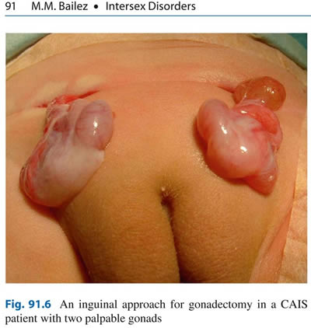
Source: Maria Marcela Bailez: “Intersex Disorders,” in: P. Puri and M. Höllwarth (eds.),
Pediatric Surgery: Diagnosis and Management, Berlin Heidelberg 2009.
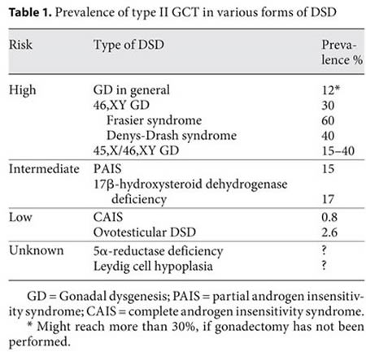
Source: J. Pleskacova, R. Hersmus, J. Wolter Oosterhuis, B.A. Setyawati, S.M. Faradz, Martine Cools, Katja P. Wolffenbuttel, J. Lebl, Stenvert L.S. Drop, Leendert H.J. Looijenga: “Tumor risk in disorders of sex development,” in: Sexual Development 2010 Sep;4(4-5):259-69.
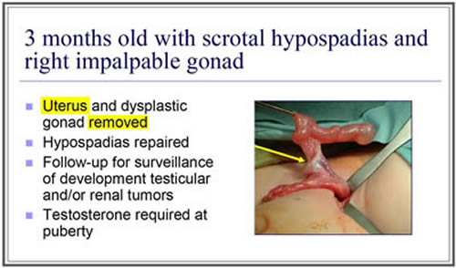
Source: J. L. Pippi Salle: “Decisions and Dilemmas in the Management
of Disorders of Sexual [sic!] Development (DSD),” 2007, at 20.
“Bad results” / “Gonadectomy, Feminising Genitoplasty”
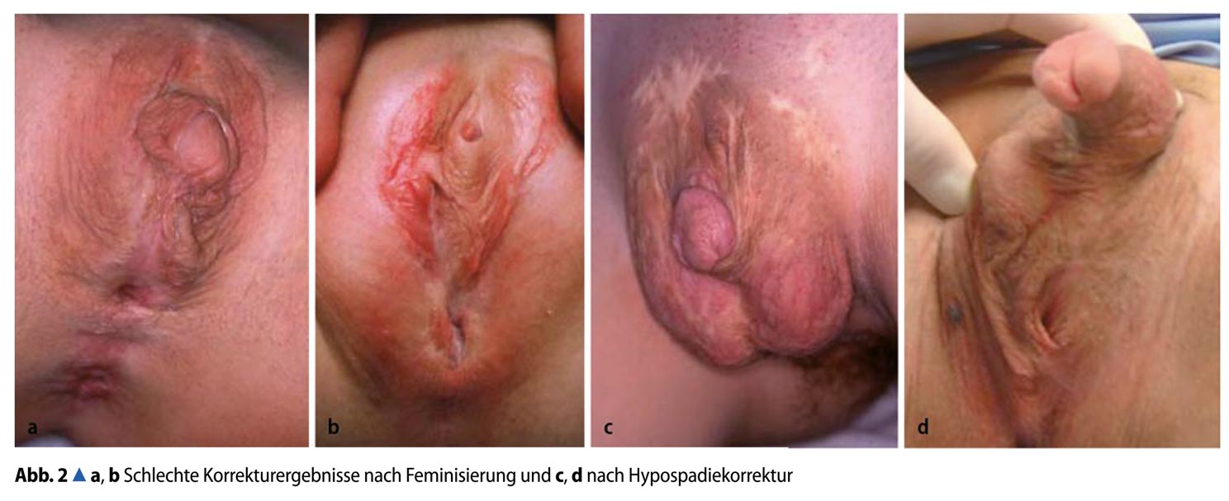
Caption: 2a,b: “Bad Results of Correction after Feminisation, and”, c,d: “after Hypospadias Repair” – Source: M. Westenfelder: “Medizinische und juristische Aspekte zur Behandlung intersexueller Differenzierungsstörungen,” Der Urologe 5 / 2011 p. 593–599.
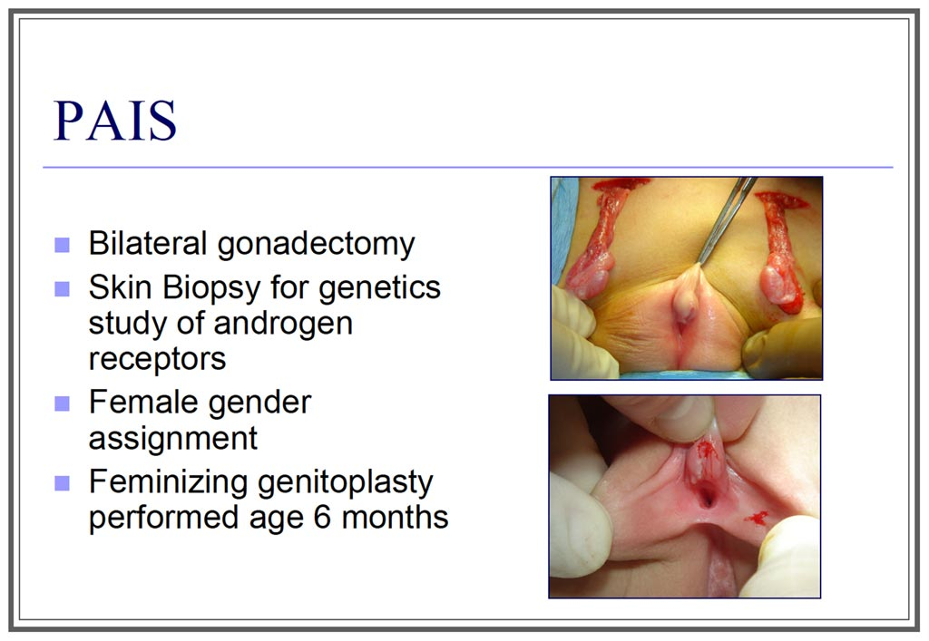
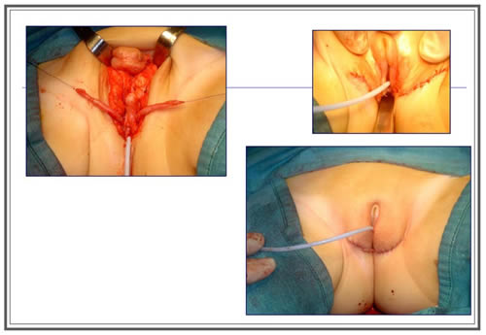
Source: J. L. Pippi Salle: “Decisions and Dilemmas in the Management
of Disorders of Sexual [sic!] Development (DSD)”, 2007, at 20.

https://Zwischengeschlecht.org/ English homepage: https://StopIGM.org
https://zwischengeschlecht.org/post/Statuten
https://intersex.shadowreport.org
https://stopigm.org/post/IAD-2016-Soon-20-UN-Reprimands-for-Intersex-Genital-Mutilations
https://intersex.shadowreport.org/public/2018-CRPD-LOIPR-Germany-NGO-Zwischengeschlecht-Intersex-IGM.pdf
https://intersex.shadowreport.org/public/2022-CRC-Germany-NGO-Intersex-StopIGM.pdf
Statement supported by Germany (and 34 other States) during the 45th Session of the Human Rights Council on 1 October 2020, https://www.dfat.gov.au/international-relations/themes/human-rights/hrc-statements/45th-session-human-rights-council/joint-statement-led-austria-rights-intersex-persons
Statement supported by Germany (and 52 other States) during the 48th Session of the Human Rights Council on 4 October 2021, https://www.bmeia.gv.at/oev-genf/speeches/alle/2021/10/united-nations-human-rights-council-48th-session-joint-statement-on-the-human-rights-of-intersex-persons/
See https://stopigm.org/post/IAD-2016-Soon-20-UN-Reprimands-for-Intersex-Genital-Mutilations
Josch Hoenes, Eugen Januschke, Ulrike Klöppel (2019), “Häufigkeit normangleichender Operationen ‘uneindeutiger’ Genitalien im Kindesalter. Follow Up-Studie”, https://omp.ub.rub.de/index.php/RUB/catalog/view/113/99/604-4
Statistisches Bundesamt (Destatis) (2017), “DRG-Statistik 2016. Operationen und Prozeduren auf Basis des 4-stelligen OPS der vollstationären Patientinnen und Patienten in Krankenhäusern”, p. 50, https://www.statistischebibliothek.de/mir/servlets/MCRFileNodeServlet/DEHeft_derivate_00048786/5231401167014_korr16012018.pdf
https://www.bmjv.de/SharedDocs/Gesetzgebungsverfahren/Dokumente/RefE_Verbot_OP_Geschlechtsaenderung_Kind.pdf?__blob=publicationFile&v=2
See https://stopigm.org/german-draft-law-fails-intersex-children/
https://dip21.bundestag.de/dip21/btd/19/246/1924686.pdf
https://dserver.bundestag.de/btd/19/279/1927929.pdf
https://www.bundestag.de/dokumente/textarchiv/2021/kw12-de-geschlechterentwicklung-kinder-830122
https://www.bmjv.de/SharedDocs/Gesetzgebungsverfahren/Dokumente/Bgbl_Varianten_der_Geschlechtsentwicklung.pdf?__blob=publicationFile&v=3
German Institute for Human Rights (DIMR), https://www.bundestag.de/resource/blob/816910/9ef1eb47e5d5954c6164ee9dec3a3bb8/stellungnahme-kittel_dim-data.pdf
Dr Ulrike Klöppel, https://www.bundestag.de/resource/blob/816514/8705e20395ba739e8881d13bca030aff/stellungnahme-kloeppel-data.pdf
Dr Konstanze Plett, https://www.bundestag.de/resource/blob/816780/9f83fb0ab7d697f86581f5eb87293a44/stellungnahme-plett-data.pdf
https://im-ev.de/wp-content/uploads/2021/03/2021-03-26-PM-Verbot-von-Operationen.pdf
https://blog.zwischengeschlecht.info/post/2021/04/18/Das-deutsche-Intersex-Gesetz-und-die-Schweiz
https://oiigermany.org/ein-steiniger-weg-fuer-menschenrechte/
https://oiieurope.org/a-good-first-step-germany-adopts-law-banning-igm/
https://www.lto.de/recht/justiz/j/gesetz-zum-verbot-geschlechszuweisender-operationen-bei-intergeschlechtlichen-kindern-in-kraft-menschenrechte/
https://www.reuters.com/article/us-germany-lgbt-health-idUSKBN2BI2MC
Reply by Tanja Florath (Officer, EU Department, Federal Ministry for Family Affairs, Senior Citizens, Women and Youth BMFSFJ), 12.10.2021. See transcript of original German reply, https://blog.zwischengeschlecht.info/post/2021/11/03/Intersex-Genitalverstmmelung-UNCCPR-befragt-Deutschland See also Session video at 0:05:52, https://media.un.org/en/asset/k1y/k1ytpbjd08
https://uroweb.org/guidelines/endorsement/
https://d56bochluxqnz.cloudfront.net/documents/full-guideline/EAU-Guidelines-on-Paediatric-Urology-2023.pdf
For details and relevant quotes, see 2023 CRPD Austria Intersex NGO Report for Session, p. 10, https://intersex.shadowreport.org/public/2023-CRPD-Austria-NGO-Intersex-StopIGM.pdf
For details and relevant quotes, see ibid., p. 10-11
For details and relevant quotes, see Ibid., p. 12-13
Globally, no survivor of early surgeries ever managed to have their case heard in court. All relevant court cases (3 in Germany, 1 in the USA) were either about surgery of adults, or initiated by foster parents.
Interministerial Working Group (2016), “Focus on the situation of trans- and intersexual people”. Status information of the BMFSFJ. Accompanying material to the Interministerial Working Group on Inter- & Transsexuality - Volume 5, Berlin, p. 17, https://www.bmfsfj.de/blob/112092/f199e9c4b77f89d0a5aa825228384e08/imag-band-5-situation-von-trans-und-intersexuellen-menschen-data.pdf
The Coalition Agreement 2018-21 of the current Government explicitly promises: “We will make it clear by law that […] medical interventions on [intersex] children are only permissible in cases that cannot be postponed and in order to avert danger to life.” CDU, CSU und SPD (2018): Coalition Agreement for 19th Legislative Term, p. 21, lines 797-799. https://www.cdu.de/system/tdf/media/dokumente/koalitionsvertrag_2018.pdf?file=1
Az. 7200 Js 66 I 22, 25.07.2022
at 52-54 http://www.gleichstellungsministerkonferenz.de/documents/2014_10_13_Beschluesse_GESAMT_Extern.pdf
Wortprotokoll, at 11 http://kastrationsspital.ch/public/19_10_HH_Wortpr_Intersex.pdf
OLG Köln 03.09.2008, Az. 5 U 51/08 http://www.justiz.nrw.de/nrwe/olgs/koeln/j2008/5_U_51_08beschluss20080903.html
LG Köln 12.08.2009, Az. 25 O 179/07 http://www.justiz.nrw.de/nrwe/lgs/koeln/lg_koeln/j2009/25_O_179_07schlussurteil20090812.html
DPA (2009), Christiane Völling: Hermaphrodite wins damage claim over removal of reproductive organs, https://zwischengeschlecht.org/pages/Hermaphrodite-wins-damage-claim
LG München, Az. 9 O 27981/12.
LG Nürnberg-Fürth, Az. 4 O 7000/11. 1st day in court was 26.02.2015.
Sentence LG Nürnberg-Fürth, 17.12.2015, Az. 4 O 7000/11.
StopIGM.org (2015), https://stopigm.org/post/Nuremberg-Hermaphrodite-Lawsuit-Damages-and-Compensation-for-Intersex-Genital-Mutilations
OLG Nürnberg, Az. 5 U 53/16.
Ulrike Löw (2019), “‘Penis-Amputation’: Intersexuelle verklagt Uni-Klinik Erlangen” (“‘Penis amputation’: Intersex woman sues Erlangen University Hospital”), nordbayern.de, https://www.nordbayern.de/region/nuernberg/penis-amputation-intersexuelle-verklagt-uni-klinik-erlangen-1.8603872
Franziska Brachthäuser, Theresa Richarz (2014): Zwischen Norm und Geschlecht – Erste Entwürfe möglicher nationaler Entschädigungs- und Schadensersatzansprüche intersexueller Menschen gegen die Bundesrepublik Deutschland, Humboldt Law Clinic: Menschenrechte, Working Paper Nr. 5, at 22-24 (p. 19-21 in PDF) http://hlcmr.de/wp-content/uploads/2015/01/Working_Paper_Nr.5.pdf
Although this person is personally known to the rapporteurs, here the case details are taken from: Franziska Brachthäuser, Theresa Richarz (2014): Zwischen Norm und Geschlecht – Erste Entwürfe möglicher nationaler Entschädigungs- und Schadensersatzansprüche intersexueller Menschen gegen die Bundesrepublik Deutschland, Humboldt Law Clinic Menschenrechte (HLCMR) Working Paper Nr. 5, at 9, 11 (i.e. 6, 8 according to page numbers within document) http://hlcmr.de/wp-content/uploads/2015/01/Working_Paper_Nr.5.pdf (All other cases are based on personal interviews.)
SG Trier, 07.02.2012 Az. S 6 VG 10/ 11 Tr. (unpublished)
SG Bayreuth, 01.08.2012, Az. S 4 VG 5/11 (unpublished); see also relevant quote in Nürnberger Nachrichten (04.11.2013) https://web.archive.org/web/20131114044728/http://www.nordbayern.de/nuernberger-nachrichten/region-bayern/schmerzliche-suche-nach-dem-eigenen-geschlecht-1.3257295
SG Nürnberg, 16.07.2014, Az. S 15 VG 9/12 (unpublished)
Az. FS 53123-17770/10-OEG (unpublished).
State Ministry for Work, Social Affairs, Family and Intergration (BASFI) Hamburg, 19.03.2013, Az. FS 53123-17770/10-OEG (unpublished)
SG Hamburg, Az. S 12 VE 46/14
SG Hamburg, 19.12.2018, Az. S 12 VE 46/14, https://zwischengeschlecht.org/public/Hamburg-Intersex-OEG-Urteil-19-12-2018_S-12-VE_46-14_web.pdf
LSG Hamburg, 13.07.2021, Az. L 3 VE 1/19 (unpublished)
BSG, Az. B 9 V 32/21 B
BSG, Az. B 9 V 32/21 B, 16.12.2021
Stellungnahme “Intersexualität”, 14. Februar 2012 (BT – Drs. 17/9088), S. 176
Interministerial Working Group (2016), “Focus on the situation of trans- and intersexual people”. Status information of the BMFSFJ. Accompanying material to the Interministerial Working Group on Inter- & Transsexuality - Volume 5, Berlin, p. 17, https://www.bmfsfj.de/blob/112092/f199e9c4b77f89d0a5aa825228384e08/imag-band-5-situation-von-trans-und-intersexuellen-menschen-data.pdf

