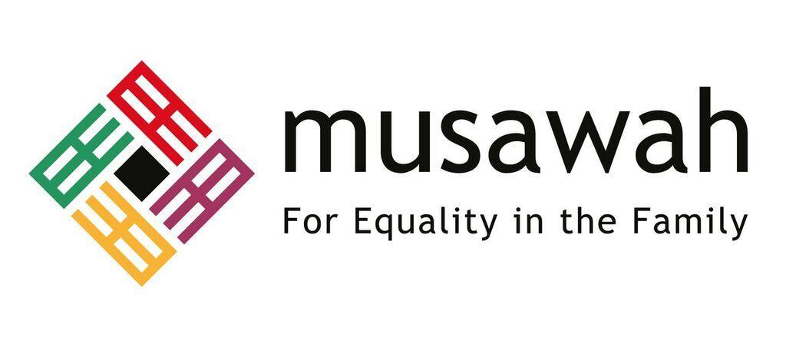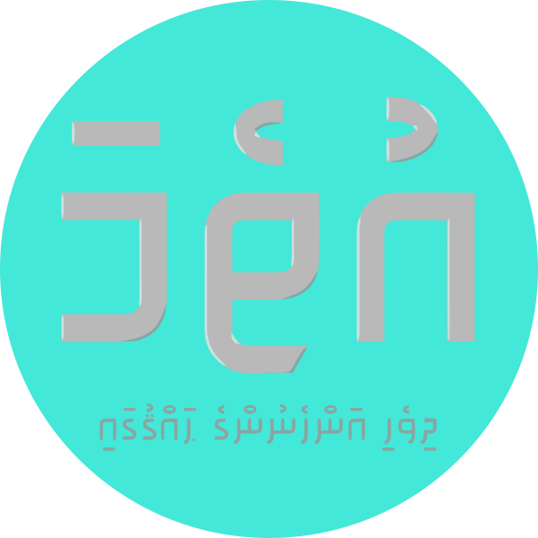

JOINT REPORT ON ARTICLE 16, MUSLIM FAMILY LAW AND MUSLIM WOMEN’S RIGHTS IN
MALDIVES

Revised & Updated – September 2021

Musawah
15 Jalan Limau Purut, 59000 Kuala Lumpur, Malaysia
Tel: +603 2083 0202
Email: musawah@musawah.org
Website: www.musawah.org
Uthema
H. Mundooge, Violet Magu,
Male’, Maldives
Email: uthema.mv@gmail.com
Website:www.uthema.org

INTRODUCTION

Uthema, a Maldivian NGO advocating for gender equality and women's empowerment in Maldives, together with Musawah, the global movement for equality and justice in the Muslim family, jointly submit this shadow report for consideration by the CEDAW Committee in its review of the 6th Periodic State Report by the government of the Republic of Maldives. This report makes the case for the removal of all reservations to Article 16 and examines Maldivian laws and practices that enforce de jure and de facto discrimination against women in the areas of access to justice, polygyny, matrimonial assets, and divorce rights under Law No. 4/2000 (hereafter referred as the Family Act) and Law No. 9/2016 and the Second Amendment to the Family Act, along with a positive development in a case related to marital rape.

We hope that the CEDAW Committee will utilize this report as a key resource during its Constructive Dialogue with the State party, and in follow-up issues in the Concluding Observations.

B. LEGAL BACKGROUND

According to the Constitution, Maldives is considered a 100% Muslim country. Article 9(d) of the Constitution of Maldives provides that a non-Muslim may not become a citizen of the Maldives. Article 17 and Article 20 of the Constitution guarantees non-discrimination based on gender and equality before the law. Article 16 of the Constitution, however, provides a limitation of a right or freedom in order to protect and maintain the tenets of Islam.

The Family Act is applicable to all marriages solemnised and/or registered in the Maldives, while Maldivians married out of the country are required to register their marriages under the Family Act. Only Muslim marriages are registered and recognised under this Act. Regulations enacted pursuant to the Family Act are applicable to all courts, including the Family Court and Magistrate Courts across the country.

C. RESERVATIONS TO ARTICLE 16

In 1993, Maldives signed CEDAW with reservations to Article 7 and 16. The original reservations to Article 16 reads as:
“The Government of the Republic of Maldives reserves its right to apply article 16 of the Convention concerning the equality of men and women in all matters relating to marriage and family relations without prejudice to the provisions of the Islamic Sharia, which govern all marital and family relations of the 100 percent Muslim population of Maldives.

Following the enactment of the 2008 Constitution, which removed the existing barrier for women to occupy the position of head of State, the government withdrew the reservation on Article 7 in 2010, as the Constitution nullified that reservation. On 24 February 2020, Maldives officially lifted reservations to Part 1 (b)(e)(g)(h) and Part 2 of Article 16. Maldives continues to hold reservations to sections (a), (c), (d) and (f) of Part 1 of Article 16.

Women’s rights advocates have called on the government to remove all reservations to Article 16, citing precedents in other majority-Muslim nations including Tunisia, Morocco and Indonesia where reservations to Article 16 have been completely lifted. In March 2020, Uthema urged the government to remove all reservations to Article 16 in order to guarantee women's rights, and to uphold the State's obligation to prioritise and act in the best interests of children. Under a different government administration in 2011, the proposal to lift reservations included Part 1 (a), while in 2020, the clause has been omitted. Hence, obstacles are not ‘culture’ or ‘religion’ per se, but perspectives that privilege particular religious interpretations, often patriarchal in nature and based on political interests and power relations.

RECOMMENDATION
We recommend the CEDAW Committee urges the State party to:

- Remove without further delay the remaining reservations to sections (a), (c), (d) and (f) of Part 1 of Article 16 of CEDAW, following the precedent of other Muslim-majority countries that have removed all reservations to CEDAW, in order to guarantee women's rights and ensure the prioritization of children's welfare in Maldives.

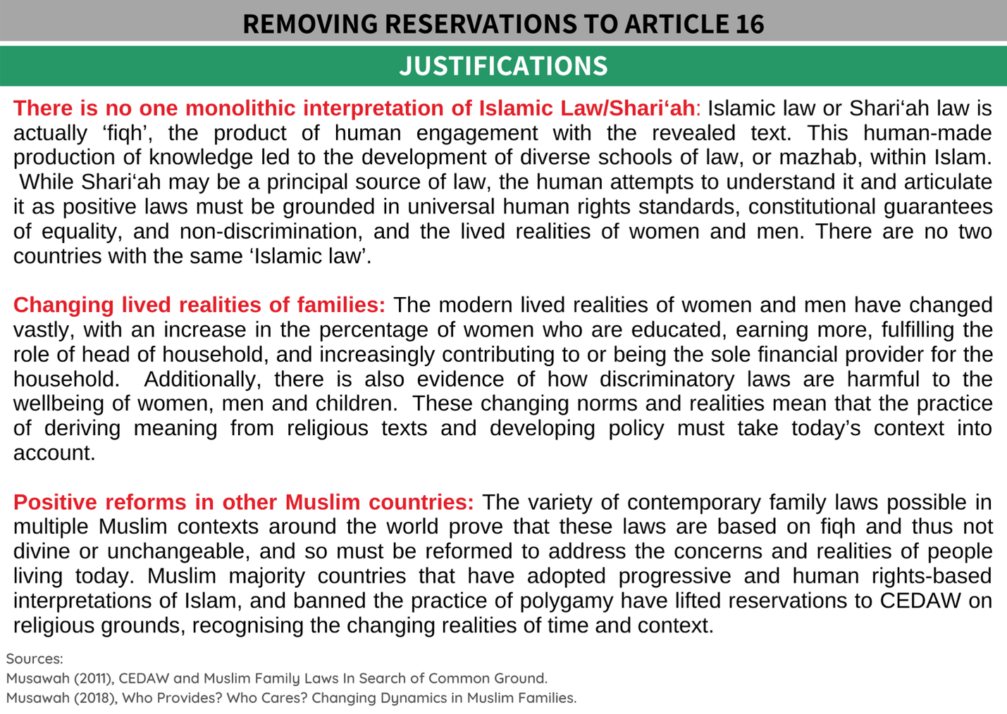

D. KEY ISSUES AND LIVED REALITIES

POLYGYNY

The Maldives Family Act allows men to marry up to four wives. The law specifically states that marriage with more than one woman must be approved by the Registrar of Marriages, based on a man’s financial competence to provide for existing wife/wives and all other dependents, including the provision of adequate housing. According to the Family Court Regulation 2011, a man wanting to enter a polygynous marriage must earn a minimum income of MVR 15,000 per month (approx. USD 971).

The assumption that this amount can sustain two (or more) marriages is highly unrealistic in today’s economy and lived realities in Maldives. In the largest urban centre, Male' City, 63% of households live in rented homes, with the cost of renting a 2-bedroom apartment close to or upwards of the minimum required income. In many cases it remains difficult to support multiple families, often causing emotional, financial, and physical stress to all parties involved. Recent research shows that during the ongoing Covid-19 pandemic, "...risk of violence have been magnified during the lockdown period, when survivors had to live in close proximity to their perpetrators or when families experienced financial strain." The deprivations, injustices, and rights violations experienced by women and families in polygynous marriages require proper research and study in the Maldives, to inform the enactment of necessary legal safeguards and remedies.

In July 2019, the Supreme Court issued a circular relating to the establishment of financial competence to provide for additional families for men engaging in polygyny. The Circular noted that in the prevailing practice, if there is no record of a claim for maintenance against a man lodged in a court by his wife, the presumption is that the man is providing for his family. The Circular further observed that past practice had been for the courts to establish financial competence for polygyny by obtaining a statement from the current wife and that non-observation of this is a recent change in practice. However, this observation by the Supreme Court is inconsistent with the Family Court Regulation 2011, which clearly states that if there is no court record of a maintenance claim against the man, the assumption is that he is providing for his wife, which in effect fulfills an eligibility criteria for polygyny. The regulation also clarified that there was no bar on the court to summon the current wife to obtain her statement, and that if three attempts to summon her for a statement prove unsuccessful, the court had the discretion to approve such a marriage based on the information provided by the husband. The disconnect between the Supreme Court’s Circular (2019) and the Family Court Regulation 2011 indicates oversight and procedural gaps within the judicial system, which need to be addressed. It is also evident that Article 116(e) of the Family Court Regulation 2011 is not consistent with Article 19 of the Family Law Regulation 2001 on the point of establishing competency for polygyny, which also needs to be addressed. Despite the renewed requirement by the Supreme Court Circular (2019) to obtain a statement from the current wife/wives to establish the de facto status of financial provision to the family by a man seeking polygyny, this does not amount to obtaining consent from the current wife to agree to a polygynous relationship.

While the law requires the registration of all marriages including polygynous marriages, the latter being subject to the discretionary approval of the Registrar of Marriages, gaps in record keeping and data management undermine the intent, purpose, and meaningful implementation of the law. There is no centralised marriage register in the Maldives and the island Magistrate Courts solemnise marriages without the mandatory approval of the Registrar of Marriages located at the Family Court in the capital Male’ City. This means that the necessary legal and financial eligibility criteria for such marriages are not established in practice, resulting in inequality and inconsistency in access to justice and legal protections for women and families living outside the Greater Male’ Area.

Anecdotal evidence suggests that many polygynous marriages continue to remain unregistered. This may result in disputes arising later pertaining to the legitimacy of children born within such unions, compromising children’s access to basic services including health, education as well as inheritance. The issue relating to inheritance was raised by the Family Court over a decade ago in 2010, where the Court expressed concern about the practices adopted by adherents to religious fundamentalism and extremism in the country that have both endorsed and performed out-of-court marriages, specifically “marriage” to minors., Women’s rights activists predict that there are many unregistered polygynous marriages of men marrying women in different islands throughout the State. The implementation of child maintenance provisions via the courts also remains weak.

A reading of the current family law and regulations on the issue of polygyny shows that while a man can have up to four wives, the language of the law does not account for the actual number of wives. Rather, it treats polygynous marriages as unions involving “more than one wife”, whether two, three, or four. In the Family Court Regulation 2011, a provision exists that in the case of a man seeking to marry more than two wives whose number of dependents exceed three in number, he must prove earnings of MVR 1000 per person in addition to the requisite MVR 15,000 per month required to enter a polygynous union in the first place. But it is not clear if the MVR 15,000 is required for each additional marriage, and therefore whether he needs to earn MVR 30,000 if he marries a third wife. The extent and legal recognition of the cost of marriages to third or fourth wives appears to be arbitrary, ambiguous, and contextually inadequate. The discretionary and arbitrary powers assigned to the Registrar of Marriages to approve such multiple marriages is unsuited to establish and ensure that a man can in actual fact, financially provide for and house his multiple families and all legal dependents, as intended by the law.

Case Study A:
One woman’s experience of polygyny and divorce

A single mother of two, who had divorced the father of her children due to his obsessive and controlling behavior and attempts to force her to give up her job, decided to become the second wife of her boyfriend from school. While initially hesitant to enter into a polygynous marriage, and despite her parents’ disapproval due to the man’s history of substance abuse, she was convinced by him. Her new husband rented an apartment before they got married but one month into their marriage said he could no longer afford to rent a separate place for her, and hence she was forced to move back into her parents’ home. However, due to the parents’ disapproval of her husband, he was not permitted to enter their home, significantly impacting the marital relationship.

The woman stated that the Magistrate Court did not verify his income status, and that the court blindly accepted that the man earns 15,000 MRF in the form, concluding that he can support two families. She has now filed for a divorce, and despite providing evidence that her husband cannot provide housing and care for her children, the couple received court-ordered reconciliation and was told that she would need to apply for divorce again after three months if reconciliation failed. As a result, she is forced to remain in the polygynous marriage.

RECOMMENDATIONS
We recommend the CEDAW Committee urges the State party to:

Short term:
- Harmonise the legal framework on polygynous marriages by ensuring consistency and clarity across the existing law and regulations, including the Family Act, Family Act Regulation 2001, the Family Court Regulation 2011 and the Supreme Court Circular (2019), to ensure just and equitable results for women regardless of residential location within the country.
- Impose stringent application of Article 12 of the Family Act throughout the country, and not just the capital, Male’ City, ensuring all polygynous marriages are administered through the courts.
- Remove all ambiguities relating to Article 12 of the Family Act, specifically subsection (b) where a man must demonstrate adequate financial capacity and commitment to provide for (including housing) multiple wives, families, and legal dependents.
- Develop a centralised marriage register to meaningfully regulate and address existing gaps, thereby halting “secret” polygynous marriages in different islands.
- Undertake research and data collection of cases and evidence of the negative impacts of polygyny on Maldivian families, especially women and children.

Long term:
- Ensure that the existing Family Law and any amendments thereto contain provisions to prohibit polygyny by following examples of other Muslim countries which have abolished the practice in the best interest of family well-being, taking into account progressive and egalitarian interpretations of Shari’ah that consider sociocultural realities of Maldivian women.

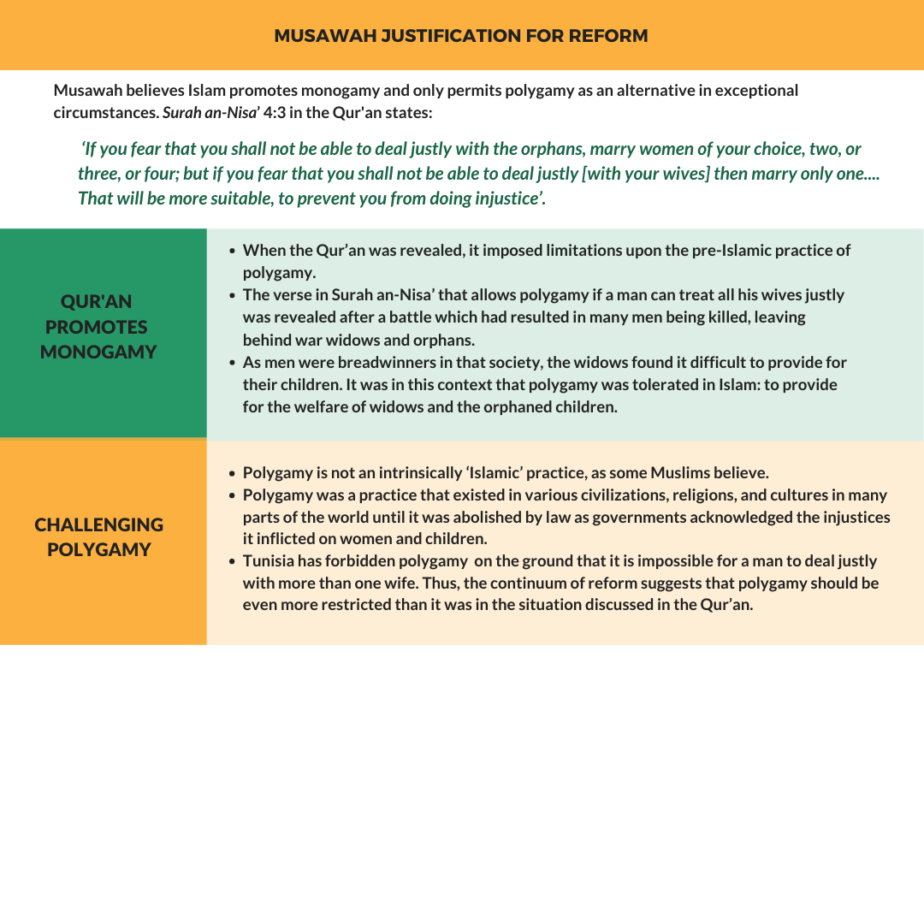

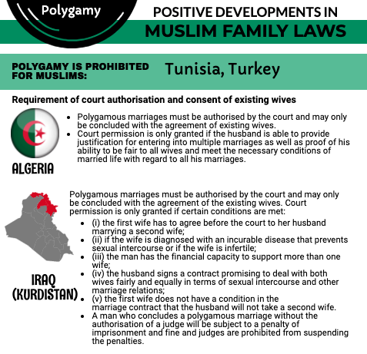

UNEQUAL PROVISIONS FOR DIVORCE

While Maldivian family law allows for both men and women to commence divorce proceedings, divorce rights are gender-discriminatory against women. The Family Act recognizes three types of divorce: Raju’ee, Khul’ and Faskh. The law requires divorce to be conducted in court, following a formal divorce application process involving the presence of both parties and the consent of the wife where the application is submitted by the man. However, the Family Act Regulation 2001 interprets the law to enable men to initiate divorce outside the court, specifying that the requirement is to submit a divorce application within 3 days of initiating divorce. This recognition of extra-judicial divorce is reiterated in the Family Court Regulation (2011). Non-compliance to this process incurs a financial penalty on both parties.

On this point, there is a clear discrepancy between the law and the regulation, notably with a specific emphasis made in the regulation for the woman to report divorce to the court, although this is required of both parties. Where a man applies for a divorce, the law provides no conditions for initiating divorce. However, the law provides four specific conditions or grounds under which a woman can apply for a divorce, although it also recognises applications for divorce that do not fall within these grounds. In the case of applications that do not fall within these specifications, the law requires the woman to go into a process of conciliation within the judicial system.

In short, a man is not required to provide justification for divorce besides being “desirous” of it. However, a woman must base her application on the grounds specified in law where the burden of proof is imposed on her, or else she would face a potentially lengthy process of reconciliation. Therefore, the law as it stands presents clear discriminatory barriers to access divorce for women. Lawyers dealing with divorce issues inform that such gender-based discrimination results in significant hardships and long-drawn-out court processes for women to access divorce. Conciliation and counselling services are not available in rural contexts, and according to lawyers, these services are weak and inadequate even in the better-resourced situation in Malé City. In the case of rural women seeking recourse in the Family Court in Malé City, the women also have to bear the financial burden involved in accessing the courts. Lawyers inform that if the husband is unwilling to divorce the wife, it is very difficult and time consuming for a woman who has initiated the process. Although the Domestic Violence Prevention Act (3/2012) facilitates judicial divorce (Thafreeq or Faskh) in cases involving domestic violence, delays and other challenges for women to access divorce processes can further traumatise survivors.

Lack of access to justice for women in communities outside the Greater Male' urban centre
There also exists inequity in practice in Male’ City and the islands outside the urban centre. In the event the husband is unwilling to grant a divorce, it is difficult for a woman to procure a Faskh (judicial dissolution of marriage) at the Family Court in Male'. In more rural communities, it is next to impossible for a woman to obtain a faskh divorce due to the absence of legal support services. Anecdotal information suggests that most divorces initiated by women drag on for approximately six to ten months and in some cases, years. Applications for divorce in Male' City are often delayed due to the mandatory reconciliation process through the court. Once again, this is an area where case law and research is absent.

The Magistrate courts do not have an automatic reconciliatory mechanism in place, unlike the Family Court, and hence the Magistrate in the islands acts as the mediator. Women's application for a Faskh in the islands often result in dismissals of claims with advice to reconcile irrespective of women's desire to procure a divorce, resulting in the woman being forced to remain in the marriage.

RECOMMENDATIONS
We recommend the CEDAW Committee urges the State party to:

- Embark on a consultative process with full involvement of women’s groups to assess the areas of discrimination faced by women and men pertaining to divorce and family matters and access to justice in the Family Court and Magistrate Courts located in the islands.
- Undertake family law reform including equalizing conditions and procedures of divorce for women and men, to ensure equal rights and access for both women and men on matters related to the dissolution of marriage, including the grounds for divorce and standards of proof.
- Ensure divorce procedures are just and fair for women, despite residential locality.
- Ensure women have access to justice through the existing Domestic Violence Prevention Act (3/2012), with timely access to judicial divorce to prevent survivors of domestic violence and their families being exposed to further violence and trauma.
- Ensure that the practice of solemnisation of marriages via video conferencing in light of the COVID-19 pandemic be made available to enable both marriages and divorces across the country, without discrimination to the residential locality of persons.

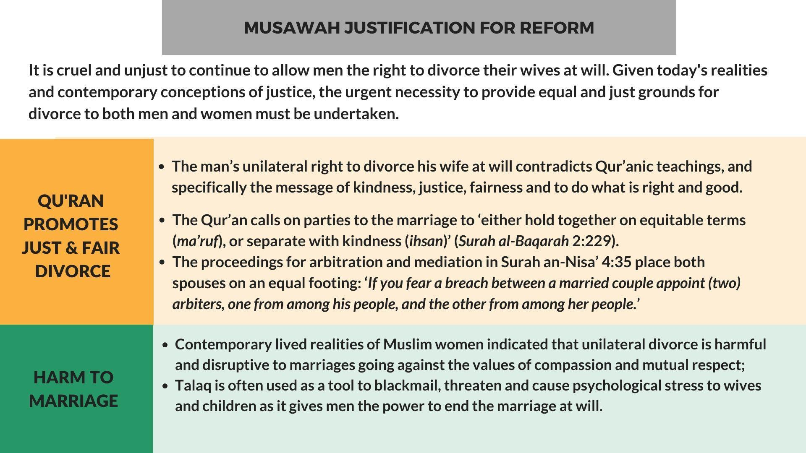

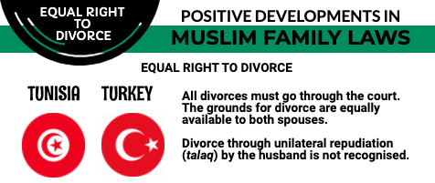

MATRIMONIAL PROPERTY – LACK OF COMPREHENSIVE LEGISLATION

There is currently no legislation guaranteeing equitable division of matrimonial assets between spouses after divorce. The 2016 amendment to Article 32 of the Family Act makes provision for the distribution of matrimonial assets only in cases where a prenuptial agreement exists which recognises asset distribution at the time of dissolution of marriage. Prenuptial agreements are recognised in law insofar as to clarify its legal permissibility, although this mechanism is not widely known about, practiced, or encouraged in the country. The 2016 amendment is therefore inapplicable to the vast majority, if not all, currently registered marriages. In addition, the amendment also added a new clause to the original statute, with Article 11(b) which states that a prenuptial agreement must comply with the principles of Islamic Shari‘ah. Hence, the amendment creates further confusion regarding its interpretation, and a possibility of inapplicability even in the rare cases that may have existing prenuptial agreements which may be viewed as being non-compliant based on interpretations of Islamic Shari‘ah.

In cases where no such agreement exists, the court will decide on the division of assets. The division of matrimonial assets is often inequitable, as it is influenced by the assumption that men are primary breadwinners. Hence, not much importance is given to recognise the nonpecuniary—yet critical—contributions of a woman to the matrimonial home when distributing matrimonial assets after divorce. This results in women being excluded from equitable access to joint assets, including property and other assets obtained within the marriage. This in turn deprives women of access to credit facilities and economic independence, thereby exposing women and children to dependency on the State or poverty and other vulnerabilities. Research conducted by Uthema has shown that women's contributions to building family homes and joint business investments are not acknowledged in practice and are not taken into account during the division of assets. These inequities contribute to significantly lower HDI (Human Development Indicator) for women than men, despite women progressing better with regard to life expectancy and expected years of schooling.

Lack of access to justice for women in communities outside the Greater Male' urban centre
In cases of eligibility for social housing and land allocation both in the capital Male' and in the islands, points are awarded based on marital status, and often this is beneficial. Allocation of social housing in Male' may result in the registration of property under both husband and wife's names. In the event of divorce, women have been able to claim their rightful share in the property, on the basis of registration, rather than eligibility and awarding of points based on marital status.

In the case of land allocation in rural communities for housing, eligibility is also often based on marital status. Anecdotal information suggests that women are often denied the right to be listed on the land registry by local councils without any legal justification for such denial, especially when a man's eligibility for land is usually based on his marital status. In the event the woman wishes to leave the husband or get a divorce, she has neither the financial means of support nor a roof over her head, as she would not have a share of the land that was procured by the husband through his marriage to her. Women also find it difficult to move back to their parents’ house for sociocultural and other reasons.

RECOMMENDATIONS
We recommend the CEDAW Committee urges the State party to:

- Introduce measures for the just and equitable division of matrimonial assets drawing from progressive legislation in other Muslim contexts (e.g. Malaysia, Indonesia and Brunei) which would be applicable to all marriages in Maldives.
- The law on matrimonial property must recognise and value both the financial and non-financial contributions of women during marriage, taking into account the past and current evidence and lived realities that women are active financial contributors to household income, whether formally or informally, in Maldivian society.
- Revise the Second Amendment to the Family Act (9/2016) to address the current significant gaps by adopting progressive and meaningful changes to achieve equitable distribution of matrimonial assets and facilitate access to justice for women.
- Raise public awareness about the legality, permissibility, and desirability of prenuptial agreements to prevent conflict at separation, and include this information in the administrative processes of marriage, including in marriage application forms as well as the mandatory premarital course conducted by the Family Court.
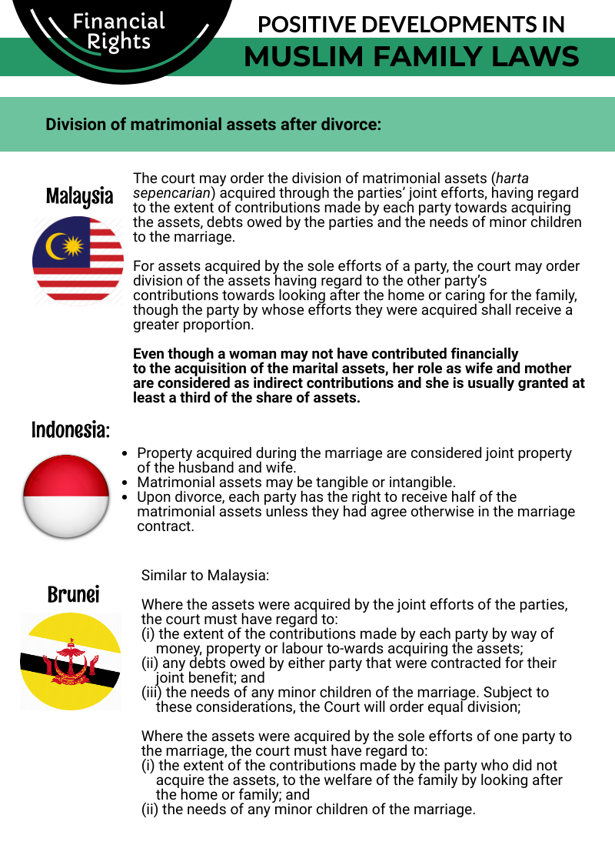

GENDER BAR ON THE POSITION OF MARRIAGE SOLEMNISER OR MAUZOON

In October 2010, the Family Court gazetted an announcement to invite applications for the position of solemniser of marriages or mauzoon, as specified in the Family Act. The announcement specified that only men could apply for the position, which was inconsistent with existing laws, including the Constitution (2008) and the Family Act. The law specifies the function and definition of the marriage solemniser or mauzoon, and contains no such gender-based discrimination using clear language that the position must be filled by “a person.” The law also provides a clear description of the term “sharu’ee mauzoon” to mean “a person appointed by a competent authority to solemnise marriages,” making no reference to the sex of the person. The decision of the Family Court to introduce this discriminatory practice initiated responses from concerned women, both within and outside the justice sector (see also Case Study B below).

Nevertheless, on 10 August 2011, the Supreme Court of Maldives issued a Circular containing the Marriage Solemnisation Regulation to be observed by all the courts dealing with family law matters. Under the general conditions for eligibility to the position, Article 6(b) of this regulation specifically states that a marriage solemniser must be a Sunni Muslim man, who had reached the age of twenty-five, thereby consolidating the gender bar initiated by the Family Court in 2010. The emergence of this Circular set a precedent through the powers of the Supreme Court that marriages in the Maldives must be solemnised solely by men, establishing a clear gender-based discriminatory practice by the court system. The Constitution specifies in Article 145(c) that the Supreme Court is “the final authority on the interpretation of the Constitution, the law, or any other matter dealt with by a court of law.” However, the legality and soundness of the Supreme Court’s decision in its above-mentioned Circular remains highly questionable, as the courts have no mandate to establish or change the law, which is the function of the Peoples’ Majlis (parliament) in the Maldives. Moreover, as detailed in the concerns raised by the women judges provided in Case Study B below, the Supreme Court’s decision to uphold the Family Court’s gender bar against women regarding marriage solemnisers contravenes the Family Act and the Constitution, as well as the Gender Equality Law (18/2016) which was ratified since.

The Supreme Court’s Circular further presents a glaring inconsistency with the prevailing realities, whereby the Family Court itself has had a woman sitting judge since 2007, adjudicating on all matters relating to family law, including the dissolution of marriages. Currently, women hold positions in all levels of the court system in the Maldives, from the Magistrates Courts, Lower Courts, High Court, and the Supreme Court, with the recent appointment of a woman as the Chief Judicial Administrator at the Department of Judicial Administration., Therefore, the deliberate exclusion of women from the administrative position of solemnising marriages is a regrettable, regressive, and erroneous development in the country context which needs immediate revocation.

Elsewhere in Muslim societies, including in Egypt and South Africa, women are not excluded from performing the administrative function to solemnise marriages within both formal and informal governance systems of family law administration. Egypt had its first maazouna, or female registrar, as far back as 2008, recognising the role of marriage solemnising as clerical rather than religious; similarly, Saudi Arabia’s Ministry of Justice sought in 2019 to launch women’s notary departments to facilitate judicial services for women. In 2018, King Mohammed VI of Morocco approved a fatwa that later became Article 4 of Law 16-03, allowing women to become adouls, officials authorised to perform legal duties relating to marriage and inheritance. Respected Moroccan feminist scholar Asma Lamrabet was quoted,
"There is no text in the Koran or in the Hadith [Prophet Muhammad’s sayings and deeds] that forbids this function for women; it is just a prohibition based on the interweaving of legal interpretation – fiqh – and social customs – ada and urf – that ended up being assimilated as belonging to the sacred. In the early days of Islam, this function was not prohibited because Aisha, wife of the prophet, married his nieces.”

Case Study B:
Women judges’ efforts to address discrimination against women by the judicial sector met with patriarchal resistance and impunity

On 12 October 2010, the Family Court of Maldives made an announcement in the State Gazette inviting applications for the position of marriage solemniser (or mauzoon), which is a position established by the Family Act. The announcement specified that applicants must be male.

In response, three women judges, including one from the Family Court and two from the Civil Court, submitted a joint letter to the Chief Justice of the Supreme Court and the Chief Judge of the Family Court on 2 November 2010, citing that this gender-based discrimination in the announcement was unlawful as per Article 17, 20 and 62(a) of the Maldives Constitution (2008). They further clarified that the Family Act did not specify such a gender bar on women for the position of mauzoon, citing Article 73(a) of that law. They also noted that such a decision by the Court was unconstitutional, citing Article 16 of the Constitution (2008), which requires an act of parliament to justify such a discriminatory decision undermining a fundamental right. In addition, citing Article 142(a) of the Constitution, the women judges noted that judges are subject to the Constitution and law, and are required to consider Islamic Shari’ah further in the instance where either of these are silent. Moreover, they observed that there was no bar on women to hold the position of Head of State, Chief Justice, or judgeship in the Maldives, making it eminently clear about the inapplicability of a gender bar on the solemniser of marriage position.

Responding to the women judges' letter, the judicial oversight body, the Judicial Services Commission (JSC), initiated a disciplinary complaint against all three women on 7 November 2011. While two of the women judges had resigned their posts during the ensuing period, the JSC concluded their disciplinary case 6 years later in August 2017, stating there was no violation of the rules of conduct for judges.

On 10 August 2011, the Supreme Court of the Maldives issued a Circular (No. 2011/02/SC) in which a regulation for marriage solemnisers was established, solidifying the Family Court's decision to bar women from the position of mauzoon.

To date, the Family Court's October 2010 decision to maintain a gender bar preventing women from holding the position of marriage solemniser remains in practice, despite it having no legal basis and, in fact, contravening applicable laws. A reversal of that decision by both the Family Court and the Supreme Court is required to uphold their credibility as duty bearers of the judicial system and law enforcement in the country.

RECOMMENDATIONS
We recommend the CEDAW Committee urges the State party to:

- Rectify the discriminatory precedent set by the Supreme Court’s Circular (No. 2011/02/SC) and the Marriage Solemnisation Regulation contained within it, to bring this matter in line with legal due processes, national laws, the Constitution as well as the Maldives international obligations to ensure non-discrimination on the basis of sex or gender, and uphold the fundamental right of women to have equal access to employment opportunities.
- Amend the arbitrary practice of discrimination against women for the post of marriage solemniser established by the Family Court and bring this practice within the remit of the relevant laws, both nationally and internationally.
- Ensure that women have equal access to the employment opportunity as marriage solemnisers and establish temporary special measures to redress the gender imbalance that has been created over the past decade due to the prevailing discriminatory practice.

PROGRESSIVE DEVELOPMENT: HISTORIC MARITAL RAPE CONVICTION

The crime of marital rape was first recognised in law in the Maldives with the enactment of the Sexual Offences Act (17/2014). The law set certain conditions to qualify as marital rape, which remains a concerning gap in the law. Article 20 of the law makes marital rape a criminal offence in four distinct circumstances, namely “when the marriage is in the process of dissolution, when one of the parties has applied for a divorce, if the husband knowingly transmits a dangerous sexually transmitted disease to the wife, or if the couple is living separately under a mutual agreement.” ,

On 1 October 2020, the High Court set a historic precedent using Article 20(a)4 of the Sexual Offences Act by convicting a man charged with marital rape, “in a case involving the rape and physical assault of ZN, which resulted in her death in 2015.” This historic precedent is well recognised and welcomed as a positive development in the Maldivian context.,, However, the full and meaningful legal recognition and redress required by law on the issue of marital rape remains yet to be achieved, the details of which are outlined in the Uthema and Equality Now Thematic Joint Submission to the CEDAW Committee in December 2020.

Some opponents of criminalising marital rape rely on a religious argument that it counters Shari’ah whereby marital sex is considered a husband's right and a wife's duty, thus precluding even the possibility of marital rape as a concept, but this goes against both broad principles and specific verses in the Qur’an, including the oft-cited 4:34, which upon deconstruction does not promote violence within marriage. These arguments selectively ignore Qur'anic verses entreating husbands to treat their wives with kindness (Qur'an 4:19), and affection and mercy (Qur'an 30:21), as well as the body of Prophetic teachings and practice contradicting domestic violence, including marital rape: "The most perfect of the believers is the best of you in character; and the best of you are those among you who are best to their wives," and "Could any of you beat your wife as he would a slave, and then lie with her in the evening?". So-called religious arguments cannot be used to justify violence against women in the family, including marital rape, instances of which are clearly admonished in our primary sources as being harmful to women and inhumane, and thus un-Islamic, as has been outlined in a fatwa by Indonesian female clerics. Clear and comprehensive legal provisions would serve as a strong negation of the patriarchal social norms that allow for the perpetuation of marital rape under the guise of religion.

RECOMMENDATION
We recommend the CEDAW Committee urges the State party to:

- Address the legal gaps on marital rape, particularly by criminalising marital rape in all circumstances, without exception, and amending the Sexual Offences Act, the Penal Code, and the Special Provisions Act to Deal with Child Sex Abuse Offenders.

ANNEX 1: MUSAWAH VISION FOR THE FAMILY

Musawah asserts that in the twenty-first century, there cannot be justice without equality. Many provisions in Muslim family laws, as defined by classical jurists and as reproduced in modern legal codes, are neither tenable in contemporary circumstances nor defensible on Islamic grounds. Not only do these family laws fail to fulfill the Shari’ah requirements of justice, but they are being used to deny women rights and dignified choices in life. These elements lie at the root of marital disharmony and the breakdown of the family.

Musawah believes that Qur’anic principles and the richness of the Islamic juristic tradition enable us to formulate Muslim family laws today that are egalitarian and reflect the needs of contemporary societies. Islamic teachings and universal human rights standards, including the CEDAW Convention, are fully compatible and are dynamic and constantly evolving, based on changing times and circumstances. Inspired by the Qur’anic vision of justice and gender relations, Musawah contends that gender equality and non-discrimination can only be achieved with laws that transform power relations in the family and in society in the direction of just outcomes. | 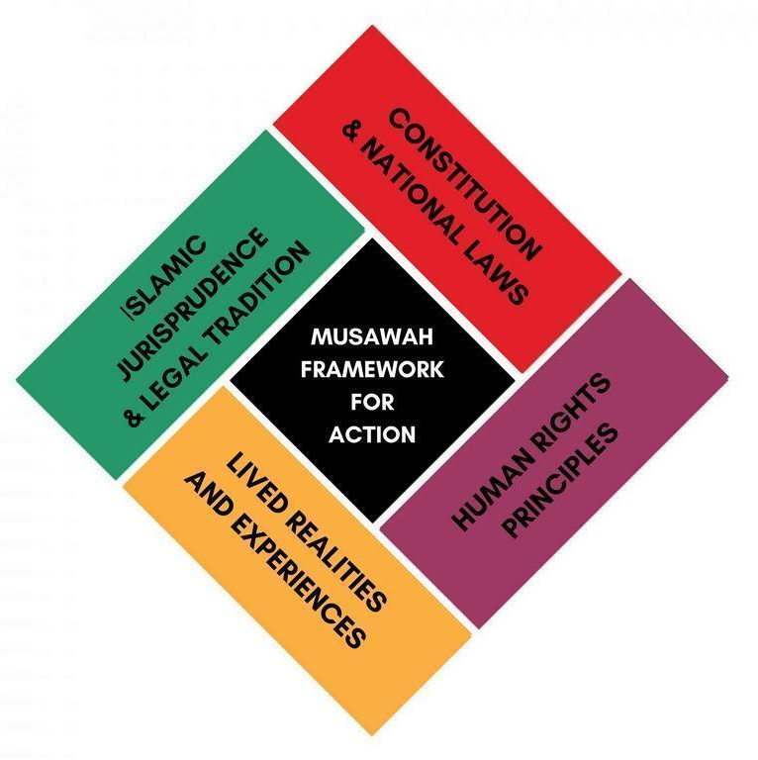

It is our hope that the CEDAW Committee will encourage Governments everywhere, and particularly those purporting to speak for and in the name of Islam and Muslim communities, to:
- Recognize the diversity of opinions, laws, and practices in the Muslim world and the growing scholarship in Islam that recognises equality and justice, and the possibility of and necessity for reform of Muslim family laws today.
- Promote human rights standards as intrinsic to the teachings of Islam, national guarantees of equality and non-discrimination, and the lived realities of women and men today.
- Encourage open and inclusive public debate regarding diversity of opinion and interpretations in Muslim laws and principles relating to family laws and practices.

Article 9, The Constitution of the Republic of Maldives (2008)
The Constitution of the Republic of Maldives (2008), https://storage.googleapis.com/presidency.gov.mv/Documents/ConstitutionOfMaldives.pdf
Article 16, The Constitution of Constitution of the Republic of Maldives (2008).
Articles 1 and 2, Family Act
Article 19, Family Act
Status of Treaties, 8. Convention on the Elimination of All Forms of Discrimination against Women (2020), https://treaties.un.org/Pages/ViewDetails.aspx?src=IND&mtdsg_no=IV-8&chapter=4#39
United Nations, (2020), Reference: C.N.73.2020.TREATIES-IV.8, https://treaties.un.org/doc/Publication/CN/2020/CN.73.2020-Eng.pdf
Mariyam Malsa, (2020), “Uthema demands govt to remove all CEDAW reservations,” The Edition, https://edition.mv/news/15366
Hope for Women, (2012), Maldives NGO Shadow Report to the Committee on the Elimination of Discrimination Against Women https://tbinternet.ohchr.org/Treaties/CEDAW/Shared%20Documents/MDV/INT_CEDAW_NGO_MDV_19479_E.pdf
Family Act, Article 7
Family Act, Article 12; Family Court Regulation, 30 November 2011, Article 116(h)
Family Court Regulation, 30 November 2011, Article 116(a)(2)
National Bureau of Statistics (2016), Household Income and Expenditure Survey, http://statisticsmaldives.gov.mv/nbs/wp-content/uploads/2016/03/HIES-Report-2016-Expenditure.pdf
Gender-based Violence During Covid-19 Pandemic in the Maldives: An Analysis of Reported Cases, Institute of Research and Development Pvt Ltd, UNFPA Maldives, 2021
Circular No. 2019/03/SC, 29 July 2019
“Rules tightened for polygamous marriages”, Maldives Independent (archive), 30 July 2019, https://maldivesindependent.com/society/rules-tightened-for-polygamous-marriages-147053
Family Court Regulation, 30 November 2011, Article 116(e)
Family Court Regulation, 30 November 2011, Article 116(f)
Minivan News Archives, (2010), “Unregistered marriages leave children unable to inherit, warns Family Court”, https://minivannewsarchive.com/society/unregistered-marriages-leave-children-unable-to-inherit-warns-family-court-5744
Minivan News Archives, (2014), “Fatwas against registering marriages a huge challenge: Family Court chief judge”, https://minivannewsarchive.com/politics/fatwas-against-registering-marriages-a-huge-challenge-family-court-chief-judge-83630
Mariyam Malsa, (2019), “Child Marriage in Maldives: Holding perpetrators and enablers accountable”, The Edition, 11 December, https://edition.mv/report/13894
See case studies collected by Uthema. “Women’s lived realities - Maldives”, YouTube, 20 March 2020, https://www.youtube.com/playlist?list=PLZQL_QMqfnbB_IHLt9wyq81nGg1W_PSod
Family Act 2000, Article 12 ; Family Act Regulation 2001, Article 18-19 ; Family Court Regulation 2011, Article 116
Family Court Regulation 2011, Article 116(c)
Forms of Divorce: 1. Raju’ee divorce (consensual, revocable divorce): This occurs when the husband applies for a divorce and it is uncontested by the wife. (Article 23 (b) of Family Act). 2. Khul’u divorce - initiated on application by the wife whereby the parties agree on divorce upon the wife making a payment or giving something of monetary value in return for granting divorce (Article 27 of Family Act). 3. Faskh divorce - Annulment of marriage on application by wife based on the following grounds (Article 28 of the Family Act): lapse of a period of one year without knowing the whereabouts of her husband; failure of husband to provide maintenance for a period exceeding three consecutive months (acted in default of two Court Orders to pay; maintenance by the husband); husband’s impotence; insanity for a period exceeding 2 years; husband’s continued suffering from a communicable and an incurable disease occurrence of other events/incidents that justifies a faskh under Shari’ah. [Note : The Domestic Violence Prevention Act (3/2012) uses the term Thafreeq divorce (judicial divorce) to the types of divorce recognised in the legal framework. This law specifies the conditions of Thafreeq or Faskh in Chapter 9 and in Article 49(b) adds the conditions of Thafreeq provided in Article 48(a)(b)(c) of that law to the conditions of Faskh in the Family Law Article 28(1-6).]
Family Act, Article 23(b)
Family Act Regulation 2001, Article 40
Family Court Regulation, 30 November 2011, Article 115(2)
Article 24(a)(i-iv) : (i) commission of an act by the husband that injures the integrity of the wife; (ii) cruelty by husband towards the wife; (iii) compulsion by husband towards woman to commit and act unlawful by religion; (iv) abstinence by husband, without just cause, from performing sexual intercourse with the wife for a period exceeding 4 months
Ibid. 24(b)
Family Court of Maldives, (2020). “Family Court announces the solemnisation and registration of marriages via video conferencing” [Dhivehi], http://familycourt.gov.mv/wp-content/uploads/2020/05/Video-Conference-koh-Kaiveni-koh-dhinun.pdf
Second Amendment to the Family Act (9/2016)
Article 11, Family Act
Article 11(b), Second Amendment to the Family Act (9/2016)
Uthema, (2020), “Comprehensive NGO Shadow Report Responding to the 6th Periodic State Report of the Maldives”, April 2019 to the UN CEDAW Committee, https://uthema.org/wp-content/uploads/Uthema-Comp-CEDAW-Shadow-Report-20Apr2020.pdf
See case studies collected by Uthema. “Women’s lived realities - Maldives”, Youtube, 20 March, 2020, https://www.youtube.com/playlist?list=PLZQL_QMqfnbB_IHLt9wyq81nGg1W_PSod
Uthema, (2020), Comprehensive NGO Shadow Report Responding to the 6th Periodic State Report of the Maldives, April 2019 to the UN CEDAW Committee, p.45 https://uthema.org/wp-content/uploads/Uthema-Comp-CEDAW-Shadow-Report-20Apr2020.pdf
Article 3(a), Family Act
Article 73(a), Family Act
Article 73(a), Family Act, Family Act : A Translation, 27 December 2004
Family Court seeks marriage registrars – women need not apply, Azra Naseem, Minivan News (Archive), 21 October 2010, https://minivannewsarchive.com/politics/family-court-seeks-marriage-registrars-%E2%80%93-women-need-not-apply-12543
Circular No. 2011/02/SC, 10 August 2011
Constitution of the Maldives 2008, Article 70
Gender Equality Law, Articles 4 , 9(b) , 10(a) , 20(a)(d) and (f)
NGO Shadow Report to UN CEDAW Committee, Uthema, 30 April 2020
Judicial Services Commission (@MaldivesJSC Twitter), 27 September 2020, https://twitter.com/MaldivesJSC/status/1310184683418779650?s=20
Amal Suleiman. “An Historic Female Ma’dhun Who Has Conquered Old Habits.” Fanack.com, 5 April 2019, https://fanack.com/egypt/faces-of-egypt/amal-suleiman/
Kenyon, Peter. "Female Wedding Registrar Is First In Muslim World." NPR: All Things Considered, 19 December 2008. https://www.npr.org/templates/story/story.php?storyId=97778450
"Saudi justice ministry to launch women’s notary departments." AlArabiya News, 23 June 2019, updated 20 May 2020. https://english.alarabiya.net/features/2019/06/23/Saudi-justice-ministry-to-launch-women-s-notary-departments
"In Morocco, Profession of Adouls Opened Up to Women for First Time." Fanack.com, 15 February 2018. https://fanack.com/social-justice-en/profession-adouls-opened-to-women~95843/
“Thematic Joint Submission to the CEDAW Committee, Equality Now and Uthema”, 22 December 2020, para. 14, https://www.equalitynow.org/maldives_cedaw_2020
Sexual Violence in the Maldives : marital rape, Uthema, April 2021 (English) https://www.youtube.com/watch?v=XgideWkpldk&list=PLZQL_QMqfnbCU25U9hB5Ww-80HpOBnJjX&index=3&ab_channel=Uthema
Ibid, para 18
“Maldives’ High Court Recognizes Marital Rape for the First Time, PGA Executive Board Member, Rozaina Adam, MP (Maldives) reacted to the news”, Parliaments for Global Action, 02 October 2020, https://www.pgaction.org/news/maldives-high-court-recognizes-marital-rape-first-time.html
“Shah sentenced to 3 years in landmark marital rape conviction”, Ahmed Aiham, The Edition, 02 October 2020, https://edition.mv/news/19491
“First and historical conviction by a Maldivian court for the crime of marital rape” [English translation], 01 October 2020, Press Statement, Uthema, https://uthema.org/noosbayaan-maritalrape/
“Thematic Joint Submission to the CEDAW Committee, Equality Now and Uthema”, 22 December 2020, para. 14-19, https://www.equalitynow.org/maldives_cedaw_2020
Ali, Kecia. 2006. ‘“The Best of You Will Not Strike”: Al-Shafi’i on Qur’an, Sunnah, and Wife Beating’. Comparative Islamic Studies 2(2), pp. 143–155.
"Domestic Violence" from "Compilation of Resources Related to Women's Rights in Muslim Family Laws." Musawah, 2016, pp.28-31. https://www.musawah.org/wp-content/uploads/2018/11/CompilationofResources-2016.pdf
Ross, Eleanor. "World's Largest Gathering of Female Muslim Clerics Issue Fatwa Against Marital Rape, Child Marriage." Newsweek, 28 April 2017. https://www.newsweek.com/gathering-female-muslim-clerics-issue-fatwa-against-child-marriage-rape-591442
“Thematic Joint Submission to the CEDAW Committee, Equality Now and Uthema”, 22 December 2020, para 16 and 32(c), https://www.equalitynow.org/maldives_cedaw_2020

