NGO Report to the UN Committee on the Elimination of Racial Discrimination in Advance of its
List of Themes for the State of Israel

Violations of the ICERD committed by the State of Israel against Palestinian citizens of Israel

Submitted by
Adalah – The Legal Center for Arab Minority Rights in Israel

12 September 2019

- Violations of the Right to Equality and Prohibition on Racial Discrimination

In its last 2012 Concluding Observations to Israel, the Committee reiterated its concern that no general provision for equality and prohibition of racial discrimination has been included in the Basic Law: Human Dignity and Liberty (1992), which serves as Israel’s bill of rights. The Committee further recommended that Israel “ensure that the prohibition of racial discrimination and the principle of equality are included in the Basic Law and that a definition of racial discrimination is duly incorporated into the Law” (CERD/C/ISR/CO/14-16, para. 13).

In the state’s last report to the Committee in 2017, Israel argued that racial discrimination is prohibited under Israel law (CERD/C/ISR/17-19, para. 24). However, as the Committee has previously recognized, the right to equality and freedom from discrimination is not explicitly enshrined in Israeli law as a constitutional right, nor is it protected by statute.

Moreover, the recent enactment of The Basic Law: Israel – The Nation-State of the Jewish People (JNS Law), on 19 July 2018, has further weakened the constitutional status of the Palestinian minority in Israel. The law is in direct contradiction of the Committee’s recommendations, along with other additional laws that discriminate against Palestinian citizens of Israel enacted by the Israeli Knesset in the interim period from 2012. Many of these laws are discussed throughout this report.

The Basic Law: Israel – The Nation-State of the Jewish People

The JNS law sets forth the constitutional order of Israel and articulates the ethnic-religious identity of the state as exclusively Jewish. It is the “law of laws”, capable of overriding any ordinary legislation. It alters the constitutional framework of the state, making changes that violate established international norms: there is no democratic constitution in the world that designates the constitutional identity of the state on racial grounds, as serving one ethnic group.

The main provisions of the JNS Law:
- Article 1 states that the Land of Israel (“Eretz Israel”) is the historic national home of the Jewish people, in which the State of Israel was established, and in which the Jewish people exercises its natural, cultural, and historic right to self-determination. It adds that the right to exercise national self-determination in the State of Israel is solely for the Jewish people.
- Article 2 sets forth the symbols of the state, all specifically Jewish in character.
- Article 3 defines the capital of Israel as Jerusalem, which includes occupied East Jerusalem.
- Article 4 states that the official language of the state is Hebrew, demoting Arabic, which was previously a second official language, to a language with an undefined “special status”.
- Article 5 establishes that immigration leading to automatic citizenship is exclusive to Jews.
- Article 6 provides that the state will strengthen ties between the state and Jewish people around the word, and preserve the cultural, historic, and religious heritage of the Jewish people in the Diaspora.
- Article 7 provides that the sate views development of Jewish settlement as a national value, and will act to encourage, promote and consolidate its establishment, thereby instituting segregation as a new legal norm, and allowing for the annexation of the West Bank.

Despite the foundational nature and far-reaching scope of the JNS Law, it contains no commitment to democratic norms, or a guarantee of the right to equality, or a prohibition of discrimination on the basis of race, nationality, ethnicity or any other category for all people living under Israeli sovereignty. Indeed, it does not even define its citizenry, referring instead to the Jewish people as its subject, and defining sovereignty and democratic self-rule as belonging solely to the Jewish people, wherever they live around the world.

The Basic Law states (inter alia) that “the State of Israel is the nation-state of the Jewish people” and that the realization of national self-determination in the State of Israel will be exclusively for the Jewish people; immigration to Israel leading to automatic citizenship is exclusive to Jews (from around the world) under the Law of Return; Hebrew is the sole official language of the state; the State shall encourage, promote and establish Jewish communities and settlements; the national anthem is Hatikvah; only Jewish people are represented in the symbols of the state: the flag is Israeli (a prayer shawl); Independence Day is a national holiday; the Hebrew calendar is the official calendar of the state; the official holidays are Jewish holidays; and the State must work to foster ties with Diaspora Jewry, while the Palestinian refugees continue to be denied the right to return to their homeland, in violation of international human rights and humanitarian law, and UN Security Council Resolutions.

Within the Green Line, the law gives constitutional backing to the state to consolidate Jewish demographic majorities throughout Israel, and is likely to be used to establish segregated, exclusively Jewish towns in areas where Palestinian citizens are most concentrated, including the Galilee and the Naqab (Negev) desert in southern Israel, the traditional home of the Bedouin. The law legitimizes discriminatory land policies, such as admissions committees that filter non-Jewish families and individuals out of small towns throughout the state. It would also give constitutional justification to discriminatory budgeting policies that channel public funds to Jewish communities and even to Jewish individuals, for the purpose of incentivizing them to relocate to certain areas.

Fourteen petitions are currently pending against the Jewish Nation-State Law before the Israeli Supreme Court (SCT), including one filed by Adalah in August 2018 on behalf of the Palestinian leadership in Israel – the High Follow-Up Committee for Arab Citizens of Israel, the National Committee of Arab Mayors, and the Joint List parliamentary faction. The petition demands that the Court cancel the law as it contradicts fundamental international human rights norms in place since the end of World War II; negates almost 20 years of Supreme Court caselaw concerning the right to equality and land rights; and constitutes an abuse of power by the majority in the Knesset. The SCT has granted multiple requests by the state to postpone its response to the petitions. While the SCT decided that an expanded 11-justice panel will hear the case, no hearing date has yet been scheduled.

Following a letter submitted by Adalah in October 2018, four UN Special Rapporteurs in the field of cultural rights, on the situation of human rights in the Palestinian territories occupied since 1967, on minority issues, and on contemporary forms of racism sent a communique to Israel expressing their deep concern that the Basic Law appears "to be discriminatory in nature and in practice against non-Jewish citizens and other minorities and does not apply the principle of equality between citizens, which is one of the key principles for democratic political systems."

The special rapporteurs also emphasized that they fear that "the law as adopted offers a legal basis for the pre-eminence of Jewish people over non-Jewish citizens who are members of other ethno-religious and linguistic minority groups, and creates a legal order and an environment that could potentially lead to further discriminatory legislative and/or policy actions, which contravene the international human rights obligations of Israel." Although asked to do so by the Special Rapporteurs, the State of Israel has not responded to the communique.

The Status of the Arabic Language in Israel

In its 2017 report to the Committee, Israel made little mention of the status of Arabic, the language of the Arab national minority in Israel, numbering over 1.5 million people or 20% of the population, only noting a number of initiatives undertaken to support the Arabic language in Israel, including an official Arabic-language day in the Knesset, and an evaluation of higher education study programs in Arabic carried out in 2014 (CERD/C/ISR/CO/14-16, para. 306-308).

Article 4 of the Jewish Nation-State Law (JNS Law) demotes the status of Arabic, providing that the official language of the state is Hebrew alone. Arabic, which was previously a second official language, has now become a language with an undefined “special status”, which is inferior to an “official status”. This “special status” offers the possibility of using Arabic only in practice and at the individual level, but does not recognize it at the collective level as the language of the minority.

Thus the JNS Law undermines the status of the Arabic language, and, for the first time, demotes its de jure status from that of an official language in Israel. In practice, the authorities did not respect the law and treated the Arabic language in a manner inconsistent with its official status. However, there is a huge gap between this unacceptable practice, and its constitutional entrenchment. Whereas previously Arabic was not treated as a second official language in public life, there was a strong argument that could be made before the authorities that its status should be respected as an official language under the law. Under the JNS Law, this argument loses its power and reduces the circumstances in which legal challenges can be made to promote the use of Arabic within Israel.

- Racial Discrimination and Policies of Demographic Control

The state’s ethnically-based self-definition, coupled with the Basic Laws, have led to the enactment of further laws that grant privileges and powers to the Jewish majority in Israel in various spheres. These fields include control over the land and discrimination in land planning and construction; demographic control and discrimination in citizenship and residency; discrimination in the realm of civil, political, economic, and social rights; and cultural dominance.

Thus, for example, the Knesset enacted laws, which perpetuate the demographic gap between Jewish and Arab citizens of the state in order to preserve a Jewish majority. This domination is achieved, inter alia, by means of two laws: The Law of Return (1950) and the Citizenship and Entry into Israel Law (Temporary Order) (2003) that focuses on the prevention of Palestinian family unification in Israel.

By actively controlling demography, the state is pursuing policies that, as a consequence, distinguish in the rights granted to different racial groups of the population, namely Jewish and Palestinians. These laws and policies violate the Convention, notably Articles 1.1, 1.4, 5, and 6. In its 2012 concluding observations, the Committee expressed its concern over demographic policies generally and clearly stated that they violate human rights and international humanitarian law (CERD/C/ISR/CO/14-16, para. 4 and 25).

Racially Discriminatory Citizenship Laws

Israeli citizenship law is split into two citizenship tracks that co-exist on the basis of ethnic separation, a track for Jews and a track for non-Jews. The first track, The Law of Return - 1950, enables every Jewish person to settle in the State of Israel (perform Aliyah) and obtain citizenship upon applying on arrival. For every other person, including Palestinians, citizenship is determined by the Citizenship Law - 1952, and the Citizenship and Entry into Israel Law (Temporary Order) - 2003, which has been continuously renewed for the last 16 years and de facto functions as a permanent law.

The Law of Return discriminates against Palestinians living in the diaspora in several ways. Firstly, this law denies the right of return to Palestinians who fled or who were forced to flee during the 1948 War and are still defined as refugees and reside in the West Bank, the Gaza Strip, and the wider Middle East and other countries around the world. The State of Israel declared these refugees as absentees and expropriated all of their land and property by law. The same legal system grants Jewish absentees the right to citizenship and residence in Israel through mechanisms for acquiring citizenship that are based solely on ethnic/religious affiliation.

Moreover, the Law of Return is the basis for distinguishing between Palestinians in the OPT and Illegal Israeli Jewish settlers in these areas. The law extending the Emergency Regulations determines that, for certain statutes, people who live in the Occupied Palestinian Territory (OPT) will be considered residents of Israel if they are Israeli citizens or are "entitled to immigrate to Israel under the Law of Return." Thus the Law of Return is the principal law that makes the existence of separate tracks based on national origin possible both within the Green Line and in the OPT.

The Committee has expressed serious concern about the Law of Return. In its concluding observations in 2007 and 2012, it recognized the problematic nature of creating a national identity based on ethnic distinctions, and has called on Israel to ensure that the right of return and possession of property is granted equally without racial discrimination (CERD/C/ISR/CO/14-16 (2012) paras. 15; 20 and CERD/C/ISR/CO/13 (2007), para. 17- 18). It concluded that Israel does not do enough to prevent racial discrimination or guarantee the protection of human rights (CERD/C/ISR/CO/14-16 (2012) para. 17), a responsibility which is firmly established in articles 2-5 of the Convention

In its previous reports, Israel states that no change has been made concerning the laws regulating citizenship, thus demonstrating its unwillingness to fulfill the Committee’s concluding observations and its duties prescribed by the Convention.

The ongoing ban on unification for Palestinian families

In its 2012 concluding observations, the Committee called on Israel to revoke the Citizenship and Entry into Israel Law (Temporary Order) – 2003, and to "facilitate family reunification of all citizens irrespective of their ethnicity or national or other origin” (CERD/C/ISR/CO/14-16, para. 18).

The law bans family unification in Israel between Palestinian citizens of Israel and Palestinians from the OPT, affecting thousands of families. The law has now been in effect for 16 years, renewed perfunctorily by the Knesset each year when it expires. The law was last extended in May 2019, and is currently valid until 30 July 2020. While officially a temporary measure, Israel is using the law to create a permanent ban on Palestinian family unification in Israel, despite the severe violations of human rights entailed, including the rights to equality, dignity and family life. This flagrantly discriminatory law continues to ban family unification in Israel, with certain exceptions, between Palestinian citizens of Israel and their spouses who are residents of the OPT and certain Arab and Muslim countries classified by Israel as “enemy states”, based entirely on the spouse’s nationality.

Other UN human rights treaty bodies have repeatedly criticized the law, and called on Israel to revoke it and to facilitate family unification:
- In 2017, the CEDAW reiterated its call on Israel from 2011 to review the law in order to facilitate family reunification of all citizens and permanent residents of Israel, and to bring the law into compliance with the CEDAW Convention, while respecting the principles of equality and proportionality (para. 41, CEDAW/C/ISR/CO/6).
- In 2014 the HRC (which monitors the ICCPR) reiterated its concerns about the Law and again called for its revocation (CCPR/C/ISR/CO/4 para. 21).
- In 2013, the CRC expressed concern that thousands of Palestinian children are deprived of their right to live and grow up in a family environment with both of their parents or with their siblings and that thousands live under the fear of being separated because of the severe restrictions on family reunifications. The CRC also recommended that Israel revoke the law (paras. 49 and 50, CRC/C/ISR/CO/2-4);
- The CESCR also called on Israel in its concluding observations in 2011, “to guarantee and facilitate family reunification for all citizens and permanent residents irrespective of their status or background, and ensure the widest possible protection of, and assistance to, the family” (para. 20, E/C.12/ISR/CO/3).

On 12 February 2018, then Israeli Justice Minister Ayelet Shaked made inflammatory, anti-democratic remarks against human rights and against Palestinian citizens of Israel at a conference held by the Israeli Congress on Judaism and Democracy. Regarding the ban on Palestinian family unification, Minister Shaked stated that “There is place to maintain a Jewish majority even at the expense of the violation of human rights”, and that “I was disturbed that in both the state’s position and the reasoning of the justices, the State did not defend the law for national demographic reasons.” The Israeli Supreme Court has twice upheld the constitutionality of this law in 6 to 5 split decisions, basing much of its reasoning on sweeping security concerns, which it did not require the state to substantiate.

In its 2017 report to the Committee, the State of Israel noted that it does not intend to cancel the law, but rather cites minor changes to it (CERD/C/ISR/17-19 (2017) paras. 146-154). These changes do not change the discriminatory nature of the law, which is unremittingly based on ethnicity and nationality, or provide evidence that limitations to family unification are "strictly necessary and limited in scope," as the CERD concluding observations demand (CERD/C/ISR/CO/13 (2007), para. 20).

Arbitrarily Revoking Citizenship

In 2008, the Knesset amended the Citizenship Law (1952) (Amendment 9) to allow the court to approve requests from the Interior Minister to revoke the citizenship of Israeli citizens for "breach of loyalty". This law is being applied by the state in a selective and discriminatory manner, only to Palestinians citizens of Israel and not to Jewish citizens. In a recent case, which is currently on appeal before the Israeli Supreme Court, the state applied the law to Mr. Alaa Zayoud, a Palestinian citizen of Israel from the town of Umm al-Fahem who was sentenced to 25 years in prison on charges related to an attempted murder.

However, the state did not apply the law to any cases involving Israeli Jewish citizens, including a number of serious incidents in which Israeli Jewish citizens attacked Palestinians in Israel and the OPT. Examples of these cases include: Three Israeli Jewish citizens convicted in the murder of Muhammad Abu Khdeir (a 16-year-old Palestinian boy from Shuafat, in East Jerusalem, who was beaten and burned to death), and the Israeli arson attack that killed three members of the Dawabsheh family in the West Bank village of Duma.

The law gives sweeping discretion to the Interior Minister, which also allows for its arbitrary application in accordance with political considerations. The revocation of citizenship is an extreme act, as it involves the taking away of the most important constitutional right of all rights – the right to citizenship. Further, the law provides for additional punishment beyond that what is imposed by the criminal law based on “breach of loyalty”, which is too vague and overbroad to serve as a justification for revoking an individual’s citizenship.

In 2018, the Knesset also passed an amendment to the Entry into Israel Law (1952) (Amendment No. 30), which allows the Israeli interior minister to revoke the permanent residency status of any Palestinian for "breach of loyalty" to Israel. Thus, with this law, the interior minister may revoke the Israeli identity card and permanent residency status of East Jerusalem Palestinians, leading to their eviction from the city of their birth, which is an occupied territory under international law. In the view of Adalah and numerous other human rights organizations, international humanitarian law forbids Israel, as an occupying power, from imposing an obligation of loyalty upon the occupied population, including Palestinian residents of occupied East Jerusalem.
The law was passed following an Israeli Supreme Court decision of 13 September 2017 to accept a petition filed against the revocation of Israeli residency permits of four Palestinian parliamentarians from East Jerusalem. The court ruled in this case that there was no law that granted the interior ministry authority to revoke residency status for "breach of loyalty."

International law abhors the revocation of citizenship, effectively leaving a person stateless, as established in various conventions such as the Article 5 of the CERD, and other international instruments such as Universal Declaration of Human Rights, the Convention Relating to the Status of Stateless Persons, and the Convention on the Reduction of Statelessness, all of which Israel has signed.

- Violations of the Rights to Political Participation of Palestinian Citizens of Israel

New laws and policies aimed at reducing the political participation of Palestinian citizens in Israel

Since the Committee’s last review of Israel in 2012, the Knesset has enacted the following new laws, which all share the common goal of delegitimizing the elected representatives of Palestinian citizens of Israel and limiting their participation in the national political life of the state as individuals and as a national minority group.

The Electoral Threshold Law – 2014: The Knesset amended the Election Law in 2014 to raise the threshold required of political parties to enter the parliament from 2% to 3.25%, ahead of the March 2015 Israeli general elections. The goal behind this anti-democratic law was to substantially weaken or exclude the three main Arab political parties, which ran separately for the Knesset, with each attaining three-to-four seats. In response to the new law, the Arab parties decided to run together as a single slate – called the Joint List (al-Qa’imah al-Mushtarakah in Arabic) – despite their political and ideological differences (socialist-secular, religious, nationalist, etc.). Adalah and the Association for Civil Rights in Israel (ACRI) submitted an amicus curiae opinion arguing for the unconstitutionality of the new law before the Supreme Court, which dismissed the case in an 8-1 vote in January 2015. The law has forced Palestinian citizens of Israel to forfeit their right to multi-party representation, with different ideologies and platforms, and to integrate their four main political parties into a single list or into two electoral lists, with the latter just barely passing the threshold.
The Expulsion of MKs Law – 2016: This law, enacted by the Knesset on 20 July 2016, allows a majority of 90 Knesset Members (MKs) to oust a serving MK for the full period of the Knesset’s remaining term on the following two grounds, as enumerated in Section 7A of the Basic Law: The Knesset: (1) incitement to racism; and/or (2) support for armed struggle of an enemy state or a terrorist organization against Israel. It presents a grave danger to the most basic civil rights in a democratic society: the right to vote and the right to be elected, and threatens to further restrict the space currently allowed for freedom of expression. The law stipulates that when the Knesset decides on an expulsion, the statements of the “suspect” MK will also be examined and not only their aims or actions. It would therefore allow the Israeli Jewish majority in the Knesset to oust elected Arab MKs and political lists on the basis of purely political/ideological considerations, despite the clear conflict of interest entailed in MKs voting to unseat their political rivals. In the case of a criminal offense, standing MKs can already be expelled from the Knesset for a conviction with moral turpitude under existing provisions of the Basic Law: The Knesset and the law is therefore superfluous and not fit for this purpose. MK Yousef Jabareen, Adalah and ACRI challenged the constitutionality of this law before the SCT. On 27 May 2018, the SCT rejected the petitions allowing MKs to oust their colleagues from the Knesset.

The Basic Law: The Knesset – Expansion of Grounds for Disqualifying Candidates from Knesset Elections - 2017: Enacted by the Knesset on 14 March 2017, this law amends Article 7A of the Basic Law to expand the grounds on which political parties and individual candidates can be disqualified from elections to the Knesset to include not only their goals and actions, but also their statements. Under the law, parties and individual candidates can be disqualified if their goals/actions – explicitly or implicitly – negate the existence of the State of Israel as a “Jewish and democratic state”; or incite to racism; or support armed struggle by a hostile state or terrorist organization against the State of Israel. The amendment makes it easier to disqualify candidates and parties from the Knesset by including statements among the accepted grounds, which are by their nature more liable to overly-broad interpretation.

Incitement and attempts to limit voter participation among Arab citizens in the 2019 elections

- Requests to disqualify Arab political parties

For the last 20 years, right-wing political parties and leaders, and in 2002 the Attorney General, have tried to disqualify Arab political parties and leaders from running in the elections on the alleged grounds that they deny the existence of Israel as a Jewish state and support terror organizations, pursuant to Section 7A of the Basic Law: The Knesset.

On 6 March 2019, the Central Elections Committee (CEC) decided to disqualify Dr. Ofer Kassif, a member of the political party list Hadash-Ta’al (Democratic Front for Peace and Equality – Arab Movement for Change) and Balad-Ra’am (National Democratic Assembly – United Arab List) from running in the April 2019 national elections. The decision violated the rights to vote and to stand for election of the Arab minority in Israel, and supported the ongoing attempts by right-wing politicians to delegitimize the elected representatives of the Arab public in Israel. Adalah represented Dr. Ofer Kassif and the Hadash-Ta'al and Balad-Ra'am lists in the disqualification motions before the CEC. The Supreme Court overturned the decisions to disqualify Dr. Kassif and Balad-Ra’am, and rejected the appeal against the CEC’s decision to qualify Hadash-Ta’al in March 2019. These processes show once again the discriminatory nature of the disqualification system. The Supreme Court’s decisions demonstrate that the CEC is a political body that operates in overt contradiction of law and court rulings in order to humiliate Arab candidates. In the run-up to the upcoming second round of national elections to be held on 17 September 2019, the “Jewish Power” political party requested the disqualification of the Arab Joint List political party, and the Supreme Court rejected the appeal against the CEC’s approval of the List on 25 August 2019.

- Racial incitement against Arab citizens by Prime Minister Netanyahu

In the run-up to September 2019 elections, Israeli Prime Minister Benjamin Netanyahu issued a statement saying that “the Arabs want to destroy all of us” in an exchange of digital messages with party activists during which he directed them how to appeal to the Israeli public in election campaign telephone calls. The Joint List of Arab political parties, via Adalah, called on the Chairman of the CEC, Justice Hanan Melcer, to issue a restraining order banning Netanyahu from further illegal dissemination of racist election propaganda, and on the Attorney General to open a criminal investigation into the Israeli Prime Minister's incitement to racism. Adalah argued that Netanyahu was illegally using election propaganda to commit racial incitement and to disseminate hate speech against Arab citizens.

Rampant incitement by Netanyahu and other politicians against the Arab citizens and their political leadership in Israel also took place during the April 2019 elections campaign. For example, Netanyahu declared that Israel is “not a state of all its citizens … Israel is the nation state of the Jewish people – and it alone”. Benny Gantz, Netanyahu’s main rival then and now, adopted the same racist rhetoric, claiming that he “can’t have any political discourse” with the Arab parties, whom he alleged “don’t serve their [Arab constituents'] interests and are irrelevant”.

- Hidden surveillance cameras in polling stations in Arab communities in Israel

During the course of the 9 April 2019 Knesset elections, media reports indicated that members of the Likud party's polling committee planted some 1,200 hidden surveillance cameras in polling stations in Arab communities. These reports were subsequently confirmed by the CEC. Following Adalah’s legal intervention, the head of the CEC decided on 26 August 2019 to forbid the Likud and all other political parties from deploying surveillance cameras in polling stations on the upcoming election day on 17 September 2019. The Likud party's placement of cameras in polling stations in Arab communities constituted ethnic profiling of Arab citizens and was intended to deter them from voting. The placement of cameras was likewise a violation of the constitutional right to vote freely and with privacy.

On 9 September 2019, the Likud party’s proposed “camera law”, that sought to allow the deployment of surveillance cameras in polling stations in Arab communities on Israeli election day by law, was defeated in the Knesset. The purpose of the bill was to influence the upcoming elections via racial incitement via selective and discriminatory monitoring of polling stations used by Arab citizens.

- Representation of Arabs and Arab Women in the Civil Service

In its 2012 Concluding Observations, the Committee refers to the issue of representation of Palestinian citizens of Israel in the civil service as a “positive aspect” in the states actions to implement the convention (para. 9). However, actions taken by the state in this regard have not been effective and demonstrate its ongoing lack of serious will to improve the situation.

The legal obligation to ensure appropriate representation for certain groups in the Israeli civil service is set forth in Article 15(a) of the Civil Service Law (Appointments) – 1959. It stipulates that government ministries and their auxiliary units must ensure appropriate representation for women (as amended in 1995) and for Arab citizens (as amended in 2000). Later amendments of the Civil Service Law introduced an obligation of appropriate representation in relation to additional groups: Ethiopians, persons with disability, new Jewish immigrants and Haredi Jews. Whereas the law sets a general obligation for proper representation, it does not define any quantitative targets for fulfilling it. Consequently, representation quotas were left to be decided by the Israeli Government itself. Over the years, the Government has released specific decisions in relation to the representation of certain groups in the civil service. With respect to Arab representation, Government Resolution No. 2579 (2007) sets an interim target of 10% Arab representation which should have been attained by the year 2012. The decision also requires ministries to designate 30% of the new positions each year to Arab citizens. As for women, Government Resolution No. 1697 (2014) requires ministries to ensure 50% of women representation in high level positions.

Since 2008, Adalah has requested regularly data from several ministries on the implementation of the law and the operative measures that were taken to ensure an appropriate representation of Arab women in the civil service. The responses received from the state up until 2013 revealed that no effective operative steps were taken by the ministries in this regard, and that the rate of employment of Arab women in the civil service remained negligible, and government ministries failed to achieve the designated 10% quota for Arab citizens.

In 2018, Adalah requested data from ministries again regarding their employees during the years 2015-2018. Based on the information we received, as well as data collected from previous years, Adalah organized employment data in tables (attached as annexes) comparing employment rates in six different ministries over a span of ten years (Ministries of Construction and Housing, Transport, Energy, Communications, Economy, and Finance). The data received shows that in 2018, six years after the date by which government ministries were supposed to attain the 10% Arab representation in the civil service, none of the reviewed ministries had met this target. The rate of Arab employment in 2018 varied widely according to the ministries (ranging from 3.2% to 9.0%), while the rate of employment in each ministry fluctuated over time. This is not surprising considering that the vast majority of government ministries (95.3 %) do not meet the stated goal of representation. The presented data suggests that no effective measures were put in place to monitor the implementation of decision No. 2579. Moreover, there was no new decision by the government since 2012 to adjust the temporary target of 10% Arab representation, or even to address the issues that prevented government ministries from reaching this target.

According to the data, the percentage of Arab women of the total number of Arab employees in all reviewed ministries falls well below 50%. While the average percentage of all women (Jewish and Arabs) employees during the period 2009-2018 was higher than 50% in all the surveyed ministries, the percentage of Arab women of the total number of women employees in each ministry remains extremely low (ranging from 0% to 4.9%). These gaps indicate that the legal provisions concerning appropriate representation for women were implemented effectively only in the case of Jewish women, and not with respect to Arab women, as a doubly-discriminated group. In fact, the percentage of Arab women of the total number of women employees in reviewed government ministries is much lower than their percentage of the total number of women in the overall labor sector.

Although government ministries are required by law to ensure appropriate representation at all professional ranks, Arab citizens are markedly absent from senior positions in the civil service. In the period 2015-2018, only two ministries (The Ministry of Finance and the Ministry of Economy) of the six surveyed ministries employed Arab citizens in high level positions, and even in those cases, their percentage of the total number of senior-level employees was under 4.1%. None of the six surveyed ministries employed Arab women in senior positions.

Government Resolution no. 2579 requires ministries to designate 30% of new positions each year to Arab citizens has also not been implemented in practice. For each year from 2015 through 2018, the percentage of Arab recruits of the total number of new recruits was far below 30% in all ministries. In some ministries, the percentage of Arab recruits even fell below 10% (the target quota for all Arab representation), leading to a decrease in the percentage of Arab employees in the ministry. In theory, the Civil Service Commission could ensure that one third of new positions be reserved to persons from entitled groups, given its power to approve requests on the part of ministries to provide new job openings. However, the low number of Arab recruits suggests that the Commission has not made full use of its authority in the case of Arab representation. Another problem was the lack of monitoring of the percentage of Arab recruits each year, as in the case of Ministry of Transport, which did not keep records of the number of new Arab employees for the years 2015-2017.
Annexes

- Tables comparing the employment rates in six ministries over a span of ten years 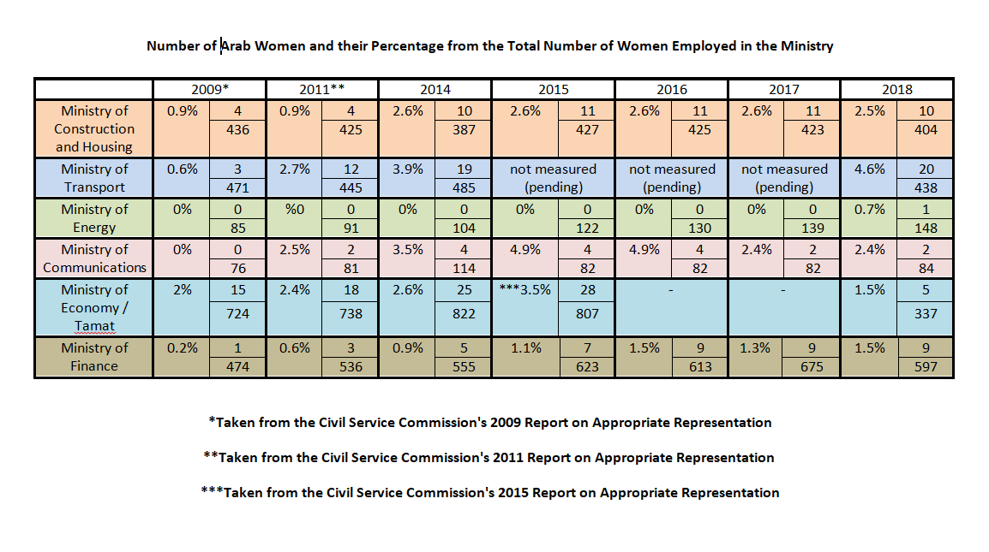

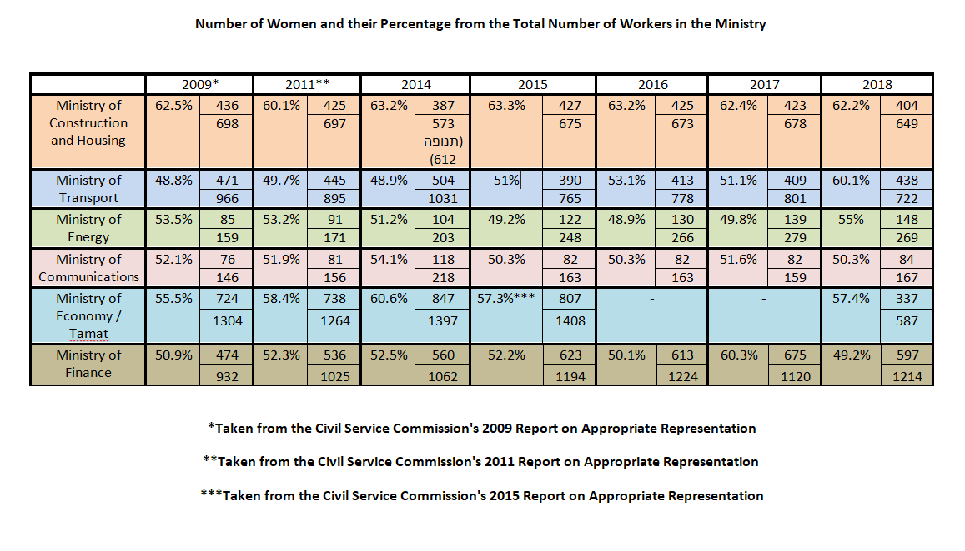

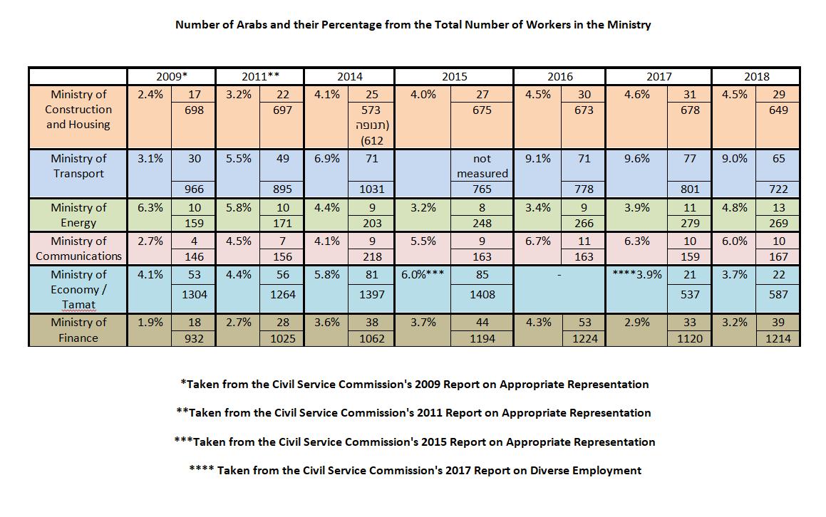
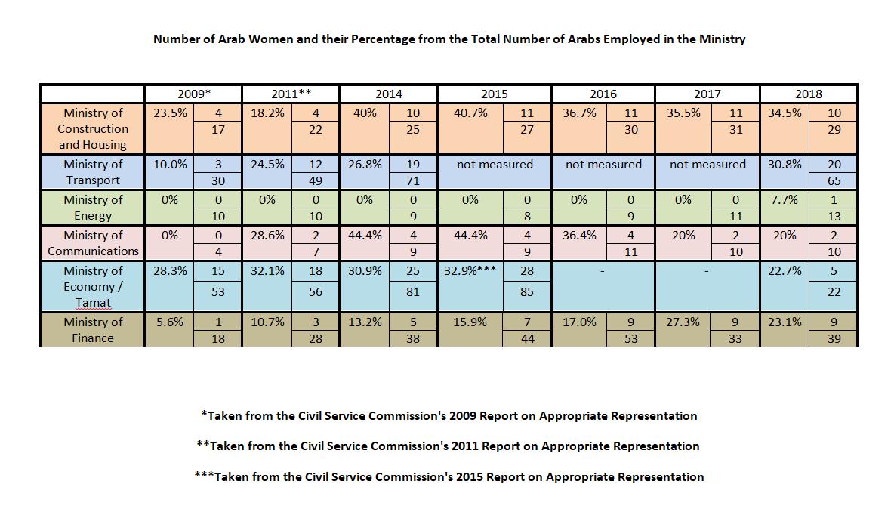

- Employment data in six ministries for the period 2015-2018

The full text of the JNS Law in the original Hebrew: https://www.adalah.org/uploads/uploads/Basic_Law_Israel_as_the_Nation_State_of_the_Jewish_People_HEB_25072018.pdf An unofficial English translation of the JNS Law is available on the website of the Knesset: https://knesset.gov.il/laws/special/eng/BasicLawNationState.pdf
HCJ 5866/18 The High Follow-up Committee for Arab Citizens of Israel, et al. v. The Knesset, et. al (case pending). An English translation of the petition is available on Adalah’s website: https://www.adalah.org/uploads/uploads/Jewish_Nation_State_Law_Petition_English_Final_October_2018.pdf
Adalah’s letter to the UN Special Rapporteurs: https://www.adalah.org/uploads/uploads/Adalah_Request_for_action_UN_Spec_Rapp_21102018.pdf. Attached to the letter is also a request for Urgent Action submitted by Adalah to the CERD Committee in September 2018. The Committee has not responded.
Communique: https://www.adalah.org/uploads/uploads/4_UN_Spec_Rapp_communication_02112018.pdf See also Adalah Press Release, “UN Special Rapporteurs give Israel 60 days to respond to 'deep concerns' regarding Jewish Nation-State Law,” 15 November 2018: https://www.adalah.org/en/content/view/9626
Ibid.
Law of Return, 1950. Available at: https://www.adalah.org/en/law/view/537
Citizenship and Entry into Israel Law (Temporary Order) – 2003. Available at: https://www.adalah.org/en/law/view/511
The Absentees’ Property Law, 1950. Available at: https://www.adalah.org/en/law/view/538
See Israel’s Reports to CERD, CERD/C/ISR/14-16, 17 January 2007, paras. 388-391 and CERD/C/ISR/17-19, 14 March 2017, para. 137.
For more information see, e.g., Revital Hovel, “Justice Minister: Israel Must Keep Jewish Majority Even at the Expense of Human Rights,” Haaretz, 13 February 2018: https://www.haaretz.com/israel-news/justice-minister-israel-s-jewish-majority-trumps-than-human-rights-1.5811106
HCJ 7052/03, Adalah et al. v. The Interior Ministry, et. al (petition dismissed 14 May 2006) and HCJ 466/07, MK Zahava Galon v. The Attorney General, et al. (petition dismissed 11 January 2012).
See Citizenship Law (1952) and Amendment 9 (2008): https://www.adalah.org/en/law/view/536
Adalah and ACRI Press Release, “Israeli Supreme Court temporarily delays revocation of Alaa Zayoud's citizenship,” 1 November 2017: https://www.adalah.org/en/content/view/9283
Ruth Margalit, “Israel’s Jewish Terrorist Problem,” The New Yorker, 4 August 2015: https://www.newyorker.com/news/news-desk/israels-jewish-terrorist-problem
See Adalah, ACRI and HaMoked Press Release, “New Israeli law that lets interior minister revoke Palestinian residency in Jerusalem for 'breach of loyalty' is illegal,” 11 March 2018: https://www.adalah.org/en/content/view/9425
HCJ 7803/06, Khalid Abu Arafeh et al. v. Minister of Interior (decision delivered 13 September 2017). See Adalah and ACRI Press Release, “After 10 years of litigation, Israeli Supreme Court rules interior minister cannot revoke Palestinian parliamentarians' Jerusalem residency for 'breach of loyalty',” 13 September 2017: https://www.adalah.org/en/content/view/9227
A new report issued by Amnesty International, Elected but restricted: Shrinking space for Palestinian parliamentarians in Israel’s Knesset, details how the right to freedom of expression of Palestinian members of the Knesset (MKs) is threatened by discriminatory legislative changes, proposed bills and Knesset regulations. It also highlights the inflammatory rhetoric used by Israeli government ministers to stigmatize Palestinian MKs and exposes how bills put forward by Palestinian MKs have been unfairly disqualified on discriminatory grounds. The report was released on 4 September 2019: https://www.amnesty.org/en/latest/news/2019/09/israel-discriminatory-measures-undermine-palestinian-representation-in-knesset/
For the text of the law in Hebrew see: https://www.adalah.org/en/law/view/571
HCJ 3166/14 Yehuda Gutman v. Attorney General et al. (petition dismissed 14 January 2014).
For the text of the law in Hebrew see: http://fs.knesset.gov.il//20/law/20_lsr_347851.pdf
Adalah, “Israeli Knesset’s approval of ‘Expulsion Law’ poses grave danger to basic democratic rights,” 20 July 2016: https://www.adalah.org/en/content/view/8866. See Adalah, “MK Jabareen, Adalah, ACRI petition Israeli Supreme Court against Expulsion of Members of Knesset Law,” 2 January 2017: https://www.adalah.org/en/content/view/8987.
HCJ 10214/16, MK Yousef Jabareen, et al. v. The Knesset (petition dismissed 27 May 2018).
For the text of the law in Hebrew see: http://fs.knesset.gov.il//20/law/20_lsr_347851.pdf
Section 7A of The Basic Law: The Knesset: https://www.knesset.gov.il/laws/special/eng/basic2_eng.htm
For more information, see Adalah press release, “Adalah files incitement complaint on behalf of Arab Joint List after Netanyahu statement ‘Arabs want to destroy all of us’,” 11 September 2019: https://www.adalah.org/en/content/view/9812
'Israel Is the Nation-state of Jews Alone': Netanyahu Responds to TV Star Who Said Arabs Are Equal Citizens, Ha’aretz, 11 March 2019: https://www.haaretz.com/israel-news/.premium-israel-is-the-nation-state-of-jews-alone-netanyahu-responds-to-tv-star-who-said-arabs-are-equal-citizens-1.7003348
Gantz Rules Out 'Political Discourse' With Arab Parties Over 'anti-Israel' Rhetoric, Ha’aretz, 19 March 2019: https://www.haaretz.com/israel-news/elections/gantz-rules-out-political-discourse-with-arab-parties-over-anti-israel-rhetoric-1.7041422
For more information, see Adalah press release, “Israeli elections committee bars surveillance cameras at polling stations, preventing intimidation of Arab voters,” 27 August 2019: https://www.adalah.org/en/content/view/9803
For more information, see Adalah press release, “Adalah responds to defeat of proposed Israeli ‘cameras law’,” 9 September 2019: https://www.adalah.org/en/content/view/9809
Other countries use other terms such as "employment equity".
https://www.gov.il/he/departments/policies/2007_des2579
Adalah also approached the The Ministry of Labor, Social Affairs and Social Services in request for employment data for the period 2015-2018. However, the data presented here relates only to the six ministries mentioned-above, given that were covered by former approaches since 2008.
Knesset Research and Information Center, Appropriate Representation for different groups in the Civil Service: Data on Israel with comparative study (n Hebrew, August 2018).
According to a 2017 survey conducted by the Central Bureau of Statistics, the number of Arab women employed in labor force is 157.8 k, whereas the number of all women employed in labor force equals 1,753.2 k. To wit, the percentage of Arab women from total number of women employed in the general work sector is 9%. (see the link: https://www.cbs.gov.il/he/publications/doclib/2019/lfs17_1746/t06_04.xls) . This number is almost double of the highest percentage recorded in government ministries which was only 4.9% (years 2015-2016, ministry of communications).
See Regulation 6/2014 of the Civil Service Commission (2 August 2014) (in Hebrew): https://www.gov.il/BlobFolder/policy/planning6-2014/he/planning6-2014.pdf

