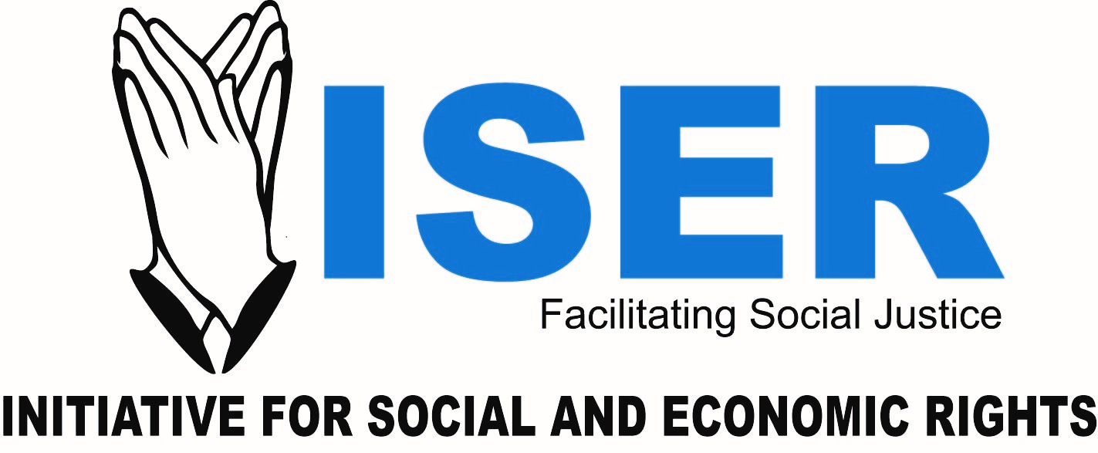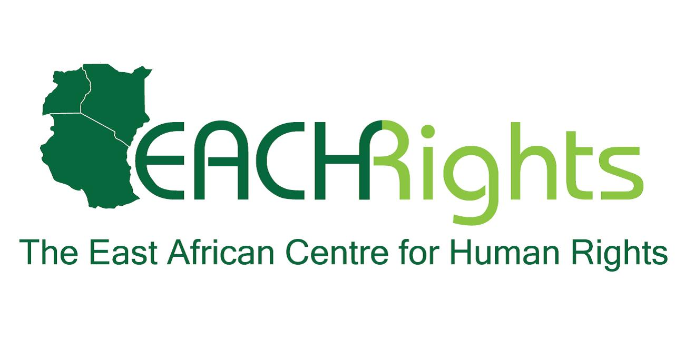
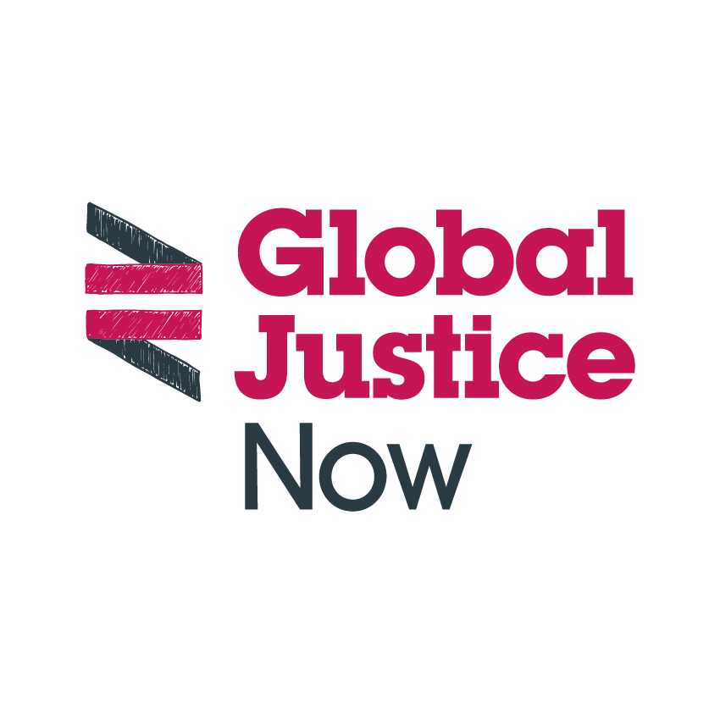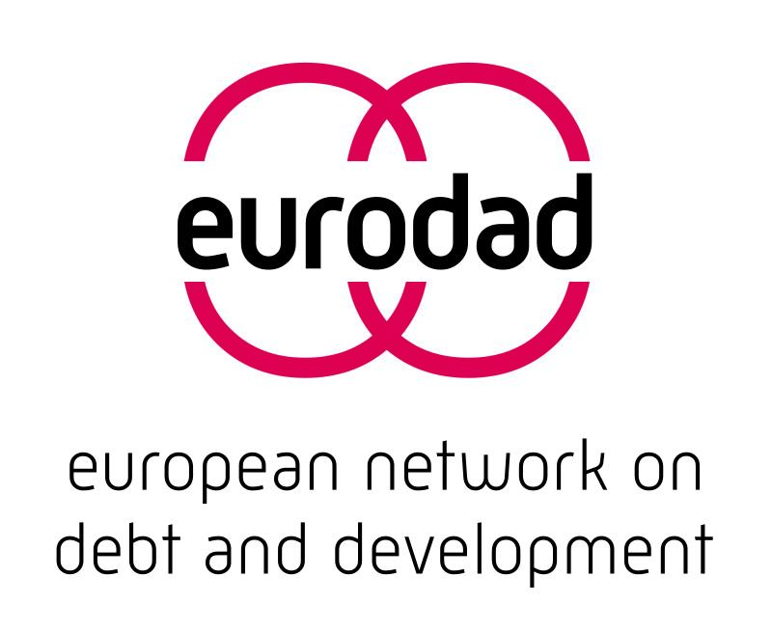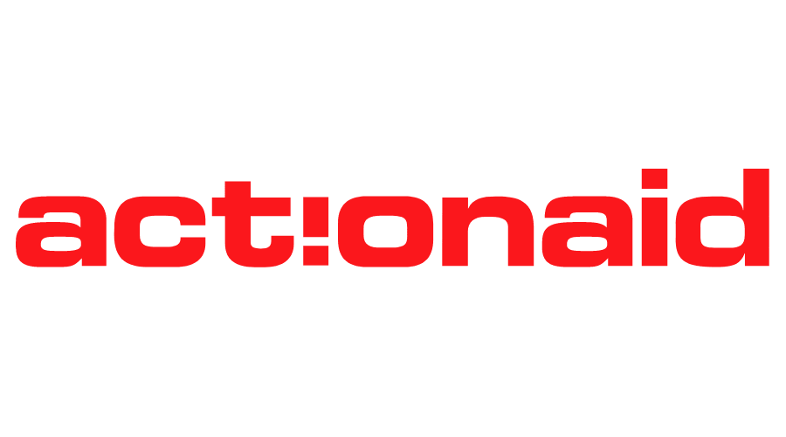
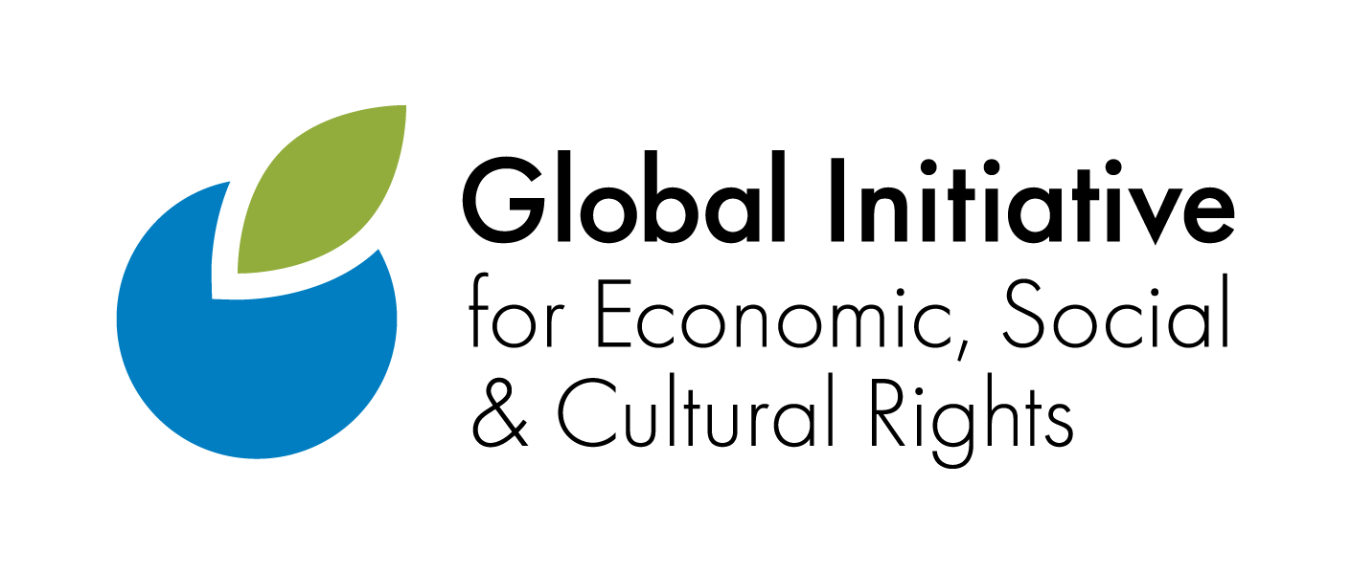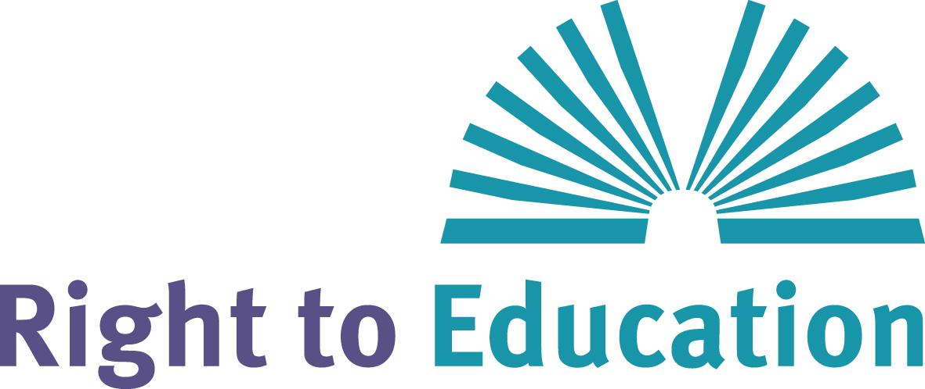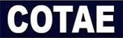

Report to the UN Committee on Economic, Social and Cultural Rights

7th Review of UK

The UK international development cooperation in the area of education

UPDATES & RECOMMANDATIONS

November 2024

SUBMITTED BY
ActionAid UK, Coalition for Transparency and Accountability in Education (Liberia), East African Centre for Human Rights (EACHRights, Kenya), Eurodad, Global Initiative for Economic, Social and Cultural Rights (GI-ESCR), Global Justice Now, Initiative for Economic and Social Rights (ISER, Uganda), Oxfam GB, Results UK, Right to Education Initiative, World Organization for Early Childhood Education-OMEP)

This is a brief update of the report submitted in January 2023 to the Committee on Economic, Social and Cultural Rights by organisations across the World including UK based organisations, organisations based in the Global South and international organisations. The updates cover:
- The major concerns raised by the International Development Committee of the UK Parliament about the UK’s investments as part of Overseas Development Aid (ODA)
- The UK’s non-response following findings from investigations by the International Finance Corporation (IFC)’s Compliance Advisor Ombudsman (CAO)
- The absence of UK’s responses to the CESCR’s questions related to UK international development cooperation in the area of education
- Update on the UK’s investments in fee-charging private education
- Key recommendations

- The International Development Committee of the UK Parliament raised major concerns about the UK’s investments as part of development aid.
In September 2023, the International Development Committee (IDC) of the UK Parliament published a report titled ‘Investment for development: The UK’s strategy towards Development Finance Institutions’, which raises major concerns about UK’s investments as part of development aid, particularly with regards to British International Investment’s (BII) activities and impacts in key sectors responsible for delivering human rights, including education and health. British International Investment is the UK’s Development Finance Institution which is wholly owned by the UK government and wholly funded by UK ODA.
The IDC's report highlights serious failings regarding the oversight, transparency and accountability of BII.
The report refers to the evidence showing serious concerns about the for-profit education chain New Globe Schools, formerly Bridge International Academies (Bridge), including the quality of education offered in these schools, the high costs in relation to family income, the poor labour conditions, and the respect for the rule of law, putting the realisation of the right to education at risk (para. 88 and notes 258, 260 and 261).
BII exited its direct investment in Bridge/NewGlobe in 2022. However, the report highlights the UK’s continued investment in Bridge (note 262), through an intermediary fund, Novastar (note 263) and cites Nick O’Donohoe, CEO of BII, who said:
‘Novastar make their own decisions as to when they are going to divest, and they have not yet divested of their position in Bridge. Because we are one of their fundholders, a small part of that accrues to us’. (note 264)
The IDC report notes that ‘this example demonstrates the reduced control that BII has over its intermediate investments when their values change’ (para. 88). The Committee’s findings also conclude that the use of financial intermediaries coupled with a ‘hands off’ approach has led to investments which ‘do not have a clear poverty focus, are in conflict with the UK Government's policies or may actually have harmed society and the environment’ (para. 94).
The IDC report goes on to flag ‘conflicting accounts’ over what BII’s current policy is towards the financing of fee-charging K12 private schools (note 266). In light of the World Bank’s Independent Evaluation Group’s evaluation and subsequent decision not to resume investments in these schools because of their negative impacts of poverty, inequality, and education outcomes, the Committee highlights that it would expect ‘BII to ensure its K-12 investments do not have unintended consequences on international development, or to exit those investments’ (note 268) (para. 89).

Recommendations made by the International Development Committee:
16. To ensure that poverty reduction is central to BII’s investment decisions and to prioritise investments that are critical to recipient countries’ development needs’, BII must:

(a) take responsibility for where its money is invested by exerting greater oversight and control over the activities of financial intermediaries who invest UK taxpayers’ money.
(b) ensure that its investments reduce inequality by targeting investments that generate tax receipts in the country of operation rather than channelling money through low-tax jurisdictions that ultimately promote tax savings for those intermediary agents.
(c) rigorously monitor all its intermediated investments to ensure that it can intervene before its money is invested in companies whose values are not aligned with the International Development Strategy.
19. BII must ensure that its entire portfolio is aligned with the UK Government’s development agenda. With a diminished ODA budget there is more pressure to target development assistance towards the poorest and most marginalised groups: consequently, there is a greater responsibility for BII to actively manage its portfolio. It should place a greater emphasis on the impact delivered with the money it controls.

20. To deliver accountability and transparency and to operate in lockstep with the International Development Strategy, BII must assess the impact of its portfolio under previous strategy periods and actively manage its portfolio. BII must perform annual assessments of the impact delivered by all of its portfolio investments, including those businesses that are invested in through financial intermediaries. BII must divest from those investments that do not have a clear development objective and do not align with the International Development Strategy. In conclusion to these concerns expressed by the Committee and some that submitted evidence, we recommend the Minister maintain closer scrutiny on the whole budget and the proportion of the ODA budget allocated to BII. At a time of limited availability of the development budget, the taxpayer needs assurance that Official Development Assistance is used to support the world’s poorest people in the most effective way.

21. BII needs to work towards greater transparency of its investment data. As BII has stewardship over taxpayers’ money, there is greater responsibility to ensure propriety over its investments by annually publishing performance data.
- The UK’s non-response following findings from investigations by the International Finance Corporation (IFC)’s Compliance Advisor Ombudsman (CAO)
The World Bank Group’s private sector arm, the International Finance Corporation (IFC), invested a total of USD 13. 5 million in Bridge/NewGlobe in 2013 and 2016. Multiple complaints concerning the investment were submitted to the IFCs Compliance Advisor Ombudsman (CAO) between 2018 and 2024, outlining negative impacts of the investment on parents, teachers and students. Findings of one compliance investigation concerning allegations of child sexual abuse, found that the IFC had failed to meet requirements of its Sustainability Policy, specifically that they had failed to adequately supervise and monitor its client. This directly contributed to the severe harm experienced by several students.
In response, the IFC proposed a range of institutional reforms and is currently designing a 3-10 year remediation programme with sector level interventions and remedial solutions that are meant to directly respond to the needs of the complainants and other survivors. While various CSOs have expressed concerns about the efficacy of the IFC's proposed plan to deliver effective remedy, a key discussion point has emerged about the role that other DFIs that invested in Bridge/NewGlobe should play in contributing to comprehensive and effective remedy. The US Development Finance Corporation (DFC) is already taking some steps in this regard. BII, who notably also invested a total of $7.6m directly and an unclear amount indirectly (via a financial intermediary known as Novastar), should also contribute to remediation efforts. In light of concerning findings that the IFC did not respond when it first became aware of the allegations of child sexual abuse, it is also imperative that the BII be required to explain when it first became aware of the child sexual abuse cases identified by the World Bank Group’s CAO, and the actions it took in response.
The East African Centre for Human Rights wrote to both BII and Novastar in July 2024 concerning the CAOs findings, urging both institutions to transparently account for their investment. No response from either party has been received to date. It would be incumbent on BII, as a responsible investor, to provide a clear and public account of their own due diligence, supervision and actions over the investment period to prevent, address or mitigate the harm experienced by former students and teachers. BII should make a clear commitment to contribute to remedy and outline a plan of action on how they will effectively address identified and confirmed harms.
- Absence of UK’s responses to the CESCR’s questions related to UK international development cooperation in the area of education
In the list of questions issued by your Committee in March 2023 to the UK government, one was specifically related to the UK international development cooperation in the area of education:

4. (...). In the light of the information on international development cooperation in the report of the State party, please provide information on the findings of the social and human rights assessments conducted in the implementation of programmes and projects in the field of education services abroad and how those findings have contributed to ensuring transparency and accountability for non-State providers of education services, including low-cost private schools. Please provide information on the measures taken to establish an effective monitoring mechanism to regularly assess the impact of low-cost and private education projects on the quality of free public education in receiving countries and to take remedial action, when required.

In its responses to the CESCR’s list of questions, the UK did not include a response to the CESCR’s question above.
- Update on the UK’s investments in fee-charging private education
As of November 2024, the UK’s DFI, British International Investment (BII) has one active direct investment in education. BII is also invested in education via several financial intermediaries. At present, BII is invested in 24 funds whose portfolios include active investments classified as ‘Consumer - Education’. These funds either invest directly in companies, in a parent company which may direct funds to its subsidiaries, or in a financial services provider which invests in companies (section 1 in the annex provides further explanation). These investment structures are complex, which makes it difficult to track and accurately assess the impact of BII’s funds in education. As demonstrated in other reviews of BII's investment portfolios, BII itself provides minimal, if any, published information on impact.
While BII’s 2022-26 strategy states that they will no longer be prioritising investments in K-12 private education, it remains invested in companies that operate or that target fee-charging K12 for-profit education provision through at least ten financial intermediaries - see Table 1 in the annex. The type of fee-charging K12 education that BII funds is varied. The annex highlights four categories: so-called low-fee education, fee-charging K12 international schools, education services, and financial services for fee-charging schools. Each is examined further in section 2 of the annex, with examples. The following presents two key concerns arising from our analysis:
- BII’s position on fee-charging education and the right to education
BII’s directory of investments on its website includes the category ‘Consumer- Education’. As such, BII appears to position education as a consumer good, rather than a human right.
Most of the funds in which BII invests have broad remits which are not specific to education. For example, Adiwale Fund I’s intended impact is to ‘[p]romote economic opportunities by creating jobs (SDG targets 8.5, 9.3)’. Similarly, the Anthem Asia Myanmar SME Venture Fund aims to ‘target SMEs focussed on consumer and business services, and tech-enabled early stage businesses’. Both invest in fee-charging education (see Table 1 in the annex). Therefore, it seems that many of the investments in fee-charging education are not entered into with the explicit goal of fulfilling the right to education. As a result, they do not provide theory of change or impact thesis around how they will improve educational outcomes. This raises questions about when and how the right to education is considered in the investment process, especially in light of the limited ‘Environmental and Social Information’ published by BII (see Table 1 below).
BII’s investment in the Regional Education Finance Fund for Africa ‘provides long-term debt to financial institutions in Africa for on-lending to affordable, private education providers’(see annex section 3, example 5). According to BII, the fund ‘will improve access to affordable and high quality education’. Given the IFC’s decision to no longer invest in fee-charging private schools based on their well evidenced negative impacts on the right to education (see section 1 above) and extensive concerns raised regarding commercial and for-profit schools, it is noteworthy and concerning that there is no information provided by BII on risks related to the funds’ impact.

- Transparency and accountability issues
As reflected in our previous report (January 2023) and the report by the UK International Development Committee (IDC) of the UK Parliament (September 2023), BII’s investments through financial intermediaries present multiple transparency and accountability issues. These include:
- A lack of transparency regarding:
  - The scale of BII’s investments in fee-charging education, especially fee-charging for profit education. For example, BII’s former direct investment in NewGlobe Schools Inc was $7.6m. The size of BII’s current investment in NewGlobe Schools Inc via Novastar Ventures East Africa Fund I LP is unknown. The same is true for all of BII’s indirect investments in education - this is illustrated with red arrows in a number of examples in the annex.

  - The organisations who ultimately receive BII funds. Investments in education through financial intermediaries and then via financial services providers, worsen transparency issues by making it impossible to know exactly which fee-charging schools receive BII funds (and how much funding). It is impossible to know how these institutions, and UK taxpayers’ money, impacts on the realisation of the right to education. Yet BII’s investments under this model are continuing (see examples of recent investments in annex section 3 (iv)).
  - Complex relationships between investors, financial intermediaries, parent companies and subsidiaries. For example, BII invested in Novastar Ventures East Africa Fund I LP, which invested in NewGlobe Schools Inc (see example 2 in the annex). According to BII’s website, it invested in NewGlobe Schools Inc in 2013, and the investment was announced in 2014 with the headline ‘CDC supports expansion of Bridge International Academies’. Until recently, NewGlobe Schools Inc was the parent company under which Bridge International Academies operated. Bridge then became subject to several serious complaints, and subsequently NewGlobe Schools Inc ended its financial ties to Bridge International Academies (now rebranded to Bridge Community Schools). The web of organisations and names contributes to a severe lack of transparency which further complicates calls for accountability.

- A lack of clarity regarding the intended impacts of investments in specific companies; or how they relate to the UK’s International Development Strategy and to the UK’s extraterritorial human rights obligations.
  - Many of the funds through which BII invests have broad remits and the ‘Expected Impact’ outlined on BII’s website is accordingly broad as well as limited. Details of the intended impacts of individual investments are vital, but missing. This is of special importance given that ‘BII must divest from those investments that do not have a clear development objective and do not align with the International Development Strategy’ according to the previous recommendations of the UK’s International Development Committee. Transparent information regarding the purpose of BII’s individual investments is also particularly significant when a client's operations are complex and varied. For example, BII invests in the Rising International Education and Learning Limited, which provides ‘tools’ for ‘education providers’ and manages both public-private partnerships and low-fee for-profit schools. It is unclear which of these activities is supported by BII’s funds and which specific impact pathways can be monitored and evaluated.
  - Updates on “ACHIEVED IMPACT” are not always forthcoming. BII’s direct investment in NewGlobe Schools Inc ended in July 2022. The impact section still reads “This information will appear shortly”.

- BII only provides vague comments regarding financial intermediaries’ due diligence processes. For each fund, BII’s web pages include a section titled ‘Environmental and Social Information’ which includes an ‘Environmental and Social Summary’ and in some cases also a section titled ‘Environmental and Social Risk’. For funds, though which BII has invested in fee-charging education, the information is often cursory only (see Table 1 below). It is therefore unclear how financial intermediaries consider human rights in their work. When no information is provided it undermines confidence that activities of the funds are being properly overseen, including regarding possible unintended impacts on the right to education.
Table 1: Due diligence information provided by BII regarding some of their financial intermediaries that invest in fee-charging education
BII investments | ‘Environmental and Social Information’
Regional Education Finance Fund for Africa | None provided.
Anthem Asia Myanmar SME Venture Fund | None provided.
Novastar Ventures East Africa Fund I LP | ‘We are working closely with the fund manager to improve its existing ESMS, including delivering an action plan.’
African Rivers Fund | ‘We will work closely with the fund manager to develop and implement an ESMS.’
Adiwale Fund I | ‘We are working closely with the fund manager to develop an ESMS (for this first-time fund). We will support implementation of the ESMS and improve it as the fund begins to invest.’
AfricInvest III | ‘The fund manager has a well-established approach to environmental and social management and we will continue to support and monitor its approach as the portfolio grows.’
Cumulatively BII’s investments via financial intermediaries provide no meaningful quality data on impact which prevents necessary, detailed assessments of policies and investments’ impacts on the right to education.

Recommendations
Referring to the serious concerns about the UK’s financial support to for-profit education providers, raised in the report we submitted in 2023, as well as the international human rights framework applying to this issue, and taking into account the information provided in this additional report, we call on the committee on Economic, Social and Cultural Rights to recommend the UK government to:
- Formally commit to cease investments in for-profit education providers in low- and middle-income countries, including through intermediated investments.

- Exit current BII investments in for-profit education providers, particularly in NewGlobe given their abhorrent track record in upholding the right to education.
- In light of the documented concerns and ongoing investigations about the behaviour and operations of Bridge International Academies, ensure BII fulfils its legal due diligence obligations and responsibilities and takes action to respond to the harms caused by their investments. The UK government should also request that BII provide a comprehensive account of when they first became aware of the child sexual abuse cases identified by the IFC’s CAO, the actions BII took in response, and an action plan to redress all the harms experienced during the period of its support for Bridge schools.

- Ensure BII complies with the right to information by publishing in a transparent and accessible way the amount of public funds invested in for-profit education providers.
- Ensure all investments in education support the right to education, comply with human rights standards, including the Abidjan Principles, and contribute to strengthening the public education system in partner countries, as well as supporting good governance, democratic control, transparency and accountability. To this end, establish an effective monitoring mechanism to assess (prior to decision-making and then regularly) the impact of operations funded by development assistance institutions - including those undertaken in the private sector by BII - on the enjoyment and realisation of the right to education in recipient countries, and take corrective action where necessary.

- Prioritise the development of free, quality, public education systems in recipient countries, particularly in areas where state provision is weak or non-existent.

Annex
- How BII invests in education
Figure 1 gives a sense of the complexity of BII’s education investment structures, which makes it hard to track and accurately assess the impact of BII’s funds.
Figure 1: How BII invests in education
Model 1 | British International Investment  Company (e.g. school chain)
Model 2 | British International Investment  Financial Intermediary (Fund)  Company (e.g. school chain)
Model 3 | British International Investment  Financial Intermediary  Parent company  Subsidiary company (e.g. school chain)
Model 4 | British International Investment  Financial Intermediary  Financial services provider  Companies (e.g. school chain)
Note: Arrows represent investments. A black arrow shows that the investment size is published on BII’s website. A red arrow shows that the investment size is not published. A red outline indicates that the final organisation receiving BII’s funds and/or the exact use of funds is unknown.
- Funds invested in fee-charging education
While BII’s 2022-26 strategy states that they will ‘not prioritise new investments in K-12 (kindergarten to twelfth grade) private education’, BII remains invested in companies that operate fee- charging K-12 education through at least ten BII funded financial intermediaries - please see Table 1 below.
Table 1: Ten financial intermediaries through which BII invests in fee-charging K-12 private schools
Financial Intermediary (Fund) | Investment | Evidence that investments operate fee charging K12 education
Adiwale Fund I | Enko Education Limited | https://enkoeducation.com/en_za/about/
African Rivers Fund | Institut Aurora | https://www.proparco.fr/en/ressources/aurora-school-social-impact-democratic-republic-congo
AfricInvest III | International Community Schools | https://icsghana.org/admissions/
Anthem Asia Myanmar SME Venture Fund | Thalun Pte Ltd | https://www.thaluninternationalschool.com/tuition-and-fees/  https://www.anthemasia.com/
Neoma South East Asia Fund II | Singapore International School | https://sisschools.org/tuition-fees/  https://sisschools.org/admissions/
Novastar Ventures East Africa Fund I LP | Newglobe Schools Inc | https://www.bii.co.uk/en/our-impact/investment/newglobe-schools-inc-investment-02/
Regional Education Finance Fund for Africa | Multiple including: EdPartners Limited | https://edpartnersafrica.com/about
Solon Capital Holdings | Rising International Education and Learning Limited | https://www.soloncapitalpartners.com/investments
SPE Capital Africa Industrialisation Fund | Holged Group and Holged Tunisie | https://www.spe-capital.com/our_investments  https://holged.com/index.php/2023/06/21/holged-acquiert-100-du-capital-d-al-massalik-prive-et-de-l-institution-larbi-benamour/  https://simulateur.iscgroupe.com/?_gl=1%2a11mpyvk%2a_ga%2aOTI1OTU0NzE1LjE3MzIyODIxMTE.%2a_ga_TJ38456GS5%2aMTczMjI4MjExMC4xLjAuMTczMjI4MjExMC4wLjAuMA..
Takura II | Oak Ed (PVT) Ltd and Vantage Properties (PVT) Ltd | https://zw.linkedin.com/in/kwaku-y-h-dzvukamanja-93389a67
- Types of fee-charging K-12 education funded by BII
The type of fee charging K-12 education that BII funds is varied. Four categories identified include low-fee education, fee-charging K-12 international schools, education services, and financial services for low-fee schools. These are discussed in more detail in the sections below (i-iv), with examples.
i. Low-fee education
Example 1: Rising International Education and Learning Limited

British International Investment
Financial Intermediary: Solon Capital Holdings (Domicile: Mauritius)
Company: Rising International Education and Learning Limited (September 2017)

Rising Academy Network (Liberia) Limited (Liberia)

Omega School Franchise Ltd (Ghana)
Rising Academy Network (SL) Limited (Sierra Leone)
Figure 2: BII invests in Rising International Education and Learning Limited

BII is an investor in the for-profit company Rising International Education and Learning Limited (known as Rising Academy Network). It runs so-called low-fee private schools, public-private partnership schools and supplies ‘tools’ to other schools. It is the owner of three companies - Rising Academy Network (SL) Limited (Sierra Leone), Omega School Franchise Ltd (Ghana) and Rising Academy Network (Liberia) Limited (Liberia). In Ghana, previous research has found that Omega Schools ‘charges fees for one student that are equivalent to 40% of the income of the poorest families’ household income.’

The Rising Academy Network is planning further expansion: ‘Diversifying its affordable private school business by rolling out its Rising International offering and expanding to a third country’.

Solon Capital Partners manages Solon Capital Holdings, which receives returns on its investments in the education company Rising International Education and Learning Limited. Solon Capital Partners therefore also benefits from the returns. It has a ‘corporate social responsibility’ arm, namely the Solon Foundation. The Solon Foundation funds scholarships for children attending the fee-charging schools belonging to the Rising International Education and Learning Limited. In this complex web shown in figure 3, the education of ‘children (particularly girls) from the most disadvantaged backgrounds’ depends on charitable giving.
Solon Capital Holdings
Rising International Education and Learning Limited
Solon Foundation
Scholarships
Corporate Responsibility
Investment
Return on investment
Solon Capital Partners
BII
Figure 3: Funding scholarships at Rising International Education and Learning Limited’s schools
Example 2: NewGlobe Schools Inc

BII invests in NewGlobe Schools Inc, which it describes as ‘a chain of nursery and primary schools delivering high-quality education for just $5 a month (on average)’. BII previously directly invested in NewGlobe Schools Inc, but exited its direct investment in 2022. However, BII remains invested in NewGlobe Schools Inc through Novastar Ventures East Africa Fund I LP. Bridge International Academies, a provider of low-fee for-profit education, was owned by NewGlobe Schools Inc. Bridge International Academies have been the subject of multiple complaints (see section 2). Civil society organisations have mobilised extensively around the negative effects of commercial schools such as those operated by NewGlobe Schools Inc.

British International Investment
Financial Intermediary: Novastar Ventures East Africa Fund I LP (Domicile: Mauritius)
Company: NewGlobe Schools Inc (March 2014)
Subsidiary company: Bridge International Academies Limited
Figure 4: BII invests in NewGlobe Schools Inc
ii. Fee-charging K12 international schools
BII is an investor in fee-charging K12 international schools through several funds. BII invests in The Holged Group (Tunisia) which describes itself as ‘un groupe intégrant des établissements d'enseignement de tout premier plan’ (a group integrating leading educational establishments) as well as International Community School Limited (Ghana) which teaches the British curriculum with students sitting IGCSE and A-level exams. Additionally, BII invests in Singapore International School (also known as SIS Group of Schools and Singapore Intercultural School). Its schools teach the ‘Singapore, Cambridge and IB curriculum’.
British International Investment
Financial Intermediary: SPE Capital Africa Industrialisation Fund (Domicile: Mauritius)
Company: Holged Group (March 2022)
Subsidiary companies: Holged Group includes 18 institutions
British International Investment
Financial Intermediary: AfricInvest III (Domicile: Mauritius)
Company: International Community School Limited (December 2016)
British International Investment
Financial Intermediary: Neoma South East Asia Fund II (Domicile: Canada)
Company: Singapore International School
Figure 5: BII invests in Holged Group, International Community School Limited and Singapore International School

Example 3: Enko Education Limited

BII invests in Enko Education Limited, a ‘fast-growing network of African international schools’ which teaches the International Baccalaureate and targets middle class families with fees that are lower than other schools offering international education in Africa. It offers ‘scholarships to between 10 and 20% of its students to increase the access of those less well-off to outstanding international education’. Enko Education Limited already operates 15 schools and plans to launch 30 more across Africa in the next five years.
British International Investment
Financial Intermediary: Adiwale Fund I (Domicile: Mauritius)
Company: Enko Education Limited
Figure 6: BII invests in Enko Education Limited
iii. Education services
Example 4: Oak Ed (PVT) Ltd and Vantage Properties (PVT) Ltd
BII invests in Oak Ed (PVT) Ltd and Vantage Properties (PVT) Ltd through Takura II. Information in the public domain about Oak Ed (PVT) Ltd and Vantage Properties (PVT) Ltd is scarce. However, according to the LinkedIn profile of its co-founder, it is also known as Oakwood Education, ‘a privately- owned Zimbabwean education company focused on the development and operation of for profit education facilities and services’. In 2020 the company launched its first school.
British International Investment
Financial Intermediary: Takura II (Domicile: South Africa)
Company: Oak Ed (PVT) Ltd and Vantage Properties (PVT) Ltd (November 2017)
Figure 7: BII invests in Oak Ed (PVT) Ltd and Vantage Properties (PVT) Ltd
iv. Financial services for low-fee schools
Recently, BII has started to invest in fee-charging K12 private education through financial services. In May 2018 BII invested $15m in the Regional Education Finance Fund for Africa - see figure eight below. This fund ‘provides long-term debt to financial institutions in Africa for on-lending to affordable, private education providers offering primary, secondary and tertiary education as well as for individual school fee loans to parents and students’. Through the fund, in November 2023 BII became an investor in EdPartners Limited (Kenya), ‘a non-banking financial institution’. EdPartners Limited (Kenya) ‘provides 2-6 year loans to low-cost private schools in Africa’ for construction projects among others purposes. According to Acumen, ‘97% of Ed Partners’ clients are the most affordable private schools, those charging less than $300 USD per year in school fees’. The Regional Education Finance Fund for Africa continues to make new investments: so far this year it has invested in Access Bank Plc.
In 2021 BII invested a further $15m in Insitor Impact Asia Fund 2, which itself invested in 2022 in Taleem - see figure 9 below. A ‘licensed non-bank financial institution’, Taleem provides for ‘the financial needs of middle and low-cost private Education Institutions’.
Example 5: Regional Education Finance Fund for Africa
British International Investment
Financial Intermediary: Regional Education Finance Fund for Africa (Domicile: Luxembourg)
Financial services provider: EdPartners Limited (Kenya)
Companies (e.g. school chain)
Figure 8: BII invests in Regional Education Finance Fund for Africa
Example 6: Insitor Impact Asia Fund 2
British International Investment
Financial Intermediary: Insitor Impact Asia Fund 2 (Domicile: Singapore)
Financial services provider: Taleem
Companies (e.g. school chain)
Figure 9: BII invests in Insitor Impact Asia Fund 2

British International Investment, ‘Solon Capital Holdings’, British International Investment, [n.d.] <https://www.bii.co.uk/en/our-impact/fund-header/solon-capital-holdings/> [Accessed 22 November 2024]; Rising International Education and Learning Limited, Home, [n.d.] <https://www.risingacademies.com/> [Accessed 22 November 2024]; Rising International Education and Learning Limited ‘The Challenge’, Rising International Education and Learning Limited, [n.d.] <https://paul-skidmore.squarespace.com/work> [Accessed 29 November 2024].
British International Investment, ‘Our Investments’, British International Investment, [n.d.] <https://www.bii.co.uk/en/our-impact/search-results/> [Accessed 22 November 2024].
British International Investment, ‘Adiwale Fund I’, British International Investment, [n.d.] <https://www.bii.co.uk/en/our-impact/fund/adiwale-fund-i-investment-01/> [Accessed 22 November 2024].
British International Investment, ‘Anthem Asia Myanmar SME Venture Fund’, British International Investment, [n.d.] <https://www.bii.co.uk/en/our-impact/fund/anthem-asia-myanmar-sme-venture-fund-investment-01/> [Accessed 22 November 2024].
British International Investment, ‘Regional Education Finance Fund for Africa’, British International Investment, [n.d.] <https://www.bii.co.uk/en/our-impact/fund/regional-education-finance-fund-for-africa-investment-01/> [Accessed 22 November 2024].
ActionAid and others, BRIEF to the UN Committee on Economic, Social and CulturalRights, 7th Review of UK, Pre-sessional Working Group submission, January 2023 (2023), pp.10-3, <https://www.right-to-education.org/sites/right-to-education.org/files/resource-attachments/Joint%20report%20to%20the%20CESCR_UK%20Review_January%202023_EN.pdf> [Accessed 22 November 2024].
Rising International Education and Learning Limited, ‘WE ARE RISING.’’, Rising International Education and Learning Limited, [n.d.] <https://www.risingacademies.com/> [Accessed 22 November 2024]; British International Investment, ‘Solon Capital Holdings’, British International Investment, [n.d.] <https://www.bii.co.uk/en/our-impact/fund/solon-capital-holdings-investment-01/> [Accessed 26 November 2024]; Rising International Education and Learning Limited ‘The Challenge’, Rising International Education and Learning Limited, [n.d.] <https://paul-skidmore.squarespace.com/work> [Accessed 29 November 2024].
Rising International Education and Learning Limited, ‘Announcing Rising Academies’ Series A Financing’, Rising International Education and Learning Limited, [2024] <https://www.risingacademies.com/risingnews/series-a-ta5ea> [Accessed 22 November 2024].
Solon Capital Partners Limited, ‘A team on a mission’, Solon Capital Partners Limited, [n.d.] < https://www.soloncapitalpartners.com/team> [Accessed 22 November 2024].
Rising International Education and Learning Limited, ‘Give’, Rising International Education and Learning Limited, [n.d.] <https://www.risingacademies.com/give-20> [Accessed 22 November 2024].
Rising International Education and Learning Limited, ‘Give’, Rising International Education and Learning Limited, [n.d.] <https://www.risingacademies.com/give-20> [Accessed 22 November 2024].
Karen Mathiasen, ‘Bridge over Troubled Waters: Accountability at the IFC’, Center for Global Development, 2024 <https://www.cgdev.org/blog/bridge-over-troubled-waters-accountability-ifc> [Accessed 22 November 2024]; International Finance Corporation, ‘Bridge International Academies’, International Finance Corporation, 2022 <https://disclosures.ifc.org/project-detail/SII/32171/bridge-international-academies/> [Accessed 26 November 2024].
PERHC, ‘Commercial Schools and the Right to Education’, PEHRC, [n.d.] <https://www.educationbeforeprofit.org/commercial-schools-and-the-right-to-education/> [Accessed 22 November 2024].
Holged, ‘Le Groupe’, Holged, [n.d.] <https://holged.com/> [Accessed 26 November 2024]; International Community Schools Ghana, ‘About Us’, International Community Schools Ghana, [n.d.] <https://icsghana.org/about-us/> [Accessed 22 November 2024]; British International Investment, ‘SPE Capital Africa Industrialisation Fund’, British International Investment, [n.d.] <https://www.bii.co.uk/en/our-impact/fund-header/spe-capital-africa-industrialisation-fund/> [Accessed 26 November 2024]; British International Investment, ‘AfricInvest III’, British International Investment, [n.d.] <https://www.bii.co.uk/en/our-impact/fund-header/spe-capital-africa-industrialisation-fund/> [Accessed 26 November 2024].
British International Investment, ‘Neoma South East Asia Fund II’, British International Investment, [n.d.] <https://www.bii.co.uk/en/our-impact/fund-header/neoma-south-east-asia-fund-ii/> [Accessed 26 November 2024];SIS SCHOOLS, ‘About SIS’, SIS SCHOOLS, [n.d.] <https://sisschools.org/about-sis [Accessed 22 November 2024].
SIS SCHOOLS, ‘About SIS’, SIS SCHOOLS, [n.d.] <https://sisschools.org/about-sis [Accessed 22 November 2024].
British International Investment, ‘Regional Education Finance Fund for Africa’, British International Investment, [n.d.] <https://www.bii.co.uk/en/our-impact/fund/regional-education-finance-fund-for-africa-investment-01/> [Accessed 22 November 2024].
British International Investment, ‘Regional Education Finance Fund for Africa’, British International Investment, [n.d.] <https://www.bii.co.uk/en/our-impact/fund/regional-education-finance-fund-for-africa-investment-01/> [Accessed 22 November 2024].
Acumen, ‘Ed Partners: Financing the future of education in East Africa’, Acumen, 2021, <https://acumen.org/case-studies/edpartners/> [Accessed 22 November 2024].
Acumen, ‘Ed Partners: Financing the future of education in East Africa’, Acumen, 2021, <https://acumen.org/case-studies/edpartners/> [Accessed 22 November 2024].
British International Investment, ‘Regional Education Finance Fund for Africa’, British International Investment, [n.d.] <https://www.bii.co.uk/en/our-impact/fund/regional-education-finance-fund-for-africa-investment-01/> [Accessed 22 November 2024].
British International Investment, ‘Regional Education Finance Fund for Africa’, British International Investment, [n.d.] <https://www.bii.co.uk/en/our-impact/fund/regional-education-finance-fund-for-africa-investment-01/> [Accessed 22 November 2024]; Ed Partners Africa Ltd., ‘About Us’, Ed Partners Africa Ltd., [n.d.] <https://edpartnersafrica.com/about> [Accessed 22 November 2024].
Analysis for this submission is based on active investments listed in BII project database tagged “Consumer - Education”, accessed November 2024: British International Investment, ‘Our Investments’, British International Investment, [n.d.] <https://www.bii.co.uk/en/our-impact/search-results/?inv-sector%5B%5D=consumer-education&inv-datefrom=2003-01-20&inv-dateto=2023-01-20> [Accessed 22 November 2024].
British International Investment is invested in 28 funds whose portfolios include investments classified as ‘Consumer - Education’. However, four of these funds have exited their ‘Consumer - Education’ investments (Pravega Ventures Fund I, SGI Ethiopia Growth and Transformation Fund, Stellaris Venture Partners India I, and Ventureast proactive Fund II): British International Investment, ‘Our Investments’, British International Investment, [n.d.] <https://www.bii.co.uk/en/our-impact/search-results/page/1/?inv-sector%5B0%5D=consumer-education&inv-datefrom=2012-01-01&inv-dateto> [Accessed 22 November 2024]; British International Investment, ‘Our Investments’, British International Investment, [n.d.] <https://www.bii.co.uk/en/our-impact/search-results/page/2/?inv-sector%5B0%5D=consumer-education&inv-datefrom=2012-01-01&inv-dateto> [Accessed 22 November 2024]
British International Investment, ‘Regional Education Finance Fund for Africa’, British International Investment, [n.d.] <https://www.bii.co.uk/en/our-impact/fund/regional-education-finance-fund-for-africa-investment-01/> [Accessed 22 November 2024].
International Development Committee, Investment for development: The UK’s strategy towards Development Finance Institutions, HC 884 (London: House of Commons, 2023), pp.57-8 <https://committees.parliament.uk/publications/41461/documents/203966/default/> [Accessed 22 November 2024].
Enko Education, ‘About’, Enko Education, [n.d.] <https://enkoeducation.com/en_za/about/> [Accessed 22 November 2024]; BIO, ‘Enko Education’, BIO, [n.d.] <https://www.bio-invest.be/en/investments/enko-education#:~:text=The%20middle%2Dclass%20segment%20offers,teachers%20and%20training%20them%20intensively> [Accessed 22 November 2024]; British International Investment, ‘Adiwale Fund I’, British International Investment, [n.d.] <https://www.bii.co.uk/en/our-impact/fund-header/adiwale-fund-i/> [Accessed 26 November 2024].
Enko Education, ‘About’, Enko Education, [n.d.] <https://enkoeducation.com/en_za/about/> [Accessed 22 November 2024]
BIO, ‘Enko Education’, BIO, [n.d.] <https://www.bio-invest.be/en/investments/enko-education#:~:text=The%20middle%2Dclass%20segment%20offers,teachers%20and%20training%20them%20intensively> [Accessed 22 November 2024].
British International Investment, ‘Novastar Ventures East Africa Fund I LP’, British International Investment, [n.d.] <https://www.bii.co.uk/en/our-impact/fund/novastar-ventures-east-africa-fund-i-lp-investment-01//> [Accessed 22 November 2024].
British International Investment, ‘Newglobe Schools Inc’, British International Investment, [n.d.] <https://www.bii.co.uk/en/our-impact/investment/newglobe-schools-inc-investment-01/> [Accessed 22 November 2024]; British International Investment, ‘Newglobe Schools Inc’, British International Investment, [n.d.] <https://www.bii.co.uk/en/our-impact/investment/newglobe-schools-inc-investment-02/> [Accessed 22 November 2024].
Example: British International Investment, ‘SPE Capital Africa Industrialisation Fund’, British International Investment, [n.d.] <https://www.bii.co.uk/en/our-impact/fund/spe-capital-africa-industrialisation-fund-investment-01/> [Accessed 22 November 2024].
Example: British International Investment, ‘Takura II’, British International Investment, [n.d.] <https://www.bii.co.uk/en/our-impact/fund/takura-ii-investment-02/> [Accessed 22 November 2024].
Example: British International Investment, ‘Takura II’, British International Investment, [n.d.] <https://www.bii.co.uk/en/our-impact/fund/takura-ii-investment-02/> [Accessed 22 November 2024].
British International Investment, ‘Novastar Ventures East Africa Fund I LP’, British International Investment, [n.d.] <https://www.bii.co.uk/en/our-impact/fund/novastar-ventures-east-africa-fund-i-lp-investment-01/> [Accessed 22 November 2024].
British International Investment, ‘African Rivers Fund’, British International Investment, [n.d.] <https://www.bii.co.uk/en/our-impact/fund/african-rivers-fund-investment-01/> [Accessed 22 November 2024].
British International Investment, ‘Adiwale Fund I’, British International Investment, [n.d.] <https://www.bii.co.uk/en/our-impact/fund/adiwale-fund-i-investment-01/> [Accessed 22 November 2024].
British International Investment, ‘AfricInvest III’, British International Investment, [n.d.] <https://www.bii.co.uk/en/our-impact/fund/africinvest-iii-investment-01/> [Accessed 22 November 2024].
‘International Call: PRIVATIZATION OF EDUCATION: ACCESS TO QUALITY DATA’, REseau de REcherche Francophone sur la Privatisation de l’Education, [n.d.] < https://refpe.org/call-data/> [Accessed 22 November 2024].
British International Investment, ‘Anthem Asia Myanmar SME Venture Fund’, British International Investment, [n.d.] <https://www.bii.co.uk/en/our-impact/fund/anthem-asia-myanmar-sme-venture-fund-investment-01/> [Accessed 22 November 2024].
British International Investment, ‘Regional Education Finance Fund for Africa’, British International Investment, [n.d.] <https://www.bii.co.uk/en/our-impact/fund/regional-education-finance-fund-for-africa-investment-01/> [Accessed 22 November 2024].
Insitor, ‘Taleem’, Insitor, [n.d.] <https://www.insitorpartners.com/insitor-portfolio#taleem> [Accessed 26 November 2024]; Taleem Finance Company Limited, ‘Mission, Vision & Core Values’, Taleem Finance Company Limited, [n.d.] <https://taleemfinance.com/vision.html> [Accessed 26 November 2024].
Rising International Education and Learning Limited, ‘Consolidated financial statements For the year ending 31 July 2023’ (Companies House, 2024), p.20 <https://find-and-update.company-information.service.gov.uk/company/FC041104/filing-history> [Accessed 22 November 2024].
‘K–12’ is a term given to schools that cater for children attending kindergarten to the 12th grade.
See our 2023 report and section 2 below.
British International Investment, ‘Newglobe Schools Inc’, British International Investment, [n.d.] <https://www.bii.co.uk/en/our-impact/investment/newglobe-schools-inc-investment-02/> [Accessed 22 November 2024].
British International Investment, ‘Novastar Ventures East Africa Fund I LP’’, British International Investment, [n.d.] <https://www.bii.co.uk/en/our-impact/fund/novastar-ventures-east-africa-fund-i-lp-investment-01/> [Accessed 26 November 2024].
British International Investment, ‘Novastar Ventures East Africa Fund I LP’, British International Investment, [n.d.] <https://www.bii.co.uk/en/our-impact/fund/novastar-ventures-east-africa-fund-i-lp-investment-01/> [Accessed 26 November 2024].
PEHRC, ‘Commercial Schools and the Right to Education’, PEHRC, [n.d.] <https://www.educationbeforeprofit.org/commercial-schools-and-the-right-to-education/> [Accessed 22 November 2024].
British International Investment, ‘Newglobe Schools Inc’, British International Investment, [n.d.] <https://www.bii.co.uk/en/our-impact/investment/newglobe-schools-inc-investment-02/> [Accessed 26 November 2024].
British International Investment, ‘Solon Capital Holdings’, British International Investment, [n.d.] <https://www.bii.co.uk/en/our-impact/fund/solon-capital-holdings-investment-01/> [Accessed 26 November 2024].
British International Investment, ‘Takura II’, British International Investment, [n.d.] <https://www.bii.co.uk/en/our-impact/fund-header/takura-ii/> [Accessed 26 November 2024].
Compliance Advisor Ombudsman, Kenya: Learn Capital-01 < https://www.cao-ombudsman.org/cases/kenya-learn-capital-01> [Accessed 22 November 2024]; Bridge International Academies, ‘Bridge Community Schools - Impact on Education’, Bridge International Academies, [n.d.] <https://www.bridgeinternationalacademies.com/about/case-studies/> [Accessed 28 November 2024].
British International Investment, ‘Solon Capital Holdings’, British International Investment, [n.d.] <https://www.bii.co.uk/en/our-impact/fund/solon-capital-holdings-investment-01/> [Accessed 26 November 2024]; Rising International Education and Learning Limited, ‘Consolidated financial statements For the year ending 31 July 2021’ (Companies House, 2021), p.26 <https://find-and-update.company-information.service.gov.uk/company/FC041104/filing-history> [Accessed 22 November 2024]; Rising International Education and Learning Limited, ‘WE ARE RISING.’’, Rising International Education and Learning Limited, [n.d.] <https://www.risingacademies.com/> [Accessed 22 November 2024].
British International Investment: Productive, Sustainable and Inclusive Investment 2022-2026 Technical Strategy https://www.bii.co.uk/en/our-2022-2026-strategy/ Page 21
Oxfam 2023 Sick Development: How rich-country government and World Bank funding to for-profit private hospitals causes harm, and why it should be stopped <https://www.oxfam.org/en/research/sick-development> [Accessed 22 November 2024].
British International Investment, ‘Newglobe Schools Inc’, British International Investment, [n.d.] <https://www.bii.co.uk/en/our-impact/investment/newglobe-schools-inc-investment-02/> [Accessed 26 November 2024].
Kwaku Y. H. Dzvukamanja (n.d.), ‘Home’, (LinkedIn), <https://zw.linkedin.com/in/kwaku-y-h-dzvukamanja-93389a67> [Accessed 28 November 2024].
Kwaku Y. H. Dzvukamanja (n.d.), ‘Home’, (LinkedIn), <https://zw.linkedin.com/in/kwaku-y-h-dzvukamanja-93389a67> [Accessed 28 November 2024].
British International Investment, ‘Insitor Impact Asia Fund 2’, British International Investment, [n.d.] <https://www.bii.co.uk/en/our-impact/fund-header/insitor-impact-asia-fund-2/> [Accessed 28 November 2024].
British International Investment, ‘CDC supports expansion of Bridge International Academies with US$6 million investment’, British International Investment, [2014] <https://www.bii.co.uk/en/news-insight/news/cdc-supports-expansion-of-bridge-international-academies-with-us6-million-investment/> [Accessed 28 November 2024]; British International Investment, ‘Newglobe Schools Inc’, British International Investment, [n.d.] <https://www.bii.co.uk/en/our-impact/investment/newglobe-schools-inc-investment-01/> [Accessed 26 November 2024].
International Finance Corporation, ‘Bridge International Academies’, International Finance Corporation, 2022 <https://disclosures.ifc.org/project-detail/SII/32171/bridge-international-academies/> [Accessed 26 November 2024].
British International Investment, ‘African Rivers Fund’, British International Investment, [n.d.] <https://www.bii.co.uk/en/our-impact/fund/african-rivers-fund-investment-01/> [Accessed 22 November 2024]; British International Investment, ‘Solon Capital Holdings’, British International Investment, [n.d.] <https://www.bii.co.uk/en/our-impact/fund-header/solon-capital-holdings/> [Accessed 26 November 2024]; British International Investment, ‘Regional Education Finance Fund for Africa’, British International Investment, [n.d.] <https://www.bii.co.uk/en/our-impact/fund/regional-education-finance-fund-for-africa-investment-01/> [Accessed 28 November 2024].
British International Investment: Productive, Sustainable and Inclusive Investment 2022-2026 Technical Strategy https://www.bii.co.uk/en/our-2022-2026-strategy/ Page 21
Example: British International Investment, ‘Takura II’, British International Investment, [n.d.] <https://www.bii.co.uk/en/our-impact/fund/takura-ii-investment-02/> [Accessed 22 November 2024].
British International Investment, ‘Regional Education Finance Fund for Africa’, British International Investment, [n.d.] <https://www.bii.co.uk/en/our-impact/fund/regional-education-finance-fund-for-africa-investment-01/> [Accessed 22 November 2024].
Example: British International Investment, ‘SPE Capital Africa Industrialisation Fund’, British International Investment, [n.d.] <https://www.bii.co.uk/en/our-impact/fund/spe-capital-africa-industrialisation-fund-investment-01/> [Accessed 22 November 2024].

