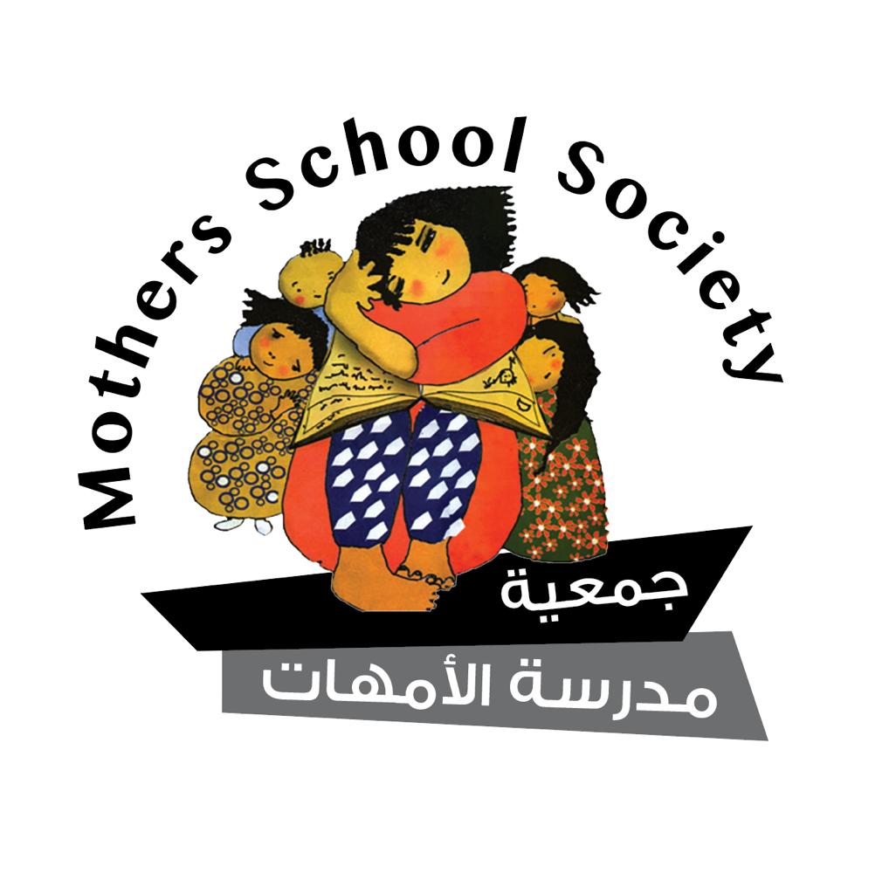
20-08-2023
Report Submitted to the Committee on Human Rights regarding the Initial Report of the State of Palestine on the International Covenant on Economic, Social and Cultural Rights
Session: 74
In accordance with Articles 16 and 17 of the International Covenant on Economic, Social and Cultural Rights,
this report is presented by the Mother School Society….
The association was established in 1999 in the Nablus Governorate in the West Bank and obtained its license in 2004.
Vision:
A democratic Palestinian society characterized by equality and social justice.
Mission:
The Mother School Society is an independent non-governmental feminist organization that plays a significant role in the Palestinian feminist and social movement. It works towards the development of society by empowering women and engaging them in social, economic, political, and human rights fields, enabling them to actively participate in public life.
Strategic Objectives:
- Contribute to ensuring women's right to education.
- Contribute to reducing gender-based violence.
- Empower women to access resources, opportunities, and enhance their roles in the most vulnerable areas.
- Enhance the governance of the Mother School Society.

Introduction
- The Mother School Society hereby presents this parallel report to the Committee on Economic Rights during its 74th session. The Committee is tasked with evaluating the initial official report of the State of Palestine regarding the International Covenant on Economic, Social, and Cultural Rights. Palestine became a party to the Covenant on April 1, 2014, without expressing any reservations. The initial report was submitted to the Committee on November 16, 2020, although it was due in 2016 according to Articles 16 and 17 of the Covenant. It is important to emphasize that Palestine has not submitted the common core document for all other relevant agreements in line with its obligations.
- The report submitted by the Mother School Society examines the extent of alignment of the official report with certain rights from a gender perspective. These rights include equality and non-discrimination in the right to work, as well as justice in enjoying the right to work and social protection (social security). The examination is based on the Committee's adopted guidelines on the form and content of initial reports of Covenant States parties. The focus is on women's right to work and Palestine's commitment to its implementation at both legislative and procedural levels, as well as its practical application on a substantial level. This assessment is based on the State's report, the list of issues provided by your Committee and the State's responses, as well as the Committee's general comments. The report is also prepared based on the observations and documentation by the Mother School Society regarding violations against working women in Palestine, their types, causes, and suggested measures required to ensure that working women enjoy the right to work in accordance with human rights standards. However, it should be noted that the information presented in the report does not fully reflect the actual situation of violations against women concerning the right to work.
- This report covers the reality of violations experienced by working women in the West Bank. It focuses on the State of Palestine's commitment to uphold the Covenant's provisions. However, this does not exempt Israel from its responsibilities towards the occupied Palestinian population, as the occupying power, to implement the Covenant's provisions. The Israeli authorities fully control all aspects of economic, social, and cultural life in Palestine, and they have the ability to impact these aspects positively or negatively. Facts on the ground indicate that even after the Oslo Accords, which resulted in the establishment of the Palestinian Authority, the occupying authorities chose to maintain effective control over all Palestinian areas, including Area (A) under Palestinian Authority control. Thus, they bear full responsibility for the violations experienced by Palestinian citizens due to the non-implementation of Covenant provisions.
- The Committee on Economic, Social, and Cultural Rights reaffirmed in its concluding observations on Israel's fourth periodic report that it reminded the State party that the International Court of Justice, in its advisory opinion issued on July 9, 2004, concerning the legal consequences of the construction of the wall in the occupied Palestinian territory, affirmed the applicability of the State party's human rights and international humanitarian law obligations in situations of armed conflict and occupation. This view has also been consistently expressed by various human rights treaty bodies, relevant General Assembly resolutions, and in reports by the Special Rapporteur on the human rights situation in the Palestinian territory occupied since 1967, as well as by the United Nations High Commissioner for Human Rights in 2019.

Recommendation: We recommend your esteemed committee to address the Palestinian context, applying both international humanitarian law and human rights law concurrently through the use of contractual mechanisms for human rights in the occupied Palestinian territory. Furthermore, efforts should be directed towards highlighting the impacts of colonial occupation and the apartheid regime on economic, social, and cultural rights within the concluding observations.

Articles 2-3: Equality and Non-Discrimination
- The attainment of decent work for women and ensuring their active participation in the labor market on the basis of equal opportunities without discrimination leads to their economic empowerment. As a result, they can enjoy other human rights as stipulated in the Covenant. In Palestine, the percentage of women's participation in the Palestinian labor force in 2023 was 19%, which remained unchanged from 2022. This represented a 2% increase from 2021 when the rate was 17% of the total working-age women. It should be noted that men's participation in the labor force reached 71% for the years 2022 and 2023, and 69% for 2021.
- Despite the existence of official legal provisions that guaranteeing the right to work for all citizens and prohibiting gender-based discrimination in employment, including Article 2 of the Labor Law, which states, "Work is a right for every capable citizen; the national authority shall ensure its provision based on equal opportunities without any form of discrimination," and Article 100 of the Labor Law that regulates women's work and prohibits gender-based discrimination according to labor laws and regulations, achieving equality in employment between men and women remains more textual than practically applied. The aforementioned statistics illustrate the low percentage of women's participation in the labor market, standing at 19% for those of working age. This rate comes after 23 years of the issuance of the Labor Law that emphasized gender equality in employment and after 9 years of Palestine's accession to the International Covenant on Economic, Social, and Cultural Rights.
- The Palestinian Labor Law No. 7 of 2000, in the aforementioned texts, stipulates equality and prohibits discrimination in employment. However, it does not define discrimination or its forms. This suggests that these provisions remain within the formal framework and may not practically be applied effectively before competent judicial authorities due to the absence of a clear definition of discrimination. Additionally, the law and its implemented regulations do not include positive discrimination measures in favor of women by introducing initiatives that could alter societal stereotypes surrounding women's acceptable roles (such as education, healthcare, and childcare). Consequently, the legal framework in place doesn't provide working women with the means to hold those responsible accountable for discrimination before the courts.
- Genuine gender equality cannot be achieved solely by enacting laws or adopting policies that appear neutral in terms of gender. When implementing Article 3 of the Covenant, the State should take into consideration that such laws, policies, and practices might not effectively address gender inequality, and in some cases, they might perpetuate it. This is because they may not adequately consider the existing disparities in economic, social, and cultural spheres, particularly those affecting women.
Recommendation:
- The State of Palestine should work on defining discrimination in employment and its various forms through a separate provision in the Labor Law. Furthermore, it should undertake specific and temporary measures aimed at curbing employment-related discrimination. These measures should seek to change the prevailing societal stereotypes regarding socially acceptable fields of women's work (such as education and childcare), thus enhancing women's chances of obtaining decent work.
- Empower women to access justice and hold accountable those responsible for violations resulting from discrimination in obtaining employment opportunities, during employment, or in terms of wage rates.

Article 6: The Right to Work
- The total number of Palestinian workers in 2022 amounted to approximately 1.1 million workers (excluding the agricultural sector). Unorganized labor constituted about 53% of the total workforce, accounting for around 558 thousand workers. Approximately 5% of the agricultural sector workers were engaged in organized employment. Among the unorganized male workforce, around 503 thousand workers, or 56%, were engaged, compared to 55 thousand females, representing 32% of the total female workers. This indicates a disparity in the rates of unorganized labor between males and females.
10. According to statistics presented by the Informal Economic Sector Women's Rights Compliance Index, it reveals that 52% of employers in the informal economic sector do not adhere to the application of the legally stipulated weekly working hours, which is 45 hours. Female workers in the informal sectors often work up to 50 or 60 weekly hours without these being considered as overtime hours. This signifies a clear exploitation of women workers' need for employment. Moreover, 34% of female workers do not regularly receive their financial compensation at the end of each month, indicating irregular payment of wages. Additionally, the data indicates that only 50% of female workers in the informal sectors usually receive sick leave, while 12% of female workers never receive any sick leave, and 38% encounter procedural complexities to obtain it. Furthermore, 31% of female workers in informal sectors report that sick leave days are deducted from their salary, and 17% have their sick leave deducted from their annual vacation days. However, 52% of them receive sick leave without any financial deduction.
11. The index results show that 34% of female workers in informal sectors still work under conditions that do not comply with health and safety standards. This could pose a threat to their health, similar to the danger faced by female workers during the peak of the COVID-19 pandemic in previous years. For instance, 30% of these sectors lack first aid kits or firefighting equipment, which could directly endanger workers in case of emergencies. Moreover, at least 47% of employers do not provide female workers with health insurance. It is worth noting that health insurance might be provided through contributions from both the worker and the employer. Moreover, only 10% of employers share some medical treatment costs, which contradicts legal provisions that obligate employers to provide health insurance.
12. The results indicate that 54% of female workers in informal economic sectors do not experience psychological well-being within their work environment. This reflects negatively on their mental health and sense of belonging to their job. Moreover, 30% of employers in these sectors firmly refuse to allow female workers to participate in community events and activities, while 22% allow limited participation. A similar pattern is observed regarding participation in skill development workshops, where 40% of female workers do not have the opportunity to attend skill development workshops, and 16% participate occasionally. This implies that a significant portion of female workers still face inequality in their right to skill development in the workplace.
13. According to the Palestinian Ministry of Labor, they have only 140 inspectors to oversee both formal and informal workplaces, which together comprise more than 81,000 establishments across 16 governorates in the West Bank. This indicates a significant gap between the ability to monitor and address violations in both organized and informal sectors. As a result, the status quo persists, violations remain entrenched in practice due to the absence of measures to mitigate violations against female workers in the informal sector. Additionally, there is a lack of specialized labor courts that can ensure swift resolution of cases, as these cases currently require several years to be resolved by regular judicial channels. This situation leads to workers being discouraged from confronting violations and accepting the realities of the informal economy. The continuation of these violations, coupled with societal biases against women's work, contributes to women's reluctance to engage in the labor market, thus explaining the low percentage of working women in Palestine.
Recommendation:
- The government should implement regulatory measures to curb informal work practices, increase the number of labor ministry inspectors, and ensure their access to all workplaces to verify suitable working conditions for female workers. Penalties and fines should be imposed on violators.
- The government should provide incentives to employers who formally employ workers, especially women, when adhering to proper employment practices.
- Specialized labor courts should be established to expedite the resolution of labor-related issues. This would encourage violated workers to seek legal recourse, significantly reducing violations.

The Right to Fair and Favorable Working Conditions (Article 7)
-Minimum Wage (Article 8)
13. The minimum wage has been increased to approximately 1880 Shekels (around $540) following the amendment introduced by the Palestinian Cabinet Resolution No. 4 of 2021. The previous minimum wage was 1450 Shekels (approximately $415). Although the new minimum wage was approved and implemented at the beginning of 2022, the established amount has not reached the national poverty line of 2450 Shekels (approximately $700). Approximately 80% of individuals covered by the minimum wage law (which applies to all workers) are female workers. Most female workers in the informal sectors earn less than the minimum wage. Their employment is largely concentrated in nurseries, kindergartens, factories, textile industry, and other administrative work.
14. Two-thirds of workers in family projects work without wages, and over 90% of female workers in family projects also work without wages. The majority of paid workers in family projects are concentrated in industrial and construction activities. The number of unpaid workers in family projects is around 124,000, accounting for 67% of the total workforce in family projects, compared to 61,000 paid workers, which make up 33% of the total. On the other hand, unpaid female workers constitute approximately 92% of all female workers in family projects, compared to 63% of males. Moreover, paid workers in family projects, mostly engaged in industrial and construction activities, account for about 92% of all paid workers.
15. According to a report issued by the Ministry of Education, there are 1,148 kindergartens in the West Bank, enrolling 78,731 children and employing 5,043 female caregivers. As for daycare centers, a report from the Ministry of Social Affairs indicates the presence of 152 licensed daycare centers with approximately 193 female caregivers. The majority of these daycare centers, around 40%, are located in the Ramallah governorate. Additionally, there are some daycare centers operating within homes who are not subject to inspection by the Ministry of Social Affairs. Furthermore, unlicensed daycare centers have also emerged, estimated at around 300. The salaries of female workers in both kindergartens and daycare centers range from 400 to 1000 Shekels monthly (approximately $120 - $300), which is among the lowest compensations for female workers in economic sectors.
Recommendation:
- The government should take further actions and measures to enforce the minimum wage, raise it to the national poverty line, and periodically review the measures taken to implement the minimum wage.
- The government has a responsibility to devise a mechanism for dealing with these vulnerable sectors, especially early childhood education, which struggles to apply the minimum wage. Partial support for worker salaries in these sectors could alleviate the burdens on the government.
- Non-compliance with the minimum wage encourages the exploitation of women in the workforce and exacerbates gender-based discrimination and violence in society.
- The government should acknowledge its responsibility for not enforcing the minimum wage and encourage positive discrimination in favor of female workers by providing incentives to employers, such as tariff reductions, to motivate them to hire women under fair working conditions and dignified wages.

-Harassment at work
16. Society's perceptions and culture play a crucial role in creating a work environment that protects female workers. This protection encompasses various systems, including laws, legislation, infrastructure, awareness, and societal norms. The General Federation of Palestinian Trade Unions recorded 310 cases of violence and sexual harassment, including 3 cases of sexual assault, in private sector workplaces during the years 2020-2021. According to the Federation, 45% of these cases were committed by employers and supervisors. Employers are obligated to provide a safe and appropriate work environment that shields female workers from all forms of harassment and sexual violence. Three surveys conducted by the Palestinian Central Bureau of Statistics (in 2005, 2011, and 2019) revealed that women experienced various forms of gender-based violence: 1 - 27.2% experienced violence in various forms, 2 - 52.2% experienced psychological violence, 3 - 36.2% experienced economic violence, 4 - 27.6% experienced social violence, 5 - 17.4% experienced physical violence, and 6 - 6.7% experienced sexual violence.
Recommendations:
- The government should criminalize harassment in its penal laws and in the Labor Law in response to the Convention No. 190 on Violence and Harassment in the World of Work, as well as implement the enhanced Recommendation No. 206.
- The government should establish a permanent body to regularly collect data and statistics on workplace violence and harassment, create mechanisms and programs for raising awareness about prevention of harassment, and establish treatment centers for its consequences.

Right to social security (Article 9)
17. The Social Security Law was abolished by Law No. 4 of 2019 on Social Security issued on February 20, 2019. Article 2 of this law stipulated ongoing dialogue between all relevant parties to reach national consensus on the provisions of the law and its effective date. However, a year after the Social Security Law was abolished, the COVID-19 pandemic emerged, leading to a complete lockdown and economic disruption. This significantly impacted the Palestinian workforce, especially the poor and marginalized segments of society. This highlighted the urgent need for a social protection system to address emergent crises, particularly the necessity of having a social security system.
In October 2022, a draft of the Social Security Law was published on the Palestinian Ministry of Labor's website, attributed to the Exploratory Committee. The Ministry stated that the draft was developed in partnership with the International Labour Organization and was formulated through joint efforts of the three production parties (government, employers, and workers) to create a new draft for the Palestinian Social Security Law. This new draft was developed to replace Law No. 19 of 2016, which was annulled in 2019. After an extensive series of meetings and intense negotiations over the past two years, the efforts of these committees led to the preliminary drafting of a Palestinian Social Security Law in alignment with international best practices for social security.
18. The presence of a social security institution would significantly reduce violations in the Palestinian labor sector, especially in the informal sector. It would also provide procedural solutions, regulatory measures, and punitive measures for violations against female workers, particularly those related to occupational safety, health insurance, sick leave, and maternity leave. The latter has historically hindered women's access to employment opportunities. Additionally, addressing the minimum wage issue is essential, as women are disproportionately affected due to their vulnerability and limited opportunities caused by societal stereotypes surrounding women's work. All these challenges can be resolved through the establishment and proper implementation of a social security system that ensures the active participation of female workers, allowing them full rights in managing the institution and enjoying the benefits it offers.
Recommendation:
- It is essential to establish a Social Security institution according to international legal standards that guarantee basic benefits. The institution's management should be government-driven, transparent, and accountable, with sustainable plans for benefit application and enhancement.
- A provision should be enacted ensuring women's participation at a rate of 40% quota in the management board of the Social Security institution, as well as in all affiliated committees, including investment committees.
- Maternity leave should be extended from 12 weeks to 14 weeks, aligning with the provisions of Public Service Employee Law.
- The government should work on amending the current draft of the Social Security Law to ensure its sensitivity to gender issues in all its provisions, thereby changing the prevailing societal stereotypes about women's work in Palestinian society.

End

- The Mother School Society relied on analyzing complaints received through community protection units spread across the West Bank, as well as the "علي صوتك" (Rise Your Voice) mobile application: https://play.google.com/store/apps/details?id=org.mss.msspal&hl=en&gl=US
- Committee on Economic, Social and Cultural Rights, Concluding observations on the fourth periodic report of Israel ‘E/C.12/ISR/CO/4 “12 November 2019 p8+9
- Statement by Ola Da'la Awad, Director-General of the Palestinian Central Bureau of Statistics, dated 7/3/2023. Available at: https://www.pcbs.gov.ps/postar.aspx?tabID=512&lang=en&ItemID=4457&mid=3915&wversion=Staging.
Articles 2 and 100 of Labor Law No. 7 of the year 2000.
- Committee on Economic, Social and Cultural Rights, General Comment No. 16 (2005), regarding equality between men and women in the enjoyment of all economic, social and cultural rights (Article 3 of the International Covenant on Economic, Social and Cultural Rights) Paragraph 8.
- Official WAFA News Agency report: "The Palestinian Central Bureau of Statistics: Unorganized labor constitutes more than half of the workforce in Palestine," 16/8/2023. Available at: https://www.wafa.ps/Pages/Details/76707#:~:text=%D8%B1%D8%A7%D9%85%20%D8%A7%D9%84%D9%84%Dن9%87%2016%2D8%2D2023,%D8%BA%D9%8A%D8%B1%20%D8%A7%D9%84%D9%85%D9%86%D8%B8%D9%85%D8%A9%20%D9%85%D9%82%D8%A7%D8%B1%D9%86%D8%A9%20%D8%A8%D8%B9%D8%A7%D9%85%202008
- Mother School Society's Report: the Index for Measuring Compliance with the Rights of Women Workers in the Informal Economic Sector 2021/2023. This index is the first of its kind in Palestine, aiming to measure the extent of commitment of informal economic sectors to providing women workers with their rights and ensuring a working environment that safeguards them against any violations they may face. This measurement is based on three criteria: The first concerns women workers in this sector, with the participation of a representative sample consisting of 300 female workers from various districts of the West Bank, in addition to representing multiple sectors.
- Mother School Society, Report on the Index of Measuring Commitment to the Rights of Female Workers in the Informal Economic Sector 2021/2023, pp. 4+5.
- Ibid.
- Ibid.
- Position paper issued by the Mother School Society, 2021: "Palestinian Government Policies towards Implementing Minimum Wages and Their Impact on Vulnerable Categories of Female Workers in the Informal Sectors," p. 6.
- Position paper issued by the Mother School Society, 2021: "Palestinian Government Policies towards Implementing Minimum Wages and Their Impact on Vulnerable Categories of Female Workers in the Informal Sectors," p. 2.
- Palestinian Central Bureau of Statistics, "Characteristics of the Unorganized Economy 2022," 16/8/2023. Available at: https://www.pcbs.gov.ps/portals/_pcbs/PressRelease/Press_Ar_FeatInformSector2022A.pdf.
- Government Media Office, Office of the Prime Minister, available at: https://www.palgov.ps/ar_print.php?id=19701fy1667103Y19701f.
- Annual Statistical Report 2019, Ministry of Social Development.
- This issue is based on a journalistic investigation conducted by journalist Bilal Al-Kiswani and published by the Palestinian News Agency "WAFA" in 2016. The actual number might be higher due to the inability of the Ministry of Social Development to inspect all home-based daycares. For further details, see: https://www.wafa.ps/ar_page.aspx?id=XwgxKVa677900350545aXwgxKV.
- Aman Foundation, journalistic investigation. Available at: https://www.aman-palestine.org/media-center/16625.html.
- Issue number 152 of Al-Waqa'i' Newspaper. Available at: https://maqam.najah.edu/media/uploads/offizial_gazette/2020-pdf-1556175829.pdf.
- https://www.mol.pna.ps/uploads/STUDIES/daman.pdf
- https://www.mol.pna.ps/uploads/STUDIES/malameh.pdf

