Annex I – Statistics

The complete annex is only available in German and French.

Paragraph 17 – Education
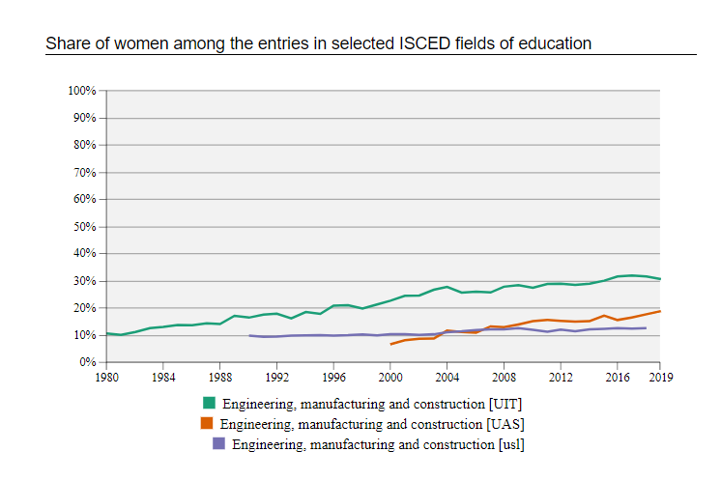

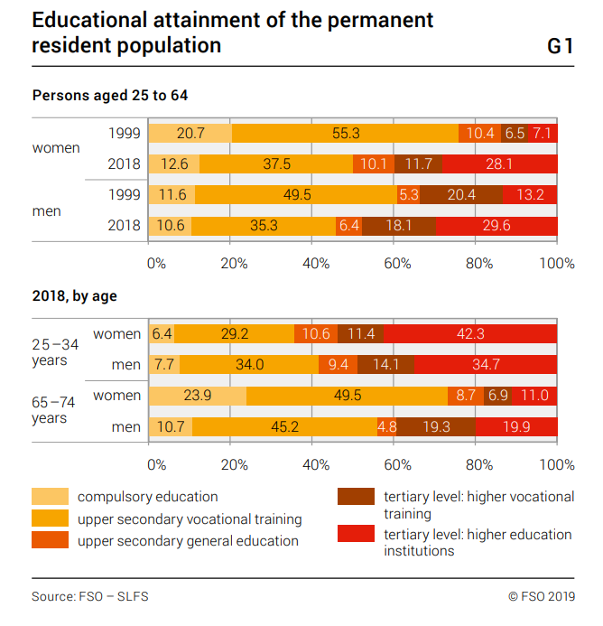
Paragraph 18 – Employment
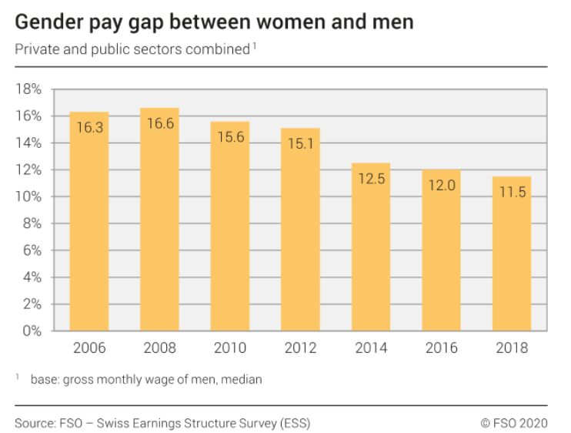

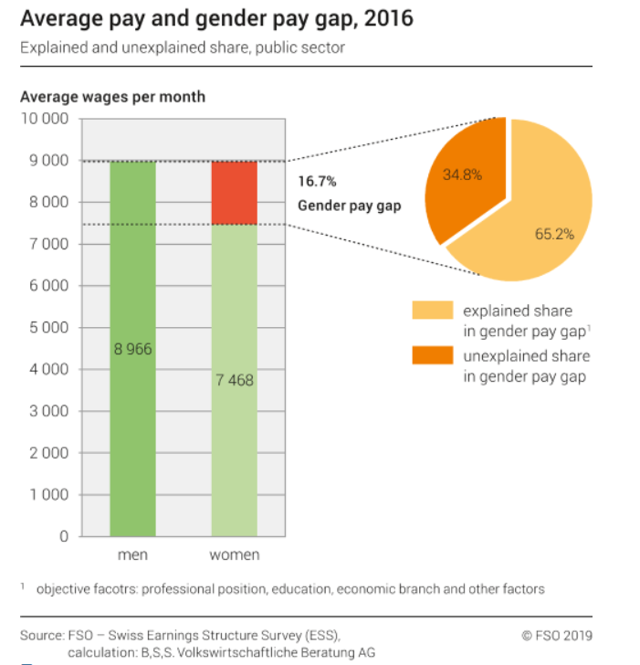

An interactive version of the graph for the years 2008 to 2016, with private and public sectors separated is available.

Paragraph 20 – Economic and social benefits
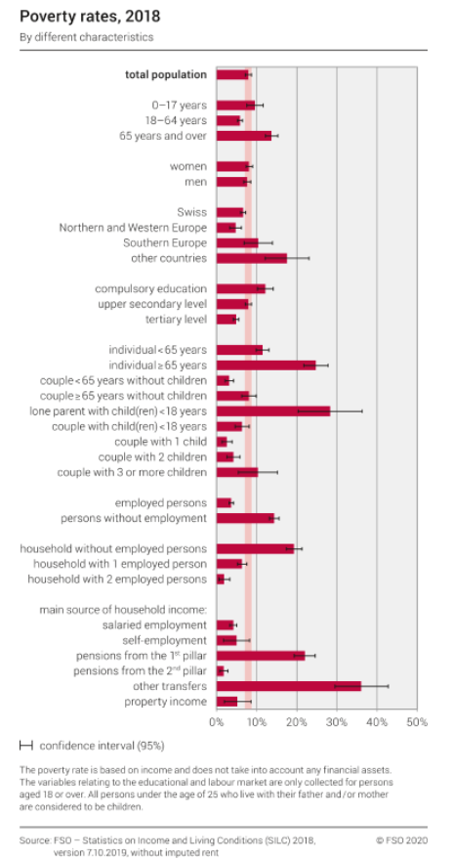

Paragraph 22 – Disadvantaged groups of women
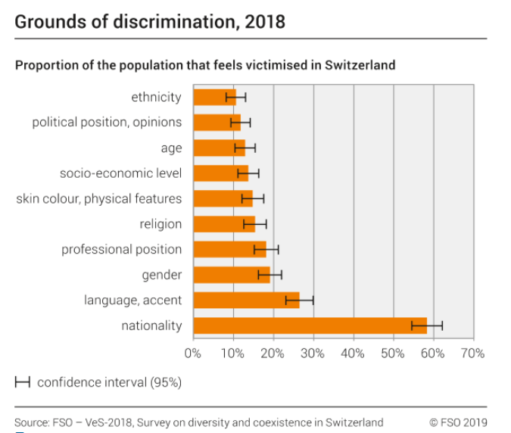

Paragraph 24 – Marriage and family relations
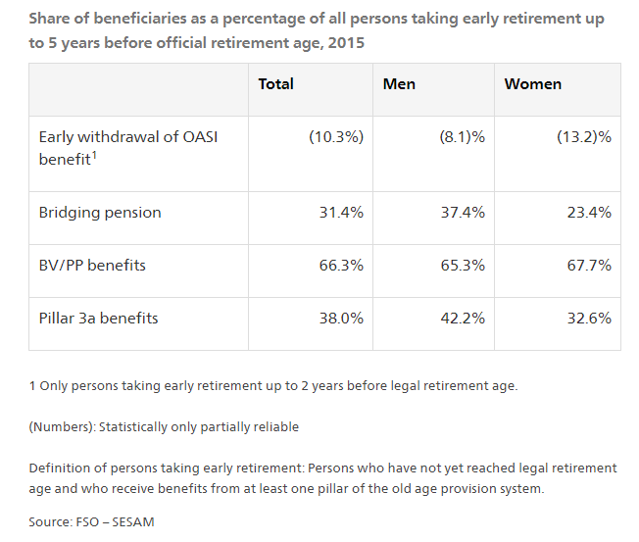
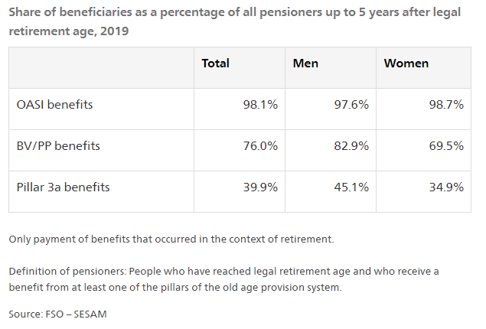

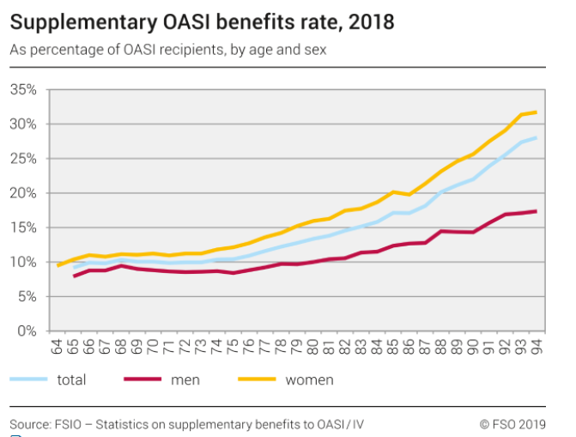

https://www.bfs.admin.ch/bfs/fr/home/statistiques/situation-economique-sociale-population/egalite-femmes-hommes/salaires.html

