
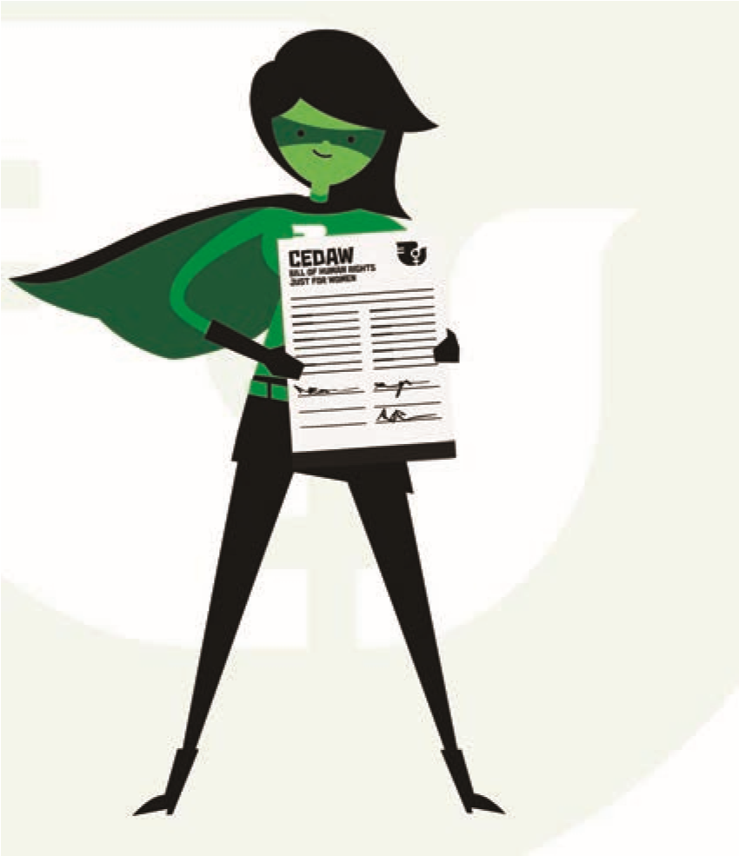
CEDAW
CONVENTION ON THE ELIMINATION OF ALL FORMS OF DISCRIMINATION AGAINST WOMEN
Follow-up to Concluding Observations
Engender, Scotland, 2021

1. Introduction

About this report
This report follows Engender’s engagement with the eighth periodic report of the government of the United Kingdom on measures taken to give effect to the UN Convention on the Elimination of All Forms of Discrimination against Women (CEDAW). The Committee requires the UK Government to report on their progress on four recommendations of particular concern (at paragraphs 13, 21 a) and b) and 25) concerning incorporation, the impact of the UK’s departure from the EU (‘Brexit’) and an oversight mechanism for women’s participation in CEDAW at UK level.

Devolution
Scotland’s legislative competence is subject to a range of ‘reserved’ policy areas where responsibility rests with the UK Parliament, including immigration, employment, equalities and most social security policy. Scotland has its own legal system, education system and health service.
The division of responsibility between UK and Scottish governing institutions can create some nuance in ascribing responsibility, especially when managing a crisis of the scale and complexity of the pandemic, which requires multiple policy levers. However, devolution should not be used to obfuscate responsibility for action.

In this report we focus on matters that fall within the Scottish Government’s full or shared responsibility.

Intersectionality
The issues raised in this report are not experienced equally. Disabled women, women from Black and minority ethnic (BME) communities, lesbian, bisexual and trans women, younger and older women, migrant, refugee, asylum seeking and stateless women, low-income women, women with minority faiths, unpaid carers, care experienced girls and women, and women in rural areas all experience inequality in particular ways because of the intersection of identities and multiple discrimination.

2. Incorporating International Human Rights Law in Domestic Law for the Protection of Women’s Human Rights


2.1 Proposals for a Scottish Human Rights Act
The previous Scottish Government (2016-2021) indicated a desire to situate Scotland as a world leader in human rights. In 2018, The First Minister’s Advisory Group on Human Rights Leadership recommended that CEDAW fall within a proposed new Human Rights Act of the Scottish Parliament. CEDAW incorporation was further recommended by bodies including the First Minister’s National Advisory Council on Women and Girls and the Social Renewal Advisory Board.⁴

A National Taskforce on Leadership in Human Rights charged with developing the ambition subsequently recommended that a single framework should be introduced, including CEDAW, the Convention on the Elimination of All Forms of Racial Discrimination, Incorporation of the Convention on the Rights of Persons with Disabilities, the International Covenant on Economic, Social and Cultural Rights as well as “A right of older people to a life of dignity and independence” and “Equality rights for LGBTI people”.

The previous Scottish Government confirmed its intention to take forward the recommendations and election commitments made by a majority of parties in the Scottish Parliament suggest there is likely to be cross-party support.

A single legislative framework will allow for the interrelated nature of rights across treaties to be made clear and signify an equality of rights protection which will benefit all women. However, as equal opportunities is reserved to the UK Parliament, technical consideration will need to be given to maximising the effectiveness of CEDAW’s approach to substantive equality of women. There is a clear role for individual women, civil society, women’s organisations and academics to inform the development of the new framework, including ensuring its capacity to respond to multiple and overlapping forms of discrimination and clear processes for monitoring interference with rights.

The Scottish Parliament has recently passed the United Nations Convention on the Rights of the Child (Incorporation) (Scotland) Bill. Given the close connection between women and children’s rights, incorporation of the UNCRC has potential to stimulate policy to advance the rights of girls and young women but also mothers and caregivers. The UK Government has recently challenged parts of the Bill as exceeding the competency of the Scottish Parliament.

The UNCRC Bill takes what has been described as a ‘maximalist’ approach to the protection of children’s rights. Should such an approach be sustained in further incorporation efforts, we would expect to see women’s rights fully integrated into all decision-making and service delivery, coupled with legal recourse in Scottish courts and tribunals, in addition to guidance to promote practical application of CEDAW.

2.2 Equality and gender mainstreaming in Scotland
The Public Sector Equality Duty (PSED) is the UK’s principal mainstreaming policy, and although equality is reserved to Westminster there are specific regulations in Scotland to support compliance with the PSED, including requirements to conduct and publish equality impact assessments, and to gather specified data. However, gender mainstreaming is undermined by a lack of skills training, prioritisation and capacity.

The commitment to a reform of the Scotland specific regulations has been much delayed, but the Government is now proceeding with a two-phase review, as suggested by Scottish women’s and equalities organisations. A report published in March 2021, ‘Learning from mainstreaming equality during the COVID-19 pandemic’ claims to be the first stage of this process. However it lacks detail and offers little insight into proposals that may be forthcoming in a second phase.

The creation of a new Equality, Human Rights and Inclusion Directorate within Scottish Government is also welcome, however this must be adequately resourced and empowered to effect action. Additionally, the Equality and Fairer Scotland Budget Statement published alongside the national budget each year does not extend to a full gender budget analysis. This should be addressed in the context of the incorporation agenda.

The Covid-19 crisis has reinforced the limits of existing gender mainstreaming duties on Scottish public sector actors. Impact assessments were haphazardly produced, minimal or drafted in retrospect.⁵³ The Coronavirus (Scotland) Act requires the Scottish Government and its agencies to have due regard to opportunities to advance equality and eliminate discrimination when using emergency powers, however there is no evidence that this provision has been utilised.

Two standalone structures were established to consider recovery – the Advisory Group on Economic Recovery and the Social Renewal Advisory Board. Gender was not systematically integrated into either process however individual recommendations such as a focus on the economic value of care, human rights incorporation and the expansion of funded childcare can be maximised to the benefit of women.

2.3 Data

Compliance with CEDAW is undermined by a lack of intersectional gender-sensitive sex-disaggregated data. The Scottish Government’s Gender Equality Index sets a baseline score for women’s equality at 73/100 (with 100 being ‘full equality’). This masks deeper inequality experienced by different groups of women and relies on selective and limited data. For example, the health indicator erroneously suggests there is near equality between women and men (99/100), despite Scottish Government action acknowledging significant disparities.

Recommendation: The Scottish Government should work collaboratively with the women’s sector and civil society to maximise the benefits of CEDAW incorporation.

Recommendation: Scottish specific duties should be underpinned by the Convention’s vision of substantive equality and create clear processes that enable public bodies to fulfil their legal obligations to women’s equality.
3. Assessing the Impact of Brexit on Women’s

Human Rights and Adopting Accurate Measures

3.1 Scottish Government impact assessment
The Scottish Government has published an independent report on the Social and Equality Impacts of Brexit, amounting to available evidence relating to groups, including women, and the estimated impacts of various Brexit outcomes. This has not been updated since the Withdrawal Agreement Act was passed. The Scottish Government recently published an updated assessment of the impact of Brexit however this did not include analysis of impacts for women.

It has become extremely difficult to separate out the impacts of Brexit and the pandemic on women’s equality, and to predict what the specific consequences of each will be. However, there is widespread concern that economic disruption will further negatively affect women. Public spending cuts have a significantly disproportionate impact on women. Women have less access to and agency over economic resources, are more likely to be clustered into underpaid and unvalued sectors, work part-time and be in precarious employment. All of this renders women more vulnerable to economic shocks than men.

3.2 Diminution of rights

The EU has been the source of many protections utilised by women, including those for part-time, temporary and insecure workers, pregnant women and mothers, and for other groups such as disabled people. Refusal to incorporate the Charter of Fundamental Rights leaves open the potential for future erosion of equality and employment rights at UK level, including through future trade negotiations.

The Scottish Parliament refused legislative consent for the Withdrawal Agreement Act and there are ongoing disputes about undermining of the devolution rights, particularly where competencies coming back from the EU are placed under reserved laws. The Scottish Parliament passed legislation to ‘keep pace’ with EU law in the UK Withdrawal from the European Union (Continuity) (Scotland) Act. This legislation allows Scottish Ministers to make laws to replicate the content of new EU law but cannot allow for amendment of certain statutes such as the Scotland Act or the Equality Act 2010.

3.3 Funding
The availability of EU Funding programmes has enabled Scottish organisations from a range of sectors to undertake projects that make a real difference to women’s lives, especially funds which have benefitted women in rural communities or areas of social deprivation. European Structural Investment Funds (ESIF) have also been used to develop employability support and skills training for disabled women.

The refusal to devolve replacement funds has denied an opportunity to align spending decisions with devolved priorities. Replacements²⁵ are orientated towards traditional infrastructure investment at the expense of elements such as social cohesion that were integral to EU funds. While UK funds demand that ‘due regard’ is given to the PSED, this falls far below the requirements in ESIF and is subject to wider concerns about the UK Government’s commitment to gender mainstreaming.

3.4 The social care sector
Workers from the EU are a disproportionately high proportion of the social care workforce in Scotland, accounting for 3% of total employment in this sector. The sector already faced a recruitment crisis before Brexit and the pandemic; in 2017 more than one in three
services had unfilled vacancies. However, care workers are not defined as a shortage occupation and must fulfil points-based immigration requirements that mean around 60% of roles in the sector are out of reach for migrant workers.

If the sector cannot recruit, care will inevitably be redistributed back onto unpaid women. Meanwhile workers, 83% of which are women, will see working conditions deteriorate even further. Disabled women will experience even greater difficulties in securing the support that they need. The Scottish Government has recently launched a consultation on a new National Care Service which takes forward recommendations from a 2020 Independent Review of Adult Social Care. However, there has been no specific focus on women or gender.

Recommendation: the Scottish Government should develop a social care workforce strategy to reposition care as highly-skilled and appropriately remunerated work

Recommendation: The Scottish Government should set out how its proposals to ‘keep pace’ with EU law in devolved areas will impact women.

4. CEDAW’s Recommendation to Establish a National Machinery for the Advancement of Women

We are deeply cautious about the UK Government’s capacity and willingness to engage with women’s organisations in devolved nations. However, it is vital that processes that claim to be participatory properly understand and reflect devolved policy areas and experiences where many of the levers needed to implement CEDAW rest.
In Scotland, an Advisory Council on Women and Girls has been established under the auspices of the First Minister to make recommendations to advance women’s equality. However this body remains temporary, has no formal role in policy processes and does not create specific roles for women’s organisations. The Council has made a number of recommendations to better integrate gender into the policy and parliamentary process in a more permanent way, which the Scottish Government is currently exploring.
Recommendation: The Scottish Government should implement the full recommendations from the National Advisory Council on Women and Girls.


This report was produced by Engender with
contributions and endorsement from:

•
Zero Tolerance
•
The Scottish Women’s Convention
•
Equality Network
•
Scottish Trans Alliance
•
Together (Scottish Alliance for Children's Rights)
•
Equate Scotland
•
Inclusion Scotland
•
Rape Crisis Scotland
•
Close the Gap
•
LGBT Youth Scotland
•
The Health and Social Care Alliance Scotland (the ALLIANCE)
•
Scottish Council for Voluntary Organisations (SCVO)
•
Scottish Women’s Aid
•
Women 50:50
•
One Parent Families Scotland
•
Coalition for Racial Equality and Rights (CRER)
•
Women’s Enterprise Scotland
•
Council of Ethnic Minority Voluntary Organisations (CEMVO)
•
Women’s Support Project
•
Poverty Alliance

Engender
10
Old Tolbooth Wynd
Edinburgh
EH8 8EQ
0131 558 9596

info@engender.org.uk
www.engender.org.uk
Twitter: @EngenderScot
Facebook: /engender

Published September 2021

Our full report published on our website extends our analysis to the Covid-19 pandemic and violence against women. It is extremely difficult to attribute causation of the evidenced rollback in women’s equality witnessed since the Committee’s report to a single issue. Engender, ‘CEDAW Scotland Follow-up Report’, 2021,https://www.engender.org.uk/content/publications/CEDAW---FOLLOW-UP-TO-CONCLUDING-OBSERVATIONS-SCOTLAND.pdf.
Concluding observations on the eight periodic report of United Kingdom of Great Britain and Northern Ireland.
First Minister’s Advisory Group on Human Rights Leadership (2018) Recommendations for a new human rights framework to improve people’s lives Report to the First Minister.
First Minister’s National Advisory Council on Women and Girls (2018) First Report and Recommendations. ⁴ Social Renewal Advisory Board (2021) If Not Now, When?
See K McCall Smith (2020) Incorporating the United Nations Convention on the Rights of Disabled People (CRPD) in Scotland. Health and Social Care Alliance and Inclusion Scotland.
Nicole Busby and Muriel Robson (2018) How can women’s rights be better realised in Scotland? Engender.
UNICEF (2018) CRC and CEDAW: Making The Connection Between Women’s And Children’s Rights Facilitator’s Guide.
Office of the Secretary of State for Scotland (2021) UK Government writes to Scottish Government on UNCRC Bill. Available at: gov.uk/government/news/uk-government-writes-to-scottish-government-onuncrc-bill
Scottish Government (2020) United Nations Convention on the Rights of the Child (Incorporation) (Scotland) Bill, Policy Memorandum.
Equality Act 2010 (Specific Duties) (Scotland) Regulations 2012.
Engender (2020) What Works for Women: Improving Gender Mainstreaming in Scotland.
Scottish Government (2021) Review of the Operation of the Public Sector Equality Duty in Scotland: Learning from Mainstreaming Equality During the Covid-19 Pandemic.
Engender (2020) What Works for Women: Improving Gender Mainstreaming in Scotland.
Scottish Government (2021) Review of the Operation of the Public Sector Equality Duty in Scotland: Learning from Mainstreaming Equality during the Covid-19 Pandemic.
Scottish Government (2020) Scotland’s Gender Equality Index 2020. Available at: data.gov.scot/genderindex/gender-equality-index-2020.html
For example, the creation of the Women’s Health Plan, see Scottish Government (2021) The Women’s Health Plan.
Scottish Government (2020) Brexit: social and equality impacts. Available at gov.scot/publications/social-equality-impacts-brexit/pages/5/
The Scottish Government (2021) The Brexit Referendum 5 Years on – Summary of Impacts to Date.
Close the Gap (2018) Women, work and poverty in Scotland: What you need to know.
Coleman v Attridge Law & Steve Law Case C-303/06. For further information see ‘Coleman v Attridge Law & Steve Law. The decision and its impact’ at The Equality and Human Rights Commission. Available at: equalityhumanrights.com/en/legal-casework/coleman-case
Scottish Government (2021) After Brexit: The UK Internal Market Act and devolution.
An earlier bill – the UK Withdrawal from the European Union (Legal Continuity) (Scotland) Bill 2018 – was successfully challenged by the UK Government in 2019 as overstepping the devolved powers of the Scottish Parliament.
Under the Social Fund element of the EU Structural and Investment Funds, disabled people’s organisations in the UK have had the opportunity to apply for significant amounts of money for projects furthering disability equality and inclusion. According to the Academic Network of European Disability Experts, 19% of EU Structural Funds grants are spent on projects that directly support disabled people.
National Assembly for Wales Finance Committee, Preparations for replacing EU funding for Wales. Available at: assembly.wales/laid%20documents/cr-ld11748/cr-ld11748-e.pdf ²⁵ House of Commons Library (2021) The UK Shared Prosperity Fund. Available at: commonslibrary.parliament.uk/research-briefings/cbp-8527/
UK Government (2021) UK Community Renewal Fund: prospectus. Available at: gov.uk/government/publications/uk-community-renewal-fund-prospectus
Care Inspectorate (2019) Staff vacancies in care services 2017. Available at: careinspectorate.com/index.php/news/4767-staff-vacancies-in-care-services-2017
The UK Government has introduced a new visa for ‘skilled’ health and social care workers but most social care workers are not eligible.
Expert Advisory Group on Migration and Population (2020) UK Immigration Policy After Leaving the EU Impacts on Scotland’s Economy, Population and Society.
The Health and Social Care Alliance (2020) My Support My Choice - Women's Experiences of Selfdirected Support and Social Care in Scotland.
Scottish Government (2021) A National Care Service for Scotland: consultation. Available at: consult.gov.scot/health-and-social-care/a-national-care-service-for-scotland/
Derek Feeley (2021) Adult social care: independent review. Scottish Government. Available at: gov.scot/groups/independent-review-of-adult-social-care
First Minister’s National Advisory Council on Women and Girls Terms of Reference. Available at: onescotland.org/wp-content/uploads/2018/05/NACWG-Terms-of-Reference.pdf
Scottish Government (2020) National Advisory Council on Women and Girls (NACWG) 2019 - report and recommendations: SG response. Available at: gov.scot/publications/scottish-governments-response-firstministers-national-advisory-council-women-girls-nacwg-2019-report-recommendations/pages/11/ ³⁵ Coalition for Racial Equality and Rights (2020) COVID-19 and ethnicity in Scotland: Where’s the data?

