ANNEXES

Annexe 1 : CARTOGRAPHIE DES JUGES EN RDC
 | RESSORT | 1er Président | Président | Juges permanents | conseillés
KINSHASA
Gombe | Cour d’Appel | 1 | 9 | 0 | 56
 | Tricom | 0 | 1 | 20 | -
 | Tribunal de travail | - | 1 | 8 | -
 | TGI /Gombe | - | 1 | 58 | -
 | TGI/Kalamu | - | 1 | 33 | -
 | Tripaix/ Pont Kasa-vubu | - | 1 | 17 | -
 | Tripaix Assossa | - | 1 | 24 | -
 | Tripaix/Gombe | - | 1 | 49 | -
 | Tripaix/Ngaliema | - | 1 | 52 | -
 | TPE /Gombe | - | 1 | 7 | -
 | TPE /Ngaliema | - | 1 | 5 | -
 | TPE/ Kalamu | - | 1 | 6 | -
Matete | Cour d’Appel | 1 | 11 | - | 49
 | TGI/Matete | - | 1 | 45 | -
 | TGI/Ndjili | - | 1 | 28 | -
 | TGI/Kinkole | - | 1 | 10 | -
 | Tricom/Matete | - | 1 | 10 | -
 | Trib. De travail/Matete | - | 1 | 5 | -
 | TPE/Matete | - | 1 | 5 | -
 | TPE/Kinkole | - | 1 | 5 | -
 | Tripaix /Matete | - | 1 | 38 | -
 | Tripaix/Lemba | - | 1 | 23 | -
 | Tripaix/Ndjili | - | 1 | 27 | -
 | Tripaix Kinkole | - | 1 | 22 | -
S/total |  | 2 | 42 | 218 | 260
BANDUNDU
 | Cour d’Appel BDD | 1 | 1 | - | 6
 | TGI BDD | - | 1 | 3 | -
 | TGI KIKWIT | - | 1 | 3 | -
 | TGI BULUNGU | - | 1 | 2 | -
 | TGI INONGO | - | 1 | 1 | -
 | TGI KANANGA | - | 1 | 5 | -
 | TPE BDD | - | 1 | - | -
 | TPE KIKWIT | - | 1 | 1 | -
 | Trib. Travail KIKWIT | - | 1 | 1 | -
 | Tripaix KIKWIT | - | 1 | 2 | -
 | Tripaix MUSHI | - | 1 | 1 | -
 | Tripaix INONGO | - | 1 | 3 | -
 | Tripaix Kutu à Noki | - | 1 | 3 | -
 | Tripaix KAYEMBA | - | 1 | 2 | -
 | Tripaix Feshi | - | 1 | 1 | -
 | Tripaix Kasongolunda | - | 1 | 2 | -
 | Tripaix Bulungu | - | 1 | 1 | -
 | Tripaix Gungu | - | 1 | 2 | -
 | Tripaix Masimanimba | - | 1 | 2 | -
 | Tripaix Bagata | - | 0 | 2 | -
 | Tripaix Idiofa | - | 1 | 2 | -
 | Tripaix Kenge | - | 1 | 3 | -
 | Tripaix Popo Kabaka | - | 0 | 2 | -
 | Tripaix Bolobo | - | 1 | 0 | -
 | Tripaix Kiri | - | 1 | 2 | -
 | Tripaix Osho | - | 0 | 1 | -
S/total |  | 1 | 23 | 47 | 6
EQUATEUR
 | Cour d’Appel BANGATA | 1 | 1 | 0 | 1
 | TGI BANGATA | - | 1 | 4 | 0
 | TGI BOENDE | - | 1 | 1 | -
 | TGI GEMENA | - | 1 | 0 | -
 | TGI LISALA | - | 1 | 1 | -
 | TGI GBADOLITE | - | 1 | 1 | -
 | TPE MBANDAKA | - | 1 | 0 | -
 | TRIPAIX MBANDAKA | - | 1 | 2 | -
 | Tripaix Bumba | - | 1 | 3 | -
 | Tripaix Bikoro | - | 1 | 3 | -
 | Tripaix Bolomba | - | 1 | 1 | -
 | Tripaix Ingende | - | 1 | 1 | -
 | Tripaix Lukolela | - | 1 | 0 | -
 | Tripaix Lisala | - | 1 | 2 | -
 | Tripaix Mobayi mbongo | - | 1 | 1 | -
 | Tripaix Businga | - | 1 | 3 | -
 | Tripaix Guemena | - | 1 | 2 | -
 | Tripaix Kungu | - | 1 | 4 | -
 | Tripaix Libenge | - | 1 | 0 | -
 | Tripaix Befale | - | 0 | 2 | -
 | Tripaix Boende | - | 1 | 0 | -
 | Tripaix Ikela | - | 1 | 0 | -
 | Tripaix Mokoto | - | 0 | 2 | -
S/total |  | 3 | 67 | 127 | 13
KANANGA
 | Cour d’Appel KANANGA | 1 | 1 | 0 | 4
 | TGI KANANGA | - | 1 | 4 | -
 | TGI Luebo | - | 1 | 2 | -
 | TGI Tshimbulu | - | 1 | 0 | -
 | Tricom Kananga | - | 1 | 1 | 0
 | PTE Kananga | - | 1 | 3 | -
 | Tripaix Kananga | - | 1 | 4 | -
 | Tripaix Ilebo | - | 1 | 3 | -
 | Tripaix Tshikapa | - | 1 | 2 | -
 | Tripaix Luebo | - | 0 | 1 | -
 | Tripaix Mueka | - | 1 | 2 | -
 | Tripaix Demba | - | 0 | 1 | -
 | Tripaix Kazomba | - | 0 | 1 | -
 | Tripaix Lwiza | - | 1 | 1 | -
S/total |  | 1 | 11 | 25 | 4
MATADI (KONGO CENTRAL)
 | Cour d’Appel Matadi | 1 | 3 | - | 18
 | TGI Matadi | - | 1 | 12 | -
 | TGI Mbanzangungu | - | 1 | 7 | -
 | TGI Inkisi | - | 1 | 6 | -
 | TGI Boma | - | 1 | 7 | -
 | TGI Tshela | - | 1 | 2 | -
 | Tricom Matadi | - | 1 | 6 | -
 | Tricom Boma | - | 1 | 3 | -
 | Trib. Travail Matadi | - | 1 | 2 | -
 | Trib. Travail Boma | - | 1 | 2 | -
 | TPE Matadi | - | 1 | 2 | -
 | Tripaix Matadi | - | 1 | 8 | -
 | Tripaix Mbanzangungu | - | 1 | 9 | -
 | Tripaix Songololo | - | 1 | 6 | -
 | Tripaix Luozo | - | 1 | 1 | -
 | Tripaix Inkisi | - | 1 | 4 | -
 | Tripaix Kasangulu | - | 1 | 5 | -
 | Tripaix Boma | - | 1 | 12 | -
 | Tripaix Muanda | - | 1 | 8 | -
 | Tripaix Tshila | - | 1 | 3 | -
 | Tripaix Lukula | - | 1 | 3 | -
 | Tripaix Sekebanza | - | 1 | 4 | -
 | Tripaix Madimba | - | 0 | 1 | -
S/total |  | 1 | 24 | 113 | 18
MBUJI-MAYI
 | Cour d’appel Mbuji Mayi | 1 | 2 | - | 7
 | TGI Mbuji mayi | - | 1 | 4 | -
 | TGI Kabinda | - | 1 | 1 | -
 | TGI Tshilenge | - | 1 | 2 | -
 | TGI Lusambu | - | 1 | 2 | -
 | Tricom Mbuji mayi | - | 1 | 0 | -
 | Tripaix Mbuji mayi | - | 1 | 3 | -
 | Tripaix Muene ditu | - | 1 | 2 | -
 | Tripaix Lodja | - | 1 | 2 | -
 | Tripaix Kabinda | - | 0 | 1 | -
 | Tripaix Lobao | - | 0 | 2 | -
 | Tripaix Kata kokombe | - | 1 | 2 | -
 | Tripaix Lomela | - | 1 | 1 | -
 | Tripaix Losamba | - | 1 | 1 | -
 | Tripaix Katanda | - | 0 | 1 | -
 | Tripaix Lupata pata | - | 1 | 1 | -
 | Tripaix Tshilenge | - | 1 | 1 | -
 | Tripaix Kole | - | 1 | 1 | -
 | Tripaix Gandajika | - | 1 | 1 | -
 | TPE Mbuji mayi | - | 1 | 0 | -
S/total |  | 1 | 18 | 28 | 7
BUKAVU
 | Cour d’Appel de Bukavu | 1 | 3 | - | 9
 | TGI Bukavu | - | 1 | 9 | -
 | TGI Uvira | - | 1 | 4 | -
 | Tricom Bukavu | - | 1 | 3 | -
 | TGI Kavumbu | - | 1 | 1 | -
 | TGI Kamituda | - | 1 | 2 | -
 | Tripaix Bukavu | - | 1 | 15 | -
 | Tripaix Uvira | - | 1 | 3 | -
 | Tripaix Kamituga | - | 0 | 2 | -
 | Tripaix Kalhe | - | 1 | 3 | -
 | Tripaix Muniga | - | 0 | 1 | -
 | Tripaix Idjui | - | 1 | 3 | -
 | Tripaix Fizi | - | 1 | 2 | -
 | Tripaix Kabare | - | 1 | 2 | -
 | Tripaix Shabuni | - | 1 | 3 | -
 | Tripaix walungu | - | 1 | 2 | -
 | TPE Bukavu | - | 1 | 4 | -
S/total |  | 1 | 17 | 59 | 9
GOMA (NORD KIVU)
 | Cour d’Appel Goma | 1 | 2 | - | 9
 | TGI Goma | - | 1 | 11 | -
 | Tripaix Goma | - | 1 | 12 | -
 | Tripaix Nyiragongo | - | 1 | 2 | -
 | Tricom Goma | - | 1 | 3 | -
 | TPE Goma | - | 1 | 0 | -
 | Trib. Travail Goma | - | 1 | 1 | -
 | TGI Butembo | - | 1 | 6 | -
 | Tripaix Butembo | - | 1 | 5 | -
 | Tricom Butembo | - | 1 | 3 | -
 | TGI Beni | - | 1 | 4 | -
 | Tripaix Beni | - | 1 | 4 | -
 | TPE Beni | - | 1 | 1 | -
 | Tripaix Lubeyo | - | 1 | 2 | -
 | Tripaix Masisi | - | 1 | 1 | -
 | Tripaix Totshuru | - | 0 | 2 | -
 | Tripaix walekale | - | 0 | 2 | -
S/total |  | 1 | 16 | 59 | 9
KINDU (MANIEMA)
 | Cour d’Appel Kindu | 1 | 1 | - | 4
 | TGI Kindu | - | 1 | 3 | -
 | TPE Kindu | - | 1 | 0 | -
 | TGI Kasomba | - | 1 | 1 | -
 | TGI Kalima | - | 1 | 2 | -
 | TGI PUNIA | - | 1 | 2 | -
 | Tripaix Kindu | - | 1 | 2 | -
 | Tripaix Kasomba | - | 0 | 1 | -
 | Tripaix Punia | - | 1 | 0 | -
 | Tripaix Kabambare | - | 1 | 2 | -
 | Tripaix Kibombo | - | 1 | 2 | -
 | Tripaix Pangi | - | 1 | 2 | -
S/total |  | 1 | 11 | 17 | 4
KISANGANI
 | Cour d’Appel Kisangani | 1 | 3 | - | 8
 | TGI Kisangani | - | 1 | 9 | -
 | Tripaix Kabondo | - | 1 | 3 | -
 | Tripaix Makiso | - | 1 | 7 | -
 | Trib. Travail Kisangani | - | 1 | 2 | -
 | TPE Kisangani | - | 1 | 0 | -
 | Tricom Kisangani | - | 1 | 3 | -
 | TGI Bunia | - | 1 | 7 | -
 | TPE Bunia | - | 1 | 2 | -
 | Tripaix Mahayi | - | 1 | 4 | -
 | Tripaix Awou | - | 1 | 3 | -
 | Tripaix Watsha | - | 1 | 3 | -
 | Tripaix Irumu | - | 1 | 8 | -
 | Tripaix Djugu | - | 1 | 2 | -
 | Tripaix Mambasa | - | 1 | 2 | -
 | TGI Yanganu | - | 1 | 5 | -
 |  |  | 1
 | TGI Banalia | - | 1 | 2 | -
 | TGI Isiro | - | 1 | 2 | -
 | Tripaix Dungu | - | 1 | 2 | -
 | Tripaix Lungu | - | 1 | 2 | -
 | Tripaix Wamba | - | 1 | 1 | -
 | TGI BUTA | - | 1 | 2 | -
 | Tripaix Buta | - | 1 | 1 | -
 | Tripaix Bondo | - | 1 | 0 | -
 | Tripaix Poko | - | 1 | 0 | -
S/total |  | 1 | 28 | 72 | 8
KATANGA (Lubumbashi)
 | Cour d’Appel Katanga | 1 | 10 | - | 32
 | TGI Lubumbashi | - | 1 | 29 | -
 | Tripaix Kamalondo | - | 1 | 34 | -
 | Tripaix Kapena | - | 1 | 28 | -
 | Tripaix Katuba | - | 1 | 15 | -
 | Tricom Lubumbashi | - | 1 | 8 | -
 | Trib. Travail Lubumbashi | - | 1 | 7 | -
 | TPE Lumbashi | - | 1 | 3 | -
 | TGI Kolwezi | - | 1 | 5 | -
 | Tripaix Kolwezi | - | 1 | 13 | -
 | Tricom Kolwezi | - | 1 | 3 | -
 | Trib. Travail Kolwezi | - | 1 | 0 | -
 | TGI Kalemi | - | 1 | 3 | -
 | Tripaix Kalemi | - | 1 | 3 | -
 | TPE Kalemi | - | 1 | 2 | -
 | Tripaix Kongolo | - | 1 | 2 | -
 | TGI Likasi | - | 1 | 11 | -
 | Tripaix Likasi | - | 1 | 12 | -
 | TGI Kipushi | - | 1 | 8 | -
 | Tripaix Kipushi | - | 1 | 3 | -
 | TGI Kamina | - | 1 | 5 | -
 | Tripaix Kamina | - | 1 | 3 | -
 | TGI Kasa ndjili | - | 1 | 2 | -
 | Tripaix Kasumbalesa | - | 1 | 9 | -
 | Tripaix Sakani | - | 1 | 4 | -
 | Tripaix Kambove | - | 1 | 6 | -
 | Tripaix Maye ma pulu | - | 1 | 1 | -
 | Tripaix Manono | - |  | 2 | -
 | Tripaix Lubudi | - | 0 | 4 | -
 | Tripaix Pueto | - | 1 | 1 | -
 | Trupaix Bukanu | - | 0 | 3 | -
 | Tripaix Lutshatha | - | 0 | 4 | -
 | Tripaix Kabongo | - | 1 | 1 | -
 | Tripaix Kasenda | - | 0 | 2 | -
 | Tripaix Kabalo | - | 1 | 1 | -
 | Tripaix Moba | - | 1 | 2 | -
 | Tripaix Nunzu | - | 1 | 1 | -
 | Tripaix Kanyama | - | 1 | 1 | -
 | Tripaix Dilolo | - | 1 | 2 | -
 | Tripaix Kapanga | - | 1 | 2 | -
 | Tripaix Sandowa | -
S/total |  | 1 | 44 | 245 | 32
Total Général |  | 14 | 301 | 1010 | 370
Source: CSM

Annexe 2 : Liste des prisons opérationnelles et non opérationnelles actualisées de la RDC
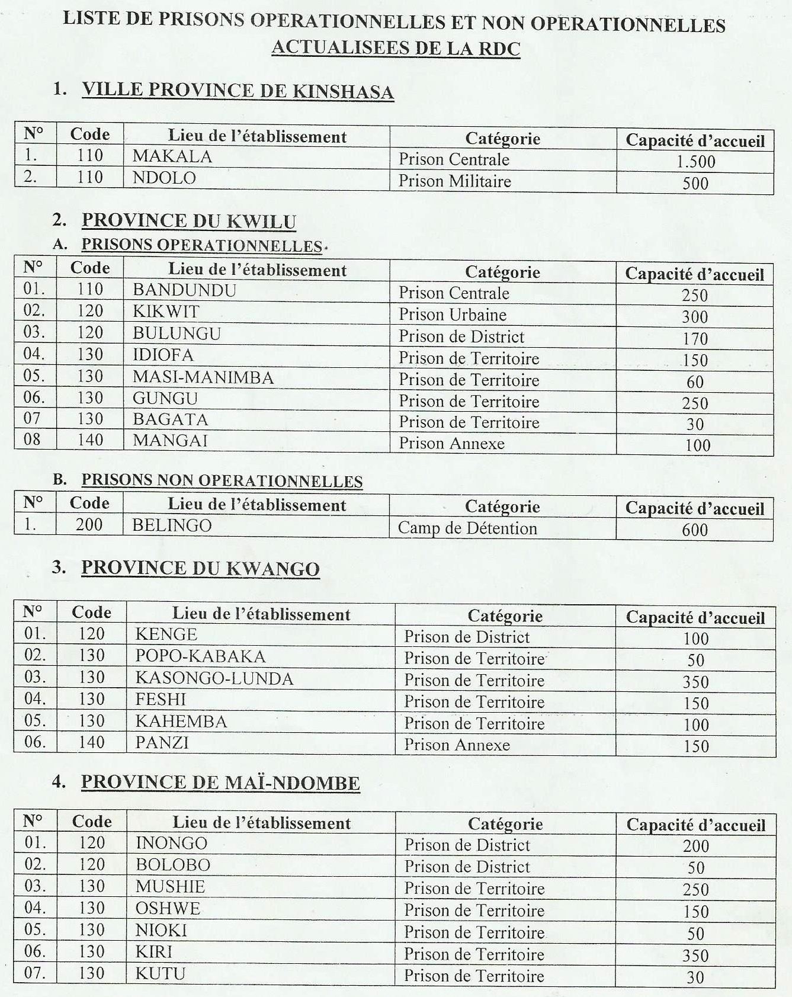

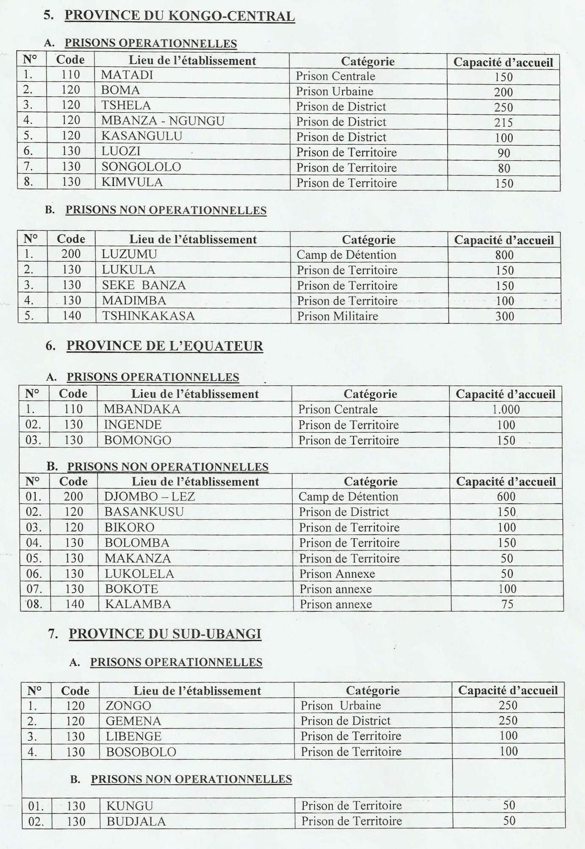

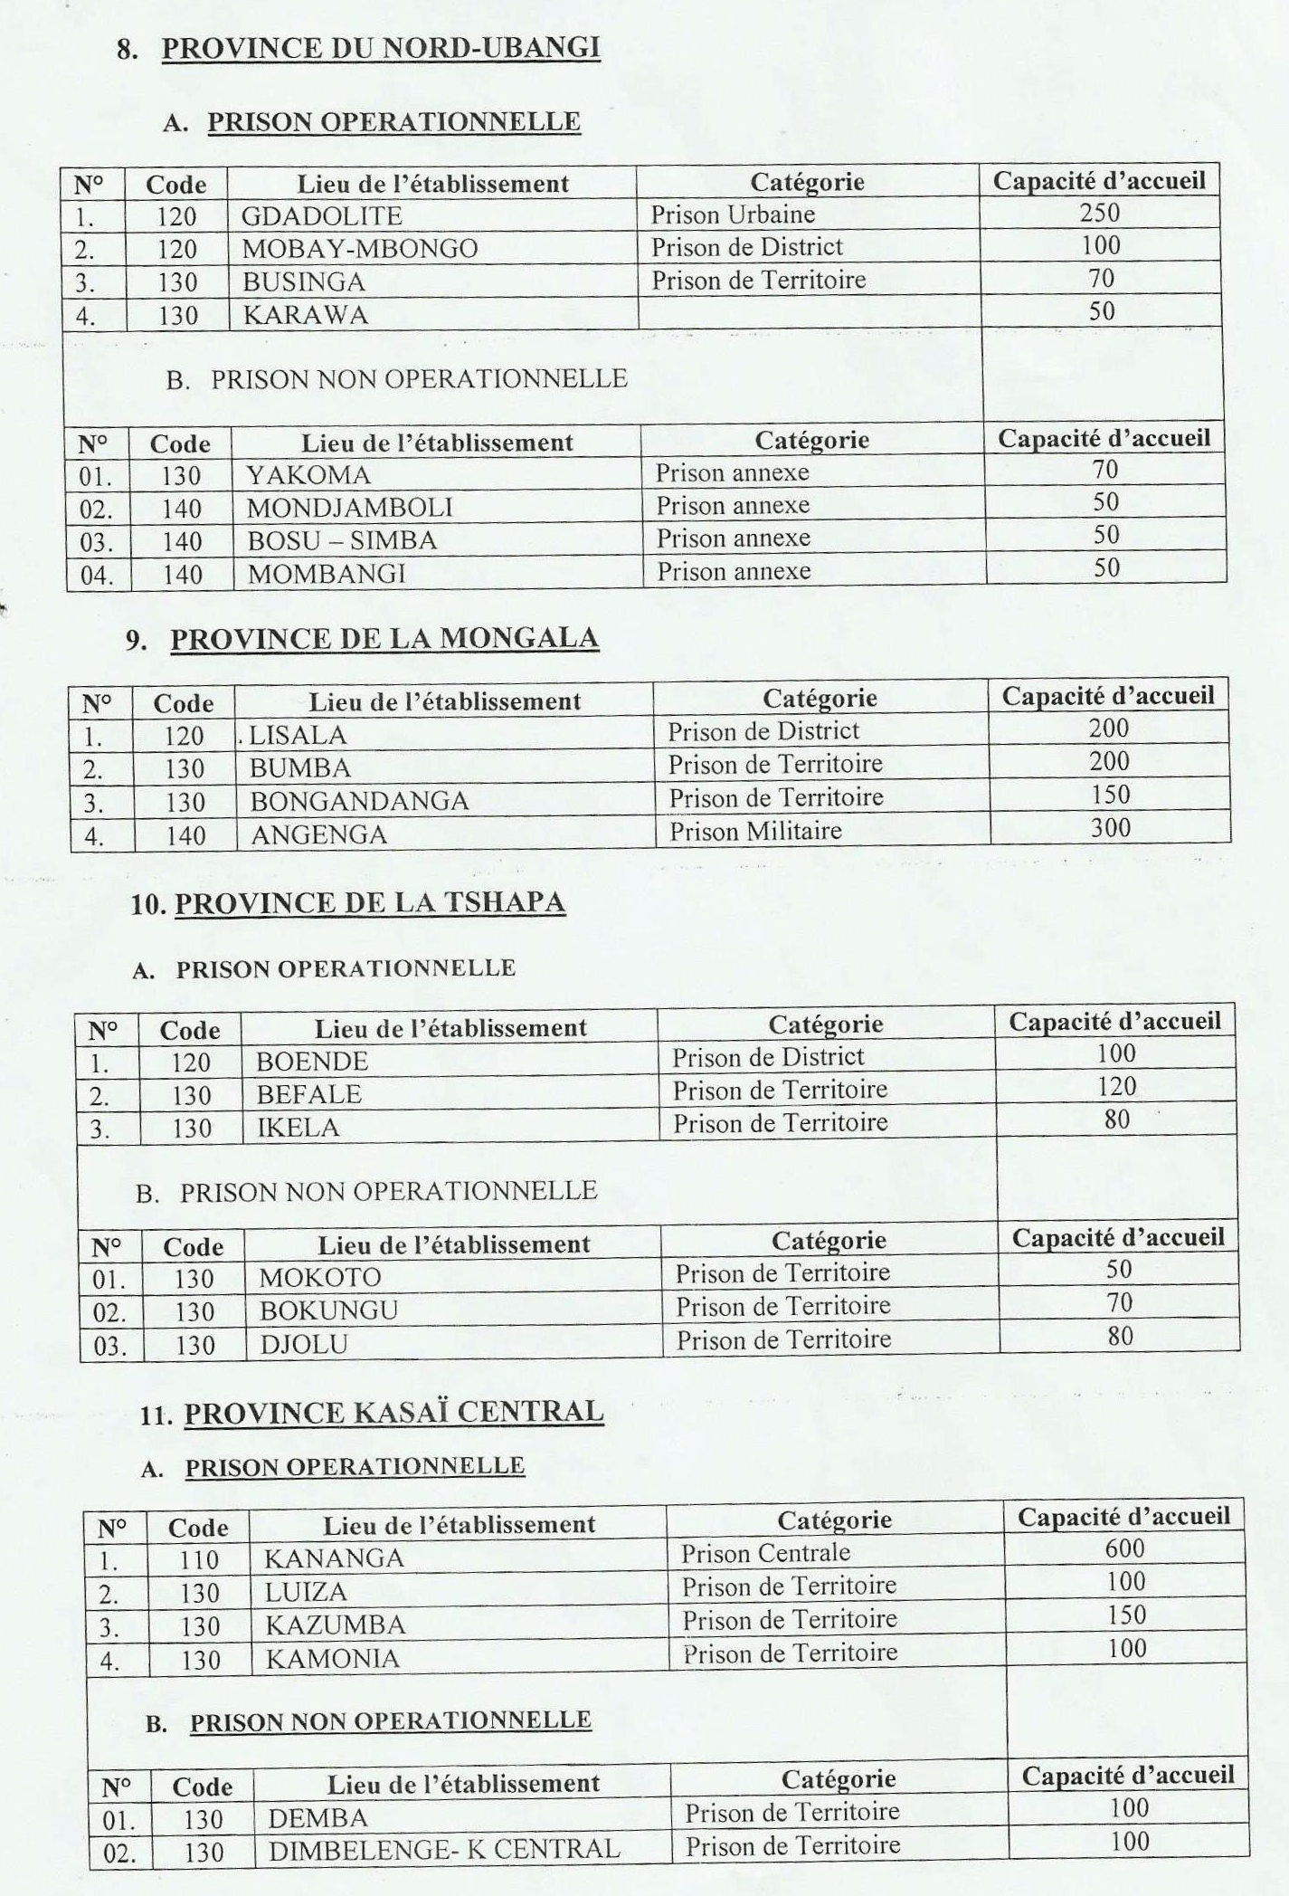

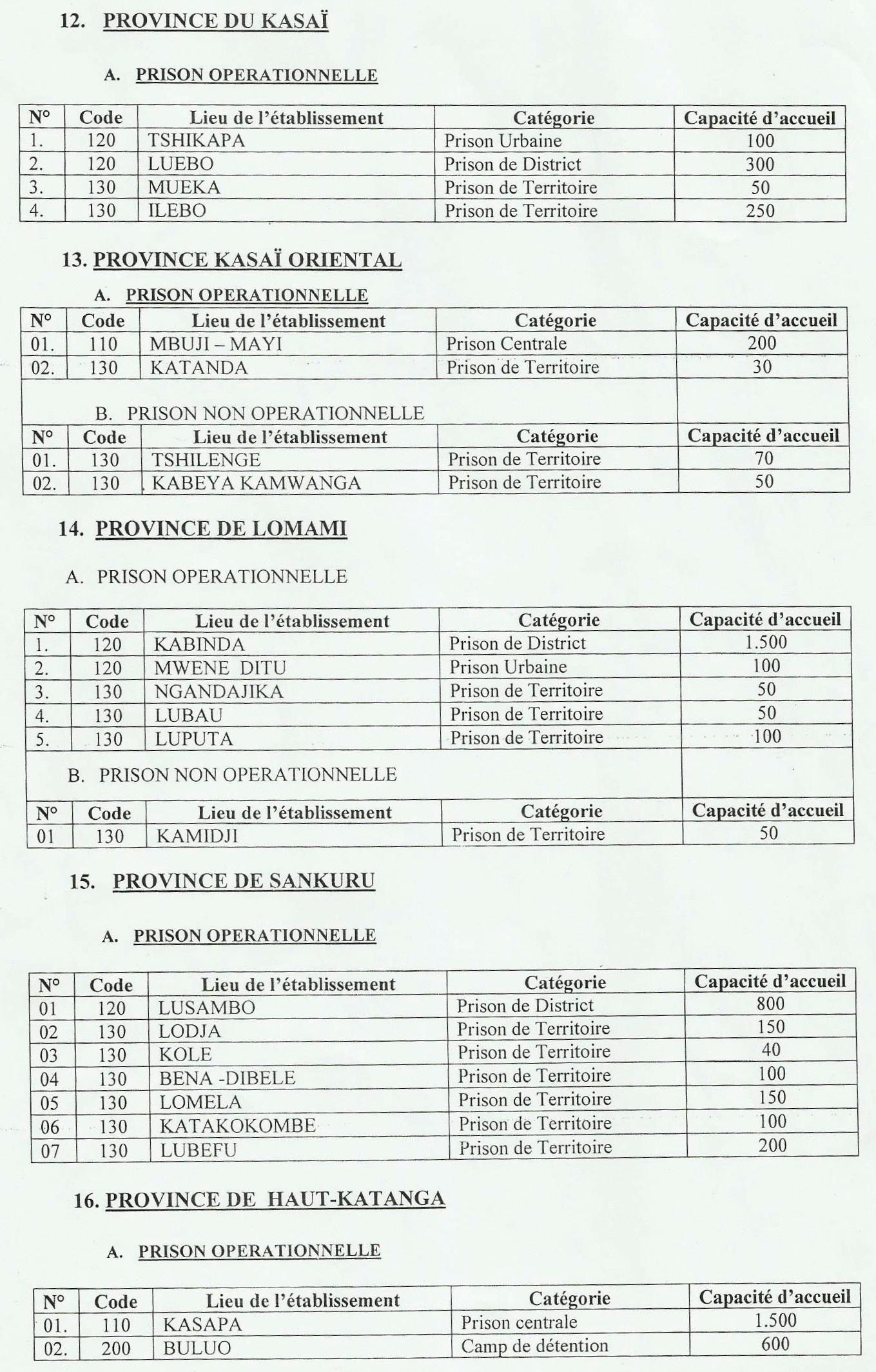

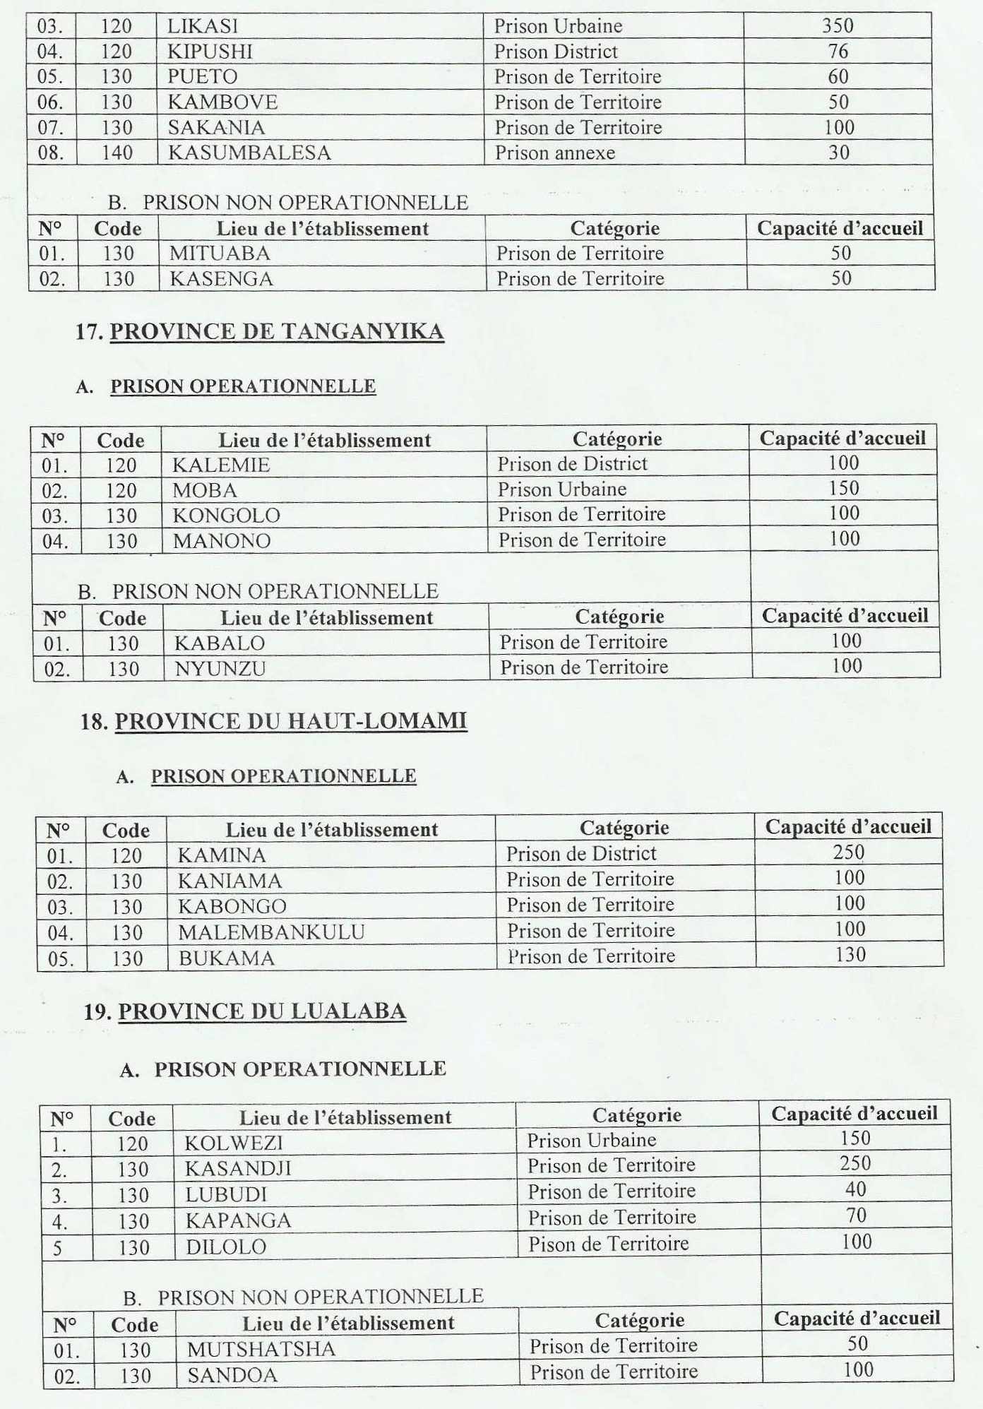

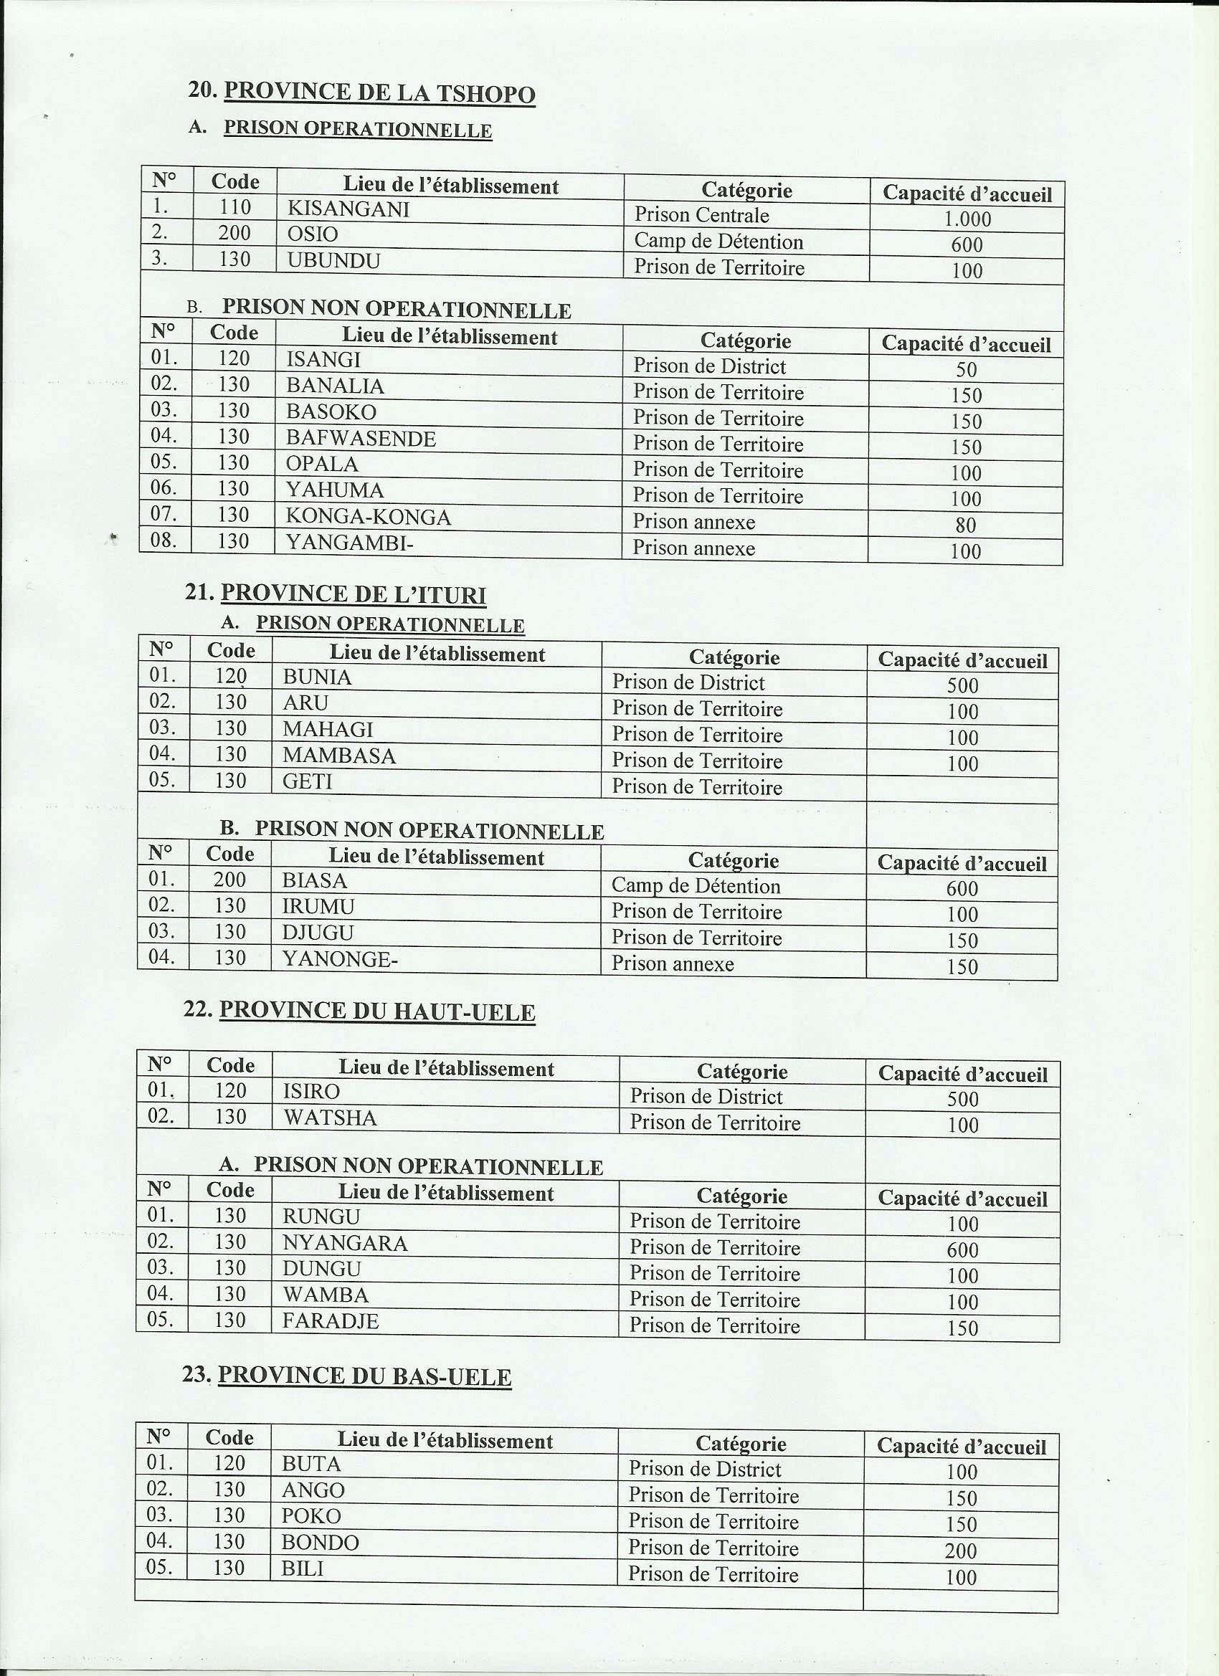

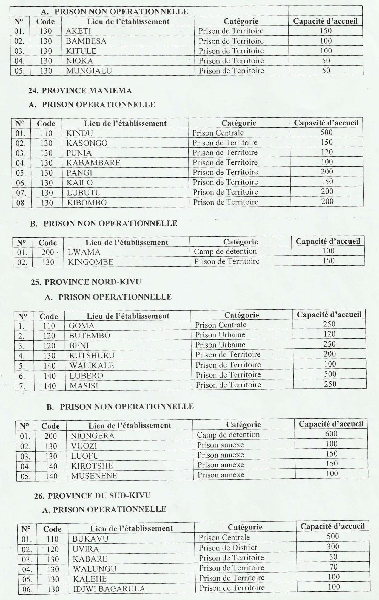

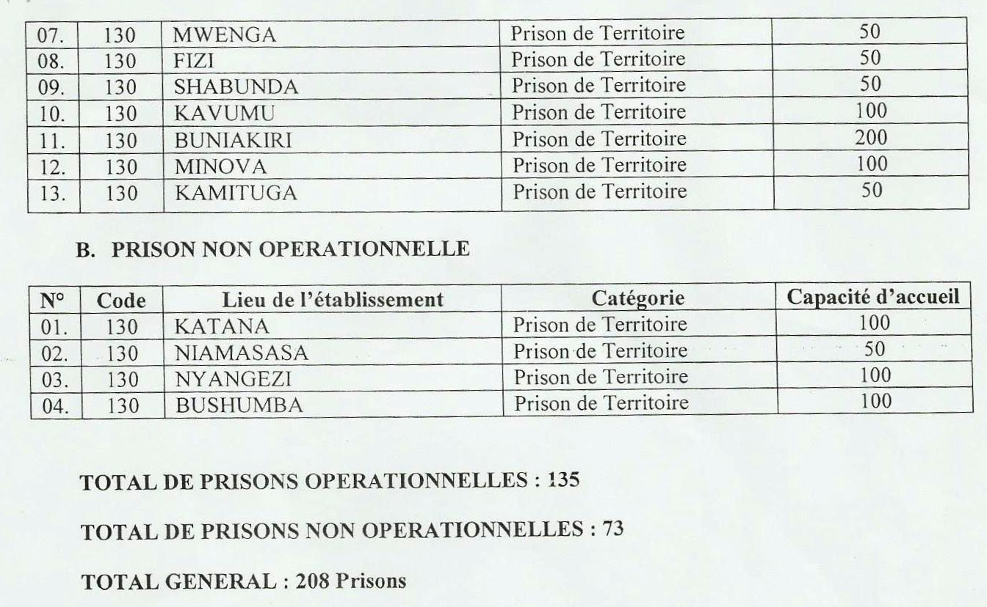

Source : Direction des services pénitentiaires

Annexe 3 : Cas de décès par prison de Juin 2015 à Août 2016
N° | PRISON | TOTAL CAS DECES
01 | MBANZA NGUNGU | 13
02 | MATADI | 4
03 | MAKALA | 30
04 | MBUJI MAYI | 29
05 | BANDUNDU | 0
06 | KANANGA | 7
07 | MBANDAKA | 0
08 | BENI | 3
09 | KENGE | 4
10 | KISANGANI | 13
11 | KASAPA | 12
12 | BUNIA | 7
13 | KASANGULU | 4
14 | ARU | 8
15 | BUTEMBO | 1
16 | GOMA | 0
17 | BUKAVU | 0
18 | KIKWIT | 0
 | Source: Direction des services pénitentiaires

Annexe 4 : STATISTIQUES DES ACTIVITES DES JURIDICTIONS CIVILES ET MILITAIRES SUR LES VIOLS DE 2014 – 2015 EN RDC
TABLEAU SYNTHESE
Provinces | Juridictions | Affaires enrôlées |  |  | Affaires en cours |  |  | Nombre de condamnés |  |  | Nombre d’acquittés
Provinces | Juridictions | 2014 | 2015 | Total | 2014 | 2015 | Total | 2014 | 2015 | Total | 2014 | 2015 | Total
Maniema | Civiles | 133 | 78 | 211 | 97 | 70 | 167 | 17 | 4 | 21 | 18 | 5 | 23
Maniema | Militaires | 13 | 10 | 23 | 2 | 3 | 5 | 6 | 7 | 13 | 3 | 0 | 3
Total |  | 146 | 88 | 234 | 99 | 73 | 172 | 23 | 11 | 34 | 21 | 5 | 26
Sud kivu | Civiles | 86 | 118 | 204 | 56 | 112 | 168 | 20 | 4 | 24 | 16 | 2 | 18
Sud kivu | Militaires | 31 | 15 | 46 | 20 | 6 | 26 | 5 | 7 | 12 | 6 | 0 | 6
Total |  | 117 | 133 | 250 | 76 | 118 | 194 | 25 | 11 | 36 | 22 | 2 | 24
Nord kivu | Civiles | 239 | 177 | 416 | 30 | 72 | 102 | 209 | 105 | 314 | 0 | 0 | 0
Nord kivu | Militaires | 90 | 28 | 118 | 3 | 12 | 15 | 68 | 22 | 90 | 9 | 4 | 13
Total |  | 329 | 205 | 534 | 33 | 84 | 117 | 277 | 127 | 404 | 9 | 4 | 13
Katanga | Civiles | 312 | 205 | 517 | 119 | 41 | 160 | 191 | 62 | 253 | 93 | 11 | 104
Katanga | Militaires | 27 | 4 | 31 | 21 | 4 | 25 | 6 | 0 | 6 | 0 | 0 | 0
Total |  | 339 | 209 | 548 | 140 | 45 | 185 | 197 | 62 | 259 | 93 | 11 | 104
Kasai Occ | Civiles | 103 | 76 | 179 | 47 | 69 | 116 | 23 | 4 | 27 | 33 | 3 | 36
Kasai Occ | Militaires | 3 | 8 | 11 | 0 | 3 | 3 | 2 | 2 | 4 | 1 | 3 | 4
Total |  | 106 | 84 | 190 | 47 | 72 | 119 | 25 | 6 | 31 | 34 | 6 | 40
Kasai Or | Civiles | 136 | 136 | 275 | 36 | 69 | 105 | 80 | 44 | 124 | 23 | 23 | 46
Kasai Or | Militaires | 9 | 8 | 17 | 1 | 4 | 5 | 7 | 1 | 8 | 0 | 1 | 1
Total |  | 148 | 144 | 292 | 37 | 73 | 110 | 87 | 45 | 132 | 23 | 24 | 47
Bas-congo | Civiles | 419 | 338 | 757 | 112 | 160 | 272 | 256 | 144 | 400 | 51 | 33 | 84
Bas-congo | Militaires | 31 | 17 | 48 | 2 | 4 | 6 | 23 | 9 | 32 | 3 | 3 | 6
Total |  | 450 | 355 | 805 | 114 | 164 | 278 | 279 | 153 | 432 | 54 | 36 | 90
Bandundu | Civiles | 119 | 102 | 221 | 57 | 77 | 134 | 73 | 40 | 113 | 20 | 17 | 37
Bandundu | Militaires | 6 | 7 | 13 | 1 | 1 | 2 | 2 | 3 | 5 | 3 | 3 | 6
Total |  | 125 | 109 | 234 | 58 | 78 | 136 | 75 | 43 | 118 | 23 | 20 | 43
Kinshasa | Civiles | 932 | 747 | 1 679 | 279 | 435 | 714 | 425 | 201 | 626 | 224 | 102 | 326
Kinshasa | Militaires | 56 | 57 | 113 | 20 | 48 | 68 | 18 | 3 | 21 | 18 | 7 | 25
Total |  | 988 | 804 | 1 792 | 299 | 483 | 782 | 443 | 204 | 647 | 242 | 109 | 351
Prov. Orient :Bunia | Civiles | 207 | 177 | 384 | 64 | 112 | 176 | 76 | 46 | 122 | 63 | 16 | 79
Prov. Orient :Bunia | Militaires | 18 | 22 | 40 | 0 | 1 | 1 | 13 | 14 | 27 | 5 | 7 | 12
Total |  | 225 | 199 | 424 | 64 | 113 | 177 | 89 | 60 | 149 | 68 | 23 | 91
Equateur | Civiles | 76 | 65 | 141 | 19 | 10 | 29 | 14 | 5 | 19 | 7 | 10 | 17
Equateur | Militaires | 12 | 19 | 31 | 32 | 8 | 11 | 5 | 6 | 11 | 4 | 9 | 13
Total |  | 88 | 84 | 172 | 22 | 18 | 40 | 19 | 11 | 30 | 11 | 19 | 30
TOTAL GENERAL |  | 3 061 | 2 414 | 5 475 | 989 | 1 321 | 2 310 | 1 539 | 733 | 2 272 | 600 | 259 | 859
Source : Cabinet de la Représentante personnel du Chef de l’Etat en matière des violences sexuelles et recrutement d’enfants

Mission de veille judiciaire en RDC de 2014-2015

