BRIEFING ON ETHIOPIA FOR THE COMMITTEE AGAINST TORTURE, SESSION 76 – April/May 2023
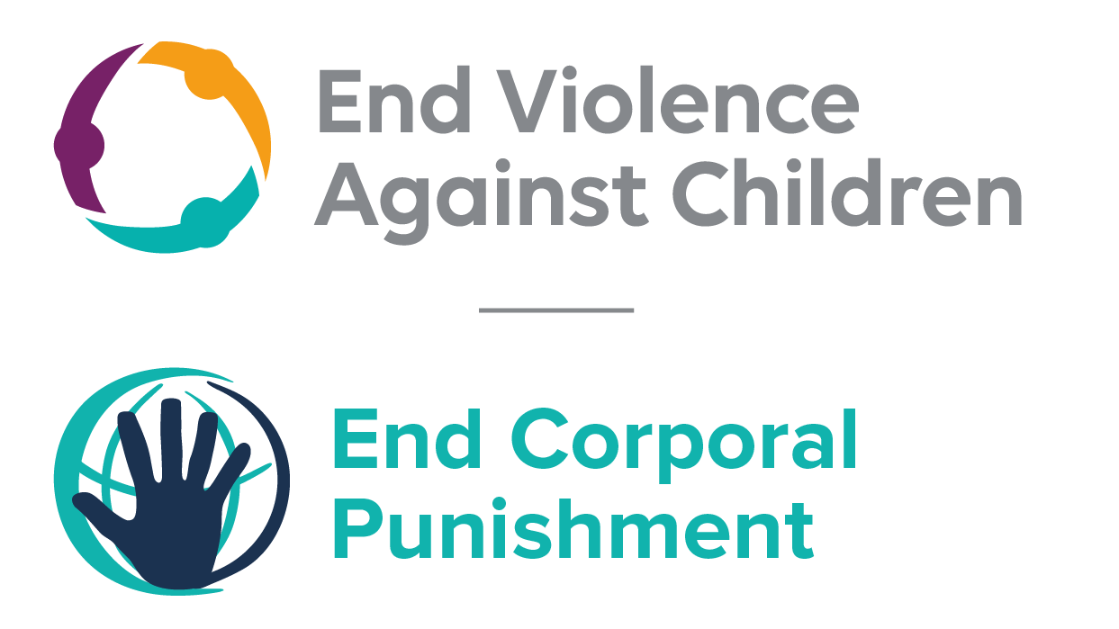
The Global Partnership to End Violence Against Children
March 2023

This briefing describes the legality of corporal punishment of children in Ethiopia. In light of the obligation under international human rights law to prohibit all corporal punishment of children, the recommendation of the UN Secretary General’s Study on Violence against Children, the repeated recommendations to prohibit all corporal punishment made to Ethiopia by the Committee on the Rights and other human rights treaty bodies, and considering the global commitment to ending all violence against children in the context of the 2030 Agenda for Sustainable Development, we hope the Committee will:
• in its concluding observations on the second report of Ethiopia, recommend that legislation is immediately enacted to explicitly prohibit corporal punishment of children in all settings including the home, and to repeal all legal defences for its use.

Summary of necessary legal reform to achieve full prohibition
Prohibition is still to be achieved in the home, some alternative care settings and some day care.
Article 576 of the Criminal Code 2005 recognises the power of parents and others with parental responsibilities to take “a disciplinary measure that does not contravene the law, for the purpose of proper upbringing” and article 258 of the Revised Family Code 2000 states that “the guardian may take the necessary disciplinary measures for the purpose of ensuring the upbringing of the minor”. These provisions need to be repealed and the law should prohibit all corporal punishment and other cruel or degrading forms of punishment, in the home and all other settings where adults exercise parental authority over children.
Alternative care settings – Corporal punishment in state-run care institutions is prohibited under the Constitution. Legislation should be enacted to prohibit corporal punishment in institutions that are not state-run and in all non-institutional forms of alternative care (foster care, places of safety, emergency care, etc).
Day care – Corporal punishment is prohibited in day care institutions under the Constitution. It should not be prohibited by law in all other early childhood care (nurseries, crèches, kindergartens, preschools, family centres, etc) and all day care for older children (day centres, after-school childcare, childminding, etc), including private as well as state organised, and non-institutional as well as institutional arrangements.

- The report of Ethiopia to the Committee Against Torture

  - The second report of Ethiopia states that Government has adopted a “Manual on positive child disciplining”. The Manual aims to prevent corporal punishment of children in schools, orphanages and at home. However, the report does not refer to prohibition of corporal punishment of children in all settings.

- Current legality of corporal punishment in Ethiopia

  - Home: Corporal punishment is lawful in the home. Article 576 of the Revised Criminal Code 2005 punishes maltreatment of children but states in paragraph 3: “The taking, by parents or other persons having similar responsibilities, of a disciplinary measure that does not contravene the law, for the purposes of proper upbringing, is not subject to this provision.” Provisions in the Civil Code 1960 allowing for “light bodily punishment” as an educative measure within the family were repealed but the Revised Family Code 2000 states that “the guardian may take the necessary disciplinary measures for the purpose of ensuring the upbringing of the minor” (art. 258). Provisions against violence and abuse in the Constitution 1995, the Criminal Code 2005 and the Revised Family Code 2000 are not interpreted as prohibiting corporal punishment in childrearing.

  - The Government reported to the Committee on the Rights of the Child in 2012 that the provision allowing parental discipline in the Revised Criminal Code is a “positive improvement” on the previous authorisation of “reasonable chastisement” in the Penal Code 1957 and that “federal and regional education institutions and justice bodies are working towards the abolishment of corporal punishment both in homes and schools”. But there was no indication of law reform to prohibit all corporal punishment in childrearing.

  - Alternative care settings: Corporal punishment is prohibited in child care institutions by article 36 of the Constitution 1995 (see under “Schools”), but we have yet to confirm that this applies to private as well as state provided care. There appears to be no prohibition in relation to non-institutional childcare, where the provisions in the Revised Criminal Code 2005 (art. 576) and the Revised Family Code 2000 (art. 25) allowing for disciplinary measures by persons with parental authority would presumably apply.

  - Day care: Corporal punishment is prohibited in institutions by article 36 of the Constitution 1995 (see under “Schools”), but we have yet to confirm that this applies to private as well as state provided care. There appears to be no prohibition in relation to non-institutional forms of day care, where the provisions in the Revised Criminal Code 2005 (art. 576) and the Revised Family Code 2000 (art. 25) allowing for disciplinary measures by persons with parental authority would presumably apply.

  - Schools: Corporal punishment is explicitly prohibited in schools in article 36 of the Constitution 1995, which states: “(1) Every child has the right … (e) to be free of corporal punishment or cruel and inhumane treatment in schools and other institutions responsible for the care of children.” Corporal punishment is not among permitted disciplinary measures in the school administration regulation issued by the Ministry of Education in 1998.

  - Penal institutions: Corporal punishment is unlawful as a disciplinary measure in penal institutions. The Constitution 1995 states that all persons in detention have the right to “treatments respecting their dignity” (art. 21) and article 36 explicitly protects children from corporal punishment in institutions (see under “Schools”).

  - Sentence for crime: Corporal punishment is unlawful as a sentence for crime under the Revised Criminal Code 2005.

Recommendations by human rights treaty bodies and during the UPR

  - CRC: On four occasions, the Committee on the Rights of the Child has recommended to Ethiopia that legislation be enacted to explicitly prohibit corporal punishment in all settings: in its concluding observations on the state party’s initial report in 1997, on the state party’s second report in 2001, on the state party’s third report in 2006 and the fourth-fifth report in 2015.

  - CAT: In its 2011 concluding observations on the state party’s initial report, the Committee Against Torture recommended law reform to prohibit corporal punishment in child-rearing in the home and alternative care settings.

  - CESC: In its concluding observations on the state party’s initial-third report in 2012, the Committee on Social, Economic and Cultural Rights recommended law reform to prohibit corporal punishment in child-rearing in the home and alternative care settings.

  - CRPD: In its concluding observation on the state party’s initial report in 2016, the Committee on the Rights of Persons with Disabilities recommended to Ethiopia that legislation be enacted to explicitly prohibit corporal punishment in all settings.

  - ACERWC: In its concluding observations on the state party’s initial report in 2014, the African Committee of Experts on the Rights and Welfare of the Child recommended that Ethiopia prohibit corporal punishment in all settings.

  - UPR: At the first cycle of the Universal Periodic Review of Ethiopia in 2009, a recommendation to include prohibition of corporal punishment in the constitution was made and rejected by the Government. Recommendations to prohibit all corporal punishment were made in the second cycle UPR 2014 and the Government accepted one of them.

26 May 2020, CAT/C/ETH/2, Second periodic report submitted by Ethiopia under article 19 of the Convention, due in 2014, para 133
23 December 2013, CRC/C/ETH/4-5, Fourth/fifth state party report, paras. 98 and 100
24 January 1997, CRC/C/15/Add.67, Concluding observations on initial report, paras. 13 and 27
21 February 2001, CRC/C/15/Add.144, Concluding observations on second report, paras. 6, 38 and 39
1 November 2006, CRC/C/ETH/CO/3, Concluding observations on third report, paras. 33 and 34
3 June 2015, CRC/C/ETH/CO/4-5 Advance Unedited Version, Concluding observations on fourth/fifth report, paras. 41 and 42
20 January 2011, CAT/C/ETH/CO/1, Concluding observations on initial report, para. 28
31 May 2012, E/C.12/ETH/CO/1-3, Concluding observations on initial-third report, para. 18
4 November 2016, CRPD/C/ETH/CO/1, Concluding observations on initial report, paras. 15 and 16
[December 2014], Concluding observations on initial report, para. 23
8 February 2011, A/HRC/13/56, Report of the Human Rights Council on its thirteenth Session, para. 744
7 July 2014, A/HRC/27/14, Report of the working group, para. 155; 17 September 2014, A/HRC/27/14/Add.1, Report of the working group: Addendum

