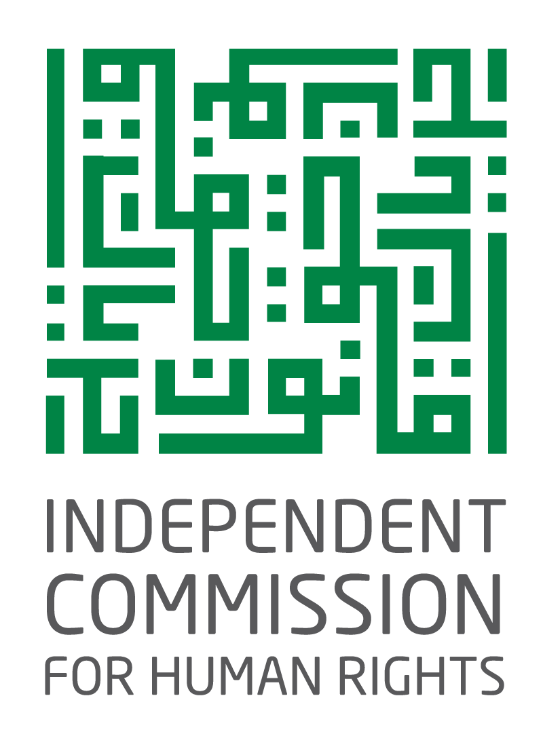

Written submissions for CEDAW Pre-Sessional Working Group
(31 October-4 November 2022)

2022
Palestine

Profile of the Independent Commission for Human Rights
As the Palestinian national human rights institution, the Independent Commission for Human Rights (ICHR) is a full member of the Global Alliance of National Human Rights Institutions (GANHRI). On 30 September 1993, the ICHR was established in accordance with a Presidential Decree promulgated by the late President Yasser Arafat. The Decree was subsequently published under number 59/1995 in the Palestinian Official Gazette in 1995. According to the Presidential Decree, ICHR functions and responsibilities are outlined as follows: “To monitor and ensure that requirements for safeguarding human rights are fulfilled by various Palestinian laws, bylaws and regulations, as well as by functions of various departments, agencies and institutions of the State of Palestine and the Palestine Liberation Organisation.”
The Presidential Decree tasks the ICHR with drafting its own bylaws in a manner that ensures the Commission’s independence and effectiveness. The ICHR commenced its activities in early 1994. Dr. Hanan Ashrawi, who initiated and spearheaded establishment of the ICHR. Having been approved by the Palestinian Legislative Council (PLC) in 1997, the Palestinian Basic Law was promulgated and published in the Palestinian Official Gazette in 2002. Article 31 of the Basic Law provides that “[a]n independent Commission for Human Rights shall be established by law, which shall specify its formation, duties and jurisdiction. The Commission shall submit its reports to the President of the National Authority and the Palestinian Legislative Council.” Despite the fact that the law has not been approved or passed yet, the ICHR clearly operates on the basis of the 1994 Presidential Decree until such time the ICHR Law is endorsed.
In its capacity as the national human rights institution and ombudsman office, the ICHR monitors and ensures that requirements for safeguarding human rights are fulfilled by Palestinian laws and regulations, as well as by functions of Palestinian departments, agencies and institutions. The ICHR scope of work is as broad as to address human rights violations, handle complaints of human rights abuses committed against citizens by the Executive branch of government, promote legal literacy, and monitor national legislation and policies, ensuring consistence with international human rights standards.
Contact Person: Khadija Zahran. Director of Monitoring Policies & National Legislations Department, E-mail: kzahran@ichr.ps

Introduction
Based on its role as a national human rights institution with an A status, the ICHR assumes the responsibility for submitting written statements and shadow reports to the United Nations bodies established under the treaties, which the State of Palestine acceded to. These interventions monitor the implementation of provisions of UN conventions by the State of Palestine. In view of its major role in monitoring the situation of human rights in the State of Palestine, in 2017, the ICHR submitted a written statement on the implementation by the State of Palestine of the provisions of the Convention on the Elimination of All Forms of Discrimination Against Women (the “Conventions”). On 11 July 2018, the Committee on the Elimination of Discrimination against Women (the “Committee”) held a session to discuss the State of Palestine’s initial report on the implementation of the Convention. Subsequently, the ICHR submitted a follow up report on implementation of the Committee’s recommendations and concluding observations by State of Palestine. The ICHR also held national consultations on the plan for implementing the Committee’s recommendations and observations.
The ICHR continues to monitor implementation by relevant bodies of the concluding observations made by the Committee at various levels to ensure complete fulfilment of the provisions of the Convention, achieve gender equality, and contribute to promoting and advance the status of women in Palestinian society.
Legal status of the Convention
Take concrete steps to acceded to the Optional Protocol to the Convention on the Elimination of All Forms of Discrimination against Women (the “Optional Protocol”), and publish the Convention in the Official Gazette
(a) Accession to the Optional Protocol
Having acceded to the Optional Protocol, the State of Palestine approves of the Committee’s competence to receive individual complaints from women in the event of alleged violations against the provisions of the Convention. Albeit important, this advanced step is not consistent with the limited progress made towards implementing provisions of the Convention. Against this background, accession to the Optional Protocol must be associated with practical steps towards integrating the provisions of the Convention into the Palestinian national legal system.
The State of Palestine has not launched awareness raising campaigns targeting women with a view to introducing women to the Optional Protocol, women’s rights deriving from the Optional Protocol, and procedures for access to justice and remedies in case any of the women’s rights under the Convention are abused.
While the Convention is not incorporated within national legislation and women lack awareness of the Optional Protocol, accession to the latter will not create an effect that changes women’s lives and enable them to enjoy all of their rights at the national level.
(b) Publication of the Convention in the Palestinian Official Gazette
In spite of incessant calls by the ICHR and civil society groups as well as the Committee’s recommendations, the Palestinian government has not published the Convention and its Optional Protocol in the Palestinian Official Gazette. This is indicative of a lack of will on the part of the government to make the Convention publicly available. As a consequence of publication, the Convention will be part of the Palestinian legal system. However, the government is unwilling to arouse the full ire and opposition of traditional community groups against the government’s role in advancing the principle of gender equality in Palestinian society.
Consolidate legal systems in the Gaza Strip and West Bank to ensure that all women and girls in the State party have access to equal protection under the law in accordance with the Convention.
The ongoing internal Palestinian political divide between the West Bank and Gaza Strip has resulted in a duplicate legal system, subjecting Palestinian women to two different legal frameworks. This is a key challenge and major obstacle that face Palestinian women in the context of making use of the international human rights system and, in particular, application of the Convention.
Along this vein, practical steps have not been taken to bring an end to the internal Palestinian political divide and restore the democratic life through elections. Regulations in the West Bank and Gaza Strip have not been consolidated, resulting in the continued impossibility of implementing laws, resolutions, and international conventions, which the Palestinian government is committed to, in the Gaza Strip. In addition, political developments indicate that a national reconciliation and government control over the Gaza Strip are still beyond reach in the near future.
The same is true of the potential applicability of the Convention to Area C in the West Bank, which falls under the full control of the Israeli occupying authorities.
It should also be noted that the government’s commitment to the Convention has declined owing to a counter attack waged by some conservative forces, religious movements, and tribal leaders. The Convention has been subject to an unprecedented assault insomuch as it runs counter to the teachings of Sharia (Islamic law) and attempts to alienate Palestinian society and destroy families. Women’s organisations have been accused of falling under the influence of Western funding and agendas. Along this vein, the Palestinian government has not taken any action that should have contributed to strengthening its sovereignty by establishing and applying the provisions of the Convention in response to that counter attack. As part of the government’s contractual obligations, this action reflects a sovereign decision, which may not be breached. Furthermore, the government has not guaranteed the protection of women human rights defenders.
Adopt national legislation, providing a comprehensive definition of discrimination against women, addressing all causes of prohibited discrimination, and including direct and indirect discrimination in both the public and the private spheres
The government has not openly adopted a national comprehensive definition of discrimination against women. Notwithstanding the definition provided under the Draft Law on Family Protection against Violence, the ICHR made observations in the previous follow up report, making clear that the definition was neither adequate nor comprehensive as to prohibit all forms of discrimination against women. A law has not been enacted, including a definition of discrimination as a constitutional norm and providing a basis for harmonising all promulgated regulations, policies, and procedures.
The ICHR continues to look forward to, and make efforts towards, putting in place a relevant provision under the operative Palestinian Basic Law, which serves as an Interim Constitution, or enacting a separate law that establishes a comprehensive prohibition on gender-based discrimination.
Harmonise legislation and repeal discriminatory laws
Between the beginning of 2014 and mid-June 2022, while the Palestinian government promulgated 286 laws in the West Bank, the Reform and Change Bloc issued forth 36 laws in the Gaza Strip. Still, no laws with a social dimension have been passed in order to end discrimination against women.
The government has not repealed effective discriminatory laws and regulations, including the Penal Law and Personal Status Law. Despite the fact that a national committee was established in 2020 to align the Penal Law with international conventions, the definition of discrimination was not adopted in the draft regulation produced by the committee. The ICHR is afraid that a definition of discrimination would not be provided in the context of legal proposals for alignment due to the lack of government will to adopt legislation, which promotes gender equality and puts an end to current legislative discrimination.
The government has consistently confirmed that work is underway to promulgate the Law by Decree on Family Protection against Violence. However, based on the ICHR monitoring, the government has reneged on many provisions of the draft law. All the more so, the government soon suspended work on the draft law owing to fear of reactions by some conservative or extremist movements.
According to ICHR monitoring, promulgation of a Law on Legal Aid has come to a halt. A national strategy for providing legal aid to all vulnerable groups has not been completed. As a result of foundered understanding between the government and relevant civil society organisations, including the Palestinian Bar Association, a budget line item has not been allocated to legal aid programmes. Consequently, women in conflict with the law would continue to resort to women’s organisations, which provide legal aid programmes.
The Committee for the Harmonisation of National Legislation with International Human Rights Conventions has neither scheduled nor placed on its agenda previously issued regulations. A timeframe has not been developed to review and harmonise national legislation with the Convention.
Allocate budgets for the empowerment of women
The public budget is an executive tool to achieve strategic objectives. In the context of examining the government’s commitment to the empowerment of women and achievement of gender equality, the ICHR monitors programme budgets approved by government, together with sector plans and strategies in relation to women, namely, the National Policy Agenda (NPA) 2017-2022 and Sector Strategies on Gender Equality. The ICHR also measures the extent to which these are reflected in budget programmes of the Ministry of Women’s Affairs (MoWA).
Programmes on women and gender mainstreaming are listed under National Priority 5: Effective Government of the NPA 2017-2022. Gender mainstreaming, gender equality, and empowerment of women are one intervention provided by this national priority. Of these, a strategy seeks to eliminate all forms of discrimination and violence against women and girls, and remove barriers that prevent the full participation of women in community and economic development and public life.
Beginning in 2017, the ICHR has monitored and taken note of the public budget in the ICHR initial report submitted to the Committee. The ICHR found out that budget allocations to the MoWA were not increased, standing at 04.0 percent of the total public budget. Of this, salaries and wages had the lion’s share of the MoWA budget appropriation. On the other hand, women development programmes continue to rely on donor funding.
Participation in political and public life
With a view to promoting all Palestinians’ right to stand for election and the right to vote, the ICHR observed the two phases of the fourth local elections held in 2021 and 2022. Along with a number of civil society actors, the ICHR signed a memorandum of understanding with the Central Elections Commission to promote the electoral environment and encourage citizens to stand for election and vote.
Due to the ongoing political divide, however, 40 percent of citizens in local government units (LGUs) across the Gaza Strip were prevented from exercising their right to vote and be elected in those local elections.
The ICHR monitored infractions of election campaigning by some electoral lists. These opted for hiding the photos of female candidates, violating the State of Palestine’s obligations under the Convention, International Covenant on Civil and Political Rights, International Covenant on Economic, Social and Cultural Rights, Palestinian Basic Law, codes of professional conduct, and charters of honour signed by political parties and electoral blocs.
According to the election results, some 20 percent of women were elected to LGU councils. The election results also revealed an entrenched tribalism and familial authority structures. Approximately 185 LGUs won the election by acclamation, depriving women and youth of democratic social dialogue and interaction.
The government, therefore, needs to amend the Law on the Election of Local Government Units by raising the quota to a minimum of 30 percent. Measures and actions should be taken to guarantee that there will be no gender discrimination throughout electoral phases. A democratic setting will be promoted to eliminate tribalism (wining by acclamation), which excludes women from social debate and activism.
Employment of women
According to available data, while accounting for 21 percent of the total labour force, 32 percent of women worked in the informal sector. Of these, only 30 percent received their employment rights. All these women were employed by civil society organisations. The percentage of youth working in the service sector was 25 percent in 2018 (19 percent males and 67 percent females) compared to 28 percent in the trade, restaurants and hotels sector (30 percent males and 14 for females).
These data showed that women were mainly employed in care sectors. Many women continued to work in traditional occupations. Women falling within the category of technicians, specialists, assistants, and clerks represented 65 percent of the labour force in the West Bank and 91.3 percent in the Gaza Strip.
Statistics also indicated that, compared to 5.5 percent of men, 23 percent of women were employed as unpaid family workers. This demonstrated that women were mainly concentrated in family enterprises and informal economy. Almost 53 percent of workers, all women, were not included in the “labour force” accounts as a consequence of unpaid household work.
Compared to previous years, in 2020, women’s participation in the labour force decreased as a result of the COVID-19 pandemic. Of all women of working age, women’s participation in the work force dropped from 18 percent in 2019 to 16 percent in 2020.
The employment-poverty nexus showed that 30.6 percent of women heads of household were poor in comparison to 29.2 percent of poor men heads of household. Poverty was higher among members of households headed by non-participants in the labour force (42.1 percent females and 25.8 males).
According to ICHR monitoring, there was a lack of data and studies on services associated the role of women in unpaid care work. A national policy is not in place to align the reality of employment and relevant responses with the requirements of the Convention. The MoWA does not play a role in the making of gender sensitive policies in care work.
The PCBS Labour Force Survey 2020 showed that, compared to 23 percent of men with disabilities, the participation of women with disabilities in the Palestinian labour force was just 2 percent of the total number of disabled women.
Access to justice
In 2020, the ICHR conducted a survey on access to justice for women detained in correction and rehabilitation centres throughout the West Bank and Gaza Strip. As at the time of the assessment, there were 63 female inmates, including 35 in the West Bank and 28 in the Gaza Strip.
A tool was designed to assess the alignment of protection homes and shelters with international standards using international conventions, particularly recommendations of the Committee. Reference was also made to international standards, including United Nations Rules for the Treatment of Women Prisoners and Non-custodial Measures for Women Offenders.
Many gaps in women’s access to justice came to the fore. Female inmates’ access to justice represented 44.8 percent during pretrial detention in different detention places, including police holding cells, 25.4 percent when brought before the Public Prosecution, 44.3 percent when put on trial before courts, and 61.9 percent when held in a correction and rehabilitation centre.
The ICHR assessment also unveiled many gaps in the application of due process of law. Police personnel did not make clear the legal rights of, and charges imputed to, female inmates. Prosecutors did not interrogate inmates in the presence of a legal counsel. Poor attention was paid to arrangements for consultation with a psychiatrist to examine if inmate were psychologically fit and legally legible for judicial proceedings.
Against this backdrop, the ICHR recommends that the Committee urge the State of Palestine to apply best practices under human rights conventions while handling cases of violence against women. The State of Palestine will ensure that proactive policies and processes are integrated and mainstreamed to institutionalise the protection and support of women’s rights under the existing legal and justice systems. The Palestinian government needs to finalise the training law enforcement personnel on the rights of women, including female detainees. Particular attention will be paid to the general recommendation No. 30 (2015) of the Convention and Model Strategies and Practical Measures on the Elimination of Violence against Women in the Field of Crime Prevention and Criminal Justice (UN General Assembly Resolution A/RES/65/228).
Protection of women human rights defenders
Effective legislation lacks a legal framework to ensure protection of male and female human rights defenders, nor is it adequate to guarantee such protection. The Palestinian government has not put in place a national strategy for the protection of human rights defenders. Protection is not provided to women human rights defenders, whose lives are at risk.
In 2019, many women human rights defenders, lawyers, and women’s organisations came under a ferocious attack by the Islamic Hizb at-Tahrir (Party of Liberation) and other traditional forces. Involving mass sit-in protests on the streets and in the virtual space, the assault aimed at demonising the Convention as well as those institutions and persons who call for implementation of the Convention. The attack featured various threats, intimidation, and labelling as unbeliever of those who called for enforcing the Law by Decree on Family Protection against Violence and applying the Convention. The offensive has continued as at the time of reporting.
The government has not provided adequate protection to Palestinian women human rights defender. It also receded from discussions of the Draft Law by Decree on Family Protection against Violence as well as from harmonising discriminatory legislation in accordance with the Convention.
Additionally, law enforcement agencies assaulted a number of female journalists on duty. The ICHR received 10 complaints from female journalists, who had been beaten, verbally abused, and had their mobile devices seized against the background of practicing journalism and exercising their right to freedom of opinion and expression during peaceful assemblies in protest against the death of activist Nizar Banat.
Recommendations
As no progress has been made towards implementing the Committee’s recommendations, the ICHR requests that the Committee urge the State of Palestine to comply with the Committee’s recommendations and concluding observations within a specific time frame.
Attachments
Women’s complaints filed to the ICHR in 2018-2021

. The committee is still in operation as at the time of reporting.
. Palestinian Central Bureau of Statistics (PCBS), On the occasion of the International Youth Day, the Palestinian Central Bureau of Statistics (PCBS) issues a press release demonstrating the situation of the youth in the Palestinian society, available at: https://www.pcbs.gov.ps/post.aspx?lang=en&ItemID=3528.
. PCBS. Data on the Reality of Youth in Palestinian Society, 2019, available at: https://www.pcbs.gov.ps/postar.aspx?la.
. Sa’id, Nader. Palestinian Women and Development. Birzeit University. Centre for Development Studies, 1998.
. PCBS, Multidimensional poverty: Main Results, 2017.
. Ministry of Social Development (MoSA). MoSA issues a bulletin on women in MoSA programmes, available at: https://www.mosa.gov.ps.
. Convention on the Elimination of All Forms of Discrimination against Women, available at: https://www.ohchr.org/sites/default/files/Documents/ProfessionalInterest/cedaw.pdf; Declaration on the Elimination of Violence against Women.

