
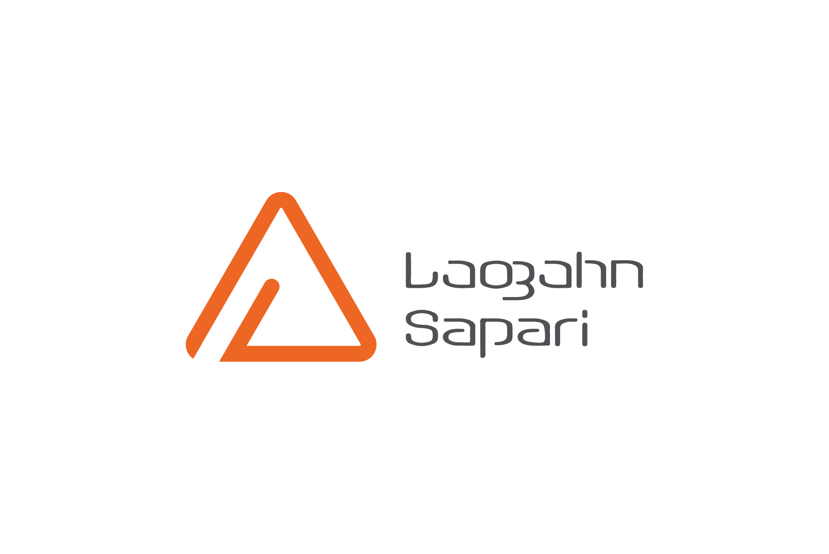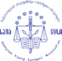
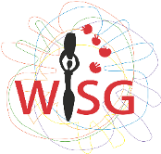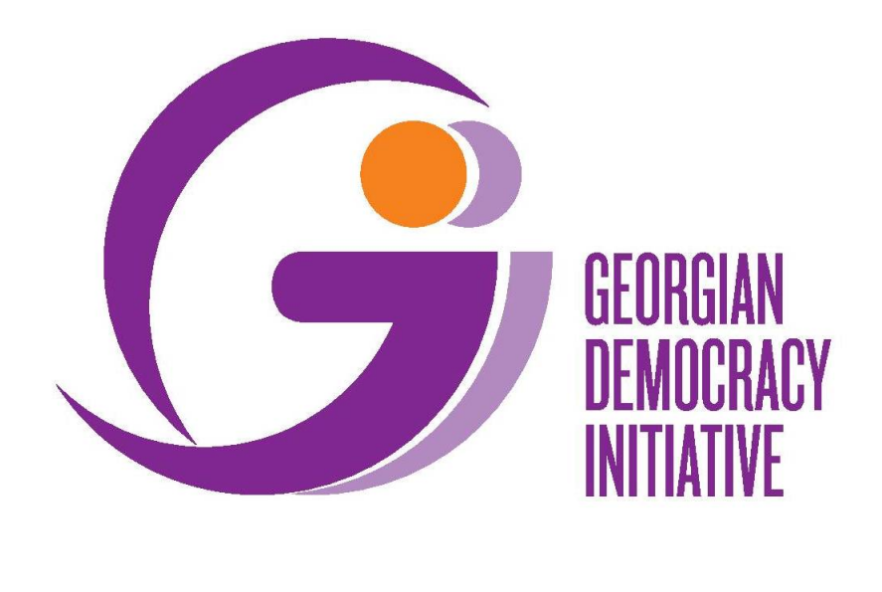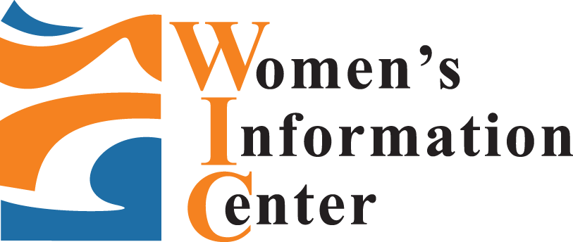
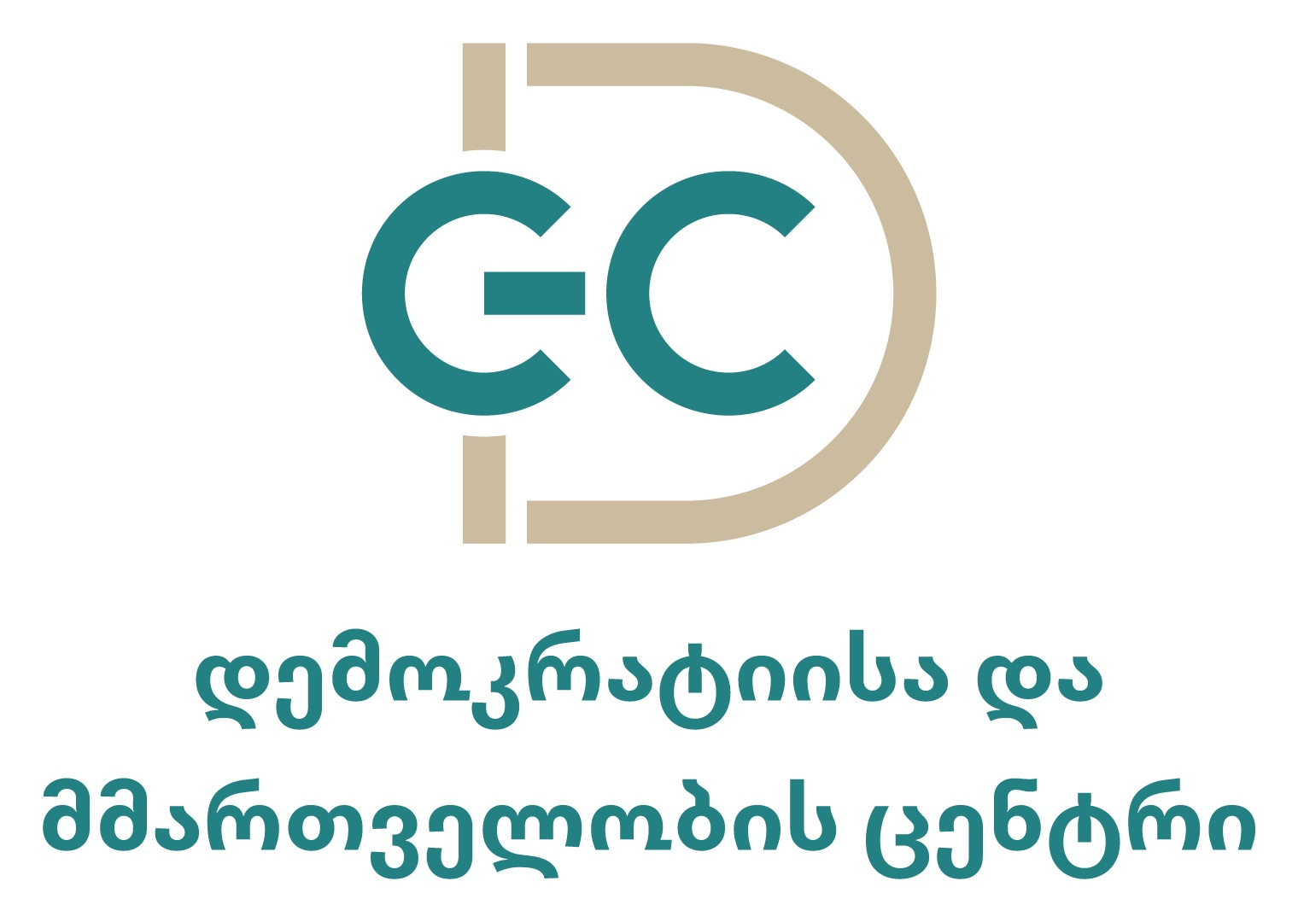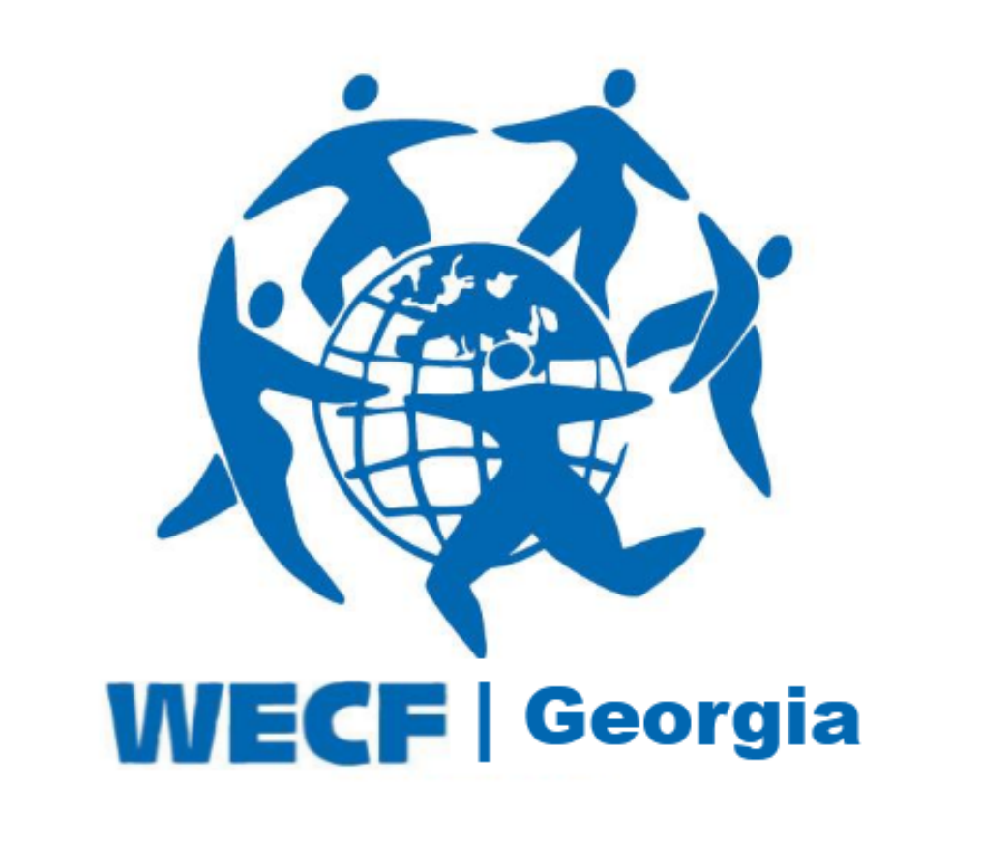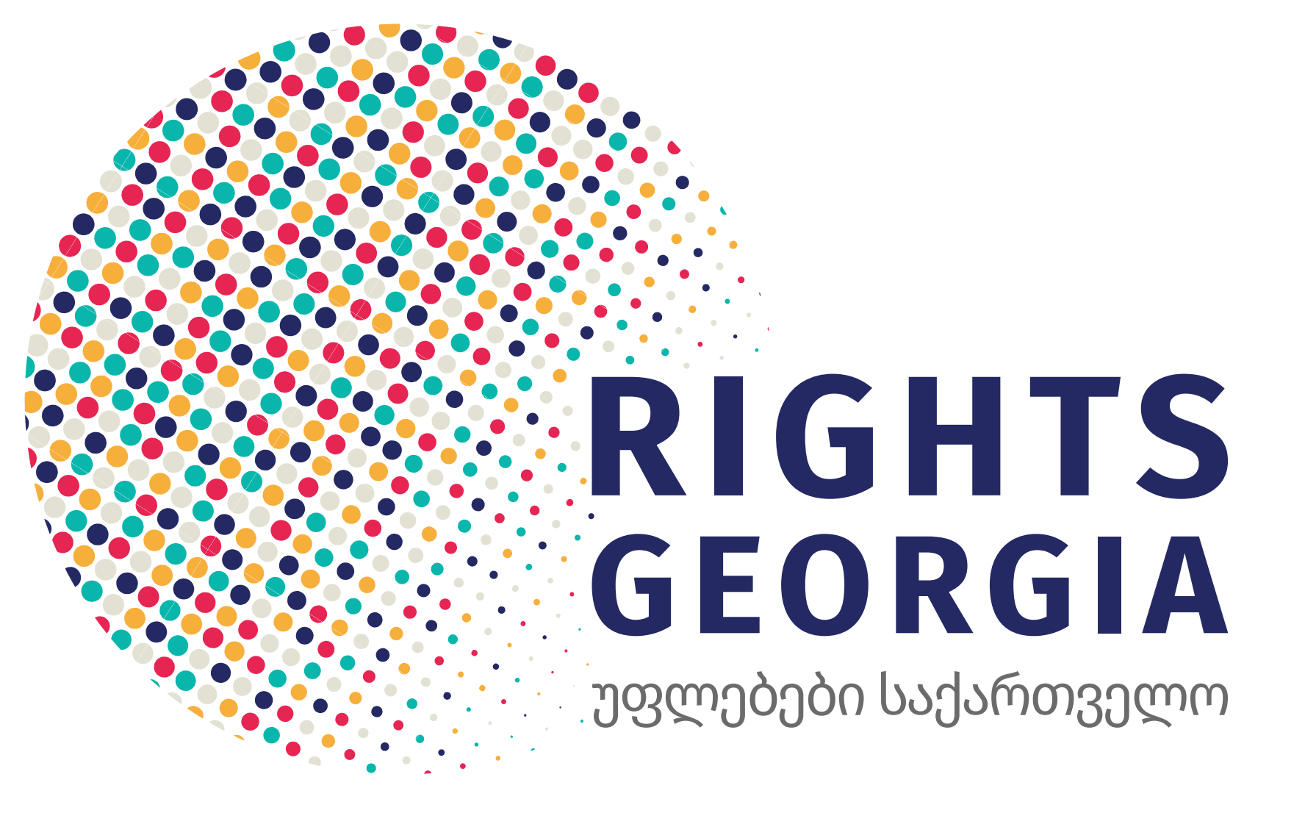
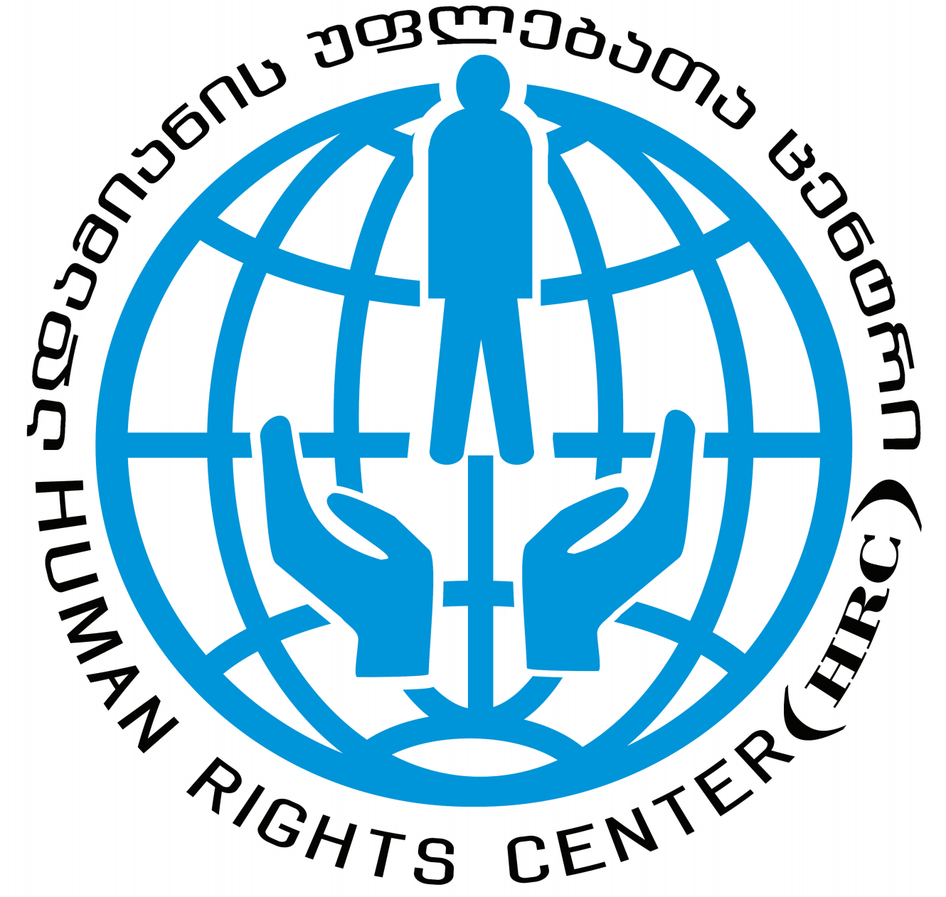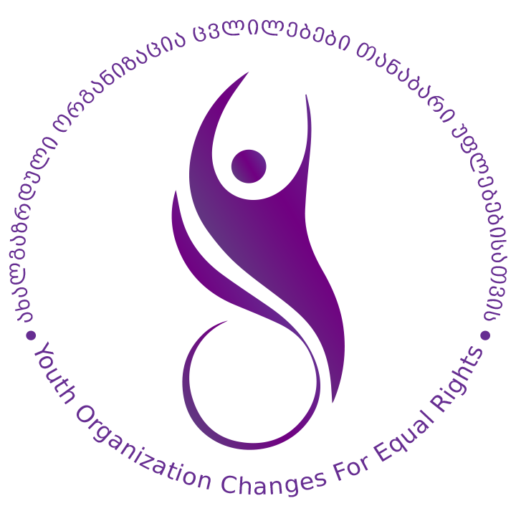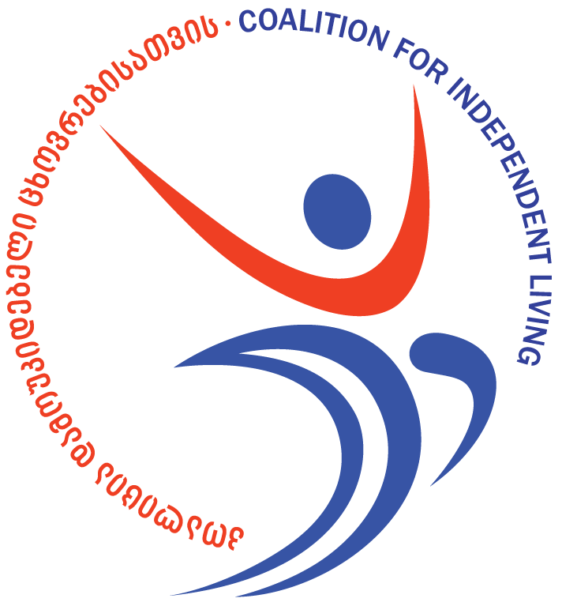

Committee on the Elimination of Discrimination against Women
Human Rights Treaties Division (HRTD)
Office of the United Nations High Commissioner for Human Rights (OHCHR)
Palais Wilson - 52, rue des Pâquis
CH-1201 Geneva
Switzerland
By Email: cedaw@ohchr.org
5 January 2023
Information on Georgia for consideration by the Committee on the Elimination of Discrimination against Women at its 84th Session (06 - 24 February 2023)
Introduction
- We respectfully submit this report for consideration of Georgia’s sixth state party report during the Committee on the Elimination of Discrimination against Women’s (‘the Committee’) 84th Session (06 - 24 February 2023). This submission expresses our concerns with regard to laws related to rape and other forms of sexual violence and procedures and practices which effectively deny access to justice for survivors of sexual violence in violation of the Convention on the Elimination of All Forms of Discrimination against Women (‘the Convention’). In September 2021, Equality Now, in collaboration with UN Women and Council of Europe, prepared a manual on “Effectively Investigating, Prosecuting and Adjudicating Sexual Violence Cases”
- Equality Now submits this report in partnership with: Georgian Young Lawyers’ Association (GYLA), Union Sapari, Partnership for Human Rights (PHR), Women’s Initiatives Supporting Group (WISG), Democracy and Governance Center, Rights Georgia, Georgian Democracy Initiative (GDI), Coalition for Independent Living (CIL), Women Engage for a Common Future (WECF) – Georgia, Women’s Information Center (WIC), Human Rights Center (HRC), and Changes for Equal Rights (CER). Please see Annex at the end of the submission for information about the submitting organisations.
- The legal provisions and practices detailed in this submission highlight the failure of Georgia to comply with its duty to provide equal protection under the law to survivors of sexual violence (Article 2(c) of the Convention) and the failure of the justice system to protect women from sexual violence (Article 2(c) and (e)). We submit that the root cause of these failures is the State’s non-compliance with the obligation to end discrimination against women in law and practice and address stereotypical and gender-discriminatory attitudes towards women and girls, contrary to Articles 2(f) and 5(a) of the Convention and the obligation to combat violence against women and provide access to justice to survivors, as described in General Recommendations 19, 33 and 35 of the CEDAW Committee.
- In the last few years, the Georgian government has taken a number of steps to address violence against women, including sexual violence that this submission focuses on. In particular, in 2021-2022, over 400 investigators, prosecutors and judges were trained on sexual violence based on the manual on Effectively Investigating, Prosecuting and Adjudicating Sexual Violence Cases: A Manual for Practitioners in Georgia. As a result, in 2021, as compared to 2020, the number of registered sexual violence crimes increased by 55%; the number of prosecution for sexual violence crimes increased by 76%; and the number of sexual violence cases resulting in conviction increased by 44%. As to the first 6 months of 2022, as compared with the first 6 months of 2021, the number of rape convictions increased by 49%.
- Despite the above, significant challenges still remain in preventing and combating sexual violence, including sexual violence committed in conjunction with harmful practices and against vulnerable women. Definitions of sexual violence crimes in the Criminal Code of Georgia still fail to meet the CEDAW standards. Amendments in the Criminal Code of Georgia to introduce a consent-based definition of rape have been discussed internally in the Parliament, however, revisions have not yet been initiated. Even according to the Sixth periodic report submitted by Georgia, there is still a lot of stigma around sexual violence and “sexual violence remains a taboo.”
Definitions of sexual violence crimes and sentences are not compliant with international human rights standards
- Despite various efforts, the Criminal Code of Georgia still does not contain a consent-based definition of rape; some serious acts of rape are still treated as minor crimes not constituting rape; and causing a person to engage in sexual acts with a third person is not specifically criminalised - all failing to meet the standards developed by CEDAW, the Istanbul Convention and other instruments.
Failure to introduce a consent-based definition of rape
- Under international human rights standards, rape and other sexual violence crimes should be based on the lack of free and voluntary consent of the victim, as provided by CEDAW and other international human rights jurisprudence and standards.
- Contrary to the above, the definition of rape and other sexual offences in the Criminal Code of Georgia focus on the use of force, threat of force, abusing the helplessness of the victim, and various forms of coercion, rather than focusing on the absence of the free and voluntary consent that should be assessed in the context of the surrounding circumstances.
- Article 137 of the Criminal Code defines rape as any form of sexual penetration of the body of another person with any body part or object, committed by the use of violence, threat of violence or by abusing the victim’s helplessness, which is punishable by imprisonment of six to eight years. Similarly, Article 138 of the Criminal Code defines an assault of a sexual nature that falls short of penetration committed under violence, the threat of violence or by abusing the victim’s helplessness, punishable by imprisonment of four to six years.
Failure to recognise some serious acts equivalent to rape as rape
- The Georgian legislation currently allows for two different rape crimes, one of which calls for more serious penalties on conviction (Article 137 as provided above) while the other, Article 139, is called coercion rather than rape and is defined as a light crime committed in circumstances other than with the use of force and threat of immediate force and helplessness. This reinforces the myth that rape always involves physical force.
- Article 139 criminalises any of the types of behaviour criminalised by Articles 137 and 138, but that have been committed using the threat of damaging property, disclosing defamatory information, information representing private life or such information that may substantially affect the right of that person, and/or by abusing a helpless condition of a person affected, or material, official or other kind of dependence. Despite the fact that this article, criminalises serious behaviour which equals rape or sexual assault, the act is only punishable by a fine or up to five years imprisonment.
- The above provision was heavily criticised by GREVIO (Council of Europe’s Group of Experts on Action against Violence against Women). In its Baseline Evaluation Report on Georgia, GREVIO noted with regard to the provisions of Articles 137 and 139, particularly with regard to the problematic nature of Article 139 (compulsion/coercion), that:
  - “Georgian legislation currently incriminates two different types of acts of rape, one of which is termed rape (Article 137) and provides for more serious penalties, and one that is termed coercion to intercourse (Article 139) and is defined as a less serious crime, mainly because it does not require the use of force or threat of immediate force. Instead of ensuring through the conceptualisation of the offences of rape and sexual violence that any sexual act performed on another person without his or her freely given consent is a form of criminal behaviour as required by Article 36 of the Istanbul Convention, the applicable definitions and differences in their sentencing ranges reinforces the myth that rape always involves physical force or threat thereof”.
  - Moreover, the existing provisions “reinforce the notion of a hierarchy of rape victims” while “in both sets of circumstances, the victim does not consent to the act, which is what criminal liability should hinge upon”.
Failure to criminalise causing a person to engage in sexual acts with a third person
- Another deficiency in the criminal legislation of Georgia, also raised by GREVIO, is that the legislation does not criminalise causing another person to engage in non-consensual acts of a sexual nature with a third person (Istanbul Convention, Article 36, paragraph 1c). GREVIO urged the Georgian authorities to criminalise such actions as they serve “as part of the control and abuse in intimate partner violence” and demonstrate “the malevolent behaviour of abrogating a woman’s sexual self-determination”.
Burdensome evidence and corroboration requirements to prove sexual violence
- Despite recent progress, resulting in the increase in investigations, prosecutions and convictions of sexual violence, burdensome evidence and corroboration requirements are still being applied for bringing charges against perpetrators of sexual violence. Overwhelmingly strict requirements are also applied to issue a judgement of conviction for these kinds of crimes.
- In particular, in the vast majority of cases, sexual violence crimes are prosecuted, and perpetrators are being convicted, when physical injuries are found on the body of the victim, as well as biological materials associated with a sexual act. Such practice leaves the range of sexual violence acts envisaged under the law (Articles 137-140) to go unpunished, because the criminal justice system is overwhelmingly focusing on sexual violence crimes where the perpetrator used physical force and the victim physically resisted. This practice is also one of the main causes of the high attrition rate of sexual violence crimes and the reason why a vast number of cases never reach the stage of prosecution and conviction.
- In addition, rigid corroboration requirements pose a significant barrier to perpetrators being brought to justice. Legislation is consistently interpreted as requiring two pieces of direct evidence on which to issue a conviction, with the whole testimony of an individual witness considered to be only one ‘piece’. This strict requirement of ‘two pieces’ means that even if the evidence of survivors is credible and reliable, it can never on its own form the basis for a conviction, unless corroborated by another ‘piece’ of direct evidence. Moreover, a victim’s evidence corroborated by evidence that can be considered ‘indirect’ (such as, e.g. the victim told someone about the rape after the incident or sought medical or psychological help) is also insufficient. Such a threshold also cuts out a determination on the merits because uncorroborated complaints of women who have been victims tend to not go to court.
- These evidentiary standards leave many forms of sexual violence unpunished and run contrary to the Committee’s recommendation to ensure that evidentiary rules and other legal and quasi-judicial procedures are impartial and are not overly restrictive, inflexible or influenced by gender stereotypes or prejudice. Furthermore, the Committee specifically recommends that States abolish “corroboration rules that discriminate against women as witnesses, complainants and defendants by requiring them to discharge a higher burden of proof than men in order to establish an offence or to seek a remedy.”
Gender stereotyping and discriminatory investigation procedures
- Despite the recent improvements, gender stereotyping and discriminatory investigation procedures are still applied in practice and constitute a significant barrier to justice for survivors of sexual violence. These include the victim being required to repeat the facts of her traumatic experiences several times, examining the victim’s prior sexual history, examining her mental health as a means to question her credibility, and lack of gender-sensitive questioning during the investigation and court proceedings. Victims of sexual violence and their lawyers still allege humiliating and ridiculing attitudes on the part of some law enforcement officials, which, coupled with the lack of adequate infrastructure in police stations, deters victims’ participation in criminal investigation in a number of cases.
- Lawyers of the victims provide that the “investigative experiment”, systematically applied in sexual violence cases, constitutes a discriminatory and degrading practice. Under the “experiment”, the victim has to re-enact the incident of the crime, which involves going to the place where the crime was committed, recalling the facts (or her statement previously given to the investigation is read aloud) and photos of the victim being taken while she points at various specific locations she was taken to when the crime was being committed. In addition to being traumatic, such participation of the victim in this investigative procedure does not add value to the evidence obtained.
- The questioning of the victim during the investigation stage is often conducted in a common/shared space at the police station where other investigators and victims are also present, and the victim’s story can be easily overheard by others. This causes additional fear and humiliation to the victims throughout the process. Victims and their lawyers report that investigative questions and comments made by investigators during questioning implicitly, and sometimes explicitly, judge the victim’s behaviour and are aimed at “sharing” the responsibility with the perpetrator for inducing the sexual violence.
- Victims and their lawyers report that the forensic medical examination of their bodies, conducted by the Levan Samkharauli National Forensic Bureau, the only public body authorised to conduct forensic examinations, is intrusive and often extremely traumatising, especially when conducted by experts of the opposite sex (men constitute the majority of forensic experts while the victims are predominantly female). Stereotypes and drawing negative inferences from the condition of the victim’s hymen also proves to be a problem, since it regularly leads to examining prior sexual history, rather than establishing current/relevant injuries. Forensic psychological examinations are no less problematic since victims are often met with bias and disbelief and are subjected to victim-blaming, unethical and sometimes humiliating questions and comments. Forensic psychiatric examinations implicitly assess whether the victim is prone to lying. Lack of evidence-based, gender sensitive protocols of psychological forensic examinations puts the practice in contravention of human rights standards.
- During the trial, victims are always forced to come face-to-face with the perpetrators and perpetrators themselves can pose questions directly to the victims, which causes victims to feel intimidated and embarrassed. The defendant’s lawyers often express a demeaning attitude toward the victim, which judges commonly do little to prevent. Measures for questioning victims remotely or for avoiding their secondary victimisation are not applied. There are no rules limiting admissibility of evidence on prior sexual history, which is very often applied against the interests of the victim.
Child marriage and bride kidnapping
- Harmful practices, such as child and forced marriages (including bride kidnapping as a form of forced marriage), remain a serious problem in Georgia, despite the Committee’s recommendation for the State to “take urgent measures to prevent [child marriage] among all ethnic groups.” In 2018, UNICEF and GeoStat estimated that among women aged 20-24, 14% claimed that they were married before the age of 18. There is a significant difference between the prevalence of child marriage in urban and rural areas. 8% of women aged 20-24, living in urban areas were married before the age of 18; whereas, 25% (aged 20-24) of women from rural areas were married or were in a union before coming of age.

- Since 2017, the minimum age of marriage in Georgia has been 18 years without any exceptions, meaning that marriage cannot be formally registered of a person under 18. However, the formulation of certain provisions aimed at addressing child and forced marriage, as well as the way they are implemented, deny justice and access to support services to survivors.
- Informal marriages of girls between the ages of 15-17 and of 13-15 years still persist. Families circumvent the legal ban on child marriage by not officially registering a marriage involving a minor. Engagement parties and wedding celebrations are sometimes held, and once a couple lives together, they are viewed by their community as culturally married and are referred to as husband and wife. The continued prevalence of unregistered marriages is the result of the failure of the authorities to address the root causes of child marriage (patriarchal culture and lack of economic and educational opportunities), as well as to put in place and enforce timely detection, prevention and referral mechanisms.
- When child marriage takes place, perpetrators are most often prosecuted under the article of sexual intercourse of an adult with a person under the age of 16 (Article 140 of Criminal Code). Rape of a minor (Article 137.3.c - defined as an act committed by using violence, threats or abusing helplessness) is a separate crime and is more severely punished.
- Enforcement of the above provisions is much more problematic when sexual violence is committed at the intersection of child marriage and bride kidnapping, as opposed to sexual violence being committed in other circumstances. Throughout the years it has been a common practice that if a kidnapped girl (under 16) was raped but there were no signs of physical resistance and physical injuries, the act would not be classified as rape, but as consensual sex. The Prosecutor’s Office has recently been classifying such acts as rape (under Article 137.3.c), rather than “consensual” sex with a minor (Article 140 of the Criminal Code). However, the Court still largely fails to treat such cases as rape and convict perpetrators for rape, stating that in the absence of physical injuries rape cannot be established. This practice goes against the ruling of the Supreme Court of Georgia in 2000, which made a context-specific assessment of the events and treated the sexual act committed against a kidnapped girl as rape. Failure to prosecute and punish perpetrators of bride kidnapping, who rape the victims, as perpetrators of rape, undermines the dignity of the survivors and promotes the impunity of sexual violence perpetrators as it fails to impose adequate penalties.

- The application of Article 140 (sexual intercourse of an adult with a person under the age of 16) in relation to child marriage in the overwhelming majority of cases means impunity of perpetrators. In the 27 randomly selected Court judgments issued in 2020-2021 under Article 140, as studied by the Democracy and Governance Center and Public Defender’s Office, plea bargaining was concluded in 23 of such cases (85%), imposing only conditional sentences on perpetrators without any prison term.
- Georgian legislation also criminalises forced marriage (both in relation to registered and unregistered marriages) under Article 150 prima of the Criminal Code. Stricter punishments are applied if a crime is committed against a minor. Bride kidnapping is not a separate crime either, however, the crime is prosecuted under the article of illegal deprivation of liberty (Article 143 of the Criminal Code), entailing more severe penalties if the victim is a minor.
- The formulation and application of the above provision on forced marriage is problematic, because marrying a child does not automatically constitute a forced marriage under the law and child marriage per se similarly does not constitute a crime. For a child marriage to be considered a crime, this has to be committed by using various forms of physical and psychological coercion. Where the victim is a child, using such means should be immaterial, since the act should automatically be considered coercive because of the age of the victim. Moreover, when perpetrators are brought to justice for forced marriage, prison sentences are mostly not applied. None of the three cases of 2020-2021 of forcing a child to marry studied by the Democracy and Governance Center and Public Defender’s Office, resulted in prison sentences.
- The use of the criminal justice system is not and should never be used as the only measure for combating sexual violence against children; child ‘marriages’ and bride kidnappings. Comprehensive and multi-sectoral prevention and support programmes, including focusing on economic empowerment, need to also be put in place to holistically tackle this issue. Further, there is a need to target the root causes of child and forced marriage through strengthening educational, health care, social and other support services and improving coordination among these bodies. However, the current policy towards perpetrators of sexual violence committed within a child ‘marriage’ sets the scene for impunity, downgrades the criminal nature of these acts and fails to have any deterrent effect.

Intersecting forms of discrimination against vulnerable women victims of sexual violence
- Women from vulnerable and marginalised groups experience intersecting forms of discrimination and serious barriers in accessing justice for sexual violence. In particular, women with disabilities, ethnic minority women, LBT women, women in prostitution, drug users and migrant women, all experience specific challenges related to their unique situation. Barriers include the existing legislative regulation preventing women from filing reports for fear of themselves being penalised for their activities (legislation penalising women in prostitution and leaving “buyers” unpunished, repressive legislation on drug use), stigma towards women in prostitution, drug users, LBT women and women with disabilities, lack of reasonable accommodation (for women with disabilities) and language barriers (for migrant and ethnic minorities).
- Women and girls with disabilities, particularly those with psycho-social needs, face a number of barriers in accessing justice for different forms of violence, including domestic and sexual violence. The barriers include the lack of sufficient means (including technical) to report violence to the authorities; absence of guidelines on interviewing victims, particularly of vulnerable groups, for sexual violence which should be tailored to their specific situation; lack of knowledge of law enforcement on how to obtain witness statements from women with disabilities (particularly from women with psycho-social needs); and the intersection of disability and gender-related prejudices throughout the process (for example, discriminatory perceptions that women with disabilities are prone to lying), all perpetuate the culture of impunity for perpetrators.
- Patriarchal norms and structures, largely unchallenged by the authorities, define strict gendered roles and also lead to violence, discrimination and stigma towards LBT women. These stem from various beliefs, including of the need to maintain traditional family units and ‘traditional values’; the view that diverse sexual orientation and gender identity is abnormal; and rigid expectations about how women and men should look and behave. Stigma and prejudice hinder the employment of effective state measures to combat sexual violence against LBT women and fight intolerance and discrimination.
Recommendations
Legal change
- Introduce a consent-based definition of rape in accordance with international human rights standards, including the CEDAW Committee and the Istanbul Convention;
- Incorporate the act criminalised under Article 139 (compulsion/coercion) into the article of rape and other acts of sexual nature (Art. 137 and 138), since it constitutes an act equivalent to rape and sexual assault, respectively.
- Criminalise causing another person to engage in non-consensual acts of a sexual nature with a third person.
- Criminalise marrying a child as forced marriage, irrespective of the means applied to commit the crime.
Practice and procedural changes
- Ensure that all cases of sexual violence against women and girls are investigated, prosecuted and adjudicated with a victim-centred approach and from a gendered perspective.
- Remove burdensome evidentiary standards and corroboration requirements in relation to sexual violence crimes.
- Move away from (or limit to situations where only absolutely necessary) the procedure of conducting investigative experiments, where the victim has to re-enact the incident of rape, and allow victims to give statements in a confidential manner, rather than in the common spaces of police stations.
- Ensure forensic medical examinations of the body of the victim of sexual violence are conducted in strict compliance with ethical norms and in a survivor-friendly environment, by professionals of the same sex who are appropriately trained on the specific rules of conducting examinations of victims of sexual violence.
- Ensure that genital injuries, including in relation to the hymen, can only ever be used to show injury and never to draw evidence of the victim’s credibility or prior sexual history (which has no relevance to the crime and undermines the gravity of the abuses the victim suffered).
- Ensure examinations of the victim’s mental health are conducted only when relevant and necessary, that such examinations are not used for the purposes of establishing victims’ credibility and that specific guiding methodology is put in place to guide mental health professionals.
- Make sure that sexual violence crimes related to child marriage, as well as forced marriage and bride kidnapping, are punished with appropriate prison sentences;
- Make sure that specific barriers to survivors from vulnerable and marginalised communities are addressed, with a specific focus to ensuring reasonable accommodation for women and girls with disabilities;
- Put in place and enforce an effective multi-sectoral prevention and response mechanism to child and forced marriages, aimed at empowering survivors and providing access to justice and support services.
Annex
- Equality Now
Europe/Eurasia office
PO Box 77508, London SW1P 9PZ, United Kingdom
Phone: +44 (0)7445 699 371
Email: ukinfo@equalitynow.org
www.equalitynow.org

Equality Now is an international human rights NGO with ECOSOC status with the mission to achieve legal and systemic change that addresses violence and discrimination against all women and girls around the world. Founded in 1992, Equality Now is a global organisation with partners and members in every region. Ending sexual violence, ending sex trafficking, ending harmful practices and achieving legal equality are the main areas of Equality Now’s work.

- Georgian Young Lawyers’ Association (GYLA)
#15, Jansugh Kakhidze, 0102, Tbilisi, Georgia
Phone: +995 32 293 61 01
E-mail: gyla@gyla.ge
https://gyla.ge/en

Georgian Young Lawyers Association (GYLA) is a non-governmental organisation which aims to protect human rights and promote good governance in Georgia through strategic litigation, advocacy and awareness-raising on human rights. Over the last 20 years, GYLA has been implementing a number of projects dedicated specifically to the recognition and protection of domestic violence victims’ rights, combating domestic and gender-based violence.

- Union Sapari
11/a Akaki Gakhokidze, Tbilisi, Georgia
Phone: +995 322 307 603, +995 599 407 603
Email: unionsapari@gmail.com

Union Sapari is a women’s rights organisation in Georgia established in 2001. The organisation covers all aspects of women’s rights, gender mainstreaming and women’s empowerment. The mission of ‘Sapari’ is to create and sustain an equal, non-discriminatory and non-violent environment. To that end, the organisation engages, inter alia, in strategic litigation, lobbying and advocacy activities, research, capacity building of professionals and awareness raising campaigns.

- Partnership for Human Rights (PHR)
Address: Tbilisi 0193, Aleksidze 1; Block #2, Apt. 26
Tel: + 995 032 2 33 13 56; +995 598 799 744
Email – abashidze.a@gmail.com
Website - www.phr.ge
Social Media - https://www.facebook.com/PHR.HumanRights/
In 2012, the people who believed in Universal Human Rights and Equality for Everyone Without Borders, established the organization “Partnership For Human Rights” (PHR). Partnership for Human Rights is a non-governmental not-for-profit organization, which aims to create an environment where all humans have equal rights and opportunities to peruse happiness. PHR unites 15 motivated human rights defenders, researchers and other professionals who are dedicated to use their knowledge, beliefs, and solidarity to reach equality and justice for children, the elderly, and individuals with disabilities, women and other the underprivileged population of Georgia. PHR is doing everything to prevent violations and defend human rights by using strategic litigation, awareness rising, advocacy and community integration.

- Human Rights Center (HRC)
11 A, Ak. Gakhokidze str., III Floor
Tbilisi, 0160 Georgia;
Phone: (+995 32) 237 69 50; (+995 32) 238 46 48
http://www.hrc.ge
Email: hrc@hrc.ge
Online Magazine at: http://www.humanrights.ge
A sorry campaign: http://www.apsni.org

Human Rights Center aims to increase respect for human rights, fundamental freedoms
and the promotion of peace processes in Georgia. To achieve this, it works towards
increasing public awareness and respect for human rights, calling for the government to
respect the rule of law, principles of transparency and the redistribution of power.

- Women’s Initiatives Supporting Group (WISG)
13 Iakob Gogebashvili street, Tbilisi, Georgia
Phone: 595190303;
Email: info@wisg.org www.wisg.org

Women’s Initiatives Supporting Group (WISG) was and remains the first organization in Georgia focused on the empowerment of lesbian and bisexual women and trans* persons. WISG has authored all basic research and policy analyses on sexual orientation and gender identity (SOGI) in Georgia. Today, the organization is a leading expert in LGBTI issues and enjoys a high level of credibility among both local and international state and non-state actors. WISG’s mission is to promote feminist ideas and support the development of women’s activism and the establishment of safe spaces where sexism and homo/bi/transphobia are recognized as a social problem on cultural, social, legal, and political levels.

- Women’s Information Center
Tsinamdzgvrishvili str #40, 0102, Tbilisi, Georgia
Email: office@ginsc.net

Women’s Information Center is one of the first organisations which started working on gender issues and improving women’s status in Georgia. Its main priorities are to provide assistance, undertake advocacy and raise awareness of women from different regions, internally displaced persons and ethnic minority women. The organisation actively lobbies and advocates for the inclusion of gender issues in legislative and executive bodies.

- Rights Georgia
Str. Akaki Gakhokidze 11a, 0160, Tbilisi, Georgia

Rights Georgia is a voluntary entity of persons protecting and promoting human rights and freedoms, increasing human rights awareness, contributing to the harmonisation of national legislation with international human rights standards and monitoring state activities in that regard.

- Democracy and Governance Center
V. Bochorishvili Street, N24, Tbilisi, 0180
info@dgcenter.ge
+995568017117

Democracy and Governance Center is the Georgia based non-governmental think-tank organization that aims to promote development of democracy and rule of law, public policy and good governance. The mandate of the Center embraces an expert analytical work to develop researches, policy and legal frameworks based on the best international practices of democracy and governance.

- Georgian Democracy Initiative (GDI)
Chavchavadze Avenue, 2nd Blind Alley,
N4-8, 2nd floor, Apt 6,
0179, Tbilisi
Georgia
Phone: (+995 32) 272 8008
E-mail: info@gdi.ge
https://gdi.ge/en/

Georgian Democracy Initiative (GDI) is a local human rights organisation focusing on civil and political rights (and their protection through strategic litigation), equality, judiciary, and civic education. During several years it provided free legal aid for the victims of domestic violence and was involved in the process of reforming criminal justice.

- Coalition for Independent Living (CIL)
Tbilisi, Kedia Str. 7
+995 32 2356609

Coalition for Independent Living (CIL) is the largest and one of the leading disability organisations in Georgia bringing together 26 organisations from all over the country including parents, women with disabilities, deaf, blind, persons with intellectual disabilities, and regional disability communities to advocate for equal opportunities and inclusion of women, men and children with different types of disabilities in the society. CIL is known in the Caucasus region with its extensive expertise in disability issues. It is a membership-based umbrella organisation, which is run by a 4-member Board of individuals, elected by member organisations, who are widely recognized disability and development experts in the country. Implementing grants from various donors for almost 20 years, CIL has facilitated and contributed to major policy changes nationwide for better protection of social, political and cultural rights of PwDs, empowered a number local disabled peoples’ organisations and disabled communities and helped establish new grassroots organisations in many regions of Georgia.

- Women Engage for a Common Future (WECF) – Georgia
Alexandre Kazbegi Avenue #44
Tbilisi, Georgia
Phone: +995 557 58 89 17
Email: ida.bakhturidze@wecf.org

Women Engage for a Common Future (WECF) – Georgia is a branch office of WECF International, which is officially registered in 1994 and has ECOSOC status. WECF is a worldwide feminist network of 150 women's, health and environmental organisations with a historical focus on Eastern Europe and Central Asia. The philosophy of WECF is to enable the local network members to conduct demonstration projects and policy advocacy themselves with support from WECF, whether a local, national or international level, thus giving space and voice to women and marginalized groups at the policy table. WECF Georgia was officially registered at the beginning of 2015 and works as a branch office of WECF international from Tbilisi to support project implementations in the South Caucasus region. WECF Georgia has the same vision, mission and goals as WECF international.

- Changes for Equal Rights (CER)
Batumi, Parnavaz Mepe Str N135

Changes for Equal Rights (CER) is a reputable disability organisation based in Batumi, A/R Adjara with experience and expertise in disability issues, run by a 3-member Board consisting of young leaders with and without disabilities who bring innovative strategies to programs in advocacy for PwDs’ rights, independent living and accessible infrastructure and are widely recognized by the disabled communities, organisations and government authorities. CER has strong links with local, regional and national state and non-state actors and a demonstrated capacity to mobilise disabled communities, human rights activists and volunteers and build bridges for effective communication and advocacy between local communities, organisations, and governments, achieving changes in infrastructural, educational and social policies and services on the regional level.

Within the framework of the UN Joint Programme for Gender Equality in Georgia (UNJP), supported by the Swedish Government and within the framework of the Council of Europe Project “Promoting an Integrated Approach to End Violence against Women and Enhancing Gender Equality in Georgia”. Available at:
The Manual was developed and the trainings were conducted as a result of the collaboration between Equality Now, UN Women, Council of Europe, Georgian authorities (Ministry of Interior, Chief Prosecutor’s Office, Judiciary, Georgian Bar Association), and local and international experts on sexual violence. https://live-equality-now.pantheonsite.io/wp-content/uploads/2021/11/Effectively_Investigating__Prosecuting_and_Adjudicating_Sexual_Violence_in_Georgia_-_A_Manual_-_English.pdf
Data provided by the Ministry of Interior, Chief Prosecutor’s Office and Judiciary as public information.
CEDAW/C/GEO/6
CEDAW/C/GEO/6, para. 111
CEDAW Committee, General recommendation No. 35. CEDAW Committee, Vertido v Philippines, Merits, Communication No. 18/2008, UN Doc CEDAW/C/46/D/18/2008 (2010); R.P.B. v Philippines, Communication No. 34/2011, UN Doc. CEDAW/C/57/D/34/2011 (2014).
Including the Istanbul Convention, the European Court of Human Rights, the International Criminal Court (ICC), the Inter-American Court, the International Criminal Tribunal for Rwanda (ICTR), the International Criminal Tribunal for the Former Yugoslavia (ICTY), the Mechanism to Follow Up on the Implementation of the Convention on the Prevention, Punishment and Eradication of Violence against Women (MESECVI), and the Declaration on Violence Against Women, Girls and Adolescents and their Sexual and Reproductive Rights.
It is also noteworthy that Article 139 also criminalises sexual coercion only, without penetration or any other act of sexual nature.
GREVIO, Baseline Evaluation Report on Georgia (22 November 2022), available at: https://rm.coe.int/grevio-report-on-georgia-2022/1680a917aa, para. 256.
ibid, para. 257.
ibid, para. 259.
Committee on the Elimination of Discrimination against Women, General recommendation on women’s access to justice, 23 July 2015, CEDAW/C/GC/33
CEDAW/C/GC/33, para 25(a)(iii)
Public Defender’s Office and Democracy and Governance Center, Harmful Practice of Early/Child Marriage in Georgia - Challenges and Way Forward, 2022, Responsible person - G. Khatiashvili, available at: https://ombudsman.ge/res/docs/2022122716265251568.pdf; 2020 annual report of the Public Defender of Georgia on the Situation of Human Rights and Freedoms in Georgia, pp. 203-205; Exploring Harmful Practices of Early/Child Marriage and FGM/C in Georgia, Final Report, UNFPA, 2017. Available at: https://georgia.unfpa.org/sites/default/files/pub-pdf/Exploring%20Harmful%20Practices%20of%20EarlyChild%20 Marriage%20and%20FGMC%20in%20Georgia_0.pdf; Georgian Young Lawyers Association: Forced Marriage - Legislation and Practice, 2020.
CEDAW/C/GEO/CO/4-5 (see para 19)
GEOSTAT, UNICEF, Child Marriage, Georgia, 2018, available at: https://www.unicef.org/georgia/sites/unicef.org.georgia/files/2019-11/child_marriage_en.pdf
Civil Code of Georgia, Article 1108.
2020 annual report of the Public Defender of Georgia on the Situation of Human Rights and Freedoms in Georgia, p.203; See Exploring Harmful Practices of Early/Child Marriage and FGM/C in Georgia, Final Report, UNFPA, 2017; UNICEF Child Marriage, Georgia, 2018: https://www.unicef.org/georgia/sites/unicef.org.georgia/files/2019-11/child_marriage_en.pdf
Equality Now & Goga Khatiashvili, Courage: Survivors of Child Marriage share their stories, https://live-equality-now.pantheonsite.io/wp-content/uploads/2021/11/Georgia_Child_Marriage_-_PDF_ENG_-_05.pdf
The crime entails 7 to 9 years of imprisonment.
The crime is punishable by imprisonment from 15 to 20 years, or life imprisonment.
Public Defender’s Office and Democracy and Governance Center, Harmful Practice of Early/Child Marriage in Georgia - Challenges and Way Forward, 2022, Responsible person - G. Khatiashvili, available at: https://ombudsman.ge/res/docs/2022122716265251568.pdf
Decision of the Supreme Court of Georgia, 12 September 2000, №2კ-67კოლ.-2000.
Public Defender’s Office and Democracy and Governance Center, Harmful Practice of Early/Child Marriage in Georgia - Challenges and Way Forward, 2022, Responsible person - G. Khatiashvili, available at: https://ombudsman.ge/res/docs/2022122716265251568.pdf
Crime committed against an adult is punishable by community service for two hundred to four hundred hours or by imprisonment for up to two years, with or without restriction of the rights regarding weapons.
Crime committed against an adult shall be punished by imprisonment for a term of two to four years, with or without restriction of the rights regarding weapons. Crime committed against a minor is punishable by imprisonment for seven to ten years, with or without restriction of the rights regarding weapons.
Public Defender’s Office and Democracy and Governance Center, Harmful Practice of Early/Child Marriage in Georgia - Challenges and Way Forward, 2022, Responsible person - G. Khatiashvili, available at: https://ombudsman.ge/res/docs/2022122716265251568.pdf
Administrative Penalties Code of Georgia, Article 1723.
Under Article 273 of the Criminal Code of Georgia, drug use and related offences constitute crimes.
Report of the Independent Expert on protection against violence and discrimination based on sexual orientation and gender identity on his visit to Georgia. A/HRC/41/45/Add.1. 15 May 2019.

