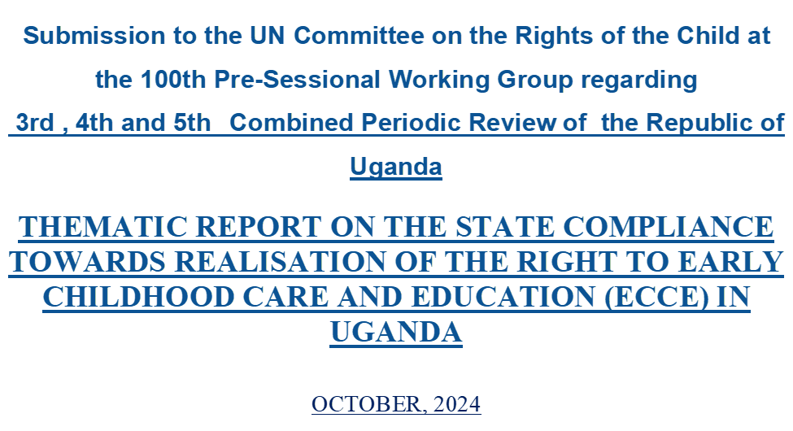

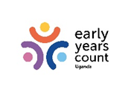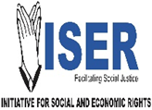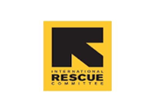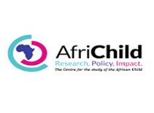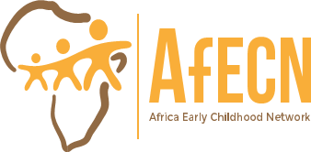

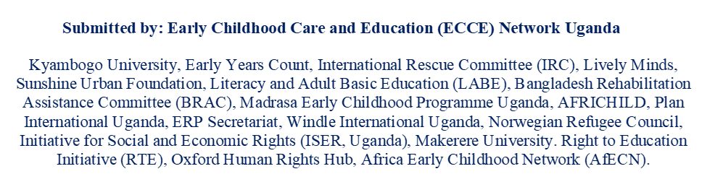

BACKGROUND AND CONTEXT

The Government of Uganda has made progress towards fulfilling its mandate of upholding the rights of the children since it ratified the UN Convention on the Rights of the Child (UNCRC) in 1990. The third, fourth and fifth combined report submitted by the State to the Committee on the Rights of the Child (Committee), outlines the measures taken and implementation status of the Committee’s recommendations pursuant to the Concluding Observations of 2005.
The report, however, has limited information about young children, in spite of the fact that they are entitled to all rights enshrined in the Convention. As reaffirmed by the Committee, early childhood is a critical period and the ‘Convention on the Rights of the Child is to be applied holistically’. In view of the State’s obligation to fulfil the rights of young children, this thematic report jointly prepared by civil society organisations aims:
- To share further information on the challenges faced by young children, especially to have equal, quality inclusive access and participation to early childhood care and education (ECCE) in Uganda and
- To suggest concrete recommendations towards ensuring the right of all children to quality ECCE services.
This report is structured as per selected four sub-clusters maintained by the Committee, that are relevant to the issues presented. Moreover, the Concluding Observations of 2005 of the Committee were revisited, referenced and acknowledged, alongside the combined 3rd, 4th and 5th Uganda State Report.

IMPLEMENTATION OF ECCE RIGHTS IN UGANDA

General Measures of Implementation

Key Issue 1 - Data Collection (paragraph 10, 11)
In the previous review the committee recommended that ‘the State party continues to strengthen its system of collecting disaggregated data as a basis for assessing progress achieved in the realisation of children’s rights and to help design policies to implement the Convention.’ The State reported that it has put in place a mechanism and system for routine data collection under the Orphans and Vulnerable Children (OVC) programme and Management Information system. Government collects data from all implementers of child rights, both governmental and non-governmental’ at all levels, from district and sub-county-based databases.

Yet, there is no adequate, disaggregated and quantitative data available on the implementation of children’s rights in early childhood, especially, on young children’s (3 - 5 years) access to quality ECCE services.

Uganda faces significant data paucity which makes it difficult to rely on, for assessment of coverage in pre-primary education. Data on coverage of pre-primary education vary considerably by source. Official data has not been collected since 2017, though a reform to the Education Management Information System (EMIS) by the Ministry of Education and Sports is underway, which should provide updated data on pre-primary education. The high level of informality in the ECCE sector is an important factor contributing to data challenges.

Moreover, the ECCE related indicators in data collection systems cover only aspects related to the number of ECCE centres and pre-primary schools licensed and registered. It does not cover other areas such as access, quality, availability of infrastructure resources, recruitment and training of ECCE personnel and adoption of standardised curriculum etc.

The Committee emphasised in its General Comment 7 (GC7), that States have to develop a system of data collection and indicators consistent with the Convention and with specific emphasis on early childhood. In view of this, the committee may inquire from the State: -

- What specific measures does the State take to collect the disaggregated data of children in early childhood?
- Are appropriate indicators included for assessing the coverage of early childhood care and education? Especially for measuring equal access and quality of pre-primary education in the new EMIS?

Civil Rights and Freedom

Key issue 2: Corporal Punishment (paragraph. 51 and 52)
The Committee recommended that the ‘State party explicitly prohibit by law all forms of corporal punishment in all settings, including in the family, the schools and alternative childcare, and implement those laws effectively’. Responding to this, the State reported that in 2006, the Ministry of Education and Sports banned corporal punishment in schools and disseminated a handbook on ‘Alternatives to Corporal Punishment’ to raise awareness of the ban.’ It also confirmed that ‘Corporal punishment was abolished for all persons under the Penal Code (Amendment) Act 8 (2007) and prohibited for children specifically under the Children (Amendment) Act 2016).

However, as acknowledged by the State, ‘there remain pockets of teachers who administer corporal punishment as a form of disciplining children or pushing them to work harder.’ In its report, the State assured that the Ministry of Education and Sports would take measures to implement the ban on corporal punishment in schools, as well as implementing the Strategic Plan on Violence against Children in Schools.

Despite the existing legal framework that bans corporal punishment, this practice continues to exist in many schools. In our opinion, these are the main reasons:
- Lack of enforcement mechanisms for the aforementioned laws, to hold accountable those who contravene the law.
- Inadequate awareness-raising campaigns and education for teachers, parents, law enforcement officers and other relevant stakeholders on the harmful effects of cultural practices, traditions and beliefs that perpetuate violence against children.
- The guidelines on the promotion of a safe learning environment in schools have not been contextualised to address the unique safety concerns and increased vulnerability faced by young children in pre-primary schools.
General Comment 8 provides that, “Challenging traditional dependence on corporal punishment and other cruel or degrading forms of discipline requires sustained action.’ The Committee may therefore, also emphasise the need to address cultural practices and traditional beliefs that perpetuate violence against children and may inquire from the State:
- Does the state have a clear enforcement mechanism in place for the implementation of the laws that ban corporal punishment in schools?
- What measures would the state take to protect children from abuse and violence in schools including ECCE centres/pre-primary, especially in educating the parents, communities, teachers, law enforcement officials and other stakeholders?

Family Environment and Alternative Care

Key issue 3: Family environment and parental guidance (paragraph 93 -96)
The Committee recommended that the State party strengthen and effectively implement its National Strategic Plan of Interventions for Orphans and Other Vulnerable Children for the years 2005/06-2009/10. In particular, the Committee recommended that the State party put more focus on effective programmes for children in vulnerable families.
In response, the State reported that the Children (Amendment) Act, 2016 obligates the government to put in place mechanisms and programs for child care and protection, and recommends the development of guidelines to promote more responsible parenting and the healthy growth of a child. Furthermore, the National Integrated Early Childhood Policy 2016 (NIECD) seeks to strengthen the government’s approach to ensure better coordination of efforts towards child development efforts that are fragmented across various sectors.
On this matter, the state has not addressed itself to the fragmented and isolated efforts by government departments and the private sector, resulting in the development of several parenting guidelines that contain conflicting information on parenting. There are parenting manuals developed by private practitioners and also three (3) developed by government agencies.
In addition, though parenting guidelines and standards have been developed by the Government, through relevant key sectors, given the various mandates, the proliferation of parenting guidelines has resulted in a fragmented support system for families with the youngest children.
The Convention provides that “State parties are required to render appropriate assistance to parents, legal guardians and extended families in the performance of their child-rearing responsibilities.” Such assistance as defined by GC7 includes provision of parenting education. Consequently, the Committee may raise the below questions to the State:
- Is there ongoing monitoring and evaluation of the delivery and impact of parenting programs at the home and community levels?
- What efforts have been made in strengthening the government's approach to achieve better coordination of child development efforts such as parental support programs?

Education, Leisure and Cultural Activities

Key issue 4: Financing Education (paragraphs 165 - 168)
In the last periodic review, the Committee recommended that ‘the State party, taking into account its general comment No. 1 (2001) on the aims of education, increases public expenditure on education, in particular pre-primary.’ Further, the committee recommended the State to undertake additional efforts to ensure access to informal education for vulnerable groups, including street children, orphans, children with disabilities, child domestic workers and children in conflict areas and camps, inter alia by eliminating the indirect costs of school education.’
However, the State report doesn’t indicate the percentage of total education budget allocated to pre-primary education, while it indicates the budget allotted for other levels of education. Similarly, the report also doesn’t indicate the specific funds allocated by the State to ensure access to informal education for vulnerable groups.
Considering the recommendations that the committee made to the State in the previous review and also taking into account the Tashkent Declaration that concurs on the importance of allocating a minimum of 10% of overall education budgets to pre-primary education, the Committee may point out the need to increase the budget allocation on ECCE.
In view of the Committee’s recommendation in General Comment 7 that ‘sufficient public investment’ is a crucial factor to achieve ‘comprehensive, strategic and time-bound plans for early childhood within a rights-based framework,’ the Committee may consider raising the following questions to the State:
- What percentage of the total education budget has been allocated to pre-primary education?
- Has the ECCE budget been adequate to provide quality and free pre-primary education to all children? Especially to the children belonging to vulnerable communities?
- How is the ECCE budget distributed amongst different ECCE institutions, programs, and regions and how does it affect access to quality ECCE?

Key Issue 5: Early Childhood Development (paragraph 169 -171)
In the last periodic review, the Committee recommended that the ‘State provide detailed information on the implementation of the early childhood education policy in its next periodic report.’The report presented by the State highlights the significant increase in the number of pre-primary schools and number of certified teachers and caregivers.

But, as clearly mentioned in the State report, 80% of these pre-primary centres are owned by private service providers and are located only in Urban areas. The state has NOT committed itself to building and strengthening public ECCE centres and pre-primary schools in the country.

The Education Act 2008 in section 10(2a) states that pre-primary education should be run by private agencies or persons. Providing education to children aged from two years to five years and the financing of that type of education shall be the responsibility of the parents or guardians.
In addition, the new ECCE Policy of 2024 in section 6.1(27) states that the government will only provide resources for children in vulnerable communities.

Similarly, the Social Services Implementation Manual of the PDM 2024 in section 3.4.2 states that, the Government shall not finance ECD but rather provide an enabling environment and regulations only.
Since ECD is dominated by the private sector, this excludes over 80% of the population who are poor and live in rural areas and is contrary to the State's commitment to the Convention, to provide equal and non-discriminatory access to education for all children.
Without adequate public ECD centres and pre-primary schools, the State will encounter challenges in fulfilling its commitment through Sustainable Development Goal 4.2 aimed to ‘ensure that all girls and boys have access to quality early childhood development, care, and pre-primary education so that they are ready for primary education’ by 2030.
Moreover, the State’s current position to provide ECCE only to vulnerable communities has the potential to be prejudicial and discriminatory towards other vulnerable groups, especially the urban poor who cannot afford private ECCE services.
In the Uganda Progress Report 2020, the government reported that efforts are underway to strengthen the monitoring and supervision of Early Childhood Development. Specifically, a monitoring Grant of UGX 2.3 billion was in place to facilitate local governments with the implementation of recommendations that come from the inspection of pre-primary and primary schools.

However, the ECCE system currently doesn’t have adequate regulatory framework and effective monitoring mechanisms. For instance, there are insufficient ECCE focal point officers; who are key for ECCE monitoring at the district level. Currently, ECCE work is mostly neglected since the assigned officials who in some cases have no ECCE training and are primarily responsible for other duties, tend to prioritise other assigned duties at the expense of ECCE duties.

Although, article 28 (right to education) of the Convention does not refer expressly to provisions with respect to early childhood; GC7 interprets ‘the right to education during early childhood as beginning at birth.’ Further, the Committee in GC7, recognized with appreciation that some States parties were '…planning to make one year of preschool education available and free of cost for all children.’ Accordingly, the Committee may inquire from the State on the below:

- Do laws/ policies on ECCE guarantee free pre-primary education? If yes, how many years of free pre-primary education?
- Are there adequate public ECCE centres/pre-primary schools available in both urban and rural areas?
- Are there any differences in accessing ECCE between rural and urban areas? Are these centres/pre-primary schools accessible for free?
- Do children from marginalised, disadvantaged, and vulnerable groups have equal access to ECCE?
- Are there laws and policies regulating the privatisation of ECCE and private ECCE centres/pre-primary schools?
- Is there an effective monitoring mechanism in place to monitor and supervise the private ECCE centres/pre-primary schools?
- Are fees and indirect costs to access private ECCE centres/pre-primary schools affordable to families from marginalised backgrounds?

Key Issue 6: Education on human rights and civic education (paragraph 200 -202)

In the previous review, the Committee recommended the reinforcement of adequate and systematic training of all professional groups working for and with children and that human rights education be included in the official curriculum at all levels of education.

The State reported that it has incorporated the teaching of rights to children in the curriculum for primary and secondary schools.

There is, however, no mention of curriculum compliance for pre-primary schools and no guidelines on what human rights content should be included in the ECCE curriculum for both personnel and children.

The Committee in GC7 recommended that ‘State parties include human rights education within early childhood education.’ For this reason, the Committee may raise the below questions to the State:
- Is there a policy commitment to include human rights education for young children (below 8 years) in home, community and centre-based programs and services?
- Have child rights concepts been integrated across the curriculum for ECCE?

RECOMMENDATIONS

The Committee may encourage the State to consider the following: -
- Providing separate funding for ECCE from primary education with a view of allocating resources towards the internationally agreed target of 10% of the total education budget.

- Making at least one (1) year of preschool education available and free of cost for all children by progressively appending government-funded ECCE units in every public primary school to utilise the resources already being spent to support underage children in such schools.

- Supporting ALL children including those with special needs in remote areas to enrol in home or community-based ECCE centres with child subsidies in places that don’t have government primary schools, as well as, empowerment and education of parents and other caregivers.

- Aligning legislative and policy provisions on ECCE specifically, through amending section 10(2a) of the Education Act 2008 to mandate the government to take on the responsibility of establishing public ECCE centres in the country, to guarantee the right of ALL children to early education.
- Establishing substantive ECCE focal point officers, an equivalent of inspector of schools in charge of ECCE, as the case for special needs or guidance officers to help coordinate ECCE data collection at district levels to inform the EMIS with disaggregated by age, gender and other at-risk or vulnerable groups.

- Effectively regulate the private educational sector, ensuring that all pre-primary or “nursery” schools and private primary schools with pre-primary classes are licensed, registered, have reasonable charges and are regularly monitored to ensure compliance with education law and standards.

General Comment No. 7 (2005): Implementing Child Rights in Early Childhood, par. 3
UNCRC Concluding Observations 2005 - Uganda, par. 23
Uganda 3rd, 4th and 5th Combined Report on the Rights of the Child , par. 10
Investing in the Future: A Cost-Benefit Analysis of Pre-Primary Education in Uganda | UNICEF Eastern and Southern Africa, pg. 18
General Comment 7(n1), par. 39
,UNCRC Concluding Observations 2005 - Uganda, par 40
Uganda Report (n3), par 51
ibid
Uganda Report (n3), par 52
General comment No. 8 (2006): The Right of the Child to Protection from Corporal Punishment and Other Cruel or Degrading Forms of Punishment (Arts. 19; 28, Para. 2; and 37, inter alia), par. 48
UNCRC Concluding Observations 2005 - Uganda, par. 42
Uganda Report (n3), par 96
One (1) by the Ministry of Gender with support from Makerere University; two (2) developed by the Ministry of Education titled “The Early Year's Experiences for 0-3years” and; One (1) parenting guide by the National Curriculum Development Centre.
Convention on the Rights of the Child, A.18.3 and A.18.4
General Comment 7(n1). par. 20(c)
UNCRC Concluding Observations 2005 - Uganda, par. 60
UNCRC Concluding Observations 2005 - Uganda, par. 60(a)
UNCRC Concluding Observations 2005 - Uganda , par. 60(c)
Tashkent Declaration and Commitments to Action for Transforming Early Childhood Care and Education (2022)
General Comment 7(n1), par. 38
UNCRC Concluding Observations 2005 - Uganda, par. 60(c)
Uganda Report (n3). par. 169
Parish Development Model
Uganda Report (n3), par. 171.
https://www.unicef.org/uganda/reports/ugandas-progress-report-committee-experts-rights-child, pg. 39
General Comment 7(n1), par. 28
ibid
UNCRC Concluding Observations 2005 - Uganda, par 25
Uganda Report (n3), par 200
General Comment 7(n1), par 33

