

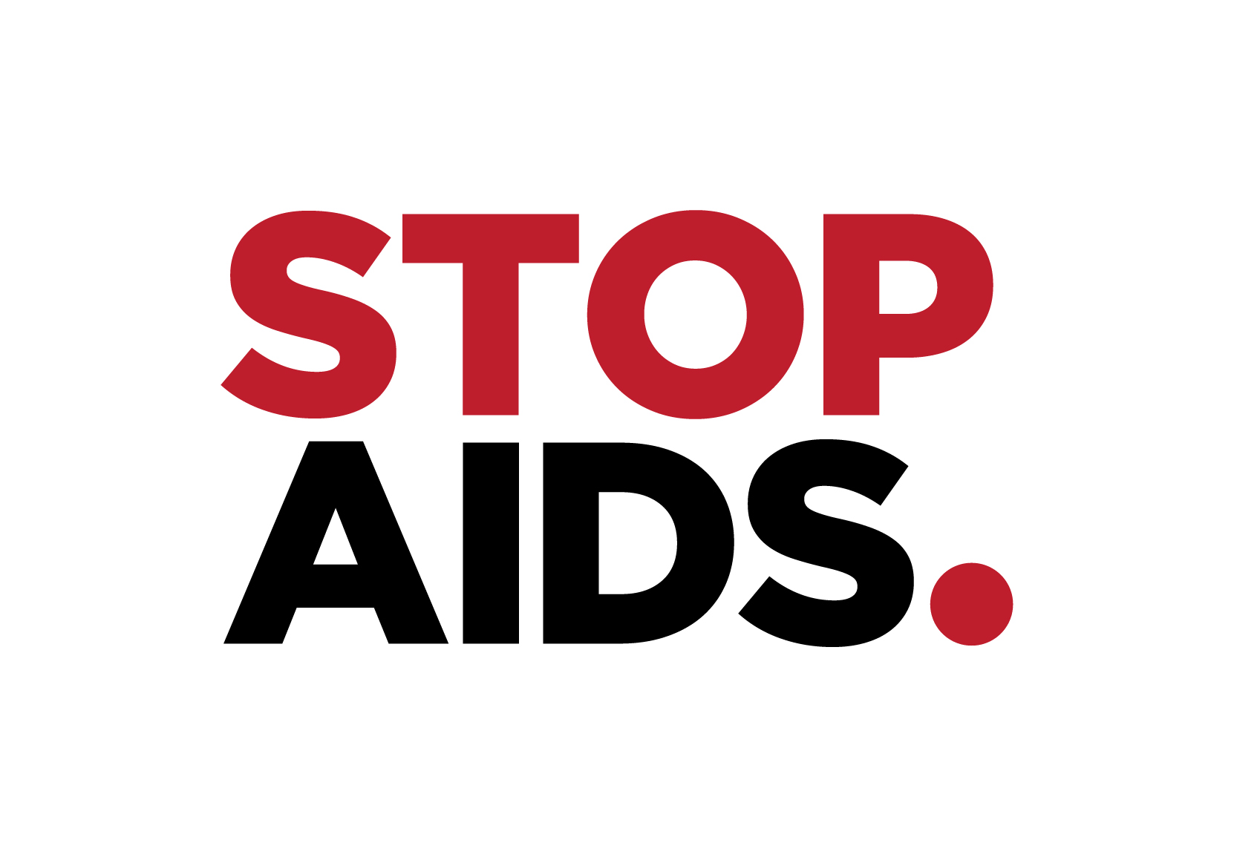

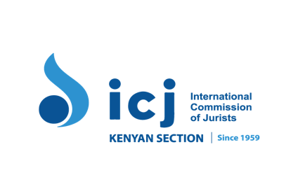

Joint submission in advance of the consideration of Kenya at the 77th session of the Committee on Economic, Social and Cultural Rights

January 2025

Introduction

This joint submission is ahead of the 77th Session of the Committee on Economic Social and Cultural Rights that will take place between 10 and 28 February 2025 in relation to the consideration of Kenya’s compliance with the International Covenant on Economic, Social and Cultural Rights (ICESCR.)

Privacy International (PI) is a global advocacy and campaigning group that works at the intersection of technology and human rights. PI campaigns against companies and governments who exploit our data and technologies. We expose harm and abuses, mobilise allies globally, campaign with the public for solutions, and pressure companies and governments to change.

The Digital Health and Rights Project (DHRP) consortium brings together international social scientists, human rights lawyers, health advocates, and networks of people living with HIV, to conduct research and advocate for rights-based digital governance in Colombia, Ghana, Kenya, Vietnam, and globally. We use a transnational participatory action research approach, centring the voices and leadership of diverse young adults to define the future of human rights in the digital age.

STOPAIDS is a UK-based membership network with a distinguished thirty-five year history of engagement on international development and HIV and AIDS. STOPAIDS convenes and unites UK civil society voices and positively shapes UK leadership in the global response to HIV and other health rights and equity issues, including as a member of the ‘Digital Health and Rights Project’.

The Kenya Legal & Ethical Issues Network on HIV and AIDS (KELIN) is a non-governmental organisation based in Kenya. Founded in 1994, KELIN advocates for a holistic and rights-based system of service delivery in health, and for the full enjoyment of the right to health by all, including vulnerable, marginalised, and excluded populations.

ICJ-Kenya (Kenyan Section of the International Commission of Jurists) is a non-governmental membership organization constituting a body of jurists drawn from members of the Bench and Bar in Kenya and the region. It is Africa's only autonomous national section of the International Commission of Jurists. ICJ Kenya has been working in Kenya and around Africa since 1959, and its mission is to promote human rights, democratic governance, justice, and the rule of law in Africa.

Haki na Sheria Initiative (HSI) is a non-governmental organization based in Garissa, Kenya dedicated to ending the discrimination and promoting the rights of marginalized communities in Northern Kenya. Some of the leading programmes of HSI include the citizenship programme which advocates for equal access to ID for all; digital rights that promotes digital literacy and focuses on bridging the digital divide and access to justice which is key in enforcement of all other human rights through community engagement, capacity buildings & trainings, research, advocacy, legal aid and public interest litigation.

Our submission will cover issues relating to Articles 2, 9, 11, and 12 of ICESCR.

- Digitalisation of essential services and social protection programmes (Articles 2, 9, 11)

Over the years in Kenya, like across many other jurisdictions, there has been a growing reliance on digital technologies for accessing and delivering public services and social protection programmes. These technologies are frequently used to identify beneficiaries, assess eligibility, distribute assistance, and purportedly combat fraud. While we recognise that certain technologies may enhance access to public services and social protection, we remain concerned by the associated human rights risks as detailed in the following sections.

- National Digital Identity Systems and its impact on the right to social security and an adequate standard of living

Kenya, like many countries, has been advancing its digital agenda by attempting to introduce a national digital ID system. In 2018, the Kenyan government tried to introduce the Huduma Namba project. The promulgation in January 2019 of the Statute Law (Miscellaneous Amendment) Act, 2018 (SLMAA) amended the Registration of Persons Act to enable the government to collect extensive personal data on Kenyans and registered foreigners in a national database including: land and house reference number, biometric data such as fingerprints, hand geometry, earlobe geometry, retina and iris patterns, voice waves and DNA in digital form. Amongst other initiatives, the Huduma Numba project established the National Identity Integrated Management System (NIIMS), a centralised database purposed to consolidate all government records about an individual into a single ID system. This system was developed without public consultation or adequate safeguards, and there were also concerns that this system could lead to the exclusion of vulnerable communities, including the Kenyan Nubian and Somali communities.

Towards the end of 2019, three petitions were filed at the Kenyan High Court challenging various aspects of the proposed NIIMS. The Kenyan High Court ruled that the system needed to be halted until there is "an appropriate and comprehensive regulatory framework on the implementation of NIIMS". It also found that the processing of GPS co-coordinates and DNA was intrusive and unnecessary for identification purposes, and concluded that the sections in the Registration of Persons Act requiring such collection, conflict with Article 31 of the Constitution and are unconstitutional, null and void. Unfortunately, the Court failed to address the issue of exclusion despite recognising the risks, and overall, the Court agreed that the processing of biometric data was necessary for the purpose of identification. Ultimately, the Court missed an opportunity to question the system's overall purpose and structure. Despite these shortcomings, the High Court’s judgement led to the Huduma Numba system being halted, and then ultimately dropped.

However, in early 2023 the government announced the implementation of a new ID system, the Maisha Namba, with a roll-out initially announced for October 2023. The term "Maisha Namba" refers to an identity ecosystem comprising four interrelated aspects: Maisha Namba, Maisha Card, Digital ID, and the National Population Master Register. Maisha Namba specifically refers to the Unique Personal Identifier assigned at birth registration, which will remain in use until death registration.

Similar to its predecessor, the Huduma Numba, the implementation of the Maisha Numba system was marred by significant flaws, including a lack of meaningful public participation and the recurrence of issues previously identified by the High Court in its judgment. Notably, the system lacks effective safeguards to prevent exclusion from social protection programmes (Article 9, ICESCR) and discrimination (Article 2, ICESCR). This is particularly concerning for individuals who face administrative and other systemic barriers that hinder their ability to register, further entrenching inequality and marginalisation. As a result, those excluded are denied access to resources necessary to ensure an adequate standard of living, violating their fundamental rights under Article 11 of the ICESCR.

Since the onset the Maisha Numba ecosystem has been repeatedly challenged in court by civil society organisations (CSOs) which has led to the registration being halted on several occasions.

ln December 2023, Haki Na Sheria Initiative filed a petition against the Government challenging the roll out of the Maisha Nama Digital Identity Ecosystem. Haki Na Sheria Initiative flagged potential violation of the Constitution, including of (i) the right to privacy given the vast processing of personal data the system would entail including extensive data sharing amongst government bodies and with the private sector, and (ii) discrimination against marginalised communities who have faced challenges to access citizenship rights including marginalized and minority communities, particularly in Northern Kenya, Coastal Kenya, and other rural areas that face regulatory and administrative challenges in the acquisition of national IDs, including secondary vetting and the inaccessibility of registration offices. Furthermore, the claimant argues that the system discriminates against the children of people from these communities as well as around 40,000 double-registered individuals who were erroneously registered as refugees despite being Kenyans, and who are now facing challenges to be able to be registered in the national identity system.

These concerns raised by Haki Na Sheria Initiative and the other petitioners are not new and have been recognised by Courts around the world, and also highlighted by the UN Secretary-General report on the role of new technologies in the realisation of economic, social, and cultural rights. The case is was due to be heard on 5th October 2024 but it was announced that the hearing has been adjourned until March 2025.

- Upholding the right to health in the context of the digital transformation in the health sector (Articles 2 and 12)

PI has documented how some key developments in Kenya’s health sector, as a result of the introduction of new technologies and wider implications associated with our increasingly digital societies, raise concerns in relation to the enjoyment of the right to health. As well as other human rights, including the right to privacy, dignity and autonomy, and the potential discriminatory impacts on specific communities including women, young people, persons living with HIV as well as LGBTIQ+ persons.

- The lack of effective regulation of health data and increasing innovation and technology in the health sector

Kenya, like many other countries, has seen an uptake in the use and implementation of digital health technologies from patient administration and hospital billing functions to management of clinical services to outpatients and wider electronic health (e-health) and mobile (m-health) initiatives rolled out by the Kenyan government as well by other third parties, including the private sector.

These have been deployed in an ineffective and fragmented regulatory and legislative framework with no specific legislation on digital health. As well as reports of weak enforcement of the existing Data Protection Act, 2019, in relation to regulating the processing of personal data, including health data.

As a result, civil society organisations in Kenya have called for the urgent need to effectively regulate the digital health sector to ensure people and their data are protected. The Digital Health Act (2023) was welcomed given the urgency to address the fragmented policy landscape despite some remaining shortcomings in the text. However, in July 2024 the Act was deemed unconstitutional by the Kenyan High Court for lack of adequate public participation, and it ordered Parliament to undertake an adequate, reasonable, sufficient and inclusive public participation as well as undertake a wider sensitization on the law itself before enacting it. As a result, Kenya’s legislative framework on digital health remains unsatisfactory, a concern compounded by the poor implementation of the Data Protection Act (2019) by actors deploying digital health initiatives, including the private sector.

- Ensuring availability, accessibility, acceptability and quality of health services mediated by digital technologies

The deployment of new technologies in the health sector in Kenya has raised some concerns relating to the availability, accessibility, and quality of health care provided by States as well as to ensuring that access is safe and secure and does not expose those seeking healthcare to harm, particularly those already marginalised, surveilled and criminalised.

Proliferation of private sector health apps - Kenya has seen significant uptake and deployment of health apps. In 2023 it was reported that at least 180 health apps were operating in Kenya. However, concerns have been raised as to how these apps are being deployed by startups and other private sector actors, and the implications for users and their rights given the weak enforcement of the Data Protection Act, alongside the fragmented regulatory regime as highlighted above concerning digital health.

Research by DHPR in Kenya has shown that young people raised concerns about private actors having access to information about them. They expressed a lack of clarity over how their data was processed and stored. Furthermore, in Kenya and Ghana, where abortion is restricted by law, young women asked focus group facilitators whether their searches for information about abortion could lead to either menstrual tracking apps or hostile organisations obtaining personal data and sharing it with the police.

Use of social media to access and provide health information and services - Social media is increasingly becoming a space for young people to seek and share information on health issues, in particular sexual and reproductive health and sexuality. Research undertaken by DHRP, revealed that young adults in Kenya reported predominantly using Google, social media, and social chat groups for seeking health information including advice on sexuality and sexual and reproductive health, and to access psychosocial support, treatment adherence advice, and coordinate medical and financial aid during Covid-19 restrictions.

Therefore, social media has filled a gap for some groups who may otherwise lack access to vital health information, and has empowered other communities such as women and young people to self-manage their healthcare. They have reported that it gives them anonymous access to HIV, Covid-19 and sexual and reproductive health information they urgently need, which they feel unsafe seeking elsewhere, including public run health centres, for fear of stigma and violence. Persons living with HIV, young men and women also reported being subject to harassment by a health care professional, and therefore these tools are considered safer and more accessible compared to attending healthcare facilities.

However, there are concerns about the accuracy of information provided and safety when using social media and other online applications to access health information. Participants in the research conducted by DHRP, also disclosed harms linked to seeking health information online including data mining, cyberbullying, and anxiety of surveillance, especially for young people living with HIV, key populations, and young women seeking information on sexual and reproductive health or access to safe medical abortion.

Furthermore, they are concerns about accessibility and digital exclusion as not everyone owns a smartphone or device to access this information. Therefore, sharing devices within a family remains very common practice and decreases the privacy and autonomy of users. Furthermore, the ability to afford increasing costs of data effects accessibility as well as language barriers as most social media and online platforms provide services in English only.

Surveillance of women and girls living with HIV: In 2023, KELIN carried out a study on the impact of HIV index testing on access to sexual and reproductive (S&R) health services among young women and girls in four sub-counties in Kisumu County. Study participants indicated that health care providers lacked training in data privacy and data security issues, and a need for more robust privacy and confidentiality protections of services, for example through encryption. These comments followed instances where there had been involuntary disclosure of service users’ HIV status during partner notification processes, as well as incidences where healthcare workers had breached confidentiality either involuntarily or voluntarily. As well as general concerns regarding who had access to their electronic medical record systems (EMR).

The study highlighted concerns around HIV Index testing, including documented practices of disclosure infractions undermining efforts to ensure safe and secure access to S&R health. A key recommendation of the study was to raise awareness about privacy and data protection responsibilities of healthcare providers, including their obligations under the Data Protection Act 2019 as well as the need to develop further regulation and guidance to protect people and their data in a healthcare context.

Safe access to accurate sexual and reproductive health - Despite an increasing number of people, in particular young people, accessing sexual and reproductive (S&R) health information and services online, research by DHRP has reported instances where people seeking information on S&R healthcare online in Kenya are concerned around accuracy of the information being shared as well as privacy and confidentiality.

- Recommendations

Based on these observations, we suggest the Committee on Economic Social and Cultural Rights include the following recommendations to the Kenyan government within their concluding observations:

- Review and amend the proposed digital identity system, the Maisha Numba, to ensure it aligns with Kenya’s national and international human rights obligations in its design and implementation, and adopts legal, policy and technical safeguards to prevent exclusion and marginalisation.
- Ensure that measures taken to develop digital public infrastructures abide by Kenya’s national and international human rights obligations including the right to social protection and the right to and adequate standard of living, and effectively regulate the involvement of the private sector in such initiatives.
- Ensure that there is an effective legal and regulatory framework in place to guarantee a human rights-based approach in the design and deployment of digital health technologies by the government and non-state actors which provides for the meaningful participation of affected communities and protects people’s rights to health, privacy, non-discrimination and equality
- Take steps to ensure that the necessary protections are in place for all, but in particular women and girls, persons living with HIV, and young people, to access sexual and reproductive health information and services safely and securely, and adopt a strong regulatory framework to protect the confidentiality and privacy of their data and health status including through the effective implementation of the Data Protection Act, 2019.

Privacy International, ‘Social protection programmes’, https://privacyinternational.org/learn/social-protection-programmes.
Privacy International, ‘Stage 3 - The policing of social benefits: punishing poverty’, 7 August 2019, https://privacyinternational.org/node/3114.
Privacy International, ‘The 'Identity Crisis' around the world’, 16 September 2023, https://privacyinternational.org/explainer/5126/identity-crisis-around-world.
Privacy International, ‘Data Protection Impact Assessments and ID systems: the 2021 Kenyan ruling on Huduma Namba’, 27 January 2022, https://privacyinternational.org/news-analysis/4778/data-protection-impact-assessments-and-id-systems-2021-kenyan-ruling-huduma.
Nation, ‘Nubian group opposes use of new ID system’, 28 June 2020. https://www.nation.co.ke/news/Group-opposes-use-of-new-ID-system/1056-4994288-pt4cru/index.html
See: http://kenyalaw.org/caselaw/cases/view/189189/
Privacy International, ‘Kenyan Court Ruling on Huduma Namba Identity System: the Good, the Bad and the Lessons’, 24 February 2020, https://privacyinternational.org/long-read/3373/kenyan-court-ruling-huduma-namba-identity-system-good-bad-and-lessons.
Namati, ‘Press Release: Huduma Namba Stopped!’, 31 January 2020, https://namati.org/news-stories/press-release-huduma-namba-stopped/.
See: https://www.kenyans.co.ke/news/92093-maisha-namba-govt-unveils-new-name-digital-id-after-signing-deal-un
See: https://www.kictanet.or.ke/understanding-maisha-namba-kenyas-new-digital-identity-system/).
See: https://nation.africa/kenya/news/high-court-puts-the-brakes-on-kindiki-s-plan-to-introduce-maisha-namba-4454474,https://itweb.africa/content/raYAyqorp3pMJ38N,https://nation.africa/kenya/news/high-court-stops-implementation-of-maisha-card-4702756; https://www.the-star.co.ke/news/2024-08-12-court-rescinds-earlier-orders-blocking-maisha-namba-rollout.
See: https://drive.google.com/file/d/1gROLgdLyJJLifgtjM39MPMEPtyT27yTE/view
See: https://drive.google.com/file/d/1ziw6aEqHdAL5Ly7Ct51TA_CN-ZaX-XAp/view; https://privacyinternational.org/video/4412/when-id-leaves-you-without-identity-case-double-registration-kenya
Privacy International, ‘A Guide to Litigating Identity Systems’, https://privacyinternational.org/learning-resources/guide-litigating-identity-systems.; A/HRC/43/29 Human Rights Council, Report on the role of new technologies for the realization of economic, social and cultural rights’, 5 March 2020, para 33, https://www.ohchr.org/en/documents/reports/ahrc4329-report-role-new-technologies-realization-economic-social-and-cultural.
A/HRC/53/65: Human Rights Council, ‘Digital innovation, technologies and the right to health’, 21 April 2023, https://www.ohchr.org/en/documents/thematic-reports/ahrc5365-digital-innovation-technologies-and-right-health.
Privacy International, ‘Digital Health: what does it mean for your rights and freedoms’, July 2024, https://privacyinternational.org/long-read/4671/digital-health-what-does-it-mean-your-rights-and-freedoms; See: https://www.graduateinstitute.ch/DigitalHealth-Rights.
Government of Kenya, Third Medium Term Plan 2018 – 2022, https://vision2030.go.ke/publication/third-medium-term-plan-2018-2022/ ; Transform Health Kenya, ‘Landscape Analysis of Digital Health & Universal Health Coverage in Kenya’, April 2022, https://www.kelinkenya.org/wp-content/uploads/2023/01/Landscape-Analysis-of-Digital-Health-Universal-Health-Coverage-in-Kenya-00000003.pdf; Some examples of initiatives which have been deployed include: the District Health Information System (DHIS2), https://dhis2.org/ ; the OpenMRS for managing TB and HIV programmes in smaller clinics, and the Kenya Master Health Facility List (KMHFL, https://kmhfr.health.go.ke/; More information https://dhis2.org/; mTiba, a health wallet, https://www.vodafone.com/digital-society/safaricoms-m-tiba; Maisha Meds, https://maishameds.org/; TransformHealth Kenya, ‘Landscape Analysis of Digital Health & Universal Health Coverage in Kenya’, April 2022, https://www.kelinkenya.org/wp-content/uploads/2023/01/Landscape-Analysis-of-Digital-Health-Universal-Health-Coverage-in-Kenya-00000003.pdf.
Digital Health and Rights Project Consortium (2022) Digital health and rights of young adults in Ghana, Vietnam, Kenya: final project report, page 3 and 19, https://repository.graduateinstitute.ch/record/300591?_ga=2.99187678.1735834843.1682602161-345088509.1672743223&v=pdf
KELIN, ‘Harnessing the Power of Digital Health Technologies to Transform Healthcare Delivery in Kenya’, 9 August 2023, https://www.kelinkenya.org/harnessing-the-power-of-digital-health-technologies-to-transform-healthcare-delivery-in-kenya/
See: CIPESA, ‘Does Kenya’s Digital Health Act Mark A New Era for Data Governance and Regulation?’, 3 May 2024, https://cipesa.org/2024/05/does-kenyas-digital-health-act-mark-a-new-era-for-data-governance-and-regulation/; KICTANET, ‘Kenya’s Digital Health Act: A Leap Forward in Data Governance’, 24 October 2023, https://www.kictanet.or.ke/kenyas-digital-health-act-a-leap-forward-in-data-governance/
ICJ Kenya, ‘Case Summary – Unconstitutionality of Social Health Insurance Act, Primary Health Care Act, Digital Health Act’, 2024, https://icj-kenya.org/news/sdm_downloads/case-summary-unconstitutionality-of-social-health-insurance-act-primary-health-care-act-digital-health-act/
KELIN, ‘Harnessing the Power of Digital Health Technologies to Transform Healthcare Delivery in Kenya’, 9 August 2023, https://www.kelinkenya.org/harnessing-the-power-of-digital-health-technologies-to-transform-healthcare-delivery-in-kenya/
See: https://www.graduateinstitute.ch/DigitalHealth-Rights.
Kabui Mwangi, Number of Kenyans seeking digital health treatment rises, study shows, 2 May 2024, Business Daily, https://www.businessdailyafrica.com/bd/corporate/health/number-of-kenyans-seeking-digital-health-treatment-rises--4611174
See: A/HRC/53/65, para 59.
Digital Health and Rights Project Consortium, ‘Digital health and rights of young adults in Ghana, Vietnam, Kenya: final project report, https://repository.graduateinstitute.ch/record/300591?_ga=2.99187678.1735834843.1682602161-345088509.1672743223&v=pdf
Ibid.
See: A/HRC/53/65, para 5 and 54.
See: Digital Health and Rights Project, https://warwick.ac.uk/fac/cross_fac/cim/research/digital-health-rights/; Digital Health and Rights Project, ‘Digitalisation, Health and Participation: a Brief on Kenya’, page 4, https://warwick.ac.uk/fac/cross_fac/cim/research/digital-health-rights/publications/dhrp_-_kenya_final_version.pdf; Digital Health and Rights Project Consortium (2022) Digital health and rights of young adults in Ghana, Vietnam, Kenya: final project report, page 13 and 15, https://repository.graduateinstitute.ch/record/300591?_ga=2.99187678.1735834843.1682602161-345088509.1672743223&v=pdf.
Ibid, page 14.
Ibid, page 13-14.
Digital Health and Rights Project Consortium (2022) Digital health and rights of young adults in Ghana, Vietnam, Kenya: final project report, page 17, https://repository.graduateinstitute.ch/record/300591?_ga=2.99187678.1735834843.1682602161-345088509.1672743223&v=pdf
Ibid, page 16.
Kisumu was selected because it is among the 4 counties with the highest HIV prevalence rates in the country and is regarded as one of the key counties in need of intensified focus to prevent new HIV infections.
KELIN (2023) Impact of HIV index testing on access to sexual and reproductive health (SRH) services for young women and girls in Kenya: A participatory action research study, Research report, https://www.kelinkenya.org/wp-content/uploads/2023/04/HIV-Index-Testing-Research.pdf
Ibid, page 35-36.
Ibid, page 39.
KELIN (2023). Impact of HIV index testing on access to sexual and reproductive health (SRH) services for young women and girls in Kenya: A participatory action research study. Research report, page 47-48. https://www.kelinkenya.org/wp-content/uploads/2023/04/HIV-Index-Testing-Research.pdf
Macharia P, Pérez-Navarro A, Inwani I, Nduati R, Carrion C. An Exploratory Study of Current Sources of Adolescent Sexual and Reproductive Health Information in Kenya and Their Limitations: Are Mobile Phone Technologies the Answer? International Journal of Sex Health, 16 May 2021, 33(3):357-370, https://www.ncbi.nlm.nih.gov/pmc/articles/PMC10929578/; Privacy International, ‘Country case-study: sexual and reproductive rights in Kenya’, 4 June 2020, https://privacyinternational.org/long-read/3859/country-case-study-sexual-and-reproductive-rights-kenya; Digital Health and Rights Project Consortium (2022) Digital health and rights of young adults in Ghana, Vietnam, Kenya: final project report, https://repository.graduateinstitute.ch/record/300591?_ga=2.99187678.1735834843.1682602161-345088509.1672743223&v=pdf

