Ukraine

Submission to the UN Committee on Human Rights on the VIII Cycle State Party Report of Ukraine on Implementation of the International Covenant on Civil and Political Rights

The Ukrainian Helsinki Human Rights Union (UHHRU) is the largest association of human rights organizations in Ukraine, which unites 27 human rights NGOs. The Union contributes to the development of a humane society based on respect for human life, dignity and harmonious relationship between man, nature and the state through the creation of a platform for cooperation between members of the Union and the other members of the human rights movement.
04070, Kyiv, Frolivska street, 3/34
Office phone +38 044 485 17 92; fax +38 044 245 99 24.
www.helsinki.org.ua, е-mail: office@helsinki.org.ua

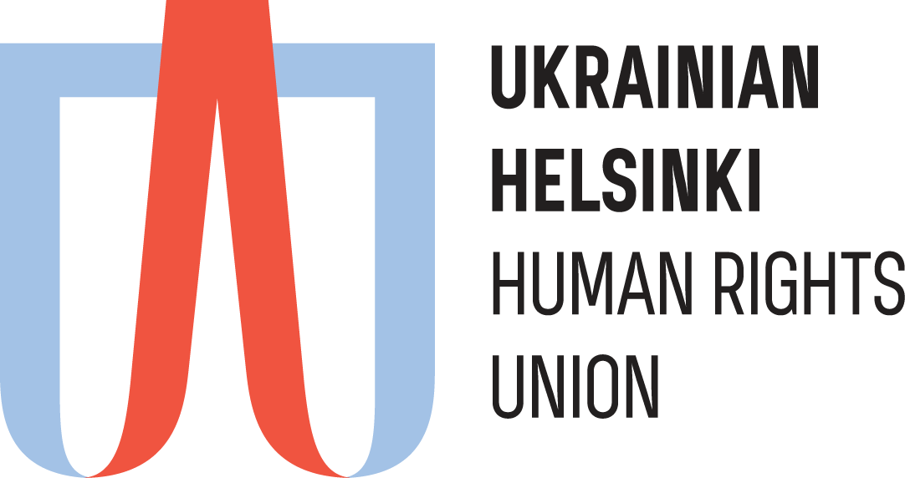

JustCraft is a Ukrainian non-Governmental informal initiative focused on strategic human rights litigations both at a national level and before a wide range of international institutions (ECtHR, UN Human Rights Committee, etc). A large part of work is devoted to the protection of human rights in the context of the occupation of the Crimean Peninsula by the Russian Federation.

www.justcraft.org
www.occupied.crimea.ua
Tel.: +38(050)4023025


Issue 1. Constitutional and legal framework in which the Covenant is implemented (art. 2)

- The legal status of internally displaced persons (IDPs) in Ukraine introduced in 2014 still has not been brought in line with international law, in particular with the UN Guiding Principles on Internal Displacement.
- In accordance with the Principles, the belonging of a person to the category of IDPs is a matter of fact. The status provides such persons with additional protection due to their vulnerable situation.
- In Ukraine, however, the IDP status is a legal status granted by the state. The absence of this status, coupled with belonging to territories that are temporarily outside the Government’s control, entails restrictions of certain rights as well as additional responsibilities, and sometimes additional responsibilities or restrictions still apply even with said status.
- This concerns, in particular, freedom of movement, when IDPs may not be absent from their permanent place of residence for more than 60 days under the threat of losing their IDP status (see part 1, Article 12 of the Law of Ukraine “On Ensuring the Rights and Freedoms of Internally Displaced Persons”). There’s also a verification procedure for recipients of social benefits which requires regular, every other month, visits to a bank in order to prove that the person is actually staying at their place of residence.
- Another issue regards Ukrainian citizens who stayed in the temporarily occupied territories.
- The Government’s comments on the registration of births that take place in the temporarily occupied territories are misleading in regards to the real situation (see paragraph 7 of the information provided by the Government). Ukrainian law establishes excessive twofold control over this procedure. The procedure for applying to court for having a birth registered is complicated but also insufficient on its own. The courts usually deny such applications unless the applicant first gets denied by civil registration authorities (CRA). Thus, before going to court, it’s necessary to apply to the CRA first and go through the official administrative procedure and obtain a refusal to register the birth. Subsequently, after securing the court decision, one must go to the CRA once again. Thus, instead of going to court with disputed cases only and having the majority of births registered by the CRA upon initial application, each applicant must apply to the state authorities three times. Since the courts often ignore their duty to give priority to such cases and given that the Ukrainian citizens submitting these applications live in the NGCA, this creates additional difficulties for them due to the need to travel away from the NGCA, often for long periods of time.
- In fact, this approach contradicts to the so-called ‘Namibia exception’, stipulated by the ICJ advisory opinion On Legal Consequences for States of the Continued Presence of South Africa in Namibia (South West Africa) notwithstanding Security Council Resolution 276 (1970). According to it, mutatis mutandis while official acts performed by the Russian Government as regards the temporarily occupied territories are illegal and invalid, this invalidity cannot be extended to those acts, such as, for instance, the registration of births, deaths and marriages, the effects of which can be ignored only to the detriment of the inhabitants of the Territory (see para 125).
- Thus, the Government’s actions not only fail to remove the negative consequences suffered by its citizens as a result of Russia’s armed aggression (IDPs in particular) but also exacerbate their situation by introducing additional legal requirements and restrictions.

Issue 2. Constitutional and legal framework in which the Covenant is implemented (art. 2)

- Ukraine has no mechanism for reviewing decisions of domestic courts when the UN Human Rights Committee finds them to be in violation of the Covenant. As a result, the Supreme Court denies such applications, unlike similar applications that get submitted on the basis of judgments of the European Court of Human Rights.
- A recent example of this is the decision of the Grand Chamber of the Supreme Court of Ukraine dated 18 September 2018, case No. 13-53zvo18. Its text can be found in the Single State Register of Court Decisions at this link http://reyestr.court.gov.ua/Review/76615349.
- The Government has also failed to take measures to remedy the violation of the Covenant in the case of Oleksiy Katashynsky v. Ukraine (communication no. 2250/2013). In particular, the Government has failed to provide just compensation, including reimbursement of court fees and non-pecuniary damages, as required by the Committee.
- Thus, the Government has failed to implement an effective mechanism for ensuring compliance with its commitments under the Covenant in regards to violations found by the Committee in individual cases.

Issue 15. Freedom of movement (art. 12)

- The measures introduced in Ukraine that concern restrictions on freedom of movement include temporary prohibition of leaving Ukraine for debtors that have not complied with appropriate court decisions. Such prohibitions are usually imposed on the basis of a court decision and can last indefinitely. Once the person fulfills the decision, they still have to secure permission to have the ban lifted. Ukrainian law also stipulates that persons banned from leaving Ukraine may also be denied entry to the Crimean Peninsula.
- Being acceptable to persons residing in the territory under the Government control, this situation is especially difficult for Ukrainian citizens living in the temporarily occupied territory of the Crimean Peninsula, as they are still subject to decisions banning them from leaving Ukraine that had been issued before the occupation. This has a significant impact on their freedom of movement: having traveled outside the temporarily occupied territory to the mainland of Ukraine, they find themselves unable to return home to the temporarily occupied territories. The threat of being unable to return for an indefinite period of time often discourages them from leaving the Crimean Peninsula in the first place. It also serves as a deterrent for others who merely suspect that they are subject to said prohibition.

Issue 17. Right to privacy (art. 17)

- At the end of 2019 the Government launched a mobile application called ‘Diya’, which only works on a smartphone and requires authentication.
- The application aggregates electronic copies of citizens’ key documents (documents on car ownership, driving licenses, Ukrainian passports for traveling abroad, new national passports in the form of an ID card, etc.). The Government plans to keep expanding the list of documents included in the ‘Diya’ application.
- The fact that all these documents with personal data are stored in one application poses a significant threat to people’s privacy.
- The Government has given no information as to security measures used in the application, or what authorities and in what manner have access to the data stored by the application and what measures have been taken to prevent abuse.
- A similar application is used to monitor individuals placed under observation to prevent the spread of COVID-19. Thus, according to available information, this application monitors the location of the mobile device, and the owners must also use the application to take pictures of themselves to confirm their identity, sending those to “regulatory authorities”.
- In early May 2020 personal data of citizens was leaked and offered for sale through a channel called UABazaBot. Using a person’s last name, first name and patronymic or a mobile phone number, it was possible to get a lot of personal information about them for a small fee. Although some of this information probably belonged to third parties (in particular the Nova Poshta courier service), it’s likely that government agencies were the original owner of most of that information.
- Thus, the Government has failed to ensure proper protection of personal data of its citizens as well as to conduct a thorough investigation of the leak.
- There have also been instances of public authorities deliberately disseminating personal data of Ukrainian citizens. Thus, when a person that used to live in the temporarily occupied territory of the Autonomous Republic of Crimea or Sevastopol applies to the Pension Fund of Ukraine to have their pension resumed, the Pension Fund sends an inquiry to the Russian government to find out whether that person was receiving a pension from the Russian Federation in the temporarily occupied territory. Said inquiries contain the applicant’s personal data, which puts people at risk. In particular, there have been cases of information about a person's participation in the Anti-Terrorist Operation in eastern Ukraine being disclosed in such a way.
- There were also incidents when Ukrainian authorities would spy on lawyers representing defendants in high-profile cases, such as lawyer Oleksandr Shadrin who is widely known for undertaking such cases. In 2015-2019 he noticed instances of both direct surveillance as well as collection of information about his cellphone communications. He also faced such interference with his professional activities as threats and arson of his car. Despite reports to law enforcement concerning these incidents, often accompanied by important information about the circumstances of the crimes, there has been no proper investigation.
- At the end of August 2018 investigators from Ukraine’s Prosecutor General's Office received a court order to access information on cellphone communications of Nataliia Sedletska, editor of Radio Free Europe/Radio Liberty's program Schemes (see details in the section on freedom of expression in the context of protecting journalistic sources). This information was held by the Kyivstar mobile operator. It’s currently unknown what information exactly was provided to the investigators. Nataliia Sedletska sent inquiries to the Prosecutor General's Office and Kyivstar to find that out but was denied in both cases. Her court appeal against this also proved futile.
- Disclosing said information would also constitute disclosure of journalistic sources. The details of this case are given in the Judgment of the ECtHR of 1 September 2021 in case no. 42634/18 Nataliia Sedletska v. Ukraine.
- Thus, the authorities are not only violating the right of Ukrainian citizens to privacy but also deprive them of an opportunity to at least learn who and how gains access to their personal information. These actions also indicate an existing threat to those providing socially significant information in Ukraine, discouraging people from speaking out and negatively affecting the overall situation with freedom of speech in Ukraine. As regards the lawyer, the facts mentioned above also means a violation of fair trial standards.

- Issue 20. Freedom of conscience and religious belief (art. 18)

- In December 2018 the Autocephalous Orthodox Church of Ukraine (OCU) was established in Ukraine, which started the transfer to the OCU of parishes of other religious organizations of Orthodox churches that existed in Ukraine.
- This is an important process for religious freedom and it was possible, among other things, due to legislative changes. At the same time, the OCU, as a newly established religious organization, is still in its infancy and is therefore vulnerable.
- The decisions of religious communities (parishes) to join the OCU were recognized by all religious communities (Orthodox churches) in Ukraine (Ukrainian Orthodox Church of the Kyiv Patriarchate, Ukrainian Autocephalous Orthodox Church, etc.), except for the Ukrainian Orthodox Church of the Moscow Patriarchate (UOC-MP).
- Most of the religious communities being transferred from the UOC-MP to the OCU belong to religious minorities in their respective settlements and often form a single Orthodox community in their region. Under these conditions, the state’s duty to ensure the existence of religious minorities is particularly important.
- Ukrainian courts in various regions are currently examining over 50 lawsuits concerning the transfer to the OCU of parishes that previously belonged to the UOC-MP.
- At the same time, the judges considering this category of cases are not always impartial. In particular, a judge's affiliation with a particular religious denomination can influence their decision. The Government has done nothing to prevent such incidents. As a result, Ukraine still has no unified case law when it comes to such cases and has thus been unable to ensure the protection of religious minorities. In the cases regarding freedom of religion a special court declaration that the court does not belong to any of the religious communities can be a proper guarantee of impartial judicial activity. At the same time, or guarantee the right to freedom of religion of the highest court, it may be suggested that insane justice declare resignation (resignation) without cause.

Right to life, prohibition of torture and other cruel, inhuman or degrading treatment (arts. 2, 6, 7 and 14)

- The reform of the National Police and pre-trial investigation bodies launched in 2015 has had both positive and negative consequences. It has reduced the frequency of unjustified violence and abuse of power among the police, even though these practices have not been eradicated completely.
- At the same time, the reform of pre-trial investigation bodies has led to the loss of many specialists, which reduced the quality of work of these bodies. It manifests, in particular, in failure to investigate such incidents as deaths resulting from traffic accidents or unjustified violence against persons held in places of detention (not just in penitentiary institutions but also in psychoneurological institutions and geriatric nursing homes as well as other institutions with various security regimes).
- In spring 2020, the Minister of Justice of Ukraine made a statement that the Government of Ukraine intends to develop special software with artificial intelligence (AI) for using in criminal judicial proceedings to improve the quality of courts' decisions. Implementation of AI into judicial proceedings creates a threat of a mass violation of the right to fair justice. On the one hand, there is a risk of manipulation with input data and algorithms that are a basis for the conclusions of AI. On the other hand, there is a risk of complete replacement of judges' decisions with decisions of AI with no person responsible for them.

Recommendation
- Avoid any measures that can undermine the adversarial character of the criminal process in Ukraine or result in replacement of judges' decisions with decisions of AI.

Issue 1
Simplify the procedure of registration of births of persons that are born in the temporarily occupied territories.

Issue 2
Amend legislation in order to implement the Committee's Views in the cases that regard Ukraine through review of the judgments of the national courts' by the Supreme Court or another judicial body and provide other means of compliance with the Views as regards individual measures.

Issue 15
Ensure freedom of movement of residents of Ukraine inside of the State borders regarding persons residing in the temporarily occupied territories.

Issue 17
Ensure protection of privacy of all persons that are under the jurisdiction of Ukraine, especially journalists and lawyers, including informing them about all cases when someone has access to their personal data and investigate all cases of illegal access to personal data.

Ensure effective investigation of all cases of illegal surveillance of journalists, lawyers and other persons

Issue 20
Provide control over the judicial processes that regard inter-Churches disputes in Ukraine in order to guarantee consideration of the cases by an independent and impartial court.

- In cases that raise an issue of changing canonical affiliation or other disputes between religious communities, to establish a procedure for judges to submit a declaration specifying that he/she does not belong to any of the religious communities involved in a case or secure the right of a judge to resign without any further explanations as an alternative to submitting the mentioned declaration.

Issue 21
Amend legislation to increase the protection of journalists' sources in Ukraine.

