United Nations Human Rights Committee 110TH Session (10 – 28 March 2014) Consideration Of The Fourth Periodic Report Of The United States Of America Under Article 40 Of The International Covenant On Civil And Political Rights
UPDATES TO THE INDIGENOUS PEOPLES CONSOLIDATED ALTERNATIVE REPORT [Originally Submitted September 13, 2013]
February 3, 2014
Contact: Danika Littlechild, Legal Counsel International Indian Treaty Council
Cell phone: +1(780)312-0246 2940 16th Street, Suite 305
danika@treatycouncil.org San Francisco CA 94103
Office phone: (415) 641-4482
Office fax: (415) 641-1298

Introduction
The International Treaty Council (IITC) et. al. provides these brief updates to our original submitted Indigenous Peoples’ Consolidated Alternative Report (September 13, 2013) to be raised in the review of the United States of America’s (“US”) compliance as a State Party to the International Covenant on Civil and Political Rights (ICCPR).
The review of the US, originally scheduled for the Human Rights Committee's 109th Session, was postponed until the 110th Session (due to the US government shutdown in the fall of 2013). We are providing updates that cover developments having taken place since that postponement.
Of the twenty-eight (28) Submissions addressing specific critical cases in the original submitted Indigenous Peoples’ Consolidated Alternative Report (September 13, 2013), three (3) of those cases require brief updates for the benefit of the Human Rights Committee Review of the US.

- Case C: Chickaloon Native Village
- Case G: Kónitsąąíí Ndé and Cúelcahén Ndé (Big Water People Clan; Tall Grass People Clan), Lipan Apache Women Defense & the Lipan Apache Band of Texas
- Case I: Muscogee (Creek) Nation and Hickory Ground Tribal Town (including an Attachment to the Update, enclosed)
We respectfully draw the Committee’s attention to the Questions for the US and the Recommendations for the US which were detailed in Section 1 of our original submitted Indigenous Peoples Consolidated Alternative Report (September 13, 2013), and thank the Committee for their kind consideration of the Updates to that Report contained herein.

Case Submission Updates (using the same alphabetized order provided in the original submitted Indigenous Peoples’ Consolidated Alternative Report, Section II)

Case C: Update from Chickaloon Native Village
Contact: Lisa Wade, Council Member and Health & Social Services Director P.O. Box 1105 Chickaloon Village Traditional Council
Human rights are at serious risk of being diminished by State of Alaska leaders and legislative initiatives. Not only has Governor Parnell challenged laws supporting rural subsistence hunting and fishing, several bills in the House of Representatives and Senate have recently been introduced which will have dire consequences for Alaska’s indigenous peoples.
On January 8, 2013, Alaska State Governor Sean Parnell introduced legislation related to the Alaska Land Act. The legislation was aimed specifically at streamlining State of Alaska Department of Natural Resources (DNR) permitting processes. It was drafted without formal government consultation with the 229 federally recognized Tribal Governments in the State of Alaska. Furthermore, it was designed in such a manner as to reduce public participation in permitting actions and strip away vital existing public rights resulting in potentially devastating impacts to subsistence food sources and cultural and spiritual practices.
Provisions of the legislation grant the Commissioner of the DNR ultimate authority to ignore “any other provision of law” and to grant general permits authorizing any activity on state land that the commissioner decides is “unlikely to result in significant AND irreparable harm to state land or resources.” It neglects to adequately clarify and describe ‘irreparable harm.” Other provisions narrow how the public can participate in, and appeal, DNR decisions as well as requires that the public bare the burden of showing how they have been “substantially and adversely impacted” by DNR permitting decisions in order to take legal action. Two other pieces of legislation are pending designed which would limit public participation on large industrial projects and require bonds for challenging these projects.
One provision of great concern to Chickaloon is the stripping away of the existing right of Tribes to file for in-stream flow or water reservations. Chickaloon has had an existing application on file with the State of Alaska for Moose Creek since 2009. This application is part of Chickaloon’s ongoing remediation efforts to enhance and protect vital salmon rearing habitat in our traditional and customary use area after previous coal mining operations damaged critical salmon habitat. Should this legislation pass the Senate, our application on file would be thrown out and we would loose the ability to ensure that our sacred salmon and moose have adequate water reserves in which to survive.
House Bill 77 passed the House of Representatives on March 4, 2013; however, it stalled in the senate after Tribal and public opposition. It is presently being considered in the current legislative session. If passed, this legislation is an assault on the human rights of Alaska’s indigenous peoples and our Tribe. The impacts would manifest as resource extraction projects were expedited with limited recourse for protecting our traditional and customary use areas and our people from these projects.

Case G: Update from Kónitsąąíí Ndé and Cúelcahén Ndé (Big Water People Clan; Tall Grass People Clan), Lipan Apache Women Defense & the Lipan Apache Band of Texas
Update regarding: Ndé Religious Freedom and the Rights of the Indigenous Girl-Adolescent in the Texas-Mexico international border region Contact: Margo Tamez, spokesperson and co-founder, Lipan Apache Women Defense, margo.tamez@gmail.com
This update highlights the case of Ch’eeké Ikék ejagał, adolescent Ndé girls, who are being obstructed from practicing the Isanaklesh Gotal coming of age ceremony in the lands of their maternal and matrilineal society. Ch’eeké Ikék ejagał’s maternal ties to customary lands are overly constrained by the state’s non-recognition of the Lipan Apache Band of Texas, and by the current-day U.S. militarized occupation of the lands currently divided by the border wall along the Texas-Mexico international region.
The Ndé have attempted to obtain formal authorization to practice the coming of age ceremony from the state of Texas for use of their traditional lands currently under the jurisdiction of the Texas Parks system, and from private land owners who currently fence-off Ndé customary lands. According to hereditary chief Daniel Castro Romero, Ndé have been refused by current occupants of their traditional lands to conduct this ceremony in the traditional manner. According to Ines Talamantez, an elder with specialized knowledge in this ceremony, it requires an 8-day fire near a clean river in the Ndé customary traditional lands, carefully performed under the careful guidance of knowledgeable spiritual leaders trained in this ceremonial. Of critical importance and urgency, all Apache knowledge keepers know this ceremony is a crucial act of making sacred relationships and connections to ancestral belonging, and ongoing forms of making sacred connections with Isanaklesh and Ussn “in the space between earth and sky.”
Structural barriers are creating a serious impediment to the unimpeded practice of the traditional Isánáklesh Gotal ceremony. The Ndé adolescent girl is now struggling to achieve/receive her ceremonial rite of passage, Isánáklésh Gotal, the transformative ritual which structures the celebratory change and rite of passage from youth to womanhood. Being Ndé requires and obligates Ndé to enact, practice, celebrate and transmit this crucial ceremony for their daughters. This core tradition relates the oral tradition, creation stories, history, food systems, ecology, and kinship relations known in their traditional and customary lands, Kónitsąąíí gokíyaa (Big Water Peoples’ Country). The structural impediments to knowledge transfer from the Nadekleshen god mother (Elder Female Sponsor) to Ch’eeké Ikék ejagał seriously threatens the survival of Ndé life ways to future generations. The layers of procedural and administrative denials of recognition is a key concern. Lack of recognition and denial of Ndé self-determination by Texas and the U.S. is severely impeding the Ndé from exercising fundamental rights to religion, identity, and membership as a Band of the larger Apache Nation.
Being obstructed from holding her ceremony in her maternal territory, prevented from participating in the crucial induction into the greater Apache world, and prevented from being held in high regard as “an exemplary Apache woman”, according to elder Inés Talamantez, is a severe loss for a young Ndé female’s core social identity in a world with increasing insecurity for Indigenous Peoples. The state’s obstructions to the Ndé peoples’ continued existence in the Texas-Mexico border region takes on a salient, negative character given that the religious practice of the Isanaklesh Gotal is a crucial link for the continuance of the Ndé creation story, oral history and knowledge which are necessary for a girl’s clan system and the futurity of Ndé identity and being for her generations to come.

Case I: Update from Muscogee (Creek) Nation and Hickory Ground Tribal Town
Update regarding: The United States Government’s Failure to protect Hickory Ground Sacred Area Contact: Brendan Lutwick, Attorney brendan@lutwick.com
It has been more than one year since the Hickory Ground Tribal Town and the Muscogee (Creek) Nation in Okmulgee, Oklahoma, have filed for an injunction to stop the development and desecration of the historic, ceremonial and burial ground, Hickory Ground, in Wetumka, Alabama, from which the Muscogee Peoples were forcibly moved to Indian Territory. To date, the federal district court has not rendered a decision. In the interim, Poarch Band of Creek Indians opened its casino expansion on Dec. 17, 2013.
Muscogee Nation Chief Tiger wrote to Members of the Oklahoma congressional delegation on Dec. 16, 2013, “to remind you of the ongoing violation of federal laws and public policy concerning the excavation of Muscogee (Creek) Nation ancestors and human remains in Wetumpka, Alabama. It is also to request your oversight and action on behalf of approximately 77,000 Muscogee (Creek) citizens and your constituents in Oklahoma….Over the past decade the Poarch Band excavated at least 57 sets of human remains of Muscogee ancestors from Hickory Ground in order to build a hotel and casino. To the shock of Muscogee (Creek) people, the Poarch Band casino was rushed to completion without proper respect for traditional or cultural standards, federal laws and public policies. Non-native and Native nations, including ours, have built many casinos, but not one of them is built on top of a sacred place and certainly none on top of a human burial site….The Poarch Band also denies access to the site by Muscogee (Creek) Nation citizens who are direct lineal descendants of Hickory Ground, who wish to memorialize our ancestors and to conduct ceremonies there. When other tribal leaders have attempted to use our national organizations to address this issue, the Poarch Band representatives have claimed this is an “Indian-against-Indian” matter and that no one else should intercede. Actually, this is a developer- against-Indian matter, and one that no non-Indian developer could get away with.”
On Dec. 30, 2013, Chief Tiger wrote to President Barack Obama imploring him “to protect our historic ancestral burial and ceremonial grounds in Wetumpka, Alabama, known as Hickory Ground. In our language, this hallowed ground is Oce’Vpoka Cvko Rakko, Hickory Ground Ceremonial Ground/ Tribal Town of the Mvskokvlke, Muscogee Nation. We urgently request that you proclaim Hickory Ground to be a national monument under the American Antiquities Act….”
Muscogee Nation and Hickory Ground await response to these requests, as well as to the federal district court’s decision.

Attachment to Case I: Muscogee Nation Update
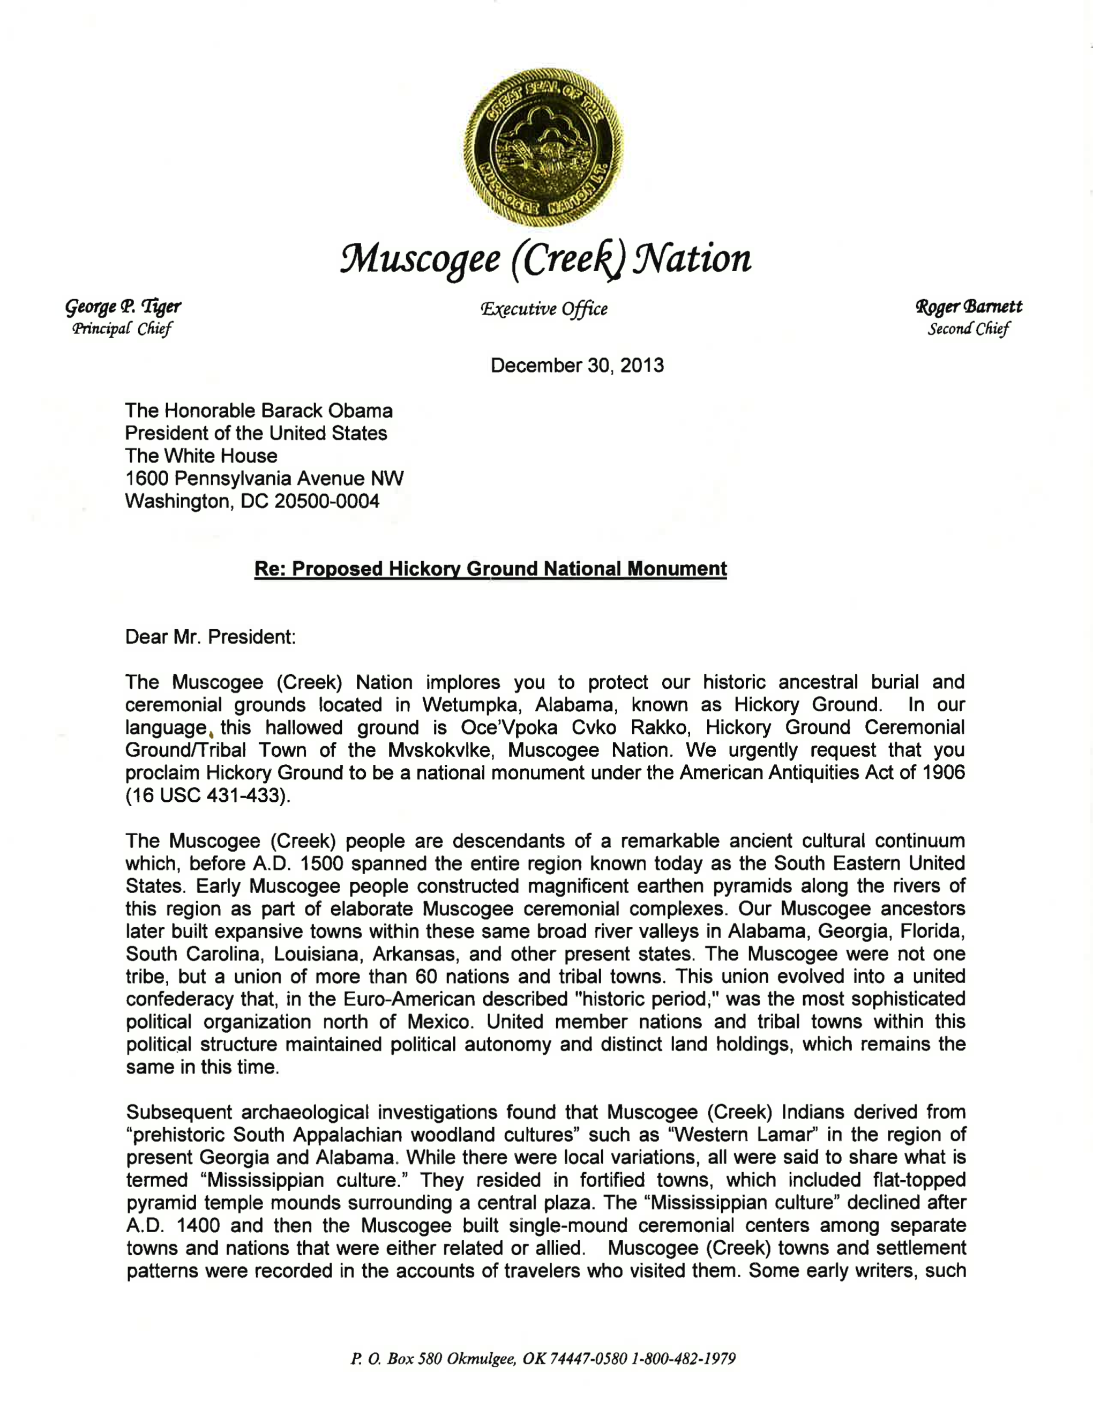
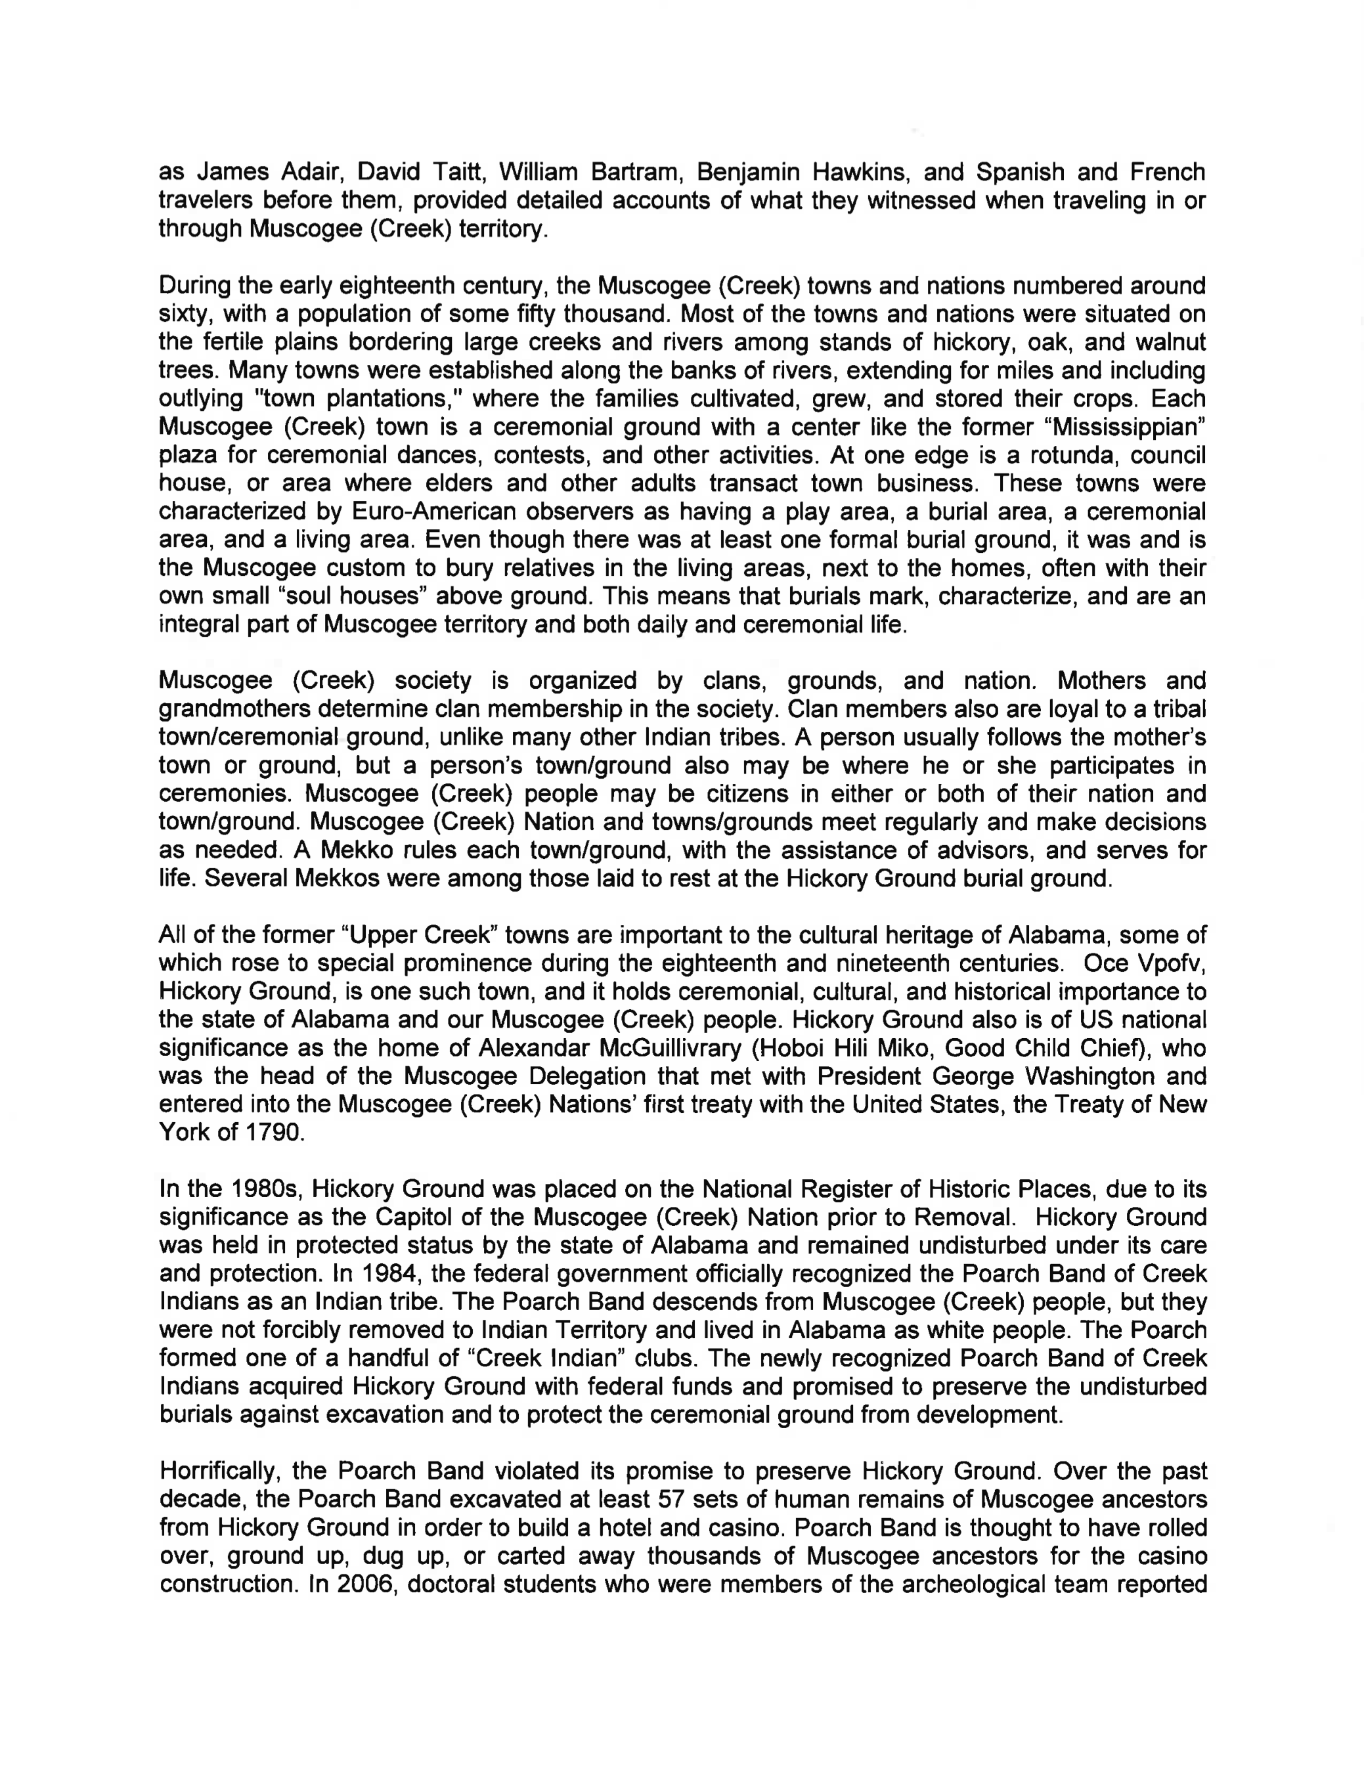

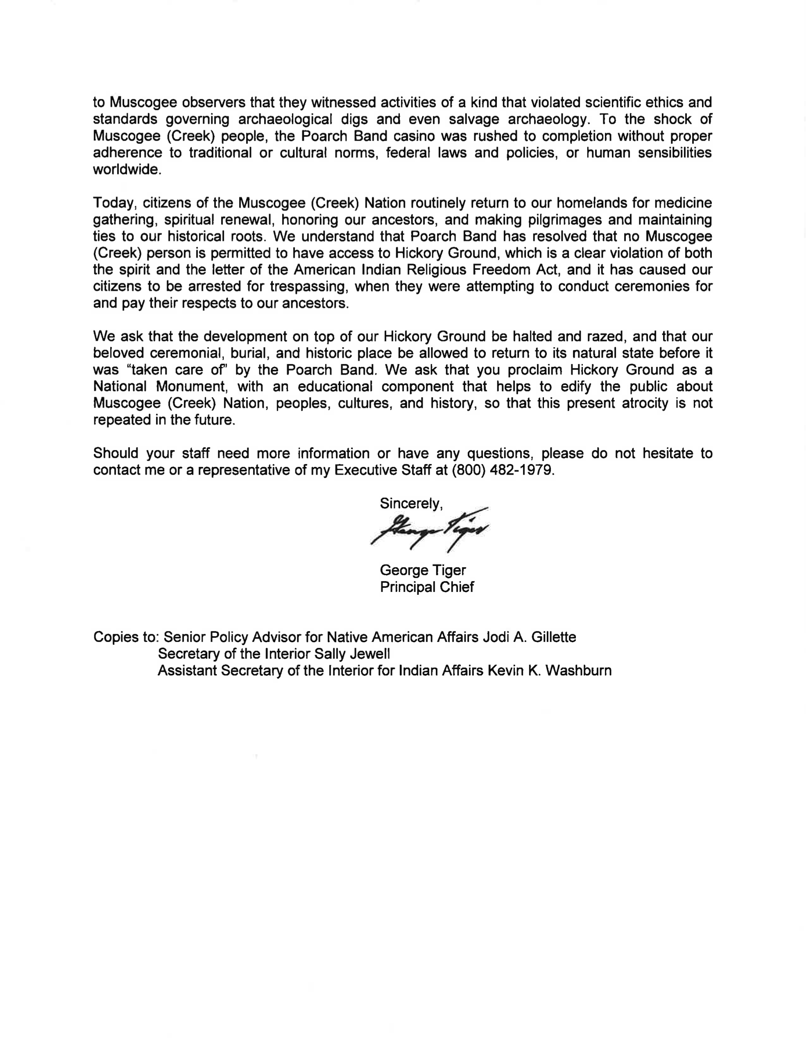

Co-submitted by the International Indian Treaty Council, Indigenous World Association, Native Village of Venetie (Gwich’in Nation), Chickaloon Native Village and Chickaloon Village Traditional Council, Laguna Acoma Coalition for a Safe Environment, Western Shoshone Defense Project, Pit River Nation, Advocates for the Protection of Sacred Sites, Lakota Treaty Council, Kónitsąąíí Ndé (Big Water People Clan) and Cúelcahén Ndé (Tall Grass People Clan) of the Lipan Apache Band of Texas, Lipan Apache Women Defense, United Confederation of Taíno People, Hickory Ground Tribal Town, Muscogee (Creek) Nation, Gila River Alliance for a Clean Environment, Guahan Coalition of Guam, Na Koa Ikaika KaLahui Hawaii, Koani Foundation, Aha Moku Council, AmendAIRFA (American Indian Religious Freedom Act), Haskell Wetlands Walkers Student Organization and The Morning Star Institute. The co-submitters of this Alternative Report thank the following for their significant contributions to the content of this Report: Pueblo of Laguna, the Gila River Indian Community Council, the Navajo Nation Human Rights Commission, the Yurok Tribe, Indigenous Youth Foundation and the Havasupai Community Tribal Members.
Pseudonym - Translation: “Teenage Girl Following in One’s Hereditary Way”.

