Committee on Economic, Social and Cultural Rights
79th Session
Report of the National Human Rights Institution of Uruguay

January 10, 2026

Contents
I. Introduction 3
II. Presentation of the National Human Rights Institution 3
III. The INDDHH and the monitoring of economic, social and cultural rights 4
IV. Protection of children and adolescents (article 10) 6
The rights of children and adolescents 6
Children and adolescents in the state protection system 8
V. Children and adolescents in the state protection system. Right to mental health (article 12). 8
VI. Right to an adequate standard of living. Right to adequate food (Article 11). 9

I. Introduction
- The National Human Rights Institution of Uruguay (INDDHH) presents this report for the 79th session of the Committee on Economic, Social and Cultural Rights in which the 6th periodic report presented by Uruguay will be considered, to contribute to the strengthening of the Rule of Law and the effective protection of human rights in the country.
- The INDDHH expresses its satisfaction with the progress achieved in several aspects referred to the promotion and defense of economic, social and cultural rights in the country contemplated in the International Covenant on Economic, Social and Cultural Rights. These advances will not be highlighted in this report, as they are contained in the communication made by the Uruguayan State.
- The INDDHH presents this second report to the Committee to strengthen the competencies established in its legal framework which, in line with the Paris Principles, establishes that the INDDHH has the attribution to collaborate with United Nations bodies that are competent in the spheres of the promotion and protection of human rights, as well as to collaborate with a culture of promotion, protection and defense of human rights in the country.

II. Presentation of the National Human Rights Institution
- The INDDHH is an autonomous state body that functions within the scope of the Legislative Branch and has the task of defending, promoting and protecting, in its full extent, the human rights recognized by the Constitution and International Law.
- It is a complementary mechanism to others already in existence, intended to provide greater guarantees to people in the effective enjoyment of their rights and to verify that laws, administrative practices and public policies, adjust to international human rights protection standards.
- It is an Institution that has been part of the Uruguayan State structure for more than a decade and that has been recognized since 2016 by the GANHRI Sub-Committee on Accreditation with Category A. This accreditation represents a recognition of the effort of the Uruguayan State and the INDDHH for the consolidation of an independent organization dedicated to the promotion and protection of the Human Rights of all people, enshrined in the Constitution of the Republic and International Law.
- The INDDHH presented a report for the first time before the DESC Committee on the occasion of the consideration of the fifth periodic report in 2017. Since then, the INDDHH has deepened its attention to economic, social, cultural and environmental rights, through different lines of action, among which the development of the Mirador DESCA stands out.

III. The INDDHH and the monitoring of economic, social and cultural rights
- The Mirador DESCA is an online platform created by the National Human Rights Institution and the Faculty of Social Sciences (FCS-UDELAR) to monitor and make visible the fulfillment of Economic, Social, Cultural and Environmental Rights (DESCA) in Uruguay.
- The objective of the Mirador DESCA is to present information that reflects the commitments assumed by Uruguay regarding Economic, Social, Cultural and Environmental Rights and that allow for the monitoring of progress and gaps regarding vulnerable populations. The information in the Mirador DESCA comes from a database consolidated from permanent sources (national and international) and continuous records from the National Statistical System.
- The information was systematized to show the evolution of Uruguay's adaptation to the parameters arising from the consideration of the commitments assumed with the international human rights system. The update of data is performed periodically and based on the availability of new information in the sources used.
- The Mirador DESCA was prepared in accordance with General Comment number 10 of the Committee which defines that NHRIs have a fundamental role in the protection of ESCR (which includes examining projected and current laws and administrative provisions to ensure their adequacy to international standards, providing technical advice and conducting studies in relation to ESCR, developing national benchmarks that allow measuring the degree of compliance with the obligations imposed by the Covenant, conducting investigations and studies with a view to determining the extent to which ESCR are put into practice in general and in relation to particularly vulnerable populations, and monitoring the observance of specific rights and preparing reports addressed to public authorities and civil society).
- The Mirador presents information on the state of the rights to health, education, housing, social security, work, food and the environment in Uruguay. It compares the exercise of these rights among different population groups (children, women, people of African descent, people with disabilities, migrants, LGBTI population and people deprived of liberty) and the national average, identifying inequalities.
- The tool, available online, offers data on international and national regulations, implemented public policies and the effective results of the rights. The Mirador enables the download of graphs and tables to understand the situation of ESCR in the country and the economic effort of the State.
- Furthermore, another relevant line of action of the INDDHH can be pointed out linked to the creation of specific work units within the INDDHH destined to monitor the gaps in the realization of rights of populations defined as groups of special protection: people of African descent, older people, migrants, people with disabilities (a unit today established by law as the Monitoring and Oversight Mechanism for the Convention on the Rights of Persons with Disabilities) and the specialized gender unit. These units work together with the complaint reception area and articulate institutional responses to complaints of discrimination.
- The INDDHH carries out the task of protection and promotion of economic, social, cultural and environmental rights, also from its Ombudsman area which channels the complaints and issues raised by citizens regarding possible violations.
- Complaints are analyzed and investigated by a team of human rights expert professionals who substantiate these cases and report to the Board of Directors of the INDDHH, which makes recommendations, statements, observations or proposals to the agencies involved in the issues.
- Thus, among the multiple issues handled, actions are taken regarding the violation of rights in the dimension of the right to work (harassment situations, abuse of power, access to training or social insurance), the right to education (access to benefits for persons with disabilities, educational accessibility, conflicts in educational centers that alter the pedagogical climate), rights linked to a dignified life and social rights (access to housing, award of social security rights, accessibility in transport), the right to family protection (accessibility of parenting support mechanisms, protection of early childhood, transparency of adoption and de-institutionalization processes), the right to health and mental health (access to high-cost treatments, care and good treatment from health institutions, access to assistance for problematic substance use) and the right to a healthy environment (request for provisional measures to prevent the consummation of damages before the start of hydrocarbon exploration, community participation measures for projects with environmental impact).
- The right to a healthy environment is also monitored by the Environment Area of the INDDHH recently created in response to demands from civil society and the monitoring of Uruguay's international commitments in the matter.
- Finally, it should be noted that the INDDHH in its deployment as the National Preventive Mechanism against Torture has carried out systematic and rigorous monitoring of the situation of children who are in the state protection system. This monitoring has revealed the severe obstacles faced by children and adolescents in fully enjoying their economic, social and cultural rights.
- Additionally, the INDDHH is working on ESCR in other areas in articulation with civil society organizations and state agencies. In particular, the right to food from the Working Groups on the right to adequate food and the right to Care, a topic addressed in the XIV National Human Rights Assembly, and treated within the framework of the Working Group on parental care leave.
- The INDDHH wishes to highlight that, ahead of the review of Uruguay's sixth periodic report, with the support of the National Association of NGOs, 4 sessions were scheduled for civil society organizations interested in presenting reports to the ESCR Committee. The following topics were prioritized: Poverty and Human Rights; Right to Adequate Housing; Right to Education; and Right to Health with emphasis on mental health.
- By virtue of this sustained work of the INDDHH in monitoring the Uruguayan State's compliance with its obligations relative to ESCR and the institution's areas of focus, this report addresses those points where the INDDHH has the greatest amount of complementary elements to those reported by the State and civil society organizations and which it considers must be addressed on the occasion of the review of the 6th periodic report presented by Uruguay.
- Therefore, this report concentrates fundamentally on articles 10, 11 and 12 of the Covenant and collects for this purpose the aspects set out in the Committee's list of issues to the Uruguayan State.
- This is without prejudice to the INDDHH pointing out the importance of continuing to strengthen public policies intended to promote rights relative to equitable and satisfactory working conditions, social security, an adequate standard of living, the maximum possible standard of physical and mental health, education and the enjoyment of the benefits of culture.
- In particular, the INDDHH insists that the country continue working on overcoming those obstacles to the full exercise of economic, social and cultural rights already noted by the INDDHH in reports to other treaty bodies such as CEDAW, CERD and CAT, and the report presented on the occasion of the UPR to the Human Rights Council. As well as in the resolutions and recommendations made to the Uruguayan State (mainly those linked to the rights of migrant persons, persons with disabilities, women and persons of African descent in relation to the manifest gaps in the realization and enjoyment of their economic, social and cultural rights).

IV. Protection of children and adolescents (article 10)

The rights of children and adolescents
- The situation of childhood in Uruguay is currently one of the topics present on the public agenda. This is revealed by both the national budget definitions for the next five-year period and initiatives by the legislative body.
- In Uruguay, poverty is concentrated mainly in households with more children and adolescents. According to studies conducted by UNICEF, in the last thirty years, the rate of poverty in children and adolescents has been between 1.5 and 2 times that of general poverty.
- Although in the last two years child and adolescent poverty decreased, in 2023 there were still around 150,000 children and adolescents living below the poverty line. Monetary poverty in households with children and adolescents implies such a scarcity of resources that it affects their possibilities of accessing an adequate standard of living, which includes their rights to food, housing and education.
- Graph 1 presented below refers to the right to housing and shows how one of the key indicators, overcrowding, maintains its highest prevalence in the households of children. The graph shows that the houses in which children aged 0 to 5 reside are those that show the highest levels of overcrowding, followed by the houses in which children aged 6 to 12 reside. This ordering by age remains constant throughout the series (2006 – 2024).
- The INDDHH is concerned about this situation of childhood that converges with other rights violations and has not been reversed despite state efforts.

GRAPH 1
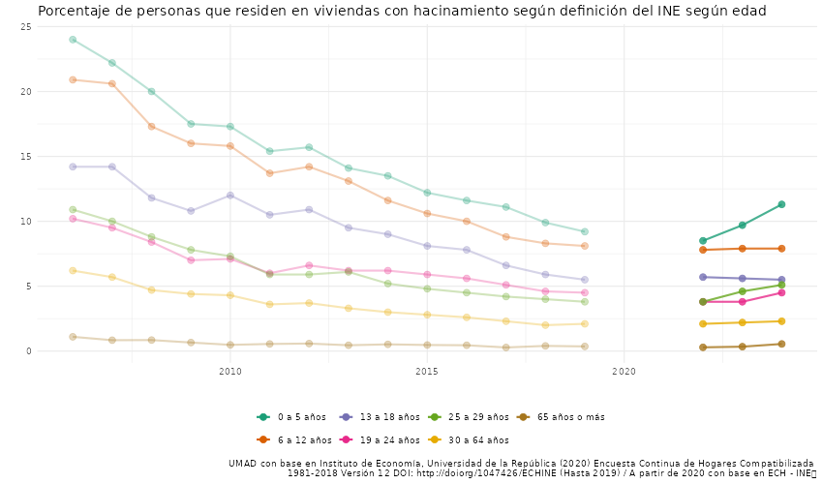
SOURCE: Mirador DESCA

Children and adolescents in the state protection system
- Uruguay presents high rates of institutionalization of children and adolescents and ranks as the country with the third highest rate in Latin America (321 children and adolescents per 100,000).
- Since 2014, the NPM monitors the protection system for children and adolescents of the Institute for Children and Adolescents of Uruguay (INAU) according to its mandate to prevent situations of ill-treatment and with emphases that have been prioritized based on the problems detected. During the period from 2023 to the beginning of 2025, priority was given to the monitoring of the attention centers of the special protection system by regions and with a focus on centers for adolescents.
- The monitoring revealed violations of fundamental rights of children and adolescents under State protection. Those linked to the right to mental health are highlighted in this report to the Committee.

V. Children and adolescents in the state protection system. Right to mental health (article 12).
- Mental health care constitutes a critical knot not only for the protection system, but also in general terms. However, when it comes to children and adolescents who are under State protection, this affects them in a specific way and reinforces vulnerabilities and human rights violations.
- The lack of devices and professionals for comprehensive mental health care is a structural problem of the health system. Delays were reported in access to psychological and psychiatric assessment and respective treatments at health providers. Cases of excessive waits reaching up to eight months for a first consultation were recorded.
- It must be taken into account that the children and adolescents who enter and transit through the special protection system have a history marked by damages (such as violence and abuse), which it is necessary to address immediately.
- In the monitoring, it was found that 56% of the protection centers had had a child or adolescent hospitalized for mental health reasons in the last month. In 53% of the centers in the country, situations of attempted self-harm were recorded. Both in Montevideo and in the interior of the country, prolonged waits were observed for admission to comprehensive mental health care centers. On average, they must wait nine months for the requested transfer to take place, and in some situations, eighteen months have been exceeded.
- As has been pointed out, the children and adolescents who enter the protection system usually present significant levels of accumulated damage, the product of life trajectories marked by multiple human rights violations. Consequently, they require comprehensive care that includes personalized, specific, consistent mental health approaches, sustained over time and in territorial proximity.
- These approaches must overcome a merely sanitarist perspective and cannot be reduced exclusively to interventions from psychology or psychiatry, care that is even insufficient. The INDDHH urges the Uruguayan State to take rapid and effective measures in this matter.
- On the other hand, in the monitoring carried out by the NPM, it continues to be found that children and adolescents remain hospitalized in mental health care centers for acute crisis episodes, despite medical discharge. In September 2025, 28% of the children and adolescents of the state protection system who were in centers for attention to acute crisis episodes, remained hospitalized despite having a medical discharge. The average time of hospitalization after medical discharge reached three months. Recording a hospitalization of 9 months after the medical discharge had been given.
- The INDDHH has pointed out that keeping a child or adolescent hospitalized beyond medical discharge is harmful to their comprehensive development, and the State cannot allege conditions of vulnerability of the same (poverty, absence of family among others), or lack of adequate places.

VI. Right to an adequate standard of living. Right to adequate food (Article 11).
- Uruguay does not yet have a framework law on the right to food. This challenge remains current even though it is a commitment on which Parliament has worked in different legislatures. While important agreements have been reached, these have not been sufficient to pass a law that guarantees the right to adequate food and orders the regulatory dispersion on the right to food in the country.
- This concern led the INDDHH to convene a Working Group (WG) that met during 2024 and 2025 with the objective of discussing the relevance of a framework law that orders the necessary intersectoral approach that this issue requires. The group included the participation of representatives of social organizations and state institutions whose work is linked to the right to food, in addition to the accompaniment and technical advice of the Food and Agriculture Organization of the United Nations (FAO) from its inception.
- The WG tried to generate a logical process regarding the analysis and its adaptation to Uruguayan legislation, although the objective was not to arrive at a document with the format of a bill, but at a report that provides elements to evidence the need for a regulatory framework, as well as the key elements to ensure its operability. In this framework, all dimensions of the right to food were addressed and analyzed.
- The INDDHH is particularly concerned about those referring to accessibility. Household income is a relevant data point in this dimension and the difficulties of economic access to food are a prevalent problem in the country.
- According to the third report on the prevalence of food insecurity prepared by the INE, INDA-MIDES and MSP, for 2024, of every 1,000 households, 137 had reduced the amount of food they consumed due to lack of money or other resources, at least once in the last 12 months (this equates to a prevalence of moderate or severe food insecurity of 13.7% of households).
- In terms of individuals, the prevalence is 15.1%, meaning that for every 1,000 people, 151 lived in households with moderate or severe food insecurity. Food insecurity is understood when a person lacks regular access to enough safe and nutritious food to lead an active and healthy life. In a country with food sufficiency like Uruguay, food insecurity is associated with difficulties in access to nutritious food for economic reasons.
- On the other hand, it is also indicated that 19 out of every 1,000 households had run out of food due to lack of money or other resources and that some person in the household had not eaten all day, at least once in the last 12 months (the prevalence of severe food insecurity in households was estimated at 1.9%). While the estimate of severe food insecurity in individuals corresponded to 2.2%, that is, for every 1,000 people, 22 lived in households with severe food insecurity.
- Another indicator that reveals the situation of the right to food in Uruguay is the existence of hundreds of community pots and popular baskets organized in the territories to prepare and share food with people, families, and communities in a situation of food insecurity (see graph 2 with information on the number of people attending dining rooms and centers).
- The existence of so many self-organized initiatives among neighbors, families, and social and neighborhood organizations, besides highlighting the lack of regular and sufficient access to food for a significant sector of the population, reveals the absence of state policies that guarantee this human right to food, as well as those other rights that make it possible such as the right to work, housing, health, social security and education, among others.
- The INDDHH will continue working and cooperating to promote the approval of a framework law that guarantees the right to an adequate food supply in Uruguay.

GRAPH 2
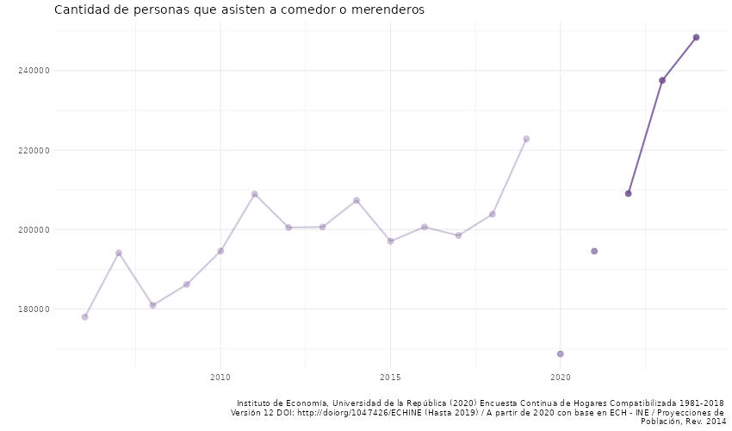

SOURCE: Mirador DESCA

It was created by Law 18446 of December 24, 2008 (subsequently amended by Law 18806 and 19763) in compliance with the Paris Principles, adopted by the United Nations General Assembly, by Resolution 48/134 of 1993, as well as the commitments assumed in the Vienna Declaration and Programme of Action, emanating from the World Conference on Human Rights of 1993. Its first Board of Directors assumed functions on June 22, 2012, when the INDDHH began to operate.
Available in https://tbinternet.ohchr.org/_layouts/15/treatybodyexternal/Download.aspx?symbolno=INT%2FCESCR%2FCSS%2FURY%2F27400&Lang=en
www.miradordesca.uy
Article 66 of Law 18446 provides for the creation of Working Groups made up of members of the INDDHH, representatives of social organizations and state agencies with the objective of preparing draft reports, proposals, recommendations, studies and other work.
See report on the Asamblea Nacional de Derechos Humanos in www.inddhh.gub.uy
See resolutions in www.inddhh.gub.uy
See report in //efaidnbmnnnibpcajpcglclefindmkaj/https://bibliotecaunicef.uy/opac_css/doc_num.php?explnum_id=318
La infancia como prioridad: seis desafíos claves de políticas públicas en Uruguay. UNICEF 2024.
https://www.gub.uy/institucion-nacional-derechos-humanos-uruguay/comunicacion/publicaciones/panorama-infancias-adolescencias-clave-regional-ninas-ninos-adolescentes
Estado del Sistema Agroalimentario Informe de Nivel 1 Pre-CCA Uruguay, FAO, pág. 29. Estado del Sistema Agroalimentario Informe de Nivel 1 Pre-CCA Uruguay, FAO.
https://www.gub.uy/ministerio-desarrollo-social/sites/ministerio-desarrollo-social/files/documentos/publicaciones/Prevalencia%20de%20inseguridad%20alimentaria%20en%20hogares%20de%20Uruguay%202024.pdf

