3rd and Final Addendum to
the Alternative Report on Canada’s Implementation
of the UN Convention on the Rights of the Child

Submitted by
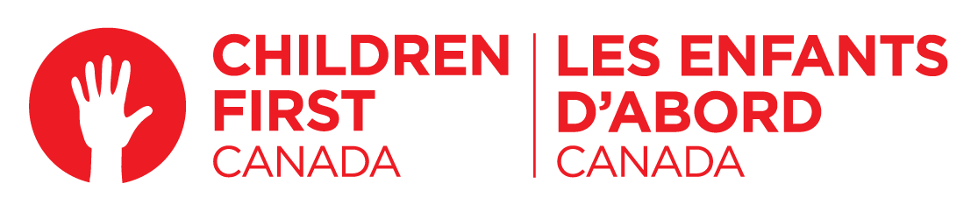

Authors & Contributors:

Sara Austin, Founder & CEO, Children First Canada
Nketti Johnston-Taylor, Director of Research and Programs, Children First Canada
Stephanie Mitton, Government Relations Advisor, Children First Canada
Andy Lee, Youth Coordinator, Children First Canada

Youth Ambassadors:
Jessica Janega, age 15, Ottawa, Ontario
Katie Tremblett, age 15, Grand Falls-Windsor, Newfoundland and Labrador
Jayden Paquet-Noiseaux, age 15, Mont Saint Hilaire, Quebec
Rahma Siddique, age 13, Calgary, Alberta
Maxwell Cooper, age 15, Grand Falls-Windsor, Newfoundland and Labrador
Simryth Sahota, age 17, Surrey, British Columbia
Estelle Kim, age 18, Calgary, Alberta
Lucy Diaz, age 14, Port Coquitlam, British Columbia

April 14, 2022

Contact information:
info@childrenfirstcanada.com
1-877-837-2258
www.childrenfirstcanada.com
TABLE OF CONTENTS
- Update on Legislative Efforts to Protect Children’s Rights............................................3
- Update on Impact of COVID-19 on Children in Canada...................................................4
- Children’s Views and Experiences ...................................................................................17
- Recommendations to the Government of Canada..........................................................19
- Conclusion .........................................................................................................................20
- References...........................................................................................................................21
Canadian Children’s Charter
Raising Canada 2018
Raising Canada 2018: Economic Analysis
Raising Canada 2019
Raising Canada 2020
Raising Canada 2021

- Update on Legislative Efforts to Protect Children’s Rights
Children First Canada previously reported that there were two Bills submitted in the Senate that would further the rights of children in Canada, namely:
An Act to Establish a Commissioner for Children and Youth in Canada, and An Act to Amend the Canada Elections Act and the Regulation Adapting the Canada Elections Act for the Purposes of a Referendum (to lower the voting age to 16).
Both Bills died when the 2021 federal election was called. As shared in previous reports, Children First Canada was involved expensively with consultations on these Bills, which included extensive consultations with children and youth in Canada.
Since the election of the 44th Parliament, several Bills have been put forward to further children’s rights, including a reintroduction of Senator Marilou McPhedran’s to lower the voting age (S-201). These include the following:
Bill | Bill Name | Sponsor | Party | Bill Type | Current Stage | Latest Activity | Link
S-201 | An Act to amend the Canada Elections Act and the Regulation Adapting the Canada Elections Act for the Purposes of a Referendum (voting age) | Sen. Marilou McPhedran | Non-affiliated | Senate Public Bill | At second reading in the Senate | Debate at second reading on February 10, 2022 (Senate) | https://www.parl.ca/legisinfo/en/bill/44-1/s-201
S-210 | An Act to amend the Canada Elections Act (voting age) | Taylor Bachrach (Skeena—Bulkley Valley) | NDP | Prive Member's Bill | At second reading in the House of Commons | Placed in the Order of Precedence on February 9, 2022 (House of Commons) | https://www.parl.ca/legisinfo/en/bill/44-1/c-210
C-212 | An Act to develop a national school food program for children | Don Davies (Vancouver Kingsway) | NDP | Prive Member's Bill | Outside the Order of Precedence | Introduction and first reading on December 14, 2021 (House of Commons) | https://www.parl.ca/legisinfo/en/bill/44-1/c-212
C-227 | An Act to amend the Canada Elections Act (voting age) | Don Davies (Vancouver Kingsway) | NDP | Prive Member's Bill | Outside the Order of Precedence | Introduction and first reading on February 3, 2022 (House of Commons) | https://www.parl.ca/LegisInfo/en/bill/44-1/C-227

For context, none of these Bills are government-led Bills, thus the likelihood of any of them passing is low. Children First Canada continues to advocate for the federal government to lower the voting age, establish and fund a national school food program, and establish a federal Commissioner for Children and Youth.
Of note is that on March 22, the NDP and Liberal party announced a new agreement, “Delivering for Canadians Now, A Supply and Confidence Agreement”. The arrangement lasts until Parliament rises in June 2025 and means that the NDP agrees to support the government on confidence and budgetary matters.
The arrangement does not currently include any of the above stated priorities, but we would urge both parties to consider these issues as they work on other possible shared priorities through their oversight group.
Another noteworthy development is that 13 youth between the ages of 12 to 18 years old have launched a federal court challenge to lower the voting age in Canada; they allege that the Electoral Act is unconstitutional and the matter is now before the courts. Details can be found here.

- Update on Impact of COVID-19 on Children in Canada
As we noted in our prior submission, the ongoing COVID-19 pandemic has resulted in widespread violations of children’s rights and continues to be highly detrimental on the physical and mental well-being of children. The alarming statistics are evidence that children’s rights to life, survival and development have steeply declined since the onset of the pandemic. Recommendation #7 in our October 2020 submission reiterated our call for urgent action to convene a First Ministers Meeting to urgently discuss the wellbeing of children in Canada amidst the COVID-19 emergency and recovery efforts.
Since our last update, Children First Canada joined with leading children’s health organizations in declaring #codePINK – a term used for pediatric emergencies, in recognition of the child health crisis resulting from the pandemic. The #codePINK campaign called for emergency action on the part of federal and provincial leaders, including requesting a First Ministers meeting (involving the Prime Minister and provincial and territorial Premiers) to take immediate action to address this crisis facing the 8 million children under 18 years of age in our country. This included urging government leaders to scale up virtual care programs, reduce backlogs for surgeries and rehabilitation, invest in new models of mental health programs to meet the urgent and rising demands, and plan now for a safe return to school.
#codePink was highlighted in the media 646 times through publications and broadcasts, amassing over 74 million views. The majority of the #codePINK news coverage has been in Canada, but there has also been coverage in the U.S., Germany, the United Kingdom, and France. It is evidence that, as we recover and reframe how to live with COVID-19, that children cannot continue to pay such a high toll and need to be at the forefront of support and recovery plans.
The realities of COVID-19 continue to exacerbate the other top threats to children who live in Canada. In September 2021, Children First Canada launched Raising Canada 2021, the fourth in an annual series of reports that track the top 10 threats to childhood, and it paints an alarming picture of children in crisis across the country. The report highlighted the impacts of the pandemic and provides policy recommendations for addressing each threat.
Mental health remains a top threat for children in Canada. According to Statistics Canada, suicide remains a leading cause of death for children and youth aged 10-19 and during the pandemic, several children’s hospitals saw significant spikes in admissions for suicide attempts. While in the province of Ontario, admissions for eating disorders increased by as much as 223% above capacity as reported by 5 paediatric hospitals in June 2021. Clinicians have indicated that this increase is unlike anything they have previously witnessed.
Food and nutritional insecurity as well as poverty continue to factor in the top 10 threats for children in Canada. During the pandemic, the Canadian Public Policy Journal, indicates a 39% increase in the prevalence of food insecurity in households with children as compared to households without children. The poverty rate was decreasing in Canada prior to the pandemic but now, one in five children live in poverty, according to Campaign 2000.
The pandemic has also raised the concerns of scholars and child advocates over rising and undetected rates of child abuse and neglect. Canada is now ranked second highest among 17 OECD countries in infant mortality rate. This is only a handful of concerning statistics and trends highlighted by the Raising Canada 2021 report.
Systemic racism and discrimination, bullying, and all 10 threats – as indicated in the report and listed in Figure 1 – continue to raise concern and needs to be addressed by the Government of Canada to turn around this downward trend of childhood wellbeing and widespread violations of their rights.
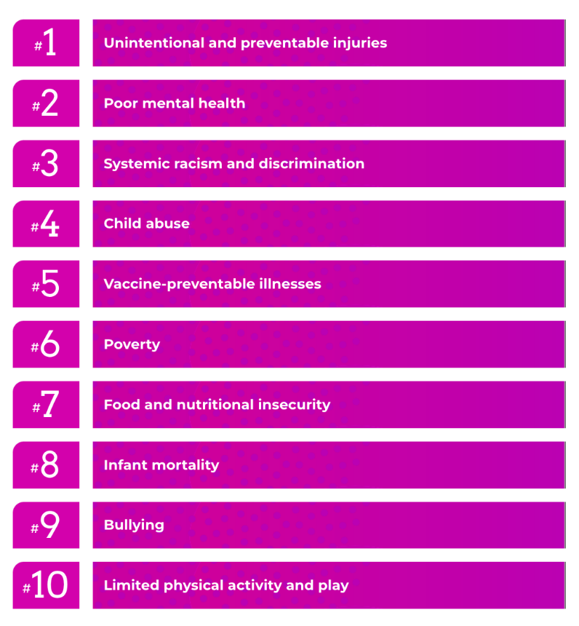
The report was accompanied by joint calls to action signed by the Council of Champions – including leaders of children’s hospitals, charities, and research institutes across the country.
The report was released amidst a federal election for a new federal government, and Children First Canada also released a Children’s Platform and #voteforourfuture campaign urging all federal parties to put children at the heart of Canada’s pandemic recovery efforts. Details of the Children’s Platform are available here.
Yet party platforms largely ignored children’s issues, with the exception of child care. The calls to action from this report in conjunction the Children’s Platform called on all federal parties to:
- Make a big, bold plan to improve the lives of children and make Canada the best place in the world for kids to grow up,
- Ensure that children’s voices are heard and that their issues are prioritized, and
- Put children at the heart of Canada’s pandemic recovery plans, and invest in short-, medium- and long-term solutions for children to survive and thrive.
We continue to look with great interest for our calls for urgent action by the Government of Canada, as indicated in our prior submission update, to be addressed.

Budget 2022
The newly-elected government released its budget for the fiscal year on April 7, 2022. Budget 2022 includes important investments on a range of issues that will positively impact children and youth, including childcare and early learning, dental care, pharmacare and housing.
Concerningly, the budget does not include big, bold investments to address the devastating impacts of the COVID-19 pandemic on children and youth in Canada. The lack of targeted investments to address the disproportionate impact of the pandemic on children is worrisome.
“We are facing a generational catastrophe that requires immediate and sustained support. Children are grappling with massive learning loss, mental and physical health issues, social isolation and many other challenges,” says Sara Austin, founder and CEO of Children First Canada. “Children are citizens with rights. They represent a quarter of our population and one hundred per cent of our future. As Canada rebuilds from the pandemic, there is nothing more critical than investing in our children. When children prosper, Canada prospers.”

Although a pandemic recovery plan for kids is lacking, Children First Canada is pleased that several commitments in Budget 2022 support recommendations from the Young Canadians’ Parliament (YCP), in their recently released report “Our Commitment to Today and Tomorrow”.
“The budget is rather robust and impressive in addressing pollution. I am extremely excited to see these promises come into action. What is missing is holding the companies responsible,” says 14 year old Lucy Diaz from Port Coquitlam, BC. “Something I am impressed about is the focus on shifting from fuel powered vehicles to zero-emission vehicles. This shift will create a big difference in our carbon footprint. Another YCP recommendation missing is to increase climate education. It is important for youth to be informed about climate, however, the education we receive today does not address this enough.”
While some recommendations from the Young Canadians’ Parliament were included, other important issues were not.
“The 2022 budget has taken into consideration the needs of many minority groups within Canada, but seems to have forgotten the needs of children and youth” says 17 year old Simi Sahota, Member of the YCP. “With important advancements in sectors such as child-care, truth and reconciliation, and more, it still fails to meet many other crucial needs of children across Canada. Issues such as mental health and ableism have no clear budget or plan to help youth and students specifically. It seems the government still has no plan to allow a discussion with diverse children to speak on youth topics which affect them.”
Children First Canada’s full response to Budget 2022 is available here, including the perspectives of the Young Canadians’ Parliament and their analysis of federal expenditures on children and the protection of their rights.
Children First Canada has proposed a roadmap to put children and youth at the heart of Canada’s pandemic recovery plans and help achieve our shared vision of making Canada the best place for kids to grow up. This will require dedicated federal leadership and the investment of financial resources, including:
- Establishing a Federal Commissioner for Children and Youth and develop a National/Pan-Canadian Strategy for Children
- Launching a Catalytic Investment Fund for Children and publish a Children’s Budget
- Collecting disaggregated data on the health and wellbeing of kids across Canada
These recommendations will advance the following key federal mandate priorities impacting children:
- Ensuring that the voices and needs of children are represented in the Government’s agenda and working to make Canada the best place to grow up.
- Ensuring that mental health supports are accessible to children and youth as they recover from the impact of the pandemic.
- Developing a National School Food Policy and working toward a national school nutritious meal program.
Children First Canada welcomes these mandate commitments and looks forward to working with the government to ensure that they are actioned quickly.

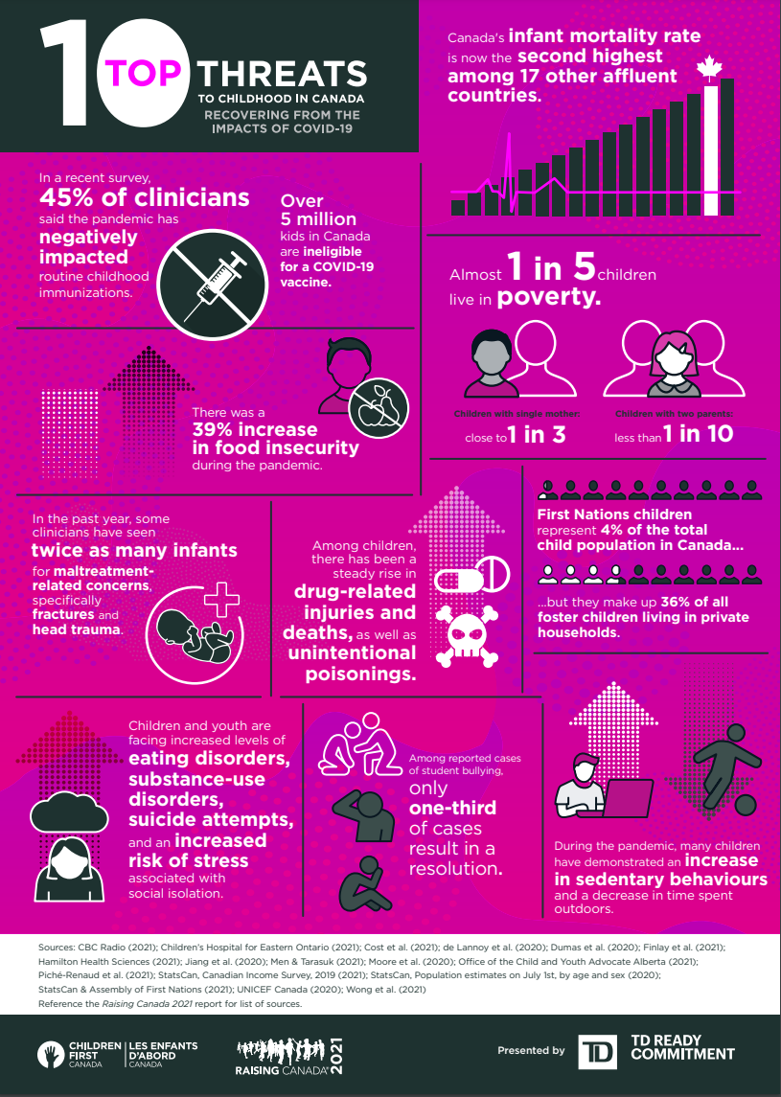
Figure 2 - Highlighted Statistics about the Top 10 Threats to Childhood in Canada

- Children’s Views and Experiences
A Letter to the UN Committee on the Rights of the Child from Youth Ambassadors of Children First Canada:
Dear UN Committee for the Rights of the Child,
We, as young people, are impacted by the decisions every adult makes. We are noticing issues in our world that aren’t getting the attention they need. This is a country with a vast mosaic of different people from all walks of life. But some are falling through the cracks. We need ways of ensuring our progress and future. To simultaneously empower and benefit our youth and ensure our future, we must take action.
Climate change has been a very prevalent issue in the past few years with many of the advocates for our climate being youth. We are not ignorant; we know the reality of the state of our climate. For example, take the strike in September of 2019, where students all over the world walked out of class as part of a mass protest to advocate for the prioritization of our climate. If we continue as we are, we as a species don't appear to have much of a future. Of course, this is awful for everybody. We are all negatively impacted by the effects of climate change, but it is especially threatening to us, children and youth.
The climate crisis we are currently facing is on track to ruin our futures. If we do not start making big changes to how we are living – like ensuring a protected environment and implementing expansive green energy – it will continue to compromise our rights as youth to a clean environment. We want to be able to plan our futures without having to constantly worry about whether or not we, or our future children, will live to see them.
Similarly, our environment also includes accessible spaces. We, as young people, have the right to be able to easily access the spaces that we are in every day – such as schools, government buildings, and any other spaces we need or want to enter. Disabled people often have to work much harder to try to find ways to gain access to these spaces. It isn't fair to force people to have to try to live and exist in spaces that were not designed with them in mind. Article 23.1 of the UNCRC says that state parties should, “recognize that a mentally or physically disabled child should enjoy a full and decent life, in conditions which ensure dignity, promote self-reliance and facilitate the child's active participation in the community.”
If Canada is to fulfill its duties as a signatory of the UNCRC, we are asking that Canada work to make all buildings accessible to people who have a disability that limits mobility. Furthermore, once people are able to get into these areas, they should be able to exist just as easily as anybody else, which means that all public bathrooms should include accessibility tools such as lifts and adult changing tables. Similarly, all people use washrooms. Therefore, they should be designed with all people in mind. People with disabilities should be listened to, and the struggles they face should be acknowledged instead of simply ignored and brushed under the rug.
It is important that young people are educated about their rights. What good is having a list of children's rights if children aren't actually taught about them? If a child's rights are being violated, how will they know unless they are taught in school what their rights are? Many people are not aware of their rights as children unless they go out of their way to look them up. That is not okay.
Most kids attend school for several hours a day, in a space made just for learning, for teaching kids about the world that we live in and how to live in it well, so why isn't it mandatory to teach them exactly how they are protected? Every child deserves to know their rights. It should be a part of every school's curriculum from the first few years of school to go over all of the rights kids have. We should not be left vulnerable to being taken advantage of because we do not know what is ok and what is not. We make kids sit down and learn so much about the past, but why do we fail to teach them how to live in the present?
Knowledge of our rights is not good enough if we are unable to speak up about them. The voices of children and youth are starting to claw their way into the conversations, but we need help. For you to be able to help, you need to understand we are not only the future but the present. We do not wish for our world to crash and burn before we can vote for the change we want.
One change that we want is to have a youth committee to represent us at the federal level. Having a youth committee in the federal government decision-making process is something that many children and youth who are members of the Young Canadians’ Parliament (YCP) feel strongly about. This would help achieve many of the recommendations YCP members have made. The YCP is a program offered by Children First Canada that brings together children and youth across Canada to learn about our rights, the democratic process, and to engage civically to have our voices heard on the matters that are important to us as young people.
Your decisions affect us. Full stop. No matter what, your choices will affect our lives - even in the smallest of ways. We need people advocating for our rights and beliefs at the highest level. Your decisions affect us, but how they affect us is up to you.
When receiving the YCP’s recommendations, it is important to understand that they are coming from children representing all children in Canada, a diverse mosaic of people from different walks of life. Too many of these children are being affected by systemic discrimination.
To grasp the problem better, we have to start systematically collecting national data about discrimination to have essential stats when discussing these issues. Collecting disaggregated data is a crucial step to start learning what the issue is so we can correct it.
YCP members provided recommendations on what exactly this correction can look like. A popular one included sensitivity training for police officers so that they know how to deal with someone who is struggling mentally or is part of a minority. Being able to effectively and safely communicate with people is in the job description. No matter the bias anyone may carry, these marginalized people are the public. They are human. They are more than a hashtag.
In addition, the COVID-19 pandemic has been a long, hard fight for everyone. Feelings of isolation and loneliness are common among children and youth in lockdown. Not being able to go to school or socialize for two years takes a toll on anyone, and it has.
According to the most recent Raising Canada Report (2021), COVID-19 has worsened the dangers to youth and children. It was quoted as being "an overall decline in children’s health and well-being in Canada."
One YCP member highlighted this and recommended focusing more funding on the top 10 threats to childhood in Canada because of the increasing numbers. We must adapt to unforeseen by-products of the pandemic. It isn't over yet, and we need help.
We are deeply troubled that we even have to speak out on issues like this at a young age at all. We should be hanging out with friends, not pleading to the UNCRC to fix our world. But we are here. And we plan to use this privilege we have been given to speak up for the change we need. We refuse to allow our world to become something we don’t want to inherit.
We genuinely hope and ask that your decisions take into consideration the contents of our request. We want to live and inherit a Canada that we are proud of, that listens to young people and recognizes that we, as young people, can and are contributing to one day, making Canada the best place for kids to grow up.
Sincerely,
Jessica Janega, age 15, Ottawa, Ontario
Katie Tremblett, age 15, Grand Falls-Windsor, Newfoundland and Labrador
Jayden Paquet-Noiseaux, age 15, Mont Saint Hilaire, Quebec
Rahma Siddique, age 13, Calgary, Alberta
Maxwell Cooper, age 15, Grand Falls-Windsor, Newfoundland and Labrador
Simryth Sahota, age 17, Surrey, British Columbia
Estelle Kim, age 18, Calgary, Alberta
Lucy Diaz, age 14, Port Coquitlam, British Columbia

- Recommendations to the Government of Canada

Children First Canada (CFC) provides the following recommendations to the Government of Canada:

- Establish a Federal Commissioner for Children and Youth
A Federal Commissioner for Children and Youth is a non-partisan and evidenced-based approach to improve the wellbeing of children, including children’s health and safety, and addressing specific issues such as child poverty and child abuse.

Children’s commissioners have been established in more than 60 countries, including Sweden, the United Kingdom and New Zealand. It’s a proven strategy to improve results for children. In the UK, the children’s commissioners in Scotland, Wales and England helped improve their international rankings for child well-being by five points. That’s measurable change for children.

During the pandemic, children’s commissioners have played a critical role in addressing the impacts of lockdowns on children by ensuring that children’s concerns are prioritized. In England, for instance, the commissioner applied a “children first” lens to the pandemic response by regularly issuing reports and policy briefs and coordinating federal and local stakeholders to mitigate the negative impacts on children. A broad array of issues has been addressed, including age-specific recommendations for infants, addressing the unique needs of highly vulnerable children, such as those experiencing abuse, children in custody, and homeless children. As someone who has heard directly from young people about their experiences, the commissioner has been a strong public advocate for children and youth.

In Canada during the pandemic, support for children has had a fragmented approach, as children fall under multiple ministerial portfolios and there is no single lead Minister with ultimate responsibility for their wellness. What is required is a comprehensive and concerted effort to address the impacts of the crisis on children, and a child-focused lens on the federal response to the pandemic, which has been absent.

Federal responsibility for children spans across government departments, including:
• Employment and Social Development Canada
• Women and Gender Equality Canada
• Canadian Heritage
• Indigenous Services Canada
• Immigration and Refugee Board of Canada
• Justice Canada
• Public Health Agency of Canada
• Public Safety Canada

This list is by no means exhaustive. As a result, big, bold comprehensive ideas for children are often difficult to gain traction on. A children’s commissioner would coordinate efforts across departments in a new way and propel action to increase child well-being.

With a mandate to promote, investigate and advise on legislation and policies impacting children and youth – and defend the rights of children and youth across federal jurisdictions and ministries – a federal commissioner would have the authority and autonomy to influence significant and positive changes with respect to better outcomes for all young Canadians.

In establishing the federal Office of the Commissioner for Children and Youth, it is essential to work nation to nation, respecting and including the self-governance rights of First Nations, Métis and Inuit peoples. The Assembly of Seven Generations and the First Nation Child and Family Caring Society of Canada spoke with Indigenous Youth about establishing the federal Commissioner for Children and Youth, the results of which have been captured in: Accountability in Our Lifetime: A Call to Honour the Rights of Indigenous Children and Youth.

Including the meaningful participation of children and youth in the creation of a Commissioner’s office is also essential. Senator Rosemarie Moodie recently released a report summarising the results of a year-long consultation with nearly 500 children and youth across Canada about the need for a Commissioner; that report provides ample evidence on children’s perspectives on this matter and requires serious consideration, support and most importantly action.

- Develop a National / Pan-Canadian Strategy for Children

In conjunction with establishing a Commissioner, CFC urges the government to develop a National Strategy for Children and Youth. National strategies or action plans for children, like Australia’s National Children’s Mental Health and Wellbeing Strategy,1 can help ensure that the voices and needs of children are represented in government agendas and work to markedly improve the overall wellbeing of children. Canada’s last national strategy, A Canada Fit for Children, was issued in 2004 in response to the UN General Assembly Special Session on Children and is an important resource that should be considered.

Canada can measurably improve the lives of kids by creating and implementing a National / Pan-Canadian Strategy for Children. This strategy, developed with the provinces, should outline priorities, targets and timelines, with a clear delineation of the responsibilities of the various levels of government that are needed to make measurable progress for children in Canada.
Priority areas to consider have been identified in the latest Raising Canada report on the top 10 threats to childhood, and must be focused on helping children recover from the impacts of the COVID-19 pandemic, including:
1. Unintentional and preventable injuries
2. Poor mental health
3. Systemic racism and discrimination
4. Child abuse
5. Vaccine-preventable illnesses
6. Poverty
7. Food and nutritional insecurity
8. Infant mortality
9. Bullying
10. Limited Physical Activity and Play

Efforts to tackle the top 10 threats to childhood and put Canada back into the top 10 global rankings for children’s wellbeing can be further catalysed by establishing an investment fund of $2 billion to be allocated over the next four years, as outlined in the following recommendation.

- Launch a Catalytic Investment Fund for Children and publish a Children’s Budget

The health and wellbeing of kids in Canada has sharply declined over the past decade, and the pandemic has threatened the survival and development of children.

The urgency to invest in children and youth has never been greater.

CFC recommends that the Government of Canada establish a Catalytic Investment Fund for Children of $2 billion to be allocated over the next four years. The aim of the fund is to catalyse efforts to tackle the immediate and urgent threats to children’s wellbeing resulting from the pandemic and to drive systemic change.

The proposed Catalytic Investment Fund for Children will provide the resources required to take immediate action to address the crisis facing kids in our country and drive sustainable change for future generations, with the goal of making Canada the best place in the world for kids to grow up.

An investment of $2 billion over four years is big and bold, and entirely warranted. While Canada’s investment in social protection throughout the pandemic “has been more robust than many of it’s peers, spending slightly more than the average of 10 per cent of pre-pandemic GDP,” according to UNICEF, “Less than 2 per cent was spent on responses directed to children.”

The proposed Catalytic Fund should be made available to credible national and local child and youth serving organizations to implement proven and effective strategies to address the short-, medium- and long-term needs of children and drive meaningful change for children. Further, Canada must ensure that First Nations, Métis and Inuit children receive equitable funding and services.

Children First Canada has developed an in-depth analysis on the development of this Fund, which is available here.

In conjunction with the Catalytic Fund, we also recommend that the government publish a Children’s Budget to ensure transparency and accountability for all federal expenditures for children. Children’s budgets are a proven strategy that have been used in jurisdictions around the world to ensure that investments are made towards evidence-based programs that improve the lives of children and of future adults.

Existing policy tools such as the GBA+ framework can be leveraged for the Children’s Budget and build on the initial efforts used by the Department of Finance in Budget 2019 for the Investing in Young Canadians’ Budget booklet.

To this end, such an approach could also capture major federal investments in children and youth, including the landmark childcare agreements signed by the federal government with provincial and territorial governments.

- Collect disaggregated data on the health and wellbeing of kids across Canada

While Children First Canada’s Raising Canada reports highlights a substantial fraction of the enormous amount of evidence emerging in Canada related to children and youth, there is still a need to invest in research related to children’s well-being and health.

For example, Canada lacks national longitudinal studies (and related data) on children and youth that can provide a foundation on examining how Canadian child and youth mental health changes across time (including during the pandemic).

Statistics Canada undertook a significant national survey on children’s health in 2019, known as the Canadian Health Survey on Children and Youth (CHSCY), which established a meaningful benchmark on children’s wellbeing prior to the pandemic. The survey is due to be repeated in 2022, and will provide data-driven evidence on changes to children’s health and wellbeing throughout the COVID-19 pandemic. While this is an important step forward, these are ad hoc surveys that are not repeated regularly.

As such, investing in a comprehensive survey led by Statistics Canada, as a follow-up to the CHSCY, represents an opportunity to obtain missing information about mental health impacts. Additionally, there must be a national priority to collect and analyze race-based data related to children, especially using longitudinal methods.

We were pleased by the Canadian Institute of Health Research’s (CIHR’s) announcement of a
funding opportunity that aims to understand and mitigate the impacts of the COVID-19 pandemic on children, youth and families in Canada. This grant opportunity was made possible by the CIHR Institute of Human Development, Child and Youth Health, in collaboration with various additional CIHR institutes. More opportunities to support scholars in undertaking child-centred research is necessary.

- Promote child rights education, awareness raising and training and fulfill the government’s duty to ensure that the UN Convention on the Rights is widely known and understood by Canadian society, in particular by children and youth and those with duties to protect the rights of children.

As noted in Children First Canada’s earlier reports to the UN Committee on the Rights of the Child, almost half (44%) of kids in Canada are not aware they have rights. An even larger number (73%) don't know what to do if their rights are violated. This data came to light as a result of CFC’s national survey of children and youth in 2020, and led to a call for funding and greater support by the federal government to ensure that every child in Canada has the opportunity to learn about the UNCRC and how to seek help if their rights are violated.

Children First Canada has since proposed the development of a national school program to support child rights education across the country, and we are awaiting a decision by the federal government regarding funding to support this endeavour.

- Ensure the right of children and youth to participate in decision making, including ensuring that there are mechanisms in place to support their participation in policy making that affects their lives.

Specifically, Children First Canada has called on the Government of Canada to:

  - Fully fund the Young Canadians’ Parliament for the next 3 years to ensure young people have a platform to be educated on and exercise their rights, increase civic engagement, gain knowledge in parliamentarian process, and play a meaningful role in the development of federal public policies that affect their lives.

  - Lower the voting age in Canada and meet its obligations under the Charter of Rights and Freedoms to protect the right of every citizen to vote.

  - Ratify the 3rd Optional Protocol to the UN CRC for the Communications Procedure and enable children and youth access to international justice when their rights are denied.

- Create a dedicated School Food Fund to support the health and wellbeing of children, families and communities, stimulating the Canadian economy during the COVID-19 recovery.

Canada remains the only G7 country without a national school food program and is ranked 37th of 41 OECD countries for providing healthy food for kids. As a member of the Coalition for Healthy School Food, Children FIrst Canada supports the call for increased investments in school food programs to ensure all kids have access to nutritious meals every day.
According to estimates by the Breakfast Club of Canada, “the number of children going to school on an empty stomach could increase between 50% and 80%. This represents over 2 million students who will potentially experience food insecurity in Canada. This means that more than one in three Canadian children may experience hunger daily.”

While the federal Budget for 2022 includes a commitment to develop a National School Food Policy, there was no funding allocated to fulfill this commitment. A food policy without funding will not yield timely results, and the urgency to create a solution is great. There was a 39% increase in food insecurity for families with young children in Canada during the pandemic.

The detailed funding commitments necessary are laid out in the Coalition’s pre-budget submission which is available here.

- Conclusion
Despite overwhelming evidence about widespread violations of children’s rights in Canada, both prior to and throughout the pandemic, and despite strong public support for action, there continues to be a lack of recognition by the federal government of the gravity of the problem.
The recent federal Mandate Letters affirmed positive commitments to prioritizing the needs and voices of children and youth, and to making Canada the best place for kids to grow up. To make these commitments meaningful, there must be big, bold investments and specific policies and legislative efforts that ensure the full implementation of the UNCRC.
Children First Canada believes that the recommendations highlighted in this report will support the realization of children’s rights and advance the following key government priorities impacting children:
- Ensuring that the voices and needs of children are represented in the Government’s agenda and working to make Canada the best place to grow up.
- Ensuring that mental health supports are accessible to children and youth as they recover from the impact of the pandemic.
- Developing a National School Food Policy and working toward a national school nutritious meal program.

CFC stands ready to assist the Government of Canada pursue the creation of these initiatives, including working in partnership with children and youth, like-minded strategic partners and federal departments to achieve real and lasting change in the lives of 8 million kids in Canada.

- References
Canadian Children’s Charter (available in English and French)
If Kids Could Vote: 2018 Election Handout and Toolkit
Raising Canada 2018
Raising Canada 2018: Economic Commentary
Raising Canada 2019: a vote for children is a vote for Canada
Raising Canada 2020
Raising Canada 2021
Budget 2022 Submission from Children First Canada
Briefing Note on the Catalytic Investment Fund for Children and Youth
Statistics Canada – Impacts on Mental Health – October 20, 2020
Canadian Public Policy – Food Insecurity amin the COVID-19 Pandemic: Food Charity, Government Assistance, and Employment – June 2021
Campaign 2000 – 2021 National Report Card: No One Left Behind: Strategies for an Inclusive Recovery

https://www.unicef.ca/en/press-release/child-poverty-rise-above-pre-covid-levels-least-five-years-high-income-countries
https://www.breakfastclubcanada.org/covid-impacts/

