Annex 1

Table 1 - Execution of programmes/projects directed to children and young people
Programme's execution
Years | 2014 | 2015 | 2016 | 2017
AS* | 28.420.586 | 25.240.700,43 | 13.268.070,24 | 8.210.700,76
Source: ISS I.P./DGCF, August 2017

To be noted that the above-mentioned programmes have different time-frames:
- AS0602 – Choices – Fiscal year 2014 to 2015;
- AS1002 – PAPI – Programme of Support to Early Childhood –Fiscal years 2014 to 2016;
- AS2017 – There are projects still underway
- AS1302 – CPCJ – Commission for the Protection of Children and Young People – Fiscal years 2014 to 2017,
- AS3004 – SERE+ - Fiscal years of 2014 to 2017.

Table 2 - Execution of PARES, 2014 - 2017
Execution PARES
 | 2014 | 2015 | 2016 | 2017
AS102* | 5.551.097,31€ | 2.990.999,16€ | 3.398.384,31€ | 980.978,97€
Source: ISS I.P./DDGCF, August 2017

Table 3 - Execution of PARES, Public financing for cooperation agreements, 2014-2015
Execution PARES – Cooperation Agreements
 | 2014 | 2015 | 2016 | 2017
AS210* | 70.560.695,72€ | 73.720,039,32€ | 77.490.233,45€ | 47.227.619,78€
Source: ISS I.P./DDGCF, August 2017

Table 4 - Training sessions on trafficking in human beings
School Year | Total of conferences
2012/2013 | 5841
2013/2014 | 8891
2014/2015 | 8302
2015/2016 | 11091
Source: Ministry of Internal Affairs

Table 5 – Scope of training activities of the ISS, IP
Year | Nr.  hours | Internal  trainees | External  trainees
2014 | 60 | 305 | 87
2015 | 214 | 1027 | 796
2016 | 171 | 343 | 394
2017* | 28 | 101 | 91
Total | 473 | 1776 | 1368
Source: DRH/ISS I.P. August 2017

Table 6 - Main initiatives conducted and the targeted population

Conferences | 2840
Students | 87242
Schools | 1934
Individual engagements | 7326
Source: Ministry of Foreign Affairs

Table 7 - Visitors inserted in school groups (No.) of museums by typology
Typology | 2012 | 2013 | 2014 | 2015
Art museums | 381 613 | 379 166 | 380 851 | 428 695
Archeology museums | 72 447 | 60 461 | 60 869 | 72 026
Natural sciences and natural history museums | 16 817 | 23 747 | 18 907 | 30 191
Science and technology museums | 350 665 | 349 389 | 271 548 | 285 762
Museums of ethnography and anthropology | 65 374 | 87 817 | 101 999 | 96 964
Specialty Museums | 151 590 | 193 669 | 179 606 | 174 981
History Museums | 289 997 | 253 017 | 266 879 | 318 068
Mixed and multidisciplinary museums | 162 674 | 174 879 | 152 026 | 216 129
Territory Museums | 47 801 | 56 795 | 7 1243 | 60 841
Total | 1 540 966 | 1 601 740 | 1 525 223 | 1 713 934
Source: INE, Museums Survey (Annual)

Table 8 - Activities of the museums oriented to the school public (No.), by typology
 | 2012 | 2013 | 2014 | 2015
Total | 293 | 312 | 329 | 338
Art museums | 61 | 64 | 67 | 63
Archeology museums | 26 | 29 | 30 | 33
Natural sciences and natural history museums | 6 | 8 | 6 | 6
Science and technology museums | 28 | 29 | 27 | 27
Museums of ethnography and anthropology | 38 | 41 | 46 | 50
Specialty Museums | 34 | 36 | 43 | 44
History Museums | 34 | 38 | 38 | 42
Mixed and multidisciplinary museums | 56 | 56 | 55 | 58
Territory Museums | 10 | 10 | 13 | 12
Other museums | 0 | 1 | 4 | 3
Source: INE, Museums Survey (Annual)
Table 9 – Reports on domestic violence and assistance to victims
 | 2012 | 2013 | 2014 | 2015 | 2016
Number of domestic violence reports | 15338 | 15790 | 15238 | 15272 | 15749
Prior engagements with the victim | - | - | - | 45661 | 33433
Proposing restrictions measures to the offender | - | - | - | 14663 | 10520
Protect victim when travels to court or hospital | - | - | - | 4373 | 2276
Stress importance of keep away of offender | - | - | - | 8826 | 7574
Individual Safety Plan | - | - | - | 34701 | 28449
Increase patrol near victim residence or work place | - | - | - | 16013 | 11223

Table 10 - Completed criminal cases/ defendants at the trial stage in the courts of 1st instance by some crimes committed against minors, in the years 2014 to 2015
Year |  |  | 2015 |  | 2014
Crime (level 1) | Crime (level 2) | Crime (level 3) | Number  cases | Number  defendants | Number  cases |  | Number  defendants
Total |  |  | 645 | 751 | 515 |  | 590
(CC) Against people | Against physical integrity | Domestic violence against minor | 67 | 74 | 61 | 71
(CC) Against people | Against physical integrity | Abuse of child and helpless persons | 111 | 143 | 106 | 131
(CC) Against people | Against physical integrity | Total | 178 | 2017 | 167 | 202
(CC) Against people | Against freedom and sexual determination | Child pimping and trafficking | 6 | 6 | … |  | …
(CC) Against people | Against freedom and sexual determination | Sexual abuse of children and dependent minors | 360 | 409 | 275 |  | 301
(CC) Against people | Against freedom and sexual determination | Sexual acts with adolescents | 15 | 18 | 7 |  | 7
(CC) Against people | Against freedom and sexual determination | Child prostitution | 3 | 6 | … |  | …
(CC) Against people | Against freedom and sexual determination |  | 57 | 61 | 27 |  | 35
(CC) Against people | Against freedom and sexual determination | Total | 441 | 500 | 311 |  | 346
(CC) Against life in society | Against family | Subtraction of minors | 22 | 29 | 31 |  | 35
(CC) Against life in society | Against family | Total | 22 | 29 | 31 |  | 35
(CC) Against life in society | Dangerous anti socialization | Minor’s exploitation for begging | 4 | 5 | 6 |  | 7
(CC) Against life in society | Dangerous anti socialization | Total | 4 | 5 | 6 |  | 7
(Source: Ministry of Justice)
Notes : The counting of the cases takes into account the most serious crime; it does not include cases carried over, incorporated, joined and sent to another entity and cases with the term “N.S” and modality of term ”N.S”; as of january 2007 the method of collection has been changed, data are collected directly from the courts computer system; Void results /under statical confidentiality
Last update: 05/06/2017

Graph 1 – Beneficiaries of the Social Insertion Income under 18 by gender
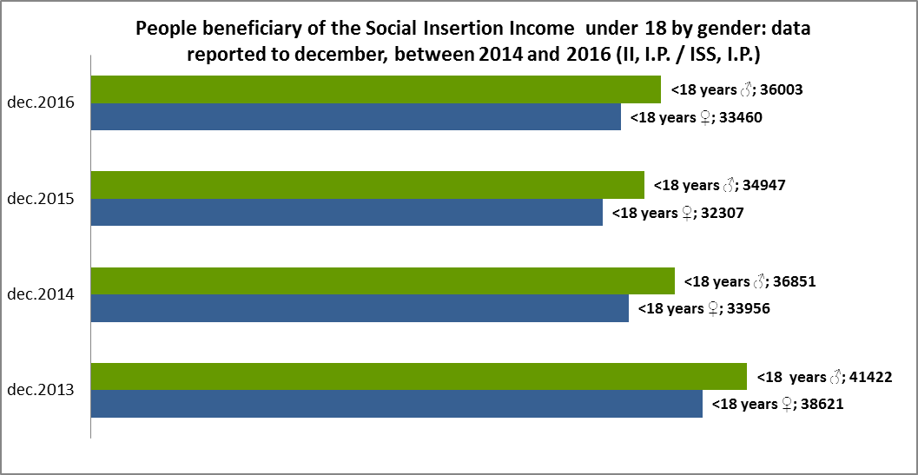

Graph 2 – Financing of Social Responses for Childhood and Youth (2014-2016)
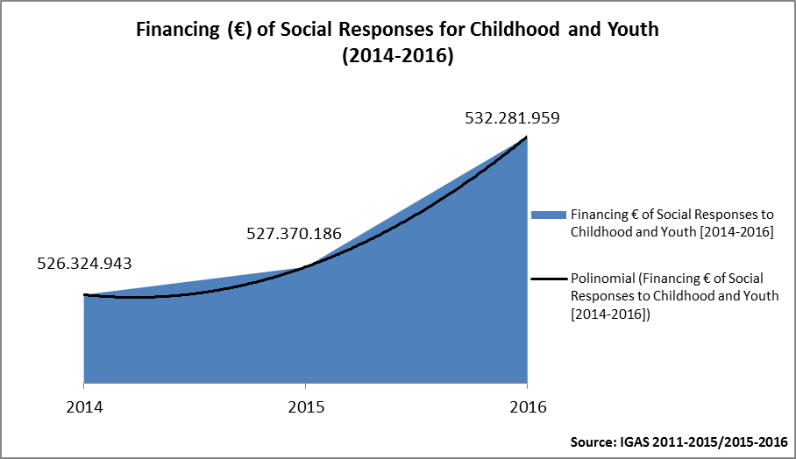

Table 11 - Foster Care Termination Placement
Year | 2014 | 2015 | 2016
Foster Care termination placement | 22% | 23% | 24%
Source: CASA 2016

Table 12 - Technical Accompaniment to social responses with cooperation agreements
Year | UNIVERSE SR | OBJECTIVE |  | EXECUTION
Year | UNIVERSE SR | n.º | % | n.º | %
2014 | 12.828 | 7.055 | 55% | 7.883 | 61%
2015 | 12.970 | 7.112 | 55% | 6.949 | 54%
2016 | 13.153 | 6.577 | 50% | 6.712 | 51%
2017 * | 13.105 | 6.291 | 48% | 2.103 | 16%
* Execution until june, 30th 2017
Source: SISS COOP 2014_2017
Table 13 – Technical accompaniment to social responses with licensing

Year | UNIVERSE SR | OBJECTIVE |  | EXECUTION
Year | UNIVERSE SR | n.º | % | n.º | %
2014 | 1.847 | 930 | 50% | 1.135 | 61%
2015 | 2.037 | 1.021 | 50% | 967 | 47%
2016 | 1.917 | 959 | 50% | 1.062 | 55%
2017 * | 2.230 | 1.071 | 48% | 393 | 18%
* Execution until 30th June 2017
Source: SISS COOP 2014_2017

Table 14 - Children and young people encompassed by agreements following under the social responses
GROUP SOCIAL RESPONSE | SUBGROUP SOCIAL RESPONSE | SOCIAL RESPONSE | 2014 | 2015 | 2016 | 2017 (June)
CHILDHOOD AND YOUNG PEOPLE  [Comprises the responses for children and young people] | Children and young people with disability  [It aggregates social responses directed to children and young people with disability] | Precocious Intervention in Childhood | 6.051 | 6.749 | 6.949 | 7.509
 |  | Support Home | 328 | 289 | 287 | 257
 |  | Transport of People with Disability | 333 | 333 | 333 | 333
Source: SISS COOP 2014_2017

Table 15 – Training actions for people working with children with disabilities
2015 | Nº of Training | Actions | Nº of trainees | Nº Hours
2015 | 1 | Early Childhood Intervention | 18 | 7
2015 | 1 | Autism Spectrum Disorders - Psychopedagogical Models of Intervention | 31 | 7
Total | 2 |  | 49 | 14
 |  | Source : MTSSS
2016 | Nº Training | Actions | Nº of trainees | Nº hours
2016 | 1 | Precocious intervention in childhood | 18 | 7
2016 | 1 | Autism Spectrum Disorders - Psychopedagogical Models of Intervention | 19 | 7
2016 | 1 | Autism Spectrum Disorders - Psychopedagogical Models of Intervention | 12 | 7
2016 | 1 | Autism Spectrum Disorders - Psychopedagogical Models of Intervention | 22 | 7
Total | 4 |  | 71 | 28
Source: MTSSS

Table 16- Proportion of children with medical surveillance until 28 days of age, in the National Health System
2012 |  | 2013 | 2014 | 2015 | 2016
 | 75,88% | 79,10,% | 81,21% | 80,86% | 84,26%
Source: Ministry of Health

Table 17 - Proportion of children with at least 6 medical surveillance visits in the first year of life, in the National Health System
2012 | 2013 | 2014 | 2015 | 2016
38.5% | 44.12% | 57.2% | 59.9% | 65.1%
Source: Ministry of Health

Table 18 - Units of continuous paediatrics care, June 2017
Typology | Beds by Typology – RNCCI and CCISM
 | 2014 | 2015 | 2016 | 2017 | Total
Unit of convalescence | 860 | 764 | 764 | 811 | 3199
Unit of Medium Duration and Rehabilitation | 1895 | 2306 | 2337 | 2548 | 9086
Unit of Long Duration and Maintenance | 3692 | 4411 | 4433 | 4703 | 17239
Unit of Palliative care | 195 | 278 | 278 | 169 | 920
Unit of Paediatric Integrated care |  |  | 10 | 10 | 20
Paediatric Ambulatory Unit |  |  |  | 10 | 10
Childhood and Adolescence Autonomy Training Residence |  |  |  | 6 | 6
Childhood and Adolescence Socio-Ocupational Unit |  |  |  | 10 | 10
Autonomous Residence (RA) |  |  |  | 14 | 14
Maximum Support Residence (MSR) |  |  |  | 24 | 24 | 0
Source: Ministry of Health

Table 19 – Infractions on sale and consumption of alcohol recorded by ASAE between 2013 to 2016

SALE OF DRINKS UNDER 18 YEARS
Infraction | Nº
Sale in public places to children under 18 years | 159
Consumption in public places by persons under 18 years | 0
Source: ASAE
Note: Data only refer infractions detected by the ASAE but the other police - GNR and PSP - also initiate proceedings.

Table 20 - Infractions on sale of tobacco recorded by ASAE between 2013 and 2016
TOBACCO LAW
Infraction | Nº
Lack of notice prohibition of sale to minors under 18 years | 29
Sale of tobacco products to persons under 18 years of age | 6
Sale of tobacco products through vending machines without compliance with requirements | 24
Source: ASAE
Note: Data only refer infractions detected by the ASAE but the other police - GNR and PSP - also initiate proceedings”.

Table 21- Teachers involved in training programs on Gender Equality co-organized by Directorate-General of Education and Commission for Citizenship and Gender Equality
School years | Certified teachers
2012/2013 | 59
2013/2014 | 156
2014/2015 | 150
Source: DGE, October 2016

Table 22 - Number of minors in child labour situations
Working Conditions Authority
 | Less than 18 | *Childlabour  (llegal labour)
2014 | 35 | 0
2015 | 62 | 4
2016 | 190 | 0
Source: ACT, MTSSS
*Violation of the legislation on minimum age and compulsory education
In http://www.act.gov.pt/(pt-PT)/SobreACT/DocumentosOrientadores/RelatorioActividades/Paginas/default.aspx

