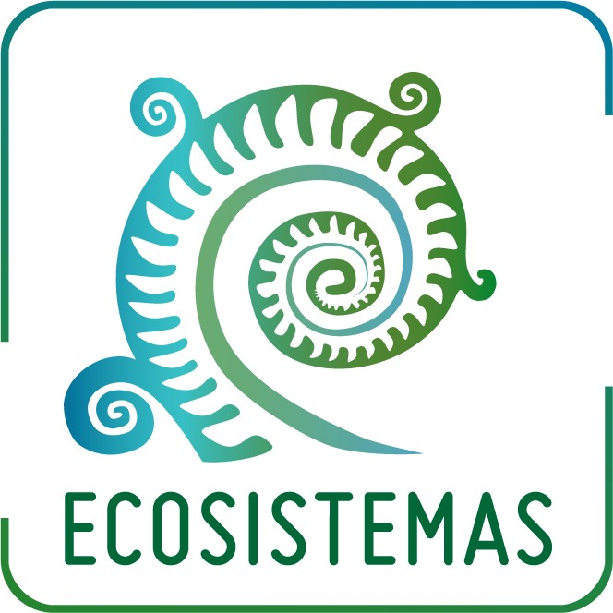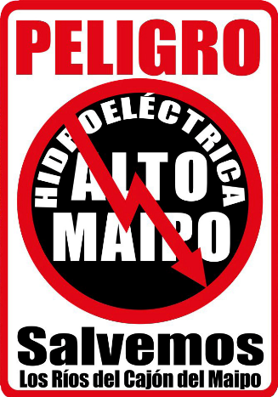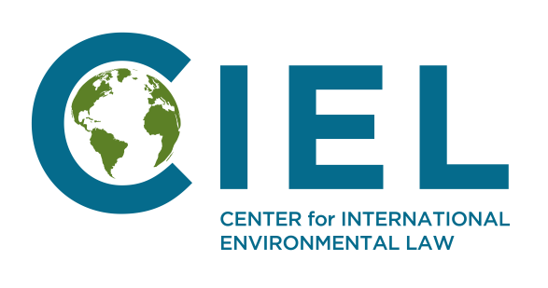

Parallel Report to the Fifth Periodic Review of Chile by the Committee on Economic, Social and Cultural Rights

Presented by: The Coordinadora Ciudadana No Alto Maipo, Ecosistemas, and the Center for International Environmental Law

Executive Summary

The Alto Maipo Project is a large-scale hydroelectric project being constructed in the Cajón del Maipo, approximately 50 kilometers southeast of the Chilean capital of Santiago. The project consists of capturing much of the water of the three main tributaries of the Maipo River and rerouting it through a system of tunnels bored in the Andes Mountains, using underground turbines to generate electricity. In addition to depriving 100 kilometers of the Maipo river valley of this water, this massive intervention in the Maipo river basin will affect access to water for millions of people, undermine local economies, and exacerbate the effects of climate change. Opposition to the project has been ongoing for nearly 12 years, with legal challenges being paired with multiple marches held by a grassroots movement and joined by thousands of Chilean citizens calling for the project’s cancellation and the protection of the Maipo River.

We highlight this situation for the Committee’s attention ahead of the upcoming Periodic Review of Chile, underscoring that the project is violating Chileans’ rights in the following ways:

The right to water: The Yeso, Volcan, and Colorado rivers, tributaries of the Maipo River, are the main source of drinking water for more than 7 million people in the Santiago metropolitan area. The project is estimated to diminish the flows of these rivers by 60-90%, putting the right to water at severe risk.

The rights to life and health: As the Committee has noted, water is essential for life and health. By threatening Chileans’ access to water, this project also jeopardizes these fundamental rights.

The right to food: The Maipo river basin provides irrigation water for over 120,000 hectares of farmland. Rerouting its rivers will paralyze the region’s agriculture, threatening the right to food.

The right to work: The Cajón del Maipo is one of Chile’s most important tourist and recreational areas. Rerouting its rivers will devastate the livelihoods of residents of this area and undermine entire local economies, which have long depended on tourism.

The right to work in adequate conditions: Since construction on the project began, the workers’ union has consistently denounced the insufficient safety measures for those working within the tunnels, as

well as a lack of due diligence regarding excavation and construction methods. These dangerous conditions have resulted in several worker injuries and even one death.

The right to adequate housing: The construction of a forebay for the project has severely affected the town of El Alfalfal, which has been surrounded by a barrier wall. Residents essentially live in the middle of a construction site, with increasingly limited access to their own homes.

The right to participate in cultural life: The project also threatens the Cajón del Maipo’s monuments, natural sanctuaries, and protected heritage sites of archeological and paleontological value, which could be lost forever.

The right to a healthy environment: In light of the crucial connection between the environment, climate change and the enjoyment of economic, social and cultural rights, as recognized, inter alia, by the Human Rights Council at its 41st session in July 2019, we consider it necessary to outline some of the environmental ramifications of the Alto Maipo Project. Of great concern is that the project will reduce rainfall and aggravate the decade-long mega-drought that Chile has experienced, contribute to a process of desertification, prevent the recharge of underground aquifers, and increase the fissuring of Chile’s glaciers – all of which exacerbate the impacts of climate change. Therefore, affected communities also question the project’s Clean Development Mechanism (CDM) designation under the UNFCCC.

The Alto Maipo Project’s adverse impacts for Chileans’ economic, social, cultural and environmental rights are indicative of the long-term effects of hydroelectric projects and large-scale energy infrastructure, with impacts already being felt throughout Chile. Therefore, we respectfully ask the Committee to request that the State of Chile provide additional information regarding the following:

Please explain what concrete measures the State Party has taken or intends to take to mitigate the negative impacts of energy infrastructure – including hydroelectric projects, such as the Alto Maipo Project – and to guarantee the rights to housing, water, food and health of persons living in affected areas.

- Please provide information regarding measures adopted by the State Party to ensure that energy projects, such as the Alto Maipo Project, do not exacerbate the climate-related phenomena that threaten economic, social and cultural rights, including prolonged drought, glacial melting, desertification, and the destruction of ecosystems.

For more information, please contact:

Marcela Mella Juan Pablo Orrego
Coordinadora Ciudadana No Alto Maipo Ecosistemas
marcelafloisi@gmail.com | +56 9 9094 9063 jp.orrego@ecosistemas.cl | +56 9 9349 9236

Carla García Zendejas
Center for International Environmental Law cgarcia@ciel.org | +1 202 742 5846

