List of Issues and Questions Report
for the examination of Sri Lanka’s State Party Ninth Periodic Report during the
86 (PSWG) Pre-Sessional Working Group (27 Feb 2023 - 03 Mar 2023) by the
Convention on the Elimination of All Forms of Discrimination against Women (CEDAW) Committee

ISSUES AND CHALLENGES FACED BY MUSLIM WOMEN AND GIRLS IN SRI LANKA

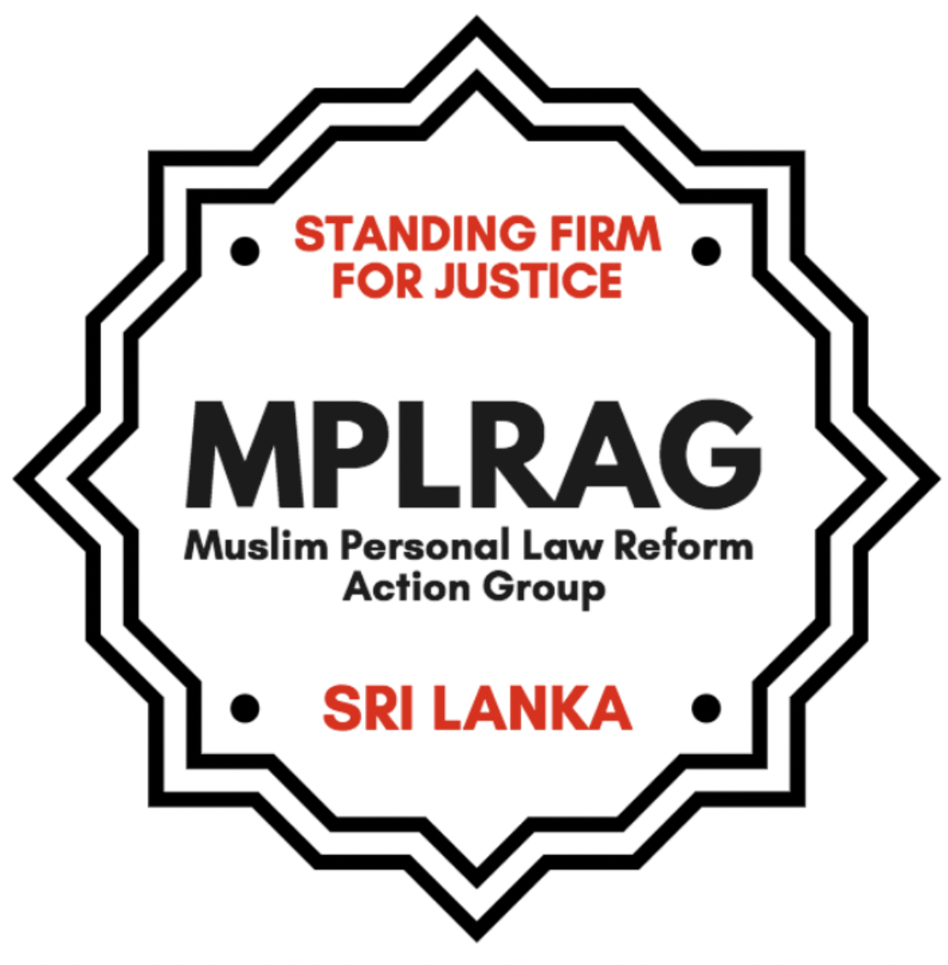
SUBMITTED BY MUSLIM PERSONAL LAW REFORMS ACTION GROUP (MPLRAG)
MPLRAG is an independent group of Sri Lankan Muslim women who are primarily rights advocates, lawyers, researchers and writers. We are a collective driven by our personal experiences, our accountability to those whose stories we represent, and our commitment towards an egalitarian Muslim family law and family court system. It is our conviction that all Muslims in Sri Lanka, women and men, should have equal access to legal rights, justice and redress on matters of marriage and family. As citizens of Sri Lanka, Muslims too must have the same protection of fundamental rights guaranteed by the Constitution.
More information: www.mmdasrilanka.org
Report submitted: 26th January 2023
- THE MUSLIM MARRIAGE AND DIVORCE ACT CONTINUES TO BE BLATANTLY DISCRIMINATORY AND UNJUST
Sri Lankan Muslims are governed by a separate family law - the Muslim Marriage and Divorce Act (MMDA), enacted in 1951. There is also a separate Quazi (Muslim judge) system that administers the MMDA around the country. The 1907 Sri Lankan (General) Marriage Registration Ordinance (GMRO) is applicable to all citizens of the country with the exception of Muslims who marry within the faith. Kandyan Sinhalese have the option to marry under the 1952 Kandyan Marriage and Divorce Act as well as the GMRO. However this option does not extend to Muslims as only the Muslim Marriage and Divorce Act 1951 (MMDA) governs Muslims inhabitants who marry another Muslim (including converts to Islam).
The MMDA violates the rights of Muslim women and girls and limits access to justice, due process and redress. These concerns are with regard to provisions within the Act itself as well as practical problems with procedures and implementation via the Quazi.

Some of these issues with regard to serious infringement of rights in the substantive law include:
- The MMDA legally allows child marriage for Muslims, as there is no stipulated minimum age of marriage. Under the MMDA, a Quazi can even permit the marriage of a child under the age of 12. However, the minimum age is 18 without exception for all other citizens of Sri Lanka.
  - MPLRAG notes that community groups are reporting an increase in cases of child marriage and school dropouts of girls during the first years of the pandemic, as well as the ongoing economic crisis.
  - Education of young women and girls who get married early is often discontinued, significantly limiting their higher educational and economic opportunities. This compels them to be highly susceptible to grave financial difficulties in the event that husbands are unable or unwilling to provide maintenance, in case of death of husbands, polygamy, divorce or abandonment.
- Women are not allowed to be Quazis, marriage registrars, jurors or Board of Quazi members under the MMDA. Under the MMDA, the position of Quazi is allowed for “Muslim male of good character”. It is a state-salaried and tax-funded position that women are denied;
- The MMDA does not require a mandatory (and written) consent from the bride, hence bride does not sign her own marriage documents;
- There are different conditions of divorce for men and women:
  - Husbands are granted the right to unilateral divorce without any reason (Talaq);
  - Divorce by wives (fasah) is procedural and practically a lengthy, requiring wives to submit reasons and evidence, witnesses and to attend multiple hearings;
  - Under a certain Shia sect there is no option for wives to even initiate a divorce on their own or for the Quazi to grant her a divorce without the express permission or consent of the husband’

5. There is no criteria or guidance in the law for calculating wife and child maintenance and it is completely dependent on the Quazi (judge). Women and children often get very little maintenance as revealed in a study conducted in 2021, an average 13 USD per month for children and 15 USD per month for wifes.

6. Practice of polygamy is permitted without any conditions. There is no check and balance whatsoever to ensure that harm is not caused to spouses and children. There is no basic requirement of ascertaining the consent of the existing wife/s or wife or even an inquiry into whether the husband is able to financially maintain another family.
Access to justice:
Muslim women’s access to justice is severely restricted within the Quazi system. Affected women have articulated in multiple forums that they are discriminated against by the sub-par Quazi system, which is significantly different from the civil court system and doesn’t allow for litigants to have legal representation. There is no minimum mandatory qualifications or compulsory training for Quazis. Quazi positions are often political appointees, and an all-male panel of jurors (with no qualifications) are selected by Quazis arbitrarily, to advise on divorce hearings.

Women are often:
- Mistreated and harassed by incompetent Quazis;
- subjected to unreasonable conditions or requirements (insistence on male witnesses, father’s presence at divorce proceedings, compelled to give up claims for reasonable compensation or maintenance);
- Unable to express their version of the facts without fear of being verbally abused, threatened and humiliated by the Quazi;
- Vulnerable to financial and sexual bribery. There have been complaints of Quazis asking for and taking bribes in exchange for information or to proceed with cases, and also to delay giving women or child maintenance payments by husbands.

These issues have further exacerbated during the COVID-19 pandemic and Sri Lanka’s ongoing economic crisis. Human Rights Watch reported lack of MMDA reforms as one of the key women’s rights issues in 2022/2023 for Sri Lanka.

The Sri Lankan government has the primary duty to address issues faced by Muslims under the MMDA and the Quazi court system, which was established, administered and is funded by the state. It has the foremost responsibility to ensure that State laws protect the rights of citizens and does not result in discrimination and injustice. It cannot suspend the individual and fundamental rights of citizens in the name of the cultural and religious rights of any group.

2. LONGSTANDING CALLS FOR REFORM
Over the past 40 years, various groups, especially Muslim women’s groups have been advocating and lobbying for reforms of the Muslim Marriage and Divorce Act (MMDA). They continue to do so in the face of serious reprisal, harassment and intimidation by conservative groups. Since 2016, MPLRAG has consistently been advocating for comprehensive reforms to the MMDA and the Quazi system.

State institutions, including the National Child Protection Authority and the National Human Rights Commission have not adequately responded to issues affecting Muslim women and girls - including intervening in child marriage complaints, often citing that such harmful practices have the legal cover of the MMDA. Despite very limited resources, community women’s groups have been the first responders, supporting women and girls with legal information and counseling and guiding them through their divorce, maintenance and also domestic violence cases.

Since 1970, few official attempts at reforming the MMDA have been to no avail. The last significant attempt was a Committee appointed by the former Minister of Justice Ali Sabry in December 2020 to reform the MMDA. This committee submitted its report in July 2021, however, there has been no reported progress to date.

Online and verbal attacks against Muslim women activists: In the last few months in particular (November 2022- January 2023), women activists across Sri Lanka have come under threat, from conservative Muslim individuals and groups, for advocating for reform to the MMDA. As the reforms are further delayed, these attacks become more frequent. MPLRAG has noted online harassment campaigns through videos, memes and posts, as well as Friday sermons, protests and speeches organised by the All Ceylon Jamiyyathul Ulama (ACJU) and associated mosque committees and groups, which has created a hostile climate of intimidation for Muslim women activists.
Such actions have the potential to create dangerous conditions for activists, as the possibility of physical harm is high. Security and safety of Muslim women and groups pushing for MMDA reform is an utmost priority.

According to Sri Lanka’s State Party Report:
140. A Cabinet Memorandum has been submitted on 11th November 2020 to change the minimum age for marriage to 18 years for both male and females. The reforms have also included recruiting women Quazis to Board of Quazi members, as marriage registrars and adjudicators. At the Cabinet meeting held on the 8th March 2021 instructions were given to the Minister of Justice to instruct the Legal Draftsman to draft legislation on (a) age limit of Muslim marriages (b) introduce laws to abolish Quazi courts and prohibit polygamous marriages of Muslim men.
Suggested questions for the State Party:
Please provide an up to date account of the detailed actions by the Ministry and the Legal Draftsman since 8th March 2021 was asked to draft legislation.
Please provide an approximate timeline for when the Bill to amend the MMDA will be completed and tabled before the Parliament.
According to recent news reports, MP's are said to have reached consensus on MMDA reforms, however conservative groups continue to scuttle and delay reforms by negatively targeting women’s rights activists. What action has the State taken or plan to take to protect women’s groups and activists from such harassment and intimidation?
3. THE PENAL CODE FAILS TO PROTECT THE RIGHTS OF MUSLIM WOMEN AND GIRLS
According to the Section 363 of the Sri Lankan Penal Code sexual intercourse with a girl below 16 years of age, with or without consent, amounts to statutory rape. However, pushback from mainly Muslim religious leaders and politicians, during the time the Penal Code was being amended in 1995 to include statutory rape provisions, meant that the provision does not apply to married Muslim girls under the age of 16 and above the age of 12, unless judicially separated. As a result, in the case of Muslims, the relevant age for statutory rape is 12 years.
Furthermore, because there is no provision for judicial separation in the event of a talaq divorce and the wife is required to stay at the husband’s residence for a period of up to three months (iddat period) after the first pronouncement of divorce. Women are not protected by the Penal Code provision even in the event that forced sexual intercourse (marital rape) occurs during this time.
On issues such as minimum age of marriage, the Sri Lankan government is mandated to establish an age that is suitable for all citizens and protect child rights and promote education, health and wellbeing. Putting perceived cultural and religious rights before gender equality and child rights and legally allowing for Muslim minors to be given in marriage at an earlier age and legally exempting their protection under the Constitution and Penal Code is a serious violation of this State responsibility.
According to the Sri Lankan State Party Report: ‘146. Once the amendment to Muslim Marriages and Divorce Act is approved a consequential amendment will be brought into amend the Penal Code.’
Suggested questions for the State Party
Please provide us with reasons as to why Muslim girls continue to be excluded from Section 363 of the Penal Code on statutory rape and what is the logic in failing to secure this legal protection without any delay by waiting until after the broader reforms to the MMDA is secured?
How will the Sri Lankan government promote and ensure that minority Muslim women are also equally protected under the state laws?

4. THE CONSTITUTION FAILS TO PROTECT THE RIGHTS OF MUSLIM WOMEN AND GIRLS
Article 16(1) of the Sri Lankan Constitution together with no constitutional provision for judicial review effectively precludes Sri Lankan Muslims, and Muslim women in particular, from utilizing the fundamental rights guaranteed under the Constitution. Article 16 proclaims any law dated prior to 1978, which includes Muslim personal laws, as being consistent with the fundamental rights provisions of the Constitution, including the equality provision, regardless of the explicit or implicit impact of the law. This has been the main barrier preventing Muslim women and girls from being protected by the Constitutional guarantees of equality and nondiscrimination, and rendering them second class citizens.
According to the Sri Lankan State Party Report - ‘21. The expert committee appointed by His Excellency the President to draft the new Constitution will look into the Repealing of Article 16 (1) of the Constitution. In addition, a subcommittee is appointed by the Ministry of Justice to look into the civil law reforms which are complimentary to the new constitutional development….’

Suggested questions to the State Party:
Why has perceived ‘religious and minority rights’ been allowed to trump equality and human rights which the State must guarantee?
Is the State considering introducing post enactment judicial review to enable those citizens whose fundamental rights as guaranteed by the constitution when violated by a law or particular interpretation or implementation of the law can be challenged by such citizen before the judiciary?
Please provide us with a detailed update of the actions taken since the expert committee was appointed and a reasoning for delays in repealing Article 16(1) of the Constitution.
Please provide us with a detailed timeline for when Constitutional reforms are expected, in order to ensure that fundamental rights apply to all citizens uniformly regardless of religion or sex.

5. HARMFUL PRACTICES AFFECTING MUSLIM WOMEN AND GIRLS - Female Genital Mutilation (FGM):
According to recent research, the practice of female genital mutilation (FGM) or ‘Khatna’ appears to be widespread and common-place among sections of the Dawoodi Bohra community in Sri Lanka. General perceptions from people interviewed is that FGM is still practiced among 80-90% of the community, possibly more. Case studies indicate that the practice is being done to children a few days or months after birth and also to young girls who are 7 years of age. The practice is carried out by traditional practitioners and also by registered medical practitioners from within particular communities. The practice continues to be shrouded in secrecy and there have been no state measures to sensitively and constructively address the practice and the emotional and physical impacts of it.
There is currently no law specifically prohibiting the practice of female genital mutilation in Sri Lanka. There exist written edicts by religious bodies promoting the practice and the state of Sri Lanka has not responded to any of them. As a result of fears of ostracization there is no public debate. The attention of national institutions such as the National Child Protection Authority and the Human Rights Commission have been drawn to this issue. There is palpable hesitancy on the part of public institutions to engage with what is seen as a “community” issue and have expressed concern of publicly engaging on based on anonymous complaints.
It is clear that there is a fear of engaging in controversy and perhaps prompting religio-political tensions particularly with Muslim community mainly male leadership, is causing State institutions to refrain from engagement. As a result there is no means of redress for the girl children who have to undergo this mutilation. As a child abuse situation there should be no hesitancy on the part of State institutions to intervene and protect the rights of these girl children.
According to the State Party Report - ‘152. The SDG 5.3.2 focuses on the elimination of all harmful practices including female genital mutilation. The issue which was hidden has emerged recently in the public and women’s groups are having public discussions on its consequences. Muslim women’s groups have approached state authorities and are lobbying with the Government to take necessary action to mitigate the situation and to be recognized as a crime. It has become a public health issue as well as a child abuse issue. The Section 308(A) (1) of the Penal Code states that any person who causes willful assault, ill- treatment, neglect or injury to the health of a person under the age of eighteen commits the offense of cruelty to children punishable with imprisonment not exceeding ten years and compensation to the victim.

Suggested questions to the State party:

How has Section 308(A)(1) of the Penal Code which has been cited as sufficient law to address the practice been used towards addressing the practice?
What health and legal measures have been taken by State bodies that have received information relating to the practice of FGM?
What measures have been introduced to Sri Lanka’s family health services and community health services to provide expertise to identify the practice, and advice and support persons impacted by the practice?

[1] Section 363 of the Penal Code of Sri Lanka.
[4] Divorce initiated by husband.
Hyshyama Hamin & Hasanah Cegu Isadeen, Unequal Citizens: Muslim Women’s Struggle for Justice and Equality in Sri Lanka, 2017, https://www.mmdasrilanka.org/unequal-citizens-study/
Zainab Ibrahim & Ermiza Tegal, Towards understanding Female Genital Cutting in Sri Lanka, December 2019. Available at http://www. fpasrilanka.org/sites/default/files/towards_understanding_female_genital_ cutting_in_sri_lanka.pdf
MPLRAG Demands for MMDA reforms https://www.mmdasrilanka.org/demands/
Human Rights Watch, World Report 2023 - Sri Lanka https://www.hrw.org/world-report/2023/country-chapters/sri-lanka
Tegal, E & Cegu-Isadeen, H. (2021) Inside the Quazi Courts of Sri Lanka” Change Organization https://www.mmdasrilanka.org/wp-content/uploads/2022/06/Inside-the-Quazi-Courts-System-in-Sri-Lanka-by-CHANGE-Humanitarian-Organization-English.pdf
UNICEF Sri Lanka, July 2013, ‘Emerging Concerns and Case Studies on Child Marriage in Sri Lanka’ http://www.unicef.org/srilanka/2013_Child_Marriage_Case_Studies.pdf
In 1995 after extensive lobby by civil society organizations including women and child rights groups, the Penal Code (Section 363) was amended for statutory rape to mean sexual intercourse with any girl below the age of 12, with or without her consent “...unless the woman is his wife who is over twelve years and not judicially separated from the man”, thereby applicable only to Muslim girls.
Ninth periodic report submitted by Sri Lanka under article 18 of the CEDAW Convention https://tbinternet.ohchr.org/_layouts/15/treatybodyexternal/Download.aspx?symbolno=CEDAW%2FC%2FLKA%2F9&Lang=en
Ninth periodic report submitted by Sri Lanka under article 18 of the CEDAW Convention https://tbinternet.ohchr.org/_layouts/15/treatybodyexternal/Download.aspx?symbolno=CEDAW%2FC%2FLKA%2F9&Lang=en
Ninth periodic report submitted by Sri Lanka under article 18 of the CEDAW Convention https://tbinternet.ohchr.org/_layouts/15/treatybodyexternal/Download.aspx?symbolno=CEDAW%2FC%2FLKA%2F9&Lang=en

