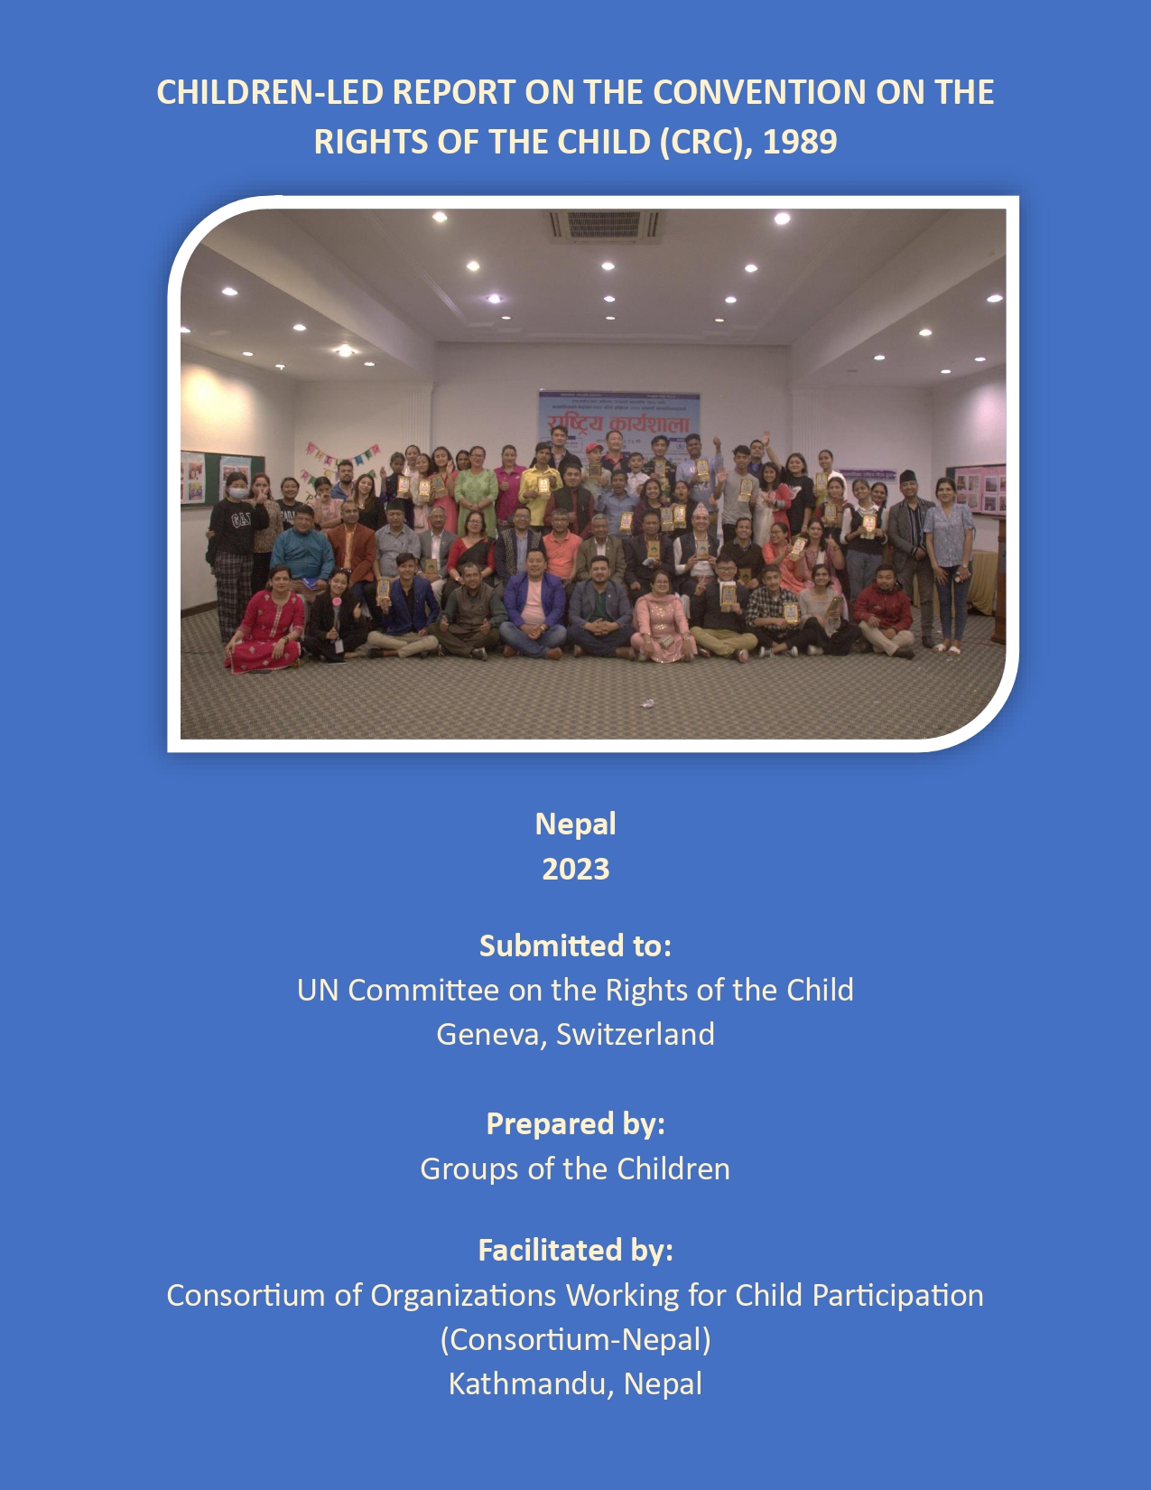

Coordination:
CRC Reporting Coalition Nepal
19 July 2023
To:
The Committee on the Rights of the Child
United Nations Human Rights Office of the High Commissioner
Palais Wilson 52 Rue des Pâquis CH-1201
Geneva, Switzerland
It is a great honor for us to submit second Child-led Convention on the Rights of the Child (CRC) report in OHCHR through Consortium of Organization working for Child Participation (Consortium Nepal).
Consortium Nepal, 1999 is a leading network to advocate for children's meaningful participations in all levels of Nepal. With regards to UN system and mechanism, Consortium Nepal prepared and submitted the first child led Report on CRC in 2014 to the UN Committee on the Rights of the Child from Nepal. A girl and a boy participated in the 69th pre sessional working group and presented the situation of Nepali children in CRC Reporting process. It facilitated the process of the first ever Girls led Report on CEDAW in 2018. Also, it facilitated in the Child led Universal Periodic Review (UPR) Report (3rd cycle).
With the same motive of meaningful participations of the children, Consortium Nepal is again facilitating in reporting process of Child- led Convention on the Rights of the Child (CRC) Report in Nepal. In this report, children themselves engaged and write up the report that represents the child rights situation of all the Nepalese children.
The Convention on the Rights of the Child (CRC) is the most universally accepted human rights instrument and the only convention focused on children to ensure their overall rights, survival, development, protection and participation. The participation of children in CRC provides opportunities to express their views in matter of their concern.
Finally, we want to thank everyone who supported the children's write-up team, who actively participated in the entire writing process of the CRC Report. We are also grateful to all of the children who engaged in the consultation process, either directly or indirectly, and contributed to increase awareness of local child rights concerns. Our heartfelt gratitude goes to the parents who worked with us to ensure that children participated in all of the consultations held during the report preparation process. We must express our gratitude to the technical team members who assisted the report's write-up team members in completing the report. We extend our heartfelt gratitude to everyone of Consortium Nepal's civil society coalitions, development partners, executive committee members, and secretariat personnel.

Yours faithfully,

On behalf of Nepalese children:

Miss. Prekshya Adhikari
Miss. Ashmita Chaulagain
Miss. Swostika Pathak
Mr. Dipendra Rajaili
Mr. Kristina Niraula
Mr. Saurav Khadka
Miss. Bhumika Shahi
Miss. Sapana Malasi
Miss. Reshma Majhi
Mr. Abhishek Poudel

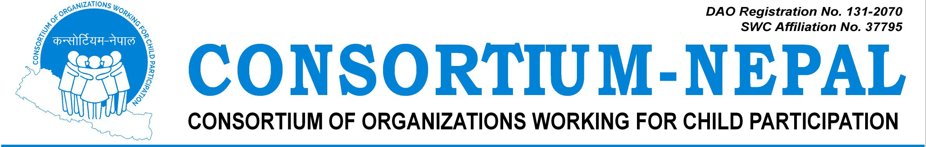
19 July 2023

Honorable Chairperson
Committee on the Rights of the Child
United Nations Human Rights Office of the High Commissioner
Palais Wilson 52 Rue des Pâquis CH-1201
Geneva, Switzerland

It has been more than two decades since the establishment of the Consortium of Organizations Working for Child Participation (Consortium-Nepal) with the primary goal of safeguarding children's right to participation in Nepal. As a national-level network, it comprises 91 organizations spread across all seven provinces.

In accordance with the UN system and mechanism, Consortium-Nepal, under the leadership of children, took the initiative to prepare and submit the first Child-led Report on the Convention on the Rights of the Child (CRC) in 2014 to the UN Committee on the Rights of the Child. This report offered insights into the situation of Nepali children in the CRC Reporting process, and it was presented by a girl and a boy from Nepal during the 69th pre-sessional working group meeting in Geneva, Switzerland in September 2014.

Consortium-Nepal has continued to foster child-led initiatives and has successfully facilitated the preparation of the first-ever Girls-led Report on the Convention on the Elimination of All Forms of Discrimination Against Women (CEDAW) in 2018 and the first-ever child-led report for the Universal Periodic Review (UPR) in 2020. Through these commendable efforts, Consortium-Nepal has been actively promoting the meaningful participation of Nepali children in the reporting process.

Today, we are proud to announce our second attempt at submitting a Child-led report to the Committee on the Rights of the Child, once again led by children themselves. This report comprehensively documents the major issues affecting children in Nepal, and it was collaboratively prepared with the direct participation of children from all seven provinces.

We extend our heartfelt gratitude to all the children, Steering Committee Members, Children's Advisory Board Members, Adult Advisory Board Members, CRC Reporting Coalition Nepal and its member networks, parents, and member organizations who provided invaluable guidance, suggestions, and contributions throughout the process of preparing this report. Our thanks also go out to the dedicated staff and facilitators who were involved in every step of this undertaking.

Furthermore, we express our deepest appreciation to our development partners for their unwavering support in finalizing this Child-led UN CRC Report.

Let us reaffirm our commitment to ensuring meaningful child participation, from families to the state. Together, we can work towards a brighter future for all children.
Sincerely,

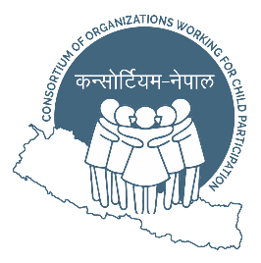
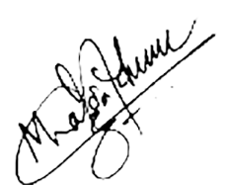

Mohan Dangal
President
Consortium Nepal

Consortium-Nepal Secretariat, PragatiMarga, Sankhamul, Kathmandu-10, Kathmandu, Nepal
Phone No: +977-1-4781327, E:Mail: participation.consortium@gmail.com, URL: www.consortium.org.np

SUMMARY
1. Nepal ratified UNCRC, 1989 on 14th September, 1990. Since then, Nepal has legally ensured child rights. And once in every four and half year, Nepal submits UNCRC report to OHCHR updating about situations, progress and recommendations on Nepalese children. Likewise, In 2014 Nepalese children prepared ''Children Led Report on UNCRC, 1989''realizing the need of children's voice and report in UNCRC Committee by children themselves, where children shared about situations, progress, and recommendation to Nepal government and UN Committee to strengthens and ensure the rights of every children.
2. This is the second "Children Led Report on UNCRC,1989" which is prepared by children of Nepal with support, and facilitation by Consortium Nepal and former write-up team leaders who had worked on ''Girl Led Report on CEDAW'' and ‘'Child Led Report on UPR, III cycle''. It was prepared by children (91 girls, 72 boys) from 13 districts of Koshi province,8 districts from Madesh province, 11 districts of Bagmati province, 9 districts of Gandaki province, 10 districts of Lumbini province, 5 districts of Karnali province, 8 districts of Sudurpashim representing all 7 provinces of Nepal. Similarly, 10 boys and 11 girls from Koshi Province, 8 boys and 11 girls from Madesh Province, 10 boys and 17 girls from Bagmati Province, 7 boys and 9 girls from Gandaki province, 12 boys and 8 girls from Lumbini Province, 11 boys and 10 girls from Karnali Province, 7 boys and 9 girls from Sudur Pashim Province. Its objective is to identify the challenges and actions that are taken to improve child rights situations at local levels in a child-friendly way.
3. "Provincial consultation" was held in all 7 provinces of Nepal where children were oriented about the CRC and the importance of Children Led CRC. Then, Child-led consultations were done to discuss and collect children’s issues in child-friendly ways (wall magazine, poem, drama, story, essay, letter, quiz, picture, drawing, case, questionnaire, audio, video, etc.). After that, a "National Validation Workshop" was organized in Kathmandu where the children discussed on achievements, problems and recommendations of Nepalese children. Throughout the discussion, we found issues like child marriage, child labor, lack of adolescent-friendly infrastructures, menstrual health, cyber-crimes, sexual abuse and exploitation, service gaps for children with disability, gender disparity etc. After that, The "Report write-up team" of 10 children i.e. 7 girls and 3 boys that includes the child with disability, child from rural and undeveloped communities, was formed and the report was finalized and submitted in technical guidance of Consortium Nepal.
4. Consortium Nepal is an umbrella organization of different organization and NGOs working in the field of child right. It has been working in ensuring child participation from constitution to practice since 1999 and Consortium Nepal has facilitated various children led reports since 2014 to ensure and strengthen children's voice and issues in international level/UN forums.
5. The problems of children are not properly addressed, though government take our suggestions but our voice remains unheard when it comes to action. As a child representative, we know that we children feel comfortable to express our word by selves rather than being expressed by the adults. We know our exact problems from the ground level. We are also responsible for not letting the people to forget about child rights. We can get a very good improvement in national level through this work. It is an opportunity to make our government responsible towards us and make our voices heard in international level.
"Our problems will remain as a complication to the nation until our voice is heard."
PROCESS
1. Provincial consultation: Children participated in provincial consultations on Child Led UNCRC Report in all seven provinces of Nepal. The discussion with the children who are under alternative care, LGBTIQA++ children and with children with disability was also done which was issue based discussion. In these consultations children were oriented about the CRC and importance of Children Led UNCRC. Then, Child-led Consultations were done to discuss and collect local child issues in child friendly ways (poem, song, drama, story, essay, letter, quiz, picture, drawing, case, questionnaire, audio etc.) Then the presentation was done by children along with stakeholders.
2. Issue Based Consultation: To ensure active participation from all the communities, issue based consultation was held. The main objective of issue based consultation was to organize focused group discussion with different groups of children. A discussion with different groups of children i.e. Alternative care, LGBTIQA++, children from labor sector ,children with disability, and children from Haruwacharuwa community. Likewise, 24 children from Alternative care including 13 girls and 11 boys, 12 children from LGBTIAQA++, ... from labor sector including ... boys and... girls, 16 children with disability including 8 girls and 8 boys, 25 children from Haruwa charuwa community including 14 girls and 11 boys.
3. Child-led Community Consultation: The consultation was a brainstorming session as children who participated in session conducted meeting in their respective local level to bring out issues regarding children as each participant of the provincial consultations were provided with the forms which the participant discussed in their family, communities, child clubs and schools in a child-friendly ways. Consultation was done with LGBTIQA++ children including children and also children with disability. Then they sent those forms to Consortium Nepal. Thus, all the children and their guardians were directly and indirectly involved in this process.
4. National Validation Workshop: After provincial consultations, National validation workshop was held in Kathmandu where there was inclusive participation of children (two selected participants-1 girl and 1 boy) from seven provinces. There were total 22 children participating in the workshop (10 boys and 12 girls). Here, the participant children were oriented about Child Led UPR Report. Also, a sharing was done on how Consortium Nepal facilitated and submitted "Child Led Report on CRC" and "Girls Led Report on CEDAW", "Children Led Report on UPR, III cycle". Afterwards, children worked in 4 different groups according to 4 pillars of child rights. The social issues like child marriage, child labor, lack of adolescent friendly structures, menstrual hygiene, sexual exploitation, service gaps for physically challenged, gender disparity etc. were raised. It was presented by children in child friendly way like drama, poem, letter, wall magazine, song, picture, paint, story etc. Then, children write-up team was formed that comprised seven provinces (7girls and 3boys) to write Children Led CRC report based on the view collected from children of all provinces. The closing session was done by cultural programs in which children wore their cultural dress and a short program in the evening was conducted which included dancing and singing.
5. Report Write-up and Submission: . Through the group discussion, write-up team had ..... meetings. In the first meeting, the team was oriented on the technical aspects of the report. Then, the team started writing the report in other meetings. Also, the recommendations to Nepal in UPR Second Cycle and other various child related articles were studied under the guidance of technical support team including girl co-leader of "Girls-led report on CEDAW ". Then, the Report was finalized and submitted by the children write-up team themselves in OHCHR.
RIGHT TO SURVIVAL
Unsafe motherhood: Nepali mothers work in the time of delivery as well which is harmful to the children. No proper nutritious food is provided to her and breast milk is not produced in adequate amount due to which most of the children has been suffered from malnutrition. Early pregnancy also results to unsafe motherhood and death of both children and mothers.
What we have seen: Many campaign for safe motherhood can be seen. Providing with nutritious package of food for mother and child, Rs 400 for each child under age of 5 is given in many districts like jumla,humla and so on. Nutritious allowances are provided in government hospitals to mother and child for post maternal care who have regularly come for checkup during the pregnancy.
What we have faced: A pregnant women from Kushe rural municipality ward 6 was admitted to Gharanga health post for three days after she started labor pain and later on she was referred and moved to another district hospital which resulted in complications while delivering her baby and could had leaded to health risk of mother and child.
What we want: Checking if any mother or children are under malnutrition. Providing nutritious food to them through different local level like health posts or any other health institution free of cost. People should be aware about safe motherhood and early pregnancy.
Lack of proper medical health facilities: Many children and mother are not getting proper medical facilities due to lack of medical instruments. Heath experts also refuses to go to rural places and try to stay in urban and developed places due to which heath facilities are not enough in rural areas. There are very few hospitals and health post in rural areas. Children even have to face death because they could not get health facilities in time. There is lack of nurses and medical rooms in all school.
What we have seen: Medical instruments are reached to only some places. Government has started "one school one nurse" program in Bagmati province in selected schools. First aid kits are provided in different schools and health institutions. People also get free medicines, free health checkups, access to vaccination without any discrimination.
What we have faced: One of the child from Dailekh Nepal suffered from Pneumonia when he was two years old but due to lack of treatment and medical health facilities he died at the age of two and half years.
What we want: Access of medical experts like doctor and nurses in rural areas as well. Health institution should be nearby us, not too far. "One school one nurse" programs should be strictly implemented in all schools and the effectiveness should be monitored.

Lack of proper nutrition:-
During pregnancy and after the birth of the baby, mother and child both needs proper diet in balanced way but due to lack of proper knowledge they are deprived of getting proper nutritious food. Due to which, the child born will have to suffer from malnutrition related diseases and other malfunction body organs or parts.
What we see:- Our government has implemented many programs related to safe motherhood, iron tablets for pregnant women, and other tablets like calcium and folic acid, free health checkup , vaccination are provided in every sectors . The constitution of our country articles 39 has ensured rights to health and nutrition and proper breast feeding up to 2 years is provided, certain amount of money is given to the mother after delivery. There is provision of providing Rs20 in five districts of Karnali (Kalikot, Humla, Jumla, Mugu, Dolpa ) and Rs15 in all the government schools of Nepal.
What we have faced:-A girl living in Illam had seen many pregnant women in her neighborhood not having the nutritious food in balanced way during the phase of pregnancy and afterbirth. And the local government of her place doesn't inform the local people about provision of nutritious diets for mother and child and doesn't implement it in require time.
What we want :-We want the local government of our country to work along with federal government and provide all the required facilities to the pregnant women. Notify them about the if there is any prevalence of support system by federal government and run program regarding proper diet for mother and baby.
Abortion: -
In our country many people abort according to sex in desire to have boy. And if there is no provision of the advance abortion facilities either they use harmful material like rod or other harmful substance. some of the family used to torture or kill the mother if she doesn't give birth to a boy after a long try.
What we have seen: -
There is provision of safe abortion in special cases like early or risk pregnancy and rape case. Similarly, sex selective abortion is made illegal. There is restrictions in identifying sex before birth.
What we have faced: A woman from Nepal got delivered four daughter, her family pressurized her for son after being pregnant for her fifth baby she felt like it was a girl and because of family pressure she aborted it by inserting sharp stick inside her vagina.
What we want:-
Strict law should be made and implemented for sex selective abortion. Sexual reproductive health education should be given and the curriculum development center should include sexual reproductive health education chapter from early grades. Safe abortion should be available in the every areas of the nation from rural to cities

RIGHT TO PROTECTION
Caste discrimination: Children are judged, bullied and made feel uncomfortable because of their caste. Caste discrimination is seen mostly in rural areas. Higher-caste people (so-called) especially discriminate the lower caste people (so called).
What we have seen: Government has the provision of punishments that includes penalties and fines, which discriminate. Nowadays, children also complain to police if such incident happens.
What we have faced: Two of the boys expressed their sadness because they are Dalit (so-called lower caste of Nepal) and are not allowed in places like temples and public taps.
What we want: The provision of punishments should be strictly implemented and monitored by the concerned departments. Those who are suffering should be taught to complain if anyone does this to us rather than staying quiet.

Gender Discrimination: Gender discrimination is one of the big issues of children of Nepal. Mostly girls and children who identify them as (LGBTIQA++), Haruwa charuwa community children are being the victim of gender discrimination. Parents give birth to many children with the expectation of having a boy and resulting in birth of many girls. Afterwards, she has to face discrimination. There is belief that "Raising a girl child is like watering neighbor's plant" so people do not invest among girl child and let them get their higher studies. Similarly, Boys are referred to hold the responsibility of whole family and trained for that purpose since younger age that adds more pressure and creates mental tension.
What we have seen: Nowadays girls are empowered with trainings, knowledge and skills. Literate and good parents do not wish for any child before birth. They are happy with daughter as well due to which she gets enough love, care and affection. Girls are coming forward in technical fields, politics, economics etc and helping boys to share the responsibility of family.
What we have faced: In a village of Nepal there lived a family with a girl and a boy. The girl was not allowed to go to school. She used to study from her friends book but her parents used to tear it thinking she will go to others home and there is no need for her to study.
What we want: We want love support and care from family and society. We want each of us to be treated equally, given equal opportunities and not judging people towards us only because we are specifically girl, boy or belong to any other community. We want more investment for girls empowerment and to end gender based discrimination.

Domestic Violence: Domestic violence is the issue that is faced by most of the children, mostly by the one from marginalized community. It is also faced by the one with family problems, having not understanding parents (alcoholic).
What we have seen: We children are raising voice against it. Awareness programs are being conducted in different parts of the country. The one who does domestic violence is punished by the government as well.
What we have faced: One of the man was alcoholic, he used to beat his children and mother. His children were depressed, his wife left her family and killed herself and after two months he also committed suicide. Hence, because of domestic violence his children lost their family.
What we want: We want people not to hurt us only because of our class, caste or family status. We want to read, write and enjoy our rights. We want all the vulnerable children to be safe and enjoy their childhood days.

Menstrual hygiene/Chaupadi pratha: Menstrual hygiene is not maintained well by the adolescence girls due to lack of sanitation or proper knowledge about mensural hygiene. Chaupadi pratha is the custom in which women or girls are kept in chaughar (a small hut like cow shed) far from home or people alone during her mensuration period. It is done because our society believes that we girls are impure during that time and we are separated from the society. It is mostly seen in Sudurpaschim ,Karnali and Koshi province. Even in some school’s teachers refuses to give hot water to the menstruating girl thinking she is impure in that phase and cannot touch the water.
What we have seen: Many programs are being held in different parts of country about the effects of chaupadi pratha on physical health. The one who forces the innocent girl to be in chaughar (a small hut like cow shed) is punished by the government. There is a provision of sanitary pads in community schools .The Government of Nepal has allocated the budget of Rs 1 billion 42 lakhs regarding sanitary pads in this fiscal year.
What we have faced: One of the girl got her period in school. Her parents were called to take her home. Her father was about to take her but her grandmother refused and said she can't see her any male family members face up to 22 days. She was thrown in chaughar. Later she was ill and fainted. When she was taken to the hospital her condition was too bad.
What we want: We want the availability of sanitary pads all around the country including schools and public toilets. Even though government has given free sanitary pads in government schools it is not provided everywhere like private schools and public areas. Pads are expensive there due to which girls prefer clothes over pads because they cannot afford it so pads should be available in cheap price everywhere. We want care and protection from our family during this phase. People from rural communities should be aware about menstrual hygiene.

Corporal Punishment: Corporal punishment refers to punishing children in name of discipline or any other factors like their mistakes in classwork and homework for fear education.
What we have seen: Corporal Punishment is illegal in Nepal and Teacher cannot punish the children in the name of fear education. The government would seize the license of that teacher if he/she is found punishing the children.
What we have faced: One of the girls in her school was sitting in the door of her class because there was sunlight and it was cold day and she was menstruating. One teacher came there and started beating her with a bamboo stick saying she was undisciplined.
What we want: We want a child friendly environment where we are asked about our difficulties before punishing us. We want a understandable teacher who will help us with our difficulties and help in easy learning in case of classwork and homework. We want counseling teachers in every school.

Trafficking: Children are trafficked to many countries for child labor, organ trafficking, sexual exploitation, begging etc. They are physically exploited. Trafficking is done by showing hope to the children for happy and prosperous life. These days traffickers convince the children through social medias. There is problem with adjustment for the children rescued from trafficking. And those children have to spend their life in hostel or shelter homes.
What we have seen: Many children are rescued by many organizations and government. The culprit is punished by the government. Awareness programs in different communities, news regarding trafficking can be seen. The check posts are checked before transportation from one country to another country. There is better re-integration facility.
What we have faced: 12 children, aged between 12 and 16, were allegedly trafficked from various districts of Nepal to India for forced labor and sex work. The children were rescued in a joint operation by the anti-human trafficking unit of the Nepal Police and Indian law enforcement agencies.

What we want: We want the people involved in trafficking to get punished. border side check posts should be available to checkout if anything wrong is happening with children and very responsible government. We want children and people to be aware about trafficking and possibilities to getting trafficked.
Child marriage: -
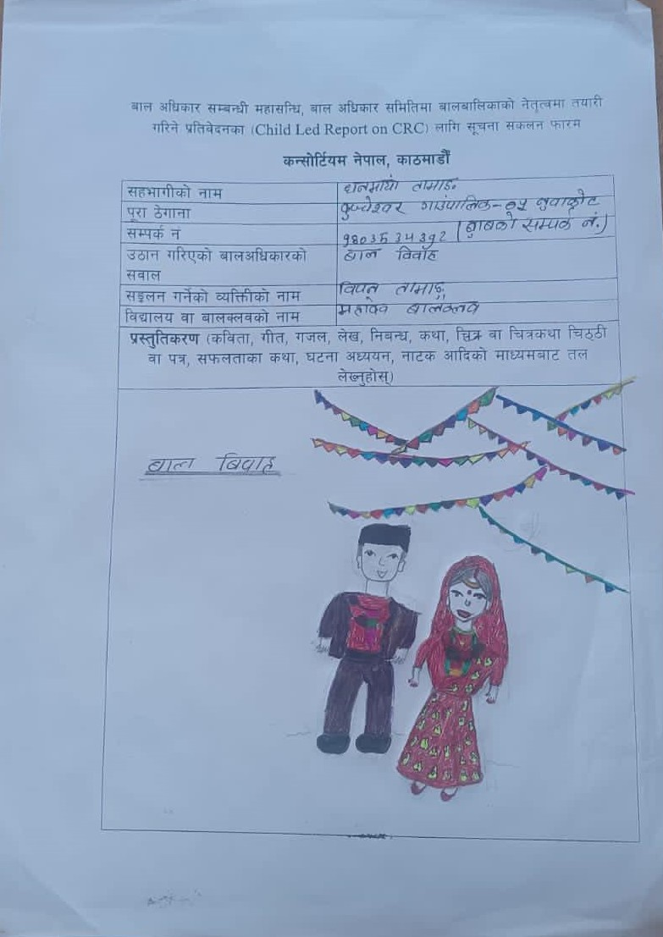
Many of the young children are getting married in early age or below 18 which is considered as child marriage. The legal age to get married is 20 in our country. So, marriage before age of 18 is considered as child marriage and marriage before age of 20 is considered as early marriage and both marriages are illegal. Children from different community like muslim community of Terai areas are forced for child marriage because their parents have to pay more dowry with the raise of age. With the misuse of social media, generational gaps and teenage affection, self-initiated child marriage has also increased which has made very challenging to end child marriage.
What we see:-
Nepal government has made marriage below 20 illegal. Many NGOs and INGOs are working in this field to end child marriage. Many awareness program and street dramas has been runNING to aware people regarding child marriage. Our government has planned to end child marriage till 2030 according to SDGs plan. Different Local levels have provision to provide certain amounts, prize who gets married after 20 to end child marriage.
What we have faced:-A girl from "Nijgad Bara" had seen a year younger girl from her school getting married at the age of 15 without the consent of her parents. It was self initiated marriage. Due to which she had suffered from different problems like financial problem and many more.
What we want:-
Our government should run different awareness program for all people. We should more focus on children and aware them not to get involved in child marriage. We want that child clubs to be more strengthened so that they can contribute to end child marriage. We want strong implementation of government rules and regulation. And we want to see child marriage being fully eradicated till 2030 as per SDGs goal.
Sexual Abuse:-As we all know we children not only girls but boys and children from LGBTIQ A++ community has also suffered from different types of sexual abuse such as Harassment, rape , acids attack etc. Many young girls are involved in sex activities due lack of education, poor economic condition and awareness in our country..
What we see:- our government are working with us through child club and other means to stop it .Different types of acts are made to protect children from this type of sexual abuses. And many help lines are made for our support and security. Government, NGO's and INGO's has been raising awareness and organizing self- defense trainings to stop sexual abuse.
What we have faced: A boy from "Belbari-Morang district" had himself suffered from sexual harassment from his relative sister. He was just 6 years old when it happened now he is 17 years old but it has tortured him so much that he is unable to move on till today.

What we want:-
We want the government to provide self-defense training to all the children from grassroots level. The basic knowledge of good and bad touch should be provided and make the children able enough to speak for themselves if these things happens. We want our government to provide knowledge to everyone that not only girls but boys also suffer from this type of harassment. More training programs should be provided to children to prevent sexual abuse, Strong reporting mechanism should be adopted and abusers should be strictly punished. .
Child labor:-
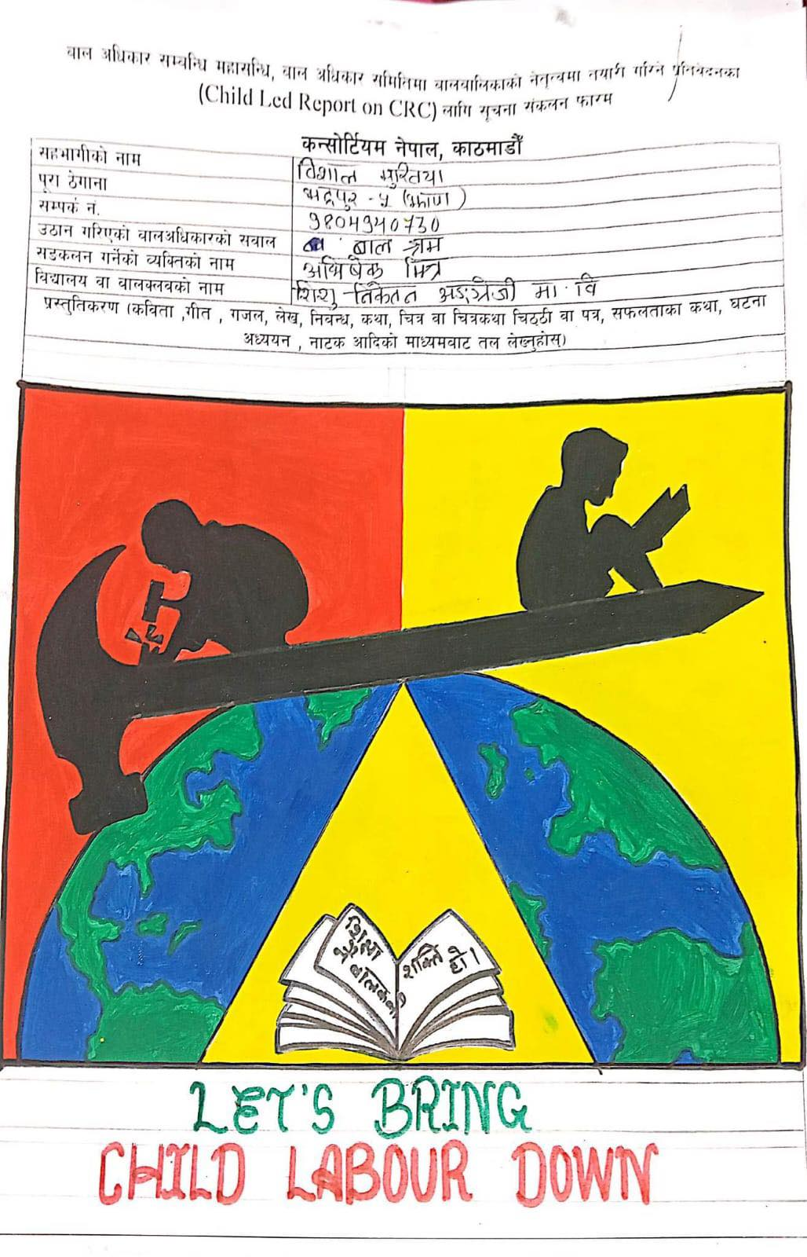
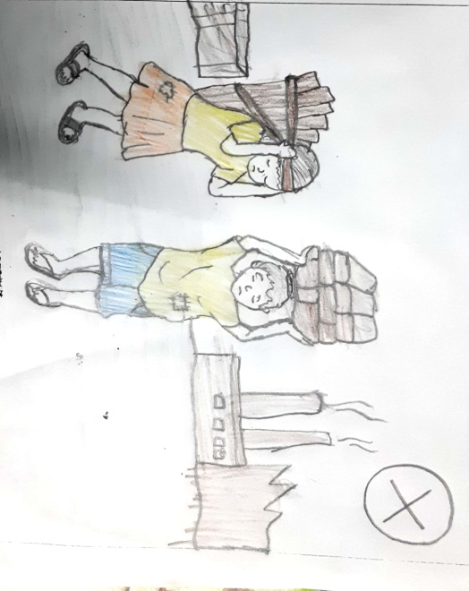
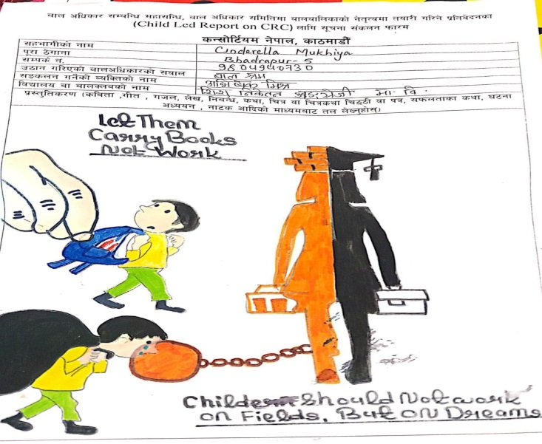
Due to poor economic condition, abuse at school, discrimination many children are stilled involved in domestic work, bricks factories, restaurants, vehicles as child labor. As a family burden many of the children below 18 are force to do work in factories and other industries for income and is deprived of education due to work and are sexually harassed and deprived of their child rights.
What we see:-
As we know our government had prohibited the factories to use children as labor. A different type of programs has been running in local level against child labor. Child labor has minimized and many children have been rescued.
What we have faced:-A boy from koshi province Jhapa has seen many of his friends working in bricks factories due to financial problem in their family. He had expressed that incident through drawing.
What we want :-
We want our government to check all the bricks factories and other possible work places with child labor and warn them that the enrollment of children below 18 in any kind of bricks work is against rule that will led to closing of the factory. And we want each and every children to be able to go to school not worrying about family finances since early age. We want strong plans and policy to end child labor and support programs for poor economic children so that they don't have to work to earn.
Street children:- Street children are living without identity and without shelter and buy earning their one time meal by picking up rags , begging , and by doing labor works. They are deprived of education and health facilities. Many children due to poor economic conditions, domestic violence, discriminations/ harassments at school left their house and live on the street. Street children are more involved in drug abuse, pick pocketing, smoking etc. Due to open borders children from India come to Nepal and stay on street. Such children has been challenged for the government to manage.
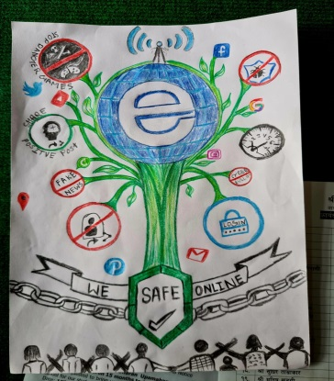
What we have seen:- Many social organizations are working to protect these types of children and are providing them education to them. Not only in cities areas many organizations are visiting different rural areas of our country to rescue and protect them. There is Child Rescue Center that has been rescuing street children and lost and found children.
What we have faced:-A girl from Nijgad, bara had seen many children below 8 roaming around her school areas without clothes, food and without proper hygiene. There were begging to her for some food to fill their stomach.
What we want: - We want our government to rescue street children from different level and provide them with adequate education facilities and establish rehabilitation trainings for them and work for their reunion with the family and provide them identity if their guardian are not found. Open borders should be checked properly and children from other countries should be sent to their respective countries.
Cybercrime: Many girls and boys below 18 are suffering from cyber bullying, sexual exploitation, blackmailing etc. It had leads to mental issues of the victim and in some cases it had leads to suicide as well. And early self-initiated child marriage is has also increased due to misuse of social media platforms like Facebook, Instagram, twitter, etc and lack of knowledge regarding social media sites.
What we see:-
Our government takes action to any kinds of sexual exploitation if reported within 35 days of being victim. Different types of programs are run to educate and aware people about safe use of Internet and What cyber bulling and what to do if you are the victim. Electronic transactions act "2063"-2008 is made.
we have seen;One of the girl in Nepal used to use Facebook. She got an known request from one of her sister whose account was hacked. She quickly accepted it , she got sex related messages and pictures. She was very afraid and mentally disturbed; thinking why was her sister sending those messages. Later on she shared the incident with her counsellor and she blocked and reported the account.
What we want:-We want our government to not to limit the time for reporting the sexual exploitation through online it should be time limitless. Not only in the cities areas programs regarding the online safety and cyber bullying should be given to all the children living in different areas of our country.

RIGHT TO DEVELOPMENT
Citizenship problem: In Nepal, children get their citizenship at the age of 16. But the children at alternative care, [children born through rape], children from slum community, refugees have to face difficulties in making citizenship due to which they get mentally stressed and can get deprived from higher education. They are deprived from basic rights and cannot perform the legal activities in their own country.
What we have seen: Now children are also raising voice for this and government also has made the plans and policies regarding this factor. Parents should make the birth certificate of child within 35 days which later on helps the child for their identity. There is provision to make citizenship through the mother's identity now.
What we have faced: One of the boy in Nepal did not get his citizenship because his mother got pregnant in early age and his father ran away. Although he got his birth certificate, he did not get citizenship and could not apply for the studies in any other countries.
What we want: Government should check if parents had made the birth certificates within 35 days or not and every child should be able to possess their citizenship after turning 16.

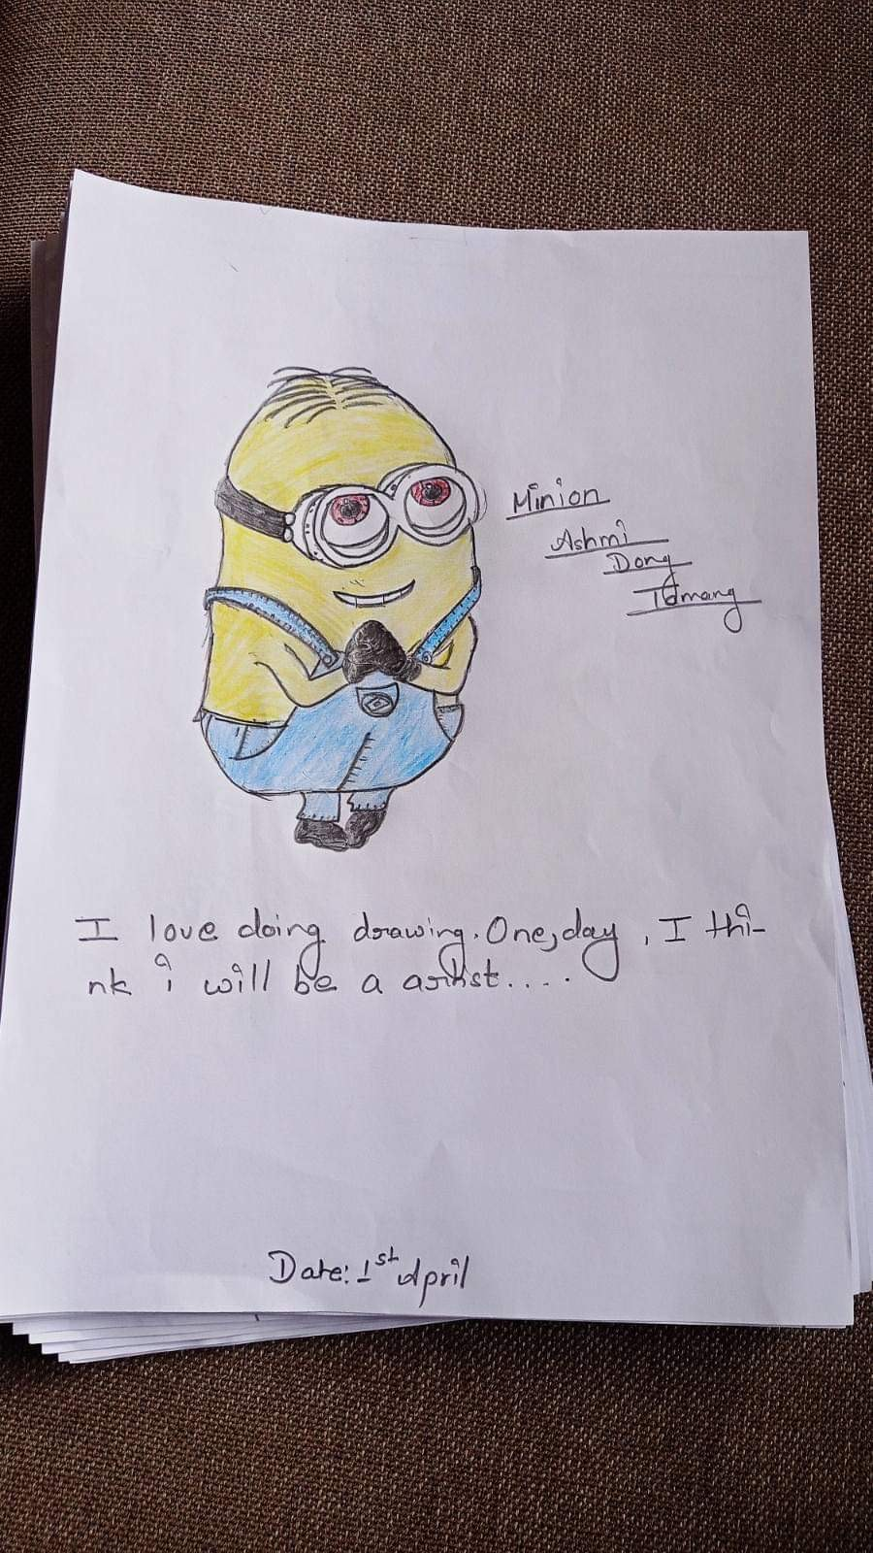
Lack of Proper Parenting: Almost all family of Nepal is of primitive thinking. They try to pull their children back because of society. They make us feel like we should not do what we want and just stay quiet only because society will judge us. Our parents decide our future, career and subjects rather than letting us choose our areas of interest.
What we have seen: Nowadays few parents are literate and only some parents give full support to their children. They understand the children psychology. They also listen to what they want and also let them choose their career goals. But the society is very judging to those parents as well.
What we have faced: 12 year old girl from Nepal, she was a very good in her studies. Her father was an alcoholic. She was demotivated by the society because of her family. Her father used to beat her mother and her family was also not supporting at all so she was mentally destroyed because of her family problem.(Individual; provincial discussion)
What we want: Parents should know our psychology and treat them well. They should support us for our aim and future. They should try to give up on their habits that create negative influences on us because all we need is happy and peaceful family with supportive Aama(mother) and Baba(father).

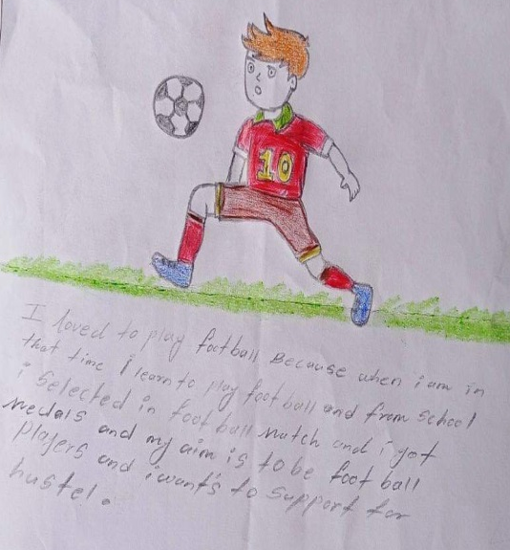
Lack of Extra Curricular Activities (ECA): We want different sports items to play for our physical and mental growth and development. But there are no sufficient sports items to play. For example: they give sports item for once and stay quiet for next five years. Extra-curricular activities classes are also not included in schools.
What we have seen: We are getting sports items like football, basketball, chess, badminton etc to play with our friends and we are also getting to connect with new circles. Nowadays schools are also including ECA items due to which we can involve ourselves in extra activities other than study in school as well.
What we have faced: Even though school has providence of ECA there is no ECA teacher. There is no availability of enough sports items. Parks and grounds are also not well managed.
What we want: Some of us have aim in sports so we should be provided with a good teacher and opportunities with ECA items. At least once in a week we should get engaged in ECAs, soft skill programs and other creational activities (gardening, tailoring, cooking, paintings etc).

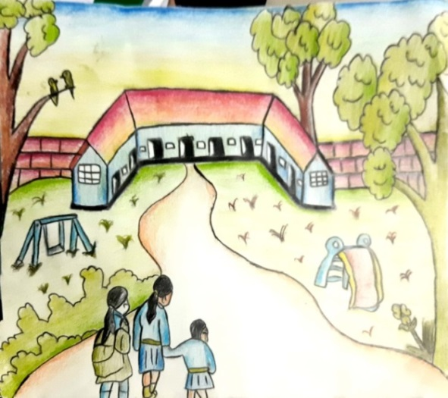
Lack of Proper Education and Educational Institutions:­ But due to geographical issues and lack of development in the country most of us haven't got proper education. it includes theoretical, practical and vocational. Due to theoretical based education in our country all of us are not being able to show our specialty in particular field cause our government asks us for degree certificate in almost every field. If we want to know basic general knowledge to enhance our capabilities, where to go? as there is no proper guidance for us.

What we have seen:- Basic education that is up to secondary level has been made compulsory and is provided with scholarship to those, who can't afford and the government school provides "chatravriti"(scholarship) to students. The government has the provision of providing lunch to every children who are studying in government school to promote education.

What we have faced:-There was a girl in sindhupalchowk and she had to drop out of the school because of financial problem in the family and had to suffer from different domestic violence in the home due to her gender and then she was deprived of education and was forced to do work to support her family.
What we want; We want our government to make +2 level education compulsory and free of cost for all children who are studying in government should provide little amount of pocket money for us children who cannot afford to buy a pen to complete homework . we want our government to give more priority to practical knowledge and improve the sports facilities ,along with proper provision of sports materials and teachers and establish proper sport stadium and fields to enhance our sportsmanship

RIGHT TO PARTICIPATION
Lack of equal opportunities: The children with disabilities, girls, LGBTIQA++ and Children with labor sector get fewer opportunities and their voice remains unheard in many places. Their difficulties are not addressed properly. They are not involved in school activities such as sports, they are also not included in many community discussions, and even the budget allocated for them is spent for other activities even though they need it. There is lack of disable friendly infrastructure in schools and public places. They get bullied for their appearance and identity. They do not get chance to express their difficulties and problem. People judge them and backbite about them. Other children don't want to get involved with such children.
What we have seen: Few schools have adopted disable friendly infrastructures to include children with disabilities. Different groups of LGBTIQA++ community are being formed in many places. They are being empowered by forming different clubs and committees.
What we have faced: A boy belonged to LGBTIQ group and he was not comfortable going to toilets. His friends used to pull off his pants and see his private parts. He was too depressed and did not want to go to school.

What we want: We want every child to get equal rights and opportunities despite of their gender and opportunities. More care and attention should be given to such vulnerable children. We want every schools and public places to be gender friendly and disable friendly.

Lack of meaningful participation: Child clubs are formed in different levels but there is less meaningful participation of children. Children remain absent in child club meetings. Even though children are included in planning process of budget and programs their voice remains unheard in outcomes. They are included in plan formation process but are not included in decision making process. Children and child clubs are mostly used to volunteer rather than letting them organize the programs on their own leadership. Rather than choosing the team or participants for the program, teachers select the participants on their own preference. In some places there is no local level child meetup before budget formulation due to which their necessities remains unheard. Child club members and other activists who are involved in activism or stopping child marriage get threaten by society and few people.
What we have seen: To ensure the participation of every child, child clubs are being formed. Children are included in different programs and competition. Children with disabilities, LGBTIQA++ children are also included in child clubs. There is the facility of translators in different programs.
What we have faced: A child club in Kirtipur has to cancel the awareness program because of lack of money and all the club members also refused to participate in the programs.
What we want: Our voice should be addressed and included in decision making process with best outcomes. We want children to select their representatives on their own rather than anyone's favoritism. Meaningful participation should be ensured everywhere.

ANNEX
Story Translations from different Consultations:
My house is in Samsi village of Mahottari district. More than 50% Muslim community resides in my village. There is a compulsion and practice of sending small children of the Muslim community to Delhi, Mumbai and other places in India. They do not know about the fundamental rights of children or because of various reasons. They can't study while labor. Through the study of this incident, I have raised my opinion and the problem of children.
Thank You
Rajib kumar yadav
Samsee-7, Mahottari
Once upon a time there was a family living in Khadbari Ward No. 3 of Sankhuwasabha District of Province No. 1. In that family there was a daughter, mother, grandfather, father. One day in that house his mother and grandfather went to the forest. Taking that opportunity, her father Jai Rai sexually assaulted her daughter Rama Rai. After that, Rama was sitting outside crying. After her mother came from the forest, when she inquired, the daughter told that her father had done such and such. After that, the mother was upset for some time, but later she called the Manobhanjang police saying that no one is exempt from sexual violence and the police arrested her husband. In this way, an ignorant victim had to become a victim of sexual violence. So we should raise our voice against it. Now no girl or no daughter should be a victim of sexual violence.
Pujana Prajuli
Khadbari, Sangkhuwasabha
Students pollute the environment by eating packaged lunches as there is no arrangement of lunch houses in the school. It has harmful effects on your health. That's why they get sick. He cannot pay attention when he is sick. Students have become addicted to drugs by consuming drugs. It is written that drugs cannot be sold around 100 meter from the school but it has not been enforced. The government of Nepal has arranged mid-day meals for students up to class 6 in government schools. Arrangements have been made for mid-day meals, but the standards specified in the guidelines are not met. We are aware of the fact that student enrollment has also increased due to mid-day meals. It has been reported that in some schools only chiura (beaten rice )is given as lunch, so it should be checked and regular monitoring should be done. Children are the future leaders of the country so don't play with child health. Students should be able to eat lunch after regular monitoring of the school's lunch houses, hygiene and nutrition
Thank You!
-Saurab Neupane
Bhalapdada, Rasuwa
I am from Mahatari district living in Samsi local development area. In my village more than 50%of the locals are Muslim. In my community it is like a ritual to send their children to India, Mumbai. This is happening because they don't know about child rights and they had to get enroll in different type of labour work. They are unable to raise voice themselves so for them i am raising their voice and i want all of them to know about their basic rights and get education which they deserve.
Rajib Kumar Nepal

I am from "suradaya" village municipality, Treasury of the Child club network from my municipality. During our child club meeting we make plans regarding the problems that we have faced in our Municipality and how to solve it. But due to low budget we are unable to work as we have planned. So from my side I want the government to make separate budget from child club.
Prabal Rai
Illam
Once there was this girl from Sakhuwasaba, Khadbari, who used to live with her family in her family there were 4 members father, mother, grandfather and the only child of her family herself. One day when her grandfather and mother went to jungle to collect some firewood. She was all alone in her home with her father. Then her father took this as a opportunity and raped his own daughter. She was just 6 years old. After 2 hours her mother came back home and when she saw her daughter crying alone in the room she asked her about the reason that made her cry so much. The girl reply honestly and told her mother what her father did to her after hearing this her mother didn't think much and went to police station to complain a file. After some investigation the police arrested her father.
Pujana parajuli
I used to live with my joint family. From childhood i didn't get any support from my family due to my girlish behaviour the only one thing which i get from my family was hatred. Because of lack of support from my family and due to family torture i was unable to complete my education. I left my hometown and family and came to kathmandu to live as i wanted to live after coming to Kathmandu I got to know about consortium Nepal and through their support and help I started to work for living. Now I live in rented room and I am happy to accept what i am with my identity.
Sadip Chaudhary

In my school there is no proper infrastructure like the tables and chairs are not properly available and are of bad condition, there is no provision of proper drinking water, the upper roof of the school is filled with holes which makes us difficult to study during rainy days. So, i want my locality to make a proper availability of the entire infrastructure in my school.
Bipana Budhathoki

Acknowledgment
We have finally completed the second child led report of UNCRC and we are really proud to be a part of it being a voice of unheard children from all over the Nepal. Collecting the issues and problems of children from ground level with collective efforts of every child, parents and NGOs and INGOs the report has been made by us children without the influence of adults. Provincial consultation was held in all the seven provinces of Nepal where children were and its process. Also, issue-based consultation, child-led community consultations were held in different places where children themselves took out their issues and problems. Issues were collected in the forms of poems, story, essay, drawing, articles. We believe that this report would support OHCHR to know the exact stage of children of Nepal and interact with Government of Nepal.
We express our gratitude to our parents, teachers and well-wishers for their support and motivation. We are thankful to all the participant members who became the part of this report in provincial consultation, issue-based consultation, child-led community consultation and national validation workshop. They all indeed contributed to find out the exact issues, problem and feelings of children. We are also thankful to the chaperones for taking care of all the participant members and fellow members.
Consortium of organizations working for Child Participations (Consortium-Nepal) took the responsibility to facilitate us during the entire process. We express our deepest gratitude to all child-centered organizations like NACG Nepal, AATWIN, CNET, CRC Secretariat-HRTMCC, CZOP, NAOSC, NCFLG Forum, National Coalition for Girl's Rights, Ratify OP3CRC Coalition, NCE Nepal, NCPA, Inclusive Education, DUCOM, Education Watch, NICS, Net for Good Alliance, SPCSN. And the Partner Organizations Save the Children, World Vision International Nepal, SOS Children's Village Nepal, ECPAT Nepal, Good Shepherd International Nepal, The freedom fund, Forget Me Not for their facilitation, technical, and financial support. We express our sincere gratitude to them all.
Before, we began the process; it was necessary for us to internalize the issue, understand the processes to be followed and our roles in each step. Further, we received support for collecting the information, analyzing it, drafting and fine-tuning the report. Hence, we would like to express our deepest appreciation to Mr. Uddhav Poudyal, Mr. Bishnu Bahadur Khatri, Mr. Kapil Aryal, Ms. Neha Gurung, Ms. Mandira Shrestha.
We extend our gratitude to Mr. Santosh Maharjan, Mr. Mohan Dangal, Mr. Kiran Thapa, Mr. Gaurav KC, Ms. Usha Karki, Ms. Yashoda Baral, Ms. Nirijana Bhatta from Consortium Nepal for holding our hands, helping us to meet the finishing line and for being our guardian during the entire process. Lastly, we would like to express our admiration to all the well-wishers for the encouragement, valuable insights, and inputs to come up with this inclusive and comprehensive report.
​​​​​​​​​​ -Write Up Team

The right to safe motherhood and reproductive health act,2075
Jan 2020, The Kathmandu Post
source: case seen by Ms. Mandira Shrestha, Nurse at Bir Hospital
Provincial level consultation, Province 1
Case seen by Ms. Mandira Shrestha, Nurse at Bir Hospital
Provincial level consultation, Koshi Province
Provincial level consultation, Koshi Province
Report write up team, Ashmita Chamlagain
Provincial level consultation, Koshi Province
Report write up team, Prekshya Adhikari
The Himalayan Times, November: 2020
Provincial level consultation, Madesh province
Provincial level consultation, Koshi Province
Provincial consultation, Koshi Province
Provincial level consultation, Madesh Province
Report write up team, Ashmita Chamlagain
Report write up team, Ashmita Chamlagain
Provincial consultation
Provincial consultation, Koshi Province
Provincial level consultation, Bagmati Province
Provincial consultation, Bagmati Province
Report write up team, Prekshya Adhikari

