BRIEFING ON EL SALVADOR FOR THE COMMITTEE AGAINST TORTURE, SESSION 75 - November 2022
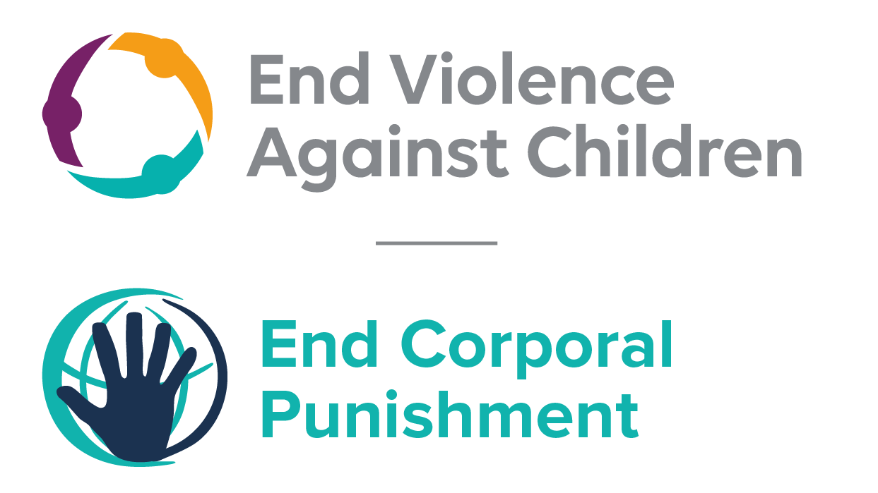
The Global Partnership to End Violence Against Children
September 2022

This briefing describes the legality of corporal punishment of children in El Salvador. In light of the obligation under international human rights law to prohibit all corporal punishment of children, the recommendation of the UN Secretary General’s Study on Violence against Children, the repeated recommendations to prohibit all corporal punishment made to El Salvador by the Committee on the Rights and other human rights treaty bodies, and considering the global commitment to ending all violence against children in the context of the 2030 Agenda for Sustainable Development, we hope the Committee will:
• in its concluding observations on the third report of El Salvador, recommend that legislation is immediately enacted to explicitly prohibit corporal punishment of children in all settings including the home, and to repeal all legal defences for its use.

Summary of necessary legal reform to achieve full prohibition
Prohibition is still to be achieved in the home, alternative care settings and day care.
Article 215 of the Family Code 1994 confirm the duty of parents “to correct their children appropriately and moderately”, article 204 of the Criminal Code 1997 recognises a “right of correction”, and article 38 of the Law for the Integral Protection of Children and Adolescents 2009 confirms the right of parents to “adequately and moderately correct” their children. These defences should be repealed. The near universal social acceptance of corporal punishment in childrearing necessitates clarity in law that no level of corporal punishment is acceptable. Prohibition should be enacted of all corporal punishment and other cruel or degrading forms of punishment, in the home and all other settings where adults have parental authority.
Alternative care settings – Prohibition should be enacted in legislation applicable to all alternative care settings (foster care, institutions, places of safety, emergency care, etc).
Day care – Corporal punishment should be prohibited in all early childhood care (nurseries, crèches, kindergartens, family centres, etc) and all day care for older children (day centres, after-school childcare, childminding, etc).
- The report of El Salvador to the Committee Against Torture

  - The third report of El Salvador states that while measures are taken to ban corporal punishment in the home, the National Council for Children and Adolescents implement an information-sharing strategy to sensitize officers working in the national protection system, national and local stakeholders, families and communities to the rights of children and adolescents. The strategy provides for awareness-raising and training activities covering child protection guidelines and mechanisms. However, the report does not refer to law reform to prohibit corporal punishment in all settings.

- Current legality of corporal punishment in El Salvador

  - Home: Corporal punishment is lawful in the home. Article 215 of the Family Code 1994 states: “It is the parents’ duty to correct their children appropriately and moderately and, if necessary, to seek assistance from professional specialists or psycho-pedagogical guidance services at schools or agencies for the protection of minors or the family. If the child’s behaviour cannot be corrected through these means, the parent can request that a judge arrange for guardianship; in making such a decision, the judge will order any studies of the family group that he or she considers appropriate.” Article 204 of the Criminal Code 1997 recognises a “right of correction” and punishes its abuse. Article 38 of the Law for the Integral Protection of Children and Adolescents 2009 appears to protect children from some corporal punishment but confirms that the “right of correction” remains in force: “Children and adolescents should be treated with respect for their person and individuality and may not be subjected to corporal punishment, psychological or any other form of offensive which infringes their dignity, without prejudice to the right of the mother and father to direct, guide moderate and correct accordingly” (unofficial translation). Provisions against violence and abuse in the Family Code 1994, the Criminal Code 1997 (amended 2005), the Law Against Domestic Violence 1996 and the Constitution 1983 are not interpreted as prohibiting all corporal punishment in childrearing. The Government reported to the Committee on the Elimination of Discrimination Against Women in 2017 that the Penal Code was also under review, with notably the addition of article 338 which would strengthen women and children’s protection from family violence.

  - In 2009, the Government reported that various courts have ruled that corporal punishment goes beyond adequate and moderate correction and therefore that article 215 of the Family Code excludes corporal punishment in childrearing, but the Government has also acknowledged the need for law reform. The Government had initially signalled its commitment to prohibition by accepting the recommendation to prohibit corporal punishment in all settings including the home made during the Universal Periodic Review of El Salvador in 2010. During the second cycle UPR of El Salvador in 2014, the Government stated that corporal punishment is prohibited in articles 38 and 89 of the Law for the Integral Protection of Children and Adolescents 2009, but also went on to accept a recommendation to “expressly prohibit corporal punishment by law in all settings”. The Government reaffirmed its commitment at a meeting of the Directing Council of the Inter-American Children’s Institute in 2014. El Salvador became a Pathfinder country with the Global Partnership to End Violence Against Children in February 2016, committing to three to five years of accelerated action towards the achievement of Target 16.2 of the Sustainable Development Goals.

  - Bills on the removal of the “right of correction” which were under discussion in 2017 were all archived. In 2018, in the context of the state’s examinations by the Human Rights Committee and by the Committee on the Rights of the Child, El Salvador’s Office of the Human Rights Advocate highlighted that article 38 of the Law for the Integral Protection of Children and Adolescents 2009 confirmed the right to “moderate correction”, and called for reform to prohibit all forms of corporal punishment, however light. When asked about prohibition of corporal punishment in the home by the Committee Against Torture, the Government responded by highlighting various awareness-raising and training programmes implemented but did not mention law reform.

  - Alternative care settings: There is no explicit prohibition of all corporal punishment in alternative care settings. Article 38 of the Law for the Integral Protection of Children 2009 protects children from some but not all corporal punishment and article 215 of the Family Code 1994 and article 204 of the Criminal Code 1997 similarly confirm a “right of correction” (see under “Home”). These defences are potentially available to guardians and others with parental responsibility.

  - Day care: There is no explicit prohibition of all corporal punishment in early childhood care and in day care for older children, with the exception of preschool provision where the prohibition of corporal punishment in the General Law on Education 1996 is applicable (see under “Schools”). In other day care, article 38 of the Law for the Integral Protection of Children 2009 protects children from some but not all corporal punishment and article 215 of the Family Code 1994 and article 204 of the Criminal Code 1997 similarly confirm a “right of correction” (see under “Home”). These defences are potentially available to guardians and others with parental responsibility.

  - Schools: Corporal punishment is prohibited in schools in article 90 of the General Law on Education 1996 (amended 2000), according to which learners have the right to “(c) be treated with fairness and respect and not to be subjected to corporal punishment, humiliation, physical or mental abuse, neglect or negligent treatment, maltreatment or exploitation including sexual abuse” (unofficial translation). The prohibition is confirmed in article 89 of the Law for the Integral Protection of Children 2009 (unofficial translation): “Public and private schools must teach the value of discipline and respect for teachers, students and all people. In the imposition of disciplinary measures, schools are obliged to respect the dignity, rights and guarantees of every girl, child and adolescent. As a result, the abuse, physical and psychological maltreatment and any form of cruel, inhuman or degrading punishment is prohibited….”

  - Penal institutions: Corporal punishment is prohibited as a disciplinary measure in penal institutions. Article 128(2) of the Prisons Act states: “Disciplinary measures shall be imposed in such a way that they do not affect prisoners’ health or dignity. Corporal punishment, such as confinement in a dark cell, or any other cruel, inhuman or degrading treatment or punishment, is prohibited….” According to article 26 of the General Regulations for Detention Centers for Juvenile Offenders 1995, “the staff of the centers, in carrying out their duties, must respect and protect the dignity and basic human rights of all the children” and authorities must not “instigate or tolerate any act of physical, sexual or emotional abuse, punishment or cruel, inhuman or degrading corrective measure or discipline.” Article 118 of the Juvenile Offenders Act 1995 also prohibits corporal punishment.

  - Sentence for crime: Corporal punishment is unlawful as a sentence for crime. The Juvenile Offenders Act 1995 does not include corporal punishment among permitted sanctions, recognises the right of young offenders to respect for dignity and protection of personal integrity, and establishes that under the law, the minor enjoys the rights and safeguards recognised in the Constitution, treaties, conventions, covenants and other international instruments signed and ratified by the country (art. 5). Article 37 of the Law for the Integral Protection of Children 2009 prohibits inhuman, cruel and degrading treatment.

Recommendations by human rights treaty bodies and during the UPR

  - CRC: On three occasions, the Committee on the Rights of the Child has recommended to El Salvador that legislation be enacted to explicitly prohibit corporal punishment in all settings: in its concluding observations on the state party’s second report in 2004, on the third-fourth report in 2010 and on the fifth-sixth report in 2018.

  - CRPD: In its concluding observations on the state party’s initial report in 2013, and on the state party’s second-third report in 2019, the Committee on the Rights of Persons with Disabilities recommended that the Government prohibit all forms of corporal punishment.

  - HRC: In its concluding observations on the state party’s seventh report in 2018, the Human Rights Committee recommended that El Salvador prohibits corporal punishment in all settings.

  - UPR: At the first and second cycle of the Universal Periodic Review of El Salvador respectively in 2010 and 2014, recommendations to prohibit violence against children in all settings were made and accepted by the Government.

17 March 2020, CAT/C/SLV/3, Third periodic report submitted by El Salvador under article 19 of the Convention, due in 2013, para 103.
9 January 2017, CEDAW/C/SLV/Q/8-9/Add.1, Reply to the list of issues on eighth/ninth report, para. 4
21 December 2009, CRC/C/SLV/Q/3-4/Add.1, Reply to list of issues, paras. 67 and 68, no specific case law cited
18 March 2010, A/HRC/14/5, Report of the working group, para. 81(38)
17 December 2014, A/HRC/28/5, Report of the working group, paras. 96 and 103(23)
February 2018, Alternative report of the Human Rights Advocate to the Human Rights Committee, paras. 134 and 135; see also September 2018, Alternative report of the Human Rights Advocate to the Committee on the Rights of the Child, paras. 40, 41 and 42
May 2019, CAT/C/SLV/3, Third report, para. 103
30 June 2004, CRC/C/15/Add.232, Concluding observations on second report, paras. 35, 36, 43 and 44
17 February 2010, CRC/C/SLV/CO/3-4, Concluding observations on third/fourth report, paras. 9, 29, 45, 54 and 55
11 October 2018, CRC/C/SLV/CO/5-6 Advance unedited version, Concluding observations on fifth/sixth report, para. 25
8 October 2013, CRPD/C/SLV/CO/1, Concluding observations on initial report, paras. 35 and 36
1 October 2019, CRPD/C/SLV/CO/2-3, Concluding observations on second-third report, paras. 30 and 31
5 April 2018, CCPR/C/SLV/CO/7 Unedited advance version, Concluding observations on seventh report, paras. 39 and 40
18 March 2010, A/HRC/14/5, Report of the working group, para. 81(38)
17 December 2014, A/HRC/28/5, Report of the working group, para. 96
17 December 2014, A/HRC/28/5, Report of the working group, para. 103(23)

