International Convention on the Elimination of All Forms of Racial Discrimination
Singapore’s Initial Report
Annex – Charts

Figure 1: Age distribution of resident population

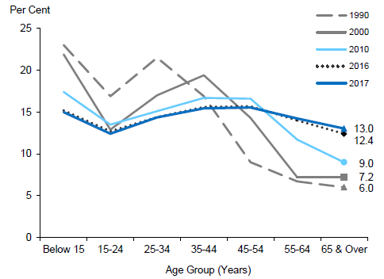

Figure 2: Male-female composition of resident population

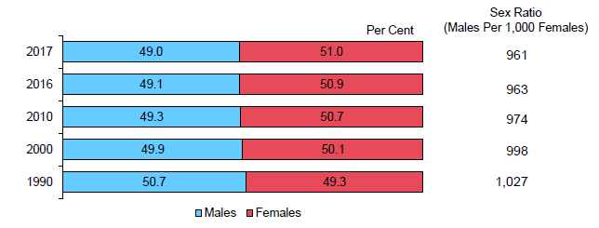

Figure 3: Ethnic composition of resident population

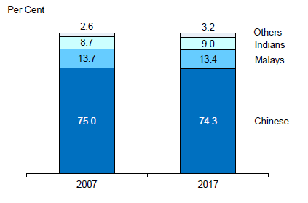

Figure 4: Highest qualification attained of resident population aged 25 years and over

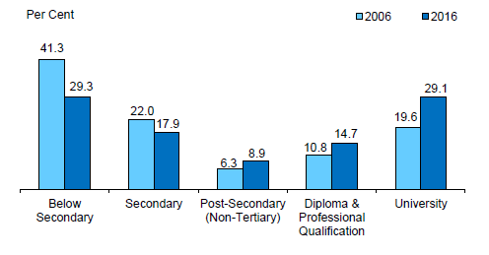

Figure 5: Ethnic Distribution by Planning Area

Figure 6: Engagement in Inter-Ethnic/Nationality Interaction by Year

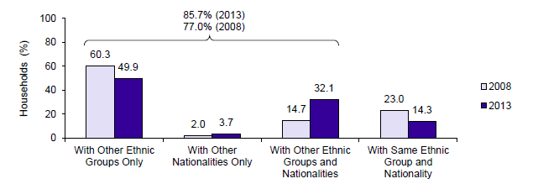

Figure 7: Percentage of O-Level Students with at least 5 Passes by Ethnic Group

Figure 8: Percentage of Primary 1 Cohort that Progressed to Post-Secondary Education

Department of Statistics, Population Trends 2017.
Department of Statistics, Population Trends 2017.
Department of Statistics, Population Trends 2017.
Department of Statistics, Population Trends 2017.
Department of Statistics, Population Census 2010.
HDB Sample Household Survey 2013.
Education Statistics Digest 2016; Progress of the Malay Community in Singapore since 1980.
Education Statistics Digest 2016; Progress of the Malay Community in Singapore since 1980.

