

Submission to the Human Rights Committee at its 143rd Session

March 2025

Geneva, Switzerland

MONTENEGRO
Submission by:

ADF International
Rue Pré-de-la-Bichette 1
1202 Geneva, Switzerland

Web: www.ADFinternational.org
Email: UN@ADFinternational.org

ECOSOC Special Consultative Status (2010)

Introduction
- ADF International welcomes the opportunity to contribute information on Montenegro’s implementation of its obligations under Articles 2, 3, 6 and 26 of the International Covenant on Civil and Political Rights (ICCPR).
- This submission highlights the urgent need for the government of Montenegro to intensify its efforts to eliminate prenatal sex selection. It examines how the country’s skewed sex ratio at birth is rooted in Montenegro’s prevalent culture of son preference and daughter aversion and offers recommendations for enhanced legislative and policy measures to address this issue effectively.
- Prenatal Sex Selection
- Until recently, Montenegro maintained one of the 10 highest sex ratio imbalances at birth in the world, resulting from widespread sex selection in the country. The government has itself attributed this to ‘abuses of early genetic testing, as well as selective abortions, mostly take place outside of Montenegro’.
- Recent government data on birth registrations reflect a notable drop in the ratio, from 107.8 boys born per 100 girls in 2021, to 102.8 in 2023. This compares to a natural sex ratio at birth estimated at 105 boys for every 100 girls.
Data source: MONSTAT (2002-2023)
- Given the low total number of national births (roughly 7,000 and declining), the ratio fluctuates significantly from year to year. Nevertheless, the data indicates a gradual trend towards a less imbalanced ratio.
- However, the root causes of sex selection remain an ongoing challenge drawing international attention. During its Universal Periodic Review in May 2023, Montenegro accepted two recommendations calling for intensified efforts to address sex selection, including through national educational campaigns. Similarly, in June 2024, at the outcome of the country’s periodic review, the Committee on the Elimination of All Forms of Discrimination Against Women called on the government to carry out awareness-raising on the negative impact and criminal nature of sex selective abortions, as well as to strengthen transnational cooperation to prevent cross-border abortions and prenatal genetic testing.
Legal framework
- Article 8 of the Constitution of Montenegro affirms that ‘direct or indirect discrimination on any grounds shall be prohibited’. Article 18 guarantees the ‘equality of women and men’, while Article 19 states that ‘Everyone shall have the right to equal protection of the rights and liberties thereof.’
- Article 18 of the 2009 Law on the Terms and Procedure for Termination of Pregnancy prohibits selective abortions on the basis of sex. It further prohibits the use of genetic testing to determine the sex of a child before the tenth week of gestation, except in cases of proven risks of hereditary diseases.
- Regrettably, these laws are not properly enforced, in part due to the lack of appropriate mechanisms to detect violations, particularly when abortions occur prior to the ten-week threshold. Moreover, the lack of effective cooperation to tackle the cross-border dimension of this phenomenon allows for national prohibitions to be entirely circumvented.
Root causes of prenatal sex selection
- Montenegro’s skewed sex ratio at birth is largely driven by the prevalent culture of son-preference and daughter aversion, whereby male children are perceived as inherently advantageous to the household, both economically and in terms of social status, while female children are often viewed as burdensome. These harmful cultural attitudes and social norms perpetuate discrimination and violence against women and girls, who are viewed as inferior or subordinate to men and boys.
- Ethnographic studies have indicated how mothers, particularly in rural or poverty circumstances, face immense pressure from their families and the broader community to bear male children. This pressure is closely linked to concerns over inheritance.
- In some regions of Montenegro, it is a common practice for families to pursue legal measures to exclude daughters from inheritance. This phenomenon is also reflected in common family discourse, where daughters are referred to as ‘sons’ or omitted entirely when enumerating children.
- A 2020 study on media discourse surrounding sex-selective abortion observed that the national media response to the phenomenon has been predominantly passive. While acknowledging its existence, the media have failed to highlight it as a human rights issue. Empirical evidence also indicates a broader societal wide lack of understanding of and engagement with the issue.
The prohibition of sex-selective practices in international human rights law
- Sex-selective practices, in all their forms and manifestations, constitute an egregious violation of the dignity and human rights of girl children.
- Article 2 of the ICCPR establishes the obligation to respect and ensure the human rights of all individuals without distinction of any kind. Article 3 explicitly guarantees the equal rights of men and women. Article 6 further guarantees the inherent right to life of every human being, establishing that ‘no one shall be arbitrarily deprived of his life’. Finally, Article 26 requires States Parties to guarantee equal protection under the law and equal and effective protection from discrimination, including on the basis of sex.
- Consistent with its relevant obligations, the government of Montenegro must redouble its efforts to eliminate recourse to sex-selective abortion, including through effective enforcement of its laws as well as enhanced cross-border cooperation aimed at preventing attempts to bypass prohibitions.
- Furthermore, Montenegro should continue efforts to initiate, invest in, and support awareness-raising and education campaigns aimed at reshaping harmful socio-cultural narratives and affirming the inherent dignity and equal status of all women and girls.
- Recommendations
- In light of the above, ADF International respectfully recommends that the Human Rights Committee include the following recommendations in its Concluding Observations on Montenegro:
  - Ensure the effective enforcement of laws prohibiting prenatal sex selection, and adopt policies to prevent and tackle circumvention of these laws, including through enhanced cross-border cooperation;
  - Further strengthen controls on the performance of prenatal genetic testing to detect the sex of the child in order to reduce the incidence of sex-selective practices;
  - Redouble efforts to promote awareness-raising and educational initiatives to eliminate prejudices and harmful practices perpetuating the culture of son preference and daughter aversion in the country;
  - Take measures to promote and protect the equal and inherent dignity of women and girls, including by addressing the root causes of son preference and daughter aversion;
  - Support the role of family members, especially parents and other legal guardians, in safeguarding the dignity and well-being of girls and countering the harmful human rights implications of son preference and daughter aversion.
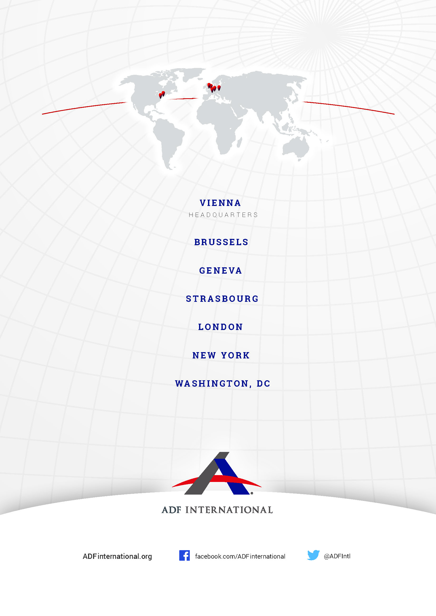
© 2025

Radio Free Europe/Radio Liberty ‘Montenegro Continues to Fumble it’s ‘Son Preference’, Sex Selective Abortion Problems’ (June 2021) https://www.rferl.org/a/montenegro-sex-selective-abortions-boys-demographics/31294610.html.
Government of Montenegro ‘Replies of Montenegro to the list of issues and questions in relation to its third periodic report’ (20 January 2023) UN Docs CEDAW/C/MNE/RQ/3, 34.
Montenegro Statistical Office (MONSTAT) ‘Vital Statistics in Montenegro: Statistics of birth and death 2021’ (2022) https://monstat.org/uploads/files/demografija/pr.kretanje/2021/Vital%20statistics%20in%20Montenegro%202021.pdf.
Montenegro Statistical Office (MONSTAT) ‘Vital Statistics in Montenegro: Statistics of birth and death 2023’ (2024) https://monstat.org/uploads/files/demografija/pr.kretanje/2023/Vital%20statistics%20in%20Montenegro%202023.pdf.
Radio Free Europe/Radio Liberty ‘Montenegro Continues to Fumble it’s ‘Son Preference’, Sex Selective Abortion Problems’ (June 2021) https://www.rferl.org/a/montenegro-sex-selective-abortions-boys-demographics/31294610.html.
Human Rights Council ‘Report of the Working Group on the Universal Periodic Review – Montenegro’ (June 2023) UN Docs A/HRC/54/14, 131.135-131.136.
Committee on the Elimination of All Forms of Discrimination Against Women (CEDAW) ‘Concluding observations on the third periodic report of Montenegro’ (6 June 2024) UN Docs CEDAW/C/MNE/CO/3, 23-24.
Constitution of Montenegro (2007), art. 8.
Ibid, art. 18 and 19.
Law on the Terms and Procedure for Termination of Pregnancy (2009), art. 18.
J. Banovic, B. Banovic ‘Selective Abortions in Montenegro: Legal and Anthropological Analysis’ (10 August 2024) Issues in Ethnology and Anthropology 19(2), 459-481.
S. Slavujevic ‘Montenegro’s Open Secret: Illegal Gender-Tests for Unborns’ (28 September 2017), Balkan Insights, https://balkaninsight.com/2017/09/28/montenegro-s-open-secret-illegal-gender-tests-for-unborns-09-27-2017/.
D. Kiscenko ‘An Ethnographic Exploration of Son Preference and Inheritance Practices in Montenegro’ (2021) Comparative Southeast European Studies 69(1), 69-88.
J. Davidovic ‘“My dear unwanted”: media discourse on sex-selective abortion in Montenegro’ (26 Jan 2022) Feminist Media Studies 23(3), 937-959.
Ibid.
International Convention on Civil and Political Rights (adopted 16 December 1966, entered into force 23 March 1976) 999 UNTS 171 (ICCPR), art. 2.
Ibid., art. 3.
Ibid., art. 6
Ibid., art. 26.

