Assessment of Economic and Social Rights Fulfilment in North Macedonia
Submission from the Human Rights Measurement Initiative to the United Nations Committee on Economic, Social and Cultural Rights for the List of Issues on the 77th Session, Geneva, February 2025.
I. Reporting Organisation
1. The Human Rights Measurement Initiative (HRMI) measures the human rights performance of countries, including North Macedonia. HRMI is an independent, not-for-profit NGO with a primary base of operations in New Zealand, and a second base in the United States at the University of Georgia’s Center for the Study of Global Issues (GLOBIS).
II. Assessment Methodology
2. HRMI uses the award-winning and peer-reviewed SERF Index methodology to measure the fulfilment of economic and social rights (ESR).
3. This methodology uses bellwether indicator data from international organisations—such as the World Health Organization and UNICEF—and compares each country’s achievement to what other countries at the same level of income have achieved. In this way, HRMI measures progressive realisation of economic and social rights (ESRs) as defined in the International Covenant on Economic, Social, and Cultural Rights (ICESCR). A country’s income-adjusted HRMI score is a measure of how well its government is converting its resources into good human rights outcomes for its people.
4. HRMI supplements these scores with qualitative information sourced by a confidential survey of on-the-ground human rights experts, such as NGO researchers, journalists, and human rights lawyers and advocates. For more details on HRMI’s methodology, please refer to the resources on our website. All HRMI’s data are published annually on the Rights Tracker and are freely available for non-commercial use under a Creative Commons License. HRMI’s Rights Tracker is a certified Digital Public Good with the Digital Public Good Alliance.
III. Overview of Economic and Social Rights Fulfilment in North Macedonia
5. HRMI’s most recent ESR scores for North Macedonia measure its achievement as of 2021.
6. Due to the partial lack of data available on North Macedonia in international databases, HRMI is unable to produce scores for some fields. HRMI’s ESR scores are shown in the graph below.

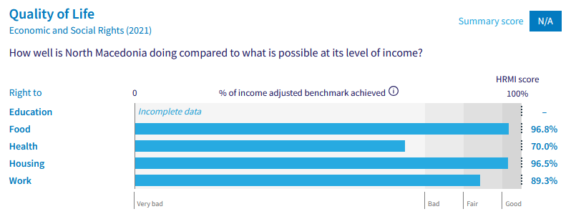
7. North Macedonia’s scores for 2021 are as follows:
▪ Right to education = Incomplete data (discussed below)
▪ Right to food = 96.8% (Good)
▪ Right to health = 70.0% (Very bad)
▪ Right to housing = 96.5% (Good)
▪ Right to work = 89.3% (Fair)
8. Compared with other countries in Europe, North Macedonia is performing lower than average when we look across the rights for which we have data (the comparison is calculated using the ‘income adjusted’ benchmark).
IV. Right to Education
9. HRMI defines the right to education in accordance with ICESCR Article 13 and CESCR General Comments 11 and 13. In the case of low- and middle-income countries, such as North Macedonia, HRMI further breaks down the right to education into three areas of measurement: primary school enrolment, secondary school enrolment, and quality of education.

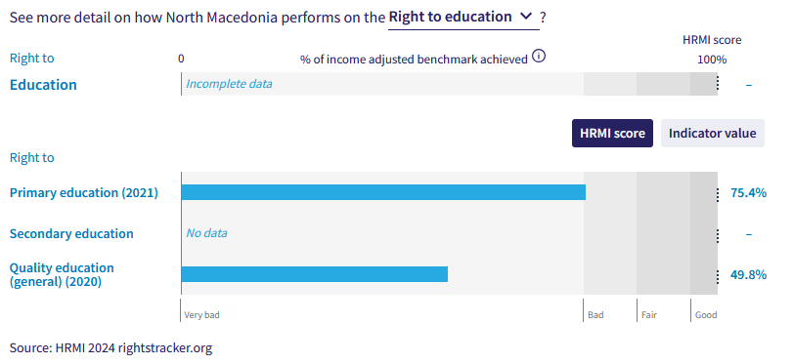
10. North Macedonia is achieving 75.4% of what it ought to be to ensure the right to primary education. This score falls within the ‘Bad’ range. Over the past two decades this score has undergone a variety of shifts, and is now currently well below the previous peak score of 98.6% in 2001, and below the decade high score of 89.7% in 2015.
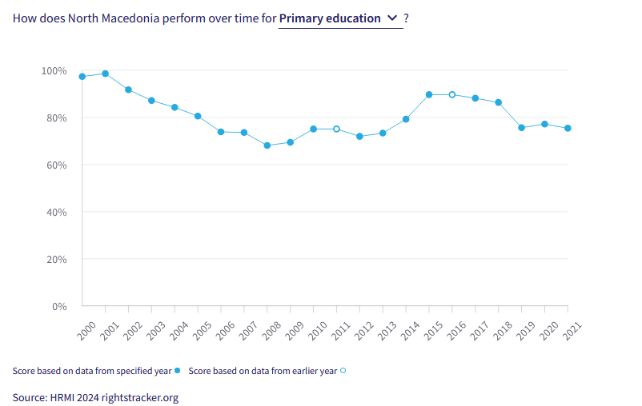
11. HRMI is unable to provide a score for what North Macedonia is currently achieving on the right to secondary education as not enough data is present in international databases to provide an accurate score. The last calculated HRMI score for secondary education was in 2005 at 68.8% in the ‘very bad’ range.
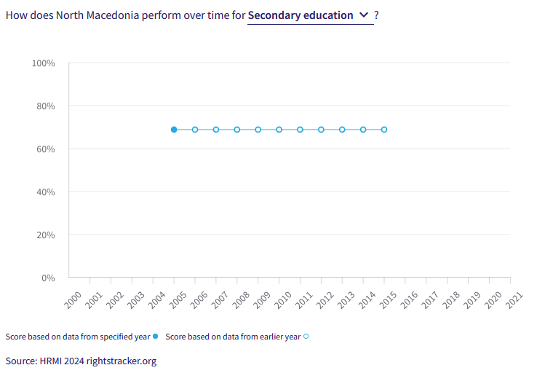
12. The right to quality education score is determined by data produced by the World Bank, The Human Capital Project. The data provided on North Macedonia begins in 2010, with a score of 52.8%, and now currently resides at a score of 49.8%. This score is in the ‘Very bad’ range and indicates that North Macedonia is only achieving 49.8% of what it could at its income adjusted level and indicates that it is inefficiently turning its resources into positive outcomes for its people.
V. Right to Food
13. HRMI defines the right to food in accordance with ICESCR Article 11 and CESCR General Comment 12. For low- and middle-income countries, such as North Macedonia, HRMI first uses a bellwether indicator of how many children are growing well (are not stunted). North Macedonia’s score for the right to food is 96.8% and falls in the ‘Good’ range. This means that North Macedonia is doing 96.8% of what ought to be possible to ensure the right to food for its people. This score draws on indicator data on child stunting rates published by the UNICEF-WHO-World Bank: Joint child malnutrition (JME) database.

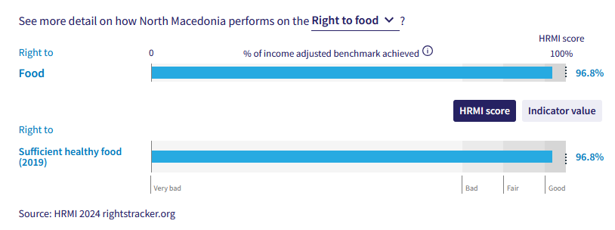
14. North Macedonia is currently achieving 96.8% of what is possible regarding the right to sufficient healthy food. This score is within the ‘Good’ range, and North Macedonia has been continuously operating at this level over the past decade.

VI. Right to Health

15. HRMI defines the right to health in accordance with ICESCR Article 12.1 and CESCR General Comment 14. In the case of low- and middle-income countries, such as North Macedonia, HRMI uses three indicators to measure the country’s achievement in child health, adult health, and reproductive health. North Macedonia is achieving only 70.0% of what HRMI calculates ought to be possible at its current level of resources, with the HRMI score for reproductive health (contraception) in the ‘very bad’ range.
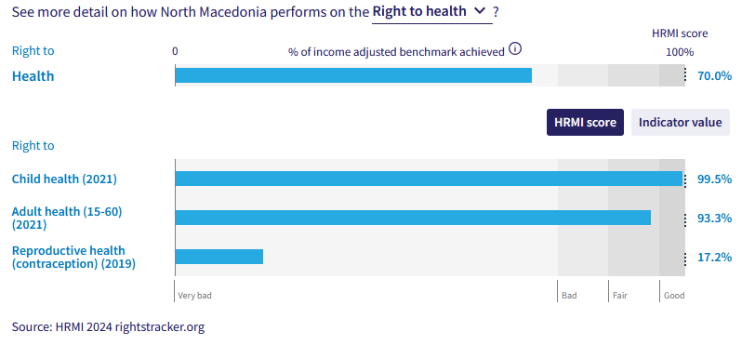
16. The overall right to health has a HRMI score of 70.0% and sits within the ‘Very bad’ range. Over the past decade, the right to health has remained at this level, beginning in 2011 with a HRMI score of 69.5%.

17. For the right to reproductive health North Macedonia has the fourth lowest score of assessed countries in Europe, at 17.2%. This score sits deeply within the ‘Very bad’ range and indicates that North Macedonia is not effectively using its resources towards positive outcomes for its people. This score also places North Macedonia at 129 out of 142 countries for this right.
Caption:HRMI Rights Tracker, income adjusted benchmarks– European Countries. Right to reproductive health (contraception)
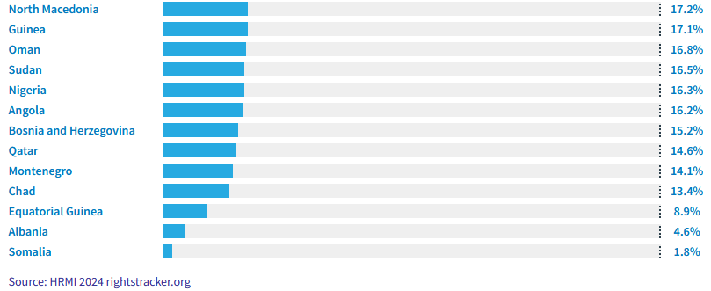
HRMI Rights Tracker, income adjusted benchmarks – bottom 13 countries. Right to reproductive health (contraception)

18. North Macedonia holds a score of 99.5% on their fulfilment of the right to child health, this is a score that has been gradually increasing over the past two decades from 97.0% in 2000. This is performing above average when compared to with other countries in Europe and is nearing its complete obligation to the right to child health under international law.

19. North Macedonia is yet to achieve full progressive realisation of its obligations to health rights and is not meeting its immediate human right to reproductive health obligations under international law.

VII. Right to Housing

20. HRMI defines the right to housing in accordance with ICESCR Article 11.1 and CESCR General Comment 4. In the case of low- and middle-income countries, such as North Macedonia, HRMI uses an assessment standard that measures the right to water on premises and ‘basic’ sanitation (each household having its own improved toilet facilities).

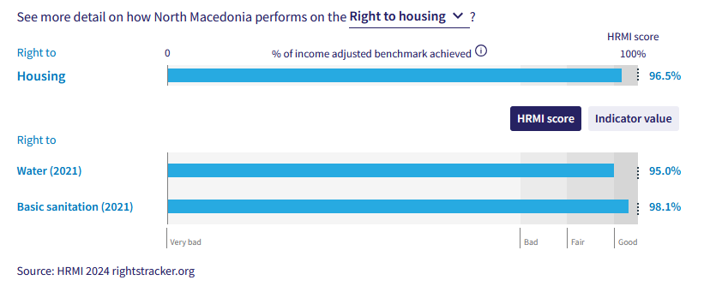
21. Overall, North Macedonia holds a HRMI score for the right to housing of 96.5% and has undergone a slight increase over the past two decades, rising from a score of 89.1%. Its current score falls within the ‘good’ range.

22. For basic sanitation, North Macedonia has a score of 98.1% and is within the ‘good’ range, this places it at 13 of the 42 assessed countries in Europe for the right to basic sanitation. This score has steadily increased over the past two decades from 83.8% in 2000.

23. North Macedonia’s score for the right to water has remained at a similar level over the past two decades and now sits within the ‘good’ range with a score 95.0%.

VIII. Right to Work and Social Security

24. HRMI measures the right to work in accordance with ICESCR Articles 6 and 7. For low and middle-income countries, such as North Macedonia, HRMI measures the right to work and social security using a subsistence income indicator. According to the World Bank PovcalNet in 20, in North Macedonia, the percentage of people who are not absolutely poor is 92.5%.

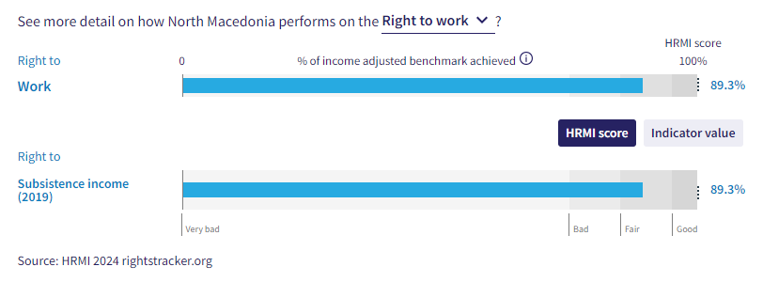
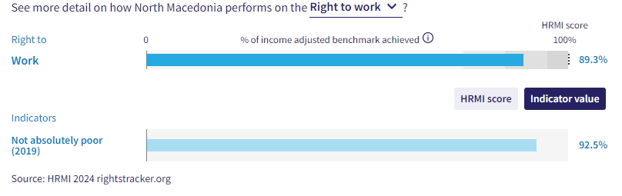
25. North Macedonia has been steadily improving its fulfilment of the right to a subsistence income with a score of 89.3%, placing it in the ‘fair’ range. North Macedonia’s score has increased from 76.8% to 89.3% in the period of 2009-2019. This does signify that the government an improvement in the levels of subsistence income for the population. While good progress is being made by North Macedonia, it ranks poorly to the rest of Europe, ranked 39 of the 42 European countries we have data for in the fulfilment of the right to at least a subsistence income.
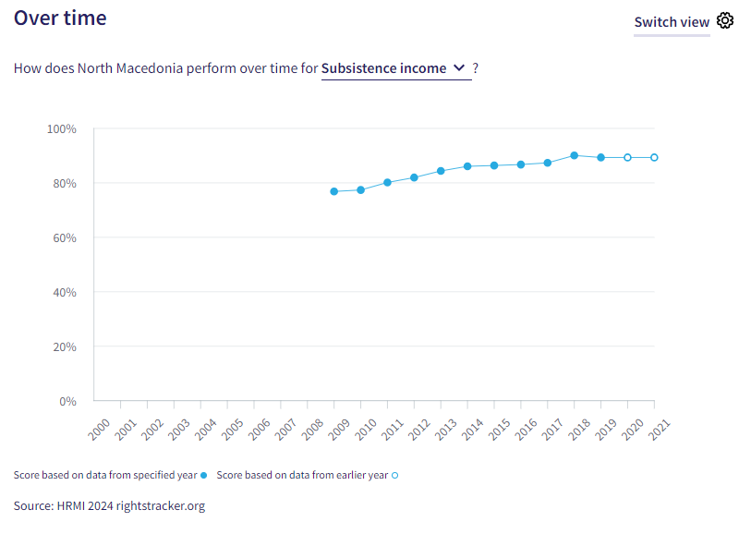
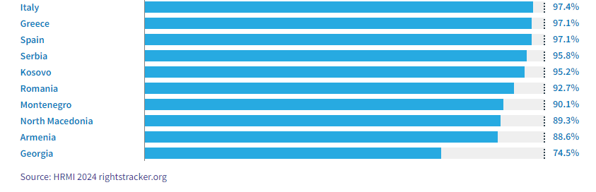
Caption: HRMI Rights Tracker, income adjusted benchmarks – bottom 10 countries. Right to Subsistence Income.
X. Concluding Remarks

29. HRMI respectfully submits its data and findings on the fulfilment of economic and social rights in North Macedonia. We hope that this submission will serve as a useful resource to the Committee on Economic, Social and Cultural Rights for drafting specific and meaningful questions to North Macedonia within the list of issues report for the 77th Session.

Prepared by:
Thalia Kehoe Rowden
Sarah Bakewell
Regan Joyce
Sam Turner

Visit HRMI’s website to learn more about our mission and work, https://humanrightsmeasurement.org/.
This content represents the opinions of the Human Rights Measurements Initiative. It carries no endorsement of the University of Georgia.
See HRMI’s methodology for measuring economic and social rights: https://humanrightsmeasurement.org/methodology and https://rightstracker.org/page/methodology.
Ibid
Ibid
HRMI 2024 Rights Tracker, https://rightstracker.org/
See Human Rights Measurement Initiative (HRMI) Digital Public Good Certificate, https://app.digitalpublicgoods.net/a/11781 The Digital Public Goods Alliance is endorsed by the UN Secretary General’s “Roadmap for Digital Cooperation,” https://www.un.org/en/content/digital-cooperationroadmap/assets/pdf/Roadmap_for_Digital_Cooperation_EN.pdf. It defines digital public goods as: “open source software, open data, open AI models, open standards and open content that adhere to privacy and other applicable laws and best practices, do no harm, and help attain the SDGs,” https://digitalpublicgoods.net/standard/.
HRMI 2024 Rights Tracker, https://rightstracker.org/country/MKD?qolFdScore=hrmi&pb=adjusted&as=core&tab=report-esr
HRMI 2024 Rights Tracker, https://rightstracker.org/metric/education.
HRMI 2024 Rights Tracker, https://rightstracker.org/country/MKD?tab=report-esr&as=core&pb=adjusted
HRMI 2024 Rights Tracker, https://rightstracker.org/country/MKD?tab=report-esr&as=core&pb=adjusted
HRMI 2024 Rights Tracker, https://rightstracker.org/country/MKD?tab=report-esr&as=core&pb=adjusted
HRMI 2024 Rights Tracker, https://rightstracker.org/metric/not-stunted.
HRMI 2024 Rights Tracker, https://rightstracker.org/country/MKD?tab=report-esr&as=core&pb=adjusted
HRMI 2024 Rights Tracker, https://rightstracker.org/country/MKD?tab=report-esr&as=core&pb=adjusted
Ibid
HRMI 2024 Rights Tracker, https://rightstracker.org/metric/contraception?tab=report-esr&as=core&pb=adjusted&region=europe-central-asia&subregion=europe
HRMI 2024 Rights Tracker. https://rightstracker.org/metric/contraception
Ibid
HRMI 2024 Rights Tracker. https://rightstracker.org/metric/under-5-survival?region=europe-central-asia&subregion=europe
HRMI 2024 Rights Tracker, https://rightstracker.org/country/MKD?tab=report-esr&as=core&pb=adjusted
Ibid
HRMI 2024 Rights Tracker. North Macedonia
HRMI 2024 Rights Tracker. North Macedonia

