
END BLASPHEMY LAWS IN GREECE
A joint campaign by 3 international and 51 national NGOs

4 July 2016

This is a joint NGO submission to the United Nations’ Committee on the Elimination of Racial Discrimination (CERD) for the review of Greece’s compliance with its obligations under the International Convention on the Elimination of All Forms of Racial Discrimination during its 90th Session, on 3 and 4 August 2016. It addresses theme 12 in CERD’s “List of themes in relation to the combined twentieth to twenty-second periodic reports of Greece:” “Actual enjoyment of the right to freedom of thought, conscience and religion and the right to freedom of association by all ethnic-religious minority groups.”

Report of UN’s Special Rapporteur on freedom of religion or belief, Heiner Bielefeldt (26 December 2013)
“70. e. (…) States should repeal blasphemy laws, which typically have a stifling effect on open dialogue and public discourse, often particularly affecting persons belonging to religious minorities.”

CERD is requested to urge Greece to abolish Articles 198 and 199 on blasphemy from the Greek Criminal Code which are still used for alleged blasphemy but only against the official Greek Orthodox religion and which call for prison sentences up to two years.

Explanatory report

On 2 June 2016, our organizations sent to the Secretary-General for Transparency and Human Rights at the Ministry of Justice, who is the Greek government official in charge of human rights and heading the Greek delegations to the UN bodies reviewing Greece in 2015 and 2016, an appeal for the abolition of the blasphemy criminal provisions, in which the provisions are listed, as is his repeated commitment to those UN bodies to have them abolished. On 9 June 2016, he sent us a reply repeating the government’s commitment to abolish those provisions, but describing procedures that in effect would postpone such procure indefinitely. The abolition of the blasphemy provisions necessitates nothing more than a one-sentence article in any bill: “Articles 198 and 199 of the Criminal Code are abolished.” Our organizations believe that the government may have the declared will to abolish these provisions but is afraid of possible reactions of the official Orthodox Church, which seems to be opposed to their abolition. Our appeal and the government’s reply follow.

Mr. Kostis Papaioannou
Secretary-General for Transparency and Human Rights at the Ministry of Justice

Subject: Abolition of blasphemy articles from the Greek criminal code

2 June 2016

Dear Secretary-General

Our organizations have appreciated that, in your concluding statement during Greece’s review by the Human Rights Committee on 20 October 2015, as head of the Greek delegation you made the unprompted commitment that Greece will extend civil partnership to same-sex couples, legally recognize gender identity, as well as abolish outdated criminal provisions such as unnatural indecency (347 Criminal Code) and the articles on blasphemy (198 and 199 Criminal Code).

We welcome the fact that with Law 4356/2015 civil partnership was extended to same-sex couples and the crime of unnatural indecency was abolished, while an experts’ committee was set up to produce a draft law on the recognition of gender identity.

We have been concerned however that the articles on blasphemy were not abolished, while new charges for blasphemy are pressed by prosecutors, for example on 1 February 2016, and the trial on appeal of blogger Philipos Loizos (aka “Elder Pastitsios”), convicted at first instance for blasphemy to a suspended prison sentence of ten months on 16 January 2014, has yet to be scheduled almost two and a half years later.

We therefore appreciated that the delegation to the UN Human Rights Council that you headed for Greece’s Universal Periodic Review expressed on 9 May 2016 its support inter alia to the recommendation by Brazil that Greece “Ensure[s] religious freedom and tolerance, by measures such as decriminalizing blasphemy and protecting the rights of religious minorities, atheists and agnostics.”

We now urge you to see to it that the government promptly tables before Parliament the abolition of the two blasphemy articles 198 and 199 from Greece’s Criminal Code and that prosecutors or courts drop all related charges pending before them.

We thank you in advance for your attention to this appeal and are looking forward to your reply.

[followed list of the signatory organizations]

Athens 09-06-2016
To: List of recipients (c/o Mr. Dimitras)
Dear Sirs/Madams,
Replying to your letter of 2 June 2016, we would like to inform you that the abolition of the articles against blasphemy remains our declared aim and its implementation is related to the overall planning of the Ministry of Justice.

In any case, issues concerning to the Penal Code are examined by the competent Legislative Commission. Your letter will be brought to the attention of that Commission, as well as, of course, of the Minister.

[signature]

Kostis Papaioannou
Secretary-General for Transparency and Human Rights
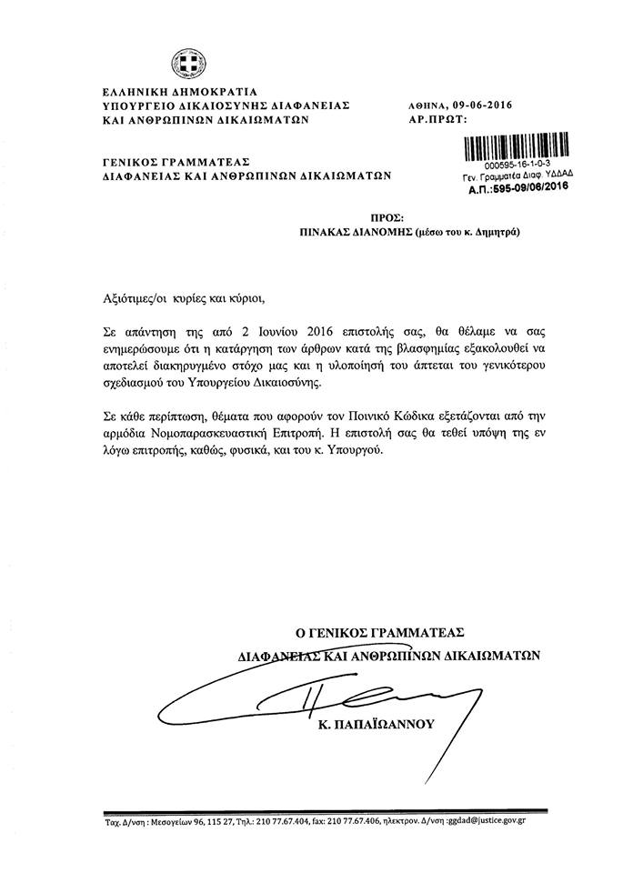

Transnational organizations: 1. Atheist Alliance International 2. European Humanist Federation 3. International Humanist and Ethical Union National organizations: 1. Action Luxembourg Ouvert et Solidaire - Ligue des Droits de l’Homme a.s.b. 2. Allianz vun Humanisten, Atheisten an Agnostiker Lëtzebuerg (Luxembourg) 3. American Atheists 4. American Humanist Association 5. Asociatia Umanista Romana (Romanian Humanist Association) 6. Association humaniste du Québec (Canada) 7. Atheist & Agnostic Alliance Pakistan 8. Atheist Ireland 9. Atheist Union of Greece 10. British Columbia Humanist Association (Canada) 11. British Humanist Association 12. Bund für Geistesfreiheit Erlangen (Germany) 13. Center for Civil Courage (Croatia) 14. Center for Inquiry Canada 15. Center for Inquiry USA 16. Central London Humanists (UK) 17. Centre d'action laïque (Belgium) 18. Centro di Documentazione, Ricerca e Studi sulla Cultura Laica “Piero Calamandrei” (Italy) 19. Coordinamento Nazionale delle Consulte per la Laicità delle Istituzioni (Italy) 20. Cyprus Humanist Association 21. Dachverband Freier Weltanschauungsgemeinschaften e.V. (Germany) 22. deMens.nu (Belgium) 23. EGALE (France) 24. Freethought Society (USA) 25. Freidenker-Vereinigung der Schweiz (Freethinkers Association of Switzerland) 26. Freidenkerbund Österreichs (Austria) 27. Greek Helsinki Monitor 28. Humanist Association of Canada 29. Humanist Society Scotland 30. Humanist Union of Greece 31. Humanisterna (Swedish Humanist Association) 32. Humanistisch Verbond (Dutch Humanist Association - the Netherlands) 33. Humanistischer Verband Deutschlands (Germany) 34. Humanistisk Samfund (Danish Humanist Society) 35. Kazimierz Lyszczynski Atheist Foundation (Poland) 36. LibMov (Italy) 37. Malta Humanist Association 38. National Secular Society (UK) 39. North American Tarksheel (Rationalist) Society-Ontario (Canada) 40. North London Humanist Group (UK) 41. Norwegian Humanist Association (Human-Etisk Forbund) 42. Polish Humanist Association 43. Polskie Stowarzyszenie Racjonalistów (The Polish Association of Rationalists) 44. Russian Humanist Society 45. Secular Student Alliance (USA) 46. Sidmennt - The Icelandic Ethical Humanist Association 47. Society for Humanism (SOCH – Nepal) 48. Unione degli Atei e degli Agnostici Razionalisti (UAAR - Italy) 49. Union des Familles Laïques (UFAL - France) 50. Vapaa-ajattelijain Liitto ry (Finland) 51. Watford Area Humanists (UK)
http://tbinternet.ohchr.org/Treaties/CERD/Shared%20Documents/1_Global/INT_CERD_POW_90_24695_E.doc
https://documents-dds-ny.un.org/doc/UNDOC/GEN/G16/112/82/PDF/G1611282.pdf?OpenElement
http://www.ohchr.org/EN/HRBodies/HRC/RegularSessions/Session25/Documents/A-HRC-25-58_en.doc
http://www.ohchr.org/EN/NewsEvents/Pages/DisplayNews.aspx?NewsID=16622&LangID=E
http://www.astynomia.gr/index.php?option=ozo_content&lang&perform=view&id=60127&Itemid=1638
https://extranet.ohchr.org/sites/upr/Sessions/25session/Greece/Documents/Draft%20Report-A_HRC_WG.6_25_L.4_Greece.docx
Article 198 of Criminal Code (CC): “Malicious Blasphemy: 1. One who publicly and maliciously and by any means blasphemes God shall be punished by imprisonment for not more than two years. 2. Except for cases under paragraph 1, one who by blasphemy publicly manifests a lack of respect for the divinity, shall be punished by jailing for not more than six months or by pecuniary penalty of not more than 3,000 euros.” Article 199 CC: “Blasphemy Concerning Religions: One who publicly and maliciously and by any means blasphemes the Eastern Orthodox Church of Christ or any other religion tolerated in Greece shall be punished by imprisonment for not more than two years.”

