For Review of Seventh and Eighth Periodic Reports of Government of Japan
on the Implementation of the Convention on the Elimination of All Forms of
Discrimination against Women (CEDAW)

Situations and Challenges of
Minority Women in Japan

Voice of Ainu, Buraku and Zainichi Korean Women

Ainu Association of Sapporo
Buraku Liberation League Central Women's Division
Apuro Korean Women's Network in Japan
Human Rights Association for Korean Residents in Japan
The International Movement Against All Forms of Discrimination and Racism

January 2016

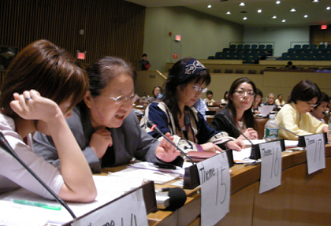

【INDEX】
Preface 2
1. Situations and Challenges of Minority Women
1) Establishment of the Rights of Ainu Indigenous Women
････Ainu Association of Sapporo 3
2) Situations of Buraku Women
･･Buraku Liberation League Central Women's Division 8
3) "Zainichi" Korean Women Are Not an Invisible Presence in Japan - for Making Human Rights Challenges We Face Visible
…Apuro Korean Women's Network in Japan 13
4) Problems faced by Korean Women in Japan in Employment
･･･Human Rights Association for Korean Residents in Japan 16
2. Proposed Recommendations 17
1) Conducting Survey on Minority Women (Article 2)
2) Participation of Minority Women in Decision-Making (Article 2)
3) Regulations and Preventions of Hate Speech (Article 2)
4) Responding to Violence against Minority Women (Article 2)
5) Supporting Education for Minority Women including Support for Japanese Language Education (Article 10)
6) Supporting Employment and Work of Minority Women (Article 11)

ANNEX: Basic Information of Minority Women Groups 19

Preface

Ainu Women, Buraku Women and Zainichi Korean Women in Japan summarized this report with the recommendations we hope the Committee will issue to the Japanese Government and research data regarding the situations and challenges of minority women to support our arguments. (for Basic Information of Minority Women Groups, see p.17 of this report)

In Japan, minority women including Buraku women, Zainichi Korean women, Ainu Women and Okinawa women, each minority group with different backgrounds, are facing multiple challenges. However, these challenges are not being addressed either in the human rights policies or women’s policies. Although in 2003 and 2009 the Committee made recommendations to the Japanese government to take effective measures, including the establishment of a policy framework and collection of information and statistical data on the situation of minority women, the Japanese government has failed to conduct any measures and has not even recognized its necessity.

In order to overcome the cross-cutting problems that Japan’s minority women face, we would like the CEDAW Committee to make recommendations to the Japanese government, which we present in this report from p.17.

For your information, below are the references to the NGO Joint Report submitted by Japan NGO Network for CEDAW (JNNC), where you can see our answers to the List of Issues related to minority women.

【References to JNNC NGO Joint Report, which were contributed by minority women】
- Paragraph 4-3: Harmful practices- “Hate Speech” (pp.13-14)
- Paragraph 6-2: Violence against women “Counselling to victims (minority women) of domestic violence”(pp.17-18)
- Paragraph 8-1: Violence against women “military base in Okinawa” (pp.20-22)
- Paragraph 13-2: Education “Education of Minority women” (pp.40-42)
- Paragraph 14-2: Employment “(b) to promote minority women’s participation in the labour market.” (pp.46-48)
- Paragraph 20-5: Disadvantaged groups of women “policy on minority women” (pp.77-78)
■Contact
The International Movement Against All Forms of Discrimination and Racism (IMADR)
Address: 6F, 1-7-1, Irifunecho, Chuo-ku, Tokyo 104-0042 Japan
Tel: (+81)3-6280-3100 Fax: (+81)3-6280-3102
Email: imadr@imadr.org Website: http://www.imadr.org

- Situations and Challenges of Minority Women

- Establishment of the Rights of
Ainu Indigenous Women
Ainu Association of Sapporo

Background:
The Ainu people are an indigenous people, that have their own language and culture, lead a common economic life and have built their unique history in Ainu Mosir (the land where the Ainu reside) which consists of the islands of Hokkaido in northern Japan, Karafuto (Sakhalin) and Chishima (Kuril Islands). At the time of the conclusion of the Treaty of Commerce and Navigation between Japan and Russia (Treaty of Shimoda) in 1854, the Japanese government declared the whole Ainu Mosir as its territory, and unilaterally, without any negotiations with the Ainu people, integrated the land as terra nullius. The Ainu people were denied of their existence as a people and their own culture, robbed of their own language, and their dignity as a people was trampled by the assimilation policy based on discrimination and prejudice. The Ainu people lost their places and means of livelihood, and suffered discrimination and poverty. Even today, there is discrimination such as in the living environment and education. Ainu women, in particular, are facing difficulties in education, employment, domestic violence and other areas.
The Japanese government recognized in 2008 that “the Ainu people are an indigenous people” but the existing Ainu policy overemphasizes cultural rights, and is powerless to achieve the inherent rights of an indigenous people in an integrated and comprehensive manner. Furthermore, matters regarding Ainu women have never been on the agenda of the Council for Ainu Policy Promotion, nor has there been a discussion on the improvement of the situation of Ainu women.

The Hokkaido Ainu Association, Sapporo Branch is requesting the following 4 issues to the Japanese government.

(1) Equal participation in political and public activities – related to Articles 2 and 7
(2) Provision of educational support – related to Article 10
(3) Provision of employment support – related to Article 11
(4) Training and development of counselors regarding violence against women – related to Article 2

(1) Equal participation in political and public activities
◆CEDAW List of Issues: para 20 (Art. 2 and 7)
●JNNC NGO Joint Report: para 20-5 absence of policy on minority women - pp.77-78

Problem
The government is not aware of the situation of Ainu women or the need for policies to address the situation. Because we do not have the authority to decide the agenda to be discussed in the preparation of policies, women’s issues are not placed on the agenda, and there still is no forum in which these can be discussed. There is no mechanism to understand the situation of everyone in vulnerable positions including Ainu women.

Proposed Recommendations
The government should take concrete measures to transform the Council for Ainu Policy Promotion into one that can reflect the voices of all affected people, and to design comprehensive policies for the Ainu people.

(2) Provision of educational support
◆CEDAW List of Issues: para 13 (Art. 10)
●JNNC NGO Joint Report: para 13-2 education of minority women – pp. 40

Problem
Both the school enrolment rates and final academic levels of the Ainu people tend to be lower compared to the non-Ainu people. The educational situation of Ainu women in particular, is troubling. According to the survey conducted by the Ainu Association of Sapporo, approximately half of the respondent Ainu women replied that the final academic level was the junior high school level. Also, the issue of the high rate of Ainu women who have problems in reading and writing must be addressed at once, but the government is not aware of the situation of Ainu women or the need for policies to address the situation.

All data are from “Survey on the Situation of Ainu Women 2005,” Ainu Association of Sapporo (241 respondents).

Proposed Recommendations
The government should conduct a survey on the situation of education and illiteracy of Ainu women, and provide educational support including ethnic education for Ainu children and opportunities for adult education for Ainu women.

(3) Provision of employment support
◆CEDAW List of Issues: para 14-b (Art. 11)
●JNNC NGO Joint Report: para 13-2 education of minority women – pp. 46

Problem
More than half of the Ainu women replied that their individual income was less than 1.3 million yen. The proportion of those in non-regular employment is also high.

Proposed Recommendations
As the Ainu women have no alternative but to be employed in unstable and low paying jobs because of insufficient education, the government should conduct a survey and formulate policies to improve the situation.

(4) Training and development of counselors regarding violence against women
◆CEDAW List of Issues: para 6(Art. 2)
●JNNC NGO Joint Report: para 13-2 education of minority women – pp. 17-18

– related to Article 2 (JNNC Report pp.17)
Problem
Ainu women also suffer from domestic violence. Approximately 30% of the respondent Ainu women replied that they were beaten, had things thrown at them, shouted at or were forced to have sexual intercourse. The proportion of Ainu women, who consulted about their suffering domestic violence was extremely small, and almost none of them went to public or government organizations. That is likely because the government offices and counselors do not fully understand the situation of Ainu people, and the Ainu women avoided going to them out of fear of secondary damages. The place the women turned to help the most was doctors, and it is of serious concern that they were unable to consult anyone until they reach the stage in which they needed medical help.

Proposed Recommendations
The government should develop peer counselors and establish offices, with which Ainu women who suffer from domestic violence can feel at ease to consult. The government should also consult with indigenous peoples’ organizations and organize trainings and seminars, so that public and government organizations including the police can gain better understanding of indigenous peoples.

All data are from “Survey on the Situation of Ainu Women 2005,” Ainu Association of Sapporo.

2) Situations of Buraku Women
Buraku Liberation League
Central Women’s Division

Origin of Buraku traces back to the Middle Ages. Under the strict social class structure of the feudal system during the Edo Era (1603～1868), ancestors of present Buraku people were placed at the bottom of society. After the Meiji Restoration in 1868, Japan entered into the modern world leaving Buraku people behind the modernization and industrialization. Exclusion and discrimination against Buraku drove them into the extreme poverty. In 1922, Buraku people stood up to found their own association called Levelers' Association demanding for the respect of their human dignity. After World War II, Buraku people were mobilized again to start the campaign under the name of Buraku Liberation League.
In 1965, the state of Japan admitted its responsibility for the solution of Buraku discrimination, and implemented special measures for 33 years under the provisional law which was terminated in 2002. Special measures have improved Buraku situation to the certain extent, but failed to effectively address problems such as the stigma on Buraku, deep-rooted prejudice of people against Buraku, or a new dimension of discrimination, i.e. "multiple forms of discrimination against women."
In this summary, we focus on the challenges of Buraku women in the fields of equal participation, education and literacy, employment and remedial measures.

- Disadvantaged Groups of Women: Survey on Situations of Minority Women including Buraku Women
◆CEDAW List of Issues: para 20 (Art. 2)
●JNNC NGO Joint Report of 10/01/2016: para 20-5, 1. absence on policy of minority women - p.77

Proposed recommendations:
The state party should conduct a survey to find actual situations of Buraku women, and make necessary statistics and analysis based on results.

Backgrounds:
The government has failed to indicate statistics and specific measures for minority women including Buraku women in its 7th and 8th periodic report (CEDAW/C/JPN/7-8) despite the repeated recommendations made by the Committee in its Concluding Observations of 2003 and 2009. The government has never conducted such a survey as it argues that recommendations made by UN human rights treaty bodies are not legally binding, giving the government no obligation to follow. It is essential for the government to understand actual situations of minority women if it is truly serious about making measures to solve human rights problems faced by minority women.

- Disadvantaged Groups of Women: Promotion of Participation of Buraku Women in Decision-Making Processes

◆CEDAW List of Issues: para 20 (Art. 4, 7)
●JNNC NGO Joint Report of 10/01/2016: para 20-5, 2. participation of minority women
in decision-making process - p.78

Proposed recommendations: The state party should promote participation of Buraku women in decision-making processes.

Backgrounds:
As of March 2015, women's direct political participation is as follows:
at the national level - 45 women out of all 475 members of the House of Representatives (Diet) accounting for 9.5%, while 38 women out of all 242 members of the House of Councilors accounting for 15.7%. Of all 33,416 local assembly members, women are 3,926 accounting for 11.7%. These figures are quite low among world's countries.

At the same time, relevant advisory bodies set up by the national, local or municipal levels should invite representatives of Buraku women so that their voices can be reflected in decisions made by such bodies and eventually in measures taken by relevant authorities.

- Education: Survey on Illiteracy among Buraku Women and Implementation of Adequate Measures
◆CEDAW List of Issues: para 13 (Art. 10)
●JNNC NGO Joint Report: para 13-2 education of minority women - p.40

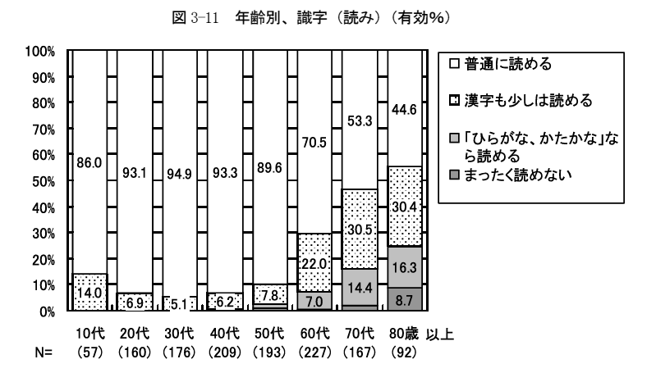
Fig 1-1: literacy rates by age group - reading (survey in 2009)

□ I read without difficulties
I read some Chinese characters.
□ I read only hirakana and katakana.
□ I cannot read at all.

age groups 10's 20's 30's 40's 50's 60's 70's 80's above N= (response number)

age groups 10's 20's 30's 40's 50's 60's 70's 80's above N= (response number)
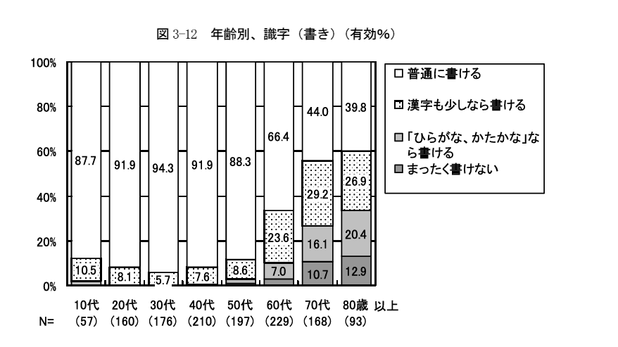
Fig 1-2: literacy rates by age group - writing (survey in 2009)

□ I write without difficulties
I write some Chinese characters.
□ I write only hirakara and katakana.
□ I cannot write at all.

age groups 10's 20's 30's 40's 50's 60's 70's 80's above N= (response number)

**Figures 1 and 2 are from the survey on Buraku women in Osaka conducted by BLL Osaka in 2009.

Proposed recommendations:
The state party should take appropriate measures to solve illiteracy among Buraku women whose right to education has not been guaranteed and fulfilled.

Backgrounds:
Illiteracy among Buraku women has been on the decrease thanks to literacy efforts, but, many elderly Buraku women still have difficulties in reading/writing. More than 10% of young Buraku women do not read and write without difficulties. Regardless the constitutional guarantee for education for all children, it has not necessarily been the case for Buraku women and children. Also, in today's society where "illiteracy" is seen as a shame, those women who have difficulties in reading and writing tend to blame themselves for their illiteracy. The government is required to clearly recognize that illiteracy is the result of the failure in guaranteeing the right to education for all, and to implement adequate measures. Illiteracy brings about "trouble" to illiterate persons in all spheres of one's daily life.

- Employment: Improvement of Regular-based Employment Conditions for Buraku Women
◆CEDAW List of Issues: para 14-b (Art. 11)
●JNNC NGO Joint Report: para 14-2 promotion of employment of minority women -p.46
Fig.2: Irregular Employment Rate by Age Group of Buraku Women
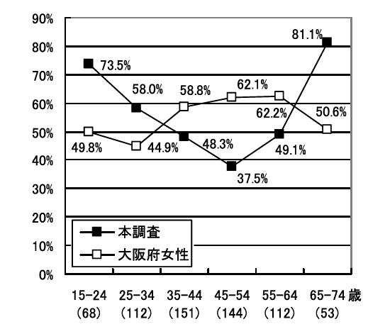

A comparison of irregular employment between:

■ Buraku women in Osaka prefecture (survey in 2009), and

□ Women in Osaka prefecture (survey in 2007)

Buraku women
women in Osaka Prefecture
wo

age groups: 15-24 25-34 35-44 45-54 55-64 65-74 (response number among Buraku women)
**numbers of women in Osaka prefecture are from the survey conducted by Osaka Prefecture in 2007.

Proposed recommendations:
The state party should ratify ILO Convention No. 175 - part time work Convention, and take necessary steps to prohibit discrimination at the time of employment against Buraku women.

Backgrounds:
As shown in the Fig. 2, the irregular employment rate among Buraku women aged between 35 to 64 is lower than that of Osaka prefecture thanks to steps taken under Dowa Special Measures. However, among the two age groups (15-24 and 25-34) of Buraku women who did not get any benefits from the Special Measures due to the termination of the Special Measures Law in 2002, the rate is higher than the same age groups of Osaka prefecture due to several reasons including the employers’ intentional exclusion of Buraku persons from employment; the generally bad economic conditions; and the lack of higher educational backgrounds which is correlative with stable employment usually with professional or skilled work. Thus, they are obliged to get jobs at small companies in unstable irregular employment. In addition to the ratification of ILO Convention, the government should take measures to improve work conditions for part-time workers, to promote regular employment and to prohibit personal background investigation in an attempt to exclude Buraku job applicants from employment.

- Institutional framework: Remedies for Victims of Buraku Discrimination, and Strengthened Human Rights Education
◆CEDAW List of Issues: para 1 (Art. 2)
●JNNC NGO Joint Report: para 1-2 national human rights institutions - p.3

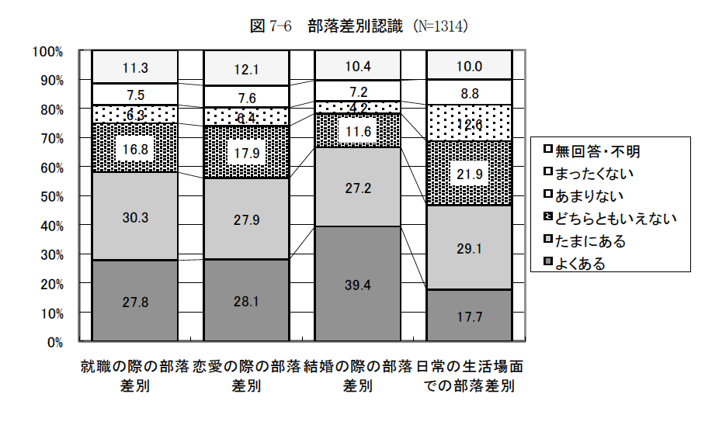
Fig.3: recognition of being discriminated against at certain occasions (N: 1,314)

Have you ever felt that you were discriminated against?
<from the top> ↓
□ n.a./unclear
□ not at all
□ not very often
□ yes and no
□ occasionally
□ very often

at the time of: employment dating marriage various occasions in daily life

**Figure is 3 from the survey on Buraku women in Osaka conducted by BLL Osaka in 2009.
Proposed recommendations:
The state party should develop remedial measures for victims of Buraku discrimination, and strengthen its efforts for human rights education to promote non- discrimination.

Backgrounds:
As shown in Fig.3, nearly 70% of Buraku women recognize Buraku discrimination at the time of marriage, nearly 60% recognized at the time of employment and dating, and 50% of them felt occasionally or very often during their daily life. Those who have directly and personally experienced Buraku discrimination are more sensitive to discrimination than those who have not. Buraku discrimination takes place in any occasion of our daily life. Existing surveys demonstrate that those with higher educational backgrounds or higher level of incomes are more likely to experience Buraku discrimination. It indicates that expansion of one's social activities and relationship with others may lead to the increase in possibility to encounter Buraku discrimination.

3) "Zainichi" Korean Women Are Not an Invisible Presence in Japan - for Making Human Rights Challenges We Face Visible
Apuro Korean Women's Network in Japan

Introduction
A large majority of "Zainichi " Koreans are those from Korea who had no way but to live in Japan during the Japan's colonial rule over the Korean Peninsula from 1910 to 1945 and their descendants. For many decades long before the recent escalation of racist hate speech against "Zainichi" Koreans, grave and serious racial discrimination and prejudice against "Zainichi" has existed and been practiced in Japan. Many "Zainichi" Koreans refrain from using their real ethic names and live under their Japanese names (practices originated from Japanese colonial policy in 1940) without expressing their national and cultural identity.

Regarding the legal status of "Zainichi" Koreans, or those from the former colony and their descendants, more than 500,000 people have been naturalized since 1952. For "Zainichi" Koreans, "Naturalization" is a synonym for "assimilation" in the Japanese context. One would face discrimination against her/him if her/his ethnic backgrounds are disclosed. Meanwhile, about 350,000 of those from the former colony and their descendants have held their "Korean" nationality with the legal status as "special permanent residence" in Japan.

"Zainichi" Koreans are tax payers just as Japanese and other foreign residents. Nevertheless, unless "Zainichi" Korean acquires a Japanese nationality, they are not eligible to vote for a national as well as local election including referendums at the local level.

- Disadvantaged Groups of Women - Absence on Government Policy for Minority Women

◆CEDAW List of Issues: para 20 (Art. 2)
●JNNC NGO Joint Report of 10/01/2016: para 20-5, 1. absence on policy of minority women - p.77

Proposed recommendations:
The state party should conduct a survey to find the actual human rights situations of minority women including "Zainichi" Korean women with the participation of experts in international human rights norms.

Backgrounds:
No official survey on human rights situation of "Zainichi" Korean women has been conducted in Japan at the national level. At the local level, a few municipalities, including Osaka (in 2001), Hiroshima (2002 and 2012) and Kyoto (1997 and 2007), out of some 1,700 municipalities throughout the country have once conducted a survey on foreign nationals who resided in the respective municipality to find out about their attitude or their living conditions. These surveys were for foreign residents in general, and not exclusively for Korean residents.
While there have been various statistical data regarding women in general and "Zainichi" Korean women must be included in these data, their presence is invisible. In other words, "Zainichi" Korean women are part of women in Japan in general, but nobody grasps their real situation as a group. Without conducting a survey, no effective policy on minority women can be developed.

The term "foreign nationals" was officially used for the first time in the Basic Plan for Gender Equality when the government developed its Third edition in 2010. But it did not refer to "Zainichi" Korean women. Naturally, challenges and needs of "Zainichi" Korean who have long resided in Japan are different from those of "new comers" from other countries. In fact, the National Women's Education Center of Japan clearly states in its publication "Reference materials in regard to support for foreign women in difficulties from the perspective of gender equality (2013)" that "foreign women referred to herein are migrant women."

- Harmful Practices - Hate Speech targeting "Zainichi" Korean Women

◆CEDAW List of Issues: para 4 (Art. 2)
●JNNC NGO Joint Report of 10/01/2016: para 4-3, Prevalence of hate speech targeting “Zainichi” Korean women - p.13

Proposed recommendations:
The state party is urged to take measures to punish those who make hate speech of serious nature against minority women. It is also urged to give warnings to government officials and politicians whose behaviors or remarks effectively encourage hate speech.

Backgrounds:
While the government has been given recommendations to take legal measures on hate speech and hate crimes by the Human Rights Committee and the CERD in their respective Concluding Observations issued in July and August 2014 respectively, it has not taken any effective steps to regulate and prevent them.

It has also been very disturbing news that one of the lawmakers of the Liberal Democratic Party made a sexist and racist hate speech remark against "comfort women" on Jan. 14, 2016, a month after the PM Abe and President Park have reached the agreement regarding the issue of "comfort women". Sakurada Yoshitaka as an LDP Diet member stated in an LDP meeting that "those women were prostitutes by occupation" and that people have been “heavily misled by propaganda work treating them as if they were victims.”

Refer to the web news of the Japan Times: http://www.japantimes.co.jp/news/2016/01/14/national/politics-diplomacy/ldp-lawmaker-retracts-statement-comfort-women-prostitutes/#.Vpsar-Rf3IU

As indicated in the JNNC NGO Joint Report on page 14 (in the third paragraph), a Korean woman journalist has filed a suit against the racist group demanding for compensation in August 2014. It is not easy to initiate legal action when in can be anticipated that the claimant would be attacked with further hate speech against her. Most "Zainichi" Korean women would bear it silently.

- Education of Minority Women: Exclusion of Korean Schools from Educational Support
◆CEDAW List of Issues: para 13 (Art. 2)
●JNNC NGO Joint Report of 10/01/2016: para 13-2, Equal educational support for Korean school girls - p.41
Proposed recommendations:
The state party should not exclude Korean schools from educational support/subsidies that other schools are entitled to.

Backgrounds:
Korean schools are public educational institutions to which the Act on School Education of Japan is applicable. Nevertheless, Korean schools are categorized as miscellaneous school under Art 134 of the Act, and not eligible for any public scholarship programs or school expense subsidies. Also, the high school tuition waiver program of the government has excluded all 10 Korean High Schools from the time when the program was launched in 2010. The purpose of the waiver program is to guarantee equal educational opportunity for every high school student.

While parents of students of Korean schools (primary, middle and high schools) fulfill their duties as tax payers, their children are deprived of their right to education that they are entitled to. Because of the cessation of school support programs for Korean schools by the national as well as local governments, many parents are finding financial burden heavier on their shoulder and withdrawing their children from Korean schools.

Long before the exclusion of Korean High Schools from the tuition waiver program and the following cessation of subsidies provided to different Korean schools by different local governments, Korean schools in Japan have been targeted by racist attacks whenever political tensions rise in the region. Starting in 1994, girl students of Korean schools were increasingly abused verbally and physically by persons whom they did not know on their way going to school/home as they wore school uniform of the typical Korean dress. Because of this, all Korean schools changed the uniform for their girl students in 1999.

One of the Korean schools has also been targeted by the racist group in 2009. The racist attackers were sanctioned both under the penal and civil procedures. With the loudspeaker, the racist attackers shouted abuse at the school by saying, "Korean schools are espionage training institution controlled by North Korea," "This is not a school for human beings," or "All Koreans, get out of Japan!" etc. In the ruling of the Osaka High Court of July 2014, it was clearly stated, "About 120 Korean schools with 12,000 students throughout the country, including this school, have acquired high social reputation for its school education based on the ethnic and cultural education. The acts of defendants not only disturbed the school operation and impaired the safe school environment, but also damaged the social environment in which ethnic education for resident Koreans is safely given in Japan."
High court upholds ruling against racist insults at Korean students, The Asahi Shimbun (08/07/2014)
http://ajw.asahi.com/article/behind_news/social_affairs/AJ201407080045
4) Problems faced by Korean Women in Employment
Supplementary Information of p.46, JNNC NGO Joint Report
Human Rights Association for Korean Residents in Japan
◆(Art. 11)
Issues and Background
(1) [Court Case] Suit for damages against Fuji housing
The respondent company not only did not listen to the voice of the plaintiff but also encouraged her to quit the job. This case is on trial.
The chairman of the respondent company distributed materials inciting racial discrimination against Koreans and gender discrimination to the plaintiff, who is Korean. The materials included the following phrases. The last one is completely false because Korean residents in Japan have to pay both prefectural tax and income tax.
“ I felt that (Koreans are) generally assertive, and they are good at lying to get their advantage. I also felt most of them are very suspicious of Japanese and selfish.”
“ It makes my skin crawl when I think of foolish housewives who visit South Korea, while I feel sorry for them as well.. (omitted) As long as that is settled, I want Japan to sever diplomatic relations with South Korea.”
“ (Korean residents in Japan) have to pay neither prefectural tax nor income tax.”

(2) Multiple discrimination seen in the unemployment and non-regular employment rate

Table 1. Unemployment rate (based on the 2010 census)

Prepared by Human Rights Association for Korean Residents in Japan

Table 2. Non-regular employment rate (based on the 2010 census)

Prepared by Human Rights Association for Korean Residents in Japan

2. Proposed Recommendations
1) Conducting Surveys on Minority Women (Article 2)
（LOI para20, JNNC report pp.76-77, This report p.3, 9, 13）
- The State party should inform the Committee of the actual human rights situation of minority women based on the data collected, particularly with regard to education, employment, health, right to autonomy and exposure to violence.
- The State party should reflect the perspectives of minority women in its policies and measures relating to or affecting minority women in order to eliminate intersectional discrimination against minority women and resolve disparities.

2) Participation of Minority Women in Decision-Making (Article 2, 4, 7)
（LOI para20, JNNC report p.77, This report p.3, 9）
The state party should ensure effective participation of minority women in all decision-making processes that would have impact on them by making it a rule to appoint minority women representatives as members of decision-making bodies of relevance both at local and national levels.

3) Regulations and Preventions of Hate Speech (Article 2)
(LOI para.4, JNNC report pp.13-14, This report p.14）
The government of Japan should take measures to punish hate speech of serious nature (against minority women) as a crime and to give warnings to government officials and politicians whose behavior or comments effectively promote hate speech.

4) Responding to Violence against Minority Women (Article 2)
(LOI para 6, JNNC report pp. 17～18, 21, This report p. 7)
- The State party (Japanese Government) should conduct trainings for people engaged in counseling service for minority women on domestic violence and other human rights issues.
- To call upon Japanese Government to provide support for the training of minority women such as Buraku, Zainichi Korean and Ainu so that they can offer counseling and other services within their group.

The Japanese government should be urged to conduct a survey on violence against women relating to the existence of the U.S. bases in Japan, particularly in Okinawa.

5) Supporting Education for Minority Women including Support for Japanese Language Education (Article 10)
(LOI para.13, JNNC report pp.40-41, This report:p.4, 10, 15)
Provide support including funding for improving opportunity and quality of education of minority women, including Japanese language training for those in need.

The state party should grant equal support of education for Korean school girls to guarantee the equal opportunity for education.

6) Supporting Employment and Work of Minority Women (Article 11)
(LOI para.14, JNNC report pp.45～46, This report: p6, 11, 16）
The Japanese Government should take effective measures to improve employment of minority women under proper working conditions and to provide assistance to them in finding decent jobs.

ANNEX: Basic Information of Minority Women Groups
Japan hosts different indigenous and minority groups: Ainu, Buraku, Zainichi Korean and Ryukyu/ Okinawa. Table 1 below shows general information of those groups. Some of the groups do not receive the recognition status recommended by the UN Committee on the Elimination of Racial Discrimination (CERD).
Table 1
 | Ainu | Buraku | Zainichi Korean | Okinawa
Population in total/ women | 23,782/ 11,680 (2006)There are no surveys covering all Ainu people. The above figure is the number of people who call themselves Ainu in Hokkaido, the indigenous land of the Ainu people. | Over 892,751/ N/A (1993)  The Buraku Liberation League estimates that there are 3 million Buraku people, and 6,000 Buraku areas. | Among Korean residents in Japan who have come to Japan because of Japan’s colonial rule over Korea, and their descendants, approximately 430,000 people have nationalities derived from Korean peninsula.. | 1,426,190 / 725,930 (2015)
Comprehensive gender-disaggregated survey/data | N/A | N/A | N/A | N/A
Specific gender policy and measures | N/A | N/A | N/A | N/A
Recognition status by the Government of Japan | Indigenous peoples | Japanese people discriminated based on social  status | Special permanent residents | Japanese people
UN Committee on the Elimination of Racial Discrimination (CERD) | Indigenous peoples | People discriminated based on descent | People discriminated as non-citizens | Indigenous peoples

“Zainichi/ resident Koreans” originate from the Korean peninsula who or whose families moved to Japan because of Japan’s colonial rule over the peninsula. .
Annex to State party report (CERD/C/JPN/3-6 (2009)), Statistics, table 24. *
This statics of Buraku population was collected from officially designated Dowa (Buraku) areas. Therefore, it excluded the Buraku population living outside of those areas.
Statistics of the Ministry of Justice as of 2013. Japan is a jus sanguinis state that attributes citizenship by parentage. In addition to this, there are more than 350,000 people (ibid.) who acquired Japanese nationality after 1952 and more than 160,000 people (As far as it can be ascertained from statistics of Ministry of Health, Labor and Welfare of Japan during 1985-2013) who hold Japanese nationality by parentage, so in total it is estimated there are more than one million Korean residents in Japan
Okinawa Prefecture, http://www.pref.okinawa.jp/toukeika/estimates/estimates_suikei.html. *The statistics includes migrants from outside Okinawa and excludes people of Okinawa living outside the islands.
CERD/C/JPN/CO/7-9 (2014), paragraph 20
Ibid, paragraph 22.
Ibid, paragraphs 11, 14 and 19.
Ibid, paragraph 21.

