Submission of the European Network on Independent Living - ENIL in relation to the implementation of Article 19 of the UN Convention on the Rights of Persons with Disabilities in Estonia (25 February 2021)

- What is ENIL’s key concern?

ENIL is concerned that Estonia is using the European Structural and Investment Funds (ESI Funds), provided by the European Union, to build segregated facilities for disabled people, such as care villages and so-called “family-type homes”, instead of investing in infrastructure and services which support their right to live independently and to be included in community.

- What evidence is there that Estonia is building segregated facilities for disabled people?

According to the information provided by the Estonian Government to the Committee on the Rights of Persons with Disabilities (dated 16 December 2019), the process of deinstitutionalisation consists of, among other, “providing services in smaller, home-like institutions (family-type houses)”. [emphasis added] It goes on to state, that by 2013, 55 family-type houses were built, with 550 places, and that there are plans to use 56 mil EUR from ESI Funds to “reorganise 1,200 places, create at least 200 new places and build family-type houses.” A total of 2,276 persons are said to be “using 24-hour special care services, from which some are small units with 24 clients divided into 6-persons “families”.

In October 2017, ENIL published a briefing setting out examples of care villages for disabled people built in Estonia with ESI Funds. We provided evidence of routines and other practices within these settings, which made them institutional in character. The briefing was presented in meetings with Members of the European Parliament, the European Commission (DG Regional and Urban Policy and DG Employment, Social Affairs and Inclusion) and was brought to the attention of Estonian Government officials at the time. One of the conclusions of a major European conference on deinstitutionalisation, organised by the Estonian Presidency of the EU at the end of 2017, was that persons with disabilities should not be moved from large into smaller institutions under the pretence of DI.

However, at the end of 2019, further evidence has come to our attention of specific examples of segregated settings for disabled people:
- Liikva Päikesekodu (Sunhome in Liikva) – funded under the Call for proposals 2.5.1.- consists of 3 family-type houses (with 10 persons in each house) and one service house. The village is specifically meant for young persons with intellectual disabilities and autism, whose parents/carers have to pay 25,000€ for a life-time place in the facility. There are places for 30 live-in residents and “day care” for 10 users. The Estonian government subsidises the service with up to 4,252€ per month, per user.

- An article and a video clip about the “Sunhome” show the interiors and exteriors of the facilities. Residents only have one room for themselves and all of the other spaces are common. The beneficiaries will also be subject to daily "minutes of silence". Anu Hall, the head of services at the “Sunhome” stated that they will be ringing a bell (situated in the centre of the circle) at every full hour to notify people of the following "minutes of silence" and to practice mindfulness. We are concerned that many people will find this practice of mindfulness panic-inducing, in addition to other concerns about the very regimented routine in the residence, its segregating character and secluded location.

- Maarja peremajad Tartus (Maarja family-type houses in Tartu) - funded under the Call for proposals 2.5.1. – 5 family-type houses will be built, accommodating 10 persons each (so, 50 persons altogether).

- There are many examples of apartment buildings with 4 flats in each building, accommodating 24 persons with disabilities per building. These purpose-built facilities (all using the same design) were built in many locations in Estonia, by AS Hoolekandeteenused (the state owned service provider). Public procurement documents can be consulted to identify the location and other specifications of these buildings. Photos of the above mentioned facilities are available at the end of the document.
3. What other choices do disabled people have?

According to ENIL’s Independent Living survey, carried out in 2020, access to personal assistance in Estonia is considered to be inadequate. Personal assistance is not adequately funded, as a result of which the PA budget is not sufficient to cover the users’ needs in practice. While funding allows users to employ PAs from the open labour market, it does not allow them to hire services not directly related to personal care.

Importantly, only adults with physical or sensory disabilities have access to PA. The eligibility and the needs assessment are led by professionals such as doctors, social workers and psychologists, with no training on the IL philosophy or the social model of disabilities. There is also no established system for providing disabled people with information and peer support during this process.

How needs assessment is carried out depends on the municipality, but in general, the number of assistance hours per user is limited. User cannot choose who provides their services. Assistance can be provided by the municipality/local authority, NGOs (including DPOs), or for-profit organisations/companies, depending on the municipality. Although individuals can freely select their assistants, the quality of provision is not monitored. Supported decision making is not available for those who need it to manage their assistance. Wages of PAs are low, so family members are often hired as assistants.

It was also brought to ENIL’s attention that, due to the changes in disability assessments, the percentage of disabled people has decreased by 8% between 31.12.2018 and 31.12.2020. The largest decrease was reported among disabled children up to age 17 – 23%. The decrease in working-age disabled people is 13%. Many parents of children with disabilities have complained about this development in the media, since losing disability means losing support, services and benefits.

4. What action has been taken by ENIL?

As mentioned above, ENIL had first notified the Estonian authorities, the European Commission and the European Parliament about the misuse of EU funds in 2017. Since then, it had become more difficult to find information about the functioning of the group homes, with AS Hoolekandeteenused (the state owned service provider) no longer making detailed activity reports available to the public.

On 22 January 2020, ENIL met with the Deputy Head of Unit for Estonia at DG Regional and Urban Policy at the European Commission (responsible for the above mentioned investments, under shared management with the Estonian Government), to set out concerns about newly uncovered investments of EU funds into institutions for disabled people and to highlight the EU’s and Estonia’s obligations under the CRPD. The points we have raised with DG Regional and Urban Policy are:
- There is nothing home like, or family like, about a group of adults with disabilities living together with others, grouped together simply because of their disability status, in facilities accommodating between 24 - 50 persons. Even the Government refers to these settings as “institutions”.

- Regardless of the location of these facilities – i.e. whether they are remote or in the middle of the town – grouping people together based on their inherent characteristics, whether disability, ethnicity, race or other, amounts to discrimination.

- Instead of investing into segregated facilities, where groups of persons with disabilities live together, Estonia should invest in mainstream housing. This refers to housing that is scattered in the community, and where individuals can choose with whom and how to live, and are provided with community-based services that facilitate their inclusion and participation in society, including personal assistance.
As far as we are aware, no steps have been taken to date by the European Commission to challenge these specific investments.

In addition, the Validity Foundation (an associate member of ENIL) had filed an official complaint about the same issue in November 2019, using the European Commission’s complaints procedure. The complaint was decided at the end of 2020, and the Commission had found there had been no violation of EU law, including the CRPD.
5. Our proposals for the Concluding Observations
In order to ensure access of all disabled people to the right to live independently and being included in the community, Estonia should take the following action, among other:
- Accelerate the process of deinstitutionalisation, which should include any form of institution, including care villages and group homes, and facilitate access of all disabled people to mainstream housing and individualised support services, such as personal assistance;

- Ensure that the European Union funds are not used to maintain or build any form of institutional care, including care villages and group homes, and that they are instead directed towards making mainstream services (including housing) accessible to disabled people, and to improving access to personal assistance services; disaggregated data should be provided on disabled people living in residential care settings and in the community, as well as on all projects funded by the EU and the state under the guise of deinstitutionalisation;

- Allocate adequate resources for personal assistance, which should be available to all disabled people (regardless of their age), including people with intellectual or psychosocial disabilities and with autism; it should include access to supported-decision making for those that require it;

- Ensure that personal assistance is available equally across the country and is not limited to personal care, but that disabled people can use it to fully participate in all aspects of life, based on their personal preferences and lifestyle choices; ensure that disability assessments do not discriminate against any group of disabled people, such as people with invisible disabilities or with rare conditions;
- Carry out awareness raising campaigns among disabled people, families, service providers and other stakeholders about the right to live independently and being included in the community, and facilitate access to peer support for disabled people and their families;

- Involve disabled people and their representative organisations in the planning of transition from institutional care to community-living, and any other processes and decisions which concern them.

Photo 1: Liikva Päikesekodu


Photo 2: Maarja peremajad Tartus



Photo 3: Apartment buildings with 4 flats in each building, accommodating 24 persons with disabilities per building

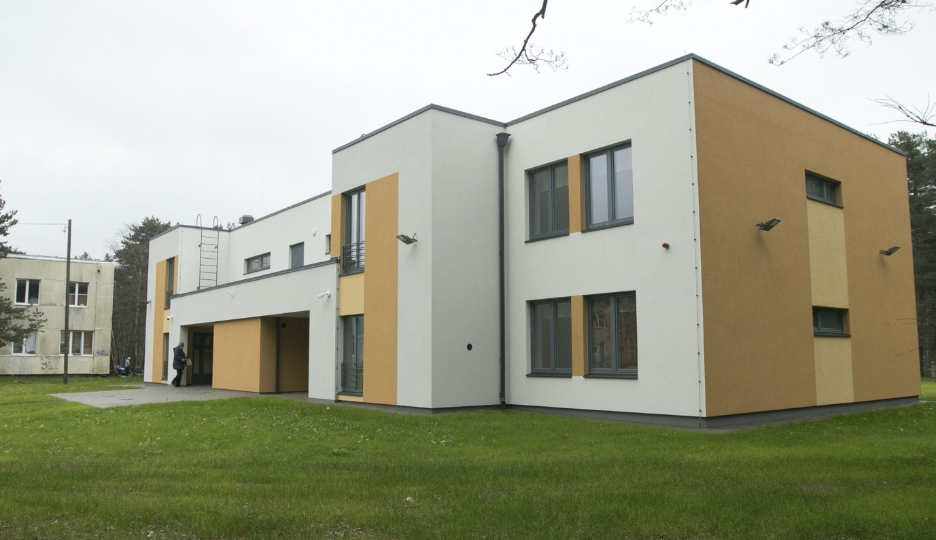

Contact: Ines Bulic Cojocariu, ENIL (ines.bulic@enil.eu) and Mari Siilsalu, Independent Living Institute (mari@independentliving.org)

ENIL prefers the term ‘disabled people’ over ‘persons with disabilities’ or ‘people with disabilities’, in order to reflect the fact that people are disabled by the environmental, systemic and attitudinal barriers in society, rather than by their impairment. This is in line with the social model of disability.
See: https://documents-dds-ny.un.org/doc/UNDOC/GEN/G19/345/41/PDF/G1934541.pdf?OpenElement
See: http://enil.eu/wp-content/uploads/2017/10/DisabilityWatchdog_Estonia_Oct2017_Final.pdf
See: https://menu.err.ee/1209886/liikva-paikesekodu-pakub-erivajadustega-noortele-turvalist-elupaika
See: https://enil.eu/independent-living/independent-living-survey/ https://enil.eu/independent-living/independent-living-survey/
See: https://enil.eu/news/commission-fails-to-stop-romania-and-estonia-from-segregating-disabled-citizens/

