Assessment of Economic and Social Rights Fulfilment in Rwanda
Submission from the Human Rights Measurement Initiative to the United Nations Committee on Economic, Social and Cultural Rights for the 77th Pre-Sessional Working Group Geneva, February, 2025.
I. Reporting Organisation
- The Human Rights Measurement Initiative (HRMI) measures the human rights performance of countries, including Rwanda. HRMI is an independent, not-for-profit NGO with a primary base of operations in New Zealand, and a second base in the United States at the University of Georgia’s Center for the Study of Global Issues (GLOBIS).
II. Assessment Methodology
2. HRMI uses the award-winning and peer-reviewed SERF Index methodology to measure the fulfilment of economic and social rights (ESR).
3. This methodology uses bellwether indicator data from international organisations—such as the World Health Organization and UNICEF—and compares each country’s achievement to what other countries at the same level of income have achieved. In this way, HRMI measures progressive realisation of economic and social rights (ESRs) as defined in the International Covenant on Economic, Social, and Cultural Rights (ICESCR). A country’s income-adjusted HRMI score is a measure of how well its government is converting its resources into good human rights outcomes for its people.
4. HRMI supplements these scores with qualitative information sourced by a confidential survey of on-the-ground human rights experts, such as NGO researchers, journalists, and human rights lawyers and advocates. For more details on HRMI’s methodology, please refer to the resources on our website.
5. All HRMI’s data are published annually on the Rights Tracker and are freely available for non-commercial use under a Creative Commons License. HRMI’s Rights Tracker is a certified Digital Public Good with the Digital Public Good Alliance.
III. Overview of Economic and Social Rights Fulfilment in Rwanda
6. HRMI’s most recent ESR scores for Rwanda measure its achievement as of 2021 and show significant room for improvement. They are shown in the graph below.

7. Rwanda’s scores for 2021 are as follows:
▪ Right to education = 72.4%
▪ Right to food = 68.8%
▪ Right to health = 94.9%
▪ Right to housing = 58.0%
▪ Right to work = 37.9%
8. Rwanda's HRMI scores for the rights to education, food, housing, and work fall in the 'very bad’ range. Rwanda is narrowly short of having a score in the 'good' range for the right to health, just falling in the 'fair’ range.

IV. Right to Education
9. HRMI defines the right to education in accordance with ICESCR Article 13 and CESCR General Comments 11 and 13. In the case of low- and middle-income countries, such as Rwanda, HRMI further breaks down the right to education into three areas of measurement: primary school enrolment, secondary school enrolment, and quality of education. The HRMI score for the right to primary education (adjusted for income) falls within the 'fair' range, while the HRMI scores (adjusted for income) for the rights to secondary education and quality education fall in the 'bad’ and 'very bad' ranges.
10. Rwanda’s HRMI score for the right to primary school education (adjusted for income) has seen a concerning decline since 2013. Rwanda’s right to primary education score initially improved from 84.9% to 95.3% in the 2000-2003 period. Stagnation between 2003 and 2013 has been followed by a steady decline to a score of 89.9% by 2021. This score is supported by UNSECO data showing that 91.2% of children were enrolled in primary school. This score places Rwanda 11th of 42 Sub-Saharan African countries for which we have data.
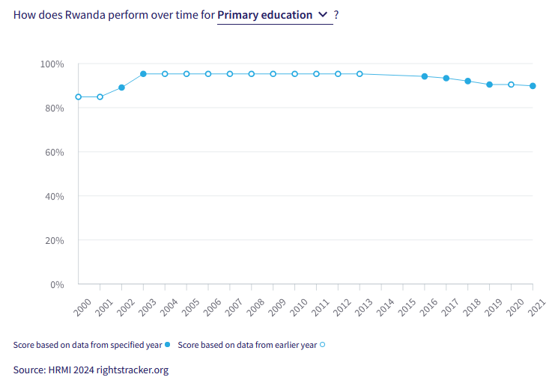
11. Rwanda’s HRMI score for the right to secondary education (adjusted to income) has shown some concerning decline. With data being available from 2017 onwards, Rwanda saw a drop from 100.0% to 68.0% in the 2017-2019 period, with a slight increase to 78.9% in 2021. This statistic is supported by UNESCO data showing that 56.2% of secondary school aged pupils are enrolled in education. This score sees Rwanda sit 9th of 38 Sub-Saharan African countries which we have data for.
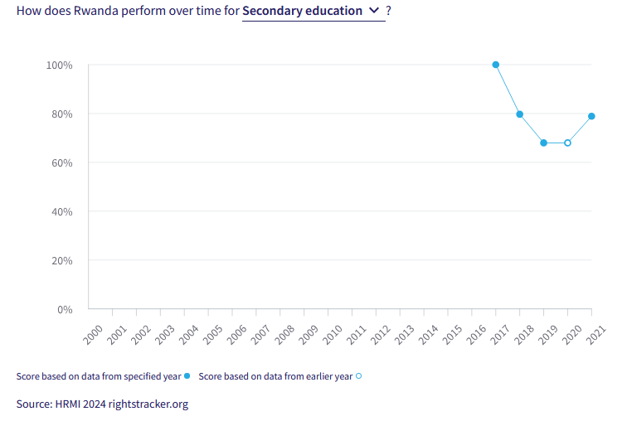
V. Right to Food
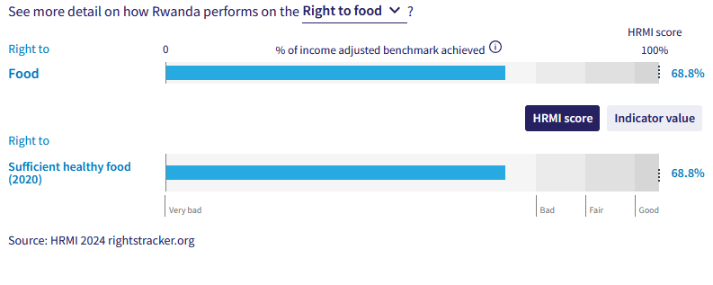
12. HRMI defines the right to health in accordance with ICESCR Article 11 and CESCR General Comment 12. In the case of low- and middle-income countries, such as Rwanda, HRMI uses two indicators to measure the country’s achievement in fulfilling their commitment to food and sufficiently healthy food. There is need for more effort by the Rwandan Government to better fulfill the right to food, with current scores for the right to food falling in the 'very bad’ range.
13. Rwanda's HRMI score for the right to food has been steadily improving, with a current score of 68.8%. Rwanda had remained steady at 67.5% from 2000 to 2004, before a sharp decline to 47.7% in 2005. Since the fall to 47.7% in 2005, there has been gradual improvement, with the current score the highest recorded score for Rwanda’s fulfillment of the right to food. While recent improvement is a good sign, the score remains in the ‘very bad’ range, and much more progress is needed to meet Rwanda’s obligations. Rwanda’s score is 28th of the 42 Sub-Saharan African countries we have data on.
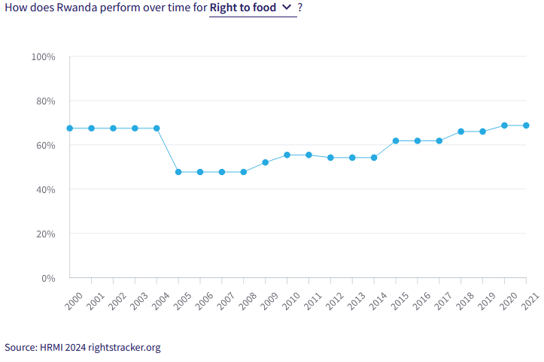
VI. Right to Health
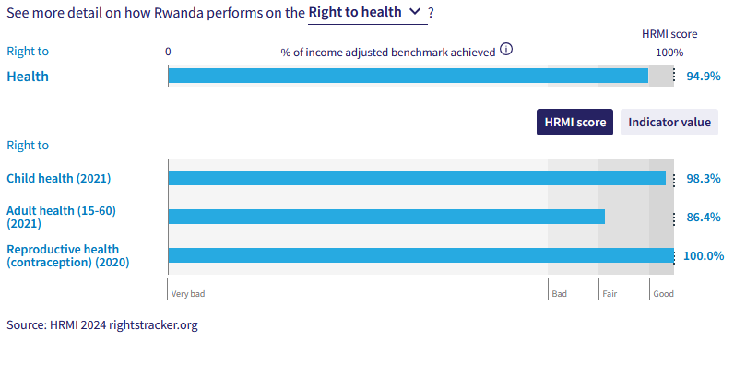

14. HRMI defines the right to health in accordance with ICESCR Article 12.1 and CESCR General Comment 14. In the case of low- and middle-income countries, such as Rwanda, HRMI uses three indicators to measure the country’s achievement in fulfilling their commitment to child health, adult health, and reproductive health. Rwanda is making good progress regarding the right to child health, with a score in the ‘good’ range. Rwanda is also doing the best it can with its limited resources in fulfilling the right to reproductive health, with a score of 100%.

15. Rwanda's HRMI score for child health (adjusted to income) had early rapid growth followed by consistent high performance, with it currently scoring 98.3%. The score for Rwanda grew from 65.1% to 97.6% between 2000 and 2012, with the score staying that high, and slightly improving, since. The retention of a high level of fulfillment of the right to child health sees Rwanda sit 7th of 46 Sub-Saharan countries.
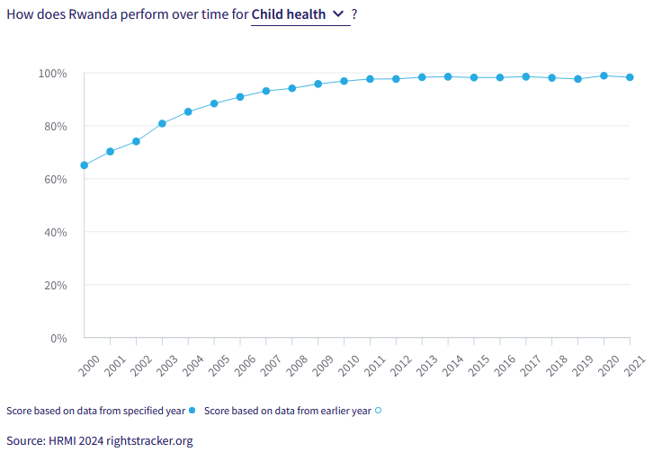
16. Rwanda’s HRMI score for the right to reproductive health has seen an impressive increase from a very concerning level of fulfillment to a current score of 100%. This drastic change is seen by scores of 22.8% in 2000 and 27.1% in 2005, to sharp increases to 60.6% in 2008 and 94.1% in 2010. The score slightly decreased between 2011 and 2019 to as low as 86.5% but reached 100% by 2020. Rwanda sits first equal of 44 other Sub-Saharan African countries, in how well it converts available resources into good outcomes for its people.
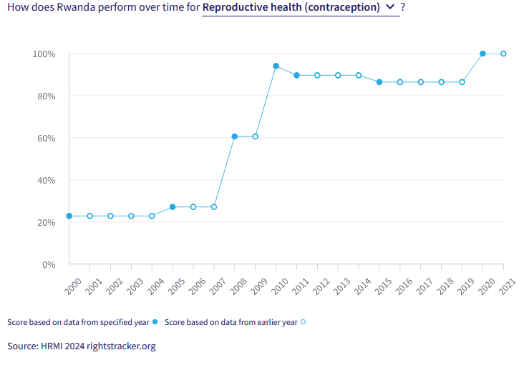
VII. Right to Housing
17. HRMI defines the right to housing in accordance with ICESCR Article 11.1 and CESCR General Comment 4. In the case of low- and middle-income countries, such as Rwanda, HRMI uses an assessment standard that measures the right to water on premises and ‘basic’ sanitation (each household having its own improved toilet facilities). The overall HRMI score for the right to housing falls within the ‘very bad’ range. The scores for the right to water and the right to basic sanitation also fall in the ‘very bad’ and ‘fair’ range, respectively, with the right to basic sanitation just short of the ‘good’ range. These scores show a concerning need for Rwanda to invest more effort into fulfilling housing rights, especially the right to water.
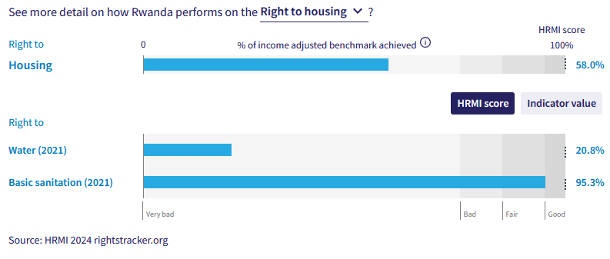
18. Rwanda’s HRMI score for the right to water has seen a concerning decline, with the score currently sitting at a very low 20.8%. What makes this decline more concerning is that the peak HRMI score for Rwanda’s fulfilment of the right to water was 25.4%, achieved in 2000. Following this the score has dropped, going as low as 16.7% in 2002, and reached a point of 20.8% in 2020, which remained in 2021. This score sees Rwanda at third from the bottom of 46 Sub-Saharan African countries we have these data for. There is significant work to be done to ensure that Rwanda fulfils the right to water.
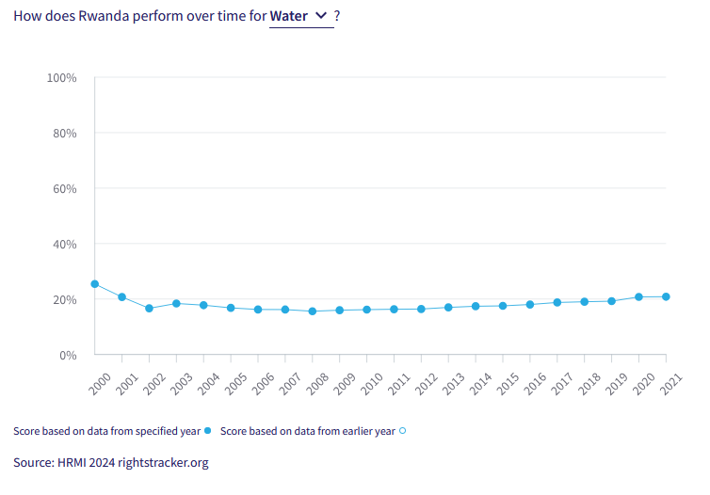
VIII. Right to Work and Social Security

19. HRMI measures the right to work in accordance with ICESCR Articles 6 and 7. For low and middle-income countries, such as Rwanda, HRMI measures the right to work and social security using a subsistence income indicator. According to the World Bank PovcalNet, in Rwanda, with 78.0% of people not absolutely poor, this provides a HRMI score of 33.7% (income adjusted).
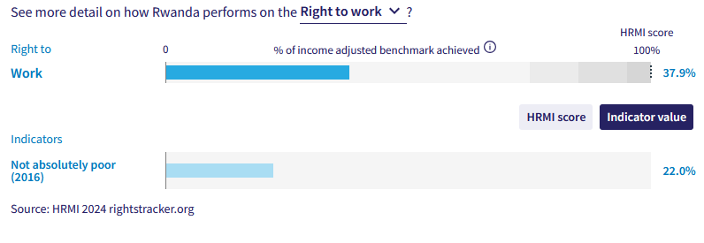
20. Rwanda’s HRMI score for the right to subsistence income has seen a concerning decline, with a current score of 37.9% which falls in the ‘very bad’ range. The score has been consistently low over two decades. More data would help this analysis but existing data highlights a concerning lack of fulfillment by the Rwandan Government. This score sees Rwanda sit 38th of 44 Sub-Saharan countries.
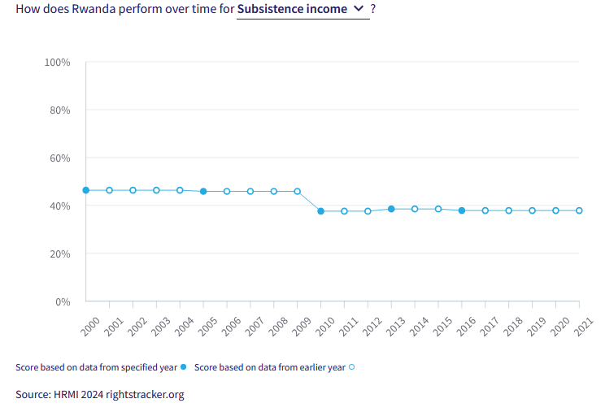
X. Concluding Remarks

21. HRMI respectfully submits its data and findings on the fulfilment of economic and social rights in Rwanda. We hope that this Submission will serve as a useful resource to the Committee on Economic, Social and Cultural Rights for drafting specific and meaningful questions to Rwanda during the CESCR’s 77th Pre-Sessional Working Group.

Prepared by:
Thalia Kehoe Rowden
Sarah Bakewell
Regan Joyce
Sam Turner

Visit HRMI’s website to learn more about our mission and work, https://humanrightsmeasurement.org/.
This content represents the opinions of the Human Rights Measurements Initiative. It carries no endorsement of the University of Georgia.
See HRMI’s methodology for measuring economic and social rights: https://humanrightsmeasurement.org/methodology and https://rightstracker.org/page/methodology.
Ibid
Ibid
HRMI 2024 Rights Tracker, https://rightstracker.org/
See Human Rights Measurement Initiative (HRMI) Digital Public Good Certificate, https://app.digitalpublicgoods.net/a/11781 The Digital Public Goods Alliance is endorsed by the UN Secretary General’s “Roadmap for Digital Cooperation,” https://www.un.org/en/content/digital-cooperationroadmap/assets/pdf/Roadmap_for_Digital_Cooperation_EN.pdf. It defines digital public goods as: “open source software, open data, open AI models, open standards and open content that adhere to privacy and other applicable laws and best practices, do no harm, and help attain the SDGs,” https://digitalpublicgoods.net/standard/.
HRMI 2024 Rights Tracker, https://rightstracker.org/country/RWA?tab=report-esr&qolFdScore=hrmi
HRMI 2024 Rights Tracker, https://rightstracker.org/country/RWA?tab=report-esr&qolFdScore=hrmi
HRMI 2024 Rights Tracker, https://rightstracker.org/metric/education.
HRMI 2024 Rights Tracker, https://rightstracker.org/country/RWA?tab=report-esr&qolFdScore=hrmi
HRMI 2024 Rights Tracker, https://rightstracker.org/country/RWA?tab=report-esr&qolFdScore=hrmi
HRMI 2024 Rights Tracker, https://rightstracker.org/country/RWA?tab=report-esr&qolFdScore=hrmi
HRMI 2024 Rights Tracker, https://rightstracker.org/country/RWA?tab=report-esr&qolFdScore=hrmi
HRMI 2024 Rights Tracker, https://rightstracker.org/country/RWA?tab=report-esr&qolFdScore=hrmi
HRMI 2024 Rights Tracker, https://rightstracker.org/country/RWA?tab=report-esr&qolFdScore=hrmi
HRMI 2024 Rights Tracker, https://rightstracker.org/country/RWA?tab=report-esr&qolFdScore=hrmi
HRMI 2024 Rights Tracker, https://rightstracker.org/country/RWA?tab=report-esr&qolFdScore=hrmi
HRMI 2024 Rights Tracker, https://rightstracker.org/country/RWA?tab=report-esr&qolFdScore=hrmi
HRMI 2024 Rights Tracker, https://rightstracker.org/country/RWA?tab=report-esr&qolFdScore=hrmi
HRMI 2024 Rights Tracker, https://rightstracker.org/country/RWA?tab=report-esr&qolFdScore=hrmi
HRMI 2024 Rights Tracker, https://rightstracker.org/country/RWA?tab=report-esr&qolFdScore=hrmi

