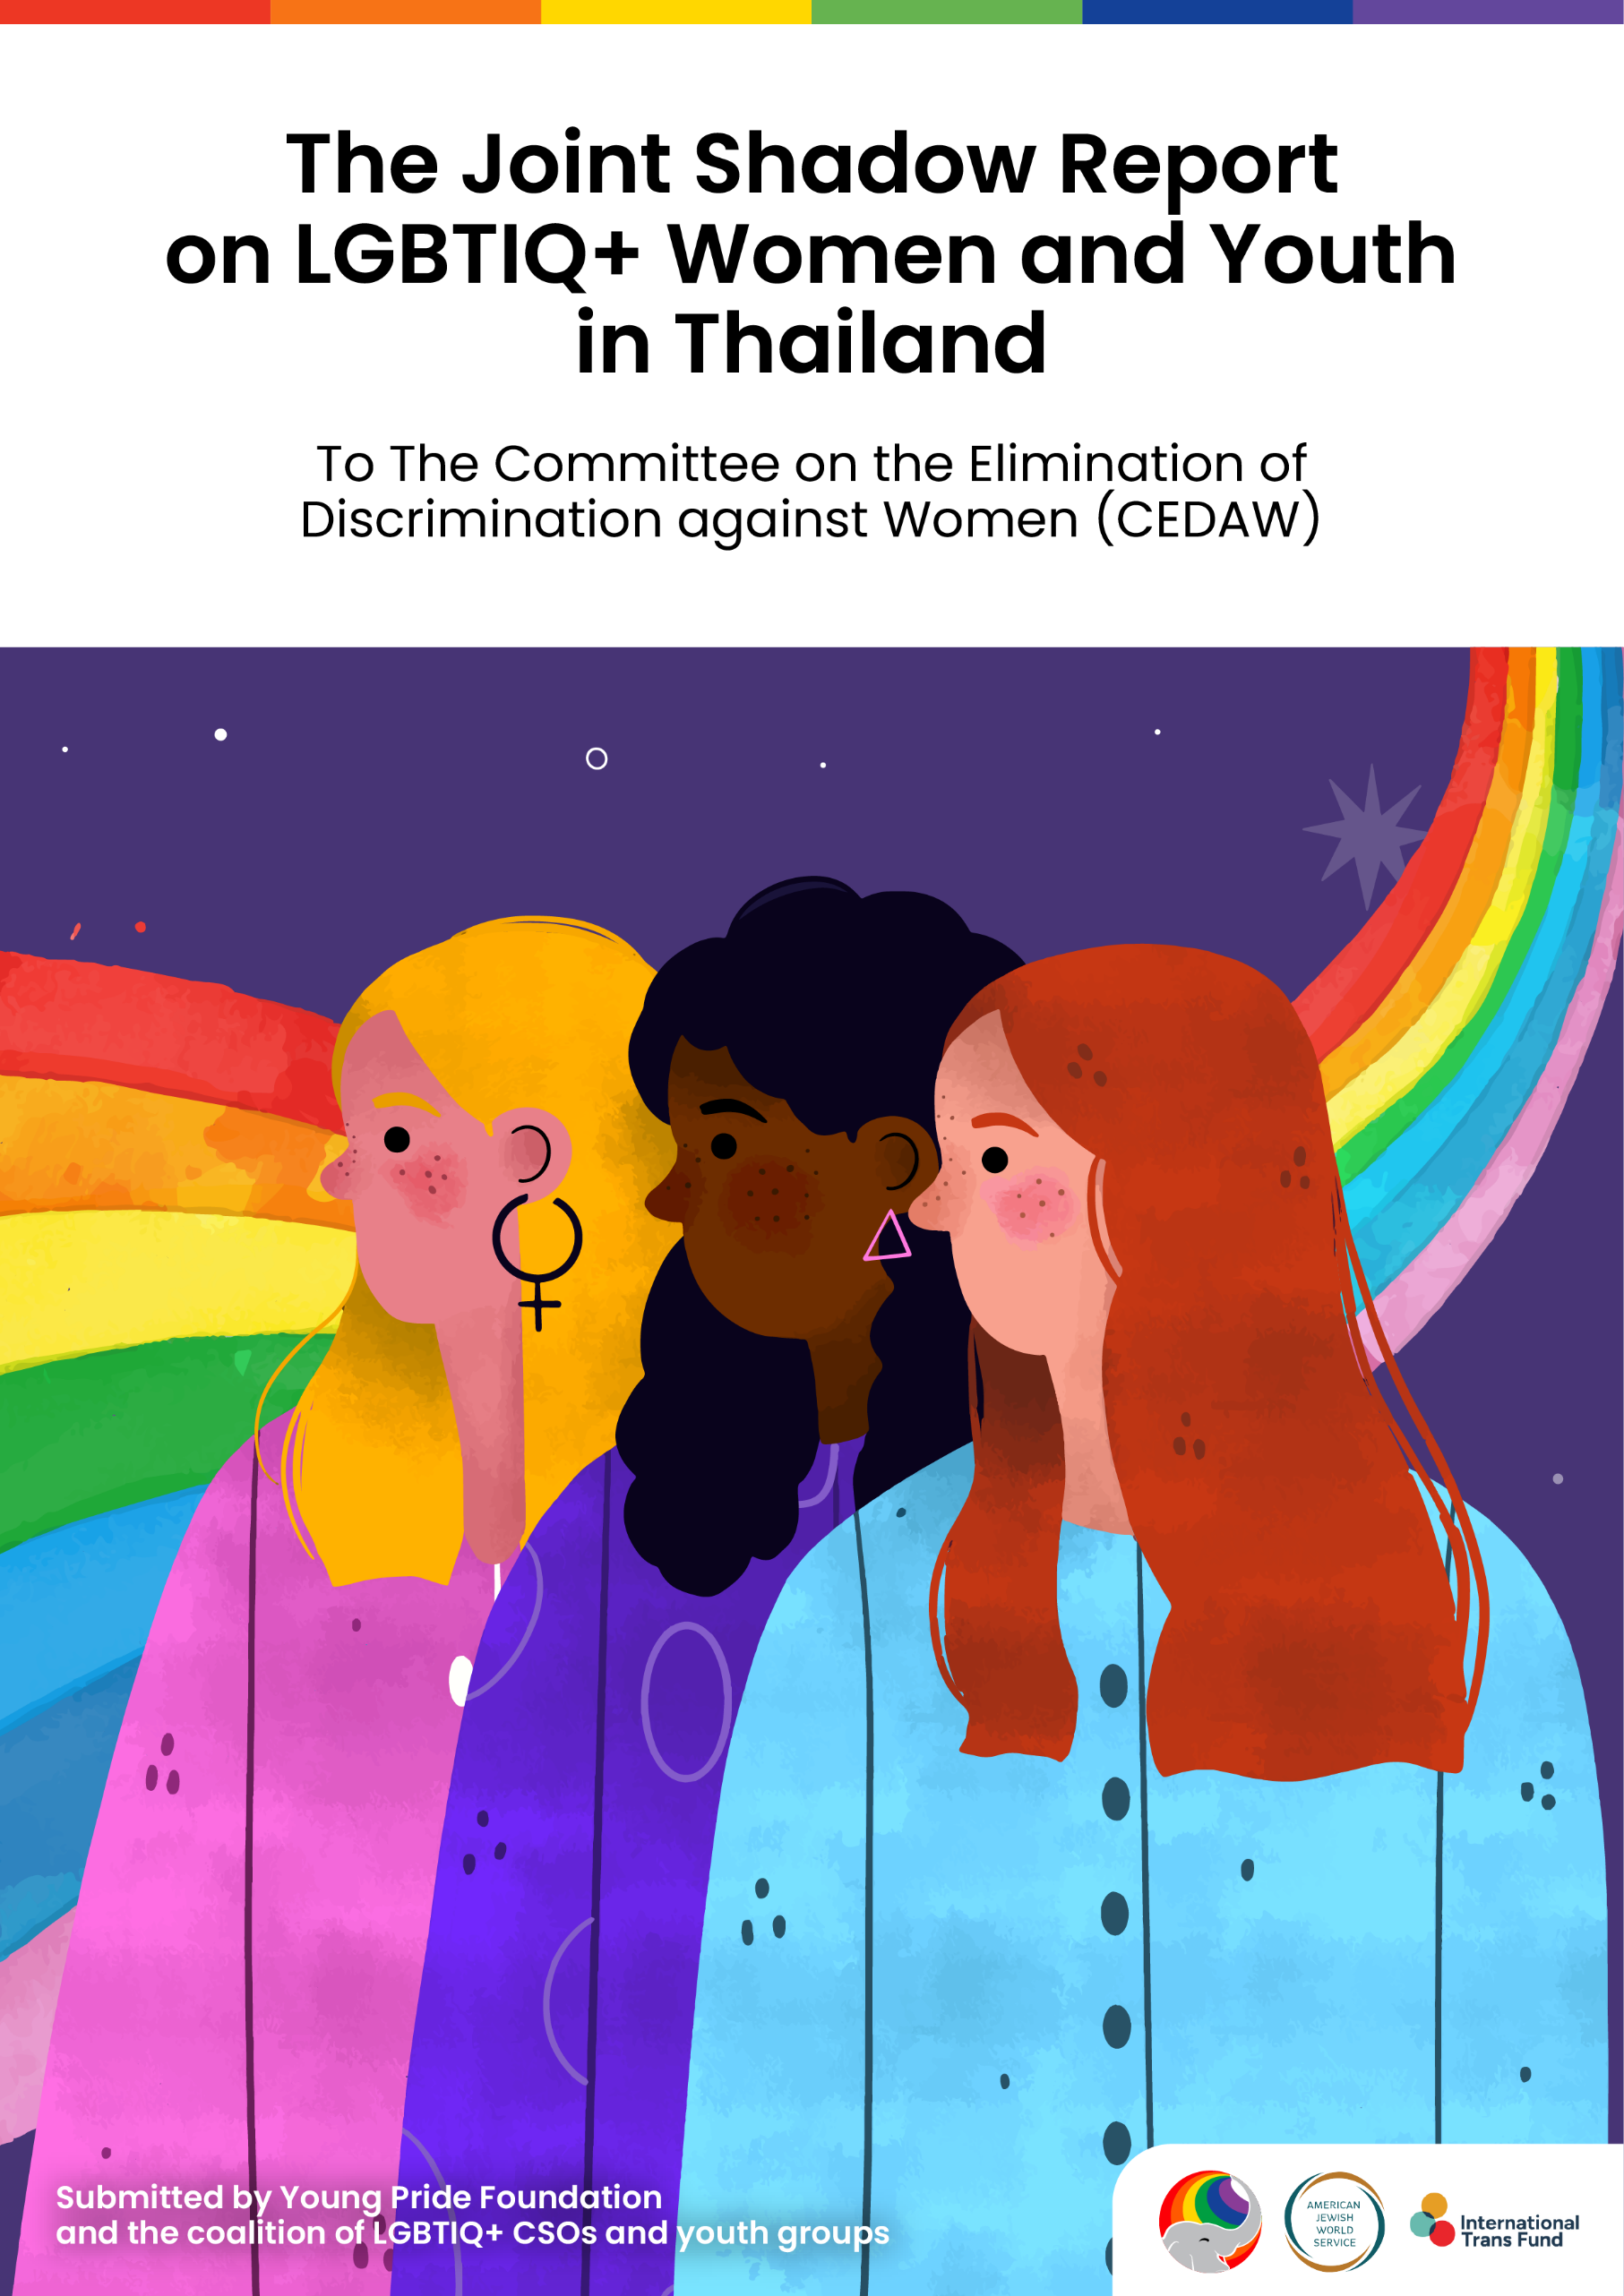

The Joint Shadow Report
on LBTIQ+ Women and Youth in Thailand

To The Committee on the Elimination of
Discrimination against Women (CEDAW)

Submission Date: 11 May 2025

Submitted by
Young Pride Foundation and the coalition of LGBTIQ+ CSOs and youth groups

- Chiang Mai Pride
- Girl x Girl
- Intersex Thailand
- Just Khon
- Mermaid Pride Thailand
- Non-binary Thailand
- The Loominate
- Queering Bangkok
- TRAMP
- Youth Pride Thailand

Prepared by
- Author: Riddy Sonsomsuk – Policy Advocacy Consultant
- Editor: Chitsanupong Best Nithiwana – Executive Director
- Editor: Pasuta Chuenkhachorn
- Coordinator: Arty Sangsuwan
- Design: Tinnawut Liwanag

INTRODUCTION
Thailand is widely perceived as an inclusive and safe space for gender diversity. Nevertheless, true gender equality remains out of reach for many, particularly for LGBTQ+ women. The term is also inclusive of other assigned female at birth people (AFAB), such as Tom, transmasculine, non-binary, and indigenous identities. To uphold Thailand’s commitments under the Convention on the Elimination of All Forms of Discrimination Against Women (CEDAW), which the state ratified in 1985 and must go beyond symbolic legal advances. Young Pride Foundation, in consultation with Thai CSOs for LGBTIQ+ rights, respectfully submits this report for consideration by CEDAW.
This report is an initiative building on ‘The Rise of Rainbow in Education: The Guide to Inclusive for All Gender Diversity (2024)’ to expand its findings into a national policy framework and recommendations for legislative changes on LGBTIQ+ rights and inclusive education. Hence, this submission relates specifically to Articles 5, 7, 9, 12, 11, 13, 14, and 16. It provides a focused and evidence-based overview of the challenges faced by LBQTI+ women and youth in Thai society, education, and healthcare, with particular attention to the lives of rural LBQTI+ women, human rights defenders, refugees, and asylum seekers.
YOUNG PRIDE FOUNDATION
Young Pride Foundation is a trans and youth-led community founded by trans survivors of unfair and transphobic discrimination in higher education in Thailand. Founded in 2018 and officially registered in 2024, we have been a leading force in promoting LGBTIQ+ rights and youth empowerment in Thailand.
1. TABLE OF CONTENTS
A. Cover Page
B. Introduction
- Table of Contents
- Context & Background
  - Thailand’s Political Landscape and Crackdown on Pro-Democracy Activists
  - Protection Against Gender-Based Discrimination
  - Marriage Equality and Challenges on Nationality Issues
  - Thailand’s Progress Toward a Gender Recognition Act
- Legislative and Institutional Framework
  - Stereotypes on LBTIQ+ Persons in Thai Education
  - Gender Binary Uniform Policies
  - LBQTI+ Rural Women
- Employment
4.1 Lack of Diversity, Equity, and Inclusion (DEI) Policies
- LBQTI+ Healthcare in Thailand
- LBQTI+ Human Rights Defenders, Refugees & Asylum Seekers
  - Digital Censorship and Misinformation
  - LBQTI+ Refugee and Asylum Seekers
- Conclusion and Policy Recommendations
- Bibliography
2. CONTEXT & BACKGROUND
This section is the excerpts which are drawn from our Human Rights Report 2025/1, which provides a comprehensive overview of national, regional, and international issues affecting LGBTIQ+ rights in Thailand. The selected excerpts highlight the current situation of LBQTI+ youth in Thailand, with a focus on the context following the legalization of marriage equality and the further legal reforms needed to achieve an inclusive society for all.
2.1 THAILAND’S POLITICAL LANDSCAPE AND CRACKDOWN ON PRO-DEMOCRACY ACTIVISTS
Thailand navigates a complex political environment, balancing democratic aspirations, and military influence. Since the 2023 general election, the country has undergone significant political shifts. The Move Forward Party (MFP), which won the most parliamentary seats in May 2023, was blocked from forming a government due to opposition from Thailand’s conservative establishment, including the military-appointed Senate. Instead, the Pheu Thai Party (PTP), previously seen as an opponent of military-backed factions, formed a coalition with those very same parties. This political realignment led to public outrage, fueling allegations of reinforcing concerns over entrenched power structures.
In addition, Thailand's Lèse-majesté law (Article 112) prescribes penalties of up to 15 years imprisonment per offense for defaming, insulting, or threatening the monarchy. However, the law allows for consecutive sentencing, leading to significantly longer prison terms when multiple charges are involved. In addition, Article 112 has significantly influenced Thailand's political landscape. In August 2024, the Constitutional Court dissolved MFP, that won the most seats in the 2023 election, on the grounds that its campaign to amend Article 112 constituted an attempt to overthrow the constitutional monarchy. This ruling not only banned MFP’s executives from politics for 10 years but also reinforced fears that Lèse-majesté is being used to eliminate opposition movements. The party’s dissolution sparked public outrage, but authorities continued to suppress dissent through arrests of pro-democracy figures.
Beyond legal penalties, digital freedom in Thailand faces increasing threats through state surveillance and targeted cyber operations against activists. The government has intensified its monitoring of online platforms, prosecuting individuals for social media posts critical of the monarchy. Therefore, online users who criticize the monarchy risk not only prosecution under Article 112 but also cyber harassment and doxxing by pro-royalist groups, leading to the worsening state of digital freedom, making it more difficult for Thai LBQTI+ activists and CSOs to advocate for their rights.

2.2 PROTECTION AGAINST GENDER-BASED DISCRIMINATION
The Gender Equality Act B.E. 2558 (2015) is a landmark Thai legislation aimed at preventing and addressing gender-based discrimination across all genders. The Act criminalizes discrimination based on gender identity and sexual orientation, providing legal protections for individuals with diverse gender expressions. It established the Committee on the Determination of Unfair Gender Discrimination (WorLorPor) to handle complaints and ensure compliance. Through these mechanisms, the Act has significantly advanced inclusive education and workplace equality for mostly transgender individuals in Thailand (see ‘The Rise of Rainbow in Education (2024).’
While this Act is a legislative step toward addressing gender-based discrimination, it exhibits notable limitations. According to its second paragraph of Section 17, in the southern border provinces of Pattani, Yala, and Narathiwat, the Act's implementation is claimed to be hindered by the coexistence of Islamic law, which governs personal and family matters for the Muslim population in respective provinces. This dual legal system can lead to inconsistencies in the application of gender equality principles, limiting the protection on queer individuals in these regions. Furthermore, the Act's definition of gender discrimination includes individuals who are "male or female or express themselves differently from their inborn gender." However, it does not explicitly recognize non-binary or gender non-conforming identities, leaving these groups without clear legal protection.
Another significant limitation is that the Act does not permit human rights defenders or observers to file complaints on behalf of victims. This restriction can impede access to justice, especially for young individuals and children who may fear retaliation or lack the resources to pursue legal action independently. These gaps highlight the need for legislative amendments to ensure comprehensive protection against gender-based discrimination for LBQTI+ youth and children in Thai education, where the gender binary is perpetuated through educational policies and amidst a lack of legal gender recognition.
2.3 MARRIAGE EQUALITY AND CHALLENGES ON NATIONALITY ISSUES (Article 9 and 16)
Thailand’s journey toward legalizing same-sex marriage culminated in a historic milestone on January 23, 2025. This historic legislation amended Section 1448 of the Thai Civil and Commercial Code, replacing gender-specific terms such as “man and woman” and “husband and wife” with gender-neutral language like “individuals” and “marriage partners.” This change effectively extended full marriage rights to same-sex couples.
As a result, they now enjoy the same legal rights and protections as heterosexual couples, including in areas such as marriage registration, child adoption, healthcare decision-making, inheritance, and property ownership.

On the day the law took effect, over 1,800 same-sex couples registered their marriages across Thailand, marking a monumental cultural shift. However, limitations remain, as equal marriage rights do not extend to granting Thai citizenship to foreign spouses of Thai nationals.
Despite this progress and challenges, activists continue to fight against deep-rooted discrimination in related laws, lack of transgender and non-binary legal recognition, and LGBTIQ+ protections in education and the workplace. Activists also recognize the remaining gaps that need attention, such as the limited access to reproductive technology for pregnancy. While the new law adopts gender-neutral language to ensure equal rights for same-sex, transgender, and diverse couples, it still lacks gender-neutral provisions concerning parenting.
2.4 THAILAND'S PROGRESS TOWARD A GENDER RECOGNITION ACT
Thailand is currently considering multiple draft bills aimed at establishing legal gender recognition for transgender and gender-diverse individuals. These efforts involve both governmental bodies and civil society organizations, each proposing different approaches to address the challenges faced by these communities.
The Draft Act on Gender Recognition, Titles, and Protection of Gender-Diverse Individuals was led by an MP from the Move Forward Party. This draft was formulated in consultation with Thai CSOs, including our founder and executive director. However, the draft was previously voted down in its first reading on February 21, 2024. Pheu Thai MP warned that allowing title changes could increase crimes like fraud and sexual assault. He also raised concerns about challenges to the correctional system, which currently separates prisoners by birth gender. The team is currently drafting a new version.
One notable draft is the Gender Identity, Gender Expression, and Sex Characteristics Recognition Act (GEN-ACT), developed by civil society groups, including the Foundation of Transgender Alliances for Human Rights. Currently, more than 11,000 Thais have signed the petition to support GEN-ACT. Another significant proposal is the Draft Gender Recognition Act, initiated by the Department of Women's Affairs and Family Development. This government-backed draft has completed public consultations and is pending submission to the parliament by the Cabinet for further deliberation. Furthermore, the Draft Act by Intersex Thailand, is in the process of gathering at least 10,000 signatures from eligible voters aged 18 and above to propose the legislation to the parliament.
These drafts represent various efforts by governmental bodies and civil society organizations in Thailand to establish legal recognition and protection for individuals of diverse gender identities. The proposals differ in their approaches, particularly concerning medical requirements, age thresholds, and the processes for legal gender change.
The GEN-ACT and the draft led by Intersex Thailand emphasize self-identification without medical prerequisites, while the government-backed draft focuses on a certification process. Age thresholds also vary, with GEN-ACT allowing individuals aged 15 and above to apply for legal gender recognition, while others set the minimum age at 18.
Aside from differences in their approaches, particularly regarding medical requirements, age thresholds, and the legal gender change process, each draft varies slightly in how titles would be implemented. While the current options are limited to นาย (Mr.), นาง (Mrs.), and นางสาว (Miss), the proposed drafts introduce gender-neutral alternatives such as คุณ (Khun), นาม (Naam), or even the option to remove titles altogether.
Despite these legislative efforts, significant challenges persist. Societal stigmas and misconceptions about transgender and non-binary identities contribute to resistance against the enactment of a comprehensive LGR. Concerns about the potential misuse of gender recognition laws and implications for existing social structures have been cited in parliamentary debates, leading to the rejection of certain draft.
3. LEGISLATIVE AND INSTITUTIONAL FRAMEWORK
The Gender Equality Act B.E. 2558 has been instrumental in combating systemic discrimination, particularly in universities' uniform policies. However, limited public awareness of this law remains a significant challenge.
In addition, the absence of the ability to change their legal title based on their self-determination, transgender and non-binary individuals continue to face discrimination in education, employment, healthcare, deepening social and economic inequalities. Without stronger legal protections and awareness-raising education, LGBTIQ+ community, particularly LBQTI+ women, will continue to face systemic discrimination and exclusion.
3.1 STEREOTYPES ON LBTIQ+ PERSONS IN THAI EDUCATION (Article 5 & 10)
Educational rights are increasingly under threat worldwide. In Thailand, particularly for LBQTI+ students and those who are from marginalized communities such as rural areas or indigenous backgrounds, faces significant gaps in LGBTIQ+ inclusivity within the education system. Most schools and universities still lack LGBTIQ+ education and awareness raising on legal protection against gender-based discrimination and violence among students and staff, leading to widespread misinformation, prejudice, and stigma.
During our first year (of the academic year), there was a class touching on LGBTQ+ but only superficially. I tried proposing a topic on SOGIESC, but the professor replied: ‘If my child joined this program, wouldn’t they turn into a sissy or gay?’ … Many professors in medical school still carry high levels of stigma and don't understand the LGBTQ+ community or their specific needs." – J, non-binary medical student.
"The university told me I had to stay in the male dormitory, just like that. I had to randomly select a roommate and ended up living with a straight male, which made me very uncomfortable.” – R, a transgender woman alumnus from a university in Khon Kaen Province.
The absence of LGBTIQ+ education in school curricula continues to fuel stigma and misconceptions about LGBTIQ+ individuals. Many teachers and university staff still misunderstand or even mistreat students who do not conform to traditional gender norms. As a result, young queer people often turn to social media as their primary source of information to better understand their gender identity.
According to a 2014 study by Mahidol University, UNESCO, and Plan International, the data from 15 schools across five provinces, including Bangkok, revealed that among 2,070 students surveyed, 246 identified as LGBT—55.6% reported being bullied. 24.5% of non-LGBT students were bullied for being perceived as LGBT. The study identified various forms of bullying, including verbal abuse, social exclusion (both in person and online), physical violence, and sexual abuse (unwanted touching and mimicking rape).
According to a report by Save the Children International Thailand, the alarmingly high levels of depression, anxiety, suicidality, and self-harm among over 3,000 survey participants and over 30 online interview participants, aged 15-24 years old, with 58.2% having thought of suicide and 15.6% attempting it in the past year. One in four reported non-suicidal self-harm, particularly transmasculine and bi/pansexual youth. Hence, persistent stereotypes and lack of inclusive education continue to expose LBQTI+ students in Thailand to discrimination and harm.
3.2 GENDER BINARY UNIFORM POLICIES
Many students continue to face challenges due to rigid uniform policies in schools and universities in Thailand. While most universities in Thailand allow freedom in hairstyles, many public schools enforce strict rules requiring students’ hairstyles and uniforms to align with the gender at birth. Teachers are often granted the authority to enforce these policies harshly, with some students experiencing forced haircuts by school staff against their will.

Most universities have made strides in creating more inclusive policies that support transgender rights, including the 2024’s TGAT/TPAT 68 university admission policies, allowing students of all gender identities to wear clothing of their choice for exams. Additionally, several other universities have adopted gender-neutral uniform policies, allowing students to dress according to their identity.
If transgender and non-binary students in universities face discrimination, such as being forced to wear uniforms that do not align with their gender identity, they can seek protection under the Gender Equality Act B.E. 2558 (2015) . While this mechanism has proven effective in institutions like Ubon Ratchathani Rajabhat University and the country's top-ranking, Chulalongkorn University have adhered to the Committee’s recommendations by eliminating gender-based uniform restrictions, representing a step toward inclusivity in higher education. However, limited public awareness of this law in rural areas lead to significant gaps of inclusive education for queer students across the country.
3.3 LBQTI+ RURAL WOMEN (Article 14)
Thailand's education system exhibits significant disparities, with quality often correlating with financial resources. Students from affluent families have access to superior educational institutions, while those from low-income households, particularly in rural areas, face limited opportunities. This disparity is evident in the decline of school attendance at the upper secondary level, where approximately 17% of boys aged 15-17 are not enrolled. Additionally, tuition fees for higher education are substantial. Government university fees range from 300,000 to 400,000 Baht per academic year, while private institutions charge between 400,000 and 500,000 Baht. These costs are prohibitive for many families, further entrenching educational inequality.
Thailand’s education system presents significant inequalities, with access to quality education largely dependent on economic status. Students from wealthier backgrounds can afford better schools and resources, while those from low-income families, especially in rural areas, face limited opportunities, and unsafe learning spaces, leading to disparities in learning outcomes.
Interviews by Mermaid Pride Thailand and local activists with LGBTIQ+ students from across Thailand reveal that queer youth in rural and religiously conservative areas, such as the Deep South and hill-tribe communities, face compounded cultural and structural challenges:

In the Deep South or southern border provinces, one participant described how strict religious norms create environments where gender non-conformity is rejected, even in universities, often forcing students to hide their identities at home. Similarly, a queer youth from a hill-tribe in Chiang Mai shared that mountain schools impose rigid rules and expose students to bullying rooted in ethnic and gender bias, discrimination less common in urban settings. Both participants noted that schools often remain passive in addressing these issues, highlighting the need for inclusive policies, safe spaces, and affirming mental health support. They also called for engaging religious and community leaders in fostering dialogue and tolerance as a crucial step toward lasting change.
“At university, I can be myself, but back home I have to wear a hijab and hide who I am. People say it’s not appropriate to act that way. It’s against our religion. Even in school, there’s pressure to stay quiet and not stand out.” – An anonymous trans masculine Muslim student from a university in Pattani province.
“On the mountain, there’s no freedom to express yourself. If you dress a certain way or act differently, people call you names or make fun of you, especially if you’re not Thai or don’t fit gender norms. In the city, I didn’t feel that as much.” – F, a trans feminine gender-nonconforming student living in a Hill tribe village in Chiang Mai.
In addition to the significant gaps of inclusive education and understanding of SOGIESC among communities in rural and local areas, LBQTI+ rural women and queer youth in Thailand face intersecting barriers and violences shaped by cultural norms, and stigma. In 2025, a user on Twitter (now known as X) reported that his parents had taken him to a Buddhist "cleansing ritual" in an attempt to "wash away his gayness" by bathing him in holy water. The account quickly attracted widespread attention online, prompting several others to share similar experiences. One user recounted being told by a monk that they were gay as a result of sins committed in a past life; the user clarified that they are actually pansexual but noted that it was too exhausting to explain. The same user also stated that an acquaintance’s partner, who identified as a "tom", had been forcibly sent to a conversion therapy camp.
From unaffordable education to gender and racial identity-based discrimination in schools and communities, their experiences highlight a gap in state protection and inclusive policy.

4. EMPLOYMENT (Article 11 & 13)
Economic inequality continues to be a major issue in Thailand. The lack of access to quality education and economic opportunities in rural Thailand perpetuates this cycle. In 2019, about 54% of employment was informal, lacking job security and benefits. Many Thai people from rural areas migrate to Bangkok in search of higher wages, stable employment, and an improved quality of life. Economic disparities between urban and rural regions force individuals to leave their hometowns, often taking on low-wage jobs in factories, construction, or the service industry.
Similarly, undocumented migrant workers from neighboring countries enter Thailand illegally, seeking employment but facing exploitation, poor working conditions, and a lack of labor protections, leaving them vulnerable to abuse and unfair treatment.
LBQTI+ students from low-income families often cannot afford higher education, restricting their employment opportunities to low-paying jobs. This cycle of limited education and low income perpetuates economic disparities and hinders social mobility.
4.1 LACK OF DIVERSITY, EQUITY, AND INCLUSION (DEI) POLICIES
Despite the Gender Equality Act B.E. 2558 (2015), the Ministry of Labour’s Regulation on Thai Labour Standards and Social Responsibility of Thai Businesses B.E. 2547, which prohibits discrimination on various grounds including “personal sexual attitude.” In addition, the Labour Protection Act B.E. 2541 (1998) includes Section 15, which requires employers to treat male and female employees equally unless the nature of the work makes equal treatment impossible. However, this provision is limited in scope, as it fails to address discrimination against non-binary individuals. It is also restricted to cisgender women and does not extend protections to transgender men, non-binary individuals, or male-identifying LGBTIQ+ parents who give birth.
Similarly, the Civil Service Regulations, which apply only to government employees, introduced a policy in 2020 granting 15 days of paternity leave to male civil servants whose spouses give birth. Yet, this policy is limited as well: it excludes private-sector employees and restricts eligibility to heterosexual relationships, specifically male spouses of female partners.
“I was allowed to present as male when I applied for the job, but was told to wear the women's uniform to work … There were many people, like a younger friend who is a kathoey (trans woman). They were active in student activities, part of the student union, and worked as an MC. But they still wore a male uniform to class. People would ask, “Why don’t you wear a wig?” or “Not wearing a wig today?” which made them extremely stressed. It created a sense of instability and suppression. That one visible and interesting trait became something people fixated on negatively. They were constantly teased about it, and it never stopped. – SB, trans masculine, working in the Human Resources department at a university in the south of Thailand
According to ‘Legal Gender Recognition in Thailand’ by UNDP Thailand, this gap in inclusivity extends into the public sector, where rigid gender norms are still enforced. The Thai civil service mandates strict gender-specific dress codes based on a person’s sex assigned at birth, requiring transgender and gender-nonconforming civil servants to adhere to binary standards that do not reflect their gender identities. For instance, transgender women must comply with the male dress code, including maintaining short hair or wearing masculine wigs, because they are legally recognized as male. These regulations contribute to psychological distress and discomfort in the workplace, while also discouraging many transgender individuals from pursuing or continuing careers in government.
In Thailand, the lack of DEI policies within the corporate sector means there are few protections against discrimination, making it difficult for marginalized groups, including LGBTQIAN+ individuals, to access equal opportunities, fair wages, and career advancement. Corporate DEI implementation remains limited. Except the multinational companies, many companies lack formal policies due to weak legal enforcement, cultural norms, and competing business priorities.
A 2018 World Bank survey found that in Thailand, 60% of transgender individuals, 30% of lesbians, and 20% of gay men reported experiencing workplace discrimination. Additionally, more than half of LGBTQ respondents said their job applications had been rejected due to their identity. Employers often reject transgender applicants whose official documents do not align with their gender presentation. For instance, a transgender woman was rejected by a major company after being asked to present herself as male during the onboarding process, which she declined, resulting in the loss of the job opportunity. Such cases highlight the systemic barriers transgender individuals face in securing employment, underscoring the need for legal reforms to allow gender marker changes on identification documents.

5. LBQTI+ HEALTHCARE IN THAILAND (Article 12)
“At the Nong Khai campus, accessing transgender-related healthcare is very difficult… but the university psychologist helped find hormone services, which made me feel supported.” – S, a transgender man from a university in Khon Kaen Province
"Whenever I use my ID card to access public services like hospitals, it draws attention, and I’m often misgendered." – R, a transgender woman alumnus from a university in Khon Kaen Province.
In a positive step, Thailand has recently approved and included hormone replacement therapy (HRT) for transgender individuals in the national healthcare system, improving access to gender-affirming medical care. The Ministry of Public Health has allocated 145 million Thai Baht to fund transgender gender affirming hormones. This acknowledgment not only enhances access to necessary services but also affirms the medical and psychological needs of transgender individuals, reinforcing their right to inclusive, respectful, and equitable healthcare. It also improves both the quality of life and mental well-being of transgender individuals, benefiting those with low incomes and those living in rural or remote areas.
Despite this progress, significant gaps remain in the availability of comprehensive gender-affirming care in Thailand. Long waiting times and a shortage of qualified healthcare providers continue to limit access in rural areas. While the surgeries for male-to-female (MTF) or transfeminine individuals are relatively more accessible compared to other countries, female-to-male (FTM) and transmasculine individuals, in particular, still face limited options and greater financial barriers to care.
Regarding mental health, a 2023 study by Save the Children Thailand found that 70% of young LGBTIQ+ individuals and children experienced at least mild symptoms of depression or anxiety. Over half reported suicidal thoughts, 16% had attempted suicide, and 25% had engaged in non-suicidal self-harm. These issues were especially prevalent among transmasculine and bi/pansexual youth. Interviews linked these mental health struggles to experiences of nonacceptance, discrimination, violence, and other stressful life events. In contrast, support from peers, families, online communities, and health professionals was found to be protective and empowering.
While Thailand has made a positive stride in LGBTIQ+ health, in 2025, the UN Special Rapporteur on the right to physical and mental health observed that in Thailand, urged the Ministry to address the systemic violence LGBTIQ+ people, particularly LBQ women and transmasculine individuals, face in healthcare and ensure services are safe, respectful, and inclusive.
6. LBQTI+ WOMEN HUMAN RIGHTS DEFENDERS, REFUGEE AND ASYLUM SEEKERS (Article 7)
Freedom House's 2024 report highlights a global decline in political rights and civil liberties for the 18th consecutive year, with election manipulation and armed conflicts as key drivers. Political freedoms deteriorated in 52 countries, while only 21 nations saw improvements, signaling a worrying trend in democratic backsliding.
In Thailand, past flawed elections have undermined democratic legitimacy, while the ongoing armed conflict in southern Thailand and police brutality against pro-democracy protesters, many of whom are youth, continue to escalate instability, human rights violations, and forced displacement. These issues make it increasingly difficult to achieve peaceful and just societies. This underscores the urgent need to strengthen democratic institutions, safeguard civil liberties, and ensure fair and transparent electoral processes in order to uphold meaningful political participation of LBQTI+ persons.
In Thailand, CSOs have played a crucial role in community development, human rights advocacy, and service delivery. The development of LGBTIQ+ CSOs in Thailand has been shaped by broader social movements and increasing awareness of gender and sexual diversity. With the rise of social media and digital activism, queer organizations have gained greater visibility and influence, allowing them to mobilize support, including emerging LGBTIQ+ youth organizations such as Gender Fair, Mermaid Pride Thailand.
“Today, the absence of legal gender recognition adds a significant layer of vulnerability, especially for transgender and non-binary human rights defenders and even those who are general internet users. If a transgender or non-binary individual simply 'likes' or shares a critique post about royal entities on platforms like Facebook or TikTok, they risk being arrested. What follows is even more terrifying, facing degrading and dehumanizing conditions inside the justice system, rooted in the denial of their legal gender identities. This fear silences people like us, LBTIQ+ persons, from political participation, particularly within pro-democracy movements in civic and online spaces.” – BC, founder and executive director of a foundation.

6.1 DIGITAL CENSORSHIP AND MISINFORMATION
The recent rollback of protections, the amplification of hate speech, and the suppression of marginalized voices have created an online landscape where discrimination flourishes under the banner of free expression. Since EM took ownership of X (formerly Twitter) on October 27, 2022, he has implemented policies that have facilitated the spread of hate speech, particularly targeting LGBTIQ+ individuals and racial minorities. Under the guise of "freedom of speech," these changes have reduced content moderation, allowing harassment and discrimination to thrive. Similarly, Meta, owned by MZ, has followed a similar path. The weakening of DEI efforts within Meta has left LGBTIQ+ employees and users without institutional support, further normalizing discrimination.
Therefore, these changes not only weaken democratic discourse and fuel political polarization but also allow harmful narratives, including anti-trans hate speech, to spread unchecked. Increasingly, freedom of speech is used as a justification for disseminating hate speech and misinformation, creating a hostile digital environment for LGBTIQ+ individuals and further marginalizing vulnerable communities. For example, advocacy organizations in the U.S., such as GLAAD and the Human Rights Campaign, have expressed concerns that the relaxation of content moderation and the removal of protective policies endanger LGBTIQ+ individuals by allowing harmful rhetoric to spread unchecked.
Similarly, a recent report by Amnesty International highlights how state-backed digital violence has been used to silence women and LGBTIQ+ activists, including tactics such as coordinated harassment, doxxing, threats, and smear campaigns. This form of online abuse, often left unchecked by social media platforms, has created a hostile digital environment that discourages political participation and activism. Combined with opaque content moderation policies, government surveillance, and targeted digital crackdowns, these practices pose serious threats to freedom of expression, safety, and civic engagement.
For example, there have been cases of online gender-based violence on Non-Binary Thailand’s pages. The users had reposted their posts to mock and make a joke at non-binary identities, resulting in some non-binary activists suffering from mental health issues.
Compounding these challenges, changes in online platform policies under tech leaders aligned with Trump’s right-wing agenda have created an increasingly hostile digital environment for LGBTIQ+ individuals. When activists and marginalized voices are systematically silenced, both through state-led intimidation and the failure of platforms to enforce meaningful protections, Thailand's democratic processes, inclusive governance, and LGBTIQ+ movements are undermined.

6.2 LBQTI+ REFUGEE AND ASYLUM SEEKERS
Meanwhile, Trump’s presidency in the U.S. has triggered sweeping rollbacks of human rights protections, including LGBTIQ+ rights, abortion access, and immigrant protections, while further weakening multilateral organizations. The suspension of U.S. foreign aid has been one of his initiatives that particularly impacted vulnerable communities the most. The refugees in Thailand and along the Thai-Myanmar border have been affected by this funding freeze, it has forced hospitals in five refugee camps to shut down, cutting off access to essential healthcare and services. According to Thai authorities, approximately 100,000 Myanmar refugees are residing in nine border camps, most of which are operated by the International Rescue Committee (IRC).
“Although Thailand is seen by many abroad as a safe and gender-equal country, transgender individuals still seek asylum here due to persecution in their home countries. Yet, once they arrive, they continue to face discrimination, such as transgender women being held in male detention facilities. The Thai government should place greater emphasis on gender sensitivity and recognize that legal recognition of gender identity.” – PC, transmasculine human rights lawyer for migrant and refugee rights.
In addition, the compound challenges faced by LBQTI+ refugees and asylum seekers amid this increasingly hostile climate against LGBTIQ+ individuals worldwide remain rising. In 2021, the CERD committee publicly denounced the intersectional discrimination faced by LGBTIQ+ individuals in Thailand, marking the first time such concerns on LGBTIQ+ refugees were raised with the Thai government.
As such marginalized individuals often face systemic invisibility and neglect. When they are arrested or investigated, Thai police rarely conduct gender-sensitive searches, particularly those who are transgender individuals. In immigration detention centers, they are exposed to degrading and unsafe conditions. For instance, transgender women who have not undergone gender-affirming surgery are placed in male detention cells, putting them at high risk of violence and harassment. This is due to the absence of legal gender recognition and the lack of SOGIESC-integrated policies for asylum seekers.

7. CONCLUSION
While Thailand has achieved notable progress in advancing LGBTIQ+ rights, systemic barriers and entrenched discrimination remain pervasive. The lived realities of LBQTI+ women and youth in Thailand reveal persistent systemic discrimination, inequality, and exclusion. Specifically, marginalized groups, including rural LBTIQ+ individuals, indigenous peoples, asylum seekers, and racial minorities, face intersectional discrimination that is often invisible in Thai society, education, workplace, and political spaces. Without urgent legislative reforms, public education, and stronger protections, Thailand risks allowing these inequalities to deepen, undermining its commitments under CEDAW and its commitments as elected members of the UN Human Rights Council (HRC).
To advance gender equality and the rights of LBTIQ+ women and youth in Thailand, the Thai government must urgently conduct policy reforms across health, education, employment, and legal systems. These include 1) enact a Gender Recognition Act based on self-identification 2) amend the Gender Equality Act to improve its accessibility and effectiveness as a complaint mechanism; 3) support inclusive uniform policies, and anti-bullying frameworks in education and workplace; 4) SOGIESC-sensitive training should be institutionalized in medical and teacher education; 5) expanding transgender-inclusive healthcare, including coverage for gender-affirming care and mental health services under Thailand's UHC system.
We will not wait silently for justice. We call on the CEDAW Committee to monitor the human rights situation of LBQTI+ women and youth in Thailand to hold the Thai government accountable to its commitments for real gender equality in the country.
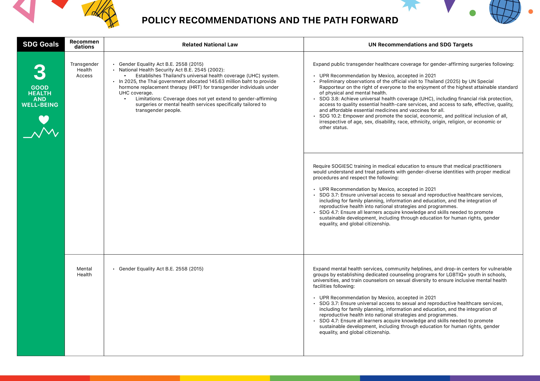
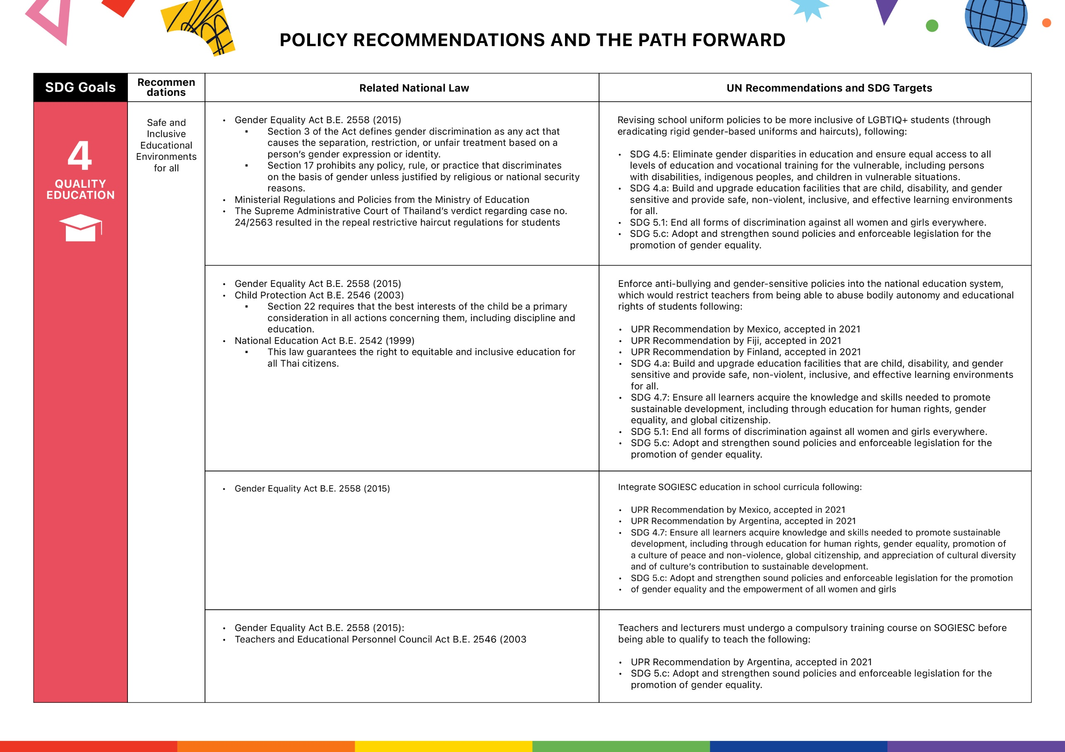

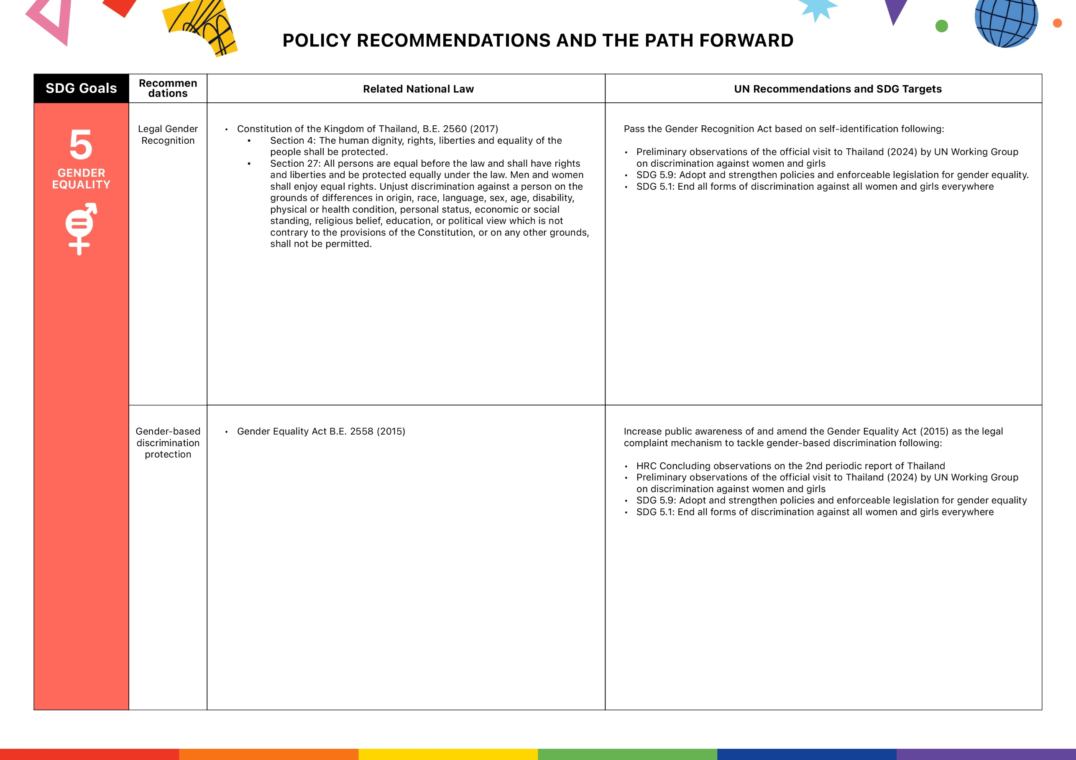

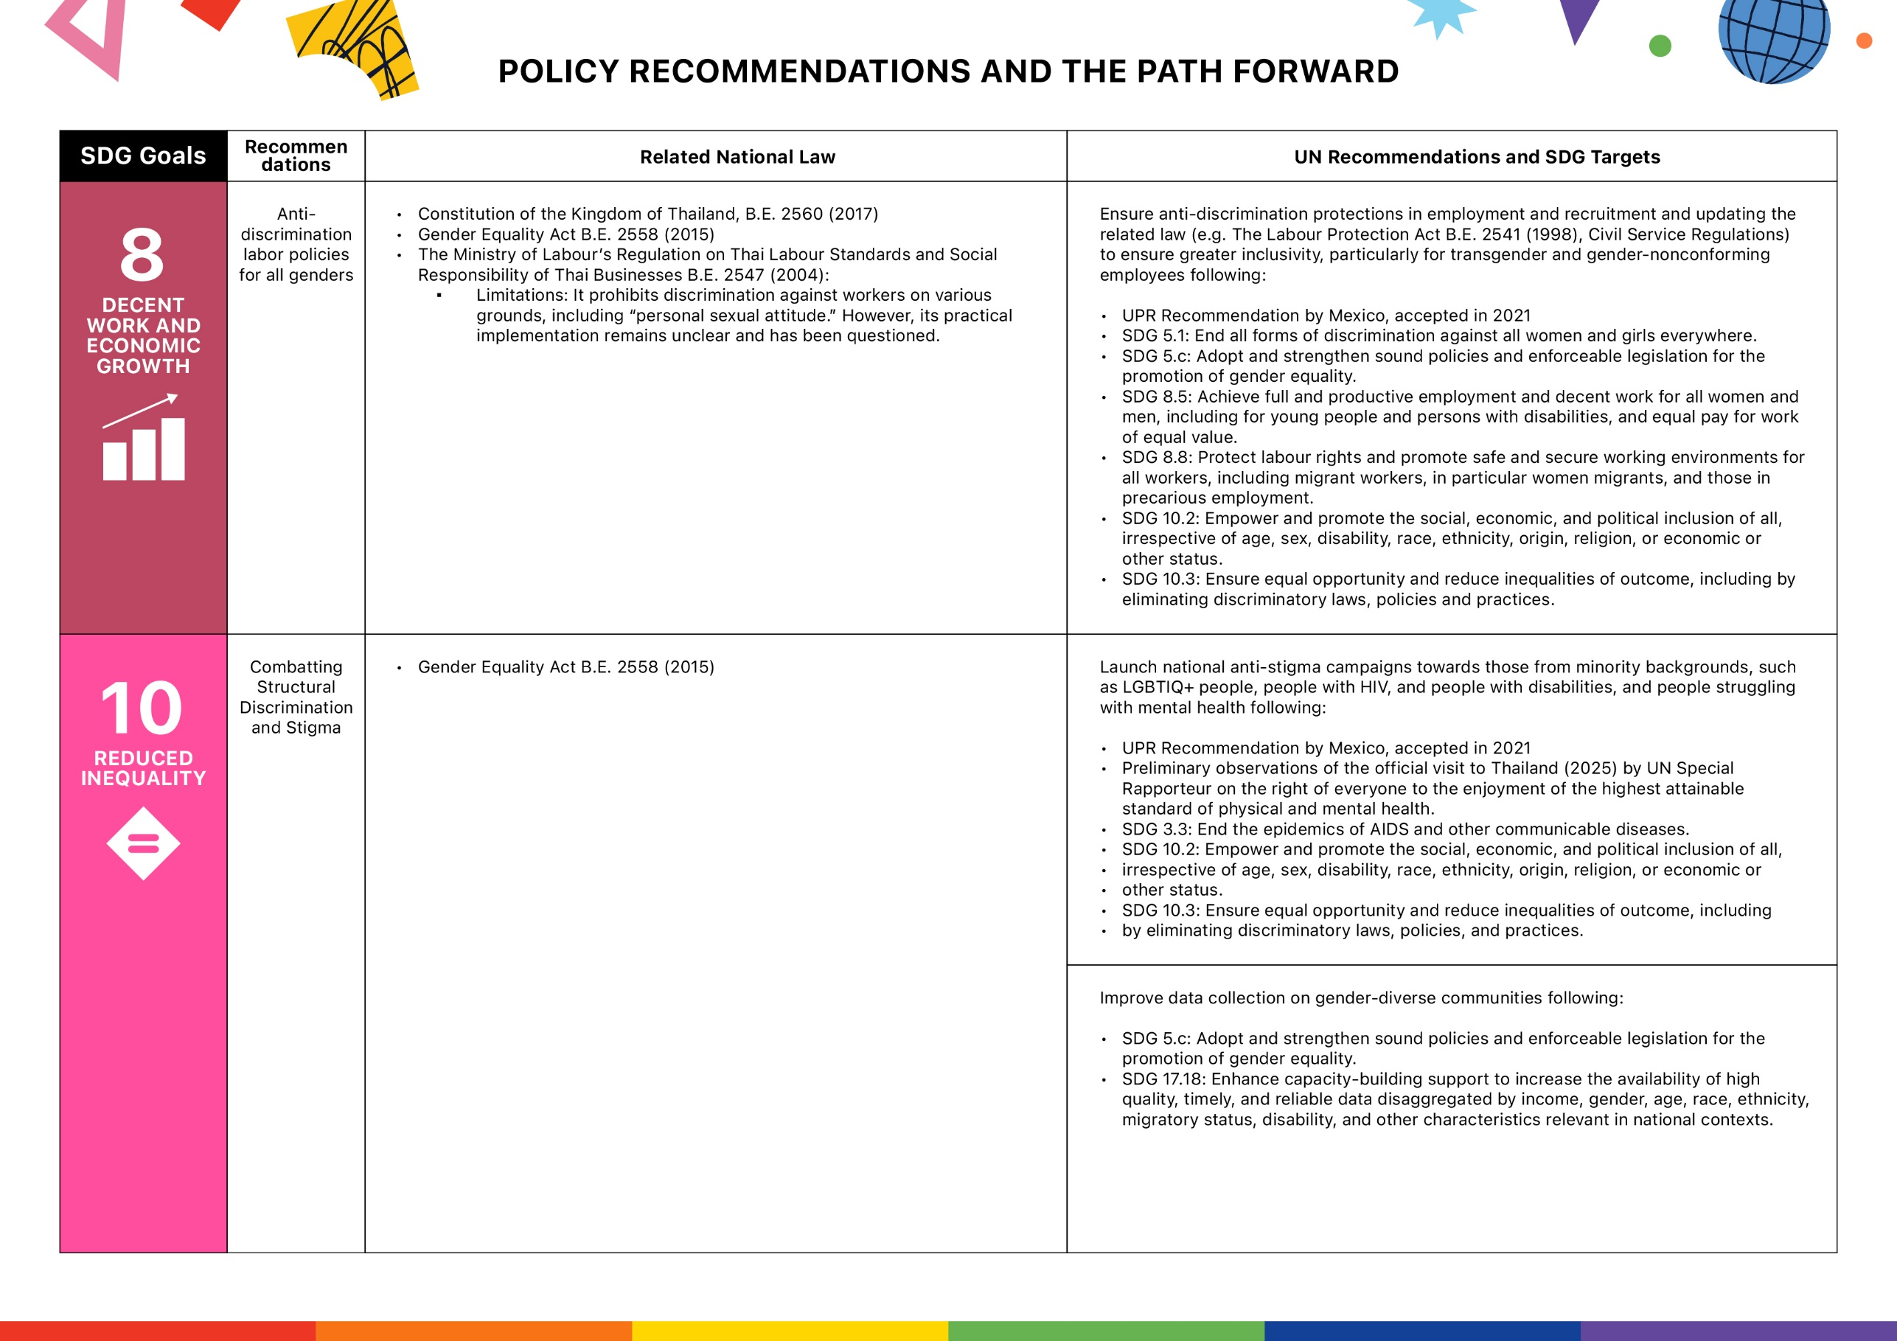

8. BIBLIOGRAPHY
- A Day Magazine. (2021, February 14). กฎระเบียบ เกลียดระบบ: คุยกับ 4 แกนนำนักเรียนเลวผู้เรียกร้องสิทธิเหนือเรือนร่าง. https://adaymagazine.com/bad-student
- Al Jazeera. (2023, August 2). Party that won Thai elections blocked from forming coalition government. https://www.aljazeera.com/news/2023/8/2/party-that-won-thai-elections-blocked-from-forming-coalition-government
- Al Jazeera. (2025, January 23). Jubilation as Thailand’s marriage equality law comes into effect. https://www.aljazeera.com/news/2025/1/23/jubilation-as-thailands-marriage-equality-law-comes-into-effect
- Amnesty International. (2021, January 19). Thailand: 87-year prison sentence handed in harshest lèse majesté conviction. https://www.amnesty.org/en/latest/press-release/2021/01/thailand-87-prison-sentence-lese-majeste/
- Amnesty International. (2023, February 8). Thailand: Child protesters face 'severe repercussions'. https://www.amnesty.org/en/latest/news/2023/02/amnesty-thailand-child-protesters-report/
- Amnesty International. (2023, February 9). Hateful and abusive speech towards LGBTQ+ community surging on Twitter under Elon Musk. https://www.amnesty.org/en/latest/news/2023/02/hateful-and-abusive-speech-towards-lgbtq-community-surging-on-twitter-surging-under-elon-musk/
- Amnesty International. (2024, August 7). Thailand: Dissolution of Move Forward Party an untenable decision that stifles human rights. https://www.amnesty.org/en/latest/news/2024/08/thailand-dissolution-of-move-forward-party-an-untenable-decision-that-stifles-human-rights/
- Amnesty International. (2024, May 16). Thailand: Human rights concerns persist amid political changes. https://www.amnesty.org/en/documents/asa39/7955/2024/en/
- AP News. (2024, June 18). After a quarter century, Thailand's LGBTQ Pride Parade is seen as a popular and political success. https://apnews.com/article/gay-lgbtq-pride-bangkok-marriage-equality-be93561331d5bf3a7d052de033d1433b
- Asian Development Bank. (2011, November). Thailand: Country Gender Assessment. https://www.adb.org/sites/default/files/publication/29149/csb-tha.pdf
- Bangkok Post. (2025, January 27). Gender titles emerge as new battleground. https://www.bangkokpost.com/thailand/general/2948182/gender-titles-emerge-as-new-battleground
- BBC News. (2022, November 18). Thailand's LGBTQ+ community celebrates Pride. https://www.bbc.co.uk/news/av/world-asia-63684836
- Bookimed. (2025). Top clinics for sex reassignment surgery in Thailand. https://us-uk.bookimed.com/clinics/country=thailand/procedure=sex-reassignment-surgery/
- CIVICUS. (2024, June 27). Thailand’s LGBTQI+ rights breakthrough. https://lens.civicus.org/thailands-lgbqi-rights-breakthrough/
- Council on Foreign Relations. (2024, June 30). Thailand's draconian 112 lèse majesté law: Any hope for change? https://www.cfr.org/blog/thailands-draconian-112-lese-majeste-law-any-hope-change
- Dek-D. (2023, June 14). มาส่อง! มหาวิทยาลัยไหนเปิดไฟเขียว "แต่งกายตามเพศสภาพ" เข้าเรียนได้. https://www.dek-d.com/tcas/62521/
- Department of Women's Affairs and Family Development. (2023, January 5). Gender equality in Thai policy. https://www.dwf.go.th/contents/36062
- GLAAD. (2025, January 10). GLAAD responds to Meta’s latest anti-LGBTQ changes to content policy and DEI that will harm users. https://glaad.org/releases/meta-anti-lgbtq-hate-speech-dei/
- Human Rights Campaign. (2025, January 15). Meta's new policies: How they endanger LGBTQ+ communities and our tips for staying safe online. https://www.hrc.org/news/metas-new-policies-how-they-endanger-lgbtq-communities-and-our-tips-for-staying-safe-online
- Human Rights Watch. (2015, September 21). Thailand Gender Equality Act. https://www.hrw.org/news/2015/09/21/thailand-gender-equality-act
- Human Rights Watch. (2021, December 15). “People Can’t Be Fit into Boxes”: Thailand’s Need for Legal Gender Recognition. https://www.hrw.org/report/2021/12/15/people-cant-be-fit-boxes/thailands-need-legal-gender-recognition
- Human Rights Watch. (2024). World Report 2024: Thailand. https://www.hrw.org/world-report/2024/country-chapters/thailand
- Human Rights Watch. (2025, January 30). Thailand invests in trans health. https://www.hrw.org/news/2025/01/30/thailand-invests-trans-health
- ILGA World. (2004). Regulation on Thai Labour Standards and Social Responsibility of Thai Businesses. https://database.ilga.org/api/downloader/download/1/TH%20-%20EXE%20-%20Regulation%20on%20Thai%20Labour%20Standards%20and%20Social%20Responsibility%20of%20Thai%20Businesses%20(2004)%20-%20OR(th).pdf Mermaid_pride.thailand. (n.d.). Mermaid Pride TH. Instagram. https://www.instagram.com/mermaid_pride.thailand
- intothebackroom. (2025, April 15). Post by @intothebackroom. [Tweet]. https://x.com/intothebackroom/status/1908747003359817831
- Irrawaddy. (2025, February 5). US aid freeze triggers healthcare crisis on Myanmar-Thai border. https://www.irrawaddy.com/news/burma/us-aid-freeze-triggers-healthcare-crisis-on-myanmar-thai-border.html
- Jackson Grant. (n.d.). DEI in Thailand. https://www.jacksongrant.io/news/DEI-in-Thailand/
- Kuroneedscoffee. (2025, April 14). Post by @Kuroneedscoffee. [Tweet]. https://x.com/Kuroneedscoffee/status/1908036602456354922
- Lambda Legal. (n.d.). Transgender workplace rights – Frequently asked questions. https://legacy.lambdalegal.org/know-your-rights/article/trans-workplace-faq
- Line Today. (2019). สุขภาพจิตเด็กและเยาวชนหลากหลาย SOGIESC ในไทยน่าเป็นห่วง. https://today.line.me/th/v2/article/eQZPJJ
- Manushya Foundation. (2022, June 21). CERD Committee denounces intersectional discrimination against LGBTIQ+ people in Thailand [Video]. https://www.youtube.com/watch?v=eJcd6xHIjbQ
- Manushya Foundation. (2022, June 27). #FightRacism: How we denounced racism in Thailand before the UN. https://www.manushyafoundation.org/post/how-we-denounced-racism-in-thailand-before-the-un
- Manushya Foundation. (2023, May 12). YouthSpeakDemocracy 🏳️‍🌈 Butae, Activist who Envisions A Democracy that Upholds LGBTIQ+ Rights [Video]. https://www.youtube.com/watch?v=-uLclDSuvhE
- Matichon. (2024, November 19). เพจดัง แฉครู ร.ร.ในโคราช บังคับตัดผม นักเรียนหญิง12 คน จนกุด ลั่น อย่าเรื่องมาก. [ข่าวออนไลน์]. Matichon. https://www.matichon.co.th/region/news_4906675
- Nation Thailand. (2018, March 26). Drive for gender inclusion. https://www.nationthailand.com/business/30341797
- Nation Thailand. (2025, January 23). MPs say 'no' to gender recognition bill. https://www.nationthailand.com/thailand/politics/40035780
- Office of the High Commissioner for Human Rights. (2024, December 13). End of mission statement: Thailand visit by the UN Working Group on discrimination against women and girls. https://www.ohchr.org/sites/default/files/documents/issues/women/wgdawg/statements/2024-12-13-eom-thailand-wgdawg-en.pdf
- Office of the High Commissioner for Human Rights. (2025, February 28). Preliminary conclusions of the Special Rapporteur on the right of everyone to the enjoyment of the highest attainable standard of physical and mental health, following her visit to Thailand. https://www.ohchr.org/sites/default/files/documents/issues/health/sr/SR-health-visit-thailand-preliminary-conclusions.pdf
- Pattaya Mail. (2023, May 23). 15-day paid paternity leave granted to male government officials. https://www.pattayamail.com/thailandnews/15-day-paid-paternity-leave-granted-to-male-government-officials-433099
- Prachatai English. (2023, January 26). Chiang Rai activist sentenced to 50 years in prison for royal defamation. https://prachataienglish.com/node/10782
- Prachatai English. (2024, January 24). Students march to Ministry of Education to demand LGBTQ rights. https://prachataienglish.com/node/11348
- Prachatai. (2025, January). ทำไมต้องมี พ.ร.บ.คำนำหน้านาม? สิทธิอินเตอร์เซ็ก คนข้ามเพศ นอนไบนารี. https://prachatai.com/journal/2025/01/112019
- Respect International. (2010). From the tiger to the crocodile: Abuse of migrant workers in Thailand. https://respect.international/from-the-tiger-to-the-crocodile-abuse-of-migrant-workers-in-thailand/
- Reuters. (2025, January 23). Thailand’s same-sex marriage law. https://www.reuters.com/world/asia-pacific/thailands-same-sex-marriage-law-2025-01-23/
- SAGE Journals. (2024). Structural stigma and mental health among LGBTQ+ individuals in Thailand. https://journals.sagepub.com/doi/full/10.1177/00221465241240465
- Save the Children. (2023). Study report: Mental health and well-being of children and youth with diverse SOGIESC in Thailand. https://resourcecentre.savethechildren.net/document/study-report-mental-health-and-well-being-of-children-and-youth-with-diverse-sogiesc-in-thailand/
- Siam Legal. (2024). Criminal Code: Royal Family (Sections 107–112). https://library.siam-legal.com/thai-law/criminal-code-royal-family-sections-107-112/
- Thai Labour Protection Act. (1998). Labour Protection Act, B.E. 2541 (1998). https://www.vertic.org/media/National%20Legislation/Thailand/TH_Labor_Protection_Act.pdf
- Thai PBS. (2019, November 12). "จุฬาฯ" เริ่มแล้ว ออกประกาศให้นิสิตแต่งกายตามเพศสภาพได้. https://www.thaipbs.or.th/news/content/286016
- ThaiEduEng577. (n.d.). Undergraduate and higher education in Thailand. https://thaiedueng577.wordpress.com/undergraduate-and-higher/
- The Diplomat. (2024, August 29). Thailand's Pheu Thai Party invites former arch-rival to join coalition. https://thediplomat.com/2024/08/thailands-pheu-thai-party-invites-former-arch-rival-to-join-coalition/
- The Guardian. (2019, May 8). Thai parties cry foul after election results favour military junta. https://www.theguardian.com/world/2019/may/08/thai-parties-cry-foul-after-election-results-favour-military-junta
- The Guardian. (2025, January 23). Thailand’s same-sex marriage equality laws. https://www.theguardian.com/world/2025/jan/23/thailand-same-sex-gay-marriage-equality-laws
- The Standard. (2020, July 29). ‘We are not freaks’: Students march for LGBT equality. https://thestandard.co/we-are-not-freaks-students-march-for-lgbt-equality/
- Time. (2022, November 3). ‘Nobody Is Taking Away My Child.’ What Thailand’s Push for Marriage Equality Means for One Family. https://time.com/6228051/thailand-lgbtq-family-marriage-equality/
- UNDP. (2018). Legal gender recognition in Thailand: A legal and policy review. https://www.undp.org/sites/g/files/zskgke326/files/migration/th/legal-gender-recognition-in-thailand-2018.pdf
- UNESCO. (2015). Thailand EFA 2015 review. https://unesdoc.unesco.org/ark:/48223/pf0000227706_tha
- World Bank. (2021). Aging and the labor market in Thailand. https://www.worldbank.org/en/country/thailand/publication/aging-and-the-labor-market-in-thailand
- World Bank. (2023, November 29). Focus on skills, education, regional development needed to create a more equal society in Thailand. https://www.worldbank.org/en/news/press-release/2023/11/29/focus-on-skills-education-regional-development-needed-to-create-a-more-equal-society-in-thailand
- World Bank. (2024). Economic inclusion of LGBTI groups in Thailand. https://www.worldbank.org/en/country/thailand/publication/economic-inclusion-of-lgbti-groups-in-thailand
- Young Pride Club. (2023, December 21). กสม. ประสานการคุ้มครองสิทธิ มรภ.อุบลราชธานีอนุญาตให้นักศึกษาหญิงข้ามเพศใช้รูปถ่ายชุดนักศึกษาตามเพศสภาพในใบรับรองคุณวุฒิได้. [Image attached]. Facebook. https://www.facebook.com/photo.php?fbid=679153391071726&id=100069312125516&set=a.238819018438501&locale=en_GB
- Young Pride Club. (2024). Act 01. https://youngprideclub.com/act-01/
- Young Pride Club. (2024). The Rise of Rainbow in Education. https://youngprideclub.com/rainbow-report/
- Young Pride Club. (2024, December 2). จะสอบ TGAT/TPAT ต้องเตรียมตัวอย่างไร. [Image attached]. Facebook. https://www.facebook.com/photo?fbid=568244355794509&set=a.169356265683322
- Young Pride Club. (2025, January 6). Annual Report 2024. https://youngprideclub.com/2025/01/06/annual-report-2024/

