
THEMATIC REPORT ON ARTICLE 16, MUSLIM FAMILY LAW AND MUSLIM WOMEN’S RIGHTS IN
IRAQ

74th CEDAW Session
Geneva, Switzerland
November 2019

Musawah
15 Jalan Limau Purut, 59000 Kuala Lumpur, Malaysia
Tel: +603 2083 0202Fax: +603 2202 0303
Email: musawah@musawah.org
Website: www.musawah.org

A. INTRODUCTION

Musawah, the global movement for equality and justice in the Muslim family, submits this Thematic Report on Article 16 and related concerns for consideration by the CEDAW Committee in its review of the Government of Iraq, reporting before the 74th CEDAW Session in November 2019.
In particular, this report examines Iraqi laws and practices that enforce de jure and de facto discrimination against women in the following areas: discriminatory legal framework, child marriage, forced marriage, temporary marriage, polygamy and violence against women.
We hope that the CEDAW Committee will utilize this report as a key resource during its Constructive engagement with the State party, and in follow-up activities on the Concluding Observations. Musawah would like to acknowledge the vital input and feedback from national women’s rights advocates and lawyers into this report.

B. legal background

Iraq has a mixed legal system that draws on both Sunni and Shi’ite fiqh for the law applied in Shari’ah courts. The legal system as a whole also includes constitutional law, legislation and statutory provisions, usage and custom, judicial precedent and authoritative juridical opinion.
Matters regarding marriage and family relations of the Muslim majority population in Iraq are mainly governed by the Iraqi Personal Status Law No. 188/1959 (IPSL). The Kurdistan Region has its own Personal Status Law – Act No. 15/2008.
The IPSL, which was drawn from both the rules of Hanafi and Jafari jurisprudence (fiqh), applies to all Iraqi Muslims regardless of sect. The IPSL confers many rights for women in marriage, divorce, custody and inheritance. However, after 2003, due to the fragile security situation in Iraq, the weaknesses in law enforcement and the dominance of tribal customs and religious edicts, women’s organisations have documented breaches of the law.

C. KEY ISSUES, LIVED REALITIES, ISLAMIC JURISPRUDENCE,

AND REFORM

1. FAMILY LAW BASED ON DISCRIMINATORY FRAMEWORK

Despite the equality guarantees under the Constitution, the IPSL provides for a marital framework based on ‘reciprocal’ or ‘complementary’ rights (as opposed to ‘equal’ rights) between the two spouses, whereby in return for maintenance and protection from her husband, a wife is expected to obey him to a certain extent.

Furthermore, Article 25 states that a wife is no longer entitled to financial maintenance if: (i) she leaves her husband’s home without his permission and without legitimate reason; (ii) if she refuses to travel or move with her husband; or (iii) if she is convicted and imprisoned for a crime or debt. However, Article 25 also stipulates that: A wife shall not be bound to obey her husband if the husband is arbitrary in his demands for obedience, intending to injure or oppress her. The court must give due consideration in issuing a ruling for the disobedience of the wife before ruling that a wife is disobedient. It must understand the reasons for her refusal to obey her husband and do its utmost to remove the causes of a wife’s disobedience.

RECOMMENDATIONS

We recommend the CEDAW committee to urge the State party to:
- Ensure men and women the same right to enter marriage, including repealing discriminatory laws, regulations, and practices requiring for a guardian’s consent or approval.
- Eliminate all provisions that refer to disobedience (nushuz) of women as a grounds by which she risks losing her right to financial maintenance.

2. CHILD and forced MARRIAGE

The minimum legal age for marriage is 18 for females and males based on Article 7(1) of the IPSL. However, Article 8 provides that a judge may permit girls and boys who are 15 and above to marry if the judge is convinced that: (i) they have reached puberty and are physically capable of being married, and (ii) the marriage is an “urgent necessity”. The judge is obligated to obtain the views of the guardian of the girl or boy regarding the marriage. Should the guardian object to the marriage, the judge may nevertheless authorise the marriage if the judge considers the objection unreasonable.

The ages of both parties are verified before a marriage is concluded by the appropriate officer in a competent court. The parties are required to submit a statement showing their age as a condition of marriage of registration. The Personal Status (Jafari) Bill proposed in 2014 threatened to allow for the marriage of girls as young as nine years old in exceptional circumstances.

Women’s rights advocates also note that there is still a tribal practice where women are exchanged between tribes as wives. In other cases, where there is a dispute or conflict between clans / tribes women are exchanged between the tribes as compensation (and in some cases as blood money). This occurs without the consent of the women in question.

RECOMMENDATIONS

We recommend the CEDAW committee to urge the State party to:

- Enforce 18 years as the absolute minimum age of marriage for Muslim girls and remove all legal loopholes that allow for exceptions.
- Improve awareness raising campaigns among tribal and rural communities about forced marriages and related penalties.

4. TEMPORARY MARRIAGES

Temporary marriage is neither legally recognised nor is it socially acceptable. These temporary marriages are not legally codified are mostly take place outside the courts through certain ‘clerical offices’ set up to arrange such marriages.

The temporary contracts that they obtain do not guarantee the rights of either the wife nor subsequent children because they are informal contracts and are not recognized by law unless ratified by the court. In cases where the couple seeks to get court recognition, the women/girl in many cases faces consequences in the event she married without the consent of her male guardians.

Women from the rural and poor areas are particularly susceptible to unregistered marriages and their adverse impact. Their marriages are conducted by local clerics without the women being aware of the need to go through official channels to register their marriages. The non-registration of their marriages causes complications for themselves and their children, particularly in instances where their husbands travel, die, or initiate a divorce.

RECOMMENDATIONS

We recommend the CEDAW committee to urge the State party to:

- Ensure that offices and centers that contract temporary marriages are shut down and individuals involved in arranging temporary marriages are heavily penalized. Increase penalties for individuals involved in running such operations.
- Encourage formal registration of temporary marriages by reducing the fees needed to get court certification of the marriage.

5. POLYGAMY

A Muslim man may marry up to four wives at one time. Unless the prospective bride is a widow, Article 3 of the IPSL prohibits a man from marrying more than one woman except with the authorisation of a judge (qadi). A judge may only authorise the polygamous marriage if three conditions are met: (i) the husband has financial capacity; (ii) there is a legitimate interest; and (iii) there is no fear of injustice between wives.

Article 3 also provides for a penalty of imprisonment and/or fine if a man concludes a marriage with more than one wife without first seeking the authorisation of the court. Article 26(1) of the Personal Status does not allow a husband to house more than one wife in the same home, unless the wives consent. Article 40(5) provides that a wife may file for divorce if a husband takes a second wife without court permission. Women’s rights advocates note an exception in the law where it is permissible for a man to marry more than one woman if the wife he intends to take is a widow, regardless of his present wife’s consent.

In the Iraq Kurdistan Region, the Personal Status Law states that marrying more than one woman is not allowed unless authorised by the judge. A judge may only authorise the polygamous marriage if the certain conditions are met. A man who concludes a polygamous marriage without the authorisation of a judge will be subject to a penalty of imprisonment and fine and judges are prohibited from suspending the penalties.

RECOMMENDATIONS

We recommend the CEDAW committee to urge the State party to:
- Amend IPFL to prohibit polygamy by Iraqi Muslim men, following examples of other Muslim countries which have abolished the practice in the best interest of family well-being.

6. VIOLENCE AGAINST WOMEN

Article 29(4) of the Constitution prohibits that all forms of violence and abuse in the family. However, Iraq has not yet adopted specific legislation to criminalise acts of domestic violence. In 2016, the Iraqi Parliament was completing its review of the draft Anti-Domestic Violence Law, which was introduced in 2015. Approval of the draft law by Parliament is still pending, as it has been met with stiff resistance from religious political parties and conservative politicians/Ministers.

The Penal Code contains some general prohibitions that are applicable to domestic violence. The Penal Code criminalises and provides for penalties for certain offences involving the family (issuing and obtaining an invalid marriage certificate, etc.) as well as rape, indecent assault, etc.

However, under the Penal Code: Article 41(1) permits a husband to use physical discipline against his wife “within the bounds of what is permissible by Shari’ah, law, or custom”.

Marital rape is not specifically criminalized in Iraq. According to women’s rights advocates, even though under the Constitution all forms of violence and abuse in the family are prohibited, the context of Iraq has posed challenges for women with regard to overcoming vulnerable and violence situations. While civil society has advocated for a law to address domestic violence and more than one draft law has been put forward to government, many politicians including religious parties are still against the adoption of this law because they believe in giving the right to husband, father and teacher for using violence under the pretext of discipline as stipulated in Article 41 of the Penal Code.

RECOMMENDATIONS

We recommend the CEDAW committee to urge the State party to:
- Expedite the passage of the Anti-Domestic Violence Law with urgency and ensure that the law covers the most prevalent forms of domestic violence including honor-based violence and harmful traditional and customary practices.

Annexe 1: justification for reform

Equality in marriage

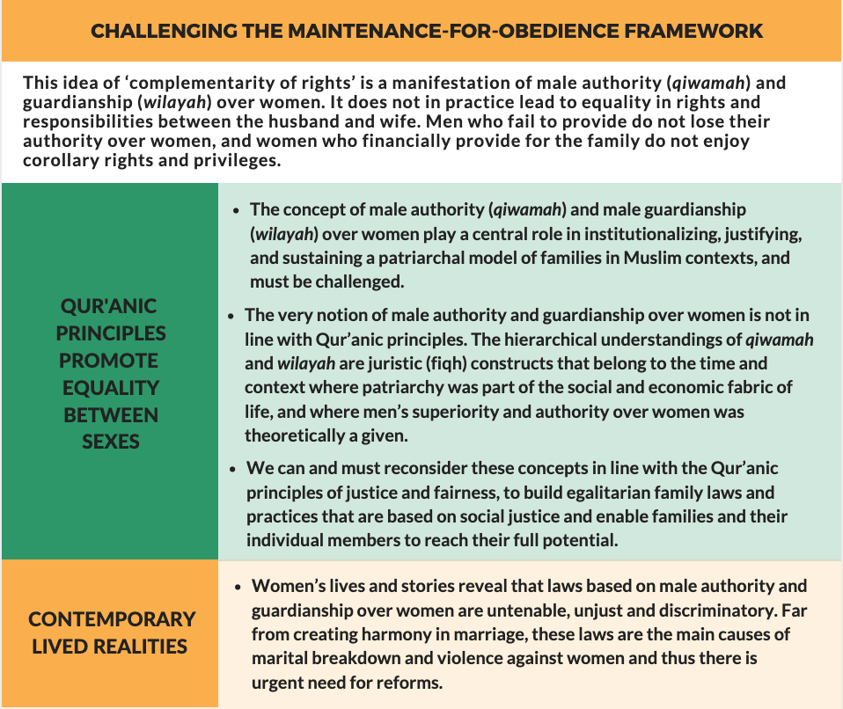

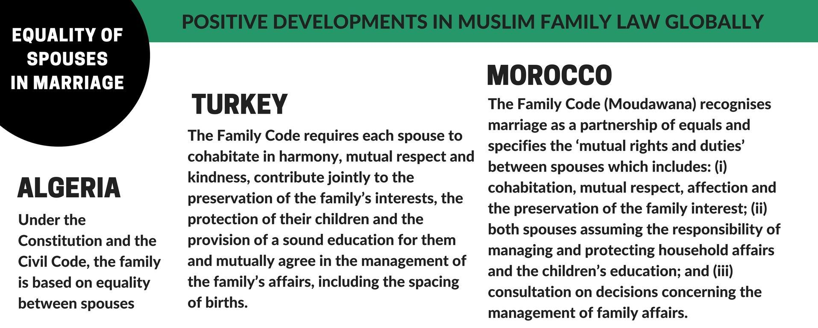

Minimum age of marriage as 18 years

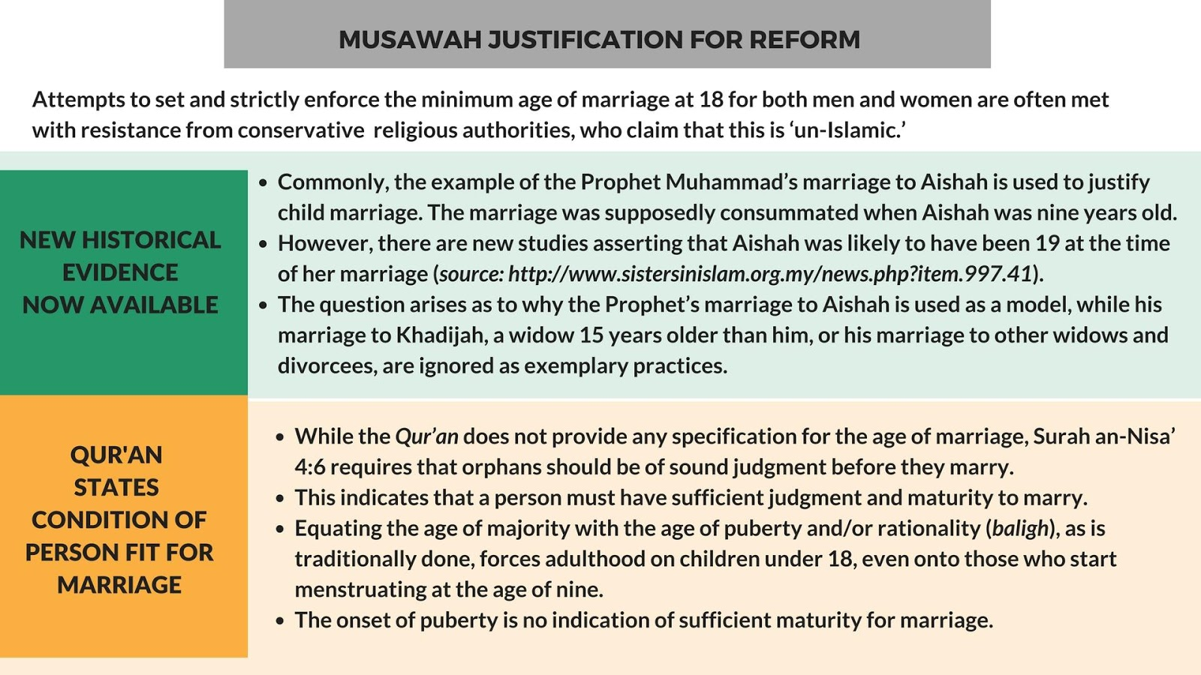

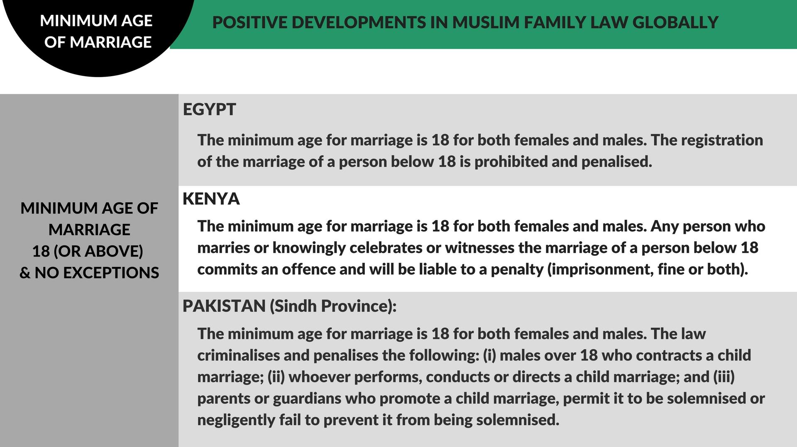

Women’s equal capacity to enter into marriage

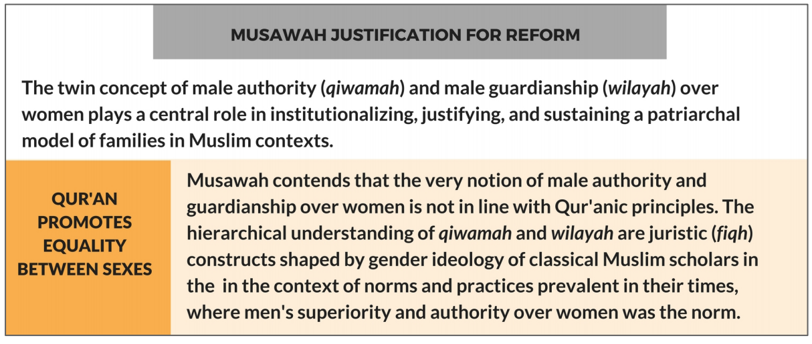

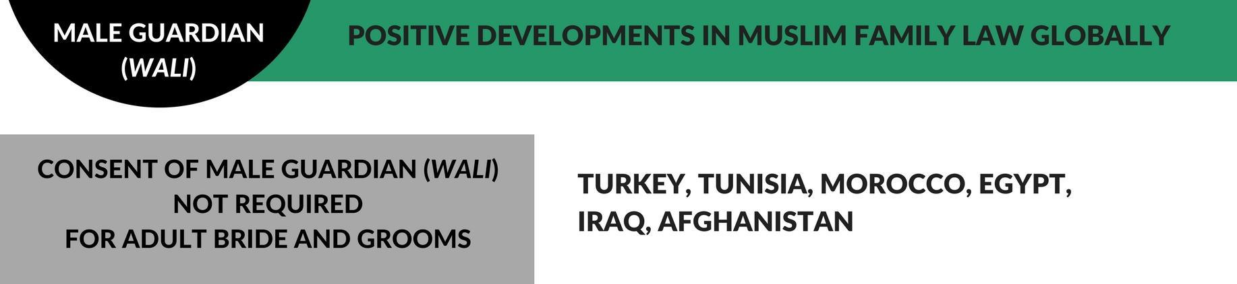

Abolishment of polygamy

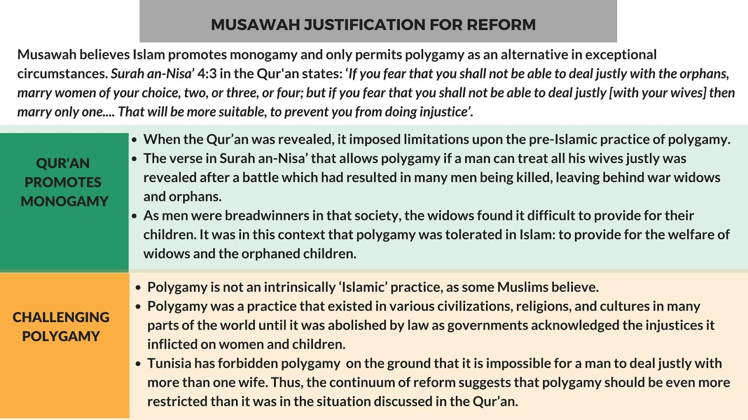

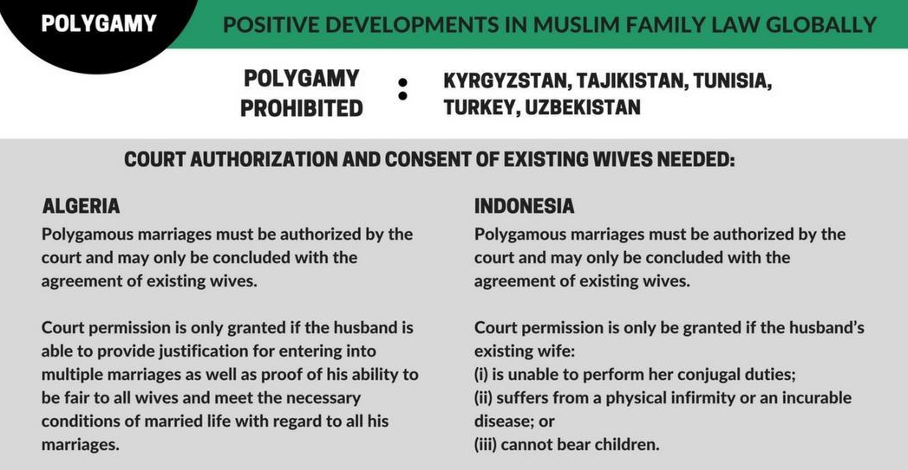

ANNEXE 2:

MUSAWAH VISION for the family
Musawah asserts that in the twenty-first century, there cannot be justice without equality. Many provisions in Muslim family laws, as defined by classical jurists and as reproduced in modern legal codes, are neither tenable in contemporary circumstances nor defensible on Islamic grounds. Not only do these family laws fail to fulfill the Shari’ah requirements of justice, but they are being used to deny women rights and dignified choices in life. These elements lie at the root of marital disharmony and the breakdown of the family.
Musawah believes that Qur’anic principles and the richness of the Islamic juristic tradition enable us to formulate Muslim family laws today that are egalitarian and reflect the needs of contemporary societies. Islamic teachings and universal human rights standards, including the CEDAW Convention, are fully compatible and are dynamic and constantly evolving, based on changing times and circumstances. Inspired by the Qur’anic vision of justice and gender relations, Musawah contends that gender equality and non-discrimination can only be achieved with laws that transform power relations in the family and in society in the direction of just outcomes.
It is our hope that the CEDAW Committee will encourage Governments everywhere, and particularly those purporting to speak for and in the name of Islam and Muslim communities, to:
- Recognize the diversity of opinions, laws and practices in the Muslim world and the growing scholarship in Islam that recognizes equality and justice and the possibility and necessity for reform of Muslim family laws today.
- Promote human rights standards as intrinsic to the teachings of Islam, national guarantees of equality and non-discrimination, and the lived realities of men and women today.
- Encourage open and inclusive public debate regarding diversity of opinion and interpretations in Muslim laws and principles relating to family laws and practices.
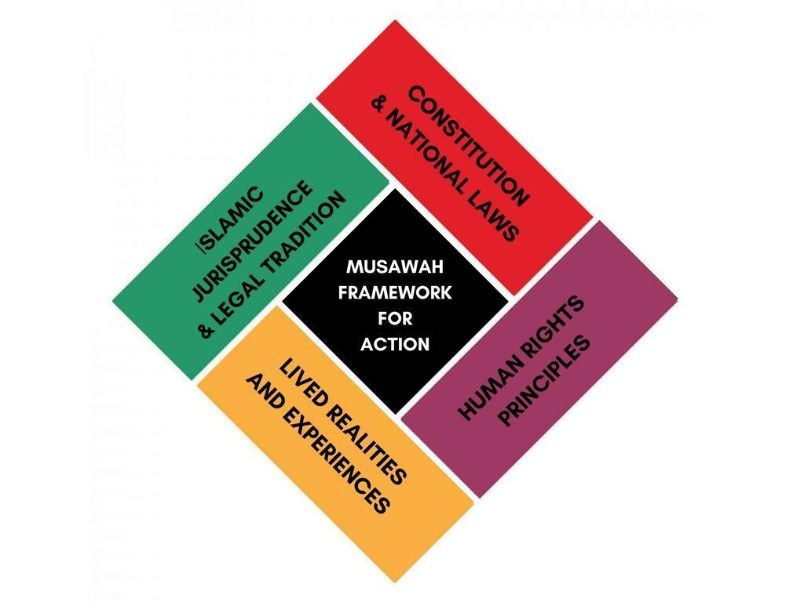

Personal Status Law (1959), https://docs.google.com/file/d/0B8ITLJi5y4TKcXF3MFJnUTFwUmc/view
Personal Status Law in Iraq Kurdistan Region (2008), http://www.ekrg.org/files/pdf/personal_status_law.pdf; Iraq State party report, U.N. Doc. CEDAW/C/IRQ/4-6 (2013), paras. 234-235, http://www.ohchr.org/en/hrbodies/cedaw/pages/cedawindex.aspx
Two major attempts have been made to circumvent the rights available to women under the IPSL. Thus far, they have not been successful - On 29 December 2003, the Iraqi Governing Council (IGC) passed Resolution 137 to abolish the Personal Status Law. The Resolution states that Shari’ah principles shall apply to matters relating to marriage and adjudication by the religious authorities of the various sects in Iraq. After a fierce fight by activists, the Resolution was repealed two months later. Kelsey Cherland, “The Development Of Personal Status Law In Jordan & Iraq,” CMC Senior Theses, 2014, 89, http://scholarship.claremont.edu/cgi/viewcontent.cgi?article=1926&context=cmc_theses
Kelsey Cherland, “Developments in Personal Status Law: Iraq and Jordan” (CMC Senior Thesis, Paper 865, 2014), p. 71, http://scholarship.claremont.edu/cgi/viewcontent.cgi?article=1926&context=cmc_theses
Article 2 of the Personal Status Law (1959), https://docs.google.com/file/d/0B8ITLJi5y4TKcXF3MFJnUTFwUmc/view
Iraqi Women Network, Rafidain Women Coalition, Gathering of “No to violence etc., “Iraqi women in armed conflict and post conflict situation” Submission to the CEDAW Committee for the mid-term review of the Concluding observations issued by the Committee after the 57th Session, 2016, pp. 12-13 http://tbinternet.ohchr.org/Treaties/CEDAW/Shared%20Documents/IRQ/INT_CEDAW_NGS_IRQ_25070_E.pdf
Following the repeal of Resolution 137, Article 41 of the Constitution was adopted by referendum in 2005. This is functionally equivalent to Decree 137. Article 41 states that Iraqis are free in their commitment to their personal status according to their religions, sects, beliefs, or choices, and this shall be regulated by law.” This article makes it possible for Iraq to propose communal based family law such as the Personal Status (Jafari) Bill.
Thus, Article 3 of the IPSL defines marriage as a contract between a man and a woman who is lawfully permissible to him, the purpose of which is to establish a bond for a mutual life and procreate children. Article 23 provides that the wife is entitled to financial maintenance from the husband even if she was staying at her parent’s house, unless the husband asks her to move to his place and she abstains unrightfully. Her abstention is considered rightful if the husband did not pay her the immediate dower or as long as he is not spending on her.
Article 7(1) of the Personal Status Law (1959), https://docs.google.com/file/d/0B8ITLJi5y4TKcXF3MFJnUTFwUmc/view
According to the Iraqi government as well as civil society and media reports, the prevalence of child marriage in Iraq is high due to: (i) customs and tradition, especially in communities still committed to tribal customs; (ii) socio-economic factors such as poverty and lack of education, health and legal awareness; (iii) difficulties in law enforcement, particularly in the rural areas; and (iv) political instability. Iraq State party report, U.N. Doc. CEDAW/C/IRQ/4-6 (2013), para. 216, http://www.ohchr.org/en/hrbodies/cedaw/pages/cedawindex.aspx; Girls Not Brides, “Iraq”, Child marriage around the world, http://www.girlsnotbrides.org/child-marriage/iraq/; Zainab Salbi, “Iraqi woman explains why she married off her daughters at ages 15 and 16,” New York Times, 10 August 2015, http://nytlive.nytimes.com/womenintheworld/2015/08/10/iraqi-woman-explains-why-she-married-off-her-daughters-at-ages-15-and-16/; Nizar Latif, “Worry over rise in divorce rate,” The National, 10 January 2010, http://www.thenational.ae/news/world/middle-east/worry-over-rise-in-divorce-rate
Article 8 of the Personal Status Law (1959), https://docs.google.com/file/d/0B8ITLJi5y4TKcXF3MFJnUTFwUmc/view
Article 10 of the Personal Status Law (1959), https://docs.google.com/file/d/0B8ITLJi5y4TKcXF3MFJnUTFwUmc/view
Jamie Tarabay, “Iraqi law would legalize marital rape, child marriage for country’s Shia”, Aljazeera, 27 April 2014, http://america.aljazeera.com/articles/2014/4/27/iraqi-shiites-protestproposedfamilylaw.html
According to reports by civil society and the media, despite these provisions forced marriage is prevalent in Iraq. Factors that contribute to such marriages include the need (or perceived need) to alleviate the financial difficulties of the family and preserve “family honour” in rape cases.
However, according to women’s rights advocates, it is on the rise in recent years, including in universities. Reasons include destitution, increase in the number of widows and young people preferring to be in a temporary as opposed to a permanent marriage.
Iraqi advocates note that majority of marriages outside the courts occur to girls without any age-specific conditions and / or a medical examination with regard to genetic or sexually transmitted diseases.
There have been cases where the woman/girl has faced violence from her family. Since Personal Status Court judges are allocated anywhere from 1,000 – 9,000 cases per year, efforts to register an unregistered marriage may be extremely delayed. Judges have the final decision and significant discretion when it comes to these cases.
Article 3 of the Personal Status Law (1959), https://docs.google.com/file/d/0B8ITLJi5y4TKcXF3MFJnUTFwUmc/view
Article 26(1) of the Personal Status Law (1959), https://docs.google.com/file/d/0B8ITLJi5y4TKcXF3MFJnUTFwUmc/view
Personal Status Law No. 188 (1959) of 1959 (as amended), Article 40(5), https://docs.google.com/file/d/0B8ITLJi5y4TKcXF3MFJnUTFwUmc/view
According to Iraq’s 2011 Multiple Cluster Indicator Survey, about 6% of marriages in Iraq are polygamous. Statistics from 2013 from the Najaf Federal Courts indicate 96 approvals for second marriages. In the same year, 450 polygamous marriages were registered in the Kirkuk Court, and 150 polygamous marriages were registered in the Makhmur Court. It is noteworthy that many marriages, including to successive wives, take place outside the courts, and are therefore unregistered. According to a media reports, polygamy may be increasing in Iraq due to the improved financial situation of many men, and the large number of widows following the war. In addition, many polygamous marriages are being performed outside the jurisdiction of the court in violation of the law. Women’s rights advocates note that even when polygamy is done via the court system, judges are biased towards the practices and authorize marriages regardless of whether husbands fulfil conditions.
Article 1 of the Kurdistan Personal Status Law (2008), http://www.ekrg.org/files/pdf/personal_status_law.pdf
According to a media report, while the amendments to the Kurdish Personal Status Law were intended to significantly reduce polygamy, the practice has been difficult to police and prevent, as some individuals travel across the border to engage in polygamous marriages. The regional government has created a special commission to investigate this issue and consider the potential of punishing those who exploit this loophole. Matt Frazer, “Iraqi Kurdistan enforces the new polygamy law,” Ekurd Daily, 26 September 2011, http://ekurd.net/mismas/articles/misc2011/9/state5458.htm
Article 29(4) of the Iraqi Constitution (2005), https://www.constituteproject.org/constitution/Iraq_2005.pdf?lang=en
Human Rights Watch, “Strengthen Domestic Violence Bill”, 19 March 2017, https://www.hrw.org/news/2017/03/19/iraq-strengthen-domestic-violence-bill
Penal Code (1969), http://www.refworld.org/docid/452524304.html
Articles 41(1), 128, 130-131, 398 of the Penal Code (1969), http://www.refworld.org/docid/452524304.html
Article 128 allows for ‘honourable motives’ or extreme provocation to be mitigating factors that can be taken into account to either exempt from or reduce punishment for a crime. Articles 130 and 131 specify the reduced punishments when a mitigating factor exists. For example, Article 131 provides that if a mitigating factor exists for a crime punishable by death, the sentence may be reduced to life imprisonment or imprisonment for a term no less than one year. Article 398 provides that any action against a rapist who marries the victim will become void and any investigation or other procedure is discontinued, and if a sentence has already been passed, the sentence will be quashed.
The Kvinna till Kvinna Foundation, “Violence Against Women in Iraq”, 2014, pp. 1-2 http://kvinnatillkvinna.se/en/files/qbank/217b4c71837fac172fabebfc299f755b.pdf
Furthermore, honor killings continue to be committed and in many cases a man may face up to 6-month suspended prison sentence. Therefore, advocates note that it is easy for perpetrators to get away with murder with impunity for murders, as some honor killings are for especially in the guise of family disputes (eg. Inheritance) or tribal hostility.

