European Union Agency for Fundamental Rights, selection of rights of the child passages from published reports related to Malta
fra.europa.eu

10 April 2019, Vienna

Contents
1. Data Explorers and tools 2
1. 1 Violence against women: an EU-wide survey (2014) 2
1.2 EU-LGBT survey (2012) 3
2. Annual reports 5
2.1 Fundamental Rights Report 2017 Report 5
3 Thematic reports 6
3.1 Combating child poverty: an issue of fundamental rights (2018) 6
3.2 European legal and policy framework on immigration detention of children (2017) 7
3.3 Violence against women: an EU-wide survey (2014) 8
3.4 EU LGBT Survey – European Union lesbian, gay, bisexual and transgender survey (2012) 9
3.5 Second European Union Minorities and Discrimination Survey (2016) 10
3.6 Second European Union Minorities and Discrimination Survey – Being Black in the EU (2018) 10
3.7 Mapping of minimum age requirements (2017 – 2018) 11

- Data Explorers and tools

1. 1 Violence against women: an EU-wide survey (2014)
The survey includes extensive information regarding Malta, these excerpts are just a selection. Violence against women: an EU-wide survey data explorer: http://fra.europa.eu/en/publications-and-resources/data-and-maps/survey-data-explorer-violence-against-women-survey
In Malta – Women who have experienced physical, sexual or psychological violence before the age of 15
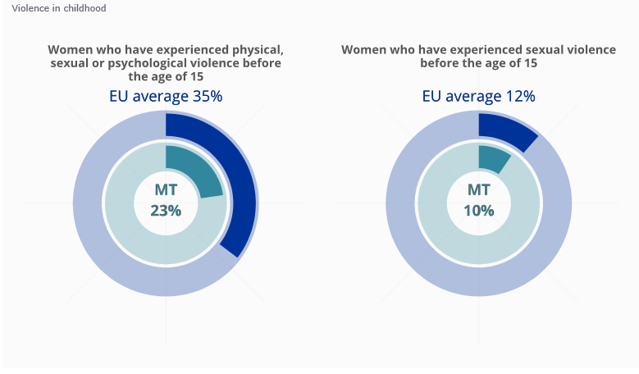
In the EU – Experiencing physical, sexual or psychological violence before the age of 15 by an adult perpetrator
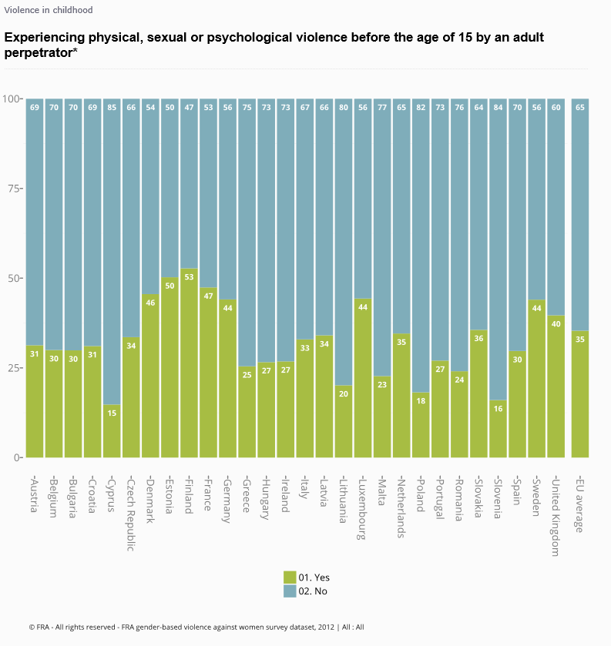

1.2 EU-LGBT survey (2012)
The survey includes extensive information regarding Malta, these excerpts are just a selection. EU LGBT survey data explorer: http://fra.europa.eu/en/publications-and-resources/data-and-maps/survey-data-explorer-lgbt-survey-2012
In Malta – During your schooling before the age of 18, did you hide or disguise that you were L, G, B or T at school?
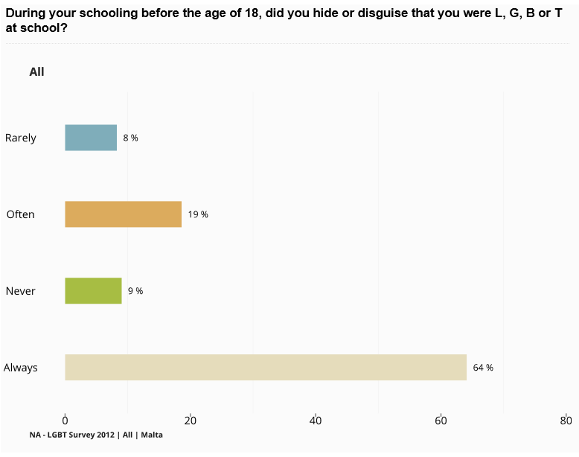

In the EU – During your schooling before the age of 18, did you experience negative comments or conduct at school because of you being L, G, B or T?

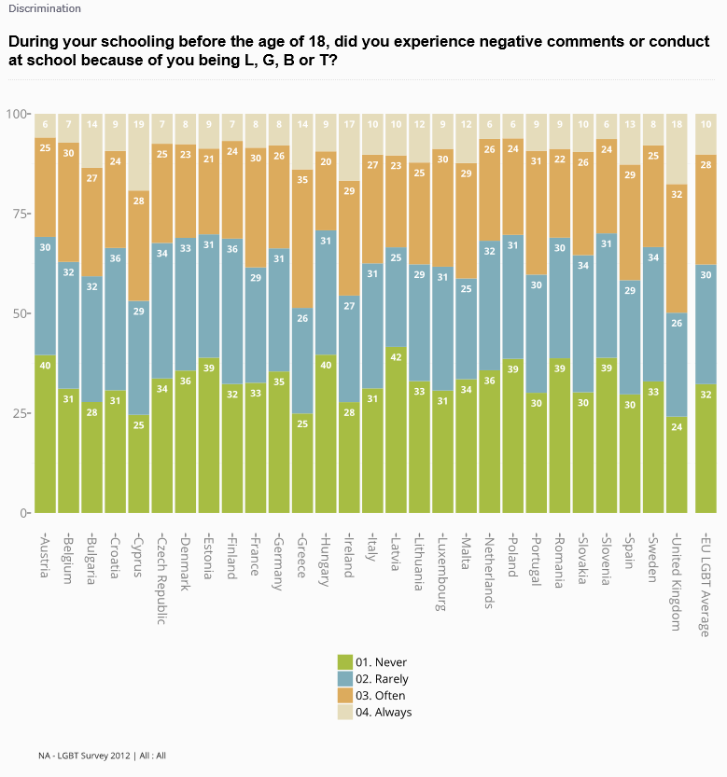
- Annual reports

  - Fundamental Rights Report 2017 Report
For more detailed information: http://fra.europa.eu/en/publications-and-resources/publications/annual-reports/fundamental-rights-2017#child-rights
“In seven countries, the proportions of children at risk of poverty or social exclusion increased by 2–12 percentage points over time: Austria, Cyprus, France, Greece, Italy, Malta and Spain. In Greece, the increase over the 10-year period in question was around 12 percentage points. In most cases, this was not a continuous process.” (p. 176)
(p. 176)
- Thematic reports

Combating child poverty: an issue of fundamental rights (2018)

For more detailed information: https://fra.europa.eu/en/publication/2018/child-poverty
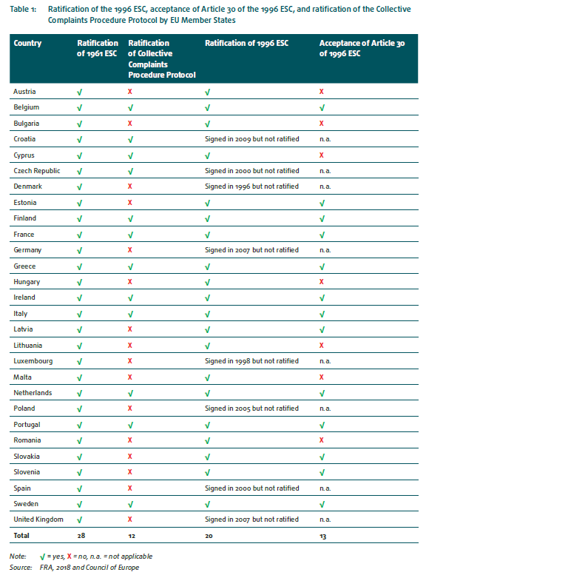

3.2 European legal and policy framework on immigration detention of children (2017)
For more detailed information: https://fra.europa.eu/en/publication/2017/child-migrant-detention
“In Malta, the Immigration Appeals Board automatically reviews the detention order imposed upon an asylum applicant after seven working days, although this period can be extended by additional seven working days for duly justified reasons. If the applicant remains in detention, further reviews are conducted every two months.” (p. 61)
“Most Member States provide internal or external mechanisms, or both. Internal complaint mechanisms take various forms. In Finland, Hungary and Malta, complaints can be addressed to the Director or Head of the detention facility.” (p. 93)

3.3 Violence against women: an EU-wide survey (2014)
For more detailed information: https://fra.europa.eu/en/publication/2014/violence-against-women-eu-wide-survey-main-results-report
“In Malta, a 2011 report on the findings from a survey of 1,200 female respondents found that 16 % said they had experienced physical violence, sexual violence or both by a current or former partner since the age of 15.8 The FRA survey found that 15 % of women in Malta have experienced physical and/or sexual violence by a current or a previous partner since the age of 15.” (p. 24)
„However, a number of EU Member States have not fully banned corporal punishment to protect children from physical violence within the family or in institutions (including Malta).” (p. 126)

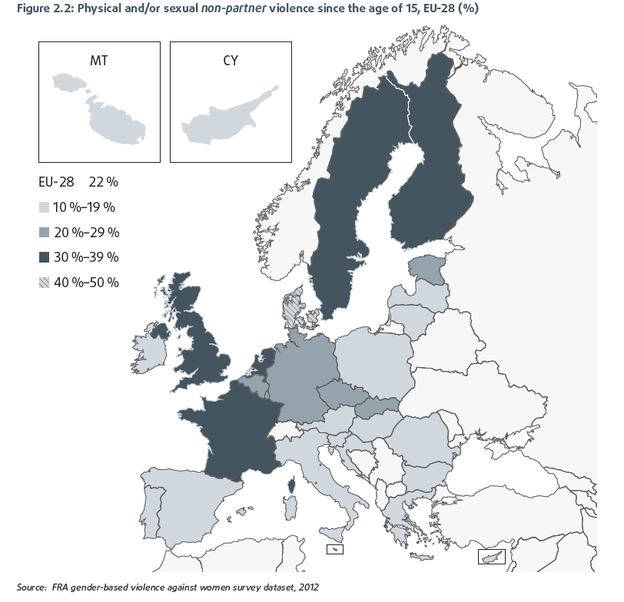
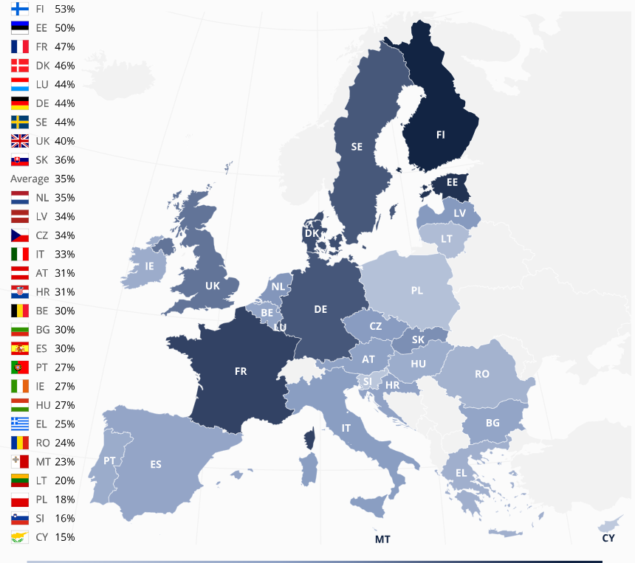
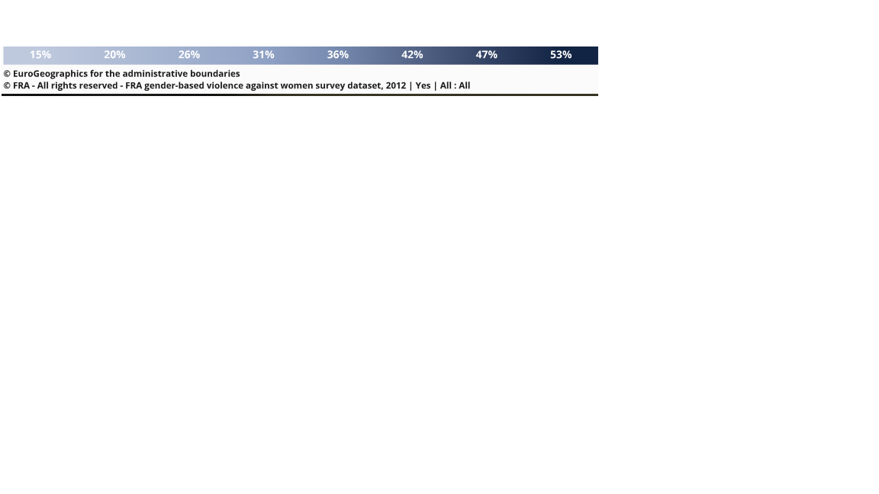
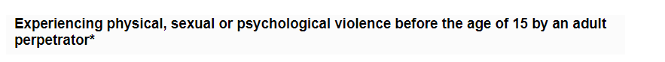

3.4 EU LGBT Survey – European Union lesbian, gay, bisexual and transgender survey (2012)
For more detailed information: https://fra.europa.eu/en/publication/2014/eu-lgbt-survey-european-union-lesbian-gay-bisexual-and-transgender-survey-main
“Overall, one in eight respondents lives with a child under the age of 18. Gay men are less than half as likely as any of the other LGBT groups to have a child living in their household. The proportion of survey participants living in a household with at least one child under the age of 18 ranges from 17 % in the Czech Republic, Ireland, Malta and Slovakia to 9 % in Austria, Germany, Greece and the Netherlands.” (p. 136)
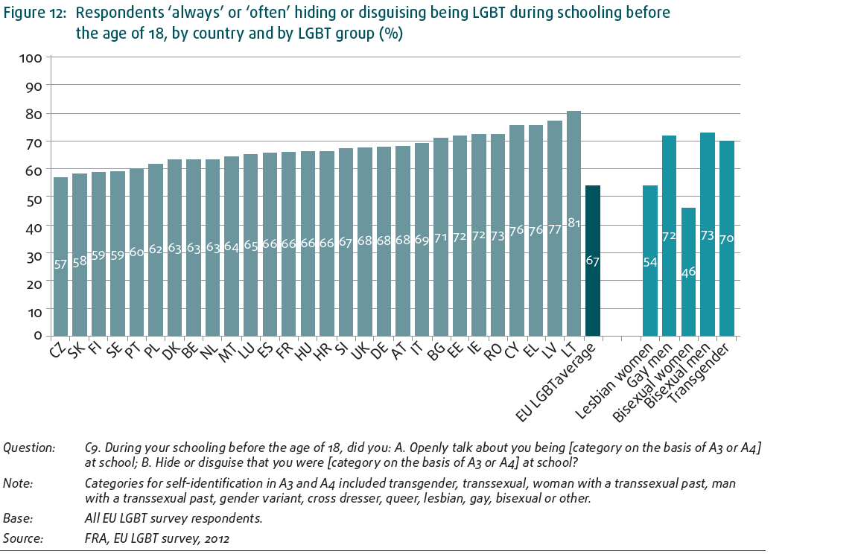

3.5 Second European Union Minorities and Discrimination Survey (2016)
For more detailed information: https://fra.europa.eu/en/publication/2017/eumidis-ii-main-results
“Among respondents who are immigrants or descendants of immigrants, 7 % have a wife, husband or children living outside the country in which they live. The percentage of those with family outside the country is higher among groups with recent immigration histories, particularly among immigrants from South Asia in Greece (44 %) and immigrants from Asia in Cyprus (29 %). Among recent immigrants in Slovenia, one in five has family outside the country (21 %). The same rate can be found among immigrants from Sub- Saharan Africa in several countries, including Italy, Luxembourg, Malta and Austria (19–20 %).” (p. 86)

3.6 Second European Union Minorities and Discrimination Survey – Being Black in the EU (2018)
For more detailed information: https://fra.europa.eu/en/publication/2018/eumidis-ii-being-black

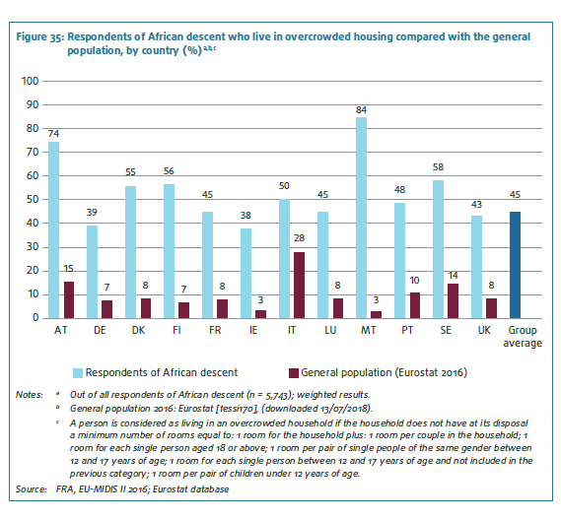(p.61)

3.7 Mapping of minimum age requirements (2017 – 2018)
In 2017, FRA is mapped national laws across EU governing age requirements linked to the child rights of protection and participation. The Convention on the rights of the Child requires States to take children's views into consideration on matters which concern them in accordance with their age and maturity. However, FRA research has shown that the way children are recognised as rights holders differs across the EU. Age requirements can also be arbitrary and inconsistent, potentially limiting child rights
The areas covered in this mapping exercise are: the legal definition of a child; political participation; social rights and welfare; education; health and medical treatment; employment; child care and child protection; access to justice (including juvenile justice); children in the digital world; asylum and migration.
For more detailed information: https://fra.europa.eu/en/publications-and-resources/data-and-maps/minag?mdq1=theme&mdq2=3509 and https://fra.europa.eu/en/publication/2017/mapping-minimum-age-requirements-concerning-rights-child-eu
As a matter of example, please find some extracts of this mapping concerning the age requirements in Belgium in the area of asylum and migration:


