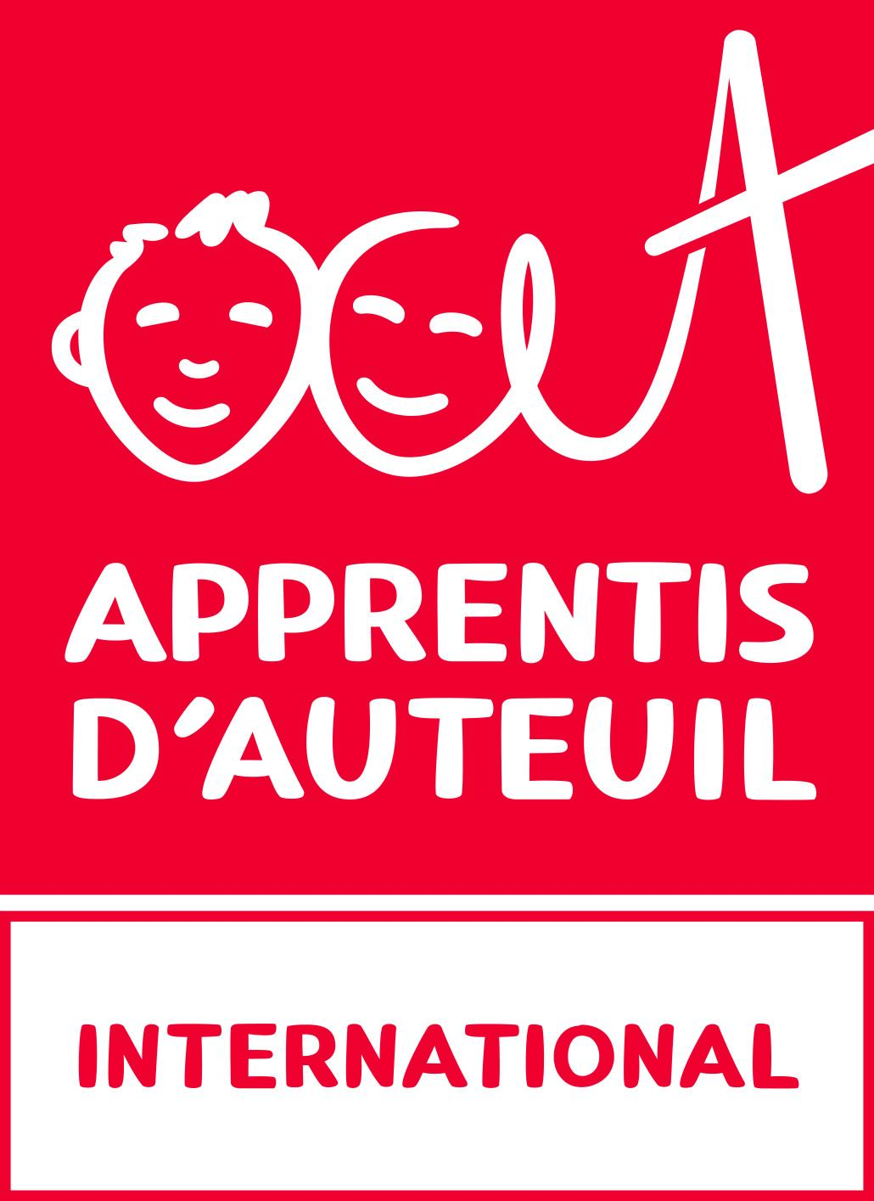
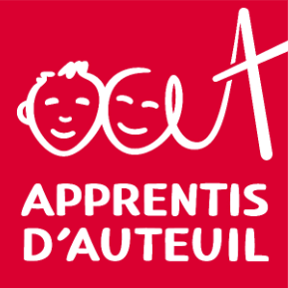
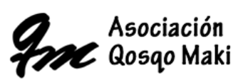

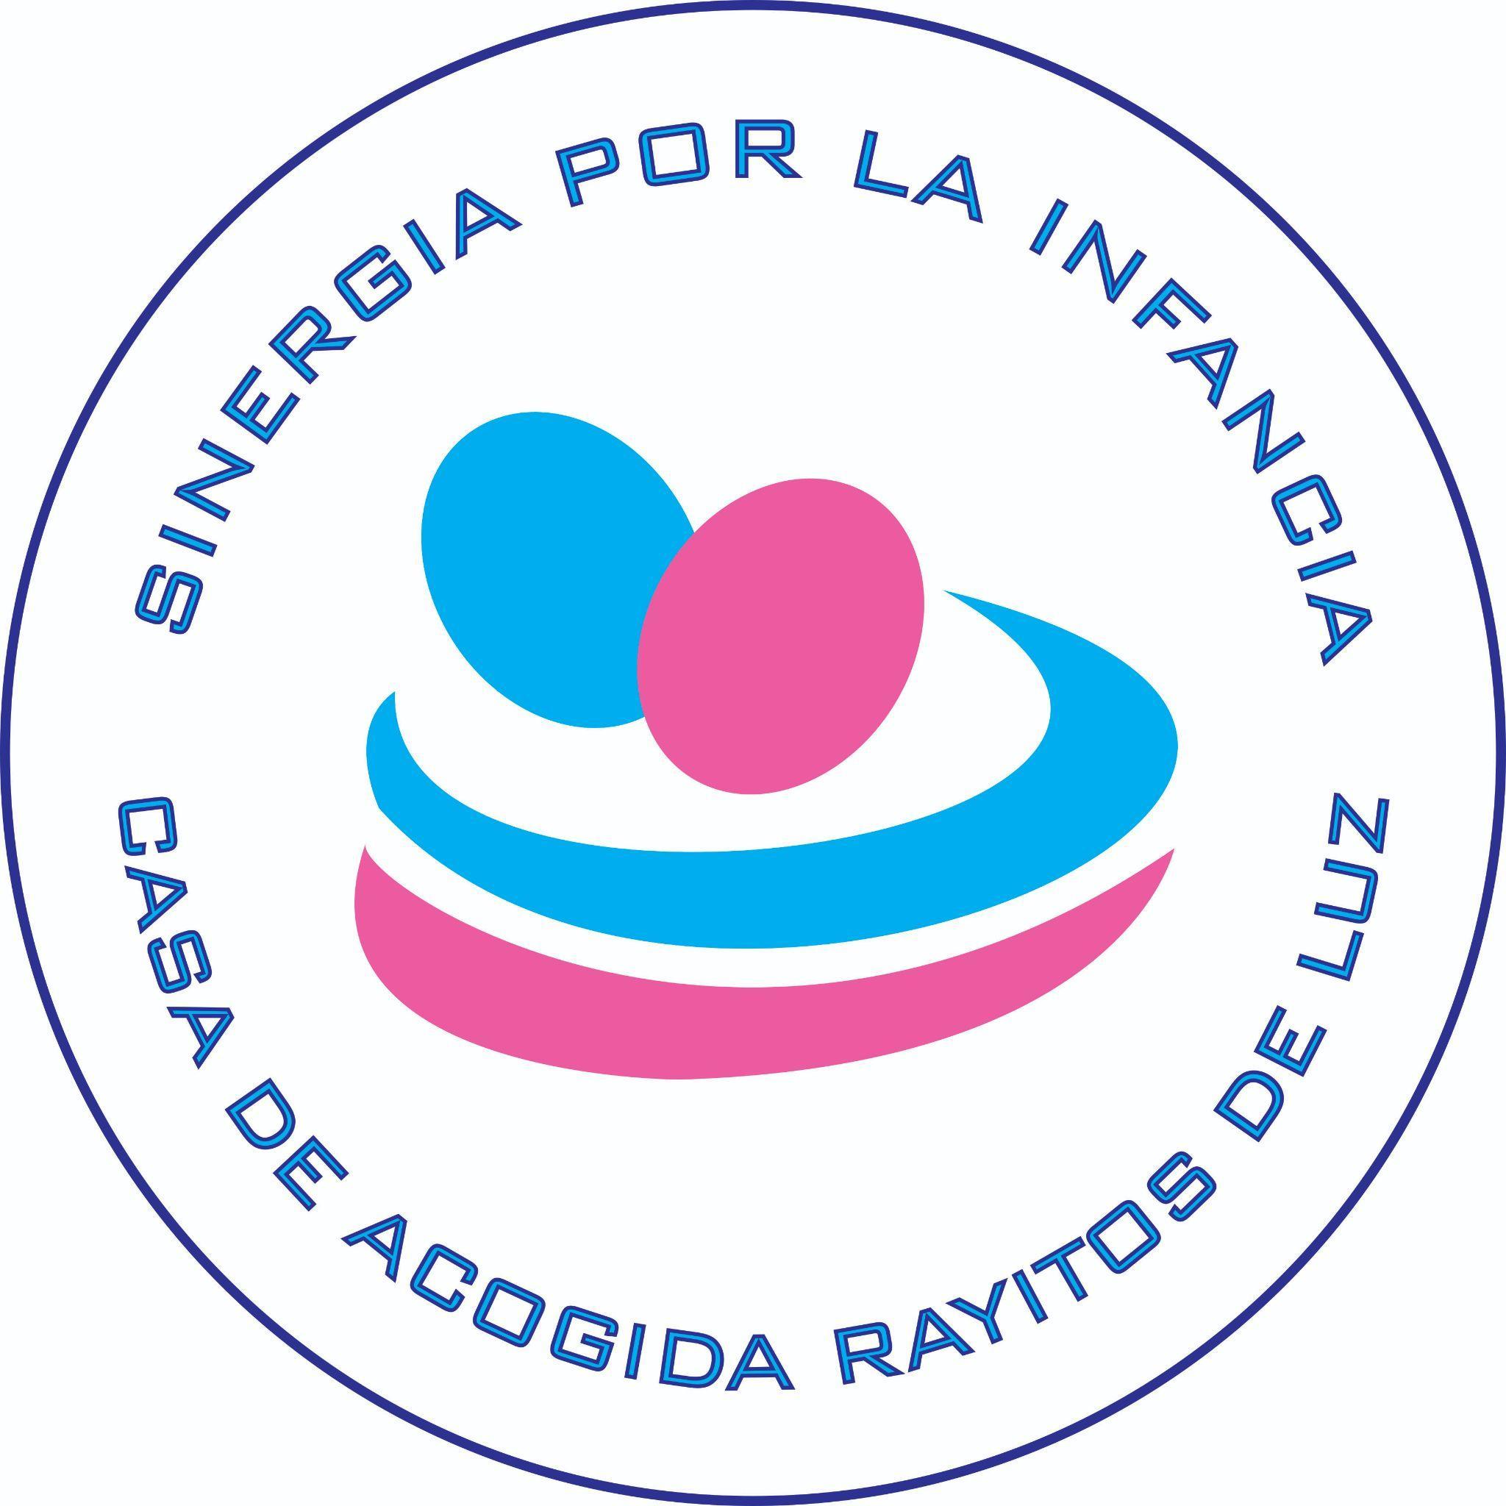
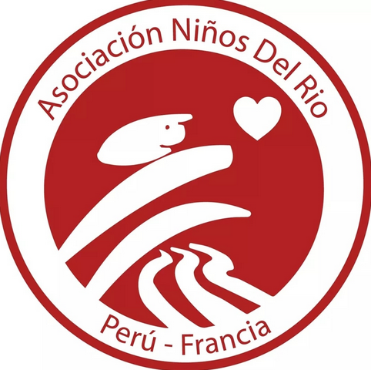
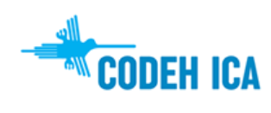

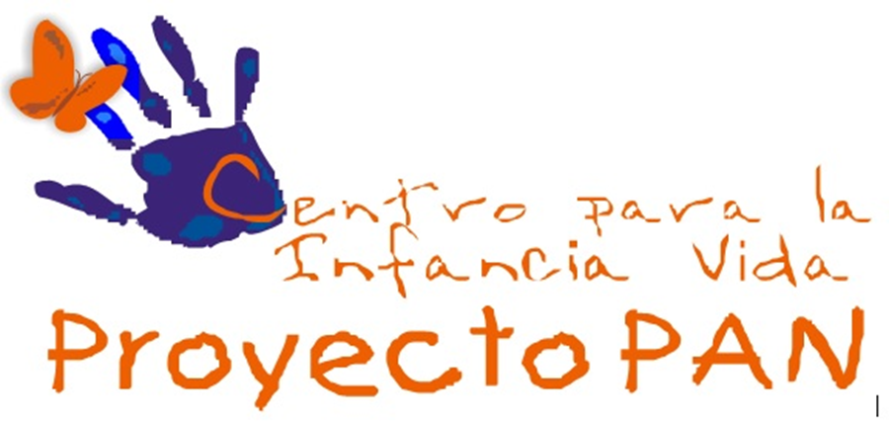


RIGHTS OF CHILDREN AND YOUNG PEOPLE IN STREET SITUATIONS IN PERU

Alternative report to the United Nations Committee on the Rights of the Child on the implementation of the Convention on the Rights of the Child in Peru
July 2024

Contact
Qosqo Maki Association +51 (084) 231513
qosqomaki@qosqomaki.org - web.qosqomaki@gmail.com
Address: Calle Fierro 525 Cusco-Cusco-Peru

List of abbreviations
APAFA: Parents' Association
CODEH ICA: The Ica Human Rights Commission
INABIF: Integral national programme for family well-being
MIMP: Ministry for Women and Vulnerable Populations
NGO: Non-governmental organisation
NAP: Children's aid project
SEC: Street educators service
SPU: Special Protection Unit
USPNNA: Child and Teenage Protection Services Unit

I. INTRODUCTION

Presentation of the authors

The "Let's make the invisible visible" collective is a network of Peruvian organisations that have been working for many years to defend the rights of children in street situations in Peru. Its members are the Fundación Cachorros in Ayacucho, the Asociación Niños del Río in Lima, the Fundación Sinergia por la infancia in Lima, the Centro para la infancia Vida Proyecto PAN in Arequipa, the Comisión de Derechos Humanos de Ica (CODEH ICA), and the Association Qosqo Maki in Cusco. The network was created on 13 October 2022 at the first national meeting of children and young people in street situations in Peru. The participating young people are representatives of five regions of Peru: Lima, Arequipa, Ayacucho, Cusco and Ica. The above-mentioned member organisations are educational actors who value the participation of children and young people in street situations.
Founded in 1866, Apprentis d'Auteuil is a charitable Catholic foundation that supports children and young people in difficulty through care, education, training and integration programmes in France and abroad. Since 2014, Apprentis d'Auteuil has had special consultative status with the United Nations Economic and Social Council (ECOSOC) and supports its local partners in their international advocacy work.

Based in Geneva, the Fondation Apprentis d'Auteuil International (FAAI) is a charitable foundation created in 2013, which supports the international projects of Apprentis d'Auteuil in partnership with local actors and defends the rights of children and young people, particularly those in street situations, with the international institutions of the United Nations in Geneva.

Methodology
This thematic report was drawn up with the member associations of the Collective "Let's make the invisible visible " in order to pool the data collected concerning children in street situations. It answers the questions on street-connected children in the of List of Issues to be addressed before the drafting of the report (LOIPR) of the Committee on the Rights of the Child for its review of Peru.
The information gathered is also based on the consultation of young people in street situations for the presentation of the report submitted by Qosqo Maki to the Universal Periodic Review in 2022. Between April and May 2022, focus groups and interviews were organised to gather the opinions and recommendations of current and former users of Qosqo Maki. The collective then organised the first national meeting of street-connected youth in October 2022, during which they shared their experiences. The young people's words are used to illustrate and accompany the report.

II. ANSWERS TO THE LIST OF POINTS TO BE ADDRESSED BEFORE DRAFTING THE REPORT (LOIPR)
- Paragraph 28. a) of the LOIPR:
In response to paragraph 28.a), civil society is not aware of any concrete action from the State to analyse the situation of children in street situations in greater depth. This lack of action reflects the absence of current statistics and specific studies on the profile of this population, which would enable specialised and appropriate attention to be paid to these children. The most recent research into the profile of children and young people in street situations was carried out in Lima in 2008 by civil society.
In response to the government's report to the Committee on the Rights of the Child, the collective "Let's make the invisible visible" regrets that the government refers only to a housing census, as this type of census is insufficient to measure the extent of the phenomenon of children in street situations.
In 2021, the Ministry for Women and Vulnerable Populations (MIMP) approved the "Protocol for the Service of Street Educators" (SEC), which aims to provide general guidelines for the intervention of these professionals in supporting children in street situations. The protocol recognises the lack of precise information to determine the universe, scale and characteristics of this population. The MIMP only publishes statistics on ambulatory care for children in street situations. As a result, the State's socio-educational interventions are developed without any structured plan to promote the gradual and voluntary exit from the streets, as recommended in General Comment No. 21 of the Committee on the Rights of the Child.
The Peruvian government is recommended to:
- Carry out a census and map of the critical situation of children and young people in street situations, taking into account the following aspects: food, housing, education and health, using a methodology adapted to this specific population and working with the civil society involved within a short timeframe.
- Paragraph 28. b) of the LOIPR:
Regarding paragraph 28.b) and the corresponding response from the State, the collective regrets that the government focuses its preventive actions solely on schools, which does not reach children in street situations, most of whom are not enrolled in school. The collective stresses the importance of working directly in the street, in contact with children to coordinate and organise activities to protect them from gang warfare and drug trafficking. Civil society organisations offer these children safe alternative spaces for interaction and inter-learning where they can spend the night, eat, get information, eat and develop their skills.

In relation to the dangers of drugs experienced by these young people and their criminalisation:
Children in street situations are the first victims of drug trafficking and the violence that goes with it. In the absence of appropriate educational strategies, this population is increasing, and the problem is getting worse as minors, having no other choice, are taken in by criminal gangs who use them, among other things, as hired killers or to sell drugs.
"They don't care about the dangers we face living on the streets. "
Safeguarding children in street situations is directly linked to the State's ability to provide them with safe spaces. Civil society deplores the fact that state measures focus more on repression and criminalisation of these young people instead of developing support and protection measures and setting up specialised reception centres.
"I wanted to stress that there is no support in Peru for the majority of children in street situations either, who suffer day after day just to have something to eat. These days, even the local authorities won't let us street vendors do our job. They throw us out, they treat us badly, they arrest us. All street children are considered to be delinquents. "
In addition, street-connected children are exposed to criminal gangs and have two problems: they often do not have the opportunity to seek protection from the police who criminalise them, and they are unaware of reality and their rights. Many children report unjustified arrests by the police because of their situation on the street. In addition, young people are now being targeted by the State, which is trying to address the problems of drug trafficking and delinquency by amending the penal code for young people with a decree that includes 16 and 17-year-olds as subjects who can be charged under the penal system as adults, a very serious fact that ignores the Convention on the Rights of the Child.
"We are victims of prejudice because we are children and young people in street situations. ”
"We are victims of abuse and mistreatment by the authorities. Often the police do not want to listen to us and simply take us into custody without the right to be defended. ”
The Peruvian government is recommended to:
- Develop and fund a programme to prevent the dangers of child trafficking and criminal gangs, working with civil society to look after children in street situations.
- Protect children in street situations from violence and harassment by training the police in the reality and rights of this population.
- Revise the juvenile criminal code to ensure that minors are not tried and deprived of their liberty in the same way as adults, thereby guaranteeing children in street situations access to alternatives for social reintegration.

- Paragraph 28. c) of the LOIPR:
Regarding paragraph 28.c), the collective deplores the absence of policies with a holistic approach to the issue of children in street situations. Article 40 of the New Code for Children and Adolescents, signed in 2000, is one of the few articles that refers exclusively to children working and living on the street. It stipulates that children working in the street must participate in specialised programmes to ensure their educational, psychological and physical development. Similarly, children in street situations have the right to participate in social assistance programmes aimed at eradicating begging and ensuring the child's educational, psychological and physical development. Civil society observes a gap between this legal norm and its concrete application, particularly regarding the resources allocated to it. As a result, the collective is concerned about the lack of interest shown by the State in the issue of these children.
In addition, the national Yachay programme in 2012 seemed to foreshadow a holistic approach. With this in mind, in 2017, the Ministry for Women and Population (MIMP) planned to gradually support 50’000 children and young people in street situations. However, in the same year, this programme disappeared and was absorbed by the Integral National Programme for Family Welfare (INABIF) with its Street Educators Service (SEC). When the Yachay programme closed, a group of children accompanied by the programme and supported by NGOs visited MIMP to understand the reasons behind the closure. The young people said that "many rehabilitation centres take in children and young people in street situations using violent, degrading and humiliating methods".
At present, children in street situations are part of INABIF's much broader target group: "families in situations of vulnerability and social risk, in particular children and adolescents, the elderly and people with disabilities who have been abandoned ". Its action is limited to obtaining documents, accessing health insurance and conventional schools. Although the aforementioned actions are relevant, the collective regrets the poor implementation of the service in the field and the lack of consideration for the needs of the population, thus denying diversity to this population deprived of specific support and monitoring for their sustainable reintegration.
In Peru, community education is an alternative educational approach that helps to develop the common sense of children in street situations, encourages teamwork to overcome difficulties, is supportive and collective, encourages children to seek practical solutions to their problems and generates life skills. Civil society has been strengthened by this educational methodology and has achieved excellent results, demonstrating that community education is relevant to the reintegration of this population. This is why State participation is necessary to ensure national coverage, given that it is practised in the most remote areas of the country.
Access to education:
According to official figures, more than 670’000 children and adolescents do not attend school. These children often work and a large proportion of them are in street situations. Civil society deplores the State's lack of consideration for these children, who are suspended in a "school vacuum", because once they have left school, their reintegration is complicated by payments for processing documents, enrolment and other fees by the Parents' Association (APAFA). Yet education should be free under Peruvian law.
The street situation of this population means that they do not have the time or peace of mind they need to aspire to a quality, long-term education. NGOs play a very important role in helping these children to continue their schooling, from dealing with paperwork to providing day-to-day support for their studies.
"The lack of opportunities to have an occupation or a job. And if we have a job, we shouldn't be exploited."
The collective notes that conventional school education is not adapted to this population in street situations, as habits, customs and timetables change with street experience, and these children have missed out on years of education. Many young people are therefore interested in technical training and aspire to professionalisation, requiring technical training in quick, manual trades. For many young people who have dropped out of school, it is not possible to enter a state vocational school without a secondary school diploma. Moreover, the civil society organisations that provide vocational training for these young people are fighting for the recognition of their training, their achievements and their skills, so that they can access recognised training leading to qualifications. Young people are then condemned to a vicious circle of exploitation, as employers do not recognise their training, which is not certified by the State.
"I don't think minors should work, they should be in a training centre, but for free [...]. I'd like to see more training centres where you can learn everything [...]. If the law says that a minor must not work, they should also look for a way for minors not to be in this situation, more education, there are many ways to solve the problem, another thing is that they never think about it. "
The Peruvian government is recommended to :
- Develop, in collaboration with civil society, a comprehensive and integrated policy for children in street situations, with services adapted to their situation, to support them in exercising their rights and reintegrating into society.
- Remove barriers to access to education by making it easier to obtain birth certificates for children who are not registered with the civil registry and by adapting State school enrolment procedures in terms of administrative requirements and age.
- Actively promote and develop educational alternatives that are better adapted to the realities and interests of children and young people in street situations, in collaboration with civil society, in order to encourage access to formal education, technical and vocational training and non-formal education, including community education.
- Facilitate the integration of young people in street situations into technical training programmes and recognise the vocational and technical training provided by civil society through official diploma, to promote the social reintegration of this population.

- Paragraph 28. d) of the LOIPR:

Regarding paragraph 28(d) and the information provided by the State in its report, civil society is concerned about the low number of young people being cared for (8,760) by the Street Educators Service (SEC) in relation to actual demand. The service is not adapted to their problems and has insufficient capacity to take in children in street situations on a long-term basis. As a result, the educators are unable to refer children in street situations. In fact, INABIF and its homes do not have the necessary resources to support them, as there is only one specialised reception centre for 40 street-connected boys in Lima. The collective stresses the need to provide appropriate shelter for children in street situations, offering flexible and open support.
The Peruvian government is recommended to:
- Increase the budget of the Street Educators Service (SEC) to improve the service's support and geographical coverage, and to financially support civil society organisations working with children in street situations in order to provide them with dignified and sustainable care.

- Paragraph 28. e) of the LOIPR
With regard to paragraph 28 e), civil society deplores the lack of measures to raise awareness among the population, the authorities, the police and health workers, who often violate the rights of children in street situations when they use these services, generating mistrust and condemning them to a spiral of marginalisation.
These prejudices particularly hamper their access to healthcare. The NGOs report repeated cases of young people in street situations they support being refused medical care, because they did not have their identity card. The educators present must insist that the right to receive medical care without ID be upheld. Many children in street situations do not have access to healthcare because the services provided are not adapted to their situation and needs.
" I almost never go to a public health centre because when you do, it's so horrible, the nurses get bored, they make you wait a long time, and they tell you to come back the next day, and the next day, if you tell them to treat you quickly, they say ‘where's the blood, are you dying?’ "
However, NGOs working on the problem of children in street situations are promoting activities to raise awareness in society. These initiatives would have a greater impact if they were supported by the State, addressing different public services such as the health sector, education, police forces and employers.
"We want decent opportunities to move forward. "
The Peruvian government is recommended to:
- Raise awareness of the situation and rights of children in street situations at national level and among public officials, in particular law enforcement and health personnel.

For security reasons, testimonials are anonymous.
Sinergia por la Infancia and Voices for Latin America. 2008. Perfil de los niños en situación de calle inhaladores en Lima, Perú.
Testimonies from children at the 2022 national meeting of children in street situations.
A child in a street situation from Qosqo Maki speaks at a meeting of the RIDIAC network on 12 April 2022.
Congreso de la República. Julio 2024. Comisión de Justicia aprueba dictamen que declara imputabilidad de adolescentes por delitos graves. https://comunicaciones.congreso.gob.pe/noticias/comision-de-justicia-aprueba-dictamen-que-declara-imputabilidad-de-adolescentes-por-delitos-graves/
Testimonies from children at the 2022 national meeting of children in street situations.
Testimonies from children at the 2022 national meeting of children in street situations.
STREHL. Talinay. Working and street children in Peru: current conditions and interventions. Foundation for International Research on Working Children (IREWOC), 2010.
Integral national programme for family well-being - INABIF. https://www.gob.pe/inabif
UNICEF. 2022. UNICEF warns that Peru is facing an unprecedented education crisis and calls for priority to be given to our children and adolescents.
Testimonies from children at the 2022 national meeting of children in street situations.
Testimony of a young person in a street situation supported by Qosqo Maki, Focus group, May 2022.
Testimony of a young person in a street situation supported by Qosqo Maki, Focus group, May 2022.
Testimonies from children at the 2022 national meeting of children in street situations.

