CERD 20th-22nd Review on the ROK

- Independent Report for Daegu Mosque -

Task Force for the Peaceful Resolution of the Daegu Buk-gu Islamic Mosque

Overview
According to the Council of Europe, the phenomenon of discrimination against Islam is a widespread form of racism, which has a negative impact not only on Muslims but on entire society. The UN Special Rapporteur on Freedom of Religion or Belief's report ‘A Working Definition of Islamophobia’ states that whereas ‘old’ racism was based on an explicit belief in biological superiority, ‘new’ racism is based on ideas of religious and cultural superiority, and that discrimination against Muslims in the wake of the 9/11 attacks is understood to be a new form of racism.
For the past four years, there has been a serious conflict between local residents, the city of Daegu and the Muslim students who are the owners of a Mosque in Daegu (hereinafter ‘the mosque’), ROK. The conflict, which began in 2020 with a legal construction permit but was not completed until 2025, has become the most prominent case of racial discrimination in the ROK, with national and international reports of 1) racist administration by the State party; and 2) the State party's neglect to racist manifestations of hatred (such as pork barbecues and the display of pig heads in front of the mosque).
In 2023, the UN Human Rights Council (Special Rapporteur on freedom of expression and on minority issues), in a communication started by the Task Force for the Peaceful Resolution of the Daegu Buk-gu Islamic Mosque, asked the State party about its tolerance policy for minorities and measures taken to combat intolerance and prejudice against certain religions, and in 2023, the UN Committee on Human Rights expressed ‘concern about discrimination and hate speech targeting specific groups, including Muslim migrants’.
While the issue should have been approached and acted upon as a matter of racial discrimination, beyond religious discrimination, the State party has failed to put in place a system to review, respond to, and address the dimensions of discrimination at issue, exacerbating the situation through racist State party’s order to halt the construction and public statements towards Muslim community, and failing to take proactive action against racist behavior by local residents, which has led to serious conflicts in the region that continue to this day.
Therefore, we ask the Committee to recommend the State party concerning: 1) the State party's efforts and concrete plans to resolve the construction of the mosque and conflicts arising from it; 2) the establishment of a public system to resolve local conflicts motivated by racism; and 3) plans to regulate racist hate speech and punish crimes committed with racist motives.
- State party’s worder to halt the construction
In September 2020, students from Kyungpook National University in Daegu, ROK, obtained a construction permit from Daegu Buk-gu District to build a mosque in an extension of a house in Buk-gu District, Daegu, which was being used as a prayer center. On February 16, 2021, local residents opposed the construction of the mosque and submitted a petition to the Daegu Buk-gu District office. And the same day, the district office issued an official order to halt the construction (hereinafter ‘the order’), citing 'emotional instability of residents, infringement of property rights, and concerns of turning the area into a slum’ as an official reason.

In connection with a religious assembly hall under construction with a building permit issued by our district on September 28, 2020, we are notifying you of the halt of construction for reasons such as property rights infringement, so we ask that you come to an agreement with the residents in the future.

A. Reasons for halt order: residents' emotional instability and property rights violation, concerns of turning the area into a slum, etc.
B. Construction halt period: February 16, 2021.~ Until the complaints are resolved by agreement with the residents.
The official order to halt the construction

The order did not guarantee the builder's rights protected under Korean law and was eventually found “invalid” by the Korean courts as ‘it was issued without any legal basis and its defects were grossly obvious', which was confirmed by the Supreme Court. However, despite the Court's decision, the resident’s opposition to the mosque construction intensified and no substantial efforts were made by the State party to facilitate the construction of the mosque.
The State party claims to have made efforts to resolve the conflict, including holding three mediation meetings from March 2021 to March 2023, but the mediation meetings were ineffective, as the State party did not have a proper mediation plan or experts, the builder, the Muslim students who does not speak Korean, were not provided with an interpreter, and the mediation meetings consisted of the residents and the Muslim students only was all about stating each party’s position with no mediation. Furthermore, the State party simply proposed to build the mosque elsewhere, without any plan to compensate Muslim students’ economic losses. In December 2023, after the mosque had not been completed and residents had become increasingly disruptive, the State party filed a complaint against the mosque and issued another order to stop the construction, citing problems with the construction process.
  - The State party took official action to halt the lawful construction of the mosque based on a racially motivated complaint, exacerbating racialized tensions in the area, and, even after the Court ruled that the State party's halt order was unlawful, the State party allowed the conflict to continue without taking adequate measures to build the mosque and recently issued another halt order.
  - There is no system to check whether the State party's action is racist and no system to respond to racist conflicts in the local society.

Hate against Muslims and the State party’s aiding and abetting
1) Racist banners covering the area and neglect by State party
Since the construction of the mosque began, banners protesting the construction of the mosque began to appear not only at the construction site but also throughout the area after the halt order was issued by the district office in February 2021. The banners, which claimed that the construction of the mosque would deprive residents of their right to happiness and survival, worsened after the court ruled on 7 July 2021 to allow construction to resume, with countless banners depicting Muslims as terrorists and blatant references to local’s fear towards Muslims.

Vehicles blocking the alleyway to the mosque construction site and the banners hanging in front of and behind them.
- Not all Islam is terrorist, but all terrorists are Muslims.
- Resuming construction of a mosque is killing the residents twice.
- Absolute opposition to Islamic homelands that create their own collective societies.
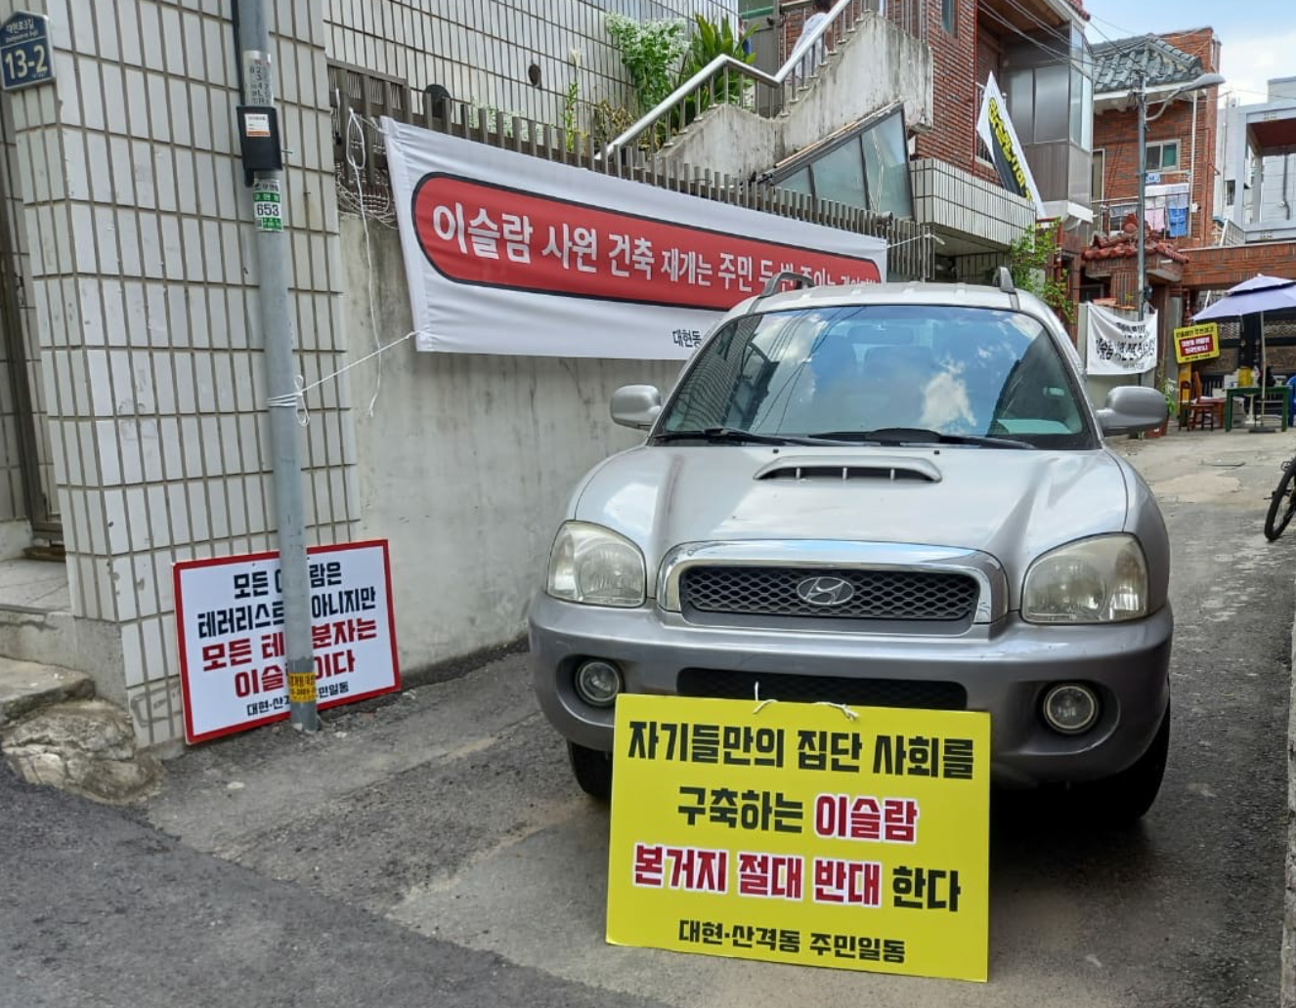
Banners in the alleyway leading to the mosque construction site and in the window of a Muslim student's family home
- Islam is an evil religion that kills people
- Muslims who brutally kill and decapitate people, get out of the area, terrorists!
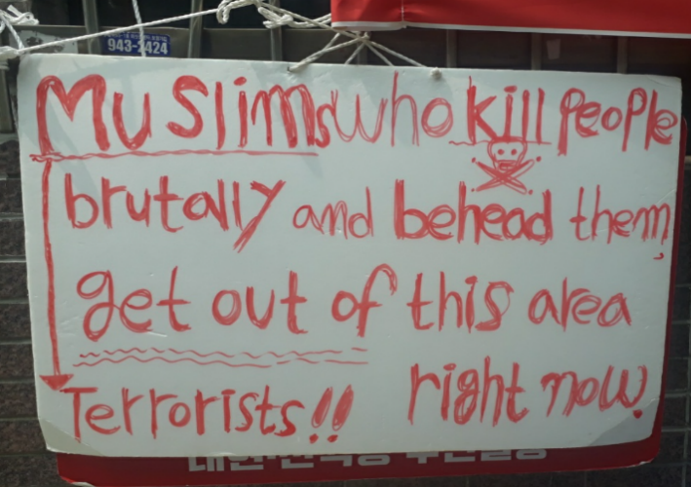
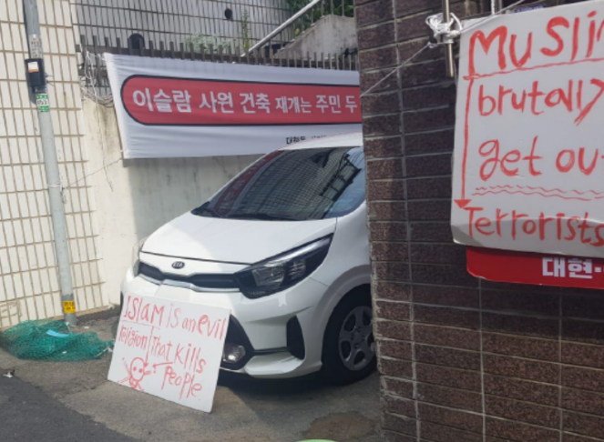
Banners on the side of the road near construction sites (also in English)
- The Nationals come first. Are the Taliban in Daehyeon-dong? Is this your country? Stop threatening our residents!
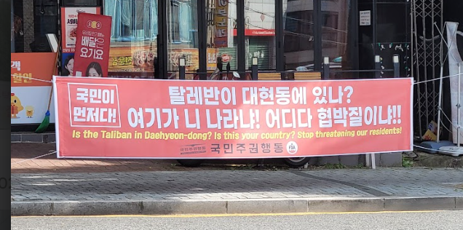
The Special Rapporteur on the right to freedom of religion or belief, the Special Rapporteur on the promotion and protection of the right to freedom of opinion and expression, and the Special Rapporteur on minority issues have also acknowledged in their communications to the ROK regarding the incident that the following hate speech occurred.

"Are there Taliban in Daehyeon-dong? Is this your country? Stop the threats against our residents!"
"Muslims who are brutally killing and beheading people, get out of the area! Terrorists, now!"
"If there are more Muslims, as in Europe, this neighborhood will turn into a slum and will be a danger to public safety."
"Islam is an evil religion that kills people."

These banners present the mosque itself as a threat to the local resident’s life and describe not only the mosque but also the Muslims who seek to use it as a threat to the local resident’s life, property rights, and the pursuit of happiness. These banners have covered the entire area, and Muslim students and their families (including their children) have been exposed to this hate speech.
In the early days of the incident, around 2021, the district office where the construction site was located responded passively, stating that it could not manage the banners because they were put up after a lawful notification of a protest, even though the district office was the official permit holder for the banners in and around the mosque construction site. After the National Human Rights Commission of Korea ruled against the district office, stating that "leaving racist banners unattended is a violation of human rights," the number of banners with extreme expression decreased, but public authorities were unable to take any action against residents hanging banners on their own cars or homes or distributing leaflets with racist content, as shown in the photo, and as of 3 March 2025, some banners were still hanging on the streets.

  - Regarding racist banners, the State party does not have internal criteria or a vetting system to review what constitutes racist language or racist expression, and its passive response to racist hate speech in areas with serious conflicts between local and migrant populations has exacerbated conflicts.

2) Neglecting the pig's head, pig bones and pork barbecues around the construction site

Despite the above Court decision, the construction was only resumed on August 5, 2022, one and a half years after the Daegu Buk-gu District office ordered the construction to be stopped, and the office is still not taking any measures to mediate the situation, which has caused significant disruption to the construction.

In the meantime, some residents who oppose the construction of the mosque hold the pork barbecue a few times next to the construction site, and on 27 October 2022, they placed a pig's head in front of a house right next to the construction site of the mosque, and since 14 November, they have been interfering with the construction of the mosque by placing a pig's head in the common area between the house to the left of the mosque and the construction site.
[as of 9 December 2022].
Three pig heads and pig bones left in front of a construction site. The gate on the right is a construction site.
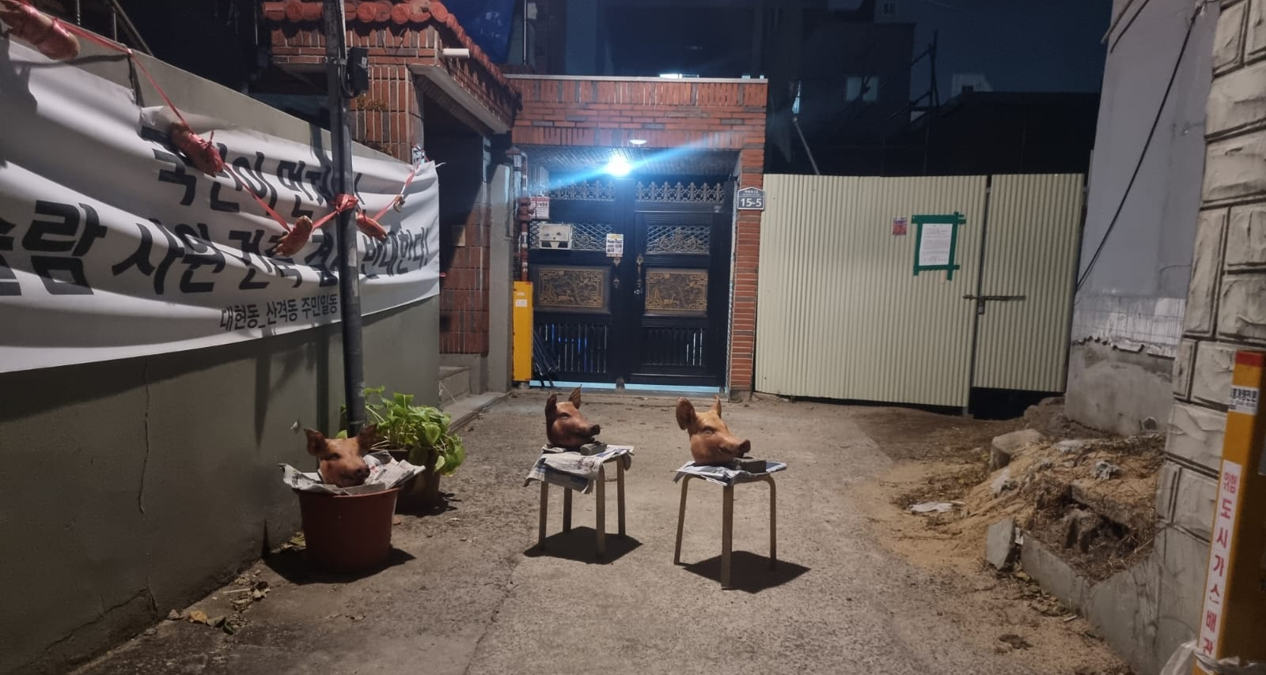
[as of 9 December 2022].
Three pig heads, pig bones and bones left in front of the construction site - the banner on the back reads: ‘the Nationals first! Mosque construction over my dead body!’
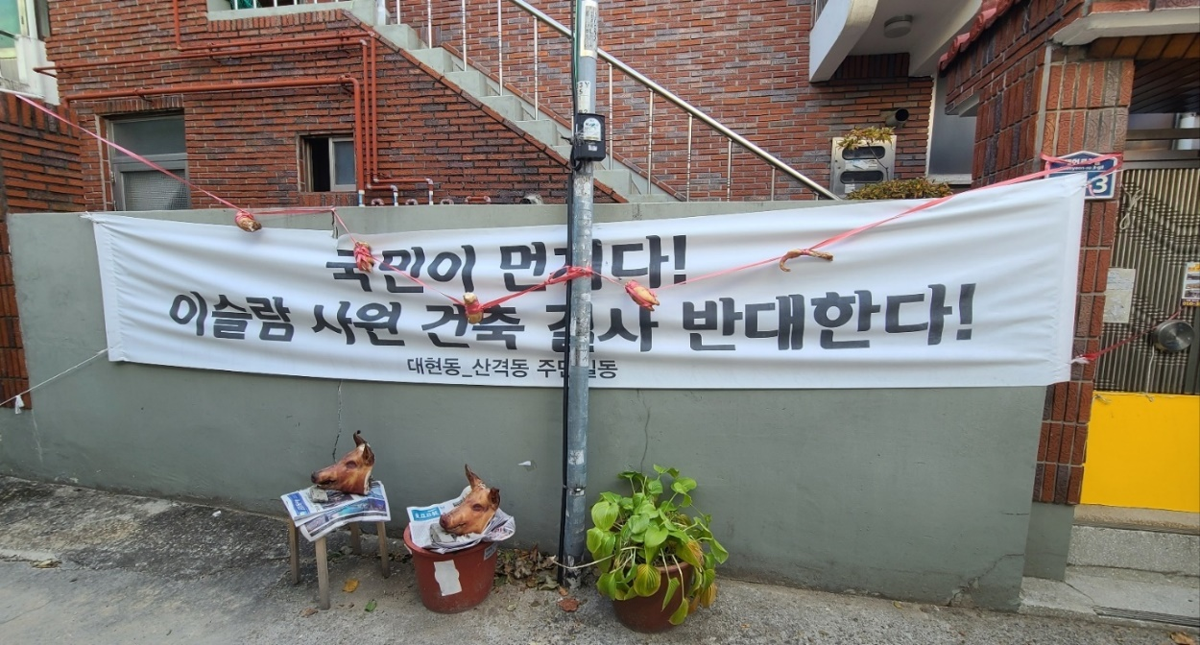
Under Korean law, even if it is private property, the owner is obligated to endeavor to maintain the cleanliness of the land or building he owns, and the city, provincial governor, or mayor of the city or district in which the land or building is located may order the necessary measures to be taken against waste dumped in a manner inconsistent with the law.
Nevertheless, the competent authorities, Daegu City and Buk-gu District office, have not taken any action against the pig heads left in front of the mosque construction site, which causing suffering to the Muslim students. So we have sent inquiries about the public authorities' stance and future plans regarding these pig heads and bones. In response, the National Police Agency responded that "the matter is not an urgent situation for the police to intervene," and did nothing, while the district office responded that "the pig heads is not a matter for the district office to intervene," and that "the pig heads are being used for the purpose of opposing the construction of the mosque and are not considered waste (to removed) because they are necessary items for the residents of the area." (Attachment. English translation of the response from the Daegu North District Office)
3) Public Officer’s racist statement

According to the UN Convention on the Elimination of All Forms of Racial Discrimination's General Recommendation No. 35, ‘Elimination of Racist Hate Speech’, "Immediate and aggressive action" is required against statements by high-level officials that promote and incite racism, disciplinary action, including removal from office, in some cases.

In an interview with the media on July 7, 2021, during the height of the conflict, the head of Daegu's Buk-gu district office, which has jurisdiction over the mosque, that "the mosque controversy is a case of reverse discrimination against the nationals."

The Korea Times 2021. 7. 7.
"Mosque controversy is a case of reverse discrimination against the nationals"
Q. The conflict over the construction of a mosque in a residential neighborhood near Kyungpook National University is turning into a lawsuit.

A. If other religious facilities such as churches, cathedrals, and temples were to be built in the alleyway residential area where the mosque is proposed, the reaction from residents would be similar. Some people have taken a macro view of the order to stop the construction after the residents objected, but this is a case of reverse discrimination against Koreans, not suppression of religion or discrimination against Islam. If it was a dispute between residents, the owner would have been required to make concessions to resolve the complaint. It is very unfortunate that the residents' voices are drowned out.

The fact that the head of district made this public statement in a media interview after the district had issued a halt order (later found to be unlawful by a court) against a legitimate building permit for a legitimate construction project because residents had filed hateful complaints against it demonstrates that the State party does not feel any responsibility for the conflict and is unwilling to make efforts to remedy it.

Recommendations from relevant UN Committees and past CERD recommendations
  - Committee on the Elimination of Racial Discrimination (Dec. 14, 2018, CERD/C/KOR/CO/17-19)

At the 17th to 19th review of the State party (2018), the Committee requested the State party to (i) amend the criminal code to make racially motivated offences an aggravating factor; (ii) take measures to combat hate speech (particularly prejudicial attitudes towards Muslims); and (iii) take measures to reduce hostility in society at large and to integrate migrants into society. (para 6. 8-a, 8-e)

- The Committee reiterates its recommendation that the State party expedite the adoption of a comprehensive law that defines and prohibits direct and indirect racial discrimination on all prohibited grounds, in line with article 1 of the Convention. It also reiterates its recommendation (ibid., para. 8) that the State party amend its Criminal Code to consider racist motivations as aggravating circumstances with respect to criminal offences, in line with article 4 of the Convention.

8. In the light of its general recommendation No. 35 (2013) on combating racist hate speech, the Committee recommends that the State party:
(a) Take measures to firmly combat hate speech and adopt a strategy to:
(i) Address prejudices, misunderstandings and misinformation about migrants and refugees, in particular Muslim refugees;
(e) Take steps to create an environment conducive to reducing the antagonism against migrants in the larger society and which facilitates the integration of migrants into society.

- UN Human Rights Committee (November 3rd, 2023 CCPR/C/KOR/CO/5)

11. The Committee remains concerned by the absence of comprehensive anti-discrimination legislation in the State party covering discrimination and hate speech on the basis of grounds including, but not limited to, race, ethnicity, age, nationality, religion, migration status, disability, sexual orientation and gender identity. The Committee is also concerned by continued reports of discrimination and hate speech targeting specific groups, including escapees from the Democratic People’s Republic of Korea and Muslim migrants and refugees, and the reported rise in hate speech towards migrants, asylum-seekers and refugees during the coronavirus disease (COVID-19) pandemic, including by politicians and public figures, both offline and online (arts. 2, 19, 20 and 26).

12. The State party should:
(a) Adopt comprehensive anti-discrimination legislation, explicitly addressing all spheres of life and defining and prohibiting direct, indirect and intersectional discrimination on grounds including race, ethnicity, age, nationality, religion, migration status, disability, sexual orientation and gender identity, and ensure access to effective and appropriate remedies for victims of discrimination,
(b) Strengthen its awareness-raising efforts aimed at promoting respect for human rights and tolerance for diversity and at eradicating stereotypical prejudices based on race, ethnicity, religion or sexual orientation and gender identity, or any other grounds protected under international human rights law;
(c) Encourage the reporting of hate crimes and ensure that such crimes are investigated effectively and thoroughly, that perpetrators are prosecuted and, if convicted, punished with appropriate sanctions, and that victims are provided with effective remedies;
(d) Provide adequate training to central and local authorities, law enforcement officials, judges and prosecutors on addressing hate speech and hate crimes, and to media workers on promoting acceptance of diversity.

- Communication of the Special Rapporteur on religious freedom and minorities (2 August 2023, AL KOR 5/2023)

On 2 August 2023, the Human Rights Counsil communicated with the State party regarding the mosque construction conflict and hate speech against Muslims, a religious minority in the ROK, requesting information on 1) measures taken by the State party to ensure that the construction of the mosque was not unduly disrupted; and 2) measures taken by the State party to ensure that the rights of members of religious minorities are respected and protected. On 10 October 2023, the State party replied that four conciliation meetings had been held at the initiative of the State party and that no hate banners had been posted.

However, as shown above, the mediation meetings organized by the State party did not result in any substantive resolution of the conflict, and despite subsequent court decisions, opposition to the mosque has intensified, and banners opposing its construction can still be found in the area. Furthermore, the State party issued another order to stop the construction in 2024, and the mosque has not been built for six years.

5. Suggested questions and recommendations

In response to a complaint of human rights violations, National Human Rights Commission of Korea identified the "racist aspect" of the incident, stating that "Muslim students and their families have a different cultural background from the ROK’s culture and are of a different nationality and race from Koreans, so the term ‘Muslim’ used by residents should be seen as referring to people with different religious, cultural, and racial backgrounds, not just people with a religion.

As such, this case should have been approached and addressed as a case of racial discrimination, not just religious discrimination, but the State party failed to have a system in place to review, respond to, and address the dimensions of discrimination at play, exacerbating the situation through racist order to stop the construction and public statements at the State party level, and failing to take positive action against racist behavior by local residents, which has contributed to the ongoing conflict in the region.

Suggested Questions to the State party

1) What efforts will the State party make in the future to ensure a peaceful resolution of the local conflict surrounding the construction of the Daegu Mosque and its neighborhood?
2) What measures will the State party take to prevent racist elements in the decision-making and enforcement stages of administrative proceedings to prevent similar situations from arising in the future?
3) What plans does the State party have to regulate racist hate speech and to punish or aggravate offences committed with racist motives?

Suggested Recommendations

1) The State party should establish a system to check the racist elements in the decision-making and law enforcement.
2) The State party should establish a system of specialized organizations to mediate in situations of racially motivated conflicts.
3) The State party should establish training programs for public officials and students to combat racism against migrants of Islamic backgrounds.
4) The State party should amend its criminal code to punish or aggravate hate speech and offences motivated by racism and enact comprehensive anti-discrimination or anti-racism legislation.
5) The State party should take steps to expedite the completion of the mosque and mitigate the local conflicts that arose because of its construction and develop a plan to prevent similar conflicts from recurring in the future.

[Attachment. English translation of the response from the Daegu Bukgu District Office]

Response to the Inquiries made by Taskforce for the Peaceful Resolution of the Daegu Buk-gu Islamic Mosque Issue

Question 1) What is the position of the Daegu Buk-gu District Office regarding the situation where two pig heads are placed in front of the construction site of the mosque for the purpose of expressing hatred towards Islam and of obstructing construction of the mosque?

- Pig heads is not a matter the district office should intervene.

Question 2) According to the Waste Control Act, "If it is discovered that wastes have been treated in a manner inconsistent with the standards for and methods of waste treatment principle, the Minister of Environment, the competent Mayor/ Governor or the head of the competent Si/Gun/Gu may order any of the following persons to change the method of treating such wastes, to suspend the treatment or carrying-in of wastes, or to take any other necessary measures, specifying a period.” What kind of administrative action plan does the Buk-gu Office have?

- According to the definition of waste in Article 2 of the 'Waste Control Act', it is defined as ‘such materials as garbage, burnt refuse, and carcasses of animals, which have become no longer useful for human life or business activities '
-Pig heads are necessary for residents as they are being used for the purpose of obstructing the Mosque construction.
- The Supreme Court case law submitted by your organization is a case of illegal dumping of industrial waste, such as waste synthetic resin, and has nothing to do with this case. As such, our department cannot intervene.

Question 3) What plans does the Daegu Buk-gu District Office have to resolve the conflict between Muslim students and residents who oppose the Mosque construction?

- Our district made efforts to resolve the conflict, such as holding three mediation meetings between the parties involved with an expert in the field of conflict management with the cooperation of Daegu City. Nevertheless the Muslim students and the opposing residents could not make a compromise, so it was not possible to reach an appropriate agreement.

Formed in June 2021, the network has been engaged in various activities such as communication with local governments, court cases, complaints to the National Human Rights Commission of Korea, complaints to United Nations, debates, and meetings regarding the construction of Mosque in Daegu city and its members include the owner of the mosque, Kyungpook National University National Council of Professors and Researchers for Democratic and Equal Society, Daekyung Migration Solidarity, Daegu MinByun - Lawyers for a Democratic Society, and Daegu People's Solidarity for Participatory Democracy
2020. 11. “A Working Definition of Islamophobia”, A Briefing Paper prepared for the Special Rapporteur on freedom of religion or belief, Preparation for the report to the 46th Session of Human Rights Council, p3
- New York Times, How ‘Multiculturalism’ Became a Bad Word in South Korea, March 1, 2021, https://www.nytimes.com/2022/03/01/world/asia/south-korea-diversity-muslims.html - The Korea Herald, Islamophobia emerges in Korea, October 6, 2021, https://www.koreaherald.com/view.php?ud=20211004000082 - The Korea times, Mosque construction triggers standoff in Daegu, May 3, 2022, https://www.koreatimes.co.kr/www/nation/2022/05/177_328375.html
AL KOR 5/2023, Mandates of the Special Rapporteur on freedom of religion or belief; the Special Rapporteur on the promotion and protection of the right to freedom of opinion and expression and the Special Rapporteur on minority issues
CCPR/C/KOR/CO/5, para 11
The Korea Times, Court rules against administrative order to halt mosque construction in Daegu, December 2, 2021, https://www.koreatimes.co.kr/www/nation/2021/12/281_319862.html
AL KOR 5/2023
https://www.hankookilbo.com/News/Read/A2021070618000001445

