Suggestions for privacy-relevant questions to be included in the
List of Issues on Venezuela, Human Rights Committee, 112th Session

The right to privacy
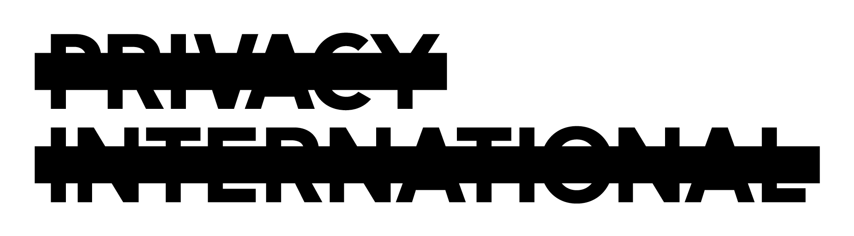
The right to privacy is protected under Article 17 of the International Covenant on Civil and Political Rights. Article 17 provides for the right of every person to be protected against arbitrary or unlawful interference with his privacy, family, home or correspondence as well as against unlawful attacks on his honour or reputation.
Any surveillance activity, including the interception of communications, is an interference with the right to privacy and can only be justified if it is in accordance with the law, has a legitimate objective and is conducted in a way that is necessary and proportionate. The aim of surveillance activities must not be to target political opponents and human rights defenders, or to suppress the right to freedom of expression.

Venezuela is failing to uphold the right to privacy
Privacy International is concerned about surveillance conducted by the State of Venezuela against political opponents and the blocking and interception of protestors’ communications in the course of the student protests taking place since the beginning of 2014. Such surveillance has reportedly been conducted in the absence of any judicial oversight.
To ensure transparency and accountability of surveillance activities, States should establish independent oversight mechanisms with the authority to assess whether the State is making legitimate use of its lawful capabilities. Independent oversight mechanisms should be established in addition to any oversight already provided through another branch of government. There is no transparency about government surveillance in Venezuela, or internal or external control mechanisms within the Venezuelan intelligence service. This heightens the risk that surveillance powers will be abused and unlawful interception will occur, and enables to intelligence services to operate outside public scrutiny.
A further essential element of the right to privacy is the right to protection of personal data. Although different laws have been enacted in Venezuela that contain provisions protecting personal data, the State still lacks a comprehensive data protection regime. Efforts by the Congress of Venezuela to elaborate a Law for the Protection of Data and Habeas Data ceased in 2005.
To provide adequate protection for all forms of personal data, a comprehensive legal framework for data protection needs to be adopted, guaranteeing lawful processing of personal data and providing data subjects with access and mechanisms to enforce their right to protection of personal data.

Based on these observations, Privacy International proposes the following questions for the List of Issues on Venezuela:
Articles 17 and 19
- What laws, policies and practices are in place to ensure that communications interception, as well as all other forms of surveillance, are only conducted in pursuit of a legitimate aim, and are conducted in a way that is necessary and proportionate? What measures have been taken to ensure accountability for unlawful surveillance?
- What steps are being taken to improve transparency about the operations of the intelligence services?
- What measures are being taken to provide for independent oversight over the surveillance operations conducted by the intelligence services?

Article 17
- What steps are being taken to ensure protection of all forms of personal data and provide data subjects with access rights and enforcement mechanisms? Have there been any attempts to reintroduce a comprehensive Data Protection Bill on the Congress’s legislative agenda?

Human Rights Committee General Comment 16, para. 8 ; see also Malone v United Kingdom (1985) 7 EHRR 14 [67].
See, International Principles on the Application of Human Rights to Communications Surveillance, available at https://necessaryandproportionate.org

