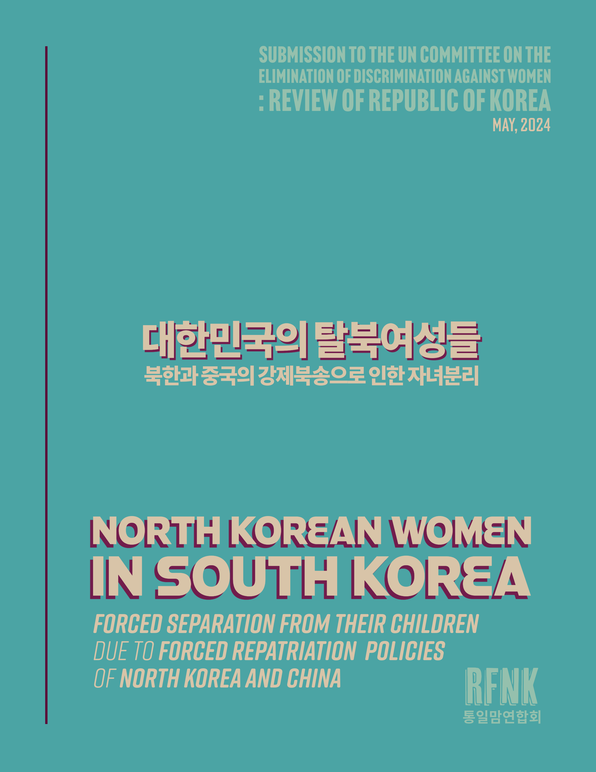
Rights for Female North Koreans (RFNK)

Submission to the United Nations Committee
on the Elimination of Discrimination against Women
| Review of Republic of Korea, May 2024 |

Rights for Female North Koreans (RFNK) is a North Korean women's rights organization that addresses the severe human rights violations experienced by North Korean defector women in the Republic of Korea who were forcibly separated from their children during their escape from North Korea. The purpose of this report is to present policy recommendations and suggestions for improvement to ensure the safety of North Korean mothers in the Republic of Korea visiting China to reunite with their children.

During their escape from North Korea, many women have suffered the pain of being separated from their children due to the forced repatriation policies of the North Korean and Chinese governments. This forced separation has left deep psychological trauma on North Korean women, and it continues to impact their daily lives even after settling in South Korea.

This report discusses the psychological trauma and health issues experienced by North Korean women in South Korea, the difficulties faced by North Korean mothers separated from their children, and measures to protect the safety of North Korean women visiting China. Through this, we aim to improve the human rights situation of North Korean women separated from their children and urge the active cooperation of the South Korean government and the international community.
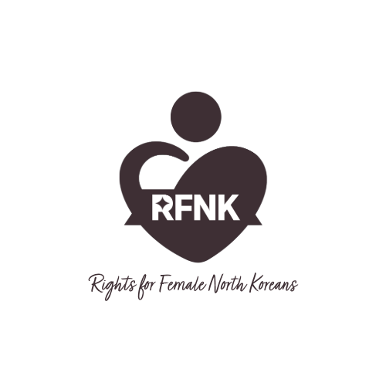
RIGHTS FOR FEMALE NORTH KOREANS
Homepage: https://rfnk.org | Email: official@rfnk.org
Rights for Female North Koreans (RFNK) is a human rights organization of North Korean women defectors who represent the serious human rights abuses suffered by North Korean women who were forcibly separated from their children during their escape to China. The title of RFNK's representative research and reports on the human rights of North Korean women, "I Want to Hold My Child," is a plea from North Korean mothers who were forcibly separated from their children during their escape from North Korea and China, encapsulating the heartbreaking reality of the North Korean mothers we represent. Established in 2015 as a non-profit civic organization based in the Republic of Korea, RFNK was registered with the Ministry of Unification of the Republic of Korea in 2016. From 2016 to the present in 2024, it has conducted 20 research reports, human rights reports, and human rights projects on North Korean human rights, making it a specialized women's NGO in North Korean human rights.
Psychological Trauma and Health Status of North Korean Women in South Korea (Article 12)
North Korean women are grappling with severe and complex psychological trauma stemming from the extreme human rights abuses they endured in North Korea and China. The vast majority have experienced forced marriage, human trafficking, sexual violence, and other forms of exploitation, with the resulting trauma continuing to impact their daily lives even after resettling in South Korea.

Suffering from various mental health issues such as depression, anxiety disorders, and post-traumatic stress disorder (PTSD), these women face difficulties in family relationships and social adaptation. Past traumatic experiences often negatively affect their current parenting abilities. Symptoms of trauma re-experiencing, avoidance, and hyperarousal threaten their daily functioning and hinder the formation of healthy bonds with their children.
Moreover, prolonged exposure to harsh conditions has left many North Korean women with serious physical health problems, including malnutrition, anemia, and chronic diseases. The physical aftermath of violence experienced in North Korea and China further contributes to a significant decline in their overall quality of life.

Economic hardship also poses a major threat to the health and well-being of North Korean women. According to the survey we conducted last year, 57% of them live below the minimum subsistence level, preventing them from accessing necessary medical services.

Given this reality, a professional and integrated support system must be established to ensure the physical and mental health of North Korean women. Long-term, sustained psychological counseling for trauma healing, along with adequate medical services for physical health recovery, is essential. Furthermore, financial support should be provided to ensure that no one is deprived of necessary services due to economic constraints.

The South Korean government and the international community must deeply understand the unique circumstances and needs of North Korean defector women due to human rights abuses in North Korea and China, and expand customized support programs tailored to their needs. Above all, they must listen to the voices of the affected women and actively strive to guarantee their rights and improve their quality of life. In particular, from the perspective of CEDAW Articles 12, concrete measures are urgently needed to ensure the right to health and equality in family life for North Korean women.

Forced Separation of North Korean Women in South Korea from Their Children due to Forced Repatriation Policies of North Korea and China (Article 9, 16)
The forced repatriation policies of the North Korean and Chinese governments are causing severe suffering to North Korean women in South Korea and their children. These women have endured the pain of being forcibly separated from their families during their escape from North Korea, and even after entering South Korea, their right to equality in family life, guaranteed under CEDAW Article 16, is being gravely violated.

Survey on the Separation of North Korean Women from Their Children

In a survey conducted by our organization in 2023 involving 100 North Korean women, 19 were separated from their children in China, and 38 in North Korea, while 14 were separated from their children in both countries. The total number of North Korean women currently separated from their children is 36, of which 29 expressed a desire to reunite with their children. Among them, 12 are able to contact their children but unable to meet, 5 are prevented from meeting due to opposition from Chinese families, and 12 are unaware of their children's whereabouts.

The survey on the process of separation from children in China revealed that 25 cases involved separation during forced repatriation by Chinese authorities, and in 17 cases, children were harmed during the arrest process. At the time of separation in China, 23 children were aged 0 to 3 years old, and 23 were aged 4 to 10 years old. Furthermore, in 25 cases, Chinese families obstructed meetings between North Korean mothers and their children through brainwashing education, telling the children that \[your mother abandoned you\], and 16 children in China suffered medical harm.

According to a 2020 survey by our organization involving 300 North Korean women living in South Korea and their Chinese husbands, the rate of harm caused by the brainwashing education of \[your mother abandoned you\] on children in China reached 49%. Every North Korean mother who was aware of this fact wept inconsolably because we had never abandoned those children for a single moment. This pain remains a deep wound in the lives of North Korean mothers in South Korea.

These findings highlight the trauma of past North Korean human rights abuses that must be overcome, even as they live as citizens of the Republic of Korea. It is questionable whether they can achieve stable and normal settlement in South Korea. Suicide and unstable depression persist among North Korean defectors as they keep this pain hidden in their hearts, underscoring the need for continuous psychological support and care.

Human Rights Watch and Amnesty International have consistently called attention to the devastating psychological consequences of human rights violations on vulnerable populations, including refugees and survivors of abuse. They stress the importance of comprehensive, culturally sensitive mental health support that addresses both immediate and long-term needs.

These organizations emphasize the need for a trauma-informed approach across all sectors, from healthcare to social services, to effectively support survivors in their healing journey. They also highlight the value of community-based interventions that empower individuals and foster resilience.

Investing in research to better understand the mental health impact of human rights abuses and develop evidence-based strategies for prevention and treatment is another key recommendation put forth by Human Rights Watch and Amnesty International.

Ultimately, they argue, addressing the psychological well-being of survivors is not only a moral imperative but also essential for building strong, resilient communities and promoting sustainable peace and development.

The forced separation from young children, in particular, poses a serious threat to the rights of the child. Children separated from their mothers are at a high risk of emotional instability and developmental disorders, hindering their healthy growth and development. Children left behind in China not only suffer from the psychological trauma of forced separation from their mothers but are also excluded from basic rights due to their precarious status within China. Some are exposed to abuse and neglect, which violates the obligation to eliminate discrimination under CEDAW.

Furthermore, children born in China to North Korean women who escaped during pregnancy face difficulties in acquiring South Korean nationality without the consent of their Chinese fathers, despite their mothers having already entered South Korea. The situation of these children, who are unable to receive effective protection from their mother's country, is closely related to the right to nationality under CEDAW Article 9.

Meanwhile, the safety of North Korean women visiting China to meet their children is being threatened due to China's strengthened anti-espionage laws. For these women, who were previously victims of forced repatriation, visiting China is a terrifying prospect in itself, and this infringes upon their right to family reunification.

All these situations foster discrimination against women and children and threaten their fundamental human rights. Urgent cooperation from the international community and improved practices by the North Korean and Chinese governments are needed to reunite separated families.

The South Korean government must play a more active role in protecting the rights of North Korean women and their children, based on international law and humanitarianism. Diplomatic efforts should be made to ensure that forcibly separated mothers and children can exercise their right to family reunification, and cooperation with the international community is necessary to guarantee the fundamental rights of North Korean children in China.

Moreover, laws and systems should be revised to allow North Korean children who wish to acquire South Korean nationality to do so without discrimination, and measures should be prepared to prove the mother-child relationship through DNA testing and other means. Furthermore, diplomatic efforts to ensure the safety of North Korean women when visiting China should be strengthened.

The issue of forced separation of North Korean women and children due to the forced repatriation policies of North Korea and China is not simply a problem for one country, but a challenge that the international community must work together to resolve. Listening to their suffering and actively working to protect their rights is our shared responsibility and a practice of humanity.
Recommendations: The Need for International Cooperation to Protect North Korean Women from South Korea Visiting China

International cooperation and intervention are absolutely necessary to ensure the safety and protect the rights of North Korean women visiting China. The 2023 Universal Periodic Review (UPR) of China and the review process of the UN Committee on the Elimination of Discrimination against Women (CEDAW) have intensively highlighted the human rights situation of North Korean women in China. The reports pointed out the severe impact of the Chinese government's forced repatriation policy on North Korean women and their families and urged urgent measures to protect their fundamental rights.

In this context, active intervention by the South Korean government, the United Nations, and the international community is required. The South Korean government, the UN Human Rights Council, and the CEDAW Committee should recommend that the Chinese government abolish its forced repatriation policy and guarantee the safe family reunification of North Korean women. Furthermore, UN agencies should closely monitor the human rights situation of North Korean women and their children in China and expand humanitarian assistance to them.

Meanwhile, cooperation between the South Korean and Chinese governments is also crucial. Both countries should establish practical measures to ensure the safety and protect the rights of North Korean women. First, it is necessary to introduce a pre-travel registration system for North Korean women visiting China and provide them with safety education. A real-time monitoring system should also be established to track their movement and safety within China.

Moreover, both governments should expand support policies for North Korean women separated from their children. Comprehensive measures should be prepared, including family tracing services, arranging reunions, psychological treatment, and economic support. In particular, urgent institutional efforts are needed to resolve the nationality issues of North Korean children born in China. Legal grounds should be established for them to stably acquire South Korean nationality by confirming the mother-child relationship through DNA testing and other means.

Above all, the Chinese government's forced repatriation policy and activities to track down North Korean defectors are serious human rights violations that contravene international law. Therefore, China must immediately cease these practices and accept the recommendations of the UN and the international community to improve its system. To this end, the South Korean government should continuously urge China to make improvements in solidarity with the international community while seeking specific solutions through bilateral consultations.

RFNK recommends that the South Korean government, in cooperation with the international community, take comprehensive measures to ensure the safety and protection of the rights of North Korean women visiting China. To this end, the government of Republic of Korea must:

- Urge the Chinese government to abolish its forced repatriation policy and ensure the safe family reunification of North Korean women, in line with the recommendations of the UN Human Rights Council and CEDAW Committee.

- Collaborate with the Chinese government to establish a pre-travel registration system for North Korean women visiting China and provide them with safety education.

- Develop a real-time monitoring system to track the movement and safety of North Korean women within China.

- Expand support policies for North Korean women separated from their children, including family tracing services, arrangement of reunions, psychological treatment, and economic assistance.

- Make institutional efforts to resolve the nationality issues of North Korean children born in China, establish legal grounds for them to stably acquire South Korean nationality through DNA testing and other means to confirm the mother-child relationship.

- Continuously urge China to improve its practices and accept the recommendations of the UN and international community, while seeking specific solutions through bilateral consultations.

- Work with the international community to closely monitor the human rights situation of North Korean women and their children in China and expand humanitarian assistance to them.

Enabling North Korean defectors who have suffered the pain of division and escape to find stability in their new homes and reunite happily with their families is a joint task for both South and North Korea and China. If we narrow the gap in mutual understanding and continue cooperation based on humanitarianism, we can shine a light of hope on North Korean women and their families who are facing difficulties. We earnestly hope that the values of human rights and reconciliation, not discrimination and oppression, will accompany us on the path toward peace and unification on the Korean Peninsula.

