Alternative Report Submitted by the Qatar Foundation for Social Work
To the Committee on the Rights of Persons with Disabilities
35th Session of the Committee on the Rights of Persons with Disabilities
Introduction
The Qatar Foundation for Social Work (QFSW) is a private, public-benefit institution dedicated to social work in the State of Qatar and holds consultative status with the United Nations Economic and Social Council (ECOSOC). Its efforts focus on social and human development, serving the society in the state of Qatar through its specialized centers in areas such as the Social Development Center 'Nama', the ‘ Shafallah’ Center for Persons with Disabilities, the Family Counseling Center 'Wifaq', the Orphan Care Center 'Dreama', the Empowerment and Elderly Care Center 'Ehsan', the Social Protection and Rehabilitation Center 'Aman', the Al Noor Center for the Blind, the Behavioral Health Support Center 'Daam', and the Parenting Center 'Kanaf'.
The Foundation is committed to continuous improvement and excellence in service delivery, empowering its beneficiaries, and integrating them into society. It also strengthens its role in monitoring social issues, positioning itself as a key advocate and supporter of Qatar's social sector through the activation of institutional partnerships and the cultivation of a robust, forward-looking organizational culture capable of efficiently and effectively managing and responding to crises.
This alternative report was prepared within the framework of monitoring the State of Qatar's implementation of its obligations under the Convention on the Rights of Persons with Disabilities (CRPD), and based on the study of the consolidated second, third, and fourth periodic reports of the State of Qatar, and the approved List of Issues Prior to Reporting (LOIPR). The QFSW focused on several priority topics related to the rights of persons with disabilities, based on its competencies, field expertise, and the services provided by its affiliated centers.
The preparation of the alternative report relied on reviewing relevant national legislation and policies, analyzing information and feedback from the Foundation's affiliated centers, in addition to holding several consultative meetings with persons with disabilities, their families, and representatives of concerned entities, in line with the principle of active participation of persons with disabilities in issues and decisions affecting their lives. The report preparation team also participated in a specialized training workshop organized by the United Nations Office for Training and Documentation in Human Rights for Southwest Asia and the Arab Region on the mechanisms for preparing alternative reports submitted to international treaty bodies, which contributed to enhancing the rights-based approach adopted in this report.

It should be noted that some data and statistics in this report are based on the 2020 General Census issued by the National Planning Council (NPC), as it is the most recent comprehensive and publicly available data on persons with disabilities in the State of Qatar. The Foundation notes the limitations in updating data disaggregated by disability, which reinforces the recommendation in the report to establish a unified national database updated periodically in accordance with Article (18) of the Rights of Persons with Disabilities Law No. (22) of 2025.
Women with Disabilities (Article 6)
The Foundation acknowledges the progress made in addressing the rights of women with disabilities in the State of Qatar, including the issuance of the Rights of Persons with Disabilities Law No. (22) of 2025, which enshrined the principle of non-discrimination, the launch of national initiatives for women's empowerment, and the programs implemented by the Social Development Center (Nama), which benefited (35) women with disabilities in entrepreneurship programs during the period 2022-2025. However, structural challenges remain that require addressing:
Women with disabilities continue to face challenges that require further assessment and monitoring across several areas, including economic participation, economic independence, participation in public life, and decision-making. There is also a need to improve the availability of data and indicators disaggregated by sex, disability, and age, and to strengthen monitoring mechanisms to enable a more accurate understanding of the challenges they face and to assess the impact of relevant policies on their equal enjoyment of rights on an equal basis with others.
-Intersectional Data and Indicators:
The limited availability of national data disaggregated by disability, sex, and age remains a prominent challenge hindering the assessment of policy impacts. Although the Q4 2025 Sample Labor Force Survey (Table 1) issued by the NPC showed that the economically active population was (88.4%) of the total adult population (15 years and older), and the economically inactive was (11.06%), of which (71.16%) were females and (28.84%) were males, these data do not include indicators disaggregated by disability. This limits the ability to measure the situation of persons with disabilities and monitor their benefit from economic and social policies.
The Foundation also notes the limited availability of updated data on persons with disabilities in the labour market, as the most recent data published by the National Planning Council on persons with disabilities and the labour force dates to 2020. The available data reveal the low economic participation of women with disabilities, who account for only 32.9% of all economically active persons with disabilities (Table 2). This points to multiple and intersecting forms of discrimination and barriers related to gender and disability that limit women's access to employment and economic empowerment, underscoring the need to strengthen targeted policies and programmes to address these gaps and promote substantive equality in opportunities and outcomes.
The absence of regularly updated data and indicators disaggregated by sex, disability, and age further limits the ability of government entities and civil society organizations to monitor progress, identify existing gaps, assess the effectiveness of measures taken, and develop evidence-based policies and programmes that respond more effectively to the needs of persons with disabilities, particularly women and girls with disabilities.
The Foundation recommends strengthening data collection, monitoring, and evaluation systems by developing national databases and indicators disaggregated by sex, type of disability, and age; integrating a disability perspective into national surveys; and ensuring the regular updating and publication of disability-disaggregated data.
The Foundation recommends accelerating the implementation of Article (18) of the Law to establish a unified national database, ensuring its periodic updating, and publishing regular statistics disaggregated by sex, age, type of disability, and geographical location. It also recommends expanding published data to include economic empowerment indicators, employment and unemployment rates, retention and promotion, and participation in vocational training and entrepreneurship programs.
-Economic Participation and Financial Independence:
Employment opportunities, vocational rehabilitation, and economic participation for persons with disabilities continue to require further expansion and development to support economic independence and inclusion in the labor market. Based on the economic participation rate of persons with disabilities aged 15 years and above, official data indicate that the economic participation rate of persons with disabilities stood at 26.4% in 2020 (3,445 economically active persons out of 13,044 persons with disabilities). This reflects the continuing challenges faced by persons with disabilities in accessing employment opportunities and participating in the economy on an equal basis with others. The gap is even more pronounced for women with disabilities, whose economic participation rate was 16.6%, compared with 37.2% for men with disabilities (Table 2). The absence of regularly updated data further highlights the need for periodic data collection to monitor progress and identify persistent gaps.
In this context, the Social Development Center (Nama), affiliated with the Qatar Foundation for Social Work, has promoted the participation of women with disabilities through entrepreneurship, business incubation, and training programmes. Between 2022 and 2025, 35 women with disabilities benefited from entrepreneurship training programmes (Table 3). While these initiatives represent positive progress, the relatively small number of beneficiaries indicates that the scope of intervention remains limited. This underscores the need to expand training, business incubation, and employment programmes for women with disabilities and to link them to clear pathways leading to employment and sustainable income generation, thereby contributing to higher rates of economic participation.
The Foundation recommends strengthening the economic empowerment and economic independence of women and girls with disabilities through expanded access to technical and vocational education and training, the development of effective school-to-work transition pathways, and more inclusive employment opportunities in both the public and private sectors. It further recommends ensuring the provision of reasonable accommodation and inclusive work environments, as well as developing specialized programmes for vocational rehabilitation, supported employment, and entrepreneurship for women with disabilities. Training programmes should be aligned with labour market needs, and partnerships with the private sector should be strengthened to create sustainable training and employment opportunities.
The Foundation also recommends establishing measurable national targets and indicators to increase the labour market participation of persons with disabilities, together with the regular publication of data disaggregated by sex, disability, and age on employment, unemployment, job retention, and career advancement, in order to assess the effectiveness of policies and programmes in this area.
-Participation in Public Life and Decision-Making:
The participation of persons with disabilities, including women with disabilities, in leadership and decision-making remains limited. There is currently no representation of persons with disabilities in the Shura Council or the Central Municipal Council, and there are no publicly available indicators demonstrating their representation in senior leadership positions at a level that reflects their right to participate on an equal basis with others. This limits their ability to contribute to the development of policies and decisions affecting their rights and interests.
These challenges are particularly pronounced for women with disabilities, who continue to face multiple and intersecting forms of discrimination that restrict their opportunities to participate in political and public life and to assume leadership roles.
The Foundation recommends adopting measures to promote the meaningful participation of women with disabilities in councils, committees, consultative bodies, and national programmes. It further recommends strengthening the representation of persons with disabilities, including women with disabilities, in leadership and decision-making positions, as well as in elected bodies, consultative bodies, and national committees. The Foundation also calls for the removal of barriers that restrict their participation in political and public life and for the provision of leadership development and advocacy programmes to support their effective participation in the development of policies and decisions affecting their rights.
Children with Disabilities (Article 7)
-Data, Monitoring and Evaluation:
There remains a need to strengthen an integrated national system for data collection and monitoring to enable more effective tracking of the situation of children with disabilities and their educational and developmental pathways. According to official data, the 2020 General Census of Population, Housing and Establishments recorded 18,360 persons with disabilities (Table 5), while 15,536 persons with disabilities were registered with disability centres in 2024 (Table 6). In addition, 3,874 students with disabilities were enrolled in inclusive government schools during the 2024/2025 academic year (Table 7).
These indicators underscore the importance of strengthening coordination and interoperability between data systems across the education, health, rehabilitation, and social protection sectors. Such integration would facilitate the monitoring of children's access to services, the identification of gaps in service delivery, and a more effective assessment of the impact of these services on their inclusion and development.
The Foundation recommends strengthening data collection, monitoring, and evaluation systems relating to children with disabilities by expediting the implementation of Article (18) of the Rights of Persons with Disabilities Law No. (22) of 2025 concerning the establishment of a unified national database. It further recommends linking data systems across the health, education, social protection, and rehabilitation sectors, and ensuring the regular publication of data and statistics disaggregated by age, sex, and type of disability to support the continuous monitoring of children's access to services and their educational and developmental outcomes.
-Access to Services and Early Intervention:
Some families continue to face challenges in accessing specialized services and timely early intervention. National studies have identified persistent barriers to obtaining timely diagnosis and access to the specialized services required by children with disabilities. They also highlight concerns regarding the continuity of services and their responsiveness to children's individual needs.
National studies further indicate continuing challenges related to waiting times for specialized services, with some families resorting to the private sector to secure rehabilitation and therapeutic services. This places an additional financial burden on families and may affect the continuity of children's access to the support they require. These findings underscore the need to strengthen the capacity of diagnostic, early intervention, and rehabilitation services; reduce waiting times; ensure the continuity and quality of services; and expand support programmes for children with disabilities and their families, so as to ensure their timely access to appropriate services on an equal basis with other children.
The Foundation recommends strengthening access to diagnosis, early intervention, and rehabilitation services by expanding the capacity of specialized services, reducing waiting times, ensuring the continuity and quality of services, and expanding multidisciplinary early intervention programmes. It further recommends strengthening coordination and integration across health, education, social protection, and rehabilitation services through the development of unified referral and follow-up mechanisms, ensuring that children with disabilities receive coordinated, continuous, and family-centred support that responds to their individual needs.
-Transition to Adulthood and Independent Living:
According to data published by the National Planning Council in 2024, 3,737 persons with disabilities aged 15–24 years were registered with disability centres (Table 6). This age group represents the critical transition period from secondary education to higher education, vocational training, and employment. By comparison, 279 students with disabilities were enrolled at Qatar University during the 2023/2024 academic year, compared with 418 students during the 2019/2020 academic year (Table 8). Although these two groups are not methodologically comparable, as the 15–24 age group includes individuals across multiple educational stages rather than university students alone, the disparity points to potential gaps in transition pathways from secondary to higher education and underscores the need for further analysis of the factors influencing this transition.
Official data also indicate that 3,445 persons with disabilities were economically active in 2020 (Table 2), reflecting the limited economic participation of persons with disabilities relative to their population size. Together, these indicators raise important questions regarding the pathways available to adolescents and young persons with disabilities after completing secondary education, including access to higher education, vocational training, employment, and opportunities for independent living. They also highlight the need to strengthen transition programmes that support young persons with disabilities in planning their educational and career pathways, developing independent living skills, and ensuring continuity of support and services throughout the transition to adulthood.
The Foundation recommends developing a national framework for the transition to adulthood and independent living through structured transition programmes for adolescents and young persons with disabilities, beginning during secondary education. Such programmes should include career guidance, independent living skills development, work-based learning opportunities, and person-centred planning for life after school, while ensuring continuity of support throughout the transition to adulthood.
The Foundation further recommends expanding support services for adolescents and young persons with disabilities during this transition, including individual guidance and counselling, decision-making and self-determination skills development, opportunities for community participation, and the continuation of support and services following the completion of secondary education or rehabilitation programmes.
Finally, the Foundation recommends ensuring the meaningful participation of children and young persons with disabilities, together with their families, in the design, implementation, and evaluation of policies and services affecting them, so that national programmes reflect their actual needs and priorities, in accordance with the human rights-based approach and the principle of effective participation.
Awareness-Raising (Article 8)
-Stereotypes and Community Awareness:
National studies indicate that some families continue to face challenges arising from limited public awareness of disability and the persistence of stereotypes and misconceptions about persons with disabilities. These attitudes may adversely affect the participation of persons with disabilities and their families in society and hinder their full inclusion and participation on an equal basis with others.
The Foundation recommends strengthening the integration of the rights of persons with disabilities and the principles of inclusion into school curricula, educational programmes, and professional training to promote a human rights-based understanding of disability founded on respect for dignity, diversity, and inclusion. It further recommends measures to combat stereotypes, prejudice, stigma, and discrimination from the earliest stages of education.
The Foundation also recommends strengthening the role of the media, educational institutions, cultural institutions, and sports organizations in promoting inclusion and highlighting the achievements and positive contributions of persons with disabilities. In addition, it recommends developing indicators and monitoring mechanisms to assess the impact of awareness-raising and social inclusion initiatives on public attitudes and behaviours and using the findings to inform policy development and improve programme effectiveness.
-Translating Awareness into Inclusive Practices:
National studies indicate that increased public awareness does not always translate into equitable access to services and opportunities for persons with disabilities and their families. They also highlight continuing challenges in accessing specialized services, with some families relying on the private sector and incurring additional financial costs to obtain the support they need. These findings underscore the need to translate awareness and inclusion into more responsive policies, services, and practices that effectively address the needs of persons with disabilities and their families.
The Foundation recommends adopting practical measures to ensure that greater awareness of the rights of persons with disabilities is translated into more inclusive and responsive policies, services, and practices. This includes strengthening family support through awareness-raising, guidance, and psychosocial support programmes; facilitating access to specialized services; and empowering families to support the independence, autonomy, and full participation of their children with disabilities in society.
-Participation in Awareness-Raising Initiatives:
Despite progress in involving persons with disabilities in certain community initiatives, there remains a need to strengthen their participation, including that of women, children, and young persons with disabilities, in the design, implementation, and evaluation of awareness-raising campaigns and community programmes. This would help ensure that their lived experiences and priorities are directly reflected, in accordance with the principle of "Nothing About Us Without Us."
The Foundation recommends ensuring the meaningful participation of persons with disabilities, including women, children, and young persons with disabilities, and their representative organizations, in the design, implementation, and evaluation of awareness-raising campaigns and community programmes. This would give practical effect to the principle of "Nothing About Us Without Us" and ensure that awareness-raising initiatives are informed by their lived experiences and priorities.
Accessibility (Article 9)
The implementation of accessibility standards remains uneven across different institutions and facilities, particularly in some public buildings, recreational facilities, and open public spaces. Challenges also persist with regard to the availability and maintenance of certain assistive products and technologies, as well as the accessibility of digital services and electronic applications, limiting the ability of persons with disabilities to access and benefit from them on an equal basis with others.
-Accessibility Standards:
Although accessibility requirements are incorporated into the Qatar Construction Specifications and national building and urban planning regulations, their implementation continues to focus primarily on the needs of persons with physical disabilities. By contrast, data published by the National Planning Council in 2024 indicate that persons with multiple disabilities, autism, and intellectual disabilities account for approximately 49.7% of all persons registered with disability centres, comprising 3,340 persons with multiple disabilities, 2,597 persons with autism, and 1,780 persons with intellectual disabilities. In addition, 1,425 persons with visual disabilities were registered (Table 9).
These figures highlight the need to strengthen accessibility requirements relating to cognitive, sensory, and visual accessibility, including the provision of easy-to-understand information, autism-friendly environments, Braille signage, tactile paving, and appropriate orientation and wayfinding systems for persons with visual disabilities. The remaining challenge is to move beyond a concept of accessibility focused primarily on physical mobility towards a universal design approach that responds to the diverse accessibility requirements of all persons with disabilities on an equal basis with others.
The Foundation recommends adopting universal design as a national policy guiding urban planning and the design of buildings, public facilities, services, transportation systems, and digital platforms, ensuring that accessibility requirements are integrated into all stages of planning, design, approval, and implementation from the outset, rather than being introduced as retrofitted or supplementary measures. This approach should ensure that the needs of persons with physical, visual, sensory, and intellectual disabilities, as well as persons with autism, are fully considered on an equal basis with others.
The Foundation further recommends strengthening cognitive, sensory, and visual accessibility across the physical environment and public services through the expanded use of Braille signage, tactile paving, orientation and wayfinding systems, easy-to-understand information and services, and the development of autism-friendly environments, thereby enabling persons with disabilities to access information and services independently, safely, and on an equal basis with others.
-Digital Accessibility and Access to Information:
Challenges remain in ensuring the consistent implementation of digital accessibility standards across government and private sector websites, applications, digital platforms, and electronic services. As digital services continue to expand and individuals increasingly rely on electronic platforms to access information and public services, it is essential to ensure that these services are accessible to persons with different types of disabilities. This includes compatibility with screen readers for persons with visual disabilities, the provision of appropriate alternatives to audio content for persons with hearing disabilities, and easy-to-understand information, intuitive navigation, and user-friendly interfaces for persons with intellectual disabilities and persons with autism.
There is also a need to strengthen monitoring and compliance mechanisms to ensure that digital platforms and applications meet accessibility standards, and that information and digital services are accessible independently, safely, and on an equal basis with others.
The Foundation recommends expanding digital accessibility requirements to cover all government and private sector websites, applications, digital platforms, and electronic services, and ensuring their compliance with internationally recognized digital accessibility standards and the accessibility requirements of persons with visual, hearing, and intellectual disabilities. This should include compatibility with screen readers, the provision of information in multiple accessible formats, and the establishment of effective compliance verification mechanisms before digital services are launched and throughout subsequent updates.
-Compliance and Monitoring:
Although legislative frameworks and technical standards governing accessibility are in place, including the Qatar Construction Code, building and urban planning requirements, and digital accessibility standards, there remains a need to strengthen monitoring and oversight mechanisms to ensure their consistent implementation across public and private facilities and services. The key challenge lies in moving beyond the existence of legal and technical requirements towards measuring actual compliance and assessing their impact on the ability of persons with disabilities to access buildings, information, and services independently and to participate fully in society.
The Foundation recommends strengthening monitoring, oversight, and periodic evaluation of accessibility across both the physical and digital environments. It further recommends developing national indicators to measure compliance with accessibility standards and to assess their impact on the independence and participation of persons with disabilities in education, employment, and community life. In addition, the Foundation recommends ensuring the meaningful participation of persons with disabilities and their representative organizations in monitoring and evaluation processes, in accordance with the principle of "Nothing About Us Without Us."
Freedom from Exploitation, Violence and Abuse (Article 16)
Challenges remain in strengthening the early identification of cases of violence, exploitation, and abuse affecting persons with disabilities, as well as in reinforcing prevention and protection measures and ensuring effective, disability-inclusive responses for those at heightened risk. It is essential to ensure that persons with disabilities have timely access to appropriate protection, support, and services.
-Protecting Children and Adolescents:
Data from the Aman Center for Protection and Social Rehabilitation for the period 2021–2025 indicate that 58 cases of violence against persons with disabilities were recorded, of which 46 cases involved children and adolescents under the age of 20, representing approximately 79.3% of all recorded cases. The 10–19-year age group accounted for the highest number of recorded cases (29 cases). These findings underscore the need to strengthen preventive measures and disability-inclusive mechanisms for early identification, reporting, protection, and response for children and adolescents with disabilities, who are among the groups at greatest risk of violence, exploitation, and abuse (Tables 9, 10 and 11).
The Foundation recommends that the State party continue the implementation of the Rights of Persons with Disabilities Law No. (22) of 2025 and strengthen preventive measures to protect persons with disabilities from all forms of exploitation, violence, and abuse, with particular attention to children, adolescents, women, and older persons with disabilities, who are among those at heightened risk.
The Foundation further recommends strengthening mechanisms for the early identification, reporting, protection, and access to justice for persons with disabilities by providing specialized training for professionals working in the social protection, health, education, law enforcement, and justice sectors to identify and respond effectively to indicators of violence, exploitation, and abuse. It also recommends ensuring the availability of accessible reporting channels, complaint mechanisms, protection measures, and investigation procedures that are disability-inclusive and accessible, including the provision of appropriate means of communication and psychosocial support throughout the reporting, investigation, and judicial processes.
-Prevention of Domestic Violence:
According to data from the Aman Center for Protection and Social Rehabilitation, 48 of the 58 recorded cases of violence against persons with disabilities during the period 2021–2025 involved domestic violence, representing 82.8% of all recorded cases, compared with 10 cases of violence occurring outside the family environment. These data highlight the need to strengthen family guidance programmes, psychosocial support, and capacity-building for families and caregivers, while reinforcing early intervention and protection mechanisms within the family environment, which serves as the primary source of protection and support for persons with disabilities.
The Foundation recommends strengthening the prevention of violence within the family through the expansion of family guidance, awareness-raising, and psychosocial support programmes, as well as capacity-building initiatives for families and caregivers. These measures should contribute to reducing risk factors and promoting safe, supportive, and protective family environments for persons with disabilities.
-Protection and Response Measures:
Cases of violence, exploitation, and abuse involving persons with disabilities require protection and investigation procedures that are disability-inclusive and responsive to their diverse needs. This includes the provision of accessible means of communication, psychosocial support, and accessible reporting and complaint mechanisms, as well as access to legal services. A continuing challenge is ensuring that all persons with disabilities, including women and girls with disabilities and persons with intellectual or communication disabilities, have access to appropriate protection, support, and justice on an equal basis with others.
The Foundation recommends strengthening coordination among the social protection, health, education, law enforcement, and justice sectors through the development of integrated referral pathways, case management, and follow-up mechanisms to ensure timely, coordinated, and person-centred responses that address the needs of persons with disabilities and their families.
-Data and Indicators on Violence:
While the available data on recorded cases of violence against persons with disabilities provide important insights, they may not fully reflect the actual extent of violence, exploitation, and abuse. This is particularly the case given the challenges that some persons with disabilities face in reporting violence, especially children and persons with intellectual or communication disabilities, who may encounter barriers in disclosing abuse or seeking assistance.
There is also a need for more comprehensive data and statistics disaggregated by type of disability, age, sex, and type of violation, including data relating to women, girls, and older persons with disabilities. Such data would enable the relevant authorities to identify risk factors, target protection measures more effectively, and develop evidence-based prevention and response programmes for those at heightened risk.
These challenges further underscore the importance of strengthening mechanisms for early identification and safe, accessible reporting, as well as enhancing monitoring and data collection systems to support a more comprehensive understanding of violence, exploitation, and abuse affecting persons with disabilities.
The Foundation recommends ensuring that indicators relating to violence, exploitation, and abuse against persons with disabilities are incorporated into the unified national database on persons with disabilities established under Article (18) of the Rights of Persons with Disabilities Law No. (22) of 2025. It further recommends the regular publication of data disaggregated by sex, age, type of disability, type of violation, and intervention outcomes, including specific data relating to women, girls, and older persons with disabilities, in order to support evidence-based protection and prevention policies and to monitor the effectiveness of measures adopted in this area.
Respect for Home and the Family (Article 23)
-Inclusive Parenting and Family Capacity:
National studies indicate that families continue to require information, guidance, and ongoing support to help them respond to disability-related needs and make informed decisions concerning their children. The studies also highlight the importance of strengthening parenting programmes as a key factor in supporting the development, participation, and independence of children with disabilities. A continuing challenge is the availability of more specialized and sustainable programmes tailored to different types of disabilities and stages of life, enabling families to acquire the knowledge and skills needed to support their children, safeguard their rights, and plan for their future.
The Foundation recommends strengthening parenting programmes and family capacity-building for families of persons with disabilities through the development of specialized, evidence-based guidance and training programmes tailored to different types of disabilities and stages of life. This recommendation responds to the findings of national studies, which indicate that some families require additional knowledge and practical skills to support their children and plan for their future.
-Pressures of Long-Term Care:
National studies indicate that some families experience psychological, social, and economic pressures associated with the long-term care of persons with disabilities, including additional responsibilities related to rehabilitation, education, healthcare, and future planning. The studies further indicate that some families incur additional financial costs in accessing specialized services, maintaining continuity of care, or obtaining complementary support services beyond those that are publicly available.
These findings underscore the need to ensure the sustainability of psychosocial support, family guidance, and support services that enable families to maintain their well-being and reduce caregiver stress associated with long-term care.
The Foundation recommends expanding family support services and psychosocial support for families and caregivers to help alleviate the psychological, social, and economic pressures associated with long-term caregiving. It further recommends strengthening sustainable support services in response to the challenges identified by national studies regarding the continuity of care, access to specialized services, and the availability of appropriate support.
-Independence and Decision-Making:
While families play a central role in the protection and support of persons with disabilities, a continuing challenge is achieving an appropriate balance between protection and enabling persons with disabilities to exercise their right to make decisions about their own lives, education, family relationships, and future. This challenge becomes particularly significant during adolescence and the transition to adulthood, when there is an increased need to develop autonomy, independent living skills, and supported decision-making, consistent with a human rights-based approach and the right of persons with disabilities to live independently and participate fully in society.
The Foundation recommends strengthening programmes and services that promote the autonomy of persons with disabilities and support their participation in decisions affecting their lives and family affairs, ensuring an appropriate balance between protection and empowerment and enabling them to exercise their right to autonomy and choice on an equal basis with others, particularly during the transition to adulthood.
The Foundation further recommends developing specialized programmes and services to support persons with disabilities and their families throughout key life transitions, including the transition from childhood to adulthood, from education to vocational training and employment, and from dependence on family support to greater independence and community participation. Such programmes should respond to the need, identified in national studies, for long-term planning and continuity of support.

-Elderly Persons with Disabilities:
As indicated in the National Planning Council's Seventh Comprehensive Social Statistics Report, elderly persons with disabilities face multiple and intersecting challenges associated with both disability and ageing. These include limited access to long-term care services, increased dependence on caregivers, and a heightened risk of social isolation, particularly as parents and other caregivers grow older.
The Foundation recommends developing specialized programmes that respond to the combined needs of older persons with disabilities, including home-based care services, psychosocial support, and their inclusion in social protection policies. It further recommends developing sustainable future care arrangements to ensure their stability, well-being, and quality of life.
-Life Transitions and Future Family Support:
National studies underscore the importance of supporting families in planning for key transition stages in the lives of persons with disabilities. This includes the transition from childhood to adulthood, from education to vocational training and employment, and from full dependence on family support to greater independence and community participation. They also highlight the importance of planning for the future care of persons with disabilities as parents and caregivers age, ensuring the availability of sustainable support arrangements that safeguard their stability and quality of life over the long term.
The Foundation recommends developing programmes and services that support future planning for persons with disabilities and their families, including future care arrangements and the continuity of support as parents and caregivers grow older, thereby ensuring the long-term protection of their rights, stability, and quality of life.
Education (Article 24)
-Sustaining and Expanding Inclusive Education:
Available data indicate fluctuations in the number of students with disabilities enrolled in inclusive government schools in recent years, declining from 3,738 students in the 2020/2021 academic year to 3,359 students in 2023/2024, before increasing to 3,874 students in 2024/2025 (Table 7). While the recent increase reflects progress in expanding inclusive education, these fluctuations highlight the need to better understand the factors influencing enrolment, retention, and participation in inclusive education, as well as the capacity of the education system to accommodate increasing numbers of students with disabilities and respond to their diverse learning needs.
There is also a need for a more comprehensive assessment of the quality and effectiveness of inclusive education, including the availability of support services, reasonable accommodation, inclusive learning environments, qualified personnel, and assistive technology. Such an assessment would help ensure that students with different types of disabilities have access to inclusive education on an equal basis with others, shifting the focus from enrolment figures alone to the quality, sustainability, and effectiveness of inclusive education.
The Foundation recommends that the relevant government authorities develop and implement a national strategy to strengthen inclusive education, including measurable targets and indicators to increase the enrolment and retention of students with disabilities. It further recommends strengthening school readiness through the provision of support services, reasonable accommodation, assistive technology, and sustained investment in the capacity-building of teachers, specialists, and support personnel in line with international good practices in inclusive education.
-Capacity Building for Educational Staff:
Despite progress in expanding inclusive education, sustaining specialized capacity-building for teachers, specialists, and support personnel remains a significant challenge. National studies involving 255 teachers in inclusive schools identified the school environment and educational resources as among the principal challenges affecting the implementation of inclusive education, while also highlighting the need for enhanced specialized training and institutional support for educational personnel.
National studies and reports further indicate the continuing need to strengthen human resources, expand support services, and improve the readiness of educational institutions to respond to the diverse needs of students with disabilities. Ensuring the availability of qualified educational and technical personnel, sustaining specialized professional development programmes, and enhancing the capacity of schools to provide the necessary support services remain essential to the continued expansion and quality of inclusive education.
-Transition to Higher Education:
Despite progress in expanding opportunities for inclusive education, with the number of students with disabilities enrolled in inclusive government schools increasing from 3,738 students in the 2020/2021 academic year to 3,874 students in 2024/2025, and the State party's positive step of introducing a dedicated scholarship pathway for persons with disabilities under the 2026/2027 Government Scholarship Plan, challenges remain in ensuring continuity of educational pathways and supporting the transition of students with disabilities to higher education and vocational education and training.
Data indicate that the number of students with disabilities enrolled at Qatar University declined from 418 students in the 2019/2020 academic year to 279 students in 2023/2024. These trends highlight the need to examine the factors affecting the transition from secondary to higher education, strengthen coordination between school education, higher education, and vocational education and training, and enhance academic and career guidance, transition planning, and support services to ensure the successful continuation of educational pathways beyond secondary education.
The Foundation recommends developing an integrated national transition framework linking school education, higher education, vocational education and training, and employment. This framework should include academic and career guidance, structured transition programmes, and targeted support services for students with disabilities to promote continuity in education and strengthen pathways to independent living and economic and social empowerment.
The Foundation further recommends continuing the implementation of the Rights of Persons with Disabilities Law No. (22) of 2025 and strengthening data collection and monitoring systems relating to inclusive education. This should include the regular publication of data disaggregated by type of disability, sex, and educational level, together with indicators measuring enrolment, retention, graduation, and transition to higher education and vocational education and training, in order to support evidence-based education policies and programmes.
Work and Employment (Article 27)
-Transition to Sustainable Employment:
National data indicate that 30 job seekers with disabilities were employed out of 35 applicants during the Employment Day for Persons with Disabilities held in 2022. In addition, 43 persons with disabilities were recruited by 16 government entities in 2023. While these initiatives reflect positive progress, the transition from education, rehabilitation, and vocational education and training to sustainable employment remains a continuing challenge.
National studies also identify a gap between the qualifications and training received by some persons with disabilities and the employment opportunities available to them. This highlights the need to strengthen the alignment between education, rehabilitation, and labour market requirements, and to develop more effective transition pathways leading to sustainable employment and long-term labour market participation.
The Foundation recommends continuing the implementation of Articles (19), (20), and (21) of the Rights of Persons with Disabilities Law No. (22) of 2025 and strengthening transition pathways from education, rehabilitation, and vocational education and training to sustainable employment. This should include the development of career guidance programmes, work-based learning opportunities, and supported employment programmes, while ensuring that education and rehabilitation outcomes are aligned with labour market needs and the skills required for future employment.
-Job Retention and "Token Employment":
The Foundation notes the phenomenon of token employment, whereby some entities recruit persons with disabilities primarily to meet employment quotas without assigning meaningful job responsibilities or ensuring their full inclusion in the workplace. Such practices may adversely affect their psychological well-being, sense of belonging, and professional fulfilment.
The challenge extends beyond creating employment opportunities to ensuring the long-term retention, career development, and advancement of persons with disabilities. While employment initiatives and supported employment programmes are available, there remains a need to expand opportunities for on-the-job training, promotion, career progression, and access to supervisory and leadership positions. There is also a need to develop indicators measuring job retention, job quality, career advancement, and other employment outcomes for persons with disabilities.
The Foundation further notes the existence of situations in which persons with disabilities are formally employed but are not assigned meaningful job responsibilities or fully integrated into the workplace. Such practices may adversely affect their psychological well-being, sense of belonging, and professional development. The Foundation therefore recommends establishing monitoring mechanisms to assess not only the quantity of employment opportunities but also the quality of employment, including the alignment of job responsibilities with the qualifications and skills of persons with disabilities and the provision of genuinely inclusive working environments.
The Foundation also recommends strengthening the sustainability of employment and career development for persons with disabilities in both the public and private sectors by ensuring the provision of reasonable accommodation and accessibility in the workplace, expanding opportunities for on-the-job training, promotion, and professional development, and strengthening the role of the private sector as a key partner in promoting inclusive employment and the economic empowerment of persons with disabilities.
-Evaluating Employment Quotas:
There is a need to evaluate the impact of employment policies on the effective labour market participation of persons with disabilities and to examine the practical challenges faced by employers in recruiting, retaining, and supporting the career development of persons with disabilities. It is also important to assess compliance with the previous requirement for government entities to reserve 2% of positions for persons with disabilities. This issue has gained further significance following the adoption of the Rights of Persons with Disabilities Law No. (22) of 2025, which requires effective implementation, monitoring, and evaluation of measures to promote the employment of persons with disabilities.
The Foundation recommends strengthening monitoring and evaluation mechanisms for the implementation of employment policies and increasing the employment quota for persons with disabilities in government entities from 2% to 4%, while ensuring equitable opportunities for persons with different types of disabilities and for women with disabilities. The Foundation further recommends establishing a monitoring framework and publishing periodic studies to assess the impact of these policies, identify challenges faced by government entities, employers, and persons with disabilities, and strengthen the collection of data and indicators disaggregated by type of disability, sex, age, and economic sector. Such measures would support evidence-based planning and contribute to achieving the Third National Development Strategy (2024–2030) target of increasing the economic participation of persons with disabilities to 30%.

Annexes and Tables:
Table 1: Population and Labor Force by Sex, Sample Labor Force Survey – Q4 2025, NPC.
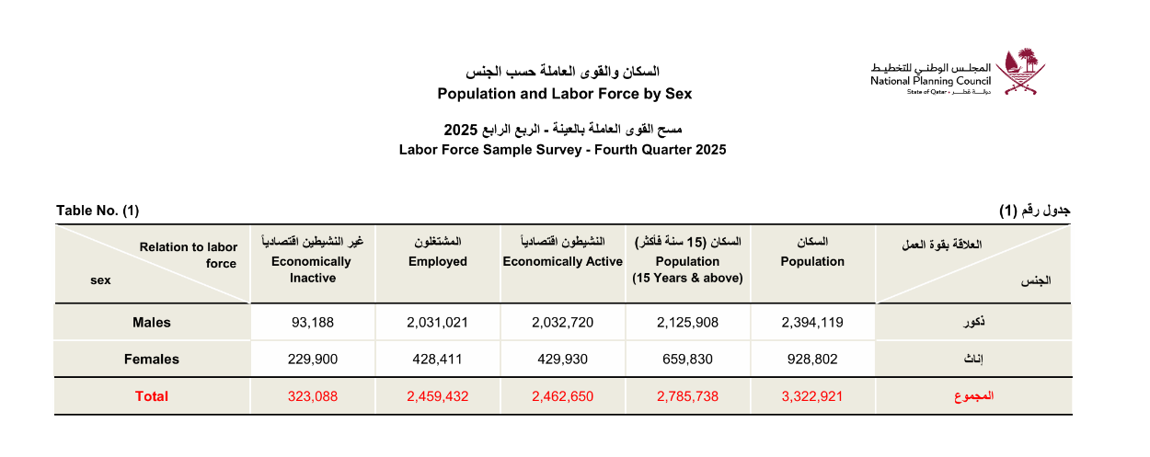

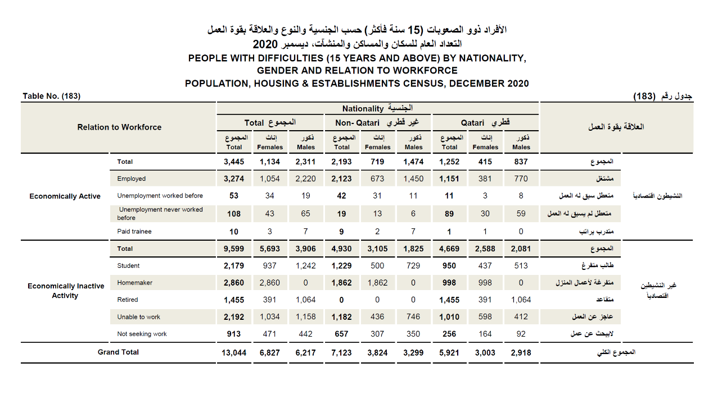
Table 2: Individuals with Difficulties (15+ years) by Nationality, Sex, and Relationship to Labor Force, 2020 General Census, NPC.

Table 3: Economic Participation Rate of Qataris with Disabilities (15+ years) out of Total PwD, 2020 Census.
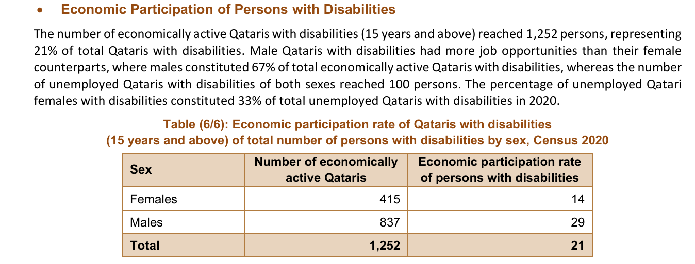

Table 4: Nama Center – Beneficiaries of Educational Support Services for PwD

Beneficiaries of Educational and Other Support Services for Persons with Disabilities
Service | Number of Beneficiaries
School Education | 10 students
University Education | 6 female students
Professional Development | 5 students received training in cooperation with the Vocational Training Department at the Al Shafallah Center
Other Services | 5 women and 1 man

Business Incubator Programmes
Women beneficiaries (women without disabilities and women with disabilities) in entrepreneurship programmes
Incubated Projects – Women Benefiting from Business Incubation Services
Nationality | Women without Disabilities | Women with Disabilities
Qatari | 143 | 2
Non-Qatari | 81 | 0

Entrepreneurship Training Programmes
Women beneficiaries (women without disabilities and women with disabilities) participating in entrepreneurship training programmes
Number of Training Courses (2022–Present) | Women without Disabilities | Women with Disabilities
46 | 562 | 35

Training and Capacity-Building Programmes for Persons with Disabilities
No. | Programme | Number of Female Beneficiaries
1 | Fursa Programme – Project Management for Persons with Disabilities (Deaf Participants) | 14
2 | Fursa Programme – Ramla bint Abi Sufyan School | 20
Note: The target age group for the Fursa Programme at Ramla bint Abi Sufyan School is 15–18 years.
Table 5: Individuals with Difficulties by Nationality, Sex, and Municipality, 2020 General Census.
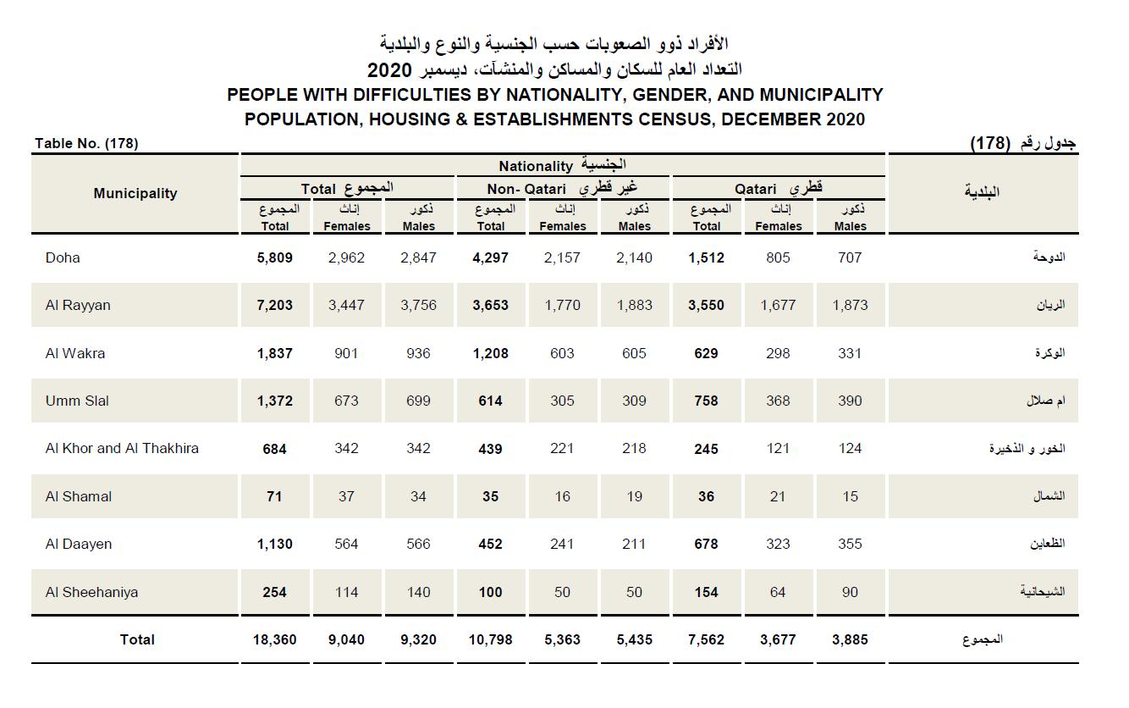

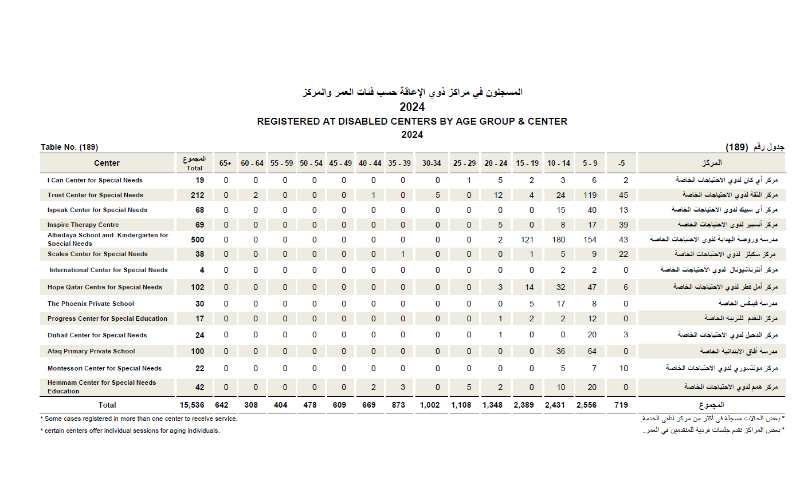
Table 6: Registrants in Centers for PwD by Age Group and Center, 2024, NPC.

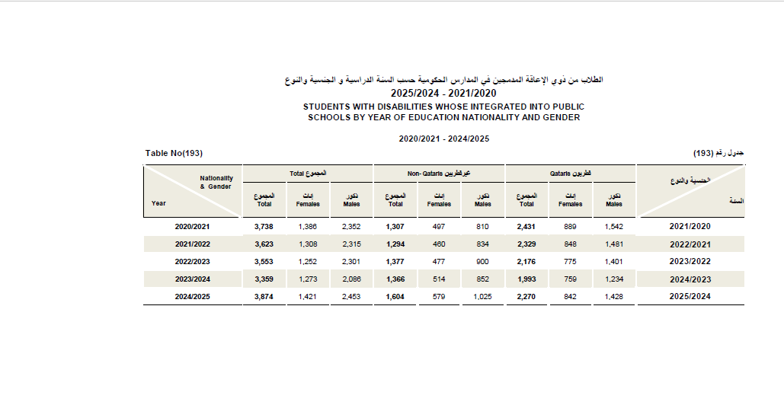
Table 7: Students with Disabilities Integrated in Government Schools by Academic Year, Nationality, and Sex (2020-2025), NPC.

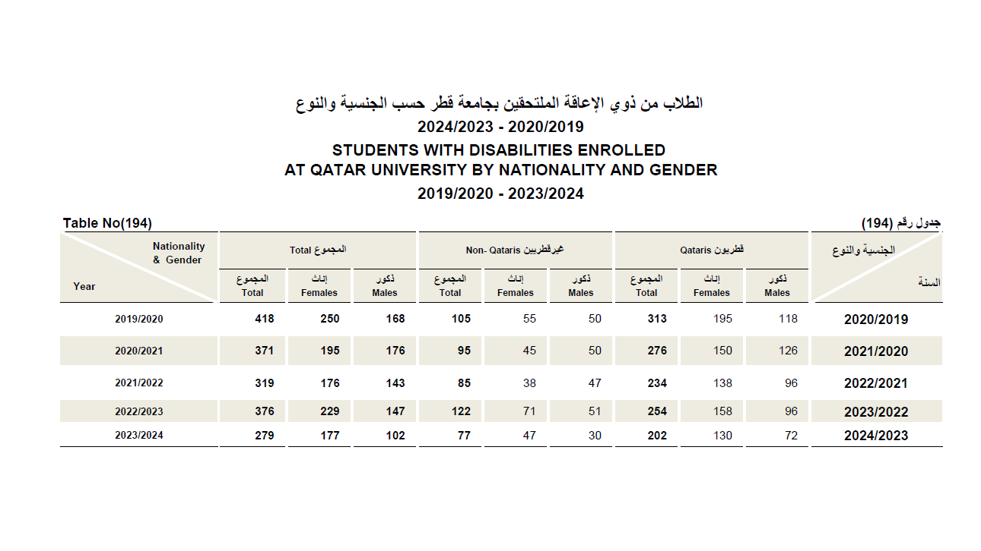
Table 8. Students with Disabilities Enrolled at Qatar University, by Nationality and Gender (National Planning Council)
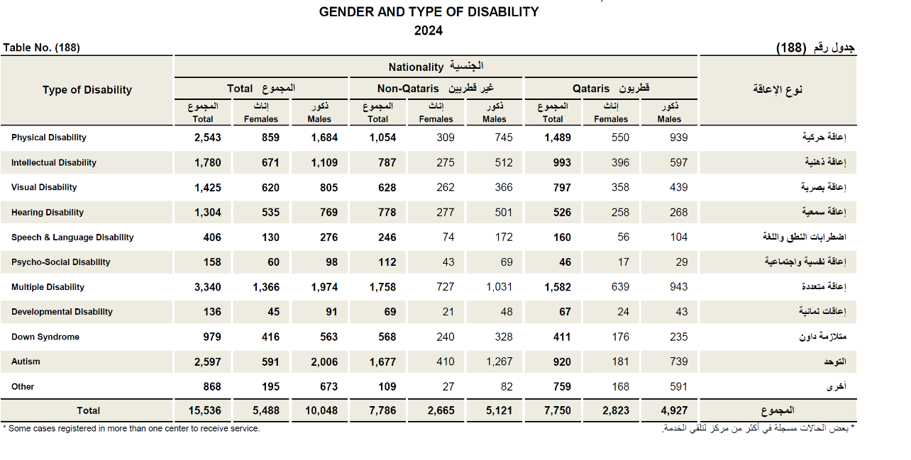
Table 9: Types of Disabilities among Registrants in Centers for PwD (2024), NPC.

Table 10: Number of Violence Cases among PwD by Year (2021–2025)
year | Children |  |  | Women | Total
year | Female | male | Total | Women | Total
2021 | 2 | 6 | 8 | 2 | 10
2022 | 1 | 2 | 3 | 2 | 5
2023 | 7 | 6 | 13 | 4 | 17
2024 | 7 | 8 | 15 | 2 | 17
2025 | 1 | 6 | 7 | 2 | 9
Total | 18 | 28 | 46 | 12 | 58
Table 11: Number of Violence Cases among PwD by Age Group (2021–2025)
Age | Children |  |  | Women | Total
Age | female | Male | Total | Women | Total
0 – 9 | 6 | 11 | 17 | 0 | 17
10 – 19 | 12 | 17 | 29 | 0 | 29
20 – 29 | 0 | 0 | 0 | 3 | 3
30 – 39 | 0 | 0 | 0 | 7 | 7
40 – 49 | 0 | 0 | 0 | 1 | 1
50 – 59 | 0 | 0 | 0 | 1 | 1
Total | 18 | 28 | 46 | 12 | 58
Table 12: Number of Violence Cases among PwD by Scope of Violence (2021–2025)

Scope of Violence | Children |  |  | Women | Total
Scope of Violence | Female | Male | Total | Women | Total
Domestic | 15 | 22 | 37 | 11 | 48
Community | 3 | 6 | 9 | 1 | 10
Total | 18 | 28 | 46 | 12 | 58

References:
Darwish, S., Alodat, A., Al-Hendawi, M., & Ianniello, A. (2025). General Education Teachers’ Perspectives on Challenges to the Inclusion of Students with Intellectual Disabilities in Qatar. Education Sciences, 15(7), 908. https://doi.org/10.3390/educsci15070908
Doha International Institute for Family (2019). Wellbeing of Families Living with Autism Spectrum Disorder in the State of Qatar.
National Planning Council (2025). Seventh Report on Comprehensive Social Statistics. November 2025.
Qatar News Agency (QNA). Official Data and Reports on the Rights of Persons with Disabilities (2020-2025).
Qatar Social Research Center. Panel Discussion: "Protecting the Elderly with Disabilities" (June 14, 2023).
Shaban, S., & Amin, H. (2025). The Financial Cost of Childhood Disability in Qatar. In: Rahman, M.M., et al. (eds) Handbook of Families in the Arab Gulf States. Gulf Studies, vol 19. Springer, Singapore. https://doi.org/10.1007/978-981-96-3412-5_30
Zaidan, E., Cochrane, L., Tok, E., Al-Fadala, A. (2025). Introduction: Future of Education in Qatar. In: Zaidan, E., Tok, E., Al-Fadala, A., Cochrane, L. (eds) The Future of Education Policy in the State of Qatar. Gulf Studies, vol 21. Springer, Singapore. https://doi.org/10.1007/978-981-97-9667-0_1

