NGO Information for the Human Rights Committee, 121st session: List of Issues Prior to Reporting, Japan

24 July 2017

Human rights situation of Korean residents in Japan with relate to the International Covenant on Civil and Political Rights
―― rights to education of minority children (arts. 26 and 27), discrimination against some of Koreans in the National Pension Fund (Art.26), Issues on Hate Speech (arts. 2 and 20(2)), right to leave and enter one’s living country (arts. 2,12 and 26), the concept of minorities (arts. 26 and 27)

Submitted by:
Human Rights Association for Korean Residents in Japan (HURAK)

* Human Rights Association for Korean Residents in Japan (HURAK) is a non-profit, non-governmental human rights organization devoted to advocating rights of Korean residents in Japan and contributing to their well-being. HURAK was founded in 1994 by legal experts, researchers and activists in the field of human rights of Korean residents in Japan. HURAK is an affiliated body of the NGO Network for the Elimination of Racial Discrimination (ERD Net), which is a nationwide network among NGOs and individuals working for the issues relating to racism, racial discrimination and colonialism in Japan.

Website http://k-jinken.net/
E-mail jinken94@yahoo.co.jp
Address 3-41-10-3F, Taitou, Taitou-ku, Tokyo, Japan 110-0016

Rights to education of minority children (arts. 26 and 27)
I. Summary
1. The Committee previously issued recommendations and asked a question about the discriminatory measures against Korean schools by the Japanese government. The issues the Committee has covered were:
(a) non-recognition of Korean schools
(b) discriminatory measures with regard to tax exemption
(c) non-recognition of diplomas from Korean schools as direct university entrance qualifications
(d) exclusion of Korean school students from the Tuition Waiver Program for high school education
(e) discriminatory measures with regard to the provision of subsidies to Korean schools

2. Other Committees such as the Committee on Economic, Social and Cultural Rights (CESCR), the Committee on the Elimination of Racial Discrimination (CERD) and the Committee on the Rights of the Child (CRC) also have repeatedly issued recommendations demanding the Japanese government revise the discriminatory measures against Korean schools.
3. However, the Japanese government has not taken any measures to address the issues the Committee pointed out. Korean schools have been therefore facing severe financial difficulties and extinction. The students who go to Korean schools feel that they have been denied their right to enjoy their own culture, to use their own language in Korean schools.
II. Background
A. History of Korean schools
a) non-recognition of Korean schools
4. Koreans, who had been prohibited from using their ethnic language and names under the Japanese colonial rule, have established Korean schools in various parts of Japan since Japan’s surrender in 1945 for the purpose of preserving their ethnic identity, language, history and culture. Today, there are more than 60 Korean schools across Japan with approximately 8,000 students from kindergarten to university. Children attending Korean schools learn language, culture and history of Korea and Japan, and the subjects in Korean schools are basically taught by Korean teachers who were born and raised in Japan, with using Korean language.
5. As the Japanese government considered Koreans had Japanese nationality even after Japan’s surrender, the Ministry of Education informed local governments that Koreans “have a duty to attend Japanese schools as well as Japanese” in 1948, which ended up compulsory closing down almost all Korean schools by police authority power and transferring Korean children to Japanese public schools. This suppression of ethnic education by the Japanese government caused a massive decrease in number of Korean schools from more than 500 to less than 50.
6. However, the Ministry of Education next informed local governments in February 1953 that the principle of free of charge of compulsory education in Japanese public schools would not be applied in case of Korean children’s education because of their foreign nationalities, in response to the notice by the Ministry of Justice which deprived all Koreans of Japanese nationality without any right to select their nationalities, issued after the effectuation of the Peace Treaty and the restoration of sovereignty of Japan in April 1952. In other words, the government decided that it would not guarantee the right to education of Korean children at all.
7. In spite of such suppression of ethnic education by the Japanese government, Koreans in Japan made every effort to maintain and rebuild Korean schools throughout Japan, devoting all their money, knowledge and labor power.
8. When the normalization of diplomatic relationship between Japan and Republic of Korea was realized in 1965, the Ministry of Education informed local governments that they “should not accredit Korean schools, which aim to cultivate ethnicity or nationality of Koreans, even as miscellaneous schools”, which meant the Japanese government would not give any right to ethnic education in Korean schools. However, the governor of Tokyo accredited Korea University in Tokyo as “miscellaneous school” in 1968 in spite of the notice from the Ministry, and all Korean schools have been accredited as “miscellaneous school” by the local governors as of today. Moreover, all local governments started to provide subsidies to Korean schools after the accreditation, but some local governments stopped providing subsidies in recent years which will be described below. The central government has never provided financial support for Korean schools and what was worse; it only excluded students of Korean high schools from the “Tuition Waiver and Tuition Support Fund Program”, which will also be described below.
b) Foreign school as “miscellaneous school” and its disadvantages
i. Foreign school as "miscellaneous school"
9. There are currently 125 foreign schools in Japan including approximately 60 Korean schools, 30 international schools, 15 South American schools such as Brazilian and Peruvian, and other national schools such as Chinese, French and Germany. These schools are accredited as “miscellaneous school” by local governments where each school is located. Approximately 26,000 children are learning in those schools including kindergarten, primary to high schools, universities and graduate schools.
10. Japanese school system is divided into three kinds of schools, which are regular school defined in article 1 of School Education Act (so-called “School of Article 1”), “technical school” defined in article 12 of the Act, and “miscellaneous school” defined in article 134 of the Act.
11. The Japanese government has insisted that “miscellaneous school” can be accredited as “School of Article 1” if the school has fulfilled the accreditation criteria and such school existed in the past. However, in order to be accredited as “School of Article 1”, the school has to fulfill the accreditation criteria determined by the Ministry of Education, Culture, Sports, Science and Technology (MEXT), such as the implementation of its school curricula for Japanese children with Japanese textbooks in Japanese approved by the MEXT and the qualifications of teachers approved by the Government. Therefore, it is almost impossible practically to be accredited as “School of Article 1” for minority schools if minority community wants to give education using their own language and textbooks written in their own language.
12. “Technical school” is an educational institution that gives practical vocational education and specialized technical education. These schools can receive public support almost equivalent to regular schools, but foreign schools cannot be accredited as technical schools owing to the legal provision which excluded “schools for foreigners”.
13. “Miscellaneous school” is an educational institution that gives skills such as driving, cooking, sewing, etc. On account of the reasons described above, foreign schools have no choice but to be accredited as “miscellaneous schools”. Regarding this problem, a several concerns and recommendations were issued to the Japanese Government by the human rights treaty bodies and the special procedures of the Human Rights Council (HRC).
ii. Disadvantages of foreign schools in Japan
14. For the reasons described above, foreign schools have been suffering various difficulties as “miscellaneous school”. Firstly, the central government does not provide any financial support for foreign schools at primary and junior high levels. While local governments provide some financial support to foreign schools, such support is limited compared to the support Japanese accredited private schools receive, which amounts to less than one-tenth in some schools.
15. Secondly, there are some cases that graduates of foreign schools cannot transfer or take national entrance examinations to enter Japanese schools due to the fact that qualifications acquired at foreign schools are not recognized as equivalent to those acquired at regular schools. For example, in Tokyo, qualification of graduates of Korean primary school was not recognized when they sought to enter Japanese middle school.
16. Moreover, foreign schools cannot receive any other services from the governments such as free health care and lunches. Foreign school students are not covered recipients of various national scholarship projects due to the lack of accreditation as regular schools.
B. discriminatory measures with regard to tax exemption
17. Thus, foreign schools must rely exclusively on high tuition fees and financial contributions by parents. However, “miscellaneous schools” cannot receive support from the central government in terms of tax exemptions, which regular schools and technical schools can. While the MEXT decided in 2003 to grant benefit of tax exemption only to Western foreign schools from the perspective of promoting trade, it didn’t grant benefit to non-Western foreign schools such as Korean schools and Chinese schools. With regard to such discriminatory measure by the central government, the Japan Federation of Bar Associations issued recommendation to the government in 2008 to revise its position, saying that the measure “will violate the right to learn of students” of foreign schools such as Korean schools and Chinese schools. Regarding this issue, a several concerns and recommendations were issued to the Japanese Government by the human rights treaty bodies and the special procedures of the HRC.
C. non-recognition of diplomas from Korean schools as direct university entrance qualifications
18. While a 2003 reform by the MEXT granted access to university entrance examinations to graduates of foreign schools, graduates from schools for those from Korean schools have been excluded, because of political reasons linked to the lack of diplomatic recognition of Democratic People’s Republic of Korea. As a consequence, their access to university has not been guaranteed and has been depending on discretion by each university. Some graduates of Korean high school have been refused to take the entrance examination by some universities. Regarding this issue, a several concerns and recommendations were issued to the Japanese Government by the human rights treaty bodies and the special procedures of the HRC.
D. Exclusion of Korean children from "Tuition Waiver and Tuition Support Fund Program for High School Education"
19. The Japanese government has expanded compulsory education to high school level since 2010 by enforcing “Tuition Waiver and Tuition Support Fund Program for High School Education” (hereafter, “Tuition Waiver Program”), which exempted tuition fees for students of Japanese public high school and provided funds equivalent to tuition fees of Japanese public high school for students of private high schools, including technical schools and foreign schools that are accredited as “miscellaneous school”.
20. As for foreign schools, they were categorized into three types to be the subject of the Program, which were (i) a school whose curriculum is equivalent to the one of high school in its native country, (ii) an international school certified by the international educational evaluation institution, (iii) a school the Minister of Education certified that it has curriculum equivalent to the one of high school level. 14 national schools such as Chinese and Brazilian as the first category and 17 international schools as the second category were designated as subjects of the Tuition Waiver Program when the Program was enforced in 2010.
21. However, students of 10 Korean schools have only been excluded among other foreign schools since 2010, owing to the arbitrary measure of the MEXT, which prolonged the application of the program to Korean students for the reasons of the military tension between Japan and Korean peninsula and ended up legally excluding them from the program in February 2013 by revising its ministerial ordinance that deleted the third category above, which had been the ground for applying the Program to students of Korean schools. The Japanese government cited the fact that “there was no progress in the abduction issue” as one of the reasons of the exclusion, which revealed that the political and diplomatic relations between Japan and Democratic People’s Republic of Korea were the grounds for the exclusion.
22. As of March 2017, more than 10,000 Korean high school students were excluded from the Program and the total damage of tuition support funds is estimated over 1.5 billion yen. In response to this discrimination, two Korean schools and 249 Korean students filed lawsuits with the court in five districts including Tokyo, Osaka, Hiroshima, Aichi and Fukuoka. Regarding this issue, a several concerns and recommendations were issued to the Japanese Government by the human rights treaty bodies.
E. Suspension of subsidies to Korean schools by local governments and the pressure from the central government to local governments to suspend subsidies
a) Suspension of subsidies by local governments
23. The discriminatory measure to exclude Korean school students from the Tuition Waiver Program by the central government has led some local governments to suspend subsidies to Korean schools since 2010.
24. Subsidies by local governments for Korean schools were approximately one-tenth of Japanese public schools and one-third of Japanese private schools on average as of 2009, though the amount of subsidy is varied with location. While it was a very small amount compared to other Japanese schools, it had become valuable financial resources for the operation of Korean schools which had had no financial support from the central government.
25. Since 2010, 13 prefectural governments out of 28 prefectures where Korean schools are located have suspended subsidies that had been provided to Korean schools over decades. The prefectural governments that have suspended subsidies include Tokyo, Osaka, Saitama, Miyagi, Chiba, Kanagawa, Hiroshima, Yamaguchi, Niigata, Ibaraki, Tochigi, Wakayama and Mie, and they cited political and diplomatic relations as the reasons for suspending their subsidies. By the same token, some cities such as Osaka city, Hiroshima city and Yokohama city have suspended their subsidies to Korean schools, following the decision of the prefecture the city belongs to that suspended the subsidies to Korean schools.
26. Those Korean schools where the provision of subsidies by the local governments had been suspended have been facing extreme financial difficulty. They had no choice but to run up tuition fees and other expenses for education. Thus, a number of parents have given up sending their children to Korean schools.
b) The pressure from the central government to local governments to suspend subsidies
27. In spite of the concern and recommendation by the Committee on the Elimination of Racial Discrimination(CERD) in 2014 that pointed out the suspension of subsidies by local governments is “government’s actions that hinder the right to education of children of Korean origin” and that recommended the Japanese government to invite local governments to resume or maintain the provision of subsidies to Korean schools, the Japanese government issued a notice named “Points to be noted concerning subsidies relating to Korean schools” in March 2016 to each local government where Korean school is located, which made other several local governments suspend subsidies to Korean schools.
28. While the notice did not refer to above CERD’s concern and recommendation, the Japanese government demanded the local governments reconsider the provision of subsidies in light of “public benefit and the effect on educational promotion”, which became a de facto pressure to make local governments suspend the provision of subsidies to Korean schools.
29. In fact, the governor of Ibaraki prefecture suspended the provision of subsidy of the fiscal year 2016 for Ibaraki Korean School in March 2017, on the ground of the notice issued by the central government. The notice also made other several local governments reconsider the provision of subsidies to Korean schools.
c) Judicial judgment on suspension of subsidies by local governments
30. In response to the suspension of subsidies by Osaka prefecture and Osaka city, the Korean School in Osaka filed a lawsuit against both the prefecture and the city in September 2012 in search of repeal of the governments’ action having suspended subsidies to the Korean school.
31. However, the Osaka District Court rejected the case without acknowledging the right to conduct ethnic education in Korean school, saying ‘The international human rights standards such as the article 19 of the International Convention on Economic, Social and Cultural Rights do not decide the specific right [to education] and therefore it cannot be said that the difference of the provision of subsidies between other private schools and “miscellaneous schools” violates the principle of equality’ and ‘The fact that the plaintiff cannot receive the subsidy from Osaka prefecture can result in the deterioration in the educational environment of children, students and parents of the school which the plaintiff is operating, and in the effect such as an increase of economic burden. However…it is unavoidable that the plaintiff cannot receive the subsidies.’
III. List of Issues to be included
a) In light of the Committee’s previous recommendation (CCPR/C/79/Add. 102, para 13), please provide information on whether the State Party is considering the official recognition of schools for minority children, including Korean schools, to ensure the right to enjoy own culture and to use own language of minorities through education.
b) Please provide information on the reason why the State Party has not been applying the tax deduction measures to Korean schools and Chinese schools in light of the Committee’s previous recommendation (CCPR/C/JPN/CO/5, para 31).
c) Please provide information on whether the State Party is considering the recognition of diplomas from Korean schools as direct university entrance qualifications in light of the Committee’s previous recommendation (CCPR/C/JPN/CO/5, para 31).
d) In light of other Committee’s previous recommendations (CERD/C/JPN/CO/3-6, para 22(e), E/C.12/JPN/CO/3, para27 and CERD/C/JPN/CO/7-9, para 19), please provide information on whether the State Party is considering applying the Tuition Waiver Program to Korean high school students.
e) In light of other Committee’s previous recommendation (CERD/C/JPN/CO/7-9, para 19), please provide information on whether the State Party is considering inviting local governments to resume the provision of subsidies to Korean schools.
IV. Relevant previous recommendations and question of the Committee
CCPR/C/79/Add. 102, para 13
13. The Committee is concerned about instances of discrimination against members of the Japanese-Korean minority who are not Japanese citizens, including the non-recognition of Korean schools. The Committee draws the attention of the State party to General Comment No. 23 (1994) which stresses that protection under article 27 may not be restricted to citizens.
CCPR/C/JPN/CO/5, para 31
31. The State party should ensure the adequate funding of Korean language schools by increasing State subsidies and applying the same fiscal benefits to donors of Korean schools as to donors of other private schools, and recognize diplomas from Korean schools as direct university entrance qualifications.
CCPR/C/JPN/Q/6, para 21
21. Please provide information on whether the State party is considering applying its tuition-waiver programme for high school education to children attending Korean schools? Does the State party recognize the Korean school leaving certificates as direct university entrance qualification?
V. Relevant previous recommendations of other Committees
CERD/C/JPN/CO/7-9
Korean schools
19. The Committee is concerned about the legislative provisions and government’s actions that hinder the right to education of children of Korean origin, including: (a) the exclusion of Korean schools from the High School Tuition Support Fund; and (b) the suspension or continued decrease of funding allocated by local governments to Korean schools (art. 2, 5).
Recalling its general recommendation No. 30 (2004) on discrimination against non-citizens, the Committee reiterates its recommendation included in paragraph 22 of its previous concluding observations that the State party ensure that there is no discrimination in the provision of educational opportunities and that no child residing in its territory faces obstacles to school enrolment. The Committee encourages the State party to revise its position and to allow Korean schools to benefit, as appropriate, from the High School Tuition Support Fund, as well as to invite local governments to resume or maintain the provision of subsidies to Korean schools. The Committee recommends that the State party consider acceding to the UNESCO Convention against Discrimination in Education of 1960.
CERD/C/JPN/CO/3-6
22. The Committee notes with appreciation the efforts taken by the State party to facilitate education for minority groups, including bilingual counsellors and enrolment guidebooks in seven languages, but regrets the lack of information on the implementation of concrete programmes to overcome racism in the education system. Moreover, the Committee expresses concern about acts that have discriminatory effects on children’s education including:
(c) obstacles in connection with school accreditation and curricular equivalencies and entry into higher education;
(d) the differential treatment of schools for foreigners and descendants of Korean and Chinese residing in the State party, with regard to public assistance, subsidies and tax exemptions; and
(e) the approach of some politicians suggesting the exclusion of North Korean schools from current proposals for legislative change in the State party to make high school education tuition free of charge in public and private high schools, technical colleges and various institutions with comparable high school curricula (art. 2, 5).
The Committee, in light of its general recommendation No. 30 (2004) on discrimination against non-citizens, recommends that the State party ensure that there is no discrimination in the provision of educational opportunities and that no child residing in the territory of the State party faces obstacles in connection with school enrolment and the achievement of compulsory education. In this regard, it further recommends that a study on the multitude of school systems for foreigners and the preference for alternative regimes set up outside of the national public school system be carried out by the State party. The Committee encourages the State party to consider providing adequate opportunities for minority groups to receive instruction in or of their language and invites the State party to consider acceding to the UNESCO Convention against Discrimination in Education.
CERD/C/304/Add.114
14. The Committee is concerned about reports of violent actions against Koreans, mainly children and students, and about inadequate reaction on the part of the authorities in this regard and recommends that the Government take more resolute measures to prevent and counter such acts.
16. The Committee is concerned about discrimination affecting the Korean minority.
Though efforts are being made to remove some of the institutional obstacles preventing minority students from international schools, including Korean schools, from entering Japanese universities, the Committee is particularly concerned that studies in Korean are not recognized and that resident Korean students receive unequal treatment with regard to access to higher education. It is recommended that the State party undertake appropriate measures to eliminate discriminatory treatment of minorities, including Koreans, in this regard and to ensure access to education in minority languages in public Japanese schools.
E/C.12/JPN/CO/3
27. The Committee is concerned at the exclusion of Korean schools from the State party’s tuition fee waiver programme for high school education, which constitutes discrimination (arts. 13 and 14).
Recalling that the prohibition against discrimination applies fully and immediately to all aspects of education and encompasses all internationally prohibited grounds of discrimination, the Committee calls on the State party to ensure that the tuition fee waiver programme for high school education is extended to children attending Korean schools.
E/C.12/1/Add.67
32. The Committee expresses its concern about the fact that there are very limited possibilities for children of minorities to enjoy education in their own language and about their own culture in public schools. The Committee is also concerned about the fact that minority schools, such as Korean schools, are not officially recognized, even when they adhere to the national education curriculum, and therefore neither receive central government subsidies nor are able to provide qualification for university entrance examinations.
60. The Committee strongly recommends that mother-tongue instruction be introduced in the official curricula of public schools enrolling a significant number of pupils belonging to linguistic minorities. The Committee further recommends that the State party officially recognize minority schools, in particular Korean schools, when they comply with the national education curriculum, and consequently make available to them subsidies and other financial assistance, and also recognize their school leaving certificates as university entrance examination qualifications.
CRC/C/JPN/CO/3
72. The Committee is concerned that schools for children of Chinese, North Korean or other origin are insufficiently subsidised. It is also concerned that graduates from these schools may not be eligible for entrance examinations to universities and colleges in Japan.
73. The Committee encourages the State party to increase subsidies to non-Japanese schools and ensure that access to university and college entrance examinations is non-discriminatory. The State party is encouraged to consider ratifying the UNESCO Convention against Discrimination in Education.
86. While noting the measures taken by the State party to improve the situation of the Ainu people, the Committee is concerned that children of Ainu, Korean, Burakumin origin and other minorities continue to experience social and economic marginalisation.
87. The Committee urges the State party to take the necessary legislative or other measures to eliminate discrimination against children belonging to ethnic minorities in all spheres of life and ensure their equal access to all services and assistance provided for under the Convention.
CRC/C/15/Add.231
49. The Committee notes the State party’s efforts to reform the education system and bring it into greater conformity with the Convention; however, it is concerned that:
(d) Although eligibility criteria have been broadened for graduates from foreign schools in Japan applying to university, some continue to be denied access to higher education;
50. The Committee recommends that the State party:
(d) Expand opportunities for children from minority groups to enjoy their own culture, profess or practise their own religion and use their own language;
VI. Annex
1. Pictures of compulsory closedown of Korean schools in 1948 by the Japanese authority and Allied Occupation Forces
2. Editorial of The Japan Times, “Treat all students equally” (1st Mar, 2013) and “Students are not political pawns” (12nd Apr, 2013)

3. Statement of President of the Japan Federation of Bar Associations objecting to exclusion of Korean Schools from Tuition Waiver Program for High School Education (1st Feb, 2013)
4. Japan’s Prefectural Governments which suspended subsidies to Korean Schools (2009 - 2016)
5. Policy speech by the Governor of Tokyo and media coverage on local governments’ suspension of subsidies to Korean schools (31st Oct, 2013)
6. Editorial of The Asahi Shimbun, “Politicians bully Korean school students for acts of Pyongyang” (22nd Mar, 2016)
7. Pictures of Korean traditional uniform dress of Korean school's female students, ripped uniform and school bag of Korean school children

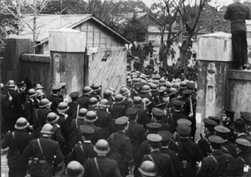

Annex 1. Pictures of compulsory closedown of Korean schools in 1948 by the Japanese authority and Allied Occupation Forces
Annex 2. Editorial of The Japan Times (1st Mar and 12nd Apr, 2013)
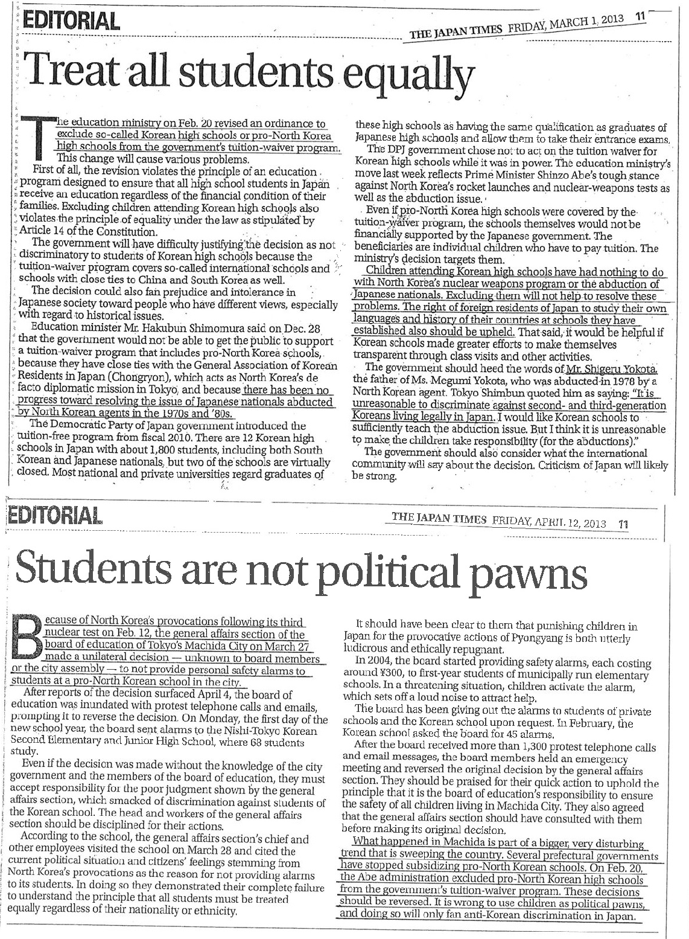

Annex 3. Statement of President of the Japan Federation of Bar Associations objecting to exclusion of Korean Schools from Tuition Waiver Program for High School Education (1st Feb, 2013)

The Ministry of Education, Culture, Sports, Science and Technology (MEXT) announced a proposed amendment to ministerial ordinance on December 28th, 2012, which amends a part of enforcement regulations regarding free tuition for public high schools and subsidies for private high schools. As for the high schools where foreign students are enrolled such as international schools and ethnic schools, the current enforcement regulations define the subject for the policy as either high schools that are confirmed through its embassy to have curriculum equivalent to that of high schools in its native state, or high schools that are certified by international evaluation body, while the rest of the schools that are evaluated as having curriculum equivalent to that of Japanese high schools can be the recipient of the subsidies, whether or not Japan has diplomatic relations with its native state, after the minister of the MEXT designates each school individually. The proposed amendment is to delete the grounds for the individual designation.

Regarding the purpose of this revision, the minister of MEXT, Hakubun Shimomura, stated at the press conference on December 28th, 2012, that the proposed amendment is aimed at deleting the grounds for designating Korean schools because there is no progress to resolve the Democratic People’s Republic Korea’s (DPRK) abduction of Japanese citizens, which makes it clear that this proposed amendment is aimed at excluding Korean Schools from applying the Free High School tuition policy.

As we stated in the “Statement on Subject High Schools of the Free Tuition Bill” on March 5th, 2010, the main purpose of this bill is “to contribute to the creation of equal educational opportunities by alleviating the financial burdens of high school education”, which is also demanded by Article 28 of Convention on the Rights of the Child. Considering the fact that Convention on the Rights of the Child as well as International Bill of Human Rights (International Covenant on Civil and Political Rights) guarantee the right to receive education with ethnic identity being maintained, the current ministerial ordinance which would include international schools and ethnic schools is in a right direction. Furthermore, it is revealed through the process of the deliberation on the bill that, as the Government’s collective view, the designation of high schools for foreign students should not be judged by diplomatic concern but should be judged objectively through educational perspective.

On contrary to that, this proposed amendment is to refuse to provide subsidies based on the grounds that there being no diplomatic relations between Japan and DPRK or no progress to resolve the DPRK’s abduction issue, either of which has nothing to do with the right of the child to receive education. It is a discriminative treatment which is prohibited by Article 14 of the Constitution of Japan.

Korean Schools in Japan completed applying for the designation based on the current bill legitimately by the end of November, 2011, this upcoming amendment is to extinguish the regulations considered as the grounds for applying and refuse the Korean Schools’ application retroactively after more than two years from the application, which poses serious doubts on its procedure.

The Japan Federation of Bar Associations strongly urges that the proposed amendment be withdrawn whilst the review of the application from Korean schools be concluded promptly based on the current law and screening standard so that all foreigners and ethnic minorities in Japan can enjoy the right to education maintaining their ethnic identities without any discrimination.
February 1st, 2013
Kenji Yamagishi
President
Japan Federation of Bar Associations
Annex 4. Japan’s Prefectural Governments which suspended subsidies to Korean Schools (2009 - 2016)

Fiscal Year | 2009 | 2010 | 2011 | 2012 | 2013 | 2014 | 2015 | 2016
Name of Prefectural Government  (start year of subsidy) | Total Subsidy  (Approximately) | Total Subsidy  (Approximately) | Total Subsidy  (Approximately) | Total Subsidy  (Approximately) | Total Subsidy | Total Subsidy  (Approximately) | Total Subsidy  (Approximately) | Total Subsidy  (Approximately)
Tokyo  (1995) | 23.5 million | 0 | 0 | 0 | 0 | 0 | 0 | 0
Saitama  (1982) | 9  million | 0 | 0 | 0 | 0 | 0 | 0 | 0
Osaka  (1988) | 185 million | 87  million | 0 | 0 | 0 | 0 | 0 | 0
Miyagi  (1992) | 1.5  million | 1.5  million | 0 | 0 | 0 | 0 | 0 | 0
Chiba  (1985) | 5.6  million | 5.6  million | 0 | 0 | 0 | 0 | 0 | 0
Hiroshima  (1992) | 13.8 million | 10.1  million | 9.6  million | 0 | 0 | 0 | 0 | 0
Niigata  (1993) | 11.5 million | 11  million | 11  million | 0 | 0 | 0 | 0 | 0
Yamaguchi  (1992) | 2.4  million | 2.4  million | 2.3  million | 2.2  million | 0 | 0 | 0 | 0
Kanagawa  (1977) | 72.5 million | 63  million | 63  million | 63  million | 0 | 56  million | 42  million | 0
Ibaraki  (1981) | 2.4  million | 2.4  million | 2.4  million | 1.6  million | 1.4 million | 1.6  million | 1.6  million | 0
Tochigi  (1991) | 1.7  million | 1.7  million | 1.5  million | 1.5  million | 1.5  million | 1.5  million | 1.5  million | 0
Wakayama  (2002) | 4  million | 4  million | 4  million | 4  million | 3.2 million | 2.3  million | 2.3  million | 0
Mie  (1993) | 3  million | 3  million | 3  million | 3  million | 3  million | 3  million | 3  million | 0
Based on a survey by Human Rights Association for Korean Residents in Japan (HURAK)
All the currency unit is Japanese yen ( 1 euro≒120 yen, 1 dollar≒110 yen [as of 29 Mar 2017] )

Annex 5. Policy speech by the Governor of Tokyo and media coverage on local governments’ suspension of subsidies to Korean schools

A. Policy Speech by the Governor of Tokyo, Shintaro Ishihara,
at the First Regular Session of the Tokyo Metropolitan Assembly, 2012

(Subsidies for North Korean schools)
Moving on, I would like to discuss the subject of subsidies to North Korean schools.
The Tokyo Metropolitan Government provides subsidies to “miscellaneous category” schools that educate foreign children in order to help defray their operational costs. This is because having foreign nationals deepen their understanding of Japan and develop an attachment to our country is also very meaningful for Japan’s future.
However, this becomes a totally different story in the case of schools that are indicated to have a close affiliation with Chongryon, the General Association of Korean Residents in Japan, which is under the influence of the North Korean government, which abducted Japanese citizens, and when there are doubts about the school’s curriculum and political neutrality. Because of such reasons, we have decided not to include subsidies for North Korean schools in our budget. We will continue thorough investigations into the management and curriculum of these schools.

B. Media coverage on local governments’ suspension of subsidies to Korean schools (31st Oct 2013)

Yokohama Stops Subsidies for Chongryon Schools

The Japanese city of Yokohama has decided to stop annual subsidies to pro-North Korean schools this year, citing North Korea's nuclear test and other provocations, the Tokyo Shimbun daily reported Wednesday.
The schools are affiliated with the General Association of Korean Residents in Japan or Chongryon, a Pyongyang mouthpiece.
The education committee in Yokohama informed three of the Chongryon schools in the city last week that they would not be receiving the subsidy of 2.5 million yen set aside in this year's budget.
They include two primary and one secondary school.
Yokohama Mayor Fumiko Hayashi said she is halting the subsidies as long as the issues of "North Korea's nuclear weapons development and abduction of Japanese citizens remain unresolved."
Earlier in February, the Japanese government cut Chongryon schools out of federal subsidies. Seven regional governments, including Saitama and Hiroshima, have followed suit.

The Chosunilbo
englishnews@chosun.com / Oct. 31, 2013 12:32 KST

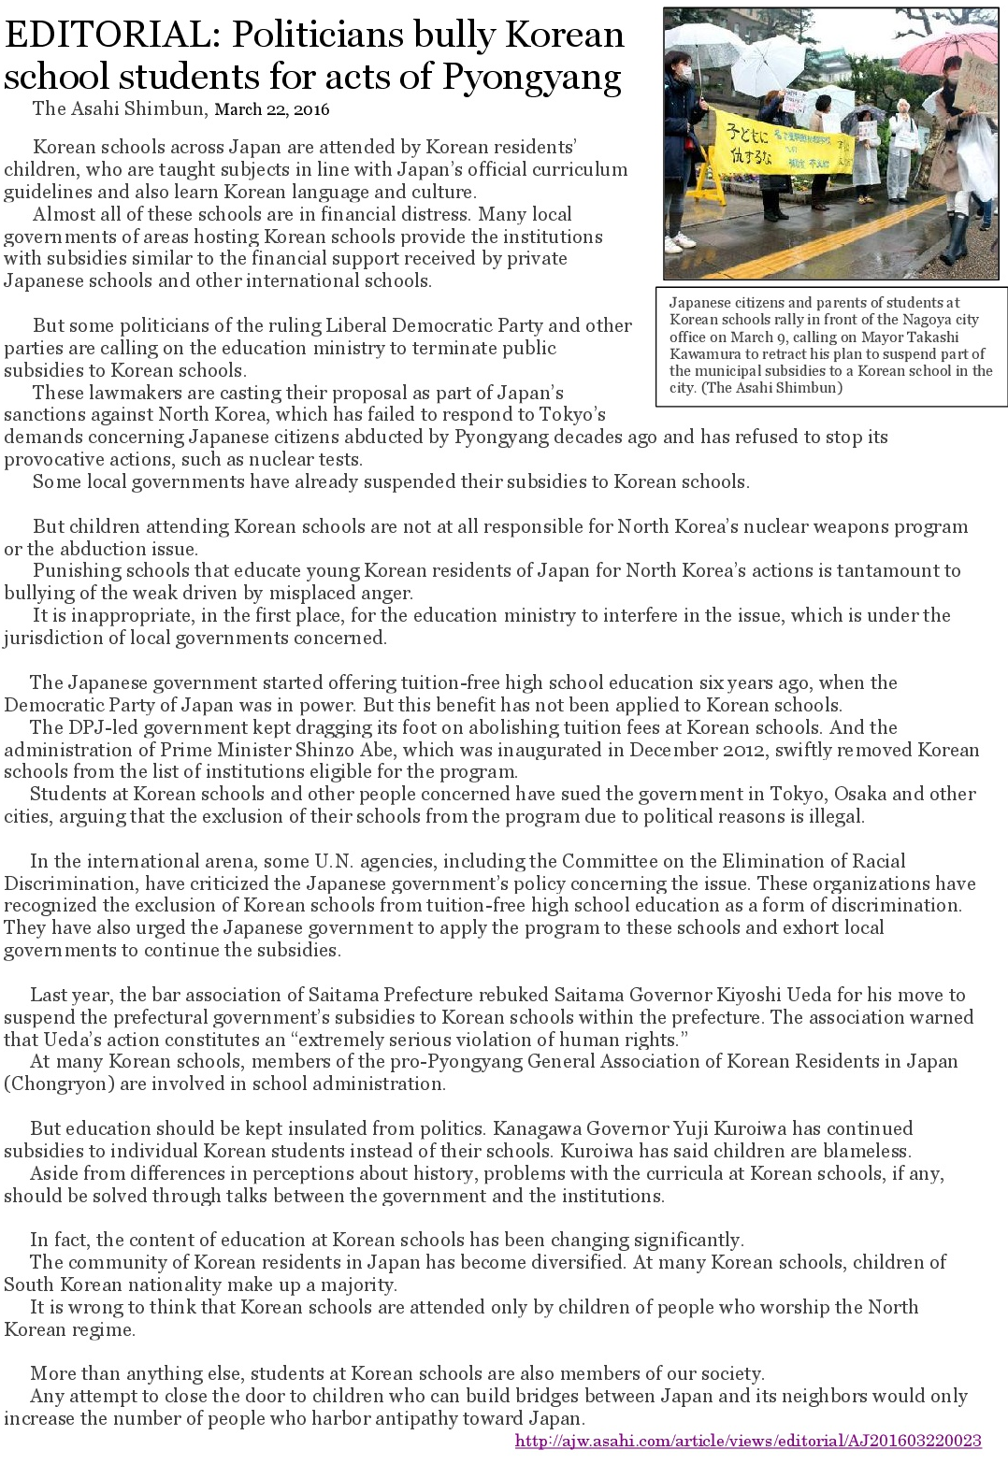
Annex 6. Editorial of The Asahi Shimbun (22nd Mar, 2016)
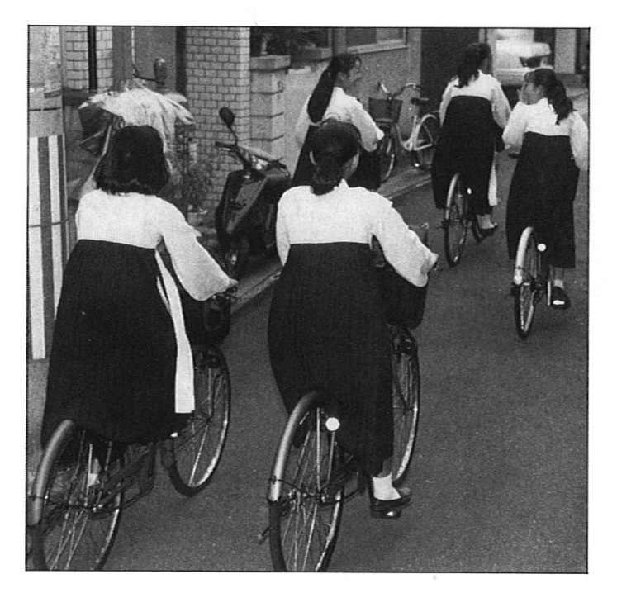
Annex 7. Pictures of Korean traditional uniform dress of Korean school's female students, ripped uniform and school bag of Korean school children

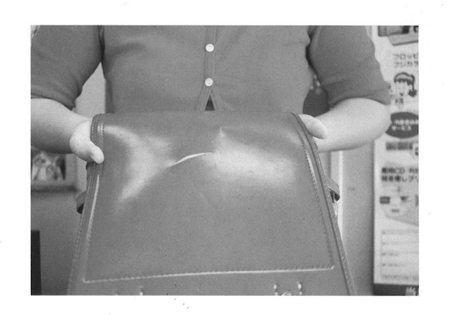
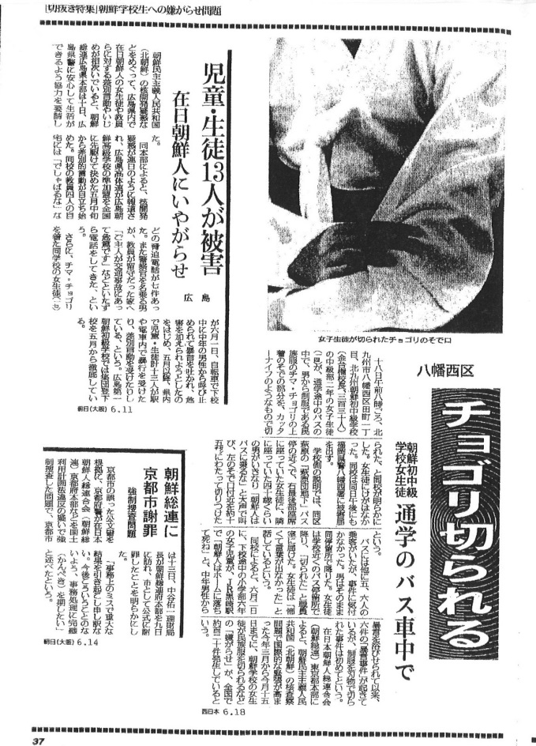
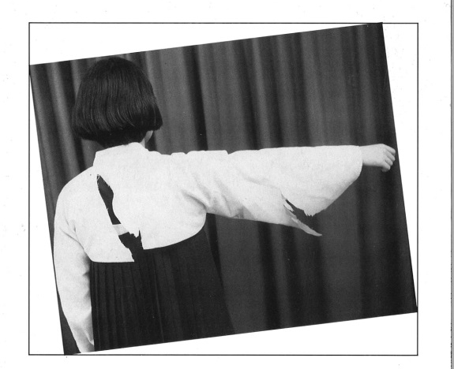

Issues on Hate Speech (mainly violence against children attending Korean schools)【Arts. 2 and 20(2)】
I. Summary
32. The Human Rights Committee expressed concern at the widespread racist discourse against members of minority groups, such as Koreans, Chinese or Burakumin, inciting hatred and discrimination against them and at the high number of extremist demonstrations authorized, the harassment and violence perpetrated against minorities, including against foreign students. Therefore the Committee recommended the Japanese Government to prohibit all propaganda advocating racial superiority or hatred that incites discrimination, hostility or violence, and to prohibit demonstrations that are intended to disseminate such propaganda in its previous concluding observation in paragraph 12.
33. The Japanese Government has been expressed concerns and required to take measures to prevent recurrences over the verbal and physical violence and hate crime against minority groups, especially children attending Korean schools by the Human Rights Committee, the Committee on the Rights of the Child and the Committee on the Elimination of Racial Discrimination.
34. Although the anti-hate speech law was enacted in May 2016, the law only clarified the basic principles with hate speech in Japan and does not prohibit the hate speech. So it is hard to say that the law could be the radical solution for hate speeches and the violence against children attending Korean schools which have been repeatedly occurred until now. Therefore, even after the enactment of the law, Korean school children have been prevented to express their identity by wearing their ethnic uniform, or calling each other’s own ethnic names without any anxiety.
II. Background
35. Hate speech and hate crimes against children attending Korean schools have repeatedly occurred whenever the tension between Japan and Democratic People’s Republic of Korea increased since 1980’s. Owing to the rampant hate crimes such as ripping or cutting ethnic Korean uniform dresses of Korean school girls in public places, Korean school children have not been able to wear their ethnic uniform and to express their identity.
36. Recognizing such hate speeches and hate crimes against Korean school children, the Japanese Government reported the measures for such incidents, such as to distribute leaflets and posters, which called for the prevention of such incidents, along roads and in transportation facilities frequently used by students of Korean schools in its 3rd periodic state party report to the Human Rights Committee. During the session, one of the Human Rights Committee members asked the Japanese delegation that positive and durable measures like establishing some institution to educate people to eliminate racial discrimination rather than distributing pamphlets and leaflets and putting up posters. Concluding observation coming out after that session, the Human Rights Committee concerned about instances of discrimination against Korean minority but any effective measures have been taken so far as the Human Rights Committee requested.
37. In particular in 2002, when some ten cases of abduction of Japanese citizens were recognized and apologized at the meeting of State heads of Japan and North Korea, more than 1000 of such cases were reported in the following half a year.
38. Measures for such incidents which the Japanese Government reported in its 4th periodic state party report was awareness-rising activities, such as distributing pamphlets and leaflets, putting up posters and calling for consultation with the human rights organs under the MOJ if they are targeted with harassment, that is not changed previous ones.
39. The Human Rights Committee as well as the Committee on the Elimination of Racial Discrimination recommended twice in 2010 and in 2014 that the government of Japan take positive measure for hate speeches and hate crimes against children attending Korean schools and correct the absence of the law to prohibit discrimination based on the ICERD Article 4.
40. Not only any effective measures have been taken to combat hate speeches and hate crimes against Korean school children, but also the Japanese government has never conducted any research or investigation on incidents targeting Korean schools and their students, in the end, racist groups attacked Korean school where children have lesson inside while the issue of hate speech against minority groups, especially Korean residents in Japan has been increasing in its number and grossness.
41. Racists targeted a Korean elementary school in Kyoto. In front of the school, they had hurled abusive, discriminatory and intimidating words to the school and people inside as well as Korean residents in Japan in general. Facilities owned by the school was moved and damaged by them in front of school. Such attack lasted about an hour. Although the police was present, but did not do anything.
42. The racist attack itself had enormous negative mental damage on the victims, especially the traumatic experience suffered by the Korean elementary school children. What is worse, racist groups filmed the whole process of attack and uploaded the video to several websites so as to incite discrimination, hatred, and violence against Korean residents in Japan.
43. While the anti-hate speech law was enacted in May 2016, the law only clarified the basic principles with hate speech in Japan and does not prohibit the hate speech. Even after the enactment of the law, there are tons of webpages of hate speech demonstrations against Korean residents in Japan, which make Korean children fear to express their ethnic identity in public places.
44. According to the survey of 1,500 children of Korean origin attending Korean schools and Japanese schools conducted in 2015 by some university teachers and researchers, 37% children came to recognize hate speech demonstrations through internet. Among them, 76% felt angry and 46% felt fear at those demonstrations.
III. List of Issues to be included
a) Is the Japanese Government planning to conduct fact-finding survey for the damage affected to Korean school children, who is the most vulnerable target of hate speeches and hate crimes? If there were no such plan, please explain the reason why.
b) Whether and what kind of measures are taken or planned by the Japanese government to regulate hate speeches and hate crimes on the internet which incites discrimination, hostility or violence against Korean residents in Japan, especially children attending Korean school? If there is no such plan, please explain the reason why.
c) Whether and what kind of plans are taken by the government of Japan to carry out comprehensive education program for the elimination of discrimination in order to eradicate hate speeches and hate crimes? If there is no such plan, please explain the reason why.
IV. Relevant previous recommendations and question of the Committee
Concluding Observation in 2014 (CCPR/C/JPN/CO,para 12)
Hate speech and racial discrimination
12.The Committee expresses concern at the widespread racist discourse against members of minority groups, such as Koreans, Chinese or Burakumin, inciting hatred and discrimination against them, and the insufficient protection granted against those acts in the Criminal and Civil Codes. The Committee also expresses concern at the high number of extremist demonstrations authorized, the harassment and violence perpetrated against minorities, including against foreign students, and the open display in private establishments of signs such as those reading “Japanese only” (arts. 2, 19, 20 and 27).
The State should prohibit all propaganda advocating racial superiority or hatred that incites discrimination, hostility or violence, and should prohibit demonstrations that are intended to disseminate such propaganda. The State party should also allocate sufficient resources for awareness-raising campaigns against racism and increase its efforts to ensure that judges, prosecutors and police officials are trained to detect hate and racially motivated crimes. The State party should also take all necessary steps to prevent racist attacks and to ensure that the alleged perpetrators are thoroughly investigated, prosecuted and, if convicted, punished with appropriate sanctions.

Right to leave and enter one’s living country freely (arts. 2, 12 and 26)
I. Summary
45. In spite of the recommendation of the Committee issued in 1998 (CCPR/C/79/Add.102, para 18), even those who hold the status of special permanent residence are still subject of the re-entry permit under the Immigration Control Refugee Recognition Act.
46. In addition, the Japanese government has recently been imposing a serious restriction on re-entry permit of Korean residents, such as repealing re-entry permit of some executives of Korean ethnic organization, citing political and diplomatic affairs between DPRK and Japan. This means that the Japanese government arbitrarily restricts the right to leave and enter the living country of Korean residents under the pretext of political affairs between DPRK and Japan.
II. List of Issues to be included
a) Please provide information on whether the State party intends to remove from the law the necessity to obtain a permit to re-enter prior to departure, in respect of permanent residents like persons of Korean origin born in Japan, in light of the Committee’s previous recommendation (CCPR/C/79/Add.102, para 18).
III. Relevant previous recommendation of the Committee
CCPR/C/79/Add.102
18. Article 26 of the Immigration Control and Refugee Recognition Act provides that only those foreigners who leave the country with a permit to re-enter are allowed to return to Japan without losing their residents status and that the granting of such permits is entirely within the discretion of the Minister of Justice. Under this law, foreigners who are second- or third-generation permanent residents in Japan and whose life activities are based in Japan may be deprived of their right to leave and re-enter the country. The Committee is of the view that this provision is incompatible with article 12, paragraphs 2 and 4, of the Covenant. The Committee reminds the State party that the words “one’s own country” are not synonymous with “country of one’s own nationality”. The Committee therefore strongly urges the State party to remove from the law the necessity to obtain a permit to re-enter prior to departure, in respect of permanent residents like persons of Korean origin born in Japan.

Discrimination against some of Koreans in the National Pension Fund (Art.26)
I. Summary
47. Some of the aged and the handicapped of Korean residents in Japan still remain being excluded from the system of the National Pension Fund.
II. Background
48. As to employee pension systems such as welfare pension, nationality clause was abolished just after the war. On the other hand, with regard to the National Pension system, it had contained nationality clause for a long time since it came into effect. At last, nationality clause was abolished in 1982 and many Korean residents in Japan could join the National Pension system.
49. As proper interim measures were not taken in accordance with the revision of the Law on National Pension, however, many old people over 91 (those who were born before 1 April 1926) or people who were both handicapped and already over 20 as of 1 January 1982 still remain being excluded from pensioning.
50. This is quite a different measure from the other pension. When the system of National Pension Fund started, those who were older than definite age were object of a non-contributory old-age welfare pension and they received a certain amount of pension. Similarly, during the period of the reversion of Ogasawara Island (returned in 1968) and Okinawa (returned in 1972) from US occupation to Japan, people in those area received a certain amount of pension, and some interim measures were taken not to bear those who could not receive pension.
51. Although the parties concerned are suing the country, all of judgements of the judiciary including the Supreme Court treat this problem as legislative discretion and do not recognize the assertions of plaintiffs.
52. Although the Human Rights Committee recommended to the Japanese Government in paragraph 30 of the concluding observation in 2008, “The State party should make transitional arrangements for non-citizens affected by the age requirements stipulated in the National Pension Law, with a view to ensuring that non-citizens are not discriminatorily excluded from the national pension scheme”, any transitional arrangements have been made so far. CCPR/C/JPN/CO/5,para30
III. List of Issues to be included

a) Based on the para 30 of the concluding observation in 2008, please give information whether there is a plan to introduce transitional measures for Korean residents in Japan affected by the age requirements stipulated in the National Pension Law. If there is no plan, please explain the reason why.
IV. Relevant previous recommendations of the Committee
Concluding Observation in 2008 (CCPR/C/JPN/CO/5, para30)
30. The Committee notes with concern that, as a result of the non-retroactivity of the elimination of the nationality requirement from the National Pension Law in 1982 combined with the requirement that a person pay contributions to the pension scheme for at least 25 years between the ages of 20 and 60, a large number of non-citizens, primarily Koreans who lost Japanese nationality in 1952, are effectively excluded from eligibility for pension benefits under the national pension scheme. It also notes with concern that the same applies to disabled non-citizens who were born before 1962 owing to a provision that non-citizens who were older than 20 years at the time when the nationality clause was repealed from the National Pension Law are not eligible for disability pension benefits (art. 2 (1) and 26).
The State party should make transitional arrangements for non-citizens affected by the age requirements stipulated in the National Pension Law, with a view to ensuring that non-citizens are not discriminatorily excluded from the national pension scheme.

The concept of minorities (arts. 26 and 27)
I. Summary
53. The Japanese government has been excluding Korean residents in Japan from the government’s concept of minorities, ignoring the Committee’s General Comment 23 and the repetitive recommendations from the Committee, which stipulated that the State may not restrict the rights under article 27 to its citizens alone and that positive measures by the State aimed at correcting conditions which prevent or impair the enjoyment of the rights guaranteed under article 27 may be necessary.
II. Background
54. The Japanese Government did not make any mention to other minorities such as Korean residents in the State party’s report submitted to the Committee in 2012, only mentioning Ainu relating to article 27.
55. Furthermore, the Japanese government stated that ‘the meaning of the term “minority” is not necessarily clear, but in Japan, all children of Japanese nationality are guaranteed the opportunity to receive sufficient education without discrimination” in the answer to the Question 21 of List of issues from the Committee, which asked about ensuring adequate education for minority children (CCPR/C/JPN/Q/6/Add.1, para228).
56. In fact, no positive measures by the Japanese government aimed at ensuring the enjoyment of culture of minorities such as Korean residents have been taken, while the government conducted some measures to promote the Ainu culture by enforcing the Act on the Promotion of Ainu Culture, and Dissemination and Enlightenment of Knowledge about Ainu Tradition in 1997. Contrary to ensuring the enjoyment of culture, the government has been severely discriminating against Korean schools, which was constructed to claim back the ethnic identities of Koreans deprived of by Japanese colonial rule, and to hand it down to the following generation.
III. List of Issues to be included
a) Please clarify whether the State Party ensures the rights of persons belonging to minorities guaranteed under Article 27, regardless of having Japanese nationality and not restricting the rights to its citizens alone, in light of the Committee’s previous recommendations (CCPR/C/79/Add.28, para 15 and CCPR/C/79/Add.102, para 13) and General Comments 23.
IV. Relevant previous recommendations of the Committee
CCPR/C/79/Add.28
15. The Committee notes with concern the exclusion of Koreans from the Government’s concept of minorities. This is not justified by the Covenant, which does not limit the concept of minority to those who are nationals of the State concerned.
CCPR/C/79/Add.102
13. The Committee is concerned about instances of discrimination against members of the Japanese-Korean minority who are not Japanese citizens, including the non-recognition of Korean schools. The Committee draws the attention of the State party to General Comment No.23 (1994) which stresses that protection under article 27 may not be restricted to citizens.

Annex 1, Pictures of compulsory closedown of Korean schools in 1948 by the Japanese authority and Allied Occupation Forces
With regard to “miscellaneous schools”, please refer the next part.
The Survey by the Ministry of Education, Culture, Sports, Science and Technology (MEXT) in May 2016.
Ibid. Besides these children, there are thousands of students who are on the register in foreign schools not accredited as “miscellaneous schools”. In addition, it is estimated there are a number of children who are not attending to any schools, though the MEXT has never conducted a survey on them.
CERD/C/JPN/CO/3-6, para22(a).
CCPR/C/79/Add.102, para13, E/C.12/1/Add.67, para 60, CERD/C/JPN/CO/3-6, para22(c), E/CN.4/2006/16/Add.2, para56, A/HRC/17/33/Add.3, para 64.
Though the Japanese government has started to provide Tuition Support Fund to students of foreign high schools, it has not provided the support to Korean high school students for political reason as described at II-D in this report.
CCPR/C/JPN/CO/5, para 31, CERD/C/JPN/CO/3-6, para22(d), CRC/C/JPN/CO3, para 72- 73, A/HRC/17/33/Add.3, para 81(e).
CERD/C/304/Add.114, para 16, E/C.12/1/Add.67, para 60, CRC/C/15/Add.231, para49(d), CCPR/C/JPN/CO/5, para 31, E/CN.4/2006/16/Add.2, para 89, A/HRC/17/33/Add.3, para 81(e).
In 2002, the then prime minister of Japan, Junichiro Koizumi, and the then leader of Democratic People’s Republic of Korea, Kim Jong-Il, met in Pyongyang and announced the “Pyongyang Declaration”. The leader Kim Jong-Il admitted the DPRK abducted some Japanese nationals in 1970-1980s and officially apologized for it at the meeting. The extreme DPRK-bashing has risen up in Japan and the hate speech and hate crimes against Koreans in Japan have come to be rampant since then.
Annex 2, Editorial of The Japan Times, “Treat all students equally” (1st Mar, 2013) and “Students are not political pawns” (12nd Apr, 2013) Annex 3, Statement of President of the Japan Federation of Bar Associations objecting to exclusion of Korean Schools from Tuition Waiver Program for High School Education (1st Feb, 2013)
CERD/C/JPN/CO/3-6, para 22(e), E/C.12/JPN/CO/3, para27, CERD/C/JPN/CO/7-9, para 19.
Annex 4, Japan’s Prefectural Governments which suspended subsidies to Korean Schools (2009 - 2016)
Annex 5, Policy speech by the Governor of Tokyo and m edia coverage on local governments’ suspension of subsidies to Korean schools on suspension of subsidies to Korean school children
CERD/C/JPN/CO/7-9, para 19.
Annex 7, Editorial of The Asahi Shimbun, “Politicians bully Korean school students for acts of Pyongyang” (22nd Mar, 2016)
It seems that the court mistook the article 19 for the article 13 of ICESCR.
Osaka District Court, Judgement, January 26th, 2017, Case (Woo) No.197 (2012), Case (Woo) No.163 (2014).
http://www.metro.tokyo.jp/ENGLISH/GOVERNOR/ARC/20121031/SPEECH/2012/fgm57103.htm
http://english.chosun.com/site/data/html_dir/2013/10/31/2013103101641.html
CCPR/C/JPN/CO/6,para12 and CCPR/C/79/Add.102,para13
CCPR/C/115/Add.3,para29
CRC/C/15/Add.90,para13
CERD/C/JPN/CO/3-6/para13 and CERD/C/JPN/CO/7-9/para11
Please refer Annex 7 in page 17
CCPR/C/115/Add.3,para29
CCPR/C/79/Add.102,para13
CCPR/C/JPN/5,para12)
Please refer the NGO report on Hate Speech submitted by the ERD-Net in 2014 http://tbinternet.ohchr.org/Treaties/CCPR/Shared%20Documents/JPN/INT_CCPR_CSS_JPN_17357_E.pdf
such videos are still on the several websites, https://www.youtube.com/watch?v=Ui0Jd3AhzwM
http://www.ryukyu.ac.jp/shukyo/committee/pdf/2015=01.pdf (available in Japanese language only)
CCPR/C/JPN/CO/5,para30
CCPR/C/JPN/CO/5,para30

